1번

create database company;

show databases;

use company;

show tables;

drop table if exists employee;
create table employee(
empno int(11) primary key,
empname varchar(20) not null,
title varchar(10),
manager int(11),
salary int(11),
dno int(11),
foreign key(manager) references employee(empno),
foreign key(dno) references department(deptno)
on delete no action
)

desc employee;

drop table if exists department;
create table department(
deptno int(11) primary key,
deptname char(10) not null,
floor int(11)
)

desc department;
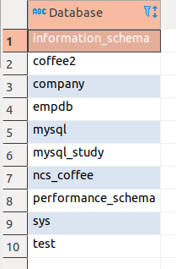
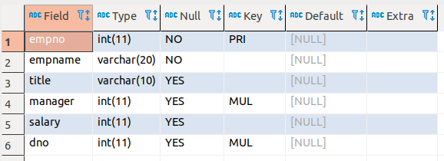
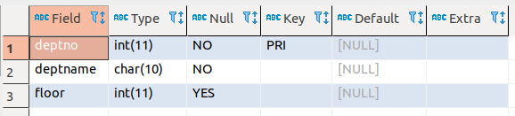
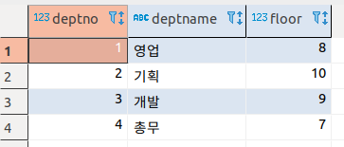
2번

insert into department values
(1, '영업', 8),
(2, '기획', 10),
(3, '개발', 9),
(4, '총무', 7);

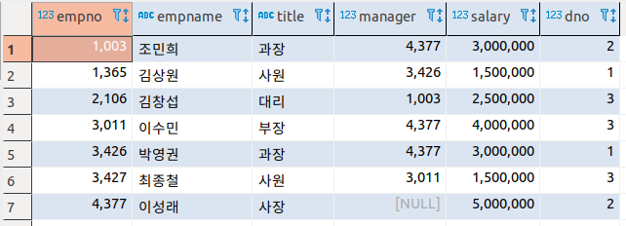
select * from department;

insert into employee values
(4377, '이성래', '사장', null, 5000000, 2),
(1003, '조민희', '과장', 4377, 3000000, 2),
(3011, '이수민', '부장', 4377, 4000000, 3),
(3426, '박영권', '과장', 4377, 3000000, 1),
(3427, '최종철', '사원', 3011, 1500000, 3),
(1365, '김상원', '사원', 3426, 1500000, 1),
(2106, '김창섭', '대리', 1003, 2500000, 2);

select * from employee;

3번

delete from department where deptno = 4;

select * from department;

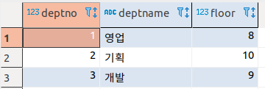

4번

update employee set dno = 3, salary = salary * 1.05 where empno = 2106;

select * from employee where empno = 2106;

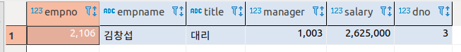

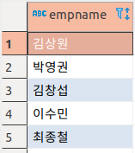
5번

select empname
from employee e, department d
where e.dno = d.deptno and d.deptname in ('영업','개발');

6번

create view v_plan(empname, title, salary)
as select empname, title, dno
from employee
where dno = (select deptno from department where deptname ='기획');

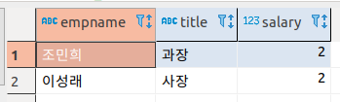
select *
from v_plan;

7번

create table sal_grade(
grade int(11),
losal int(11),
hisal int(11)
);

insert into sal_grade values
(1, 0, 1500000),
(2, 1500001, 2000000),
(3, 2000001, 3000000),
(4, 3000001, 4000000),
(5, 4000001, 9999999);

select * from sal_grade;

select empno, empname, title, salary, grade
from employee e, sal_grade s
where e.salary between losal and hisal
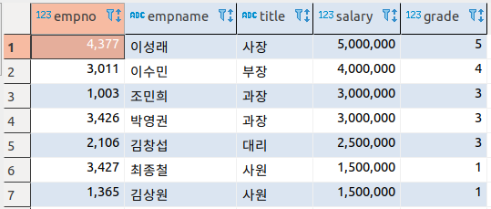
order by field(title,'사장','부장','과장','대리','사원');
8번

-- join
select empno, empname, title, dno
from employee e, department d
where e.dno = d.deptno and d.deptname = '영업';

-- subquery
select empno, empname, title, dno
from employee
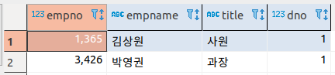
where dno = (select deptno from department where deptname = '영업');

9번

select deptname as '부서명', count(*) as '사원수'
from employee e, department d
where e.dno = d.deptno
group by dno;
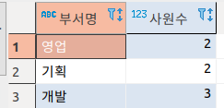

10번

SELECT p.code, name, price
from product p left join sale s on p.code = s.code
where s.code is null;

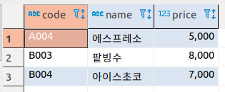

11번

select p.code as '코드', p.name as '제품명', sum(saleCnt) as '판매량합계'
from product p join sale s on p.code = s.code
group by p.code;

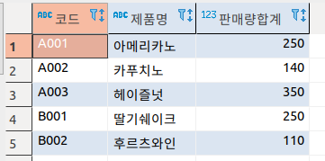

12번

select p.code, name, ifnull(saleCnt, 0)
from product p left join sale s on p.code = s.code;

