BAGM: Geometry-Aware Masked Graph Modeling of Spatial Cell States
Bio-Architectural Graph Modeling · Initial draft · 16 October 2026
Abstract
Spatial transcriptomics makes it possible to study a cell together with its tissue context. We propose Bio-Architectural Graph Modeling (BAGM), a masked expression model that learns cell representations using a Relative-Geometric QKV Graph Transformer. Cells form the graph nodes, and measured relative geometry provides an additive bias to attention between neighboring cells. The model predicts hidden expression from visible expression, morphology and spatial context. Preliminary visual observations from an earlier fitted-cohort analysis suggest that the final representations delineate putative tumor-associated regions more clearly than earlier hidden states. These observations motivate quantitative evaluation rather than establish segmentation accuracy. The current study extends the original architecture to donor-separated training and validation. We further propose attention and sensitivity analyses to investigate which inputs support predictions, while distinguishing model dependencies from biological mechanisms.
1 Introduction and related work
A cell is part of a tissue, and its state is associated with both intracellular programs and its local environment. Spatial molecular imaging platforms such as CosMx preserve this context while measuring RNA and protein distributions at subcellular resolution [1]. This creates opportunities for richer cell representations, spatial annotation and the study of tissue organization. The present BAGM model uses RNA measurements and morphology/imaging covariates; it does not jointly model a protein-expression assay.
Existing models use several learning objectives. scGPT uses generative pretraining [2], STAGATE reconstructs expression with a spatial graph attention autoencoder [3], and GraphST combines reconstruction and contrastive learning [4]. Masked reconstruction is also established in GraphMAE [5] and spatial methods such as SpaMask [6]. Building on these approaches, we study whether explicitly separating cell features, spatial geometry and neighborhood aggregation supports useful representations and a clearer analysis of model behavior.
BAGM follows a simple design principle: retain the measured organization of the tissue in the computational structure. A node represents a cell, an edge represents a candidate spatial relationship, and an edge feature describes relative geometry. This is a biological inductive bias, not a claim that each edge is a physical interaction or that each learned weight has a direct biological meaning.
2 Preliminaries
Let X contain expression features for N cells and G genes, C contain permitted morphology/imaging covariates, and P contain cell coordinates. A graph connects spatial neighbors within each tissue core. For a directed edge j → i, ρᵢⱼ denotes its relative geometry and N(i) the incoming neighbors of cell i. A binary mask M marks expression entries hidden during training. Graph attention [7] aggregates neighbor states with learned, receiver-normalized weights. BAGM uses scaled query–key–value attention with an additional geometry bias, rather than the original additive GAT scoring function.
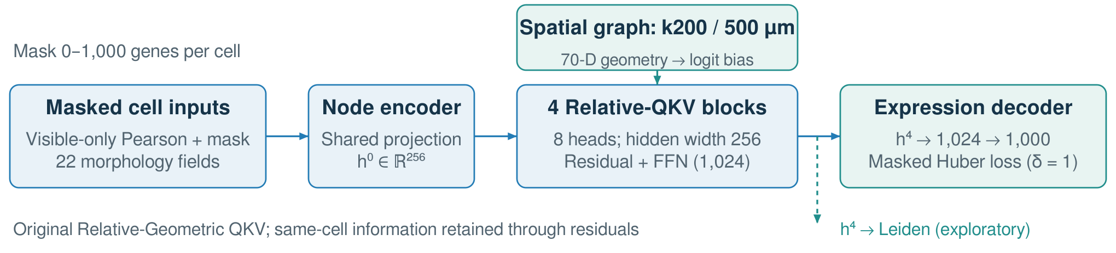
Figure 1. BAGM overview. Visible expression, the mask and morphology enter the cell encoder. Relative geometry contributes an attention-logit bias in four graph blocks. The decoder predicts masked expression; the final cell state also supports exploratory clustering. Same-cell information is retained through residual paths. This diagram describes the original Relative-QKV architecture used in the current run.

3 BAGM model and learning objective
Data and graph. The current joint-slide study contains 407,659 cells from 28 gastric tissue cores, with 1,000 biological genes and 22 morphology/imaging features. Ten donor groups contribute 20 training cores; four separate donor groups contribute eight validation cores. No donor or graph crosses the split. Within each core, coordinate-based graphs sample neighbors across radial distance bands up to 500 μm, with a nominal budget of 200 neighbors before bidirectional union. Each edge has 70 geometry features, combining distance basis functions, relative orientation and anisotropy. These edges represent neighborhood context, including scales broader than direct contact.
Masking. For each cell and each view, we draw the number of hidden genes uniformly from 0 to G and sample those genes without replacement. Ten mask views are used per training core per epoch. Inputs are recomputed from visible raw counts using frozen training statistics; hidden counts cannot affect input normalization. The targets are quasi-Poisson Pearson residuals computed before masking and standardized with frozen training statistics. Thus, this task predicts masked expression features rather than fitting a raw-count likelihood.
Geometry-aware attention. The encoder combines visible expression, mask indicators and morphology into h⁽⁰⁾. Four independently parameterized, pre-normalized Transformer blocks use width 256 and eight attention heads. For one layer and head a, query qᵢᵃ, key kⱼᵃ and value vⱼᵃ are projections of normalized cell states, and:
sᵢⱼᵃ = (qᵢᵃ)ᵀ kⱼᵃ / √32 + fₐ(ρᵢⱼ), αᵢⱼᵃ = softmaxⱼ∈N(i)(sᵢⱼᵃ)
zᵢᵃ = Σⱼ∈N(i) αᵢⱼᵃ vⱼᵃ, x̂ᵢ = Decoder(hᵢ⁽⁴⁾)
A small geometry network produces one bias per head. Geometry does not enter the value projection directly. Each block applies multi-head aggregation, a residual update, and a 1,024-wide feed-forward network with a second residual update. There are no graph self-loops. A 256 → 1,024 → 1,000 decoder maps the final state to expression predictions.
Lview = Σᵢg Mᵢg Huber₁(x̂ᵢg − Xᵢg) / Σᵢg Mᵢg
The objective averages masked-entry Huber loss equally across cores and views. AdamW uses learning rate 10⁻⁴ and weight decay 10⁻⁵. Three fixed mask views per validation core support checkpoint selection and early stopping. The current experiment is exploratory, single-seed validation; an untouched test cohort is not yet available.
4 Preliminary observations
Earlier analyses of the original architecture used 246,063 cells from 14 SO2 cores, with standardized log1p-count features and no held-out donor evaluation. Leiden clustering [8] of the final hidden states produced spatially coherent regions. An author-reported visual comparison suggested sharper putative tumor-associated regions than PCA and scVI [9]; a reproducible scVI comparison, matched clustering settings and independent pathology scoring remain pending. It concerns tissue-domain delineation, not segmentation of individual cells.
The final layer also appeared to show clearer regional structure than the input embedding and intermediate layers. The saved layer analyses confirm that partitions change across depth, but do not establish that only the final layer contains useful biological information. This pattern is consistent with progressive context aggregation; self-only and geometry/graph ablations are needed to isolate the spatial contribution. These historical observations are separate from the current training run, whose final validation results remain pending.
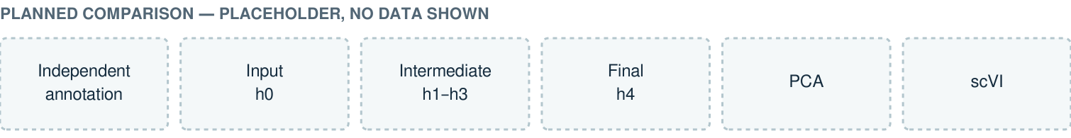
Figure 2. Planned result panels, not experimental images. Use the same tissue regions for h⁽⁰⁾, intermediate states, h⁽⁴⁾, PCA and scVI, alongside independent tumor annotations. Match clustering settings and report region overlap, boundary agreement and donor-level variability. Replace this placeholder with the final figures.

5 Biological analysis and next evaluation
We aim to use BAGM not only for representations, but also to ask what supports each prediction. Planned analyses include attention as a function of distance and cell context, differences between layers and heads, and the contribution of neighbor messages relative to a matched cell-autonomous model. Because there are no graph self-loops, this is not a comparison between a self-attention coefficient and neighbor coefficients. Attention describes information routing and is not, by itself, a measure of biological importance [10].
For a selected target gene g in cell i, a Jacobian entry Jᵢg,ⱼk = ∂x̂ᵢg/∂xⱼk measures local model sensitivity to gene k in another cell j, where xⱼk is a visible, transformed input feature and morphology, the mask and graph are held fixed. We will distinguish one-hop from multi-hop dependencies and test sensitivities with bounded input perturbations and message ablations. Such quantities may nominate predictive relationships; independent molecular evidence and perturbation experiments are needed before interpreting them as mechanisms or causal effects.
The next evaluation will compare BAGM with PCA, scVI, cell-autonomous and spatial-smoothing baselines, and established spatial models under matched splits. Independent tumor-region annotations will support Dice/IoU and boundary agreement; masked prediction will be assessed on held-out donors. Geometry removal, constrained graph rewiring and multiple seeds will test whether gains depend on meaningful spatial structure. Cell composition, core effects and segmentation spillover remain alternative explanations. Protein measurements are a possible future extension.
6 Conclusion
BAGM combines masked expression prediction with geometry-aware graph attention to learn cells in their tissue context. Preliminary regional and layer-wise observations motivate further evaluation. The immediate goal is to establish reproducible spatial predictive value; the longer-term goal is to turn model analyses into testable biological hypotheses.
References
[1] He S, Bhatt R, Brown C, et al. High-plex imaging of RNA and proteins at subcellular resolution in fixed tissue by spatial molecular imaging. Nature Biotechnology. 2022;40:1794–1806. 10.1038/s41587-022-01483-z
[2] Cui H, Wang C, Maan H, et al. scGPT: toward building a foundation model for single-cell multi-omics using generative AI. Nature Methods. 2024;21:1470–1480. 10.1038/s41592-024-02201-0
[3] Dong K, Zhang S. Deciphering spatial domains from spatially resolved transcriptomics with an adaptive graph attention auto-encoder. Nature Communications. 2022;13:1739. 10.1038/s41467-022-29439-6
[4] Long Y, Ang KS, Li M, et al. Spatially informed clustering, integration, and deconvolution of spatial transcriptomics with GraphST. Nature Communications. 2023;14:1155. 10.1038/s41467-023-36796-3
[5] Hou Z, Liu X, Cen Y, et al. GraphMAE: Self-Supervised Masked Graph Autoencoders. Proceedings of KDD. 2022:594–604. 10.1145/3534678.3539321
[6] Min W, Fang D, Chen J, Zhang S. SpaMask: Dual masking graph autoencoder with contrastive learning for spatial transcriptomics. PLOS Computational Biology. 2025;21:e1012881. 10.1371/journal.pcbi.1012881
[7] Veličković P, Cucurull G, Casanova A, et al. Graph Attention Networks. ICLR. 2018. arXiv:1710.10903
[8] Traag VA, Waltman L, van Eck NJ. From Louvain to Leiden: guaranteeing well-connected communities. Scientific Reports. 2019;9:5233. 10.1038/s41598-019-41695-z
[9] Lopez R, Regier J, Cole MB, Jordan MI, Yosef N. Deep generative modeling for single-cell transcriptomics. Nature Methods. 2018;15:1053–1058. 10.1038/s41592-018-0229-2
[10] Jain S, Wallace BC. Attention is not Explanation. Proceedings of NAACL-HLT. 2019:3543–3556. 10.18653/v1/N19-1357

