基于计量的网络用户行为研究分析

摘要：

关键词：

1背景介绍

2数据来源和研究方法

以 SCI-EXPANDED SSCI A&HCI CPCI-S CPCI-SSHI 数据库为来源，以“online user behavior”为主题进行检索，结果有4851条，由于结果比较多，所以在基本分析的时候使用全部数据，而在共引分析时使用以该关键词为题名检索出来的156条结果，检索时间为2016年6月25日。使用软件为可视化软件citespace第三版，版本号为4.0.R5.SE.64-bit.12.29.2015。

3可视化分析

3.1基本分析

该部分包含该主题研究相关的基本分析，包括国家、机构、研究领域、关键字等分析，旨在了解该主题目前研究的主要热点及基本概况。

3.1.1领域分析

这些奠定知识基础的关键节点文献进行学科分类，节点类型选择Category。网络用户行为研究涉及多个学科，向更多领域渗透而且很多学科之间交叉合作，跨领域的情况越来越多见。由下表可以看到，研究最多的领域为计算机科学，频次达到2231，这也在预料之内。其次是经济领域，频次达到739，需要说明的是，通过对网络用户行为的研究从而探索用户在进行网上消费时的规律及偏好达到提高收益精准营销的目的，该主题是很多电子商务领域研究的热点，事实上，电子商务也是研究该主题的重要领域。还有一些常规的领域，包括心理学及管理学，在该主题上同样有很多研究，比如用户在网络环境下心理上不同于现实中的变化类似的课题不仅是学术研究热点，也是社会关心的话题。

表一：网络用户行为研究涉及领域

|  |  |  |  |
| --- | --- | --- | --- |
| 排序 | 频次 | 中心度 | 来源领域 |
| 1 | 2231 | 0.28 | Computer science |
| 2 | 739 | 0.08 | Business&economics |
| 3 | 724 | 0.33 | Engineering |
| 4 | 512 | 0.08 | Information science&library science |
| 5 | 461 | 0.3 | Psychology |
| 6 | 376 | 0.04 | Business |
| 7 | 302 | 0.04 | Management |

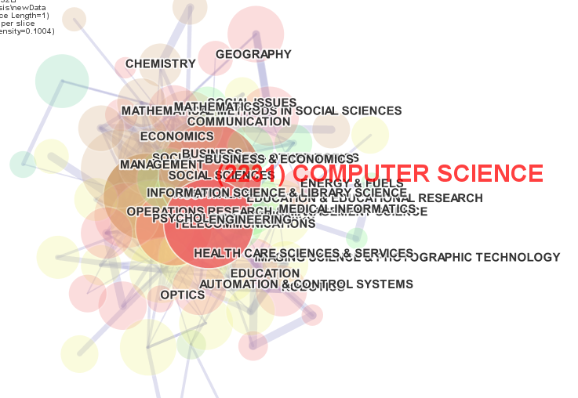

图一：computer science交叉领域示例

关键词分析

|  |  |  |  |
| --- | --- | --- | --- |
| 排序 | 频次 | 中心度 | 关键字 |
| 1 | 887 | 0.35 | Behavior |
| 2 | 812 | 0.06 | Internet |
| 3 | 480 | 0.08 | Model |
| 4 | 449 | 0.14 | Online |
| 5 | 341 | 0.08 | Information technology |
| 6 | 337 | 0.04 | User acceptance |
| 7 | 327 | 0.03 | Trust |
| 8 | 268 | 0.07 | Information |
| 9 | 237 | 0.01 | System |
| 10 | 231 | 0.04 | Technology acceptance |
| 11 | 225 | 0.11 | Web |
| 12 | 210 | 0.01 | Technology |
| 13 | 205 | 0.04 | Communication |
| 14 | 204 | 0.11 | Ecommerce |

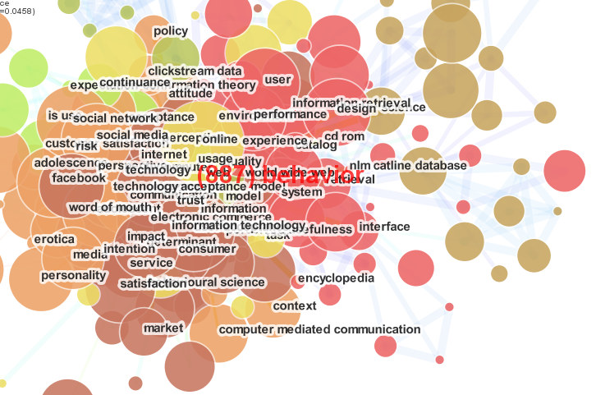

国家分析

|  |  |  |  |
| --- | --- | --- | --- |
| 排序 | 频次 | 中心度 | 国家或地区 |
| 1 | 1518 | 0.51 | 美国 |
| 2 | 619 | 0.09 | 中国 |
| 3 | 337 | 0.05 | 台湾 |
| 4 | 322 | 0.3 | 英国 |
| 5 | 219 | 0.09 | 德国 |
| 6 | 216 | 0.09 | 澳大利亚 |
| 7 | 208 | 0.11 | 西班牙 |

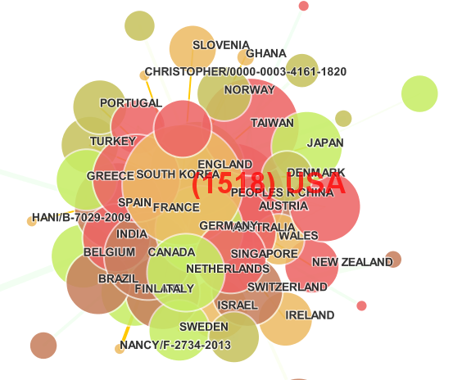

机构分析

|  |  |  |  |
| --- | --- | --- | --- |
| 排序 | 频次 | 机构 | 所属国家 |
| 1 | 47 | Penn State Univ |  |
| 2 | 41 | Nanyang Technol Univ |  |
| 3 | 39 | City Univ HongKong |  |
| 4 | 35 | Tshinghua Univ |  |
| 5 | 33 | Univ Wisconsin |  |
| 6 | 30 | Korea Avi Inst Sci&Technol |  |
| 7 | 30 | UCL |  |

作者共引

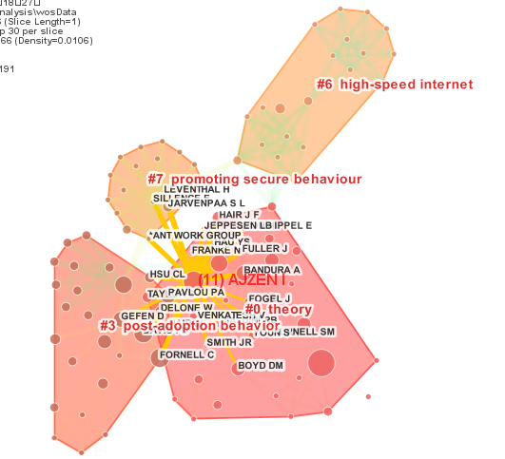

|  |  |  |  |  |  |  |
| --- | --- | --- | --- | --- | --- | --- |
| **ClusterID** | **Size** | **Silhouette** | **Label (TFIDF)** | **Label (LLR)** | **Label (MI)** | **mean(Citee Year)** |
| 0 | 38 | 0.873 | (22.02) theory | planned behavior (39.07, 1.0E-4) | proposal | 2013 |
| 1 | 30 | 0.899 | (18.7) web user | web user (54.78, 1.0E-4) | hotel online booking | 2008 |
| 2 | 28 | 1 | (23.02) practitioner end user | practitioner end user (135.65, 1.0E-4) | information behaviour | 1996 |
| 3 | 27 | 0.93 | (18.2) post-adoption behavior | factor (59.54, 1.0E-4) | hotel online booking | 2009 |
| 4 | 22 | 1 | (22.55) internet-based instrument | internet-based instrument (124.33, 1.0E-4) | ... | 2001 |
| 5 | 22 | 0.954 | (19.65) retrospective review | attribute (70.1, 1.0E-4) | mobile device | 2007 |
| 6 | 20 | 0.969 | (18.73) high-speed internet | high-speed internet (69.23, 1.0E-4) | promoting secure behaviour | 2003 |
| 7 | 17 | 0.986 | (14.78) promoting secure behaviour | promoting secure behaviour (117.77, 1.0E-4) | promoting secure behaviour | 2010 |

|  |  |  |
| --- | --- | --- |
| **citation counts** | **references** | **cluster #** |
| 26 | [Anonymous], 2011, SO, V, P | 0 |
| 11 | Ajzen I, 2010, SO, V, P | 0 |
| 9 | Fornell C, 2011, SO, V, P | 3 |
| 9 | Davis FD, 2011, SO, V, P | 3 |
| 8 | Hoffman DL, 2005, SO, V, P | 0 |
| 8 | Venkatesh V, 2012, SO, V, P | 0 |
| 7 | Bhattacherjee A, 2005, SO, V, P | 3 |
| 7 | Newman MEJ, 2009, SO, V, P | 35 |
| 6 | Gefen D, 2011, SO, V, P | 3 |
| 6 | Barabasi AL, 2008, SO, V, P | 9 |

参考文献共引

**Table 1. Summary of the largest 10 clusters.**

|  |  |  |  |  |  |  |
| --- | --- | --- | --- | --- | --- | --- |
| **ClusterID** | **Size** | **Silhouette** | **Label (TFIDF)** | **Label (LLR)** | **Label (MI)** | **mean(Citee Year)** |
| 0 | 31 | 1 | (23.44) web site | web site (100.7, 1.0E-4) | behavioural pattern | 2007 |
| 1 | 30 | 0.994 | (25.31) online behavior | online behavior (133.34, 1.0E-4) | internet | 2003 |
| 2 | 21 | 1 | (23.44) practitioner end user | practitioner end user (122.9, 1.0E-4) | online | 1991 |
| 3 | 21 | 1 | (23.44) internet-based instrument | internet-based instrument (112.92, 1.0E-4) | risk-taking behavior | 1996 |
| 4 | 19 | 0.963 | (17.07) empirical study | empirical study (34.26, 1.0E-4) | behavioural pattern | 2009 |
| 5 | 14 | 0.989 | (21.09) information behavior | information behavior (85.99, 1.0E-4) | web user | 2004 |
| 6 | 14 | 1 | (21.09) high-speed internet | high-speed internet (92.78, 1.0E-4) | user behavior | 1999 |
| 7 | 13 | 1 | (20.66) self-report | self-report (88.01, 1.0E-4) | internet user | 2001 |
| 8 | 13 | 1 | (20.66) promoting secure behaviour | promoting secure behaviour (109.94, 1.0E-4) | internet user | 2005 |
| 9 | 12 | 1 | (20.2) ergotracer | ergotracer (103.37, 1.0E-4) | ... | 1996 |

|  |  |  |
| --- | --- | --- |
| **citation counts** | **references** | **cluster #** |
| 5 | Xiang Z, 2010, TOURISM MANAGE, V31, P179 | 4 |
| 4 | Buhalis D, 2008, TOURISM MANAGE, V29, P609 | 0 |
| 4 | Boyd DM, 2007, J COMPUT-MEDIAT COMM, V13, P210 | 4 |
| 3 | Spink A, 2004, WEB SEARCH PUBLIC SE, V, P | 5 |
| 3 | Bhattacherjee A, 2004, MIS QUART, V28, P229 | 12 |
| 2 | Borna C, 2000, TELECOMMUNICATIONS, V34, P83 | 11 |
| 2 | Albert R, 2002, REV MOD PHYS, V74, P47 | 15 |
| 2 | Ahn YY, 2007, P 16 INT C WORLD WID, V,, P | 46 |
| 2 | Giles DE, 2005, EWP0511, V, P | 64 |
| 2 | Newman MEJ, 2003, SIAM REV, V45, P167 | 65 |

期刊共引分析

|  |  |  |  |
| --- | --- | --- | --- |
| 排序 | 频次 | 中心度 | 期刊 |
| 1 | 27 | 0.06 | Comput hun behav |
| 2 | 21 | 0.03 | Commun acm |
| 3 | 21 | 0.2 | Inform syst res |
| 4 | 21 | 0.21 | J marketing res |
| 5 | 21 | 0.04 | Mis quart |
| 6 | 18 | 0.01 | Manage sci |
| 7 | 17 | 0.09 | J marketing |

**Table 1. Summary of the largest 4 clusters.**

|  |  |  |  |  |  |  |
| --- | --- | --- | --- | --- | --- | --- |
| **ClusterID** | **Size** | **Silhouette** | **Label (TFIDF)** | **Label (LLR)** | **Label (MI)** | **mean(Citee Year)** |
| 0 | 55 | 0.678 | (17.08) service | factor (72.86, 1.0E-4) | france | 2009 |
| 1 | 37 | 0.866 | (17.08) attribute | attribute (46.55, 1.0E-4) | using content | 2004 |
| 2 | 31 | 0.919 | (18.29) internet-based instrument | internet-based instrument (63.38, 1.0E-4) | france | 2005 |
| 3 | 29 | 0.937 | (13.82) promoting secure behaviour | promoting secure behaviour (109.38, 1.0E-4) | promoting secure behaviour | 2008 |

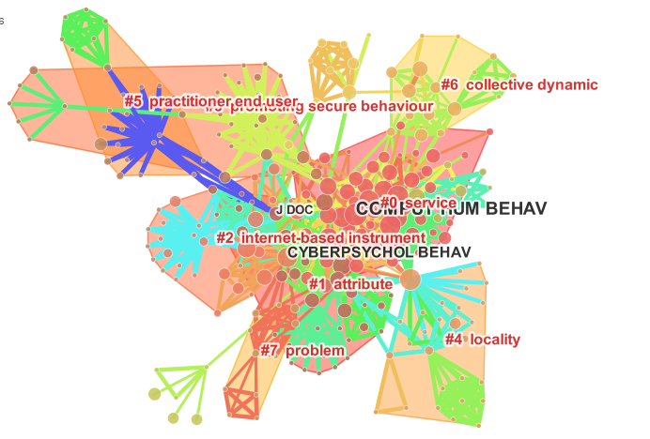

|  |  |  |
| --- | --- | --- |
| **citation counts** | **references** | **cluster #** |
| 27 | Comput HUM BEHAV, 2003, COMPUT HUM BEHAV, V, P | 0 |
| 21 | J MARKETING RES, 2005, J MARKETING RES, V, P | 0 |
| 21 | Commun ACM, 2001, COMMUN ACM, V, P | 4 |
| 21 | Mis QUART, 2005, MIS QUART, V, P | 0 |
| 21 | Inform SYST RES, 2005, INFORM SYST RES, V, P | 0 |
| 18 | Manage SCI, 2007, MANAGE SCI, V, P | 0 |
| 17 | J MARKETING, 2007, J MARKETING, V, P | 0 |
| 16 | Cyberpsychol BEHAV, 2003, CYBERPSYCHOL BEHAV, V, P | 2 |
| 15 | J CONSUM RES, 2007, J CONSUM RES, V, P | 0 |
| 15 | J AM SOC INF SCI TEC, 2004, J AM SOC INF SCI TEC, V, P | 1 |