CISC 327 GROUP-51 readme first

How to run payment feature program and test cases (Sungmoon Choi):

* Change the directory to Payment directory inside Assignment-2
* Create a virtual environment (this command is using Windows, the command is

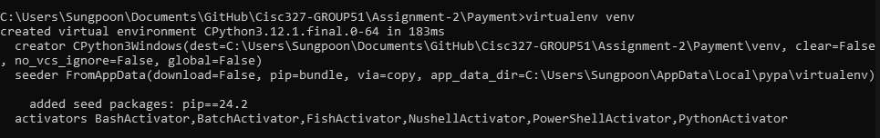different depending on the operating system)

* activate the virtual environment



* Using pip to install the required packages

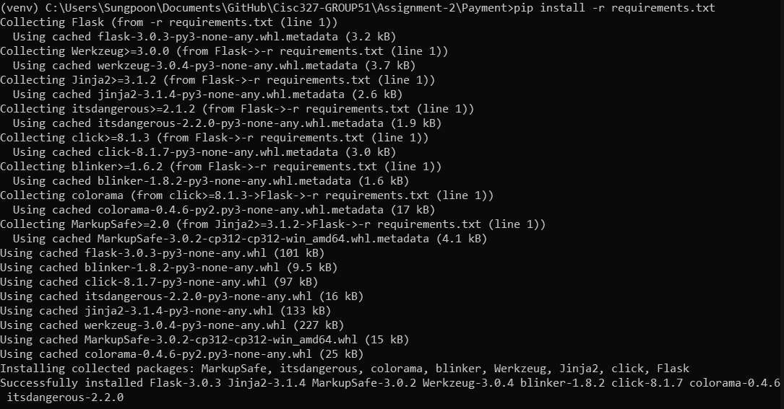

* now run app.py to start the program

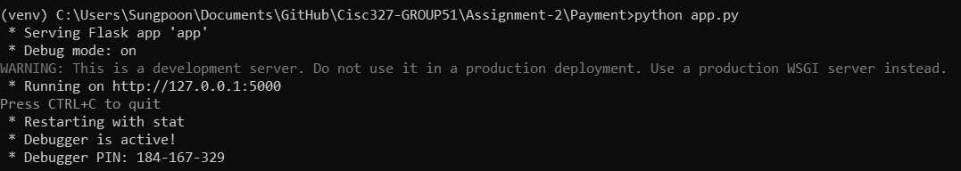

* typing http://localhost:5000/ into the browser will load the website for payment feature

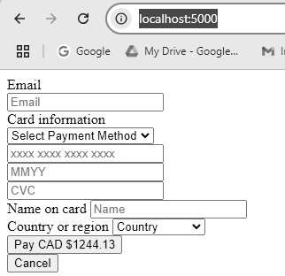

* 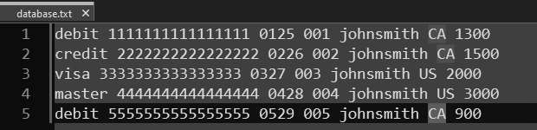from here, you can manually test by inputting information as written in database.txt (note that name is written in lower case with no space, this is because program is made to interpret name input as such, for example, "John Smith" will be interpreted as "johnsmith")
* **or to run the test case, run the command "python -m unittest discover -s tests"**

(venv) C \Users\Sungpoon\Documents\GitHub\Cisc327 GROUP51\Assignment 2\Paymcnt>python m

. . . . . . . . . . .

unittest discover

s tests

- - - - - - - - - - - - - - - - - - - - - - - - - - - - - - - - - - - - - - - - - - - - - - - - - - - - - - - - - - - - - - - - - - - - - -

Ran 11 tests **in** 0.0O1s

OK

**(note that 11 tests include both success and fail cases)**

**fail cases are tested by ensuring that no balance is returned if any of the information is incorrect, thus returning an error message on the website**