A Collaboration Middleware for Peer-to-Peer Architecture
Sung-Soo Kim, Chunglae Cho, and Jongho Won

Abstract —We introduce a novel mobile middleware which provides a collaboration service among associated apps in a symmetric fashion. This paper focuses on the challenge that how users can receive the seamless collaboration services regardless of the changes of physical device configurations in the multiscreen environment. In order to solve this problem, we propose a novel system architecture which supports primitive operations, such as remote invocation, session join/invitation, push/pull migration and synchronization for collaboration among associated applications. The major advantages of our system are that the system can provides communication transparency, seamless collaboration services and scalability. The experimental results demonstrate that our system can be successfully applied to the collaboration services among multiple apps in the small network.

Index Terms — Smart Devices, Mobile Middleware, Multiscreen, Collaboration Session.

Introduction
In the fields of broadcasting especially IPTV and content delivery, multiscreen video describes video content transformed into multiple formats, bit rates and resolutions for display on smart devices such as television, mobile phone, tablet computer and computer [7]. However, previous methods related to multiscreen IPTV focused on transcoding the multimedia for adaptive content delivery. In recent years, there has been an increased interest in smart applications (or apps) running on various smart devices, such as smartphones and tablets. The main reason for this has been the realization that many diverse apps need a dedicated middleware for managing apps and collaborating among multiple associated apps.
A second screen is a second smart device used by television viewers to connect to a program they’re watching. A second screen is often a smartphone or tablet, where a dedicated complementary app may allow the viewer to interact with a television program in a different way – the tablet or smartphone becomes a TV companion device.
In this paper, we propose a novel mobile middleware to support the seamless collaboration services among heterogeneous multiple apps in diverse smart devices. To provide convincing the collaboration services in multiscreen environments, we describe the key requirements as follows:
- Service Discovery: Since the wireless hosts in the wireless network are highly dynamic, service hosts should periodically announce their presence in the network. Service discovery is one of the most important functions in order to collaborate among apps through remote invocation and session join/invitation in mobile computing environments.
- Collaboration: The system must support collaboration services among apps in smart devices. To satisfy this requirement, the system allows apps to join or leave a collaboration session which is a logical space being synchronized via associated information at runtime. However, collaboration session management in a peer-to-peer environment is quite challenging since its dynamic property.
- Mobility: The system must support app migration function, which migrates certain running apps from arbitrary device to other device at runtime.
- Scalability: The system must be able to scale with the growth in the number of apps for collaboration services. For example, it must support the dynamic session joins for new apps during a certain collaboration service is provided. So, it is necessary to develop the collaboration session management techniques to provide the service scalability.

Main contributions: We present a novel system architecture for the multiscreen-based collaboration services, which utilizes the collaboration middleware for multiple associated apps in the same wireless network and the remote service cloud. The contributions of our work can be summarized as follows.
- Collaboration middleware: Our proposed middleware, which is based on peer-to-peer communication model, provides common APIs for diverse collaboration-based applications. Our middleware APIs include the primitive functions, such as, remote execution, session join/invitation and app migration.
- Service scalability: We introduce a schema for representing inter-app relationship in collaboration sessions. This model can help design collaboration services and add additional apps for service extension.
- Lifecyle managment: We propose a method for logical app lifecycle management to support seamless collaboration session.
The rest of the paper is organized as follows. Section II describes the proposed the system architecture and the core components in our system. We briefly survey previous work on multiscreen middleware, multiscreen IPTV, and second screen in Section IV. In Section III, we present the experimental results of our work in terms of service discovery. Finally, we discuss future work and conclude in Section V.

System Architecture
In this section, we describe the proposed system architecture for the multiscreen-based collaboration services. Our architecture consists of two major systems such as the proposed middleware for smart devices and n-screen service cloud as shown in Fig. 1. More specifically, our middleware decomposes into 2 layers; the n-screen application library (NSAL) and the collaboration agent (CA).

System Overview
Basically, our system architecture divided into two major systems as shown in Figure 2. First, our proposed architecture based on the Smart Home concept is targeted at the smart home environment in terms of communication and socialization.
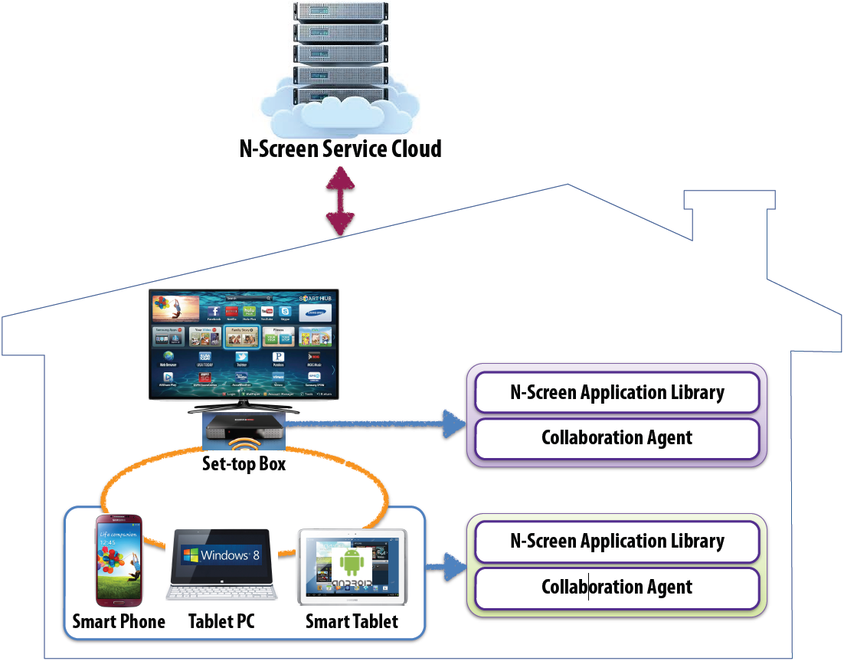
Fig. 1. The proposed system architecture

In our work, the smart home consists of various wireless hosts such as smartphone, smart set-top, smart tablet, or laptop which connects each other through a wireless communication link in the same wireless network environment. Each wireless host has the n-screen application library and collaboration agent, which provide abstractions that reduce development effort and support interoperability between applications. These mobile devices communicate directly with each other in a peer-to-peer fashion with no centralized control. Hence, the synchronization for collaboration services is achieved through direct communication between applications.
Second, the n-screen service cloud is responsible for providing the collaboration applications similar to the apps in the App Store and managing the application contexts for users. The primary benefit from the N-screen service cloud is scalability, persistency and mobility for the collaboration service. To represent the context of the application, we use the key-value pair which is the most simple context model. Context information of the applications and collaboration sessions are stored in the context repository at the service cloud.

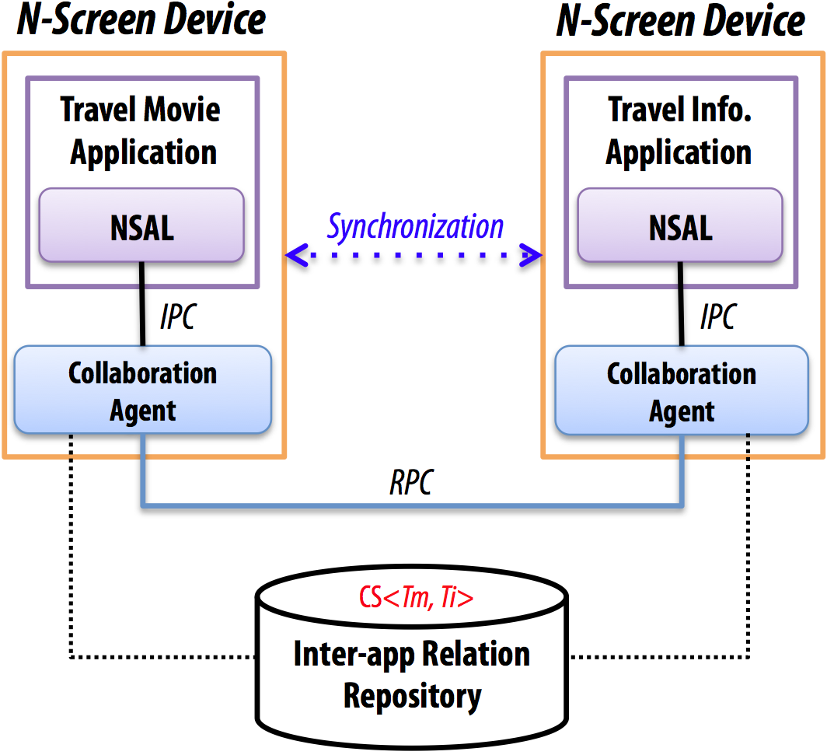
Fig. 2. The proposed system architecture

In the interest of speed and economy, the IEEE Transactions on Consumer Electronics only accepts “camera-ready” papers that are printed directly from this electronic template as furnished by the author. Since the final printed pages look exactly like the submitted copy, it is urged that authors take the utmost care in the preparation utilizing this electronic template.
Do not include any blank pages either at the beginning or end of your manuscript, or any messages to the editor or reviewers in your submission. Paper is expensive, so do not leave any excessive white/unused spaces in your paper. Authors should avoid the situation where the last page of the paper only contains a sub-set of the authors’ biographies.
Due care should be exercised to avoid the use of abbreviations and phrases which may not be familiar to all readers. Readers of the IEEE Transactions on Consumer Electronics have wide and diverse backgrounds and may not be employed in the specific area of any given paper, but are still interested in following the state-of-the-art. All abbreviations and phrases need to be suitably defined in the main text, usually, the first time they occur. It is good practice not to use abbreviations in the title but if they are used then make sure they are also defined in the title.
The length of contributed technical papers is limited to 9 pages or less (including all figures and biographies). The length of invited papers is at the discretion of the editor.
Page numbers and page headings are not to be added by authors. Neither is “Manuscript Received” or “Correspondence Author” information.
Only those who personally write the paper are to be listed as authors. Since it is unlikely that a large number of authors can write a cohesive paper, submissions listing more than five authors will not be accepted. The efforts of the persons who contributed to the project described, or who otherwise provide help to the author(s) may be recognized in an Acknowledgments section at the end of the paper.
For each author, a brief biography for each author is to be included at the end of the paper as detailed in this template. The inclusion of a small photograph (head only) of each author is encouraged but not mandatory.

Submission Procedure
The only acceptable electronic format is Word 6.0 or later (.doc or .docx). The title of the electronic file should include the last name of the first author; i.e., smith.doc. For papers presented at the ICCE (IEEE International Conference on Consumer Electronics), the file should also include the paper presentation date and the paper number, e.g., 1234567890. For non-conference papers, use the first two words of the paper title and last name of first author, e.g., Preparation of_FirstAuthor.doc.
All papers must be submitted to http://www.cloznet.com/ieee-ce. The web site will require you to enter information about the paper as well as contact information, to justify what is new about your paper and why your paper is relevant to Consumer Electronics. If the paper was presented at a Consumer Electronics society sponsored Conference then the paper number must be entered in the appropriate location. Upon successful submission of the paper an automatic email confirmation will be sent to the contact author. If the email does not arrive please contact the Editor-in-Chief (details below)
The above contact information will also be used to provide a complimentary copy of the issue in which the paper is published to each author. Only one complimentary copy per paper of the issue in which the paper is published will be sent to the contact author. The T-CE cannot be responsible for wrong, incomplete, or changed mailing addresses or delays by postal services.
If there are any questions then prospective authors may wish to contact:
R. Simon Sherratt, Editor-in-Chief
IEEE Transactions on Consumer Electronics sherratt@ieee.org

Submission Timing
There are four issues published per year, dated February, May, August and November. The submission deadlines for these four issues respectively are January 1, April 1, July 1 and October 1, respectively. The deadline time is before midnight in the EDT time zone (as of New York, USA.) Authors may submit papers at any time and the editorial process will assign papers to the relevant issue.

ICCE Submissions
Currently, the May issue is reserved for enhanced versions of papers that were presented at the January ICCE. Authors should note that as a consequence of the May issue being reserved for ICCE papers, then contributed (non ICCE) papers submitted after the 1st January will normally considered for the following August issue. Extended ICCE papers submitted for the May issue must cite (reference) the ICCE paper in the extended paper as a normal reference to previously published literature, and detail the enhancements in the extended paper over the original ICCE paper.
Where a paper has been submitted to the May issue, rejected and later resubmitted for a non-ICCE T-CE issue then make sure the original ICCE paper is still properly cited in the same fashion as other previously published papers are cited.

Other (non ICCE) enhanced paper submissions
Enhanced papers from any other (non ICCE) Consumer Electronics Society owned conference can be submitted as normal contribution papers to the February, August or November issues providing the original paper is properly cited in the same fashion as other previously published papers.
Only enhanced papers derived from conferences that are owned by the Consumer Electronics Society can be considered for publication.

Review Process
All papers, including resubmitted papers, submitted to the IEEE Transactions on Consumer Electronics are subject to a thorough review process. The Editor-in-Chief is responsible for coordinating the review among the Associate Editors and making final decisions on each paper.
When a paper submitted, an automatic email receipt is sent to the contact author containing copyright form generation and a unique URL that allows authors to resubmit new versions of their paper. This URL will be available until the issue submission deadline. Please use this method to send updated papers before the deadline rather than creating new submissions.
The contact author will be notified by email at the conclusion of this Review Process. Routine inquiries as to the status of the submitted paper within the Review process or questions about when the issue will be completed and available, either in hard copy or on IEEE Xplore, will not be accommodated. Questions on papers can only be answered to the contact author for obvious security reasons therefore authors are advised to use reliable email addresses.
IEEE members should note they can sign-up to an e-mail notice to inform when new issues are posted to Xplore, or an RSS feed.
The accept/reject results are e-mailed normally in the third to fourth week of the month of the issue of concern (i.e. February, May, August and November.)
If the paper is accepted, there is no opportunity to make any changes from what was originally submitted. What was submitted is what will be printed and posted on IEEE Xplore.
Any papers that do not conform to these Instructions for Authors will be administratively rejected without technical review.

Resubmissions
In cases where the Editor rejects a submission, resubmission may be encouraged. Corrected manuscripts may be resubmitted via the same T-CE web site, being sure to select the “Yes” button indicating a resubmission and submitting a new copyright form.

Copyright
It is the policy of the IEEE to own the copyright to the technical contributions that it publishes on behalf of the interests of the IEEE, its authors, their employers, and to facilitate the appropriate re-use of this material by others. To comply with the U.S. copyright law, authors are required to sign an IEEE Copyright Form before publication. Authors must submit a signed copy of this form after submitting each manuscript. The form will be generated during the electronic submission process. Also a unique URL is given in the email submission receipt to regenerate the form if required and submit the form to the paper submission site.
Print it
Sign it
Scan it (PDF preferred)
Upload it to: (the unique URL provided)

Open-Access Policy

Where papers are accepted, an acceptance e-mail will be sent that also contains information on how authors may select their paper to be published on Xplore in an Open Access format as per the current IEEE Open Access Policy. There is a standard IEEE set fee for this process. For details, see IEEE documentation or the acceptance e-mail sent to the contact author. The IEEE Open Access FAQ is at http://www.ieee.org/publications_standards/publications/authors/open_access.html.
All papers, whether intended to be published using the OA model, or not, receive the same high quality peer review process.

Specific Requirements

Commercialism
All evidence of commercialism is to be meticulously avoided in the title, text, footnotes, tables and figures of the paper. This includes company names, trademarks, registered logos and commercial part numbers. It is appropriate to put the company affiliation of the authors(s), along with email addresses within the footnote on the first page, as indicated by this template. All commercial part numbers, whether the subject of the paper or not, are to be avoided in the title, text, tables and illustrations. No commercial names or part numbers are now allowed in any footnote.
The IEEE Transactions on Consumer Electronics must convey a professional approach to its readers and attempts at injecting commercialism in papers presented for publication have been, and will continue to be, adequate cause for rejection.

Image Copyright
In general images that are under copyright should be avoided, and in some cases would also contravene the commercialism rule. However, in extreme cases, authors can use non-commercial images that are under copyright providing that the authors have permission to do so by the original copyright holder and clearly state after the image caption that the authors have permission from the original copyright holder to use the image.

Plagiarism
The IEEE Transactions on Consumer Electronics performs an electronic check on papers to detect plagiarism as per IEEE policy. If authors of submitted papers are suspected of significantly presenting work that has been published before, by any author, then the submitted paper will be removed from the submission queue and fully investigated. Violators will be reported to IEEE and could be subject to suspension of publication opportunities.

Paper Title and Author Line
The title of the paper should be written in uppercase and lowercase letters, not all uppercase. Avoid writing long formulas with subscripts in the title. Do not write “(Invited)” in the title. Do not begin a title with the word “On ... .” Do define all terms used in the title.
Full names of authors are preferred in the author field, but are not required. Put a space between authors’ initials. Do not list author affiliation at the top of this page under the title – that is what the page 1 footer is for. Make sure any IEEE membership details tally with the content of the biographies.

References
Number citations/references consecutively in square brackets [1], in numerical order. The sentence punctuation follows the brackets [2]. Multiple references [2], [3] are each numbered with separate brackets, or cascaded [1]-[4].
Cite by the authors name(s) or technology, for example “Vetro et al [1]” or “Scalable DTV decoding [1]”. Note the reference pointer does not form part of the readable text, therefore authors should not reference in the format of “… as in [3]”, “In [3] …”, or “Reference [3] …”.
Number footnotes separately in superscripts (Insert | Footnote). Place the actual footnote at the bottom of the column in which it is cited; do not put footnotes in the reference list.
Note that IEEE referencing style is quite different from that used by many physics journals. In the reference list, give all authors’ names; do not use “et al.” unless there are six authors or more. Use a space after authors’ initials. Only cite papers that have been published or are in-press. Papers that have been accepted for publication should be cited as “accepted for publication” [4] and the journal name is not italicized. Please give affiliations and addresses for personal communications [5].
Books [2] should be listed in the reference list with their title italicized. Conference papers [6] should have the full name of the conference with no acronym (e.g. do not state ICCE) and not in italics. The publisher or sponsor of the conference should be given [6].
Capitalize only the first word in a paper title, except for proper nouns and element symbols. For papers published in translation journals, please give the English citation first, followed by the original foreign-language citation [7].
Websites, URL’s and other on-line sites are not permitted as references in these archival publications because they are subject to change. This policy includes references anywhere in the paper including the reference list, figures, footnotes or main text.

Use of English
Please note our official publication language is English and to maintain quality consistent with our formal archival publication, it is required that all submissions conform to the style and formal grammar rules of the English language. For this reason, it is encouraged that all authors whose native language is other than English to enlist the services of a native language speaking colleague or associate to review and edit your submission. Improper use of the English language will continue to be a sufficient reason for rejection
The paper needs to be written in the third person tense, therefore avoid terms of “we”, “us”, “our”, “I”, etc.

Figures and Tables
All figures and tables should have adequate titles or captions and formatting as exampled later in this document, and must be integrally placed at their proper location(s) in the text. For the benefit of the readers, the figures, tables, graphs and photos should be placed near the corresponding text; that is, not accumulated at the end of the text or at the end of the manuscript.
It is preferable to keep figures and tables (illustrations) to one column width, inline with text.
Make the caption bold. Insert the illustration using Edit | Paste Special | As Picture. Resize the illustration as necessary. Use Format | Picture and set Layout to “In Line with Text”. Insert a paragraph mark (hit “enter”) immediately after the illustration. Select the illustration and apply “Table Title” style. Start the caption on the next line (no blank line between illustration and caption). The above procedure will prevent the illustration and caption from becoming disassociated across page boundaries while also preventing them from jumping to another part of the document when different printer drivers or versions of Word are used.
Do not use unusual or non-English fonts in the text of any figure or table; they will not reproduce correctly.

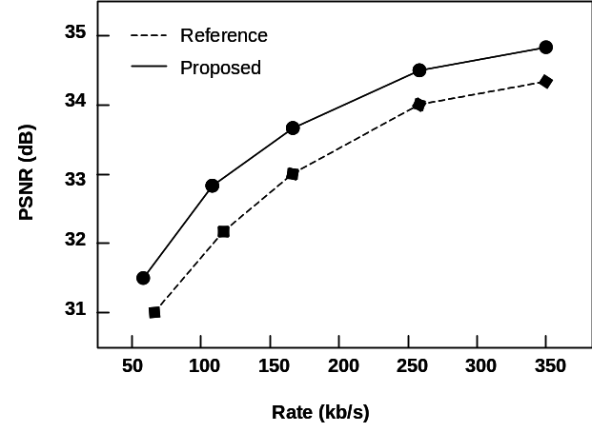
Fig. 1. Rate-Distortion curves comparing Reference and Proposed algorithms. Note that “Fig.” is abbreviated. There is a period after the figure number, followed by two spaces. It is good practice to explain the significance of the figure.

Large figures and tables may span both columns if required for readability. Illustrations spanning both columns should be placed in a separate single-column section of the document (separated by section breaks), and must be placed at the top or bottom of the page so that the text on the page is read as one complete left column followed by one complete right column. Place figure captions below the figures, as indicated in Figure 1. Place table titles above the tables, as illustrated in TABLE I, and using the table format as per TABLE I. Select the table title and the entire table, and use Format…Paragraph…Indents and Spacing to set “Keep with Next.” This will prevent the title and the table from breaking across page boundaries. If there are captions, apply “Keep With Next” to all but the last caption. Contents of tables may not be split between two different columns.
Only tables of the correct format as detailed in TABLE 1 are acceptable.
If your figure has two parts, for example, include the labels “(a)” and “(b)” as part of the artwork. Please verify that figures and tables that you mention in the text actually exist. Use the abbreviation “Fig.” even at the beginning of a sentence. Do not abbreviate “Table.” Tables are numbered with Roman numerals. See Fig. 1 for an example of a single-column illustration.

TABLE I
Units and Corresponding Symbols
Unit | Unit Symbol
megabytes per second | MB/s
kilohertz | kHz
nanosecond | ns
Statements that serve as captions for the entire table do not need footnote letters.

Figure axis labels are often a source of confusion. Use words rather than symbols. As an example, write the quantity “Rate,” or “Rate, R,” not just “R.” Put units in parentheses. Do not label axes only with units. As in Fig. 1, for example, write “Rate (kb/s)” or “PSNR (dB).” Do not label axes with a ratio of quantities and units. For example, write “PSNR (dB),” not “PSNR/dB.”
Multipliers can be especially confusing. Write “Rate (kb/s)” or “Rate (10³ b/s),” not “Rate (b/s) × 1000.” Figure labels should be legible, approximately 8 to 12 point type.

Abbreviations and Acronyms
Define abbreviations and acronyms the first time they are used in the text, even after they have already been defined in the abstract. Abbreviations such as IEEE, SI, ac, and dc do not have to be defined. Abbreviations that incorporate periods should not have spaces: write “C.N.R.S.,” not “C. N. R. S.” Do not use abbreviations in the title unless they are unavoidable (for example, “IEEE” in the title of this article). For a more complete listing of common abbreviations and acronyms please refer to Appendix II of http://www.ieee.org/portal/cms_docs/pubs/transactions/auinfo03.pdf.

Equations
When using Word, use either the Microsoft Equation Editor or the MathType add-on (http://www.mathtype.com/) for equations in your paper (Insert | Object | Create New | Microsoft Equation or MathType Equation). “Float over text” should not be selected. Do not submit papers where equations are pictures (bitmaps).
Number equations consecutively with equation numbers in parentheses flush with the right margin, as in (1). First use the equation editor to create the equation. Then select the “Equation” markup style. Press the tab key and write the equation number in parentheses. To make your equations more compact, you may use the solidus ( / ), the exp function, or appropriate exponents. Use parentheses to avoid ambiguities in denominators. Punctuate equations when they are part of a sentence, as in

 (1)

Be sure that the symbols in your equation have been defined before the equation appears or immediately following. Italicize symbols. Refer to “(1),” not “Eq. (1)” or “equation (1),” except at the beginning of a sentence: “Equation (1) is ... .”.

Units
Use either SI (MKS) or CGS as primary units. (SI units are strongly encouraged.) Imperial units may be used as secondary units (in parentheses). For example, write “15 Gbit/cm² (100 Gbit/in²).” An exception is when English units are used as identifiers in trade, such as “3½ in disk drive.” Avoid combining SI and CGS units. This often leads to confusion because equations do not balance dimensionally. If you must use mixed units, clearly state the units for each quantity in an equation. For further information on units and quantity symbols, please refer to Appendix I of http://www.ieee.org/portal/cms_docs/pubs/transactions/auinfo03.pdf.

Helpful Hints

Other Recommendations
Use one space after periods and colons. Hyphenate complex modifiers: “zero-field-cooled magnetization.” Avoid dangling participles, such as, “Using (1), the potential was calculated.” [It is not clear who or what used (1).] Write instead, “The potential was calculated by using (1),” or “Using (1), the potential was calculated ...”
Use a zero before decimal points: “0.25,” not “.25.” Use “cm³,” not “cc.” Indicate sample dimensions as “0.1 cm × 0.2 cm,” not “0.1 × 0.2 cm².” The abbreviation for “seconds” is “s,” not “sec.” Do not mix complete spellings and abbreviations of units: use “Mb/s” or “megabits per second,” not “megabits/s.” When expressing a range of values, write “7 to 9” or “7-9,” not “7~9.”
A parenthetical statement at the end of a sentence is punctuated outside of the closing parenthesis (like this). (A parenthetical sentence is punctuated within the parentheses.) In American English, periods and commas are within quotation marks, like “this period.” Other punctuation is “outside”! Avoid contractions; for example, write “do not” instead of “don’t.” The serial comma is preferred: “A, B, and C” instead of “A, B and C.”
Remember to check spelling. If your native language is not English, please get a native English-speaking colleague to proofread your paper. Many papers are rejected for poor use of the English language or simple spelling errors.
Additional guides and suggestions may be found at http://www.icce.org/authors_page/14steps.pdf

Some Common Mistakes
The word “data” is plural, not singular. Use the word “micrometer” instead of “micron.” A graph within a graph is an “inset,” not an “insert.” The word “alternatively” is preferred to the word “alternately” (unless you really mean something that alternates). Use the word “whereas” instead of “while” (unless you are referring to simultaneous events). Do not use the word “essentially” to mean “approximately” or “effectively.” Do not use the word “issue” as a euphemism for “problem.”
Be aware of the different meanings of the homophones “affect” (usually a verb) and “effect” (usually a noun), “complement” and “compliment,” “discreet” and “discrete,” “principal” (e.g., “principal investigator”) and “principle” (e.g., “principle of measurement”). Do not confuse “imply” and “infer.”
Prefixes such as “non,” “sub,” “micro,” and “ultra” are not independent words; they should be joined to the words they modify, usually without a hyphen. There is no period after the “et” in the Latin abbreviation “et al.” The abbreviation “i.e.” means “that is,” and the abbreviation “e.g.” means “for example.”
An excellent style manual and source of information for science writers is available on the IEEE website under Information for Authors.

Chester Sall Memorial Awards
All papers published in the IEEE Transactions on Consumer Electronics become candidates for one of the three Chester W. Sall Best Paper awards. Three papers are chosen each year by the Society’s Awards Committee.

Conclusion
Although a conclusion may review the main points of the paper, do not replicate the abstract as the conclusion. A conclusion might elaborate on the importance of the work or suggest applications and extensions.
Appendix
Appendices, if needed, appear before the Acknowledgment.
Acknowledgment
The preferred spelling of the word “acknowledgment” in American English is without an “e” after the “g.” Use the singular heading even if you have many acknowledgments. Avoid expressions such as “One of us (S.B.A.) would like to thank ... .” Instead, write “S.B.A. thanks ... .”
Put sponsor acknowledgments, if any, in the footnote on the first page, not in the acknowledgments section.
References
Note: Authors need to use the format and style of the reference list exactly as (make sure this sentence is removed from the submitted paper):
- A. Vetro, H. Sun, P. DaGraca, and T. Poon, “Minimum drift architectures for three-layer scalable DTV decoding,” IEEE Trans. Consumer Electron., vol. 44, no. 3, pp. 527-536, Aug. 1998.
- A. N. Netravali and B. G. Haskell, Digital Pictures, 2nd ed., Plenum Press: New York, 1995, pp. 613-651.
- H. Sun, W. Kwok, and J. Zdepski, “Architectures for MPEG compressed bitstream scaling,” IEEE Trans. Circuits Syst. Video Technol., vol. 6, no. 2, pp. 191-199, Apr. 1996.
- R. Nicole, “Title of paper with only first word capitalized,” accepted for publication in IEEE Trans. Broadcast Technology.
- C. J. Kaufman, Rocky Mountain Research Laboratories, Boulder, CO, personal communication, 1992.
- J. O. Cadenas, R. S. Sherratt, P. Huerta, W.-C. Kao, and G. Megson, “Parallel Pipelined Histogram Architecture Via C-slow Retiming,” in Proc. IEEE International Conference on Consumer Electronics, Las Vegas, USA, pp. 230-231, Jan. 2013.
- Y. Yorozu, M. Hirano, K. Oka, and Y. Tagawa, “Electron spectroscopy studies on magneto-optical media and plastic substrate interface,” IEEE Transl. J. Magn. Jpn., vol. 2, pp. 740-741, August 1987 [Dig. 9th Annual Conf. Magn. Jpn., p. 301, 1982].

biographies

Note: It is required that all authors provide a brief biography with a requested photo of the size detailed below. The picture layout is formatted such that text wraps “square” and to the right. Author photos are not mandatory, but empty photoboxes where photos would be inserted should then be deleted. Please follow the following example for the first author. As can be seen from the brackets this author became a Student member (S) of IEEE in 1973, a Member (M) of IEEE in 1976, a Senior Member (SM) in 1981, and a Fellow (F) in 1987, therefore in the biographies do NOT state “this author became a Member (M) of IEEE in 1976” because this information is in the brackets. IEEE membership is not required to be an author. The IEEE membership information in biographies should match details in the page 1 author line below the title (make sure this paragraph is removed from the submitted paper.)

A. N. Author (S’73-M’76-SM’81-F’87) and the other authors should include biographies at the end of the paper. Usual biography information includes birth date and place, education, employments, and memberships of other professional societies.
Author’s
Photobox

Keep box size

It is also appropriate to include research interests, professional activities and awards that have been received. Copy and paste this paragraph, with picture, for additional authors.

This work was supported by ETRI R&D program ("Development of Big Data Platform for Dual Mode Batch Query Analysis, 14ZS1400") funded by the government of South Korea. Sung-Soo Kim is with the Electronics and Telecommunications Research Institute (ETRI), Daejeon, South Korea (e-mail: sungsoo@etri.re.kr). Chunglae Cho is with the Electronics and Telecommunications Research Institute (ETRI), Daejeon, South Korea (e-mail: clcho@etri.re.kr). Jongho Won is with the Electronics and Telecommunications Research Institute (ETRI), Daejeon, South Korea (e-mail: jhwon@etri.re.kr).
It is recommended that footnotes be avoided. Instead, try to integrate the footnote information into the text wherever possible.

