INPUT THE TYPE OF MANUSCRIPT

Input the title of your manuscript

Author1†, membership type and Author2††, membership type

SUMMARY Input here the part of summary.

† The author is with NTT, Musashino-shi, 180-8585 Japan.
†† The author is with IEICE, Minato-ku, Tokyo, 105-0011 Japan.
key words: Input here the part of 4-5 keywords.
1. Introduction
From this section, input the body of your manuscript according to the constitution that you had. For detailed information for authors, please refer to [1].
2. Tables, Figures and Equations
2.1 Tables and Figures
To insert “Tables” or “Figures”, please paste the data as stated below. All tables and figures must be given sequential numbers (1, 2, 3, etc.) and have a caption placed below the figure (“FigCaption”) or above the table(“FigTalbe”) being described, using 8pt font and please make use of the specified style “caption” from the drop-down menu of style categories.
Table 1 Margin specifications.
Margin | A4 Paper | US Letter Paper
Left | 18.5 mm | 14.5 mm (0.58 in)
Right | 18mm | 13 mm (0.51 in)
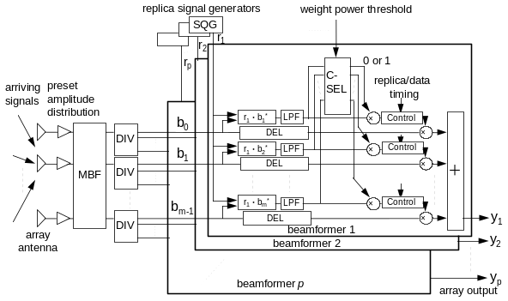
Fig. 1 Proposed beam former.
2.2 Equations
If a displayed equation needs a number, place it flush with the right margin of the column (e.g., see Eq. 1).
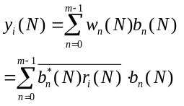 (1)
3. Paragraphs and Itemizations
• If you would like to itemize some parts of your manuscript, please make use of the specified style “itemize” from the drop-down menu of style categories.
• In the case that you would like to paragraph your manuscript, please make use of the specified style “paragraph” from the drop-down menu of style categories.
4. Page Charges
Please note that any page charges discount will not be applied to a manuscript in Word format.
http://www.ieice.org/eng/shiori/page2_ess.html#5-3
Acknowledgments
Insert acknowledgment, if any.
References
[1] http://www.ieice.org/eng/shiori/index.html

Taro Denshi ceived the B.S. and M.S. degrees in Electrical Engineering from Shibaura Institute of Technology in 1997 and 1999, respectively. During 1997-1999, he stayed in CRL, Ministry of Posts and Telecommunications of Japan to study beamforming antennas. He now with DDI Tokyo Pocket Telephone, Inc.

