Final Project

ENGN 1300: Structural Analysis

Professor Yuri Bazilevs

May 15, 2023

Miriam Kastens, Sungwon La, and Lauren Long

**Overview**

The structural system to be analyzed is a suspension bridge and deck, as shown in Figure 1 below. The bridge deck and pylons are created out of reinforced concrete, and the cables are made of high grade steel. In part 1 of the project, we were asked to perform a static analysis of the bridge under a pre-tensioned load of the cables and a uniform distributed load on the deck. In part 2 of the project, we built upon the distributed configuration from part 1 and added in a time dependence factor from an earthquake load. From this dynamic analysis, we produced an animated structure and multiple time dependent graphs of the acceleration components at nodes D and K and the support reactions at nodes Q, R, A, and N.

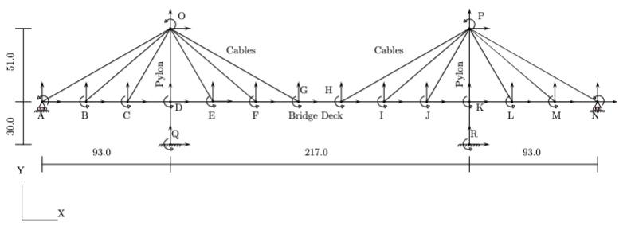

**Figure 1:** diagram of the suspension bridge structure

**Instructions**

The static part and dynamic part are both conducted in driverFinal.m. Simply run the code without making any adjustments, and Figures 1 and 2 will output the result for the static analysis. Figure 3 will output the animation of the deformed structure under dynamic analysis with the consistent mass matrix, and Figure 4 will output the animation of the deformed structure under dynamic analysis with the lumped mass matrix. Figures 5, 6, 7 will yield plots of the acceleration components and support reactions, as shown below in the next section

**Plots**

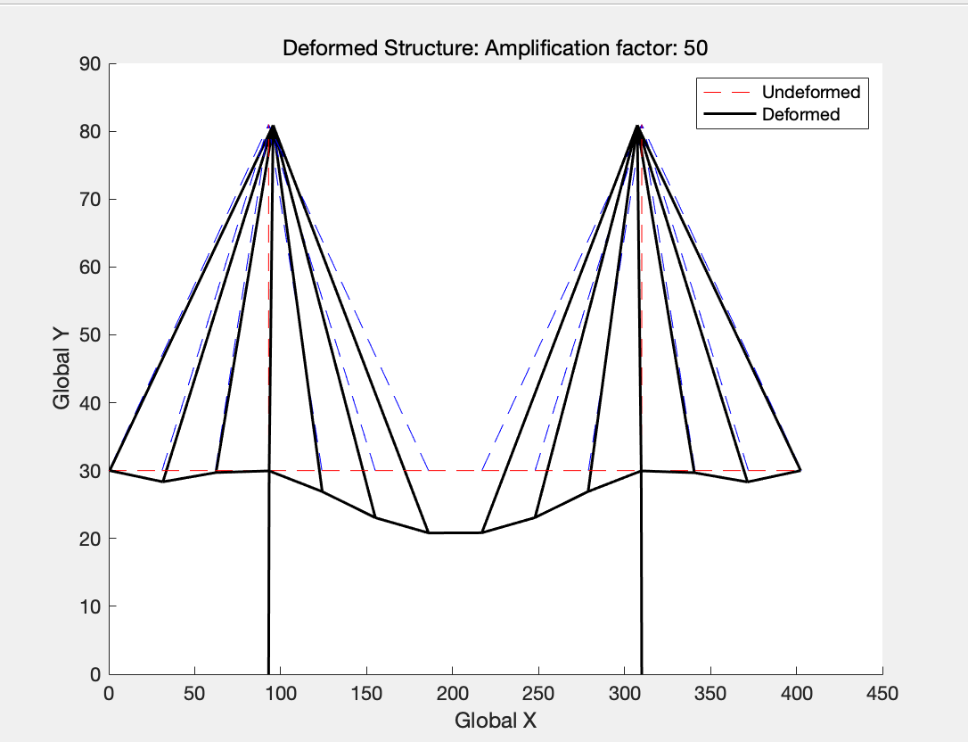

**Figure 2:** Plot of the deformed structure with distributed loading and pretensioned cables, after conducting static analysis

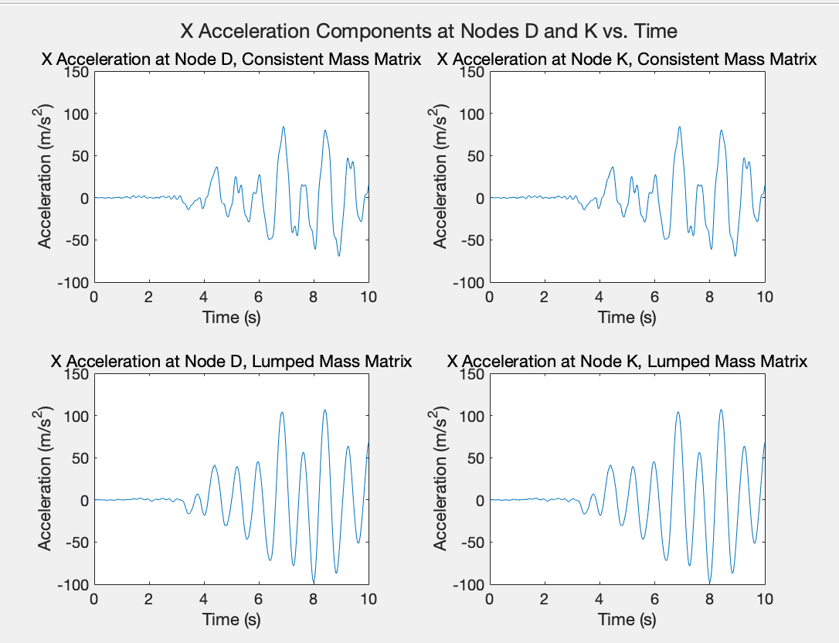

**Figure 3:** time-dependent plots of the x-acceleration components at nodes D and K, for analyses conducted with both the consistent mass matrix (top) and lumped mass matrix (bottom)

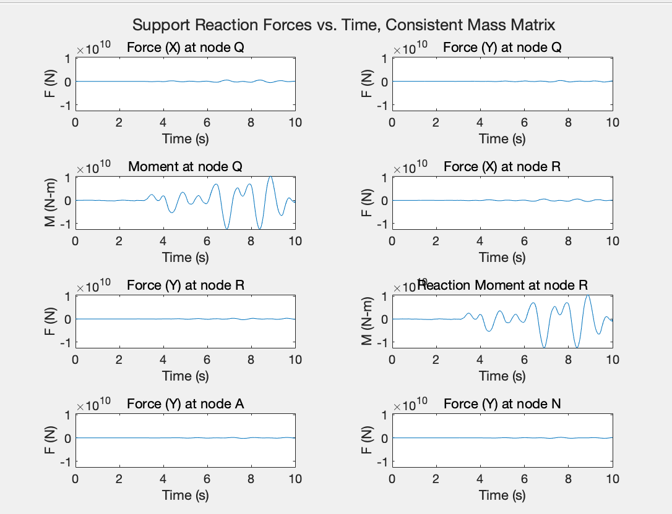

**Figure 4:** time-dependent plots of all the support reactions at nodes Q, R, and A, for analysis conducted with both the consistent mass matrix

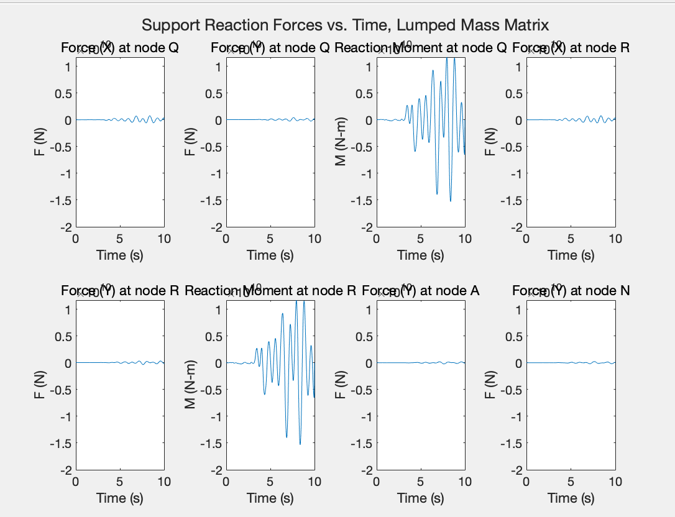

**Figure 5:** time-dependent plots of all the support reactions at nodes Q, R, and A, for analysis conducted with both the lumped mass matrix