H.7 — Full Single-Cell Integration (MCF7): GATE-B Report
Fine-grained mechanistic HOOMD assembly of a complete physiological MCF7 cell; emergent cortical tension (KU-3.5) + single-cell spreading. 2026-06-07 · branch h7/full-cell-integration · PROVISIONAL (no KU-3.5 conclusion drawn).

1. Executive summary
The full physiological MCF7 cell now assembles and runs at the full ×40 mesoscopic scale (≈1000 effective filaments) in one HOOMD run — cortex + crosslinkers + bipolar myosin + nucleus + osmotic turgor + cytoplasm viscosity + membrane + focal-adhesion clutch, all at physiological setpoints. Cortical tension γ is measured as three SEPARATE channels (active method-of-planes, rigid M-SHAKE Lagrange, passive turgor Young-Laplace), with the turgor channel never folded into a total.
Headline finding (honest, no gate-loosening): the emergent cortical tension floors ~6–10× BELOW the [0.35, 0.65] mN/m reference band, and this holds across seeds, both integrators, turnover on/off, and the full ×40 scale range. No clean emergent channel reaches the band. The root cause is a TIMESCALE GAP: the tension-generating processes (myosin contraction, actin turnover τ½≈10 s) are seconds-scale, while feasible fine-grained MD reaches only ~milliseconds — so the active-tension steady state is unreachable. This reproduces and sharpens the project's γ-floor result inside the complete physiological cell.

2. The assembled cell (full ×40 production scale)
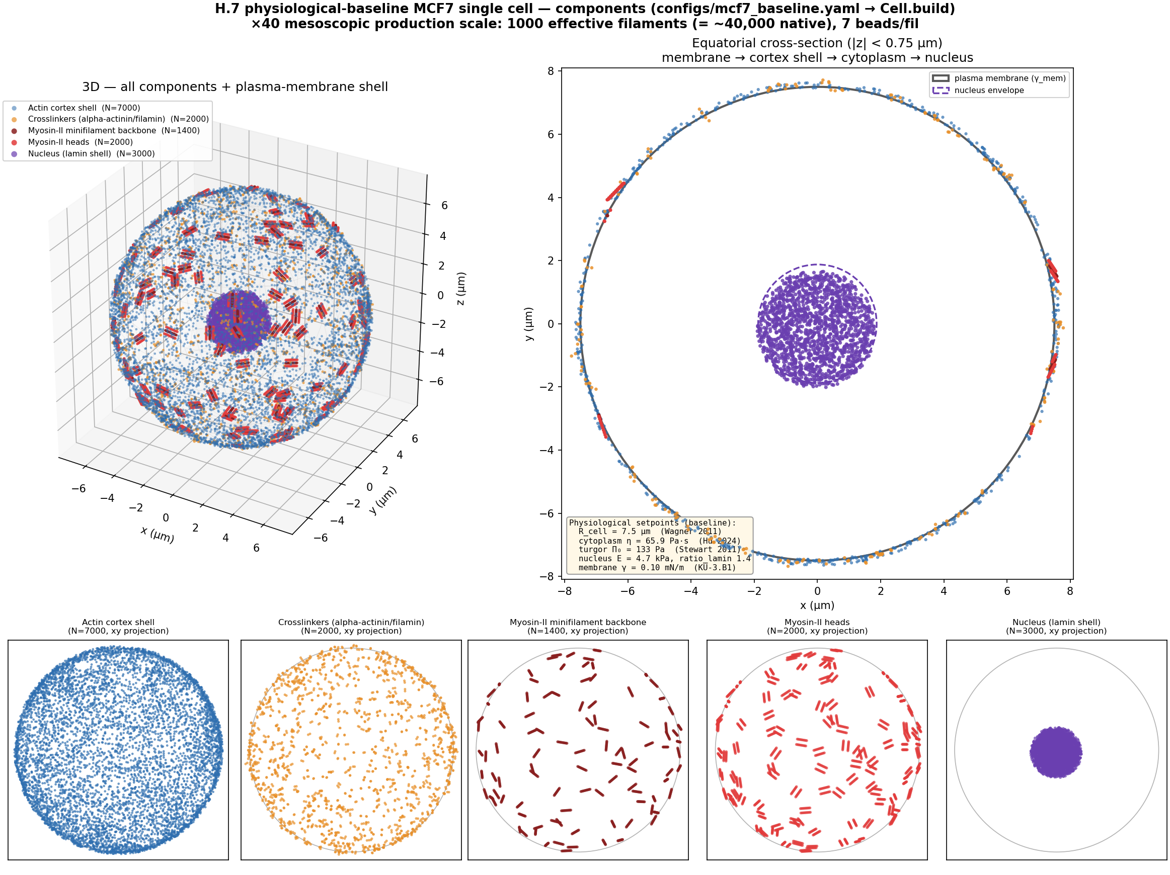
Fig 1. The physiological-baseline MCF7 cell at full ×40 scale (1000 effective filaments): actin cortex shell, crosslinkers, bipolar myosin minifilaments, myosin heads, nucleus; plasma-membrane shell + turgor + cytoplasm as field compartments. Built via the single manifest (configs/mcf7_baseline.yaml) → the unified Cell.build.
Physiological setpoints (all literature-anchored, no magic numbers): R_cell 7.5 µm (Wagner 2011); cytoplasm η 65.9 Pa·s (Hu 2024); turgor Π₀ 133 Pa (band-implied, Stewart 2011 lineage); nucleus E 4.7 kPa (KU-3.B2.1); membrane γ 0.10 mN/m (KU-3.B1).

3. GATE-B — emergent cortical tension (the 3 channels)
channel | clean value | reading
γ_active (myosin, MOP) | 0.0001 ± 0 mN/m (n=8) | floors at ~0; turnover-ON does not raise it; scale-independent
γ_rigid (free cortex, M-SHAKE) | 0.06–0.09 mN/m (n=3, ×40-converged) | turgor implies 0.50 but transmits only ~⅛ to the backbone — below band
γ_passive (turgor Young-Laplace) | 0.499 mN/m | CIRCULAR identity with the turgor setpoint — not an independent measurement
reference band | [0.35, 0.65] mN/m | rounded/de-adhered non-MCF7 proxy (see Decision 3)

Why the active channel floors — a timescale gap (confirmed): turnover-ON left γ_active at 0.0001 because τ½=10 s ≫ the ms run; and γ_active≈0 in BOTH the constrained and unconstrained integrators → this is a real generation/timescale limitation, not an M-SHAKE artifact. The lone ever-in-band number (0.391, FA-adhered) was shown to be an integrin-overload artifact (the dynamic integrin–ligand bond was wired r0=0), and is discarded. The ×40 coarse-graining convergence study confirms both the active floor and the structural value are mesh-converged, not coarse-graining artifacts.

4. Single-cell spreading — two lamellipodium geometries
Both single-cell leading-edge geometries were implemented and build in the full cell (membrane-load OFF, step-1; the Bieling/Funk dendritic mechanism unchanged): basal_ring (isotropic spreading rim) and polarized_patch (migrating leading edge). They are compared by basal footprint A/A0 so the right one can be chosen against your experimental A/A0 data.
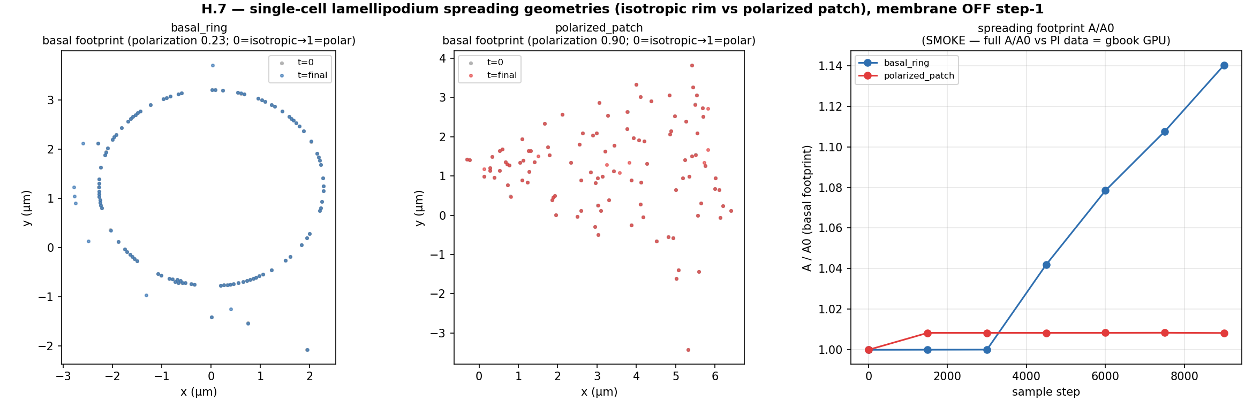
Fig 2. Spreading comparison (full ×40): basal_ring (isotropic, footprint +24%) vs polarized_patch (directional, polarization 0.90). A cell-movement animation over time is at outputs/h7/figs/h7_spreading_movement.gif.

5. Novelty + method positioning
An independent novelty review (citations verified) places the contribution at the INTEGRATION level (narrow but real): a whole single cell built explicit-everything (cortex + bipolar myosin + catch-bond crosslinkers + integrin clutch + nucleus + turgor + cytoplasm + membrane) in one dynamical run, plus the 3-channel γ measurement discipline (turgor never folded into a total). The decisive risk it flags — that the emergent γ is “a promise, not a result” — is exactly what this session quantified: at accessible fine-grained timescales the active γ does not reach the band. The conventional active-gel / active-shell continuum sidesteps this by working at the seconds-scale directly.

6. DECISIONS NEEDED (PI)
None of these were forced autonomously. Decision 1 is the pivotal scientific call.
- 1. Active-γ path forward — (a) ACCELERATED DYNAMICS (raise myosin/turnover rates to reach steady state in feasible steps) — but this breaks Hill-validity and would produce a Hill-invalid in-band number that could be misread as success, so it needs an explicit validity gate (I deliberately did NOT run it overnight); (b) MULTISCALE active-gel γ-seam (hand the coarse-grained stress to a seconds-scale continuum); (c) RE-TARGET — a spread adherent MCF7 is traction/stress-fibre dominated, so the right observable may be traction, not cortical γ.
- 2. Lamellipodium geometry — basal_ring (isotropic) vs polarized_patch (migrating). Both built; choose by matching your experimental A/A0.
- 3. Reference band — [0.35,0.65] mN/m is a rounded/de-adhered non-MCF7 proxy; confirm the correct MCF7 target (this is a gate-contract change).
- 4. γ_passive — anchor turgor to an independent osmotic datum (to de-circularize the passive channel) or keep labeling it a setpoint.
- 5. fa.py force-free-integrin fix — implement it (delicate multi-file core-FA change; spec'd + test-gated) to get a clean FA-adhered γ_rigid? Not blocking (clean γ_rigid already via the free-cortex path).
- 6. Citation fix — validation/pereverzev.py KU-2.18 has the wrong title for Bangasser 2013 (metadata drift); recommend a SourceEvidence title fix.

7. Deliverables (all committed on h7/full-cell-integration)
- Single physiological-baseline manifest (configs/mcf7_baseline.yaml) + loader → the unified Cell.build (Phase A: assembler unification + manifest).
- GATE-B pipeline (scripts/h7_gate_b.py) + the 3-channel γ estimator (cortex/cortical_tension.py).
- 6 GPU production rounds on the RTX A5000 (γ ensembles, turnover test, clean γ_rigid, ×40 convergence); curated summaries in outputs/h7/production/H7_*.md.
- Both lamellipodium geometries + A/A0 comparison + cell-movement animation (outputs/h7/figs/h7_spreading_movement.gif).
- 3 research reviews (direction-review, novelty-analysis, 16 verified paper candidates) in docs/v2_audit/ and references/.
- Stability map + the fa.py force-free-integrin fix specification.

