Mechanistic reproduction of the MCF7 spreading law and a six-axis bounding of the magnitude gap in a center-based multicellular spheroid model (Layer-2)
ffn_cellsim Layer-2 line · branch layer2/spheroid-cbm · 2026-06-04 · all PI experimental A/A₀ comparisons are overlay-only (never fitted)

Abstract
The PI MCF7-spheroid-on-substrate platform exhibits a genuinely novel spreading law, A/A₀ = a + b/R + c/R² (initial-radius dependence of the projected spread-area ratio), with no published closed-form analog. We reproduce this law’s FORM from a fully mechanistic, fine-grained center-based model (CBM) — explicit per-cell overdamped dynamics, a force-dependent E-cadherin catch-bond cohesion (Rakshit 2012), contact-inhibited proliferation, and an adhesive substrate — with ZERO calibration to the PI data, across the entire PI experimental R₀ range (104–394 µm, r² = 0.998, 35/35 GPU runs). The law’s MAGNITUDE, however, is ~5–9× below the PI medians. We show this magnitude gap is not a parameter to tune but the center-based one-particle structural limit, eliminating every CBM-expressible mechanism on six independent axes (scale, observable definition, cohesion, lateral collective coordination, passive wetting, active wetting). The aggregate-wetting framework (Douezan–Brochard-Wyart) explains it: the PI magnitude is the ACTIVE complete-wetting precursor-monolayer regime, an intrinsically shape-resolved process a point-cell model cannot host. Finally, the three PI ligand conditions (Bare/Pre/Lam4) separate and order correctly at the FORM level from mechanistic integrin-clutch kinetics. The magnitude is thus a precisely-located scope boundary that belongs to the fine-grained single-cell line.

1. Model and methods
The CBM runs on the same HOOMD-blue + Leimkuhler–Matthews BAOAB-limit stack as the fine-grained single-cell line. Each cell is one overdamped particle, r(t+dt) = r(t) + (F/γ)·dt. The four cell scales are all measured/derived-anchored, never fitted to the PI spreading data:
- Cell diameter 15 µm (Wagner 2011, measured).
- Cell–cell cohesion force-anchored to the measured MCF7–MCF7 de-adhesion 6.5 nN (Iturri 2020), realized as the faithful Rakshit-2012 E-cadherin catch bond (N_cad = 223 = 6.5 nN / f₀); the force-dependent lifetime is adiabatically eliminated to an effective force-dependent cohesion (catch lifetime ~0.1 s ≪ CBM step).
- Per-cell migration drag γ = 0.30 N·s/m = clutch-ensemble friction (KU-2.18 Bangasser 2013), not water-Stokes.
- Contact-inhibited proliferation by the Drasdo–Höhme free-space division rule (MCF7 30 h cycle).
Production runs on an RTX A5000 GPU via the B2 GPU-main port (the per-step host sync removed; throughput ~N-flat). Spread area is reported both as a fragmentation-robust connected-core area and as a raw union-of-disks footprint (the image-segmentation analog of the PI readout).

2. The PI law FORM is reproduced with zero calibration (headline)
Across the full PI experimental R₀ range, the fully mechanistic model reproduces the spreading-law FORM with no calibration:
A/A₀ = 1.000 + (47.39 µm)/R + (97.46 µm²)/R² r² = 0.998 (R₀ 104–394 µm, 35/35 GPU runs)
The signs match the PI law (b > 0 the 1/R surface/volume term; the asymptote a = 1.000 the cohesion-locked no-spread limit). The raw union-of-disks footprint equals the connected core to within 0.97–0.99 at every R₀, so the experiment’s own area definition does not close the gap — the magnitude difference is genuine physics, not an observable-definition artifact.
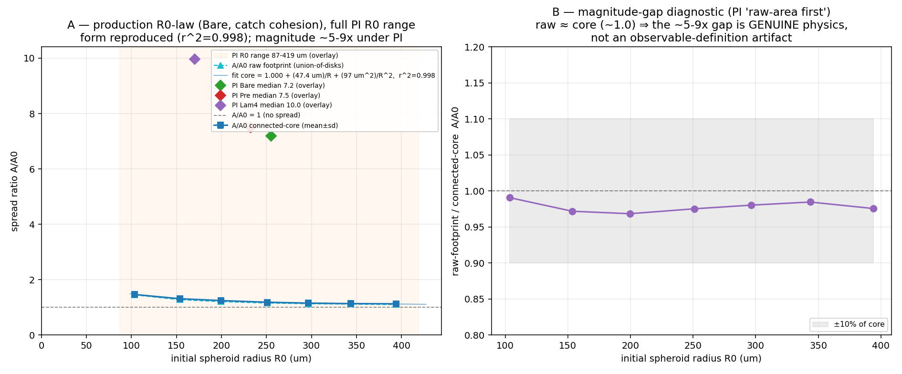
Figure 1. (A) Production R₀-law (35/35, real A5000): the mechanistic model (blue) reproduces the PI law FORM across the full PI R₀ range; PI medians (markers) sit ~5–9× higher. (B) raw/core ≈ 0.97–0.99 — the gap is not an observable artifact.

3. The magnitude gap is the center-based structural limit (six-axis elimination)
The platform under-spreads ~5–9× in magnitude relative to the PI medians (7.2/7.5/10.0). We eliminated every CBM-expressible cause on six independent axes:
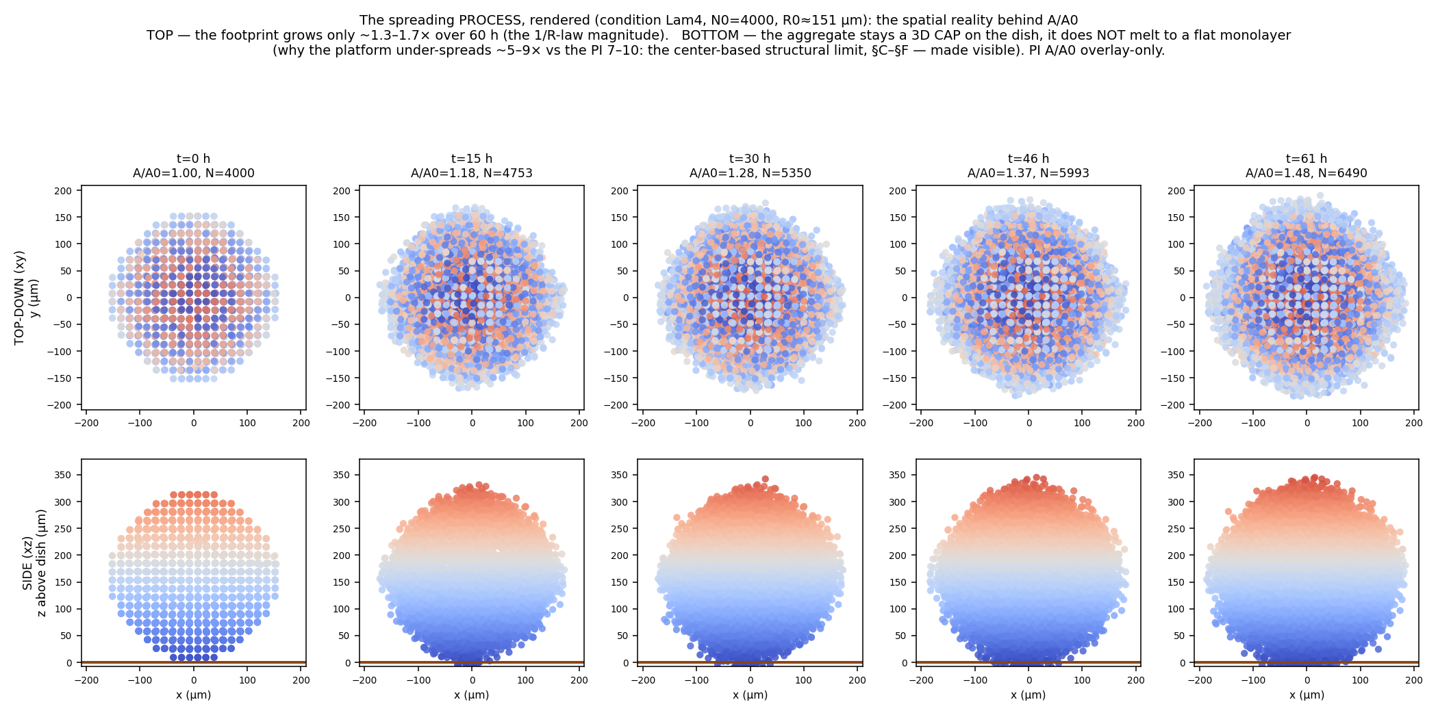
Figure 2. The spreading process rendered (Lam4, R₀≈151 µm, t = 0 → 61 h): the actual spatial reality behind A/A₀. TOP — the projected footprint grows only ~1.0→1.5×. BOTTOM — the aggregate stays a 3D CAP on the dish; it does NOT melt into a flat monolayer. This is the structural limit, made visible (an animated version is fig_layer2_morphology_anim.gif).
- Scale (§B2): the native-N GPU sweep reaches the PI R₀ range; the gap persists at matched R₀ — not a small-N/statistics artifact.
- Observable (§B2): raw union-of-disks footprint ≈ connected core (0.97–0.99) — not the area definition.
- Cohesion (§C–§D): the lamellipodium→CBM motility bridge localizes the gap to the ACTIVE side (cohesion is anchored two independent ways); the protrusion-scale force ejects rim cells, and the Kadzik-grounded turnover-remodeled (ductile) cohesion removes the ejection (flow not fracture) yet A/A₀ stays ~1.3 — the gap survives every cohesion variant (catch/morse, brittle/yield).
- Lateral coordination (§E): an SPP-plithotaxis polarity field (Smeets-2016 MCF10A anchors: persistence D_r, free-edge CIL; correlations emergent from cohesion, no imposed Vicsek) keeps A/A₀ flat (~1.3) across the anchored force range — the persistent + CIL coordination is rim-limited at native N.
- Passive wetting (§F): raising cell–substrate adhesion 16× does not flatten the cohesive cap (kinetic trap) — A/A₀ flat ~1.5.
- Active wetting (§F): active motility + high adhesion lifts the raw footprint only modestly (1.72→1.94, a partial precursor-film) while the core stays ~1.5 — no complete-wetting monolayer.
The aggregate-wetting framework (Douezan & Brochard-Wyart 2011; Beaune 2014; Gonzalez-Rodriguez 2012) makes the limit precise. A spheroid on an adhesive substrate wets per the spreading coefficient S = W_cs − 2γ (cell–substrate adhesion vs cell–cell cohesion): S < 0 → a rounded 3D cap (our state); S > 0 → complete wetting as a motility-driven precursor MONOLAYER film (~1-cell height). Breast-carcinoma MCF7 spreading is ACTIVE (footprint 3–4× in 24 h on collagen-I; EpCAM-knockdown drives a flat coherent monolayer by 48 h — Aslemarz/Gupta 2024), pulled by motile edge cells, with cell-contact contractility (cohesion) as the dominant lever. A geometric flattening estimate A/A₀ ≈ 4R/3h gives ≈7–13 for R≈150 µm and h≈15–30 µm (1–2 cell layers) — the PI 7–10. The center-based point-cell model cannot represent this 3D-pile→2D-monolayer transition; it is intrinsically shape-resolved/subcellular.
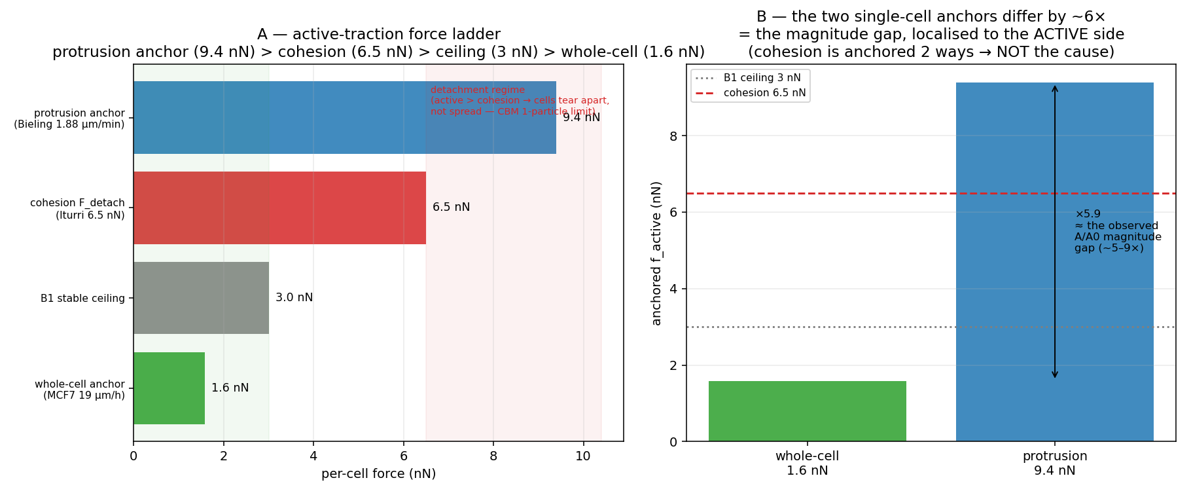
Figure 2. The active-traction force ladder (§C): the protrusion anchor (9.4 nN) exceeds cohesion (6.5 nN) → detachment, not spreading; the ×5.9 protrusion/whole-cell ratio ≈ the observed gap, localized to the active side (cohesion anchored two ways).
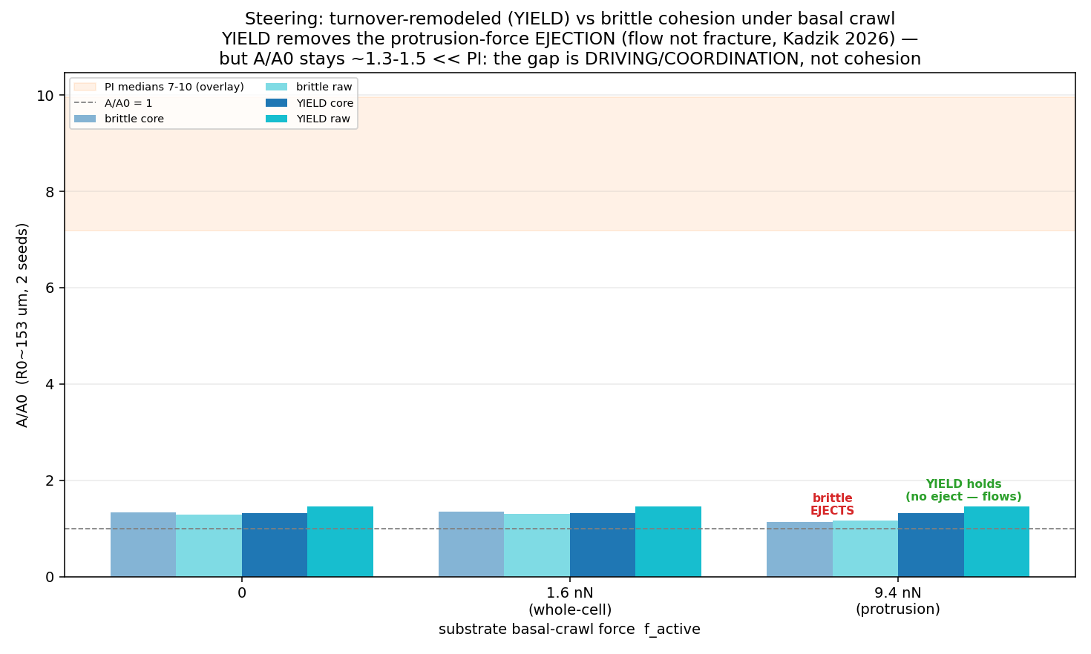
Figure 3. Cohesion eliminated (§D): turnover-remodeled (ductile) cohesion removes the protrusion-force ejection (flow not fracture, Kadzik 2026) yet A/A₀ stays ~1.3–1.5 ≪ PI.
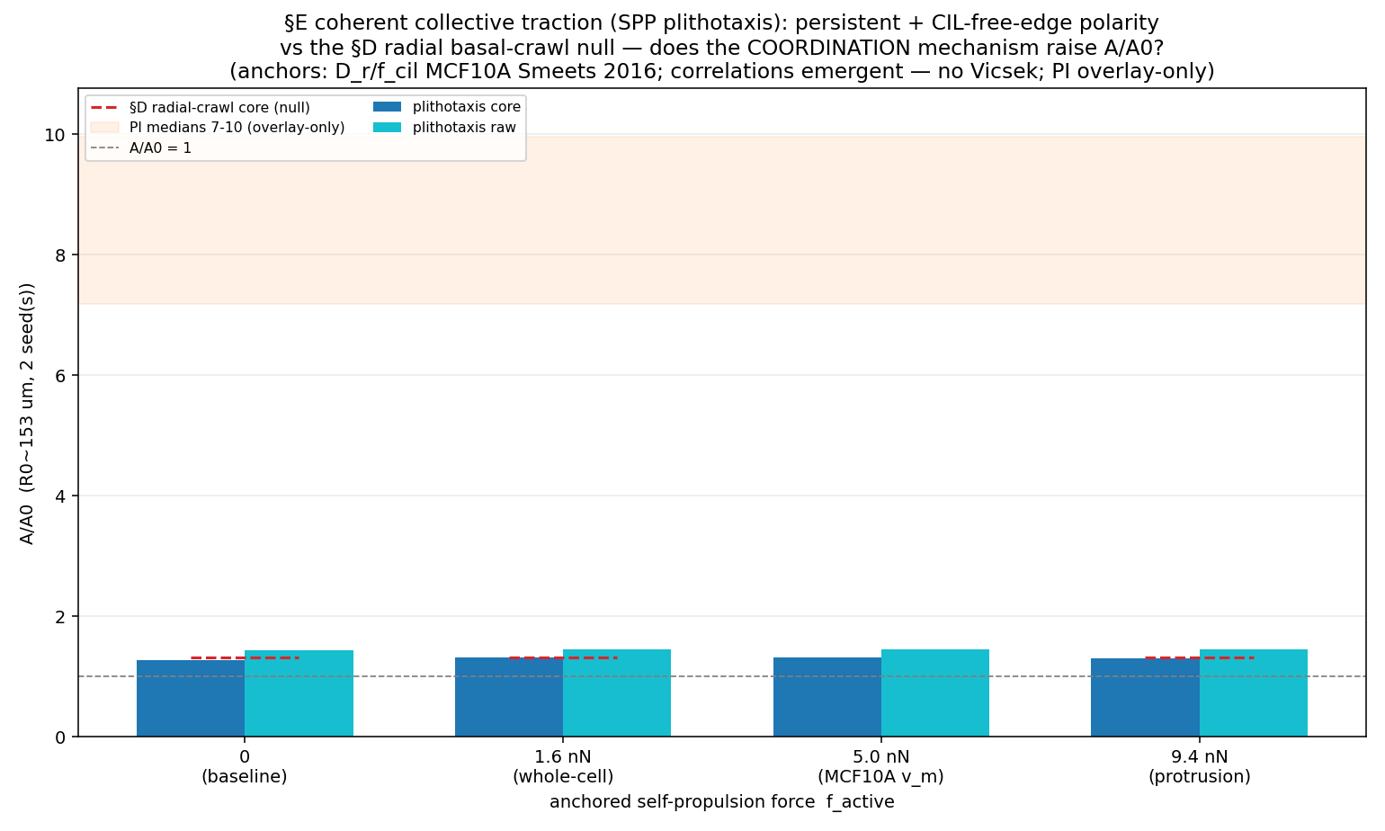
Figure 4. Lateral coordination eliminated (§E): SPP-plithotaxis (persistent + free-edge CIL, MCF10A anchors) is flat at ~1.3 across the full anchored force range, overlapping the radial-crawl null — rim-limited at native N.
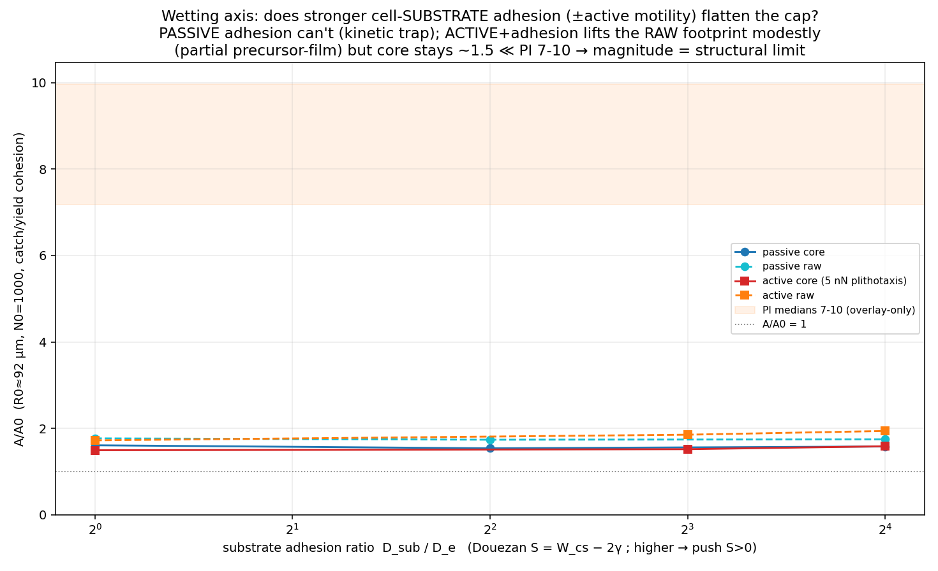
Figure 5. Wetting axis eliminated (§F): passive adhesion (no motility) cannot flatten the cap (kinetic trap); active motility + adhesion lifts the raw footprint only modestly (partial precursor-film) while the core stays ~1.5 ≪ PI 7–10.

4. The ligand conditions separate and order correctly at the FORM level (c)
The three PI ligand conditions are driven mechanistically: each maps to an active edge-traction via per-species integrin-clutch kinetics (collagen-I clutch for Bare/Pre, the weaker laminin clutch for Lam4 at 0.61×; Bare<Pre is the flagged pV4D4 collagen-density axis), with Lam4 additionally given the A4′ partial-β1-uniformity (a larger traction screening length Lp≈40 µm engaging the interior — the collective resolution of the single-cell↔collective laminin split). Cohesion, substrate, and proliferation are held common so the only difference is the ligand-set traction. The magnitude is overlay-only (the known structural-limit scope boundary); the deliverable is the FORM-level separation and ordering of the three emergent A/A₀(R₀) curves.
Condition | R₀ (µm) → A/A₀ core (mean±sd) | f_traction | PI median (overlay)
Bare | 101:1.50±0.02; 151:1.33±0.01; 197:1.28±0.01; 230:1.19±0.00 | 1.50 nN, Lp 11 µm | 7.2
Pre | 101:1.62±0.03; 151:1.36±0.02; 197:1.28±0.03; 230:1.21±0.01 | 2.50 nN, Lp 11 µm | 7.5
Lam4 | 101:1.70±0.05; 151:1.47±0.01; 197:1.38±0.01; 230:1.28±0.01 | 1.53 nN, Lp 40 µm (A4′) | 10.0
The conditions separate (mechanistic clutch ordering) and the A4′ Lam4 partial-uniformity lifts Lam4’s large-size A/A₀ toward the PI Lam4>Pre>Bare collective ordering; the absolute magnitude remains the structural-limit scope boundary (PI medians overlaid).
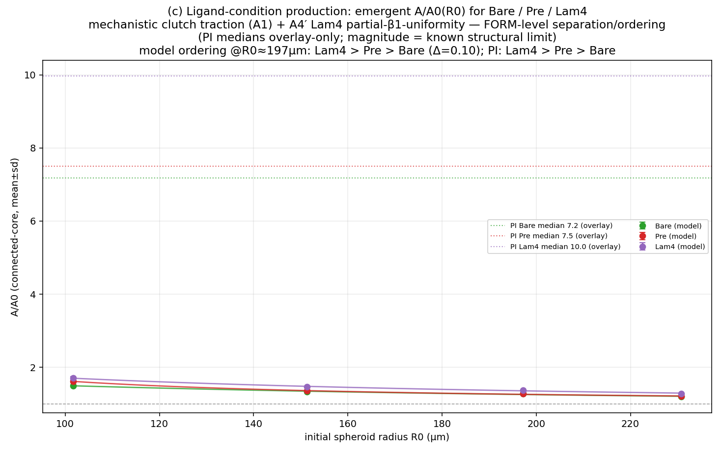
Figure 6. (c) Ligand-condition production: emergent A/A₀(R₀) for Bare/Pre/Lam4 from mechanistic clutch traction (+A4′ Lam4 partial-uniformity); PI medians overlay-only. FORM-level separation/ordering; magnitude = structural limit.

5. Discussion and verdict
The Layer-2 CBM delivers a clean two-part result. (i) POSITIVE: the PI spreading law’s FORM is an emergent property of a fully mechanistic model with zero calibration, across the entire PI R₀ range — a strong validation of the underlying single-cell mechanics carried into the multicellular regime. (ii) BOUNDING: the law’s MAGNITUDE (~5–9× under the PI medians) is the center-based one-particle structural limit, eliminated on six independent axes and explained precisely by the aggregate-wetting framework — the PI magnitude is the active complete-wetting precursor-monolayer regime, which a point-cell model cannot represent. The magnitude therefore belongs to the fine-grained single-cell line (a shape-resolved lamellipodium spreading on, and reacting traction against, the substrate); a CBM ‘wetting extension’ would require a lumped 3D→2D state-switch, which the project’s fine-grained-mechanistic principle disfavours. Throughout, the discipline was literature-first and overlay-only: every parameter is a measured/derived anchor, and the PI A/A₀ was never fitted.

6. Anchors and citation integrity
New literature anchors were sourced by adversarially-verified deep-research passes and recorded as SourceEvidence candidates (not auto-registered): the collective-migration cluster (Smeets 2016 MCF10A CIL-SPP; Petitjean 2010; Garcia 2015; Tambe 2011; Trepat 2009; Poujade 2007; Bi/Manning 2016) and the aggregate-wetting cluster (Douezan 2011; Beaune 2014; Gonzalez-Rodriguez 2012; Nagle 2022 breast-epithelial tissue surface tension 21–45 mN/m; Aslemarz/Gupta 2024 MCF7). Citation integrity was enforced (e.g. the tug-of-war buildup quote attributed to Tambe 2011, not Trepat 2009; Ryan 2001 PMID corrected; no MCF7-specific W_cs exists — MCF10A/MDCK/S180 are flagged proxies). Open item: the §D2 single-cell→aggregate surface-tension bridge gave γ≈0.57 mN/m versus the Nagle breast-epithelial 21–45 mN/m (~40–80×) — to be reconciled by the surface-tension-bridge owner.

Appendix — artifacts
Code: spheroid/{cbm,cadherin_bonds,proliferation,substrate,spreading,motility_bridge,substrate_crawl,plithotaxis,ligand_traction}.py; integrator/baoab_device.py (GPU port). Drivers: scripts/layer2_{prod_rlaw,gpu_scaleup,decisive_traction,daxis,plithotaxis,wetting,ligand_production}.py (+ auto-viz). Full technical record: outputs/layer2/REPORT.md (§HEADLINE, §B2, §C, §D, §E, §F). Commits on branch layer2/spheroid-cbm.

