PROJECT ALEPH
From ffn_cellsim to an
Evidence-Bounded Probabilistic Mechanistic Virtual Cell
Graduate cell mechanics report · architecture, equations, components, connectors, parameter sweeps, neural inference, system optimization, and current evidence
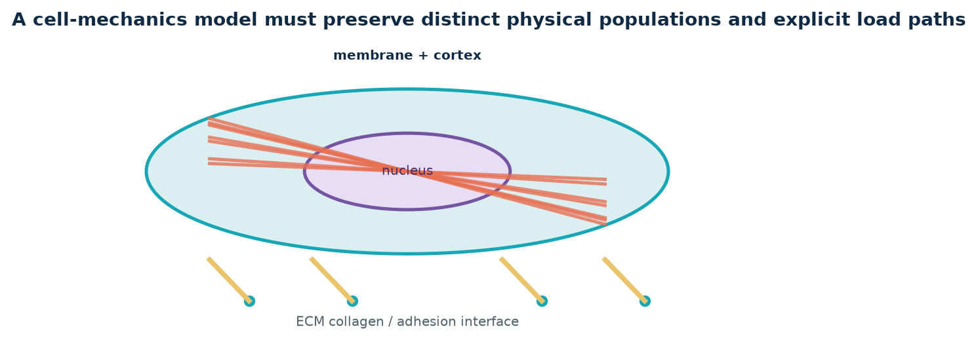
Prepared in English for a graduate audience. Status claims are scoped to the project records available on 10 August 2026.

Contents and use
1. Executive framing and project lineage
2. Mechanics and stochastic-process foundations
3. Canonical components, connectors, runtime, and evidence ladder
4. Parameter provenance and principled sweeps
5. Neural surrogates, posterior inference, and active learning
6. Current evidence, ongoing work, optimization, and experimental use
7. Formula sheet and selected sources
How to read: each page gives a point, a visual, and a scope statement. “Current evidence” is intentionally conservative; results omitted from the quotable registry are not upgraded by this report.
Communication objective By the end, a cell-mechanics graduate student should be able to distinguish mechanistic representation, numerical evidence, and probabilistic inference—and see how they fit into one virtual-cell research program.
Sources / scope: Project primary records listed in the reference appendix.

EXECUTIVE FRAMING
Why build Aleph?
A graduate-level synthesis of ffn_cellsim, Project Aleph, and the path from earlier representations to the current canonical engine.
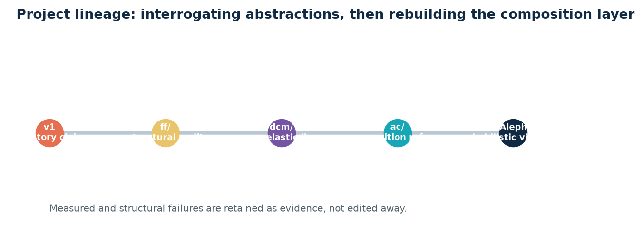
The aim is an evidence-bounded posterior over latent cell state, mechanisms, and parameters. A simulator is the instrument that generates mechanistic hypotheses; it is not itself the final scientific claim.
The key deliverable is an honest account of what observations identify, what they do not identify, and what experiment or simulation would discriminate among competing explanations.
Sources / scope: Project charter (CLAUDE.md, 2026-08-09); STATE.md (2026-08-10).

READING THIS REPORT
A disciplined interpretation guide
This package separates three kinds of statements: mechanistic theory, project architecture, and current evidence. They must not be conflated.
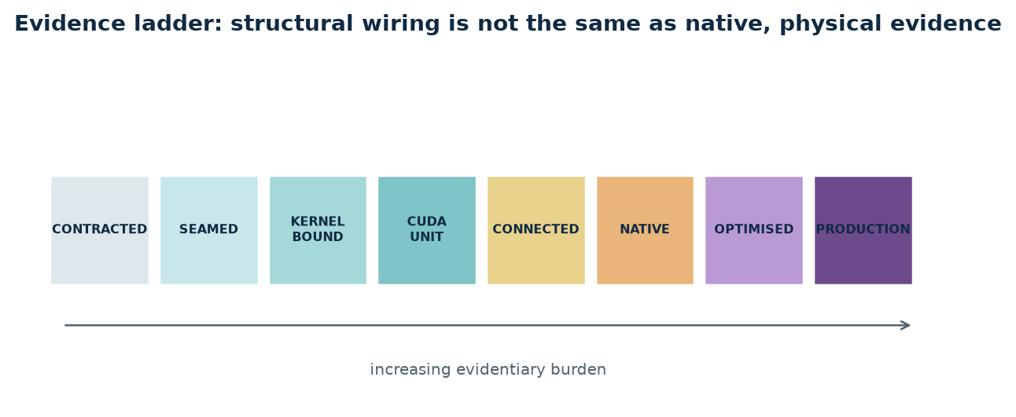
Formula pages present standard representative equations. They explain model families and numerical contracts; they are not evidence that every parameter or mechanism is already quantitatively validated for a particular cell line.
Status pages use the project’s current state registry. Claims marked non-quotable are deliberately not promoted into results.
Sources / scope: Project charter; STATE.md §(b)–(c); ROLLING_ROADMAP.md.

PROBLEM
Cell mechanics is an inverse problem
Different instruments observe different projections of a coupled, active, stochastic cell. A fitted scalar is rarely a unique molecular explanation.
p(z, θ, M | y) ∝ p(y | z, θ, M) p(z, θ | M) p(M)
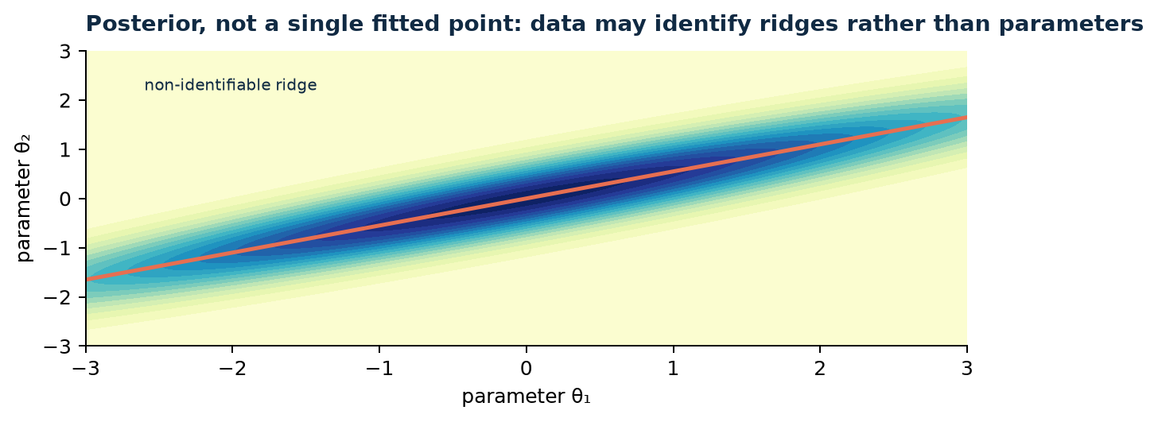
Let latent state z include geometry, topology, molecular occupancy, field variables, and history; θ contains parameters. An observation y is generated through the simulator and a measurement map, y = H(x(z, θ), ε).
Aleph therefore asks for p(z, θ, M | y), including model M and unidentifiability, rather than a single “best” parameter set.
Sources / scope: Engelhardt et al., J R Soc Interface 2017; Gonçalves et al., eLife 2020; project charter.

HISTORY
The lineage matters because failures changed the architecture
The early v1 and later ff/ and dcm eras generated useful artifacts but also exposed claims, abstractions, and validation paths that did not survive audit.

The useful lesson is not that earlier work was “bad.” It is that an attractive trajectory, a green test suite, or a local agreement cannot repair an incorrect representation or a missing load path.
The current engine inherits mechanisms and laws selectively while making ownership, connector semantics, native-population evidence, and provenance explicit.
Sources / scope: TRAJECTORY_HOW_WE_GOT_TO_AC_2026-07-25.md; AUDIT_WHOLE_REPO_2026-07-25.md.

HISTORY
From a monolith to component ownership
The decisive reframe was architectural: a mechanical system should not be assembled by naming regions inside one label-blind network.
Each physical filament belongs to exactly one state-owning component.
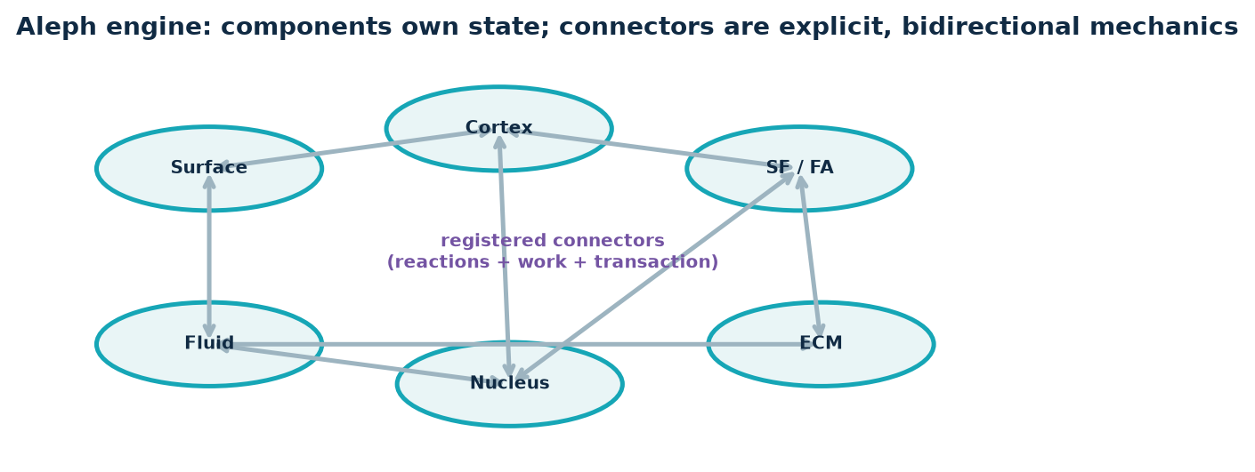
Cortex, stress-fiber/arc, lamellipodium, and filopodium own disjoint filament populations. Physical communication is a connector with paired reactions, not co-location in an array.
This is a modeling claim about identity and mechanics, not merely software hygiene.
Sources / scope: CLAUDE.md hard runtime contract; CELL_ENGINE_ARCHITECTURE.md.

HISTORY
Selective migration, not a wholesale merger
Project_Aleph was a separate experimental / replacement tree. The current ffn_cellsim repository is its successor only through controlled, selective migration; it is not governed by two simultaneous charters.

The current tree imported 53,602 lines of the external-training-corpus pipeline into aleph/outer on 2026-08-09. It retained useful provenance and experimental-observation ideas while keeping current CLAUDE.md and STATE.md as the authority for runtime and evidence.
Therefore, historical Project_Aleph numbers and claims are context unless re-established by current records.
Sources / scope: aleph/outer/__init__.py; STATE.md §(f), 2026-08-09; /Users/sw1/Project_Aleph/CLAUDE.md (historical context).

HISTORY
Adopted, rebuilt, deferred, and rejected
Adopted: the outer research-corpus pipeline and an evidence-first inference framing. Rebuilt: the component–connector composition layer and the one-way law-to-engine architecture.
Adopt only if: mechanism + ownership + evidence scope remain explicit.

Deferred: an inner surrogate trained on accepted runs, because no declared experiment and accepted-run corpus currently opens that stage. Rejected: Project_Aleph’s runtime↔vertical import cycle, CPU/NumPy simulation authority, and an untracked “replacement tree” as a second source of truth.
The scientific reason is not aesthetic. A bidirectional import graph confounds laws with assembly; a non-native runtime cannot be a production physics reference; and a premature surrogate can only learn an unnamed observable.
Sources / scope: aleph/outer/__init__.py; aleph/inner/__init__.py; aleph/tests/architecture/test_layer_directions.py; CLAUDE.md.

ARCHITECTURE DECISIONS
Why components and connectors replaced a monolithic network
Adopted: disjoint state owners plus typed connectors. This retains filament identity, endpoint eligibility, reaction signs, topology events, and independent failure modes.
F_a←b + F_b←a = 0; co-location ≠ connection.

Rejected: regional labels over a shared, label-blind filament array; spatial co-location as a mechanical connection; and hidden callbacks that bypass a connector ledger. Those shortcuts make it impossible to ablate or audit a specific load path.
The explicit alternative is mechanically testable: for each edge, dispatch once, record reactions and work, and restore its candidate state when the physical step rejects.
Sources / scope: CLAUDE.md hard contracts; CELL_ENGINE_ARCHITECTURE.md; ROLLING_ROADMAP.md R1.

ARCHITECTURE DECISIONS
Why Warp CUDA and analytic oracles have different roles
Adopted: Warp CUDA for every simulation physical-time update. The GPU-resident accepted-step transaction is necessary for the coupled mechanics, fields, and kinetic events to share one physical history.
runtime ≠ oracle; Warp CUDA physical-time update only.
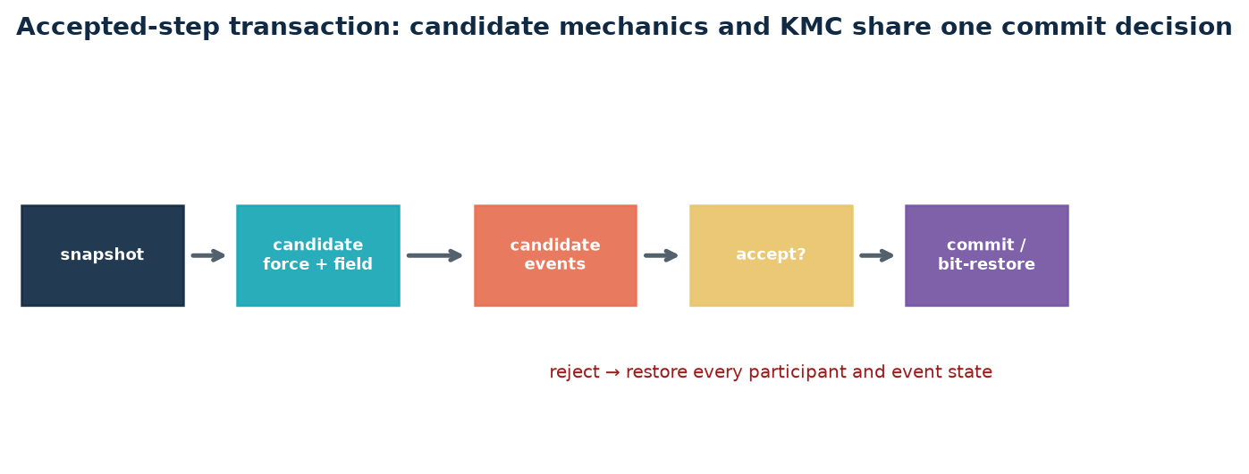
Rejected: HOOMD or CPU/NumPy stepping as a production, parity, benchmark, or fallback physics runtime. Also rejected: closed-form Bell, Hill, or poroelastic relations as the runtime mechanism.
Analytic relations remain valuable as dimensional checks and acceptance oracles. An oracle judges a native implementation; it must not become the implementation that it is meant to test.
Sources / scope: CLAUDE.md runtime contract; STATE.md §(a), §(c); aleph/tests/architecture/test_layer_directions.py.

CURRENT ARCHITECTURE
What 14 components and 38 connectors mean today
As of 10 August 2026, aleph/engine is canonical: 14 components and 38 registered connector objects. Each connector names a runtime and the census checks that it can bind a concrete class.
14 components / 38 connectors; structural closure ≠ device execution.

This is structural progress, not a device-run result: the registry explicitly records 38 objects and zero device-run connectors. Production cortex kernels do fire behind --engine-cortex, but complete connected mechanics must earn its own native evidence.
An earlier 32-edge roadmap coverage figure is a historical interim subset, not the current connector census. The current count to present is 38.
Sources / scope: STATE.md §(a), §(f), last verified 2026-08-10; ROLLING_ROADMAP.md.

PURPOSE
Aleph’s scientific objective
Aleph is a classical probabilistic mechanistic virtual cell. It combines explicit mechanics with probabilistic inference and external biological knowledge.

A posterior prevents an illusory conversion of uncertain, non-identifiable biology into a neat parameter table. It retains correlations, multimodality, and model ambiguity.
For cell-mechanics trainees, the practical consequence is simple: every predicted observable must carry a scope, a source, and an evidence class.
Sources / scope: CLAUDE.md “What this is”; Gonçalves et al., eLife 2020.

THEORY
State evolution: active, stochastic, and constrained
A general semi-discrete representation collects positions, fields, and internal states in x. The physical-time update is governed by force balance, transport, events, and constraints.
M(x) ẋ = Fint(x, z, θ) + Fext − J(x)ᵀ λ, g(x)=0
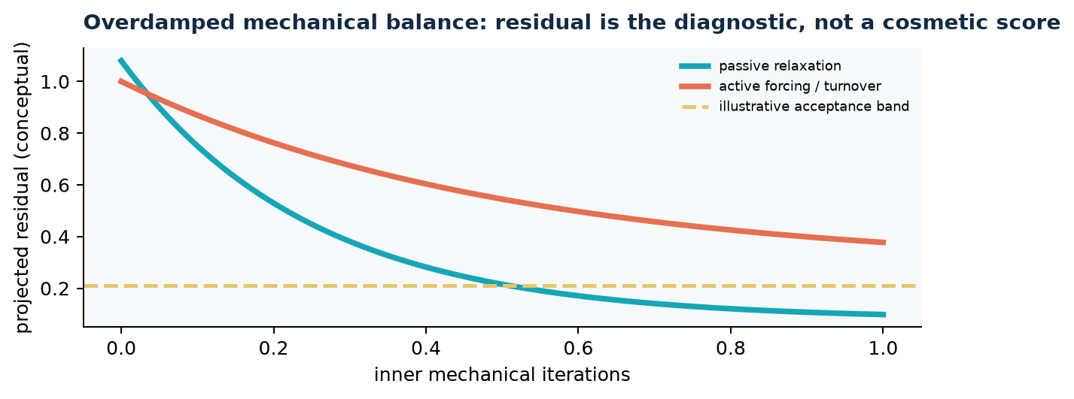
In an overdamped mechanical view, velocity is mobility times net force. In an inertial extension, mass and damping enter. Constraints contribute Lagrange multipliers rather than hidden penalty forces.
The exact project runtime is Warp/CUDA with a mechanical inner solve and an outer physical-time loop; the equation here is a conceptual lens for that architecture.
Sources / scope: Project charter; standard constrained overdamped mechanics.

THEORY
Filament elasticity is local but its consequences are network-scale
For an actin or microtubule centerline r(s), extension and bending energy create forces after differentiation with respect to nodal coordinates.
Efil = ∫ [½ ks(|∂sr|−1)² + ½ κ |∂²sr|²] ds
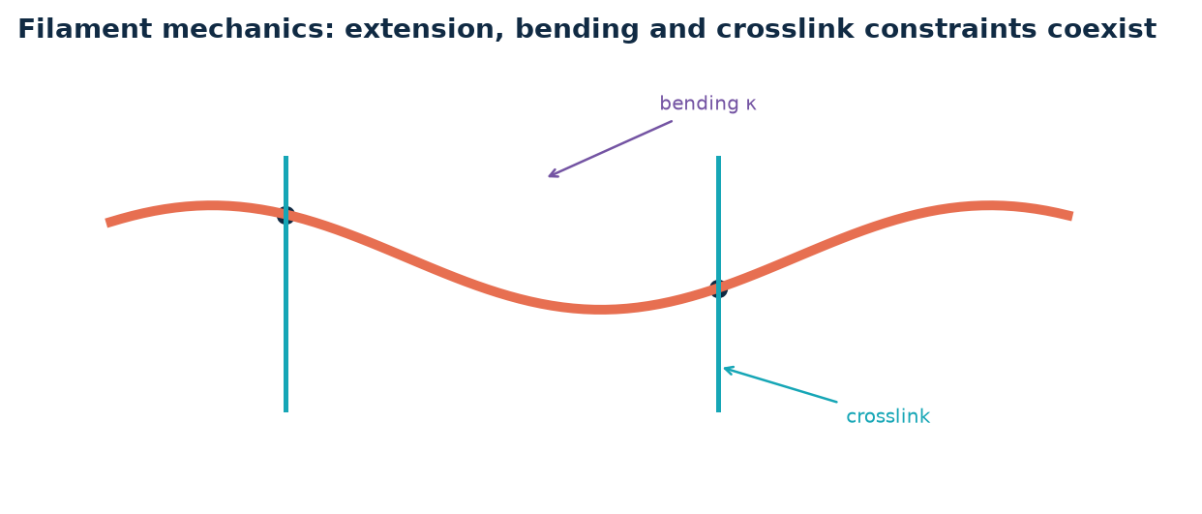
A discrete implementation evaluates these terms on segments, hinges, and crosslinks. It must retain the filament identity and topology necessary for turnover, attachment, and remapping.
The teaching point is that “an elastic network” is not enough: filament contour, branch history, crosslink states, and attachments determine the admissible mechanics.
Sources / scope: Nédélec et al., New J Phys 2007; project laws/ and engine architecture.

THEORY
Membrane mechanics: curvature, tension, pressure, and attachments
A lipid membrane can be described with a Helfrich bending term, surface tension, and pressure work. The model’s job is not to reduce the cortex to membrane tension; it must represent their connector.
Emem = ∫S [κm/2 (2H−C0)² + γm] dA − ΔP V

The membrane–cortex relation is mediated by explicit linker / connector semantics. Therefore a membrane node and a cortical node stored in nearby memory are not mechanically joined unless a connector registers their reactions.
This distinction is essential for blebbing, load transfer, and membrane–ECM contact.
Sources / scope: Helfrich membrane framework; CELL_ENGINE_ARCHITECTURE.md.

THEORY
Actomyosin: force–velocity is an oracle-shaped relation, not a substitute for heads
A Hill-like relation summarizes that motor sliding slows under load. Aleph’s intended mechanism is explicit head-resolved NMII with binding events and working strokes.
v(F) = v0 · (1 − F/Fstall) for 0 ≤ F ≤ Fstall
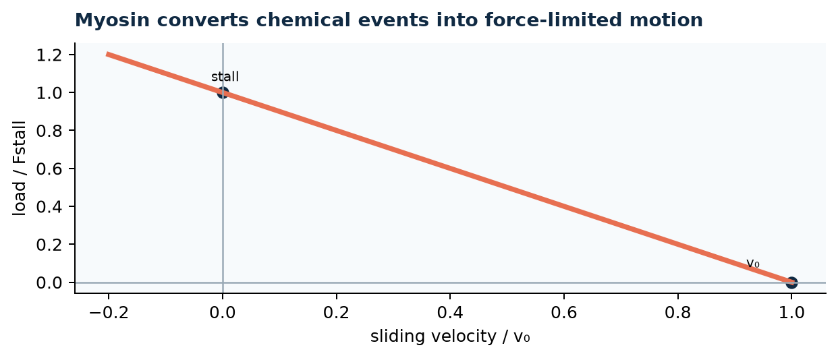
The equation is useful for sanity checks, limits, and parameter interpretation. It is not permission to replace a population of heads, attachment states, and partner reactions with a static contractile stress.
A motor must change both the actin-side and reaction-side force ledgers.
Sources / scope: Project charter; Stam–Hocky mechanism cited in project provenance audit.

THEORY
KMC event dynamics links chemistry to topology
Binding, detachment, polymerization, capping, severing, crosslinking, and remodeling are discrete events with hazards λi(x, θ).
P(event i in Δt) = 1 − exp[−λi(x, θ) Δt]
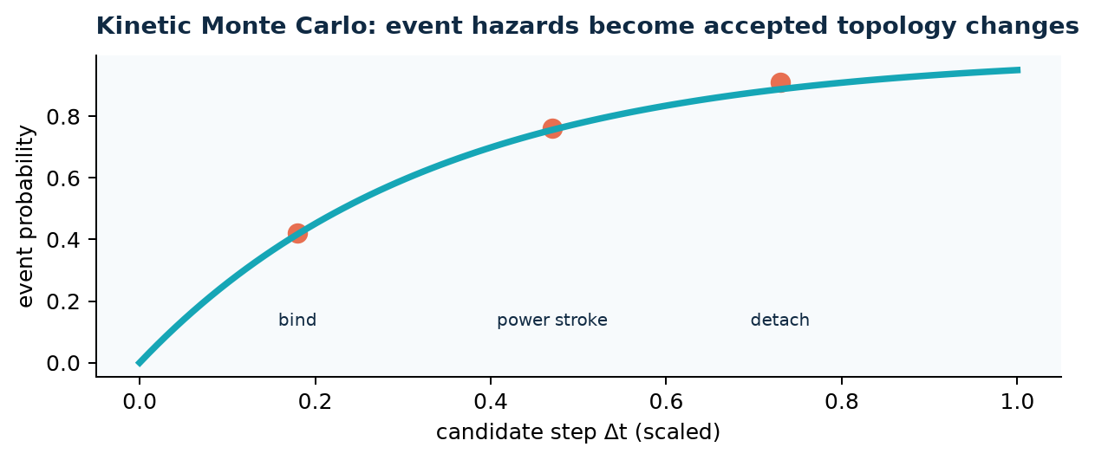
For a small physical step Δt, an event probability follows 1−exp(−λiΔt). Candidate events are provisional until the physical step is accepted, preventing solver retries from changing chemistry.
This is why event state belongs inside the same accepted-step transaction as geometry and fields.
Sources / scope: Project charter; ROLLING_ROADMAP.md R7; standard continuous-time Markov process formulation.

THEORY
Force-dependent bonds are mechanical state variables
A Bell-like slip bond increases its off-rate under tensile load; catch-slip laws can have a stabilizing range before slip-dominated failure.
koff(F) = koff,0 exp(F xb / kBT)
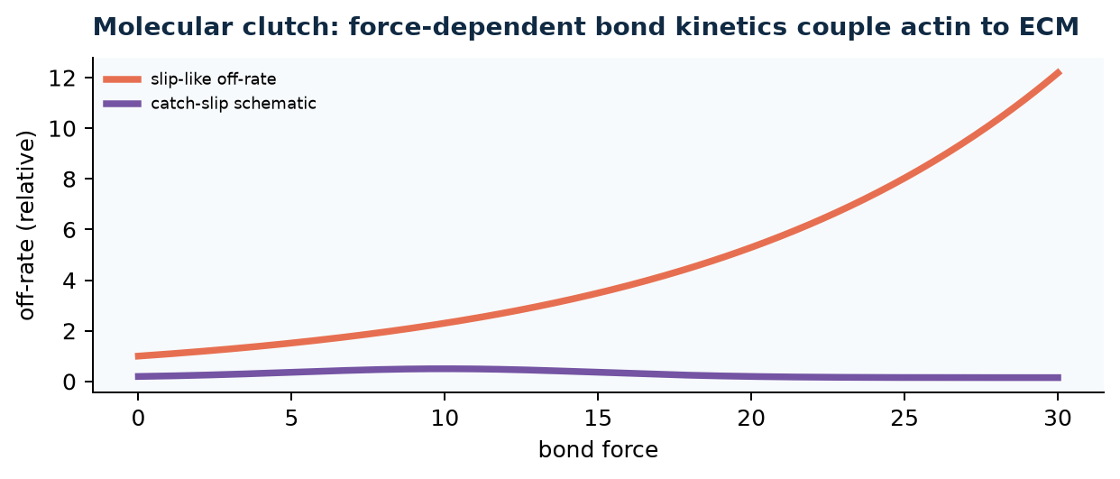
These models need an assay- and isoform-specific provenance. A mathematical curve can be structurally correct while its numerical parameters remain a project “PI-GAP.”
In a clutch, bond kinetics and elastic extension create feedback: load alters lifetime, lifetime alters load sharing, and the network changes traction.
Sources / scope: Bell-type kinetics; PARAM_PROVENANCE_AUDIT_2026-07-24.md.

THEORY
Poroelastic cytosol couples pressure, deformation, and transport
A Biot-style closure provides a continuum representation of the fluid / porous core while mechanics evolves on moving boundaries.
S ṗ + α ε̇v + ∇·q = s, q = −(k/μ)∇p

A schematic mass balance uses storage S, pressure p, Darcy flux q, and volumetric strain εv. Coupling must be conservative across interfaces; a field “near” a component is not automatically a mechanical connection.
The implementation contract keeps this update GPU-resident inside the physical-time system.
Sources / scope: Moeendarbary et al., Nat Mater 2013; project provenance audit.

THEORY
Energy, work, and reaction ledgers make a coupled model auditable
For conservative parts, a potential E gives F=−∂E/∂x. Active motors, binding, and chemical reactions are non-conservative and require explicit work / ATP accounting.
Fa←b + Fb←a = 0, ΔWconnector = Σ endpoints F · Δx

A connector must apply equal-and-opposite forces to endpoints. Its discrete work must agree with endpoint increments within the declared convention.
This turns conservation checks into component-level evidence rather than a vague expectation that total force “looks reasonable.”
Sources / scope: CLAUDE.md; CELL_ENGINE_ARCHITECTURE.md global acceptance gates.

THEORY
The accepted-step transaction is a physics contract
A candidate step includes forces, field updates, topology events, and ledger changes. The acceptance predicate decides whether they are committed together.
state(t+Δt) = {candidate, if A=1; state(t), if A=0}

On rejection, all participating device-resident state is restored exactly. Partial commit would create a physical history that never existed: a bound motor with a rejected displacement, or a remodeled ECM with unaccepted forces.
This is the bridge between numerical reliability and biological causality.
Sources / scope: CLAUDE.md; aleph/engine/transaction.py; ROLLING_ROADMAP.md.

ARCHITECTURE
The canonical layer is aleph/engine
As of 2026-08-10, aleph/engine is the canonical composition layer. It contains 14 components and 38 connectors, all naming a runtime but not yet all device-run.

The incumbent remains imported during migration because it owns prior native physics. It is feature-frozen: only P0 fixes, instrumentation, and parity—not new biology.
The laws layer supplies Warp kernels and does not import upward. Closed-form oracles live outside runtime paths.
Sources / scope: STATE.md §(a), last verified 2026-08-10.

ARCHITECTURE
Components own state
Representative components include surface body / membrane, cortex, cytosol-fluid core, nucleus, stress-fiber / arc, focal adhesion, ECM world, NMII actuator, microtubule rig, intermediate filament rig, and protrusion actors.

Ownership means the component controls its device-resident arrays, topology, lifecycle, and ledger contribution. Slices into a global allocation can be an implementation step, but are not automatically private allocations.
The biological ownership rule is strictest for actin: the regional populations are disjoint.
Sources / scope: STATE.md §(a), §(f); CELL_ENGINE_ARCHITECTURE.md.

ARCHITECTURE
Connectors are the only mechanical connections
Connectors encode contact, attachment, transfer, and load paths: ERM–cortex, surface porous transfer, SF–cortex transient coupling, LINC, spectraplakin, focal-adhesion joints, and membrane–ECM contact.
Graph rule: one registered edge → one mechanics/field dispatch owner → one transaction + ledger path.

Each connector has endpoints, a mechanics / field dispatch owner, transaction participation, and a ledger. The graph must dispatch each edge exactly once in each mechanical phase.
A connector is therefore a scientific hypothesis that can be ablated, validated, and traced.
Sources / scope: ROLLING_ROADMAP.md R1; CELL_ENGINE_ARCHITECTURE.md.

ARCHITECTURE
Component–connector graph: a minimal connected load path
The central pedagogical load path is NMII → stress fiber / arc → focal adhesion → integrin–collagen series joint → ECM → far-field reaction.

Parallel to it, surface, cortex, fluid, and nucleus form a vertical mechanical path. The future whole-cell model is not a pile of modules; it is a causal graph whose edges mediate reactions.
Ablation should remove only reactions reachable through the graph, producing a testable causal prediction.
Sources / scope: ROLLING_ROADMAP.md R4–R6; LOAD_PATH_PLAN.md.

ARCHITECTURE
Evidence ladder prevents category errors
The eight states are CONTRACTED, SEAMED, KERNEL_BOUND, CUDA_UNIT, CONNECTED, NATIVE, OPTIMISED, and PRODUCTION.

A structural test can establish a seam but cannot establish native population mechanics. A native build can establish existence but not convergence. A successful run cannot establish a physical magnitude without the required gate.
This hierarchy is a presentation tool as much as a development tool: it tells the audience what kind of sentence is scientifically allowed.
Sources / scope: CELL_ENGINE_ARCHITECTURE.md; STATE.md §(c).

RUNTIME
Warp CUDA is the only simulation runtime
All authoritative physics kernels, PDE/KMC updates, neighbor queries, and mechanical iterations are GPU-resident Warp/CUDA. There is no CPU or HOOMD physics fallback.

Python can configure, orchestrate, and postprocess. It cannot be the authoritative per-step state owner. Host readback belongs between accepted steps and is not a substitute for a device transaction.
This constraint is part of reproducibility: a result from a forbidden CPU path is not a weaker physics result; it is outside the project’s evidence contract.
Sources / scope: CLAUDE.md hard runtime contract.

RUNTIME
Native population is a scientific constraint, not a convenience setting
The full physiological population is derived from density × geometry for each compartment. The project explicitly rejects lowering biological density to fit memory.
Npopulation = densityphysiological × geometrycompartment

Coarse configurations may support development, structural tests, and diagnosis. They cannot support a biological conclusion that depends on population, geometry, topology, or compartments.
Exact active IDs, allocated state, node / head totals, and peak GPU bytes must be recorded for native claims.
Sources / scope: CLAUDE.md; STATE.md evidence rules.

RUNTIME
Solver acceptance must be interpreted mechanistically
An inner solver can improve a numerical residual without making an active state physical. Conversely, an active steady state can have a nonzero local residual because discrete motor forcing is real.
r(x) = F(x) − J(x)ᵀλ; report its definition, projection, time window, and acceptance rule.

The project distinguishes operator closure, physical convergence, and dynamic stationarity. A predicate that checks adjoint wiring cannot be relabeled a convergence test.
Graduate readers should ask: what scalar was declared before the run, what field generated it, and what physical alternative could make it nonzero?
Sources / scope: STATE.md §(e); TRAJECTORY audit; ROLLING_ROADMAP.md.

PARAMETERS
Parameter provenance is part of the model
Every parameter must be classified as SOURCED, DERIVED, CONVENIENCE, or PI-GAP. The classification changes what a result may claim.

A sourced number has a verified provenance; a derived number has an explicit derivation; a convenience number cannot silently become physiology; a PI-GAP is an acknowledged missing value that blocks quantitative closure.
This framework makes “unknown” a first-class output rather than an embarrassing omission.
Sources / scope: PARAM_PROVENANCE_AUDIT_2026-07-24.md.

PARAMETERS
Examples of honest parameter limits
The audit identified baseline quantities such as turgor, cortex segment length, representative filament length, and percolation-related density as convenience/proxy concerns in the inspected configuration.
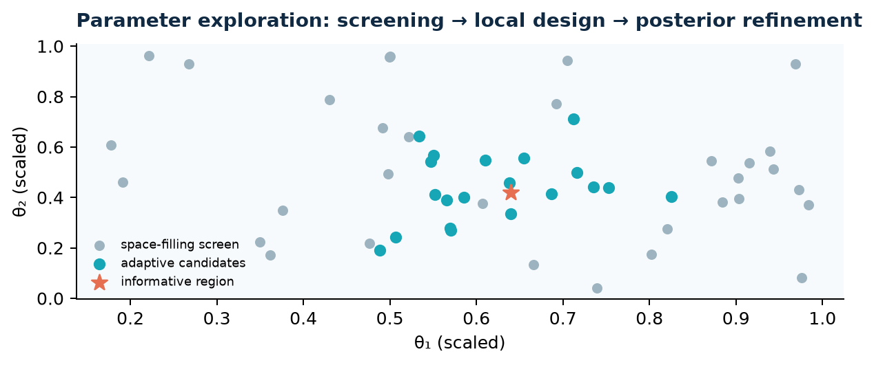
NMII force-scale and kinetic parameters include PI-GAPs. That means a mechanism can be demonstrated while its reported tension magnitude remains non-quotable.
The correct next action is evidence acquisition or PI decision, not tuning to make a gate pass.
Sources / scope: PARAM_PROVENANCE_AUDIT_2026-07-24.md; STATE.md §(c).

PARAMETERS
Dimensional analysis is a first gate
Dimensionless groups expose whether a proposed sweep changes biology, numerics, or both. Examples include a motor load ratio, a bond-force scale, a poroelastic diffusion time, and a bending-to-stretching stiffness ratio.
Πmotor=F/Fstall; Πbond=F xb/kBT; τporo=L²/Dporo; Πbend=κ/(ks L²)

A sweep must preserve declared units and state its operating point. Grid-dependent constants require a convergence / invariance argument before they are interpreted as molecular properties.
This is particularly important when numerical stiffness, capture radius, and reaction rates interact.
Sources / scope: Standard nondimensional analysis; project parameter audit.

SWEEPS
Why brute-force parameter sweeps fail
A mechanistic virtual cell has interacting continuous parameters, discrete topology, stochastic events, and expensive native runs. A regular grid suffers the curse of dimensionality: n levels across d variables costs nd evaluations.
Ngrid = n^d (e.g., 10 levels across 12 parameters = 10¹² runs)

The answer is not to hide uncertainty by tuning one parameter at a time. It is staged experimental design: screen, diagnose sensitivity and non-identifiability, then refine a posterior or decision boundary.
Native reference evaluations remain the oracle for any reduced, neural, or optimized method.
Sources / scope: ROADMAP.md; project charter; standard design-of-experiments principle.

SWEEPS
Space-filling designs establish broad coverage
Latin hypercube, Sobol sequences, and constrained designs distribute candidate points across a prior domain more evenly than independent random draws.
Sobol / LHS objective: minimize gaps in a constrained prior domain Θphys.

They should respect source-derived bounds, physical feasibility, and named PI-GAPs. They are not licenses to sample unphysical baseline states.
A practical unit of analysis is an observable bundle: morphology, force / work ledger, topology, event statistics, and an experimental measurement map.
Sources / scope: ROADMAP.md; project parameter governance.

SWEEPS
Sensitivity analysis separates influential from identifiable
A parameter can have a large local derivative and still be unidentifiable because another parameter produces the same observable change.
Si = Varθi[E(y|θi)] / Var(y), STi = 1 − Varθ−i[E(y|θ−i)]/Var(y)

Local sensitivities use ∂y/∂θ; global approaches partition output variance. Both should be computed on declared observables and at physiological operating points.
The result should drive experiment choice: seek a modality that changes the posterior geometry, not only the simulation fit.
Sources / scope: Saltelli-style sensitivity framework; inverse-problem framing in project charter.

SWEEPS
Bayesian optimization chooses expensive next runs
For an expensive native simulation, a probabilistic surrogate can predict an objective and its uncertainty. An acquisition function trades predicted value against information gain.
EI(x) = E[max(0, fbest − f(x))] or choose x maximizing expected information gain.
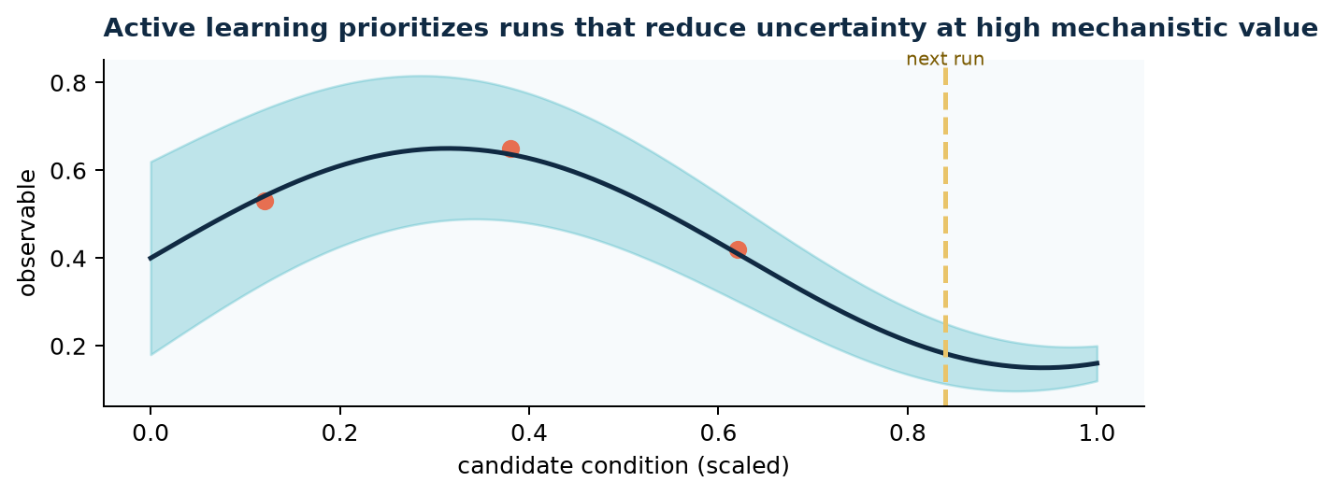
The objective must never be “make a gate pass.” Valid goals include discrimination between mechanisms, reduction of posterior uncertainty, prediction error under a held-out experiment, or profiling of a declared bottleneck.
Every selected point is returned to the native simulator and its provenance is recorded.
Sources / scope: Shahriyari et al., 2024 Bayesian optimization of physics models; ROADMAP.md.

SWEEPS
Multi-fidelity methods need an error model
A lower-fidelity or reduced simulation can be useful only when its discrepancy from the native reference is measured over a declared domain.
yHF(x) = yLF(x) + δ(x), p(y|θ) must include uncertainty in δ.

A standard decomposition is yHF(x)=yLF(x)+δ(x). The uncertainty in δ belongs in the likelihood or prediction interval; it cannot be buried in a footnote.
The charter therefore treats a surrogate / reduced result as non-reference physics until a native comparison gate closes.
Sources / scope: Choi et al., Comput Biol Med 2026; CLAUDE.md evidence rules.

NEURAL NETWORKS
Two neural layers: target architecture versus current maturity
The charter distinguishes an inner network learned from this engine’s accepted runs from an outer network learned from external research. They are intentionally different training distributions and different evidence lanes.
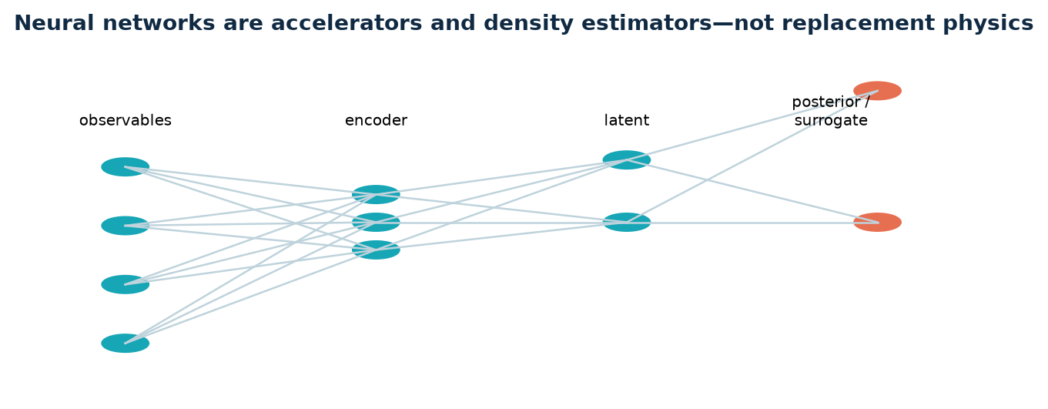
Inner is Stage 2 and is not open: it has no declared target experiment and no accepted-run training corpus, so this report does not claim a trained simulator surrogate. Outer is Stage 4 and has an imported research pipeline; its external reference is ready, but comparison is BLOCKED as of 10 August 2026.
Both remain subordinate to native evidence, explicit observation definitions, and documented uncertainty. Neither can silently turn a literature value into a parameter.
Sources / scope: aleph/inner/__init__.py; aleph/outer/__init__.py; STATE.md §(f), 2026-08-10; CLAUDE.md.

NEURAL NETWORKS
Simulator-based inference learns distributions, not just regressions
Neural posterior estimation trains a conditional density estimator qφ(θ|y) from simulated pairs (θ, y). Once trained, it can rapidly produce an approximate posterior for a new observation.
qφ(θ|y) ≈ p(θ|y); L(φ)=−Eθ,y~sim[log qφ(θ|y)]

This is valuable when likelihoods are intractable because the simulator contains topology changes and stochastic events. But calibration, simulation coverage, and model discrepancy remain visible quantities.
A posterior must be checked with posterior predictive simulations and coverage diagnostics.
Sources / scope: Gonçalves et al., eLife 2020; project charter.

NEURAL NETWORKS
Surrogates accelerate queries, not validation
A surrogate maps a parameter / condition to selected observables, ŷ=fφ(θ, u). It may reduce cost for optimization, experimental design, and fast sensitivity screening.
ŷ = fφ(θ,u), loss = Σ||y−ŷ||² + calibration / uncertainty terms

It must carry uncertainty and out-of-distribution detection. Its prediction is not a native result; it is a proposal that needs a native confirmation before it closes a physics gate.
Training sets must contain accepted physical runs, plus rejected / infeasible labels where they are meaningful to the decision.
Sources / scope: CLAUDE.md evidence rules; Choi et al. 2026.

NEURAL NETWORKS
Physics-aware learning uses constraints without pretending they solve identifiability
Mechanistic residuals, conservation penalties, symmetry, and graph structure can regularize a neural model. For example, forces may be represented as an energy gradient for conservative submodules.
Ltotal = Ldata + λr ||rphysics||² + λc ||C(x)||²

Active motors and KMC topology remain non-conservative and stochastic; a single energy-based network cannot erase those facts.
The strongest pattern is gray-box: explicit simulator + learned observation, discrepancy, or posterior model with a measured error budget.
Sources / scope: Physics-informed / gray-box modeling literature; project work model.

NEURAL NETWORKS
Graph neural networks match connector topology
A component–connector graph naturally provides nodes with state summaries and edges with typed mechanical relations. A GNN can learn reduced operators, anomaly detectors, or dispatch-cost predictors.
hᵥ^(l+1)=ϕ(hᵥ^(l), Σu∈N(v) ψ(hᵥ^(l), hu^(l), euv))

The graph must preserve component identity, direction / adjoint semantics, and transaction boundaries. It may not create unregistered mechanical edges simply because two embeddings are similar.
Use cases include learned preconditioners, performance models, and posterior summaries—not unrestricted topology invention.
Sources / scope: CELL_ENGINE_ARCHITECTURE.md; standard message-passing GNN notation.

NEURAL NETWORKS
Neural operators may map fields across conditions
A neural operator targets functions: it can learn a map from parameter fields and boundary conditions to response fields. This is attractive for repeated observation maps or coarse proposals.
G: a(x) ↦ u(x); learn Gφ over a declared function-space domain.

For Aleph, any neural operator must preserve the declared domain, boundary condition, units, and error statistics against native GPU data.
It should be benchmarked on full compartments and native population, not only on a convenient stripped configuration.
Sources / scope: CLAUDE.md native-reference rule; neural operator literature.

INFERENCE
Observation models connect simulation to experiment
The same latent cell state can be observed through image features, traction fields, AFM force curves, micropipette deformation, ablation response, or molecular occupancy proxies.
yobs = H[x(t;θ,z)] + εmeas, εmeas ~ chosen noise model
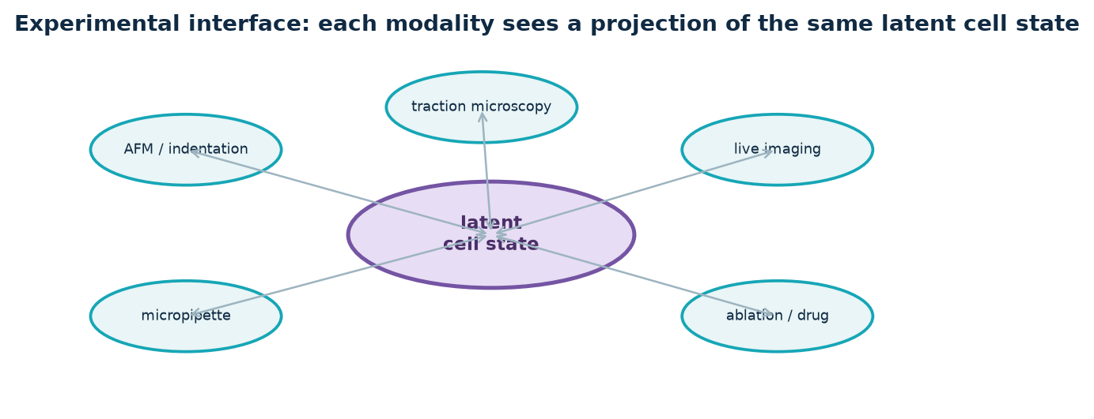
The observation operator H must include instrument geometry, noise, and sampling. Comparing a simulation’s raw internal force to a measured projection without H is a category error.
This is where experimental design becomes a system-identification problem rather than a visualization exercise.
Sources / scope: Project charter; in silico inverse-problem framework (PMID 26309811).

INFERENCE
Posterior predictive checking is the scientific feedback loop
After inferring θ and z, draw posterior samples, rerun the simulator, and compare predicted observables with held-out or non-fitted measurements.
yrep ~ p(y|θ,z,M), compare T(yrep) to T(yobs)

A parameter posterior can look tight while the model family is wrong. Posterior predictive residuals reveal systematic mismatch, missing mechanisms, or an inadequate measurement model.
Failures should create a traceable hypothesis or connector / parameter question, not an undocumented tolerance adjustment.
Sources / scope: Bayesian workflow; CLAUDE.md evidence rules.

INFERENCE
Mechanism selection must compete models, not narrate a favorite
If multiple connector hypotheses or kinetic laws explain a measurement, evaluate their predictive adequacy and uncertainty. A model index M can be part of the posterior.
p(M|y) ∝ p(y|M) p(M)

The goal is not necessarily one winner. It may be a set of models that remain observationally equivalent under the current experiment.
The next experiment should target the observable on which their posterior predictive distributions diverge.
Sources / scope: Project charter; systems-biology inverse-problem literature.

CURRENT EVIDENCE
What is established and may be discussed
The state registry contains carefully scoped Tier-(a) entries. Examples include native full-population build/step evidence, GPU-residency gate evidence, native ECM constitutive sign evidence, and structural/ownership proofs.

These statements are narrow by design. For example, tension may emerge from binding events without authorizing a reported physical magnitude.
The report intentionally uses project evidence labels rather than upgrading mechanism, wiring, native scale, and convergence into one headline.
Sources / scope: STATE.md §(b), last verified 2026-08-10.

CURRENT EVIDENCE
What must not be claimed
The project maintains an explicit non-quotable blocklist: e.g., several old γ magnitudes, connected-rung claims, coarse crawl rates, and results from a reduced population or insufficient physical duration.

This is not a weakness to hide in a talk. It is the methodological center of a credible virtual-cell program: a result is restricted until the evidence that would make it physical exists.
Audience-facing recommendation: label every result slide with the evidence type and the remaining disqualifier.
Sources / scope: STATE.md §(c); STATE_NONQUOTABLE.md.

CURRENT WORK
The active architecture is broad, but production evidence is staged
The canonical engine has 38/38 structural connector closure, while the registry still reports zero device-run connectors. R1 focuses on exact-one dispatch; R2–R7 bind native mechanics, ECM, load paths, connectivity, protrusions, and chemistry.

The current roadmap intentionally does not leap from graph closure to a full-cell production claim. It treats every component and connector as a separate evidence path.
The biological breadth is a strength only if each new path closes reactions, transactions, ledgers, and native evidence.
Sources / scope: STATE.md §(a), §(f); ROLLING_ROADMAP.md R1–R7.

CURRENT WORK
Traction spine: the highest-value connected experiment
The near-term causal experiment is the active SF–FA–ECM load path: NMII changes stress-fiber tension, focal adhesion occupancy, collagen displacement, and far-field reaction.
NMII → SF → FA → integrin–collagen joint → ECM → far-field reaction

The path requires a composite series joint, explicit capture / catch-bond law, accepted topology events, and force/work/ATP ledgers. A generic callback is not connected biology.
Once closed, this path is an ideal target for traction microscopy, ablation, and perturbation-informed inference.
Sources / scope: ROLLING_ROADMAP.md R3–R4; STATE.md §(f).

CURRENT WORK
Protrusion, transport, and whole-cell composition remain future evidence waves
Lamellipodium / filopodium actors require explicit branching, polymerization, capping, severing, membrane contact, and cytosol exchange. Transported chemistry must drive event hazards, not appear only as a postprocessed field.

The first whole-cell native baseline comes only after the full actor set and ledgers exist. It requires exact population and peak-memory records, convergence / stationarity definition, figures, and run artifacts.
This is a roadmap—not a claim that the full dynamic cell has already been solved.
Sources / scope: ROLLING_ROADMAP.md R6–R8.

VALIDATION
Validation is a lattice, not one benchmark
Each production mechanism should cross dimensional analysis, limiting cases, analytic acceptance oracles, mesh / population convergence, stochastic ensembles, and literature-response tests.

A closed-form relation is an acceptance oracle, never a replacement runtime mechanism. A test suite only proves the questions it actually asks.
The strongest validation artifacts include raw observables, predeclared projections, protocol metadata, source provenance, and figures generated alongside the run.
Sources / scope: CLAUDE.md; ROLLING_ROADMAP.md R14.

OPTIMIZATION
Measure the system before optimizing it
The charter states that filament count is not assumed to be the dominant cost; fluid-grid and moving-boundary work can dominate. Consequently, fidelity is not the first trade-off.
Costtotal = Σcomponents Cc + Σconnectors Ce + Csolver + Cfields
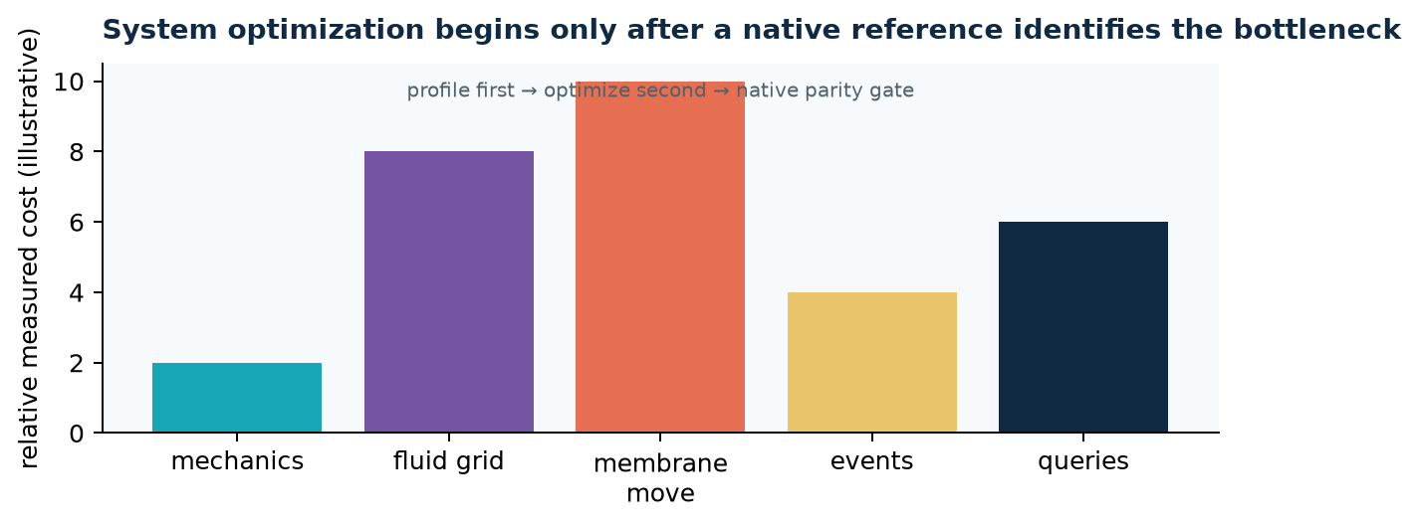
The performance atlas must report wall time, launches, occupancy, bandwidth, memory, nonlinear iterations, spatial-query cost, and event density by component, connector family, and solver phase.
Optimization candidates include device work queues, kernel fusion, topology-aware scheduling, and spatial-query reuse—but only with ON/OFF native parity evidence.
Sources / scope: CLAUDE.md; ROLLING_ROADMAP.md R10–R11.

OPTIMIZATION
Why native reference precedes reduction
Later waves may introduce reduced nuclear modes, resolution adaptation, local refinement, sleeping, multirate scheduling, and multi-GPU partitioning.
Compare reduced vs native over a declared domain D: supx∈D ||Ored(x)−Onative(x)|| ≤ εdeclared

Each is a mapping from reference state to altered representation. The mapping must preserve declared response spectra, transient work, topology / identity, event statistics, and perturbation outcomes.
The native full population remains the oracle, not the slow baseline to be quietly abandoned.
Sources / scope: ROLLING_ROADMAP.md R11–R13; CLAUDE.md.

APPLICATIONS
How a cell-mechanics lab could use Aleph
Use Aleph to plan discriminative experiments: identify parameter / mechanism combinations that remain ambiguous under current imaging, then choose perturbations or measurement modalities predicted to separate them.

Use the native simulator for ground-truth candidate responses; use surrogates for fast candidate selection; use posterior inference to return uncertainty rather than one fit.
Examples: distinguish adhesion kinetics from motor-force changes, test nucleus-coupled load transfer, or identify ECM remodeling regimes.
Sources / scope: Project charter; ROADMAP.md; simulator-based inference literature.

APPLICATIONS
Experimental campaign template
1. Declare a physiological baseline and measurement map. 2. Register parameters and provenance. 3. Generate constrained simulator designs. 4. Run accepted native reference cases. 5. Train / calibrate a posterior estimator or surrogate. 6. Choose the next discriminative experiment. 7. Recompute posterior predictive checks.

Every stage writes artifacts and preserves the possibility that the current mechanism set is insufficient.
This is compatible with AFM, traction microscopy, live-cell imaging, micropipette aspiration, laser ablation, and drug perturbation, provided the observation operator is explicit.
Sources / scope: Project charter; inverse-problem workflow (PMID 26309811).

APPLICATIONS
Neural-network training data should be designed, not harvested blindly
A useful training set spans source-constrained parameter ranges, relevant geometries, perturbations, and stochastic seeds. It includes failure / infeasibility labels where those are meaningful.
Dataset record = {θ, z0, protocol, seed, evidence, population, observables, commit}

Data splits should hold out conditions or experimental modalities, not merely random time frames from the same trajectory. Calibration is evaluated with coverage and posterior predictive error.
Metadata should record code commit, population, evidence class, operating point, observable definition, and parameter provenance.
Sources / scope: CLAUDE.md provenance and evidence rules; Gonçalves et al., eLife 2020.

APPLICATIONS
A practical inference stack
Layer 1: native Warp simulator produces accepted, self-stamped reference runs. Layer 2: feature / observation map produces experiment-comparable summaries. Layer 3: posterior estimator and surrogate quantify uncertainty. Layer 4: active-learning controller selects the next native run or physical experiment.
θ → simulator → x(t) → H(x) → y; yobs → qφ(θ,z,M | yobs)

The controller never overwrites the evidence ladder. It only prioritizes information acquisition.
This modularity makes model discrepancy and out-of-distribution behavior visible at the interfaces.
Sources / scope: Project charter; Gonçalves et al. 2020.

RISKS
Failure modes to surface in a graduate presentation
Do not show coarse or reduced runs as biological conclusions. Do not convert a source gap into a tuned constant. Do not treat connector declaration as runtime force dispatch. Do not treat a green structural suite as native evidence.

Do not hide failed or retracted earlier results; they motivated better controls. Do not call a learned surrogate “physics” without an error model and native comparison.
These are general lessons in computational cell mechanics, not merely local repository rules.
Sources / scope: CLAUDE.md; TRAJECTORY audit; STATE.md §(c).

RISKS
Reproducibility and governance
A record must stamp its build, population, device, accepted-step protocol, and evidence status. Result figures should be generated beside the record. Parameter and literature provenance should be traceable.

The project’s Notion Contract-Graph and materialized knowledge layers serve this traceability, but an audited source is still necessary before a deliverable cites it.
PI-gated changes—thresholds, magic-number triggers, parameter sourcing, mechanistic choices, and frozen contracts—are proposals, not autonomous edits.
Sources / scope: CLAUDE.md knowledge-base and closeout rules; STATE.md §(e).

TEACHING CLOSE
What students should take away
A virtual cell is strongest when it makes assumptions inspectable, not when it produces the prettiest trajectory. The mechanism, the measurement, and the uncertainty have to travel together.

For Aleph, this means explicit components, bidirectional connectors, accepted-step transactions, native reference evidence, provenance-aware parameters, and neural tools that accelerate rather than obscure inference.
The research opportunity is to turn cellular mechanics experiments into iterative, hypothesis-discriminating posterior updates.
Sources / scope: Project charter; current engine roadmap.

Formula sheet
Representative equations used throughout the report. Symbols must be instantiated with declared units, sources, boundary conditions, and evidence scope before they support a project result.
Topic | Representative equation
Constrained mechanics | M ẋ = Fint + Fext − Jᵀλ ; g(x)=0
Filament energy | Efil = ∫[½ks(|∂sr|−1)² + ½κ|∂²sr|²]ds
Membrane energy | Emem = ∫S[κm/2(2H−C0)²+γm]dA − ΔPV
Motor force–velocity | v(F)=v0(1−F/Fstall)
KMC event | P=1−exp(−λΔt)
Bell off-rate | koff(F)=koff,0 exp(Fxb/kBT)
Poroelasticity | S ṗ+α ε̇v+∇·q=s; q=−(k/μ)∇p
Connector reaction | Fa←b+Fb←a=0
Bayesian posterior | p(z,θ,M|y)∝p(y|z,θ,M)p(z,θ|M)p(M)
Neural posterior | qφ(θ|y)≈p(θ|y); L=−E log qφ(θ|y)
Sobol index | Si=Varθi[E(y|θi)]/Var(y)
Multifidelity | yHF=yLF+δ
Sources / scope: Definitions and scope are given in the relevant report pages; project-specific acceptance criteria live in project primary records.

Selected sources
Project records are the authority for project status; the external sources below provide conceptual / theoretical context. This reference list is intentionally selective rather than a parameter ledger.
Project primary records. CLAUDE.md (project charter, read 2026-08-10); STATE.md (last verified 2026-08-10); ROADMAP.md; aleph/docs/v2_audit/TRAJECTORY_HOW_WE_GOT_TO_AC_2026-07-25.md; aleph/docs/v2_audit/cell_engine/CELL_ENGINE_ARCHITECTURE.md; aleph/docs/v2_audit/cell_engine/ROLLING_ROADMAP.md; aleph/docs/v2_audit/PARAM_PROVENANCE_AUDIT_2026-07-24.md.
Gonçalves et al.. Training deep neural density estimators to identify mechanistic models of neural dynamics. eLife 2020;9:e56261. PMID: 32940606.
Engelhardt et al.. A Bayesian approach to estimating hidden variables as well as missing and wrong molecular interactions in ordinary differential equation-based mathematical models. J R Soc Interface 2017. PMID: 28615495.
Choi et al.. On the performance of multi-fidelity and reduced-dimensional neural emulators for inference of physiological boundary conditions. Comput Biol Med 2026. PMID: 41406632.
Moeendarbary et al.. The cytoplasm of living cells behaves as a poroelastic material. Nature Materials 2013.
Nédélec et al.. A model for large-scale simulations of cytoskeletal dynamics. New Journal of Physics 2007;9:427.
Wear et al.. Actin dynamics: assembly and disassembly of actin networks. Current Biology 2000. PMID: 11137023.
Bieling et al.. The molecular mechanism of load adaptation by branched actin networks. eLife 2022. PMID: 35748355.
Shahriyari et al.. Reverse engineering morphogenesis through Bayesian optimization of physics-based models. 2024. PMID: 38714708.
In silico inverse problems. In silico model-based inference: an emerging approach for inverse problems in engineering better medicines. Curr Opin Chem Eng 2015. PMID: 26309811.
Status disclaimer
This report is an educational synthesis. It does not certify a new simulation result, change a gate, source a parameter, or close a PI decision. For a current claim, consult STATE.md and the linked committed artifact before quotation.

