HW4

Question 2

1. Name all the layers in the network, describe what they do.

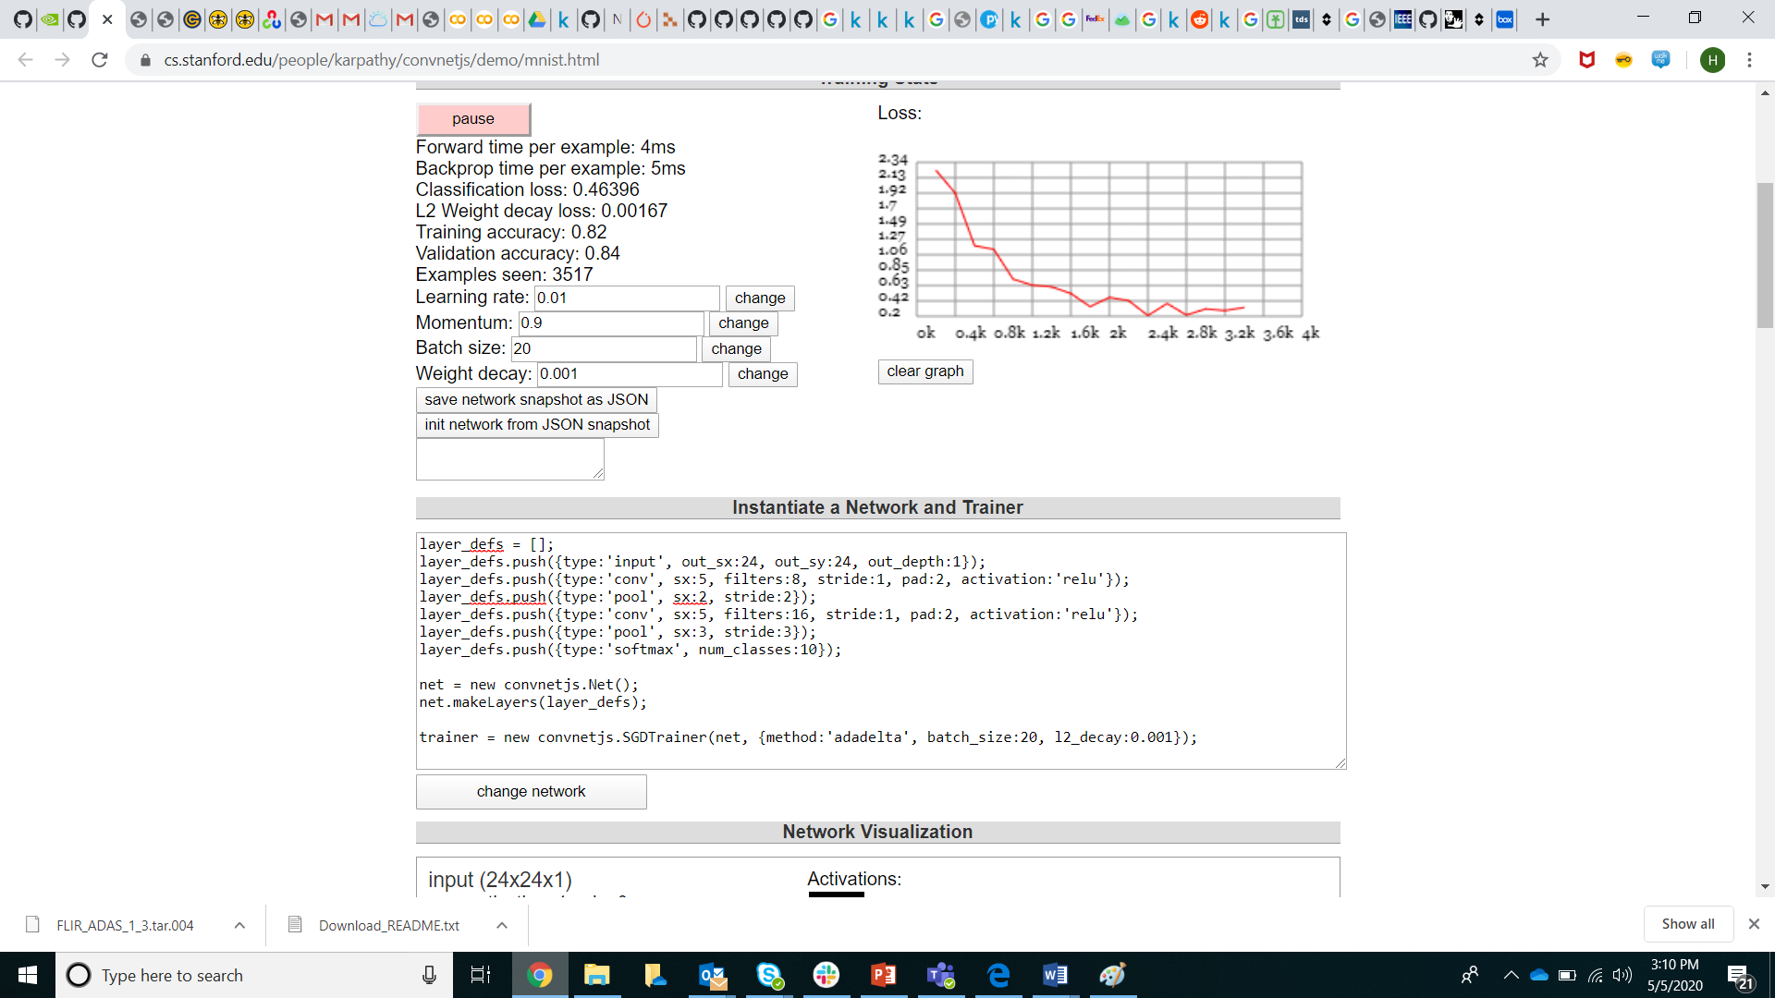

First layer is input layer, input is 24x24x1

Second layer is convolutional layer, filter size 5x5x1, stride=1, 8 filters, padding is 2, activation function is relu

Third layer is pooling layer,pooling size 2x2, stride=2

Fourth layer is convolutional layer, filter is 5x5x1, stride=1, 16 filters, padding is 2, activation function is relu

Fifth layer is pooling layer, pooling size=3x3, stride=3

Sixed layer is Softmax layer, convert the number to a number between 0 and 1, 10 classes.

1. Experiment with the number and size of filters in each layer. Does it improve the accuracy?

Increasing number of filter, accuracy slightly decreased.

Increasing filter size, slightly decreased accuracy

1. Remove the pooling layers. Does it impact the accuracy?

Removing pooling layer, accuracy is decreased a little. With pooling layer, the validation accuracy is 95% (for 8000 sample size). Without pooling layer, the accuracy is ~0.92 (8000 sample size).

1. Add one more conv layer. Does it help with accuracy?

Add one more conv layer,

layer_defs.push({type:'conv', sx:5, filters:16, stride:1, pad:2, activation:'relu'});

layer_defs.push({type:'pool', sx:3, stride:3});

The accuracy is slightly decrease

1. Increase the batch size. What impact does it have?

Increasing batch size does not increase the accuracy (0.87 vs. 0.95)

1. What is the best accuracy you can achieve? Are you over 99%? 99.5%?

Best validation accuracy is 97%, best training accuracy is 99%