Samantha Sun

BIOEN 585

April 8th, 2019

Article 1

1. Using verification tools to assess model

Mistakes found: 3

* Nasal concentration in the paper is:



But it should be the change in concentration of $c_{N}$ over time, not $c_{E}$. This seems to be a typo, since they later use this equation when calculating the nasal drug concentration and it was fixed to $c_{N}$.

* The second term in the circulation equation should be a negative sign, since it is the concentration flux into the circulation. It’s difficult to immediately tell whether this was a typo or actual model mistake, but in order to do so it would require re-solving the differential in order to check if the signs in the final equation are correct. Assuming that it was an actual mistake, there would be large doubts about the final conclusions since it is not representative of the model they built.



The authors used all the information present in the model

Dimensional analysis of equations



Dimensions valid



Dimensions valid

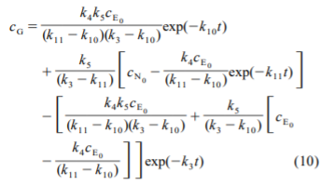

Dimensions valid

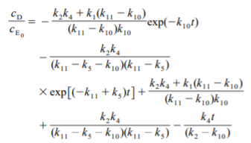

All the terms in this equation are dimensionless, but the last term has an additional t variable, which is not consistent with the rest of the terms. The authors later simplify this equation and condense the rate constants, but the last term still contains the time term.



My best guess is that this was a typo on their part; however, it does show up twice in both of their equations. The reason I think it’s a typo is due to the equation not being solvable as it is, with the dimensions inconsistent. If they used this equation, there would be obvious errors in the model or during the solving process.

1. What set of verification tools would have caught all the mistakes found in actual modeling?

For the positive/negative sign, comparing equations with another person would have quickly solved this problem. For the inconsistent dimensional analysis, actually performing dimensional analysis would have quickly caught the error, whether it was a typo or not.