Samantha Sun

BIOEN 585

20190404

Lab 1: Model Building

# 1. Electrical Model

1. Model response over time

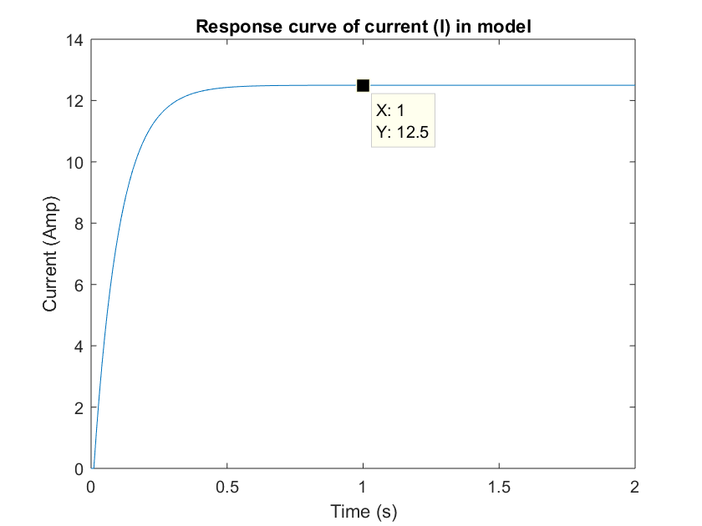

1. Analytic solution at steady state

The analytical solution for this model at steady state matches the value we obtain from the numeric approach, as seen in the plot above.

1. Model response when voltage input is sinusoidal

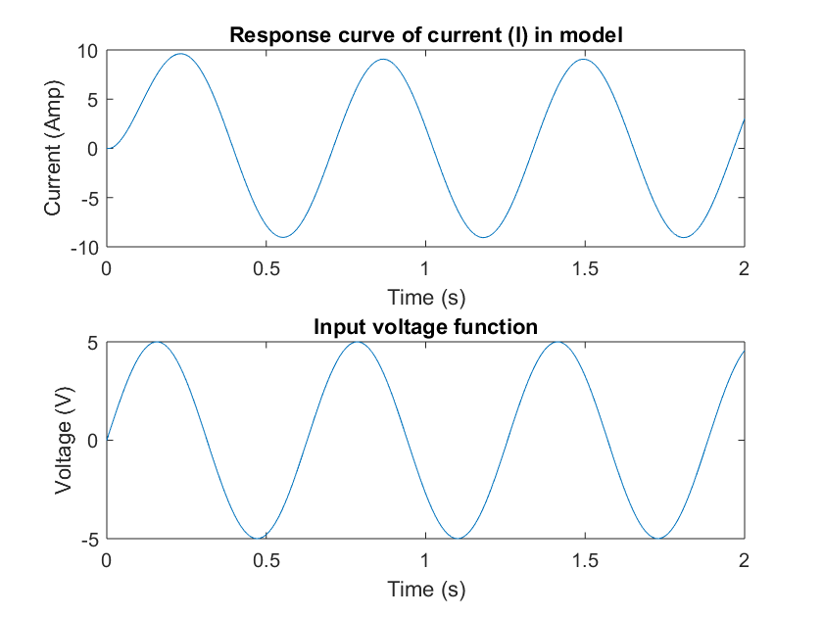

# 2. Fluid Model

1. Derive mathematical form of ODE model

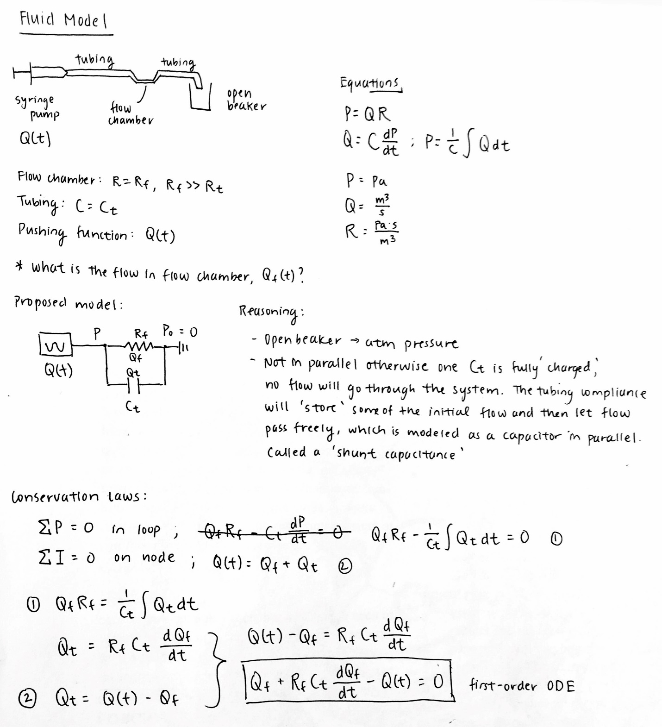

1. Solve model numerically, plot both Q, Qf

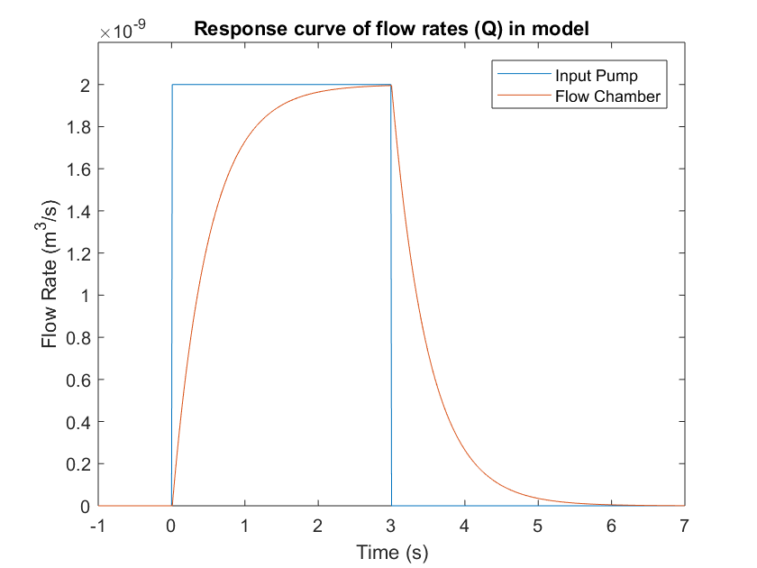

Figure: Demonstrates the flow rate of the input pump (blue) and flow chamber (orange).

1. Interpretation of 2b plot

The plot demonstrates that the behavior of the flow chamber model is similar to an RC circuit, where a step input produces an exponential increase until the flow rate is equal to the input flow rate, and when the pump is stopped, the flow rate through the chamber has an exponential decrease until no flow remains.

# 3. Chemical Model

1. Derive equations
2. Solve numerically

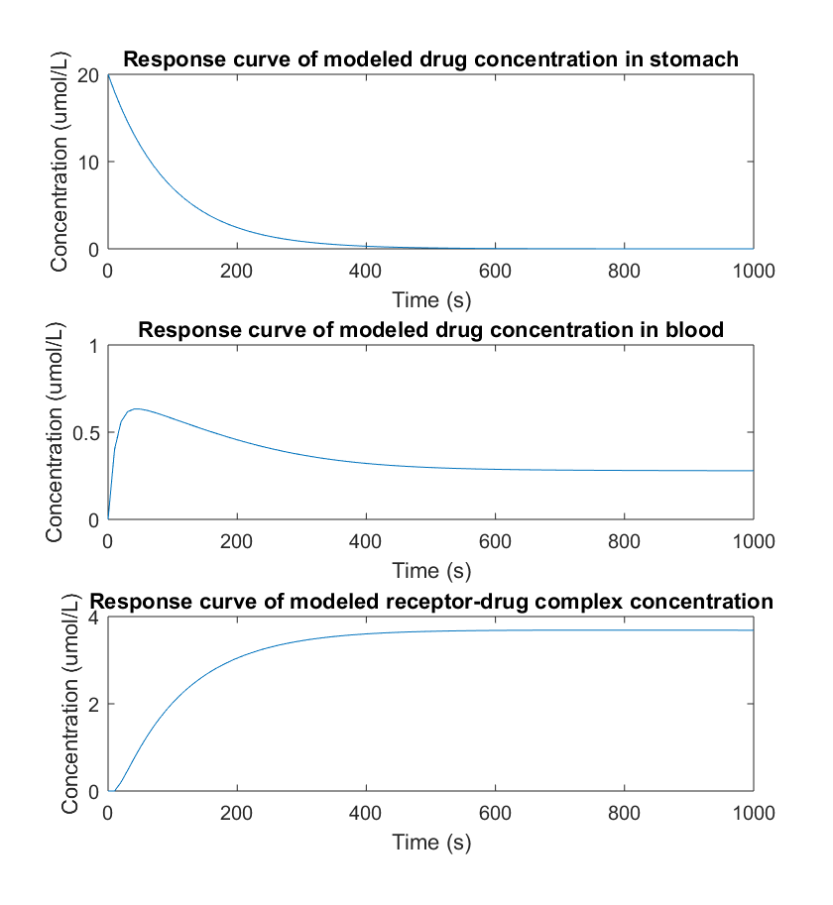

Figure: Visualizes the short response of the drug concentration in the stomach (top) and blood (middle), and the concentration of the drug-receptor complex (bottom).

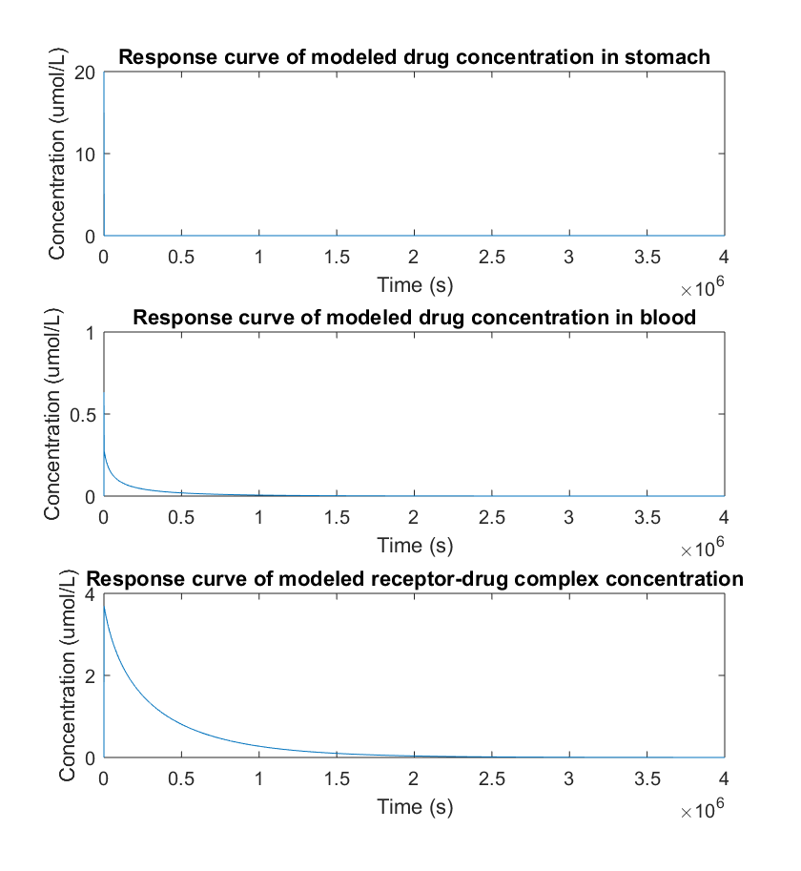

Figure: Visualizes the long response of the drug concentration in the stomach (top) and blood (middle), and the concentration of the drug-receptor complex (bottom).

1. Verify model with steady-state solution

*the term in the parentheses goes to zero, since it represents how the concentration of A changes in the reaction, which at steady state is 0.

At steady state, all variables are at zero, which makes sense as steady state is only achieved in this system when all the drug has left the body.

# 4. Mechanical Model

1. Draw diagram

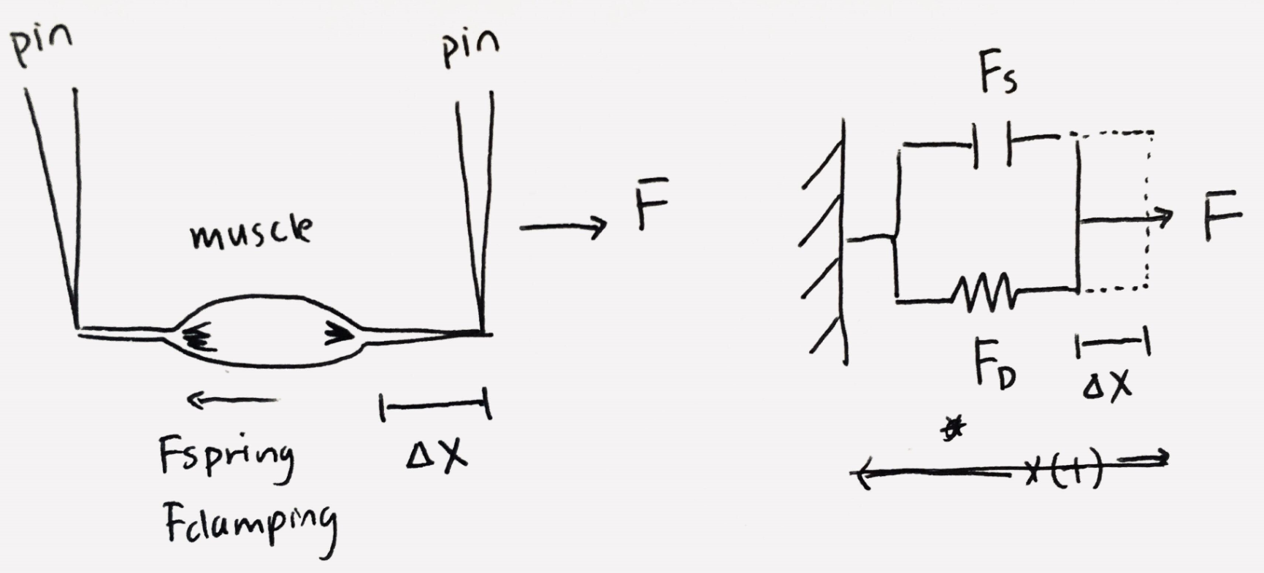

1. Derive mathematical model

**,** where x = change in length from equilibrium

1. Verifications

Used all the information: applied force (F), damping (Fd), spring (Fs), spring and damping in parallel.

Dimensional analysis: , all Newtons

1. Plot model response: muscle length from t = 0 to t = 10 seconds, initially 2.5mm in, pulled with a motor force of 3mN

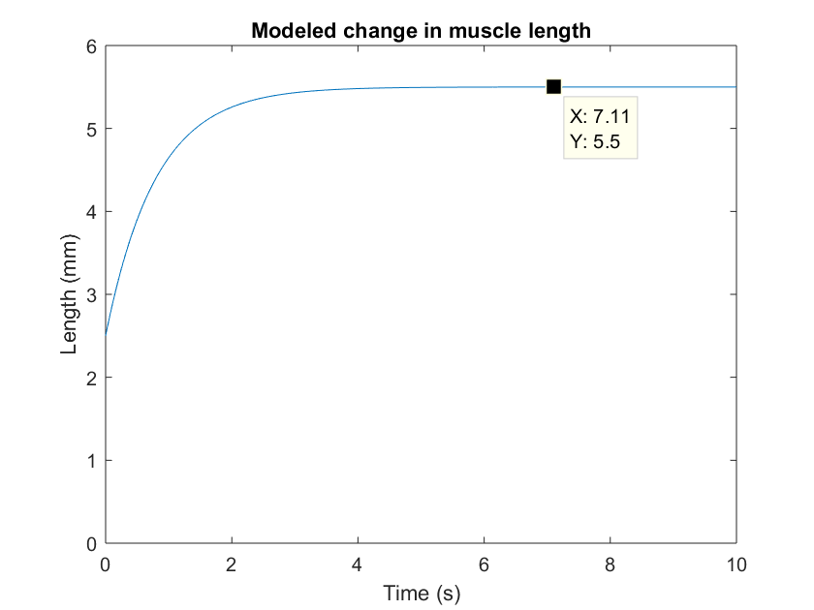

Figure: Plot of the length of the modeled muscle over time. The muscle starts at a length of 2.5mm and increases to a length of 5.5mm.

1. Interpretation

The muscle length started at 2.5mm at equilibrium and was stretched until it reached a length of 5.5mm, gaining 3mm. The stretching behavior followed an exponential gain, where there was initially a large increase in length, but over time the muscle was stretched until the spring and damping force was the same as the force applied to stretch the muscle. The steady state answer for our mathematical model confirms that the change in muscle length was indeed 3mm.

# Appendix: MATLAB Code

## Lab 1

Samantha Sun BIOEN 585 20180404

clear all; close all; clc

## Question 1: Electrical Model

first-order ODE, solve numerically for I

clearvars  
  
% define constants  
r1 = 0.2; % ohm  
r2 = 0.2; % ohm  
c = 1; % farad  
  
% time step + time values  
dt = 0.01; % seconds  
t = 0:dt:2;  
  
% variables  
I = zeros(1,length(t));  
I(1) = 0; % intial condition  
V = zeros(1,length(t));  
V = V + 5; % for t > 0, V = 5, does not vary with time  
V(1) = 0;  
  
% step through loop  
for i = 1:length(t)-1  
 I(i+1) = I(i) + dt * (1/c/r1/r2) * (V(i) - I(i)*(r1+r2));  
end  
  
% plot response  
figure;  
plot(t, I)  
xlabel('Time (s)')  
ylabel('Current (Amp)')  
title('Response curve of current (I) in model')  
  
% change voltage generator input  
I2 = zeros(1,length(t));  
V2 = 5*sin(10*t); % given from assignment  
  
% step through loop  
for i = 1:length(t)-1  
 I2(i+1) = I2(i) + dt * (1/c/r1/r2) * (V2(i) - I2(i)*(r1+r2));  
end  
  
% plot response  
figure;  
subplot(2,1,1)  
plot(t, I2)  
xlabel('Time (s)')  
ylabel('Current (Amp)')  
title('Response curve of current (I) in model')  
  
subplot(2,1,2)  
plot(t, V2)  
xlabel('Time (s)')  
ylabel('Voltage (V)')  
title('Input voltage function')

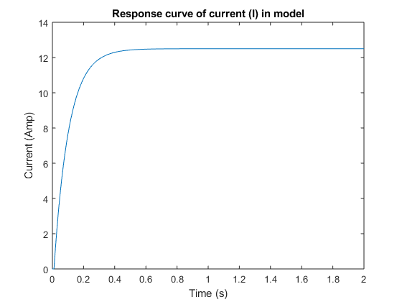

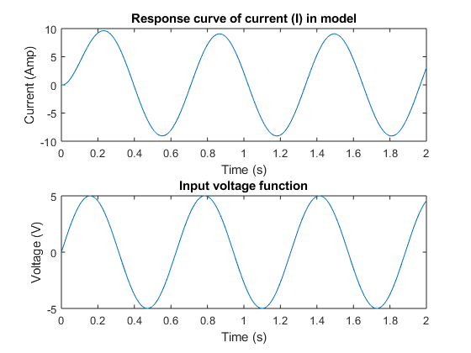

## Question 2: Fluid model

solve for flow in flow chamber

clearvars  
  
% time  
dt = 0.01;  
t = -1:dt:7;  
  
% parameters  
Rf = 5e9; % Pa*s/m^3  
Ct = 1e-10; % m^3/Pa  
Q = zeros(1, length(t));  
Q(t > 0 & t < 3) = 2e-9; % flow starts at t=0, stops at t=3  
  
% variables  
Qf = zeros(1,length(t));  
  
% numeric solution  
for i = 1:length(t)-1  
 Qf(i+1) = Qf(i) + dt * ((Q(i)-Qf(i))/Rf/Ct);  
end  
  
% plot  
figure;  
plot(t, Q, t, Qf)  
xlabel('Time (s)')  
ylabel('Flow Rate (m^3/s)')  
title('Response curve of flow rates (Q) in model')  
legend('Input Pump','Flow Chamber')  
ylim([0 2.2e-9])

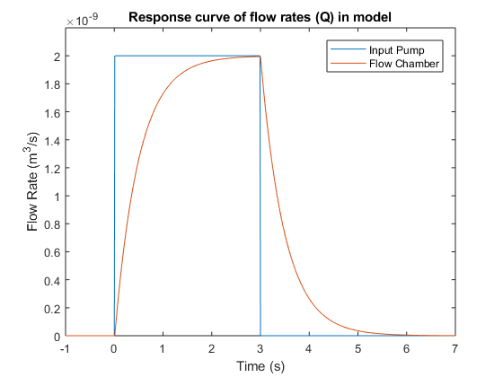

## Question 2: Fluid model using ode function

solve for flow in flow chamber

clearvars  
  
% time  
dt = 0.01;  
t = -1:dt:7;  
  
% parameters  
Rf = 5e9; % Pa*s/m^3  
Ct = 1e-10; % m^3/Pa  
Q = zeros(length(t),1);  
Q(t > 0 & t < 3) = 2e-9; % flow starts at t=0, stops at t=3  
  
% variables  
Qf = zeros(length(t),1);  
  
% numeric solution  
for i = 1:length(t)-1  
 Qf(i+1) = Qf(i) + dt * ((Q(i)-Qf(i))/Rf/Ct);  
end  
  
% use ode45 function  
[t2, Qf2] = ode45(@(t,y) q2ode(t,y,Rf,Ct), t, 0);  
  
% use ode stiff solver function  
[t3, Qf3] = ode15s(@(t,y) q2ode(t,y,Rf,Ct), t, 0);  
  
% change abs tolerance  
options = odeset('AbsTol',1e-15);  
[t4, Qf4] = ode45(@(t,y) q2ode(t,y,Rf,Ct), t, 0, options);  
  
% plot  
figure;  
plot(t, Qf, t2, Qf2, t3, Qf3, t4, Qf4)  
xlabel('Time (s)')  
ylabel('Flow Rate (m^3/s)')  
title('Comparing numerical vs ode function solution')  
legend('Numerical','ode45','ode15s','ode45+change abs tol')  
ylim([0 2.2e-9])

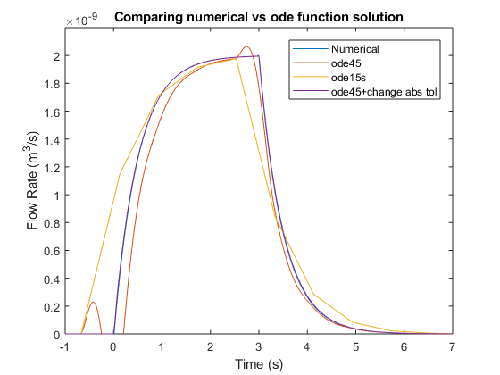

## Question 3: Chemical Model

solve for concentrations of A1, A2 over time M = moles

% time  
dt = 10;  
t = 0:dt:1000;  
  
% variables  
A1 = zeros(1,length(t));  
A2 = zeros(1,length(t));  
C2 = zeros(1,length(t));  
  
% parameters  
D = 20e-6; % M  
V1 = 1; % L  
V2 = 5; % L  
RT = 5e-6; % M  
k_off = 0.001; % s^-1  
k_on = 1e4; % s^-1 M^-1  
P1 = 0.01; % L/s  
P2 = 0.0005; % L/s  
  
% initial conditions  
A1(1) = D;  
  
% solve  
for i = 1:length(t)-1  
 A1(i+1) = A1(i) + dt * (-P1*A1(i)/V1);  
 A2(i+1) = A2(i) + dt * (P1*A1(i)/V2 - P2*A2(i)/V2 + k_off*C2(i) - ...  
 k_on*A2(i)*(RT-C2(i)));  
 C2(i+1) = C2(i) + dt * (k_on*A2(i)*(RT-C2(i)) - k_off*C2(i));  
end  
  
% plot  
figure;  
subplot(3,1,1)  
plot(t,A1*1e6)  
xlabel('Time (s)')  
ylabel('Concentration (umol/L)')  
title('Response curve of modeled drug concentration in stomach')  
  
subplot(3,1,2)  
plot(t,A2*1e6)  
xlabel('Time (s)')  
ylabel('Concentration (umol/L)')  
title('Response curve of modeled drug concentration in blood')  
  
subplot(3,1,3)  
plot(t,C2*1e6)  
xlabel('Time (s)')  
ylabel('Concentration (umol/L)')  
title('Response curve of modeled receptor-drug complex concentration')

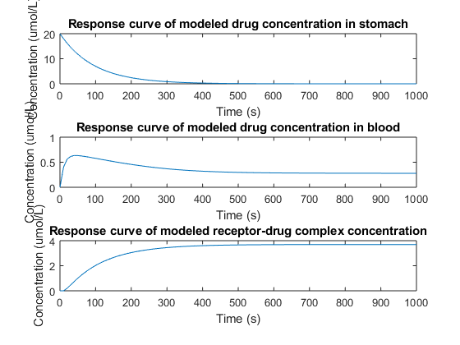

## Question 4: Mechanical model

clearvars  
  
% time  
dt = 0.01;  
t = 0:dt:10;  
  
% variables  
x = zeros(length(t),1);  
  
% params  
b = 0.8; % Ns/m  
k = 1; % N/m  
m = 0; % kg  
F = 3e-3; % N  
  
% initial condition, x = 0  
% starting muscle length = 2.5mm, add on to end  
% because we're solving for change in mucle length  
  
% solve  
for i = 1:length(t)-1  
 x(i+1) = x(i) + dt * (F - k*x(i)) / b;  
end  
  
% make adjustments  
x = x * 1e3; % convert to mm  
x = x + 2.5; % muscle length @ equilibrium  
  
% plot  
figure;  
plot(t, x)  
ylim([0 6])  
xlabel('Time (s)')  
ylabel('Length (mm)')  
title('Modeled change in muscle length')

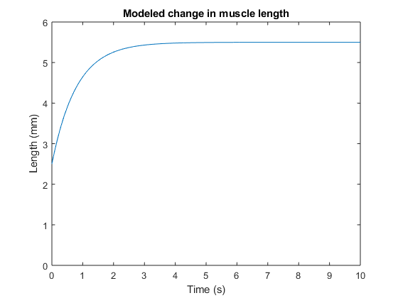

[*Published with MATLAB® R2017b*](http://www.mathworks.com/products/matlab)