Samantha Sun

BIOEN 585

20190410

Lab 2

# Analytic work

* 1. Transfer function

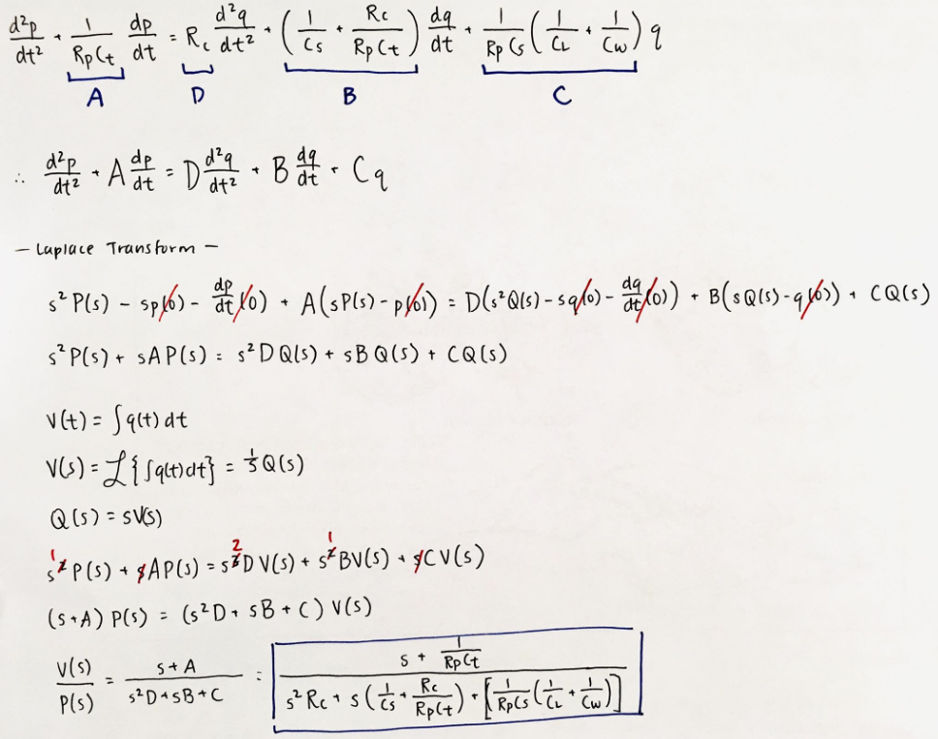

* 1. Steady-state gain
  2. Pressure used to produce steady-state volume of 0.5 L
  3. System stability

Find roots of the characteristic equation (denominator of transfer function)

Both roots are negative, therefore the **system is stable**

* 1. Time constants

The **slower time constant is 0.15 seconds**, which means that the system will take 0.15 seconds to have a 2.71-fold decay or amplification

# SIMULINK numeric model

* 1. Response to step function – MATLAB

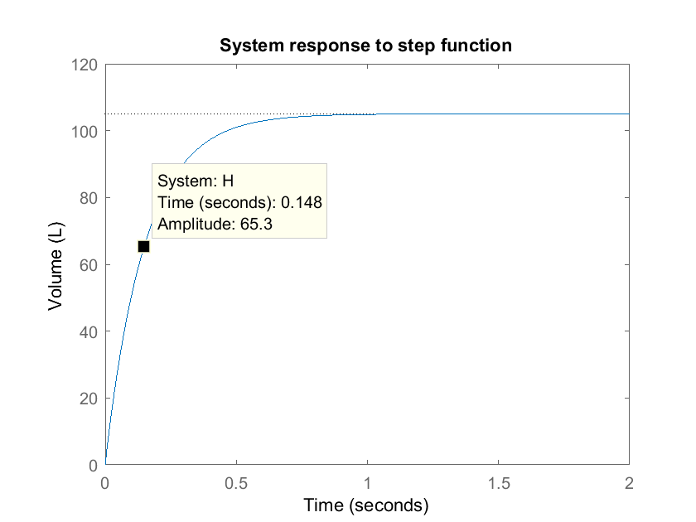

**Figure:** We observe that when the pressure ventilator is turned on at t=0, the air volume in the lungs has an logarithmic gain until it reaches the capacity of about 105 L after about 1.2 seconds.

* 1. Response to step function – SIMULINK

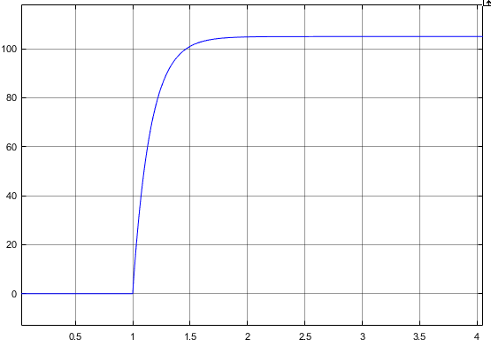

Figure: This plot shows the time response of the lungs given a step function at t=1. The x-axis describes time in seconds and the y axis describes air volume in lungs in liters. The same behavior was observed as in the previous figure.

* 1. Verify work

The plots in part 2a, 2b are identical other than the time at which the step function began. We calculated in part 1 that the steady state gain was 105 L/atm, which is verified by the steady state value in both plots, which is 105 L, given an input of 1 atm. We also observe that the system is stable. The time constant of 0.15 seconds indicates when the volume of air has increased by ~2.7-fold, or when it has gained 63% of its final value. For a steady-state value of 105 L/atm, this would mean that in 0.15 seconds, there would be a value of 66.25 L/atm, which is just about the same value as seen in the first figure.

* 1. Response to periodic input

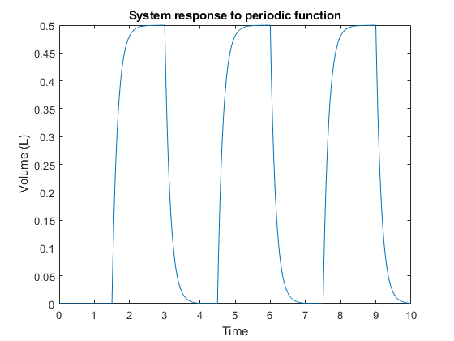

**Figure:** We observe that when given a periodic (sinusoidal) input with a maximum pressure of and a period of 3 seconds, the air volume in the lungs logarithmically reach a value of 0.5 L and then exponentially decreases back to 0 L.

* 1. Tidal volume for periodic input

The tidal-volume is 0.5 L, which is what was expected given that we calculated the amount of pressure needed to fill the lungs to 0.5 L in part 1c.

# State-space model

* 1. Solving state space equation

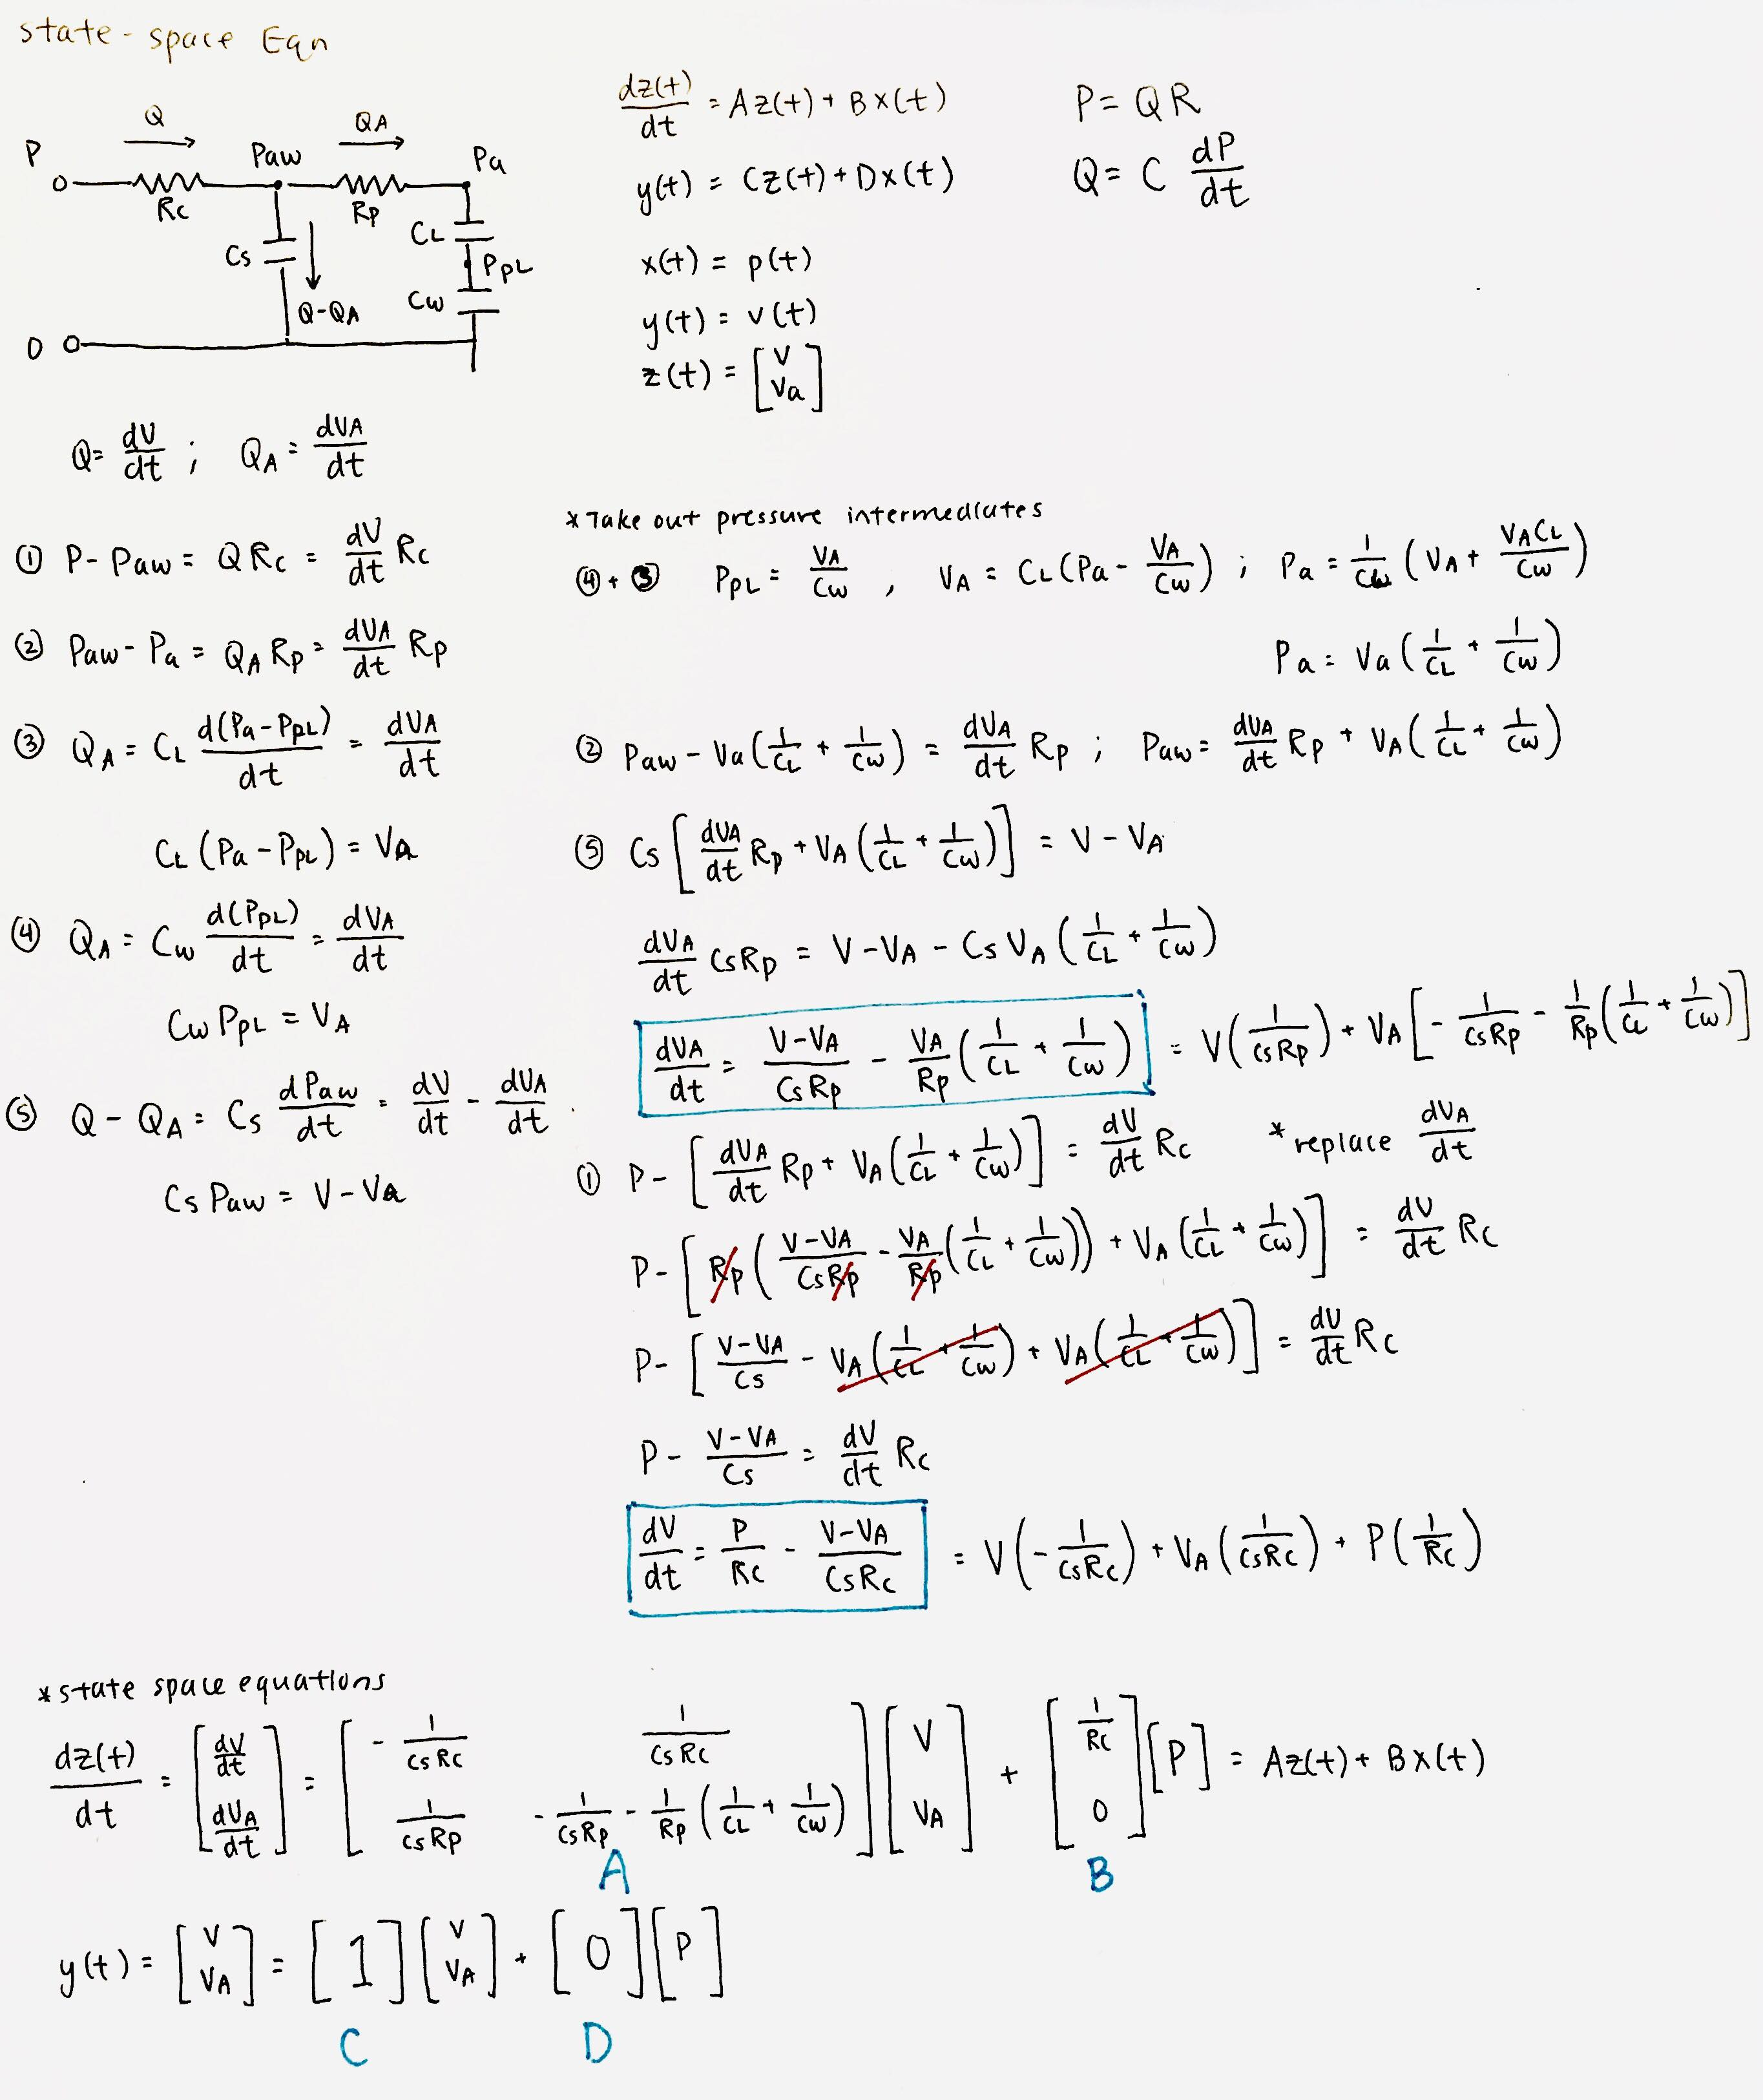

* 1. Stability + time constant

**The system is stable**, as shown with the negative eigenvalues.

* 1. Steady-state gain

The **SSG of the volume of air in the lungs is 105 L/atm** and the SSG of the air in the alveoli is 100 L/atm.

# Diseased state

* 1. Plot volumes of model with decreasing alveoli compliance (CL)

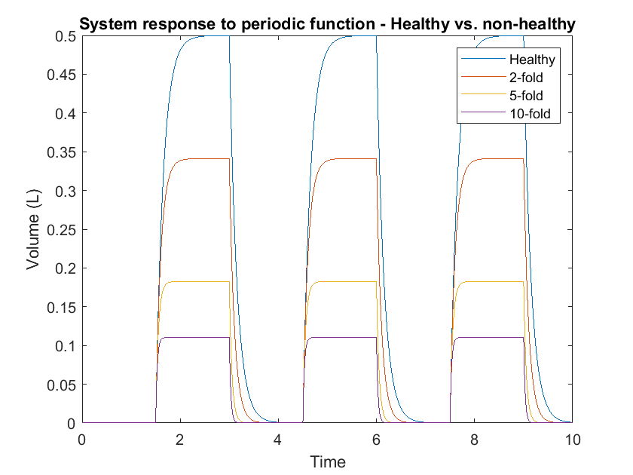

Figure: We observe that with decreasing lung compliance, the total air volume in the lungs, given the same pressure input, decreases. Time is measured in seconds.

* 1. Fractional sensitivity of SSG, slowest time constant, tidal volume

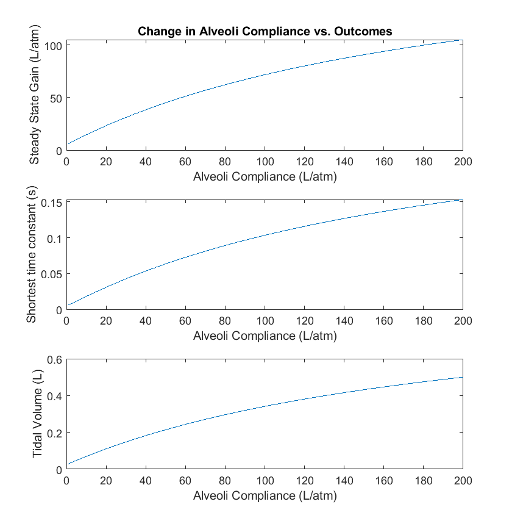

Figure: Displays the value of SSG, shortest time constant, and tidal volume with respect to the value of the lung compliance. 200 L/atm was the original lunch compliance.

To determine fractional sensitivity, we can decrease the lung compliance by 1% and determine the percent decrease of each respective variable.

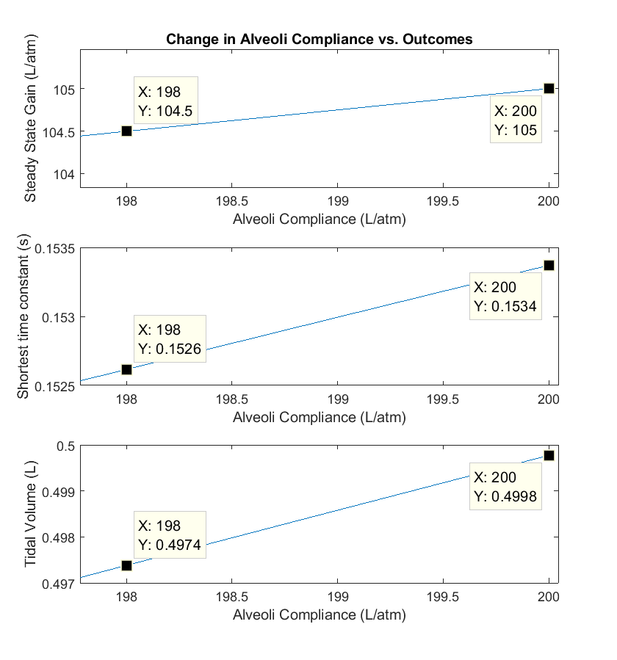

Figure: Same plot as above but zoomed in.

SSG: percent decrease = 0.467%; fractional sensitivity = 0.467

STC: percent decrease = 0.521%; fractional sensitivity = 0.521

TV: percent decrease = 0.480%; fractional sensitivity = 0.480

All of the parameters of interest are sensitive to the lung compliance.

* 1. How to change ventilation protocol for a patient with ARDS

An increase in the pressure ventilation input would be beneficial for a person with ARDS. In order to have the same air volume in the lungs, a 2-fold decrease would require about a 1.47 magnitude increase in the pressure input, a 5-fold would need a 2.74x increase, and a 10-fold would need a 4.53x increase. There seems to be no linear pattern to determine these increase values. However, simply changing the magnitude of the pressure may not be sufficient, since increasing the pressure also increases the rate at which the lungs fill with air, and if the pressure is very high, it may cause damage to the lungs. Changing the period of the pressure input would solve this problem, at the cost of having slower ventilation times.

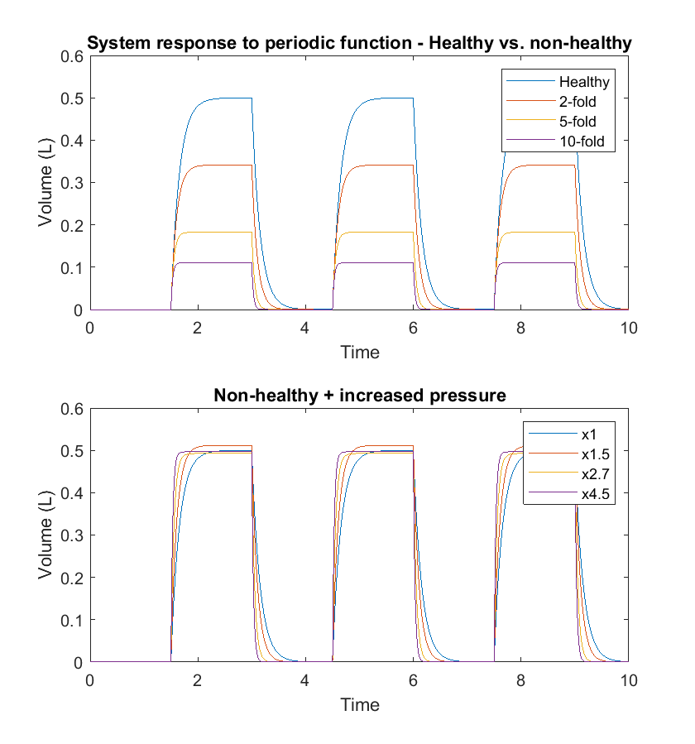

Figure: The top plot shows the lung volume with varying levels of decreased lung compliance, and the bottom plot shows the same diseased states while also increasing the pressure magnitude, as indicated by the legend. While we are able to reach about the same level of air volume in lungs, the rate at which the lungs fill with air increases with decreased lung compliance, with the most rapid change occurring in the 10-fold compliance case.

# Appendix: MATLAB Code

## Lab 2: Linear Systems

Samantha Sun BIOEN 585 20190410

clear all; close all; clc  
plotOn = 0;  
  
% Modeling Lung Mechanics  
% Pressure-input P(t)  
% Measure volume of air in lungs V(t)  
  
% variables  
Rc = 0.001; % atm*s/L  
Rp = 0.0005;  
Cl = 200; % L/atm  
Cw = 200;  
Cs = 5;  
Ct = (1/Cl+1/Cw+1/Cs)^-1;  
  
% transfer function  
num = [1, 1/(Rp*Ct)];  
den = [Rc, 1/Cs+Rc/Rp/Ct, 1/Rp/Cs*(1/Cl+1/Cw)];  
H = tf(num,den);  
  
% periodic input  
maxP = 4.76e-3; % atm  
T = 3; % s  
t = 0:0.001:10; % time vector  
input = square(2*pi*t/T+pi);  
input = (input+1)/2*maxP; % adjust to params  
resp = lsim(H,input,t);  
  
if plotOn == 1  
 % plot response to step function  
 figure;  
 step(H);  
 xlabel('Time')  
 ylabel('Volume (L)')  
 title('System response to step function')  
 xlim([0 2])  
  
 % plot response to periodic input  
 figure;  
 plot(t,resp)  
 xlabel('Time')  
 ylabel('Volume (L)')  
 title('System response to periodic function')  
end  
  
% calculate tidal volume (difference between min + max)  
TV = max(resp) - min(resp);  
fprintf('Tidal volume: %0.2d Liters \n',TV)

Tidal volume: 5.00e-01 Liters

## State space model - steady state gain

A = [-200, 200; 400, -420];  
B = [1000; 0];  
C = 1;  
D = 0;  
  
SSG = -C*A^-1*B;

## Diseased patients - decreased compliance of alveoli

Cl_mod = [200, 100, 40, 20];  
resp_mod = [];  
  
for i = 1:4  
 Ct = (1/Cl_mod(i)+1/Cw+1/Cs)^-1;  
 num = [1, 1/(Rp*Ct)];  
 den = [Rc, 1/Cs+Rc/Rp/Ct, 1/Rp/Cs*(1/Cl_mod(i)+1/Cw)];  
 H_mod = tf(num,den);  
 resp_mod = [resp_mod, lsim(H_mod,input,t)];  
end  
  
figure;  
plot(t,resp_mod)  
xlabel('Time')  
ylabel('Volume (L)')  
title('System response to periodic function - Healthy vs. non-healthy')  
legend('Healthy','2-fold','5-fold','10-fold')

## Diseased patients - increase pressure protocol

input_mod = [1 1.5 2.7 4.5];  
resp_mod_help = [];  
  
for i = 1:4  
 Ct = (1/Cl_mod(i)+1/Cw+1/Cs)^-1;  
 num = [1, 1/(Rp*Ct)];  
 den = [Rc, 1/Cs+Rc/Rp/Ct, 1/Rp/Cs*(1/Cl_mod(i)+1/Cw)];  
 H_mod = tf(num,den);  
 resp_mod_help = [resp_mod_help, lsim(H_mod,input*input_mod(i),t)];  
end  
  
figure;  
a1 = subplot(2,1,1);  
plot(t,resp_mod)  
xlabel('Time')  
ylabel('Volume (L)')  
title('System response to periodic function - Healthy vs. non-healthy')  
legend('Healthy','2-fold','5-fold','10-fold')  
  
a2 = subplot(2,1,2);  
plot(t,resp_mod_help)  
xlabel('Time')  
ylabel('Volume (L)')  
title('Non-healthy + increased pressure')  
legend('x1','x1.5','x2.7','x4.5')  
  
linkaxes([a1 a2],'xy')

## fractional sensitivity of SSG, slowest time constant, tidal volume

to compliance of alveoli

Rc = 0.001; % atm*s/L  
Rp = 0.0005;  
Cw = 200;  
Cs = 5;  
Cl = 1:200; % L/atm  
Ct = (1./Cl+1/Cw+1/Cs).^-1;  
  
num = zeros(200,2);  
num(:,1) = 1;  
num(:,2) = 1./(Rp*Ct);  
  
den = zeros(200,3);  
den(:,1) = Rc;  
den(:,2) = 1/Cs+Rc/Rp./Ct;  
den(:,3) = 1/Rp/Cs*(1./Cl+1/Cw);  
  
% periodic input  
maxP = 4.76e-3; % atm  
T = 3; % s  
t = 0:0.001:3; % time vector  
input = square(2*pi*t/T+pi);  
input = (input+1)/2*maxP; % adjust to params  
  
% steady state gain  
SSG = (Cs*Cw + Cs*Cl + Cl*Cw)./(Cl + Cw);  
  
% shortest time constant tidal volume  
sT = zeros(200,1);  
TV = zeros(200,1);  
  
for i = 1:length(sT)  
 sT(i) = -1/max(roots(den(i,:)));  
  
 H = tf(num(i,:),den(i,:));  
 resp = lsim(H,input,t);  
 TV(i) = max(resp) - min(resp);  
  
end  
  
% plots  
figure;  
ax1 = subplot(3,1,1);  
plot(Cl, SSG)  
xlabel('Alveoli Compliance (L/atm)')  
ylabel('Steady State Gain (L/atm)')  
title('Change in Alveoli Compliance vs. Outcomes')  
  
ax2 = subplot(3,1,2);  
plot(Cl, sT)  
xlabel('Alveoli Compliance (L/atm)')  
ylabel('Shortest time constant (s)')  
  
ax3 = subplot(3,1,3);  
plot(Cl, TV)  
xlabel('Alveoli Compliance (L/atm)')  
ylabel('Tidal Volume (L)')  
  
linkaxes([ax1, ax2, ax3], 'x')  
%TV = max(resp) - min(resp);