Samantha Sun

BIOEN585

20190417

Lab 3: Nonlinear Analysis

# Question 1: Stability Analysis

1. Solve for nullclines and equilibrium points, plot on phase plane plot

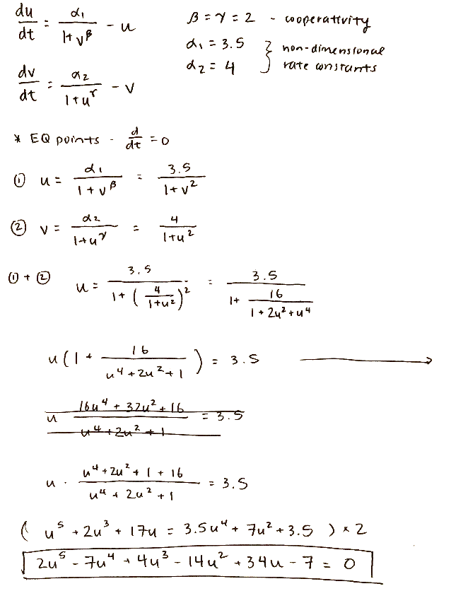

1. Stability analysis: bi-stable switch?

There are three equilibrium points in this system, which can be seen by the three intersections in the figure. To determine the stability at each point, we create the Jacobian matrix and solve for the eigenvalues at each point.

At point 1 and point 3, the eigenvalues are both negative, which means they are stable equilibrium points. At point 2, there is one positive eigenvalue, which means it is an unstable equilibrium.

Question 2: Phase Plane Analysis

Question 3: Bifurcation Analysis

Question 4: Model Building