Samantha Sun

BIOEN585

20190514

Lab 6

# Question 1: Graphing data

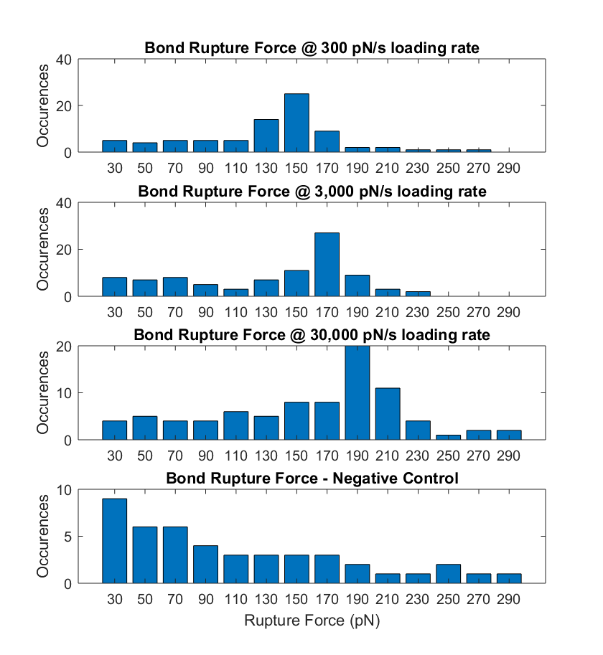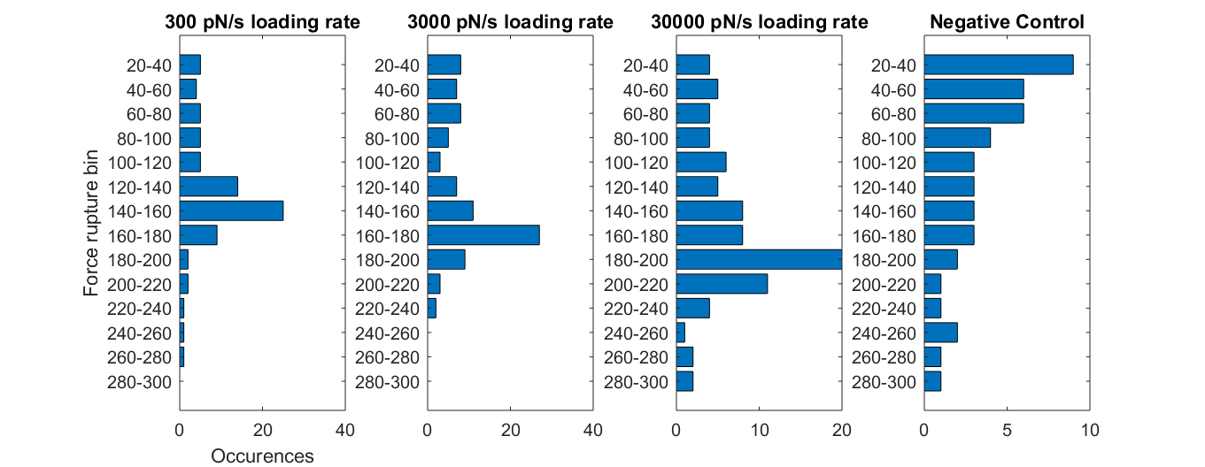

Figures: Bar and line representations of the experimental data.

# Question 2: Setting up ODE model (done)

# Question 3: Solving model with initial guesses

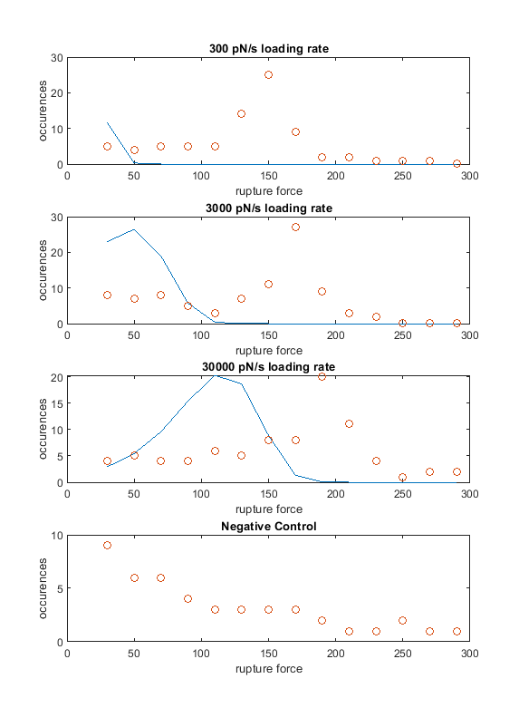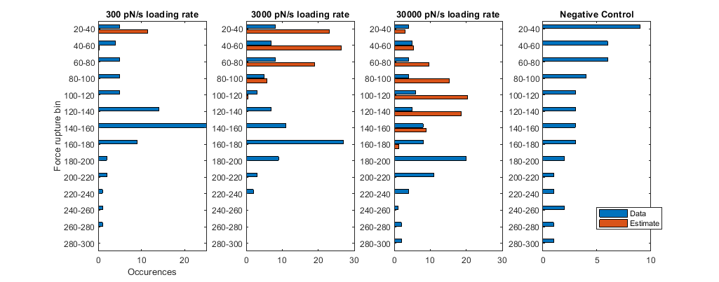

Figures: Shows both a line and bar representation of the experimental data and the estimated parameters for a proposed model to explain the behavior of the data. Due to no parameter estimation, it is expected that the estimate does not match the real data well.

# Question 4: Parameter estimation

Assumed a constant standard deviation for the errors for the weighting scheme.

1. Plotting best parameters

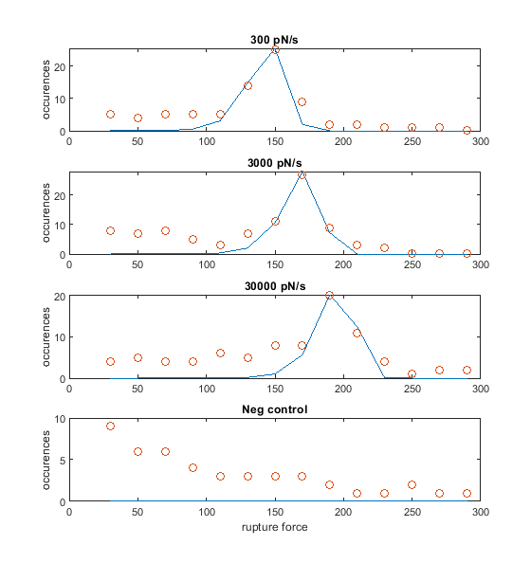

Figure: Shows experimental data in orange and parameter-fit model in blue.

After running the parameter fit program several times with different initial guesses, the best parameters were determined by looking at the final objective function error and seeing which parameter set gave the lowest error.

1. Analysis of parameters

The parameters are as follows:

k = 4.7*10^-5

fs = 11.1

initial condition for r=300: 45.8

initial condition for r=3000: 48.2

initial condition for r=30000: 39.5

Objective function: 103

These parameters are all physiologically relevant, since they are all positive.

1. Residuals

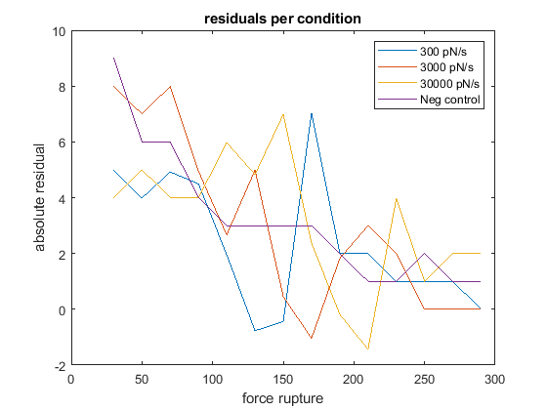

Figure: Shows the value of the residuals for each rate condition.

Since we did not consider the negative control while fitting the parameters, I will disregard its respective trace. The residuals seem to not follow a trend based on the data, but looking at the orange trace, there may be a slight negative correlation. Otherwise, the residuals do not seem to be dependent on the force of rupture, which tells us that our parameters are not biased, and our model is effective.

One area in which the model could be improved is for the lower force rupture bins. None of the predictions effectively captured the beginning occurrences of ruptures – they all were at or near zero. This observation is also reflected in the residual plot, where the residuals at smaller force bins tended to be greater than the residuals at higher force bins. Being able to accurately portray the initial force rupturing at lower force bins would improve the model.

# Question 5: Addressing negative control data

The negative control data was added to the parameter estimation procedure.

1. Plotting new model

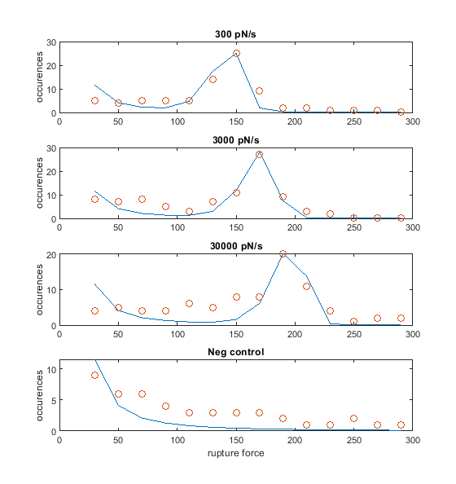

Figure: Shows the model fit of the experimental data when considering the negative control values.

The new parameters for this model are:

k = 8.3*10^-5

fs = 11.53

a = 0.18

initial condition for r=300: 47.49

initial condition for r=3000: 48.97

initial condition for r=30000: 40.60

initial condition for neg control: 2873.57

The value of the objective function is: 131.4

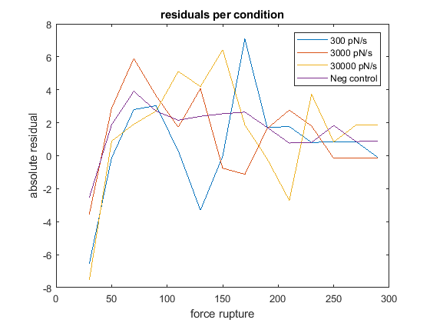

Figure: Shows the residual values for the proposed model

1. Determining if approach is better

After adding an additional two parameters for this parameter fit, there are a total of 7 parameters as opposed to the 5 parameters needed to fit the previous version of the model. Generally, it is preferred for models to have the fewest number of parameters that can still accurately capture the data behavior.

The objective function for this model reached a value of 131.4, while the other model reached a value of 103. Although the behavior looks better for the lesser forces, the overall error was still larger than without considering the negative controls.

Looking at the weighted residuals, it seems like there is a clear trend in this model where there is initially a low residual value and then an increase, which tells me that this is not a great model due to potential parameter bias.

# Question 6: Using a different weighting scheme

1. Plotting new model

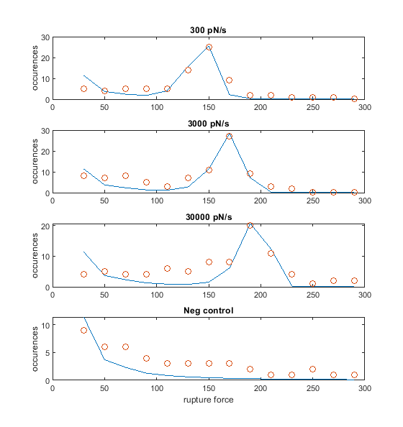

1. Parameters and initial conditions

k = 4.85*10^-5

fs = 11.11

a = 0.04

initial condition for r=300: 45.84

initial condition for r=3000: 48.07

initial condition for r=30000: 39.53

initial condition for neg control: 12919.57

objective function: 29.298

1. Plotting residuals

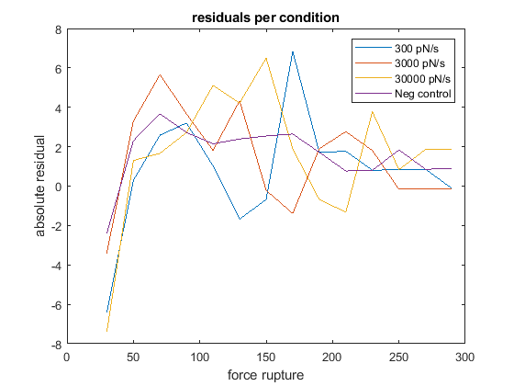

1. Objective function value

The objective function end value was 29.298. It’s difficult to compare this to the previous objective function values, since this used the variance instead of the standard deviation, so we expect the overall objective value to be lower since it’s scaled more aggressively.

1. Comparison of new weighting scheme

This new weighting scheme does almost identically to the standard deviation weighting scheme. Although the weights are fairly different, the shape of the curves and residuals are very similar. This does confirm the concerns earlier that the parameter we selected may be biased to the force variables. From the observations made, to improve on this model, it may be better to stick to fewer parameter values and explore other types of parameter weighting schemes, such as constant coefficient of variation.

# Appendix: MATLAB guide

The matlab code is as follows:

* “lab6.m” Can press play on this code and it will run all the model building and generate all the figures found in this report.