Samantha Sun

BIOEN 585

20190515

Lab 7a

# Question 1: Method and verification – no tracks

1. Plot trajectories

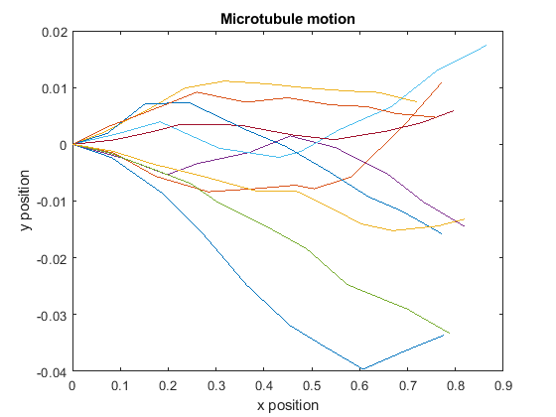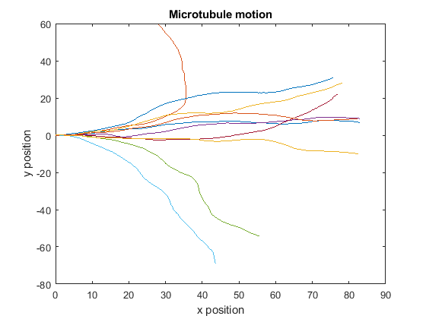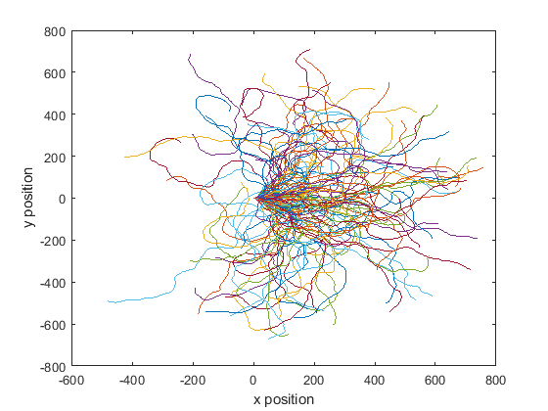

Figure: (Top) traces of 10 microtubules given a time span of 1 and 100 time units. (Bottom) traces of 100 microtubules given a time span of 1000 time units. From these traces, we can observe the impact of the initial angle driving the direction of movement, but for longer time spans, we can better observe the random-ness that appears from random movement.

1. Calculate V_avg and Dv and compare

The given parameter values for V_avg and Dv are:

$$V_{avg}=0.85\frac{μm}{s};D_{v}=2*{10}^{-3}\frac{μm^{2}}{s}$$

To estimate the mean velocity, we took the total distance travelled for each of the 10 traces and divided it by the total time travelled:

$$V_{avg}=\left\langle \frac{distance}{total time}\right\rangle =0.8504\frac{μm}{s}$$

To estimate the diffusion coefficient, we used the following formula:

$$D_{v}=\left\langle \frac{distance diffused \left(μm^{2}\right)}{2*total time \left(s\right)}\right\rangle =1.9*{10}^{-3}\frac{μm^{2}}{s}$$

These values are comparable to the given values.

1. Calculate persistence length and compare

The given persistence length was: $L_{p}=111 μm$

Persistence length was calculated using the following formula:

$$\left\langle \cos\left(θ_{seg}\right)\right\rangle =e^{-\frac{s}{L_{p}}}; \\ L_{p}=-\frac{s}{\ln\left(\cos\left(θ_{seg}\right)\right)}=252.3 μm$$

Where theta_seg is the change of angle between the beginning and end of that segment. We plotted both sides of the equation and observed that the plots do not match. The given value of Lp causes the function to decay at a rate about 2x faster than the estimated Lp value, which makes sense since the given value is about 2x smaller than the estimated value.

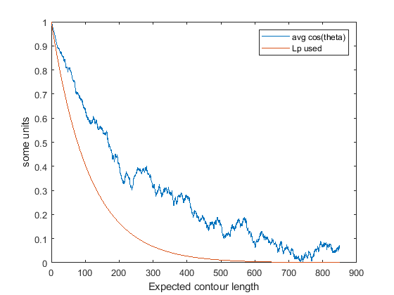

Figure: Comparison between Lp constants used in the paper (red) and numerically derived from the model (blue). We observe a disparity between these two plots that demonstrate a potential error/typo in the paper.

1. Analysis of time step:

Running our model with different time steps (dt), we demonstrated that our results were independent of the time step implemented.

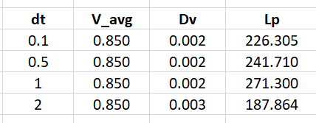

Table: shows that our model constants under different time step conditions remain the same

# Question 2: Simulate motion in track (5.5 um)

1. Sample trajectories

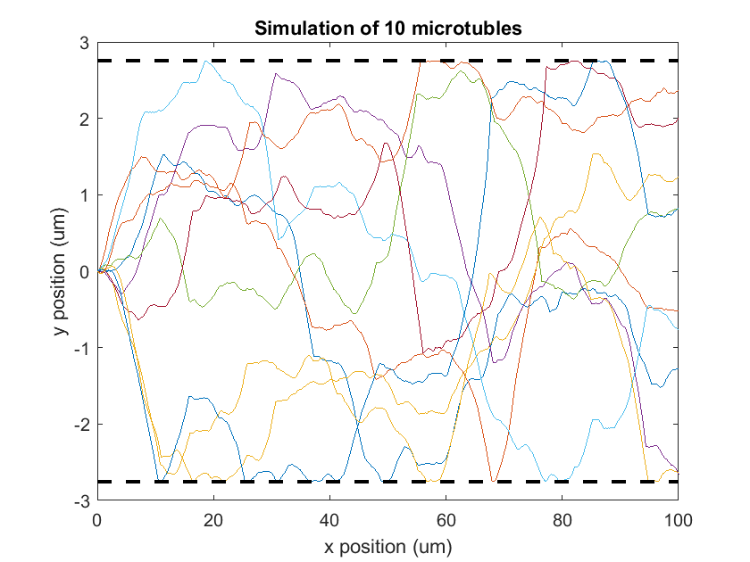

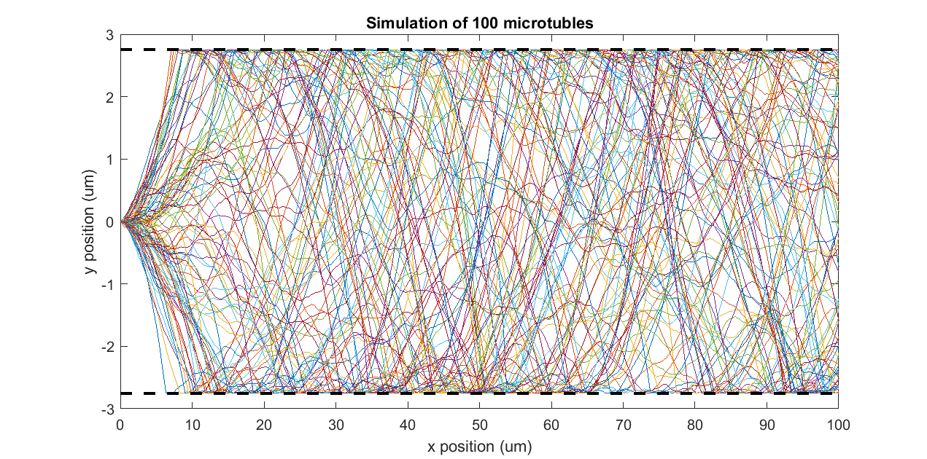

Figure: Shows example traces of 10 (top) and 100 (bottom) microtubules in a channel with diameter 5.5 um. We can observe that the microtubules “bounce” off the borders and do not pass the border line.

1. Avg distance between collisions, avg collision angle, validation to paper

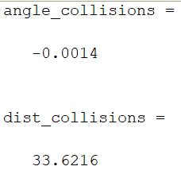The average distance between collisions from 50 runs of our model was 33.62 um, which is within the paper’s confidence interval, and the average collision angle was -0.0014 degrees, which is far from the paper’s reported value of 28 +/- 21 degrees. We observed that our angle (Q) values hardly went above 1 degree, which may explain this disparity.

When looking at individual plots, we do see that these microtubules eventually turn around after hitting a wall. This is most likely due to after hitting the wall, there are limited directions that the microtubule can continue moving, which increases the chance for the microtubule to eventually go the opposite direction. We do see angle differences that are much larger than 1 in these plots, but it may be due to scaling. Other than the angle information of our model failing validation, these traces are what we expect in terms of stochastic movement within a contained region.

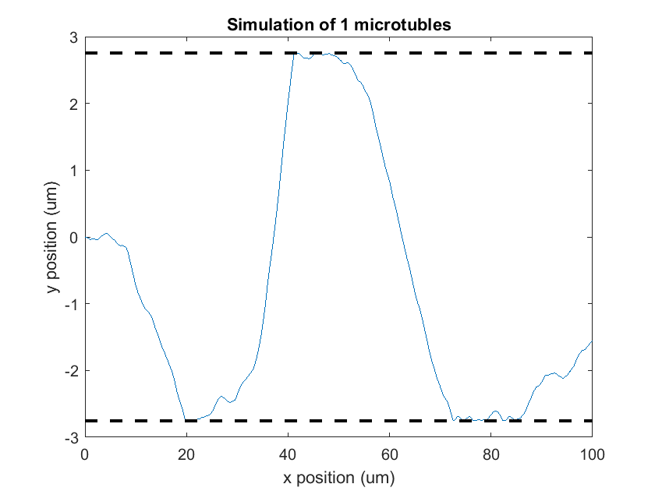

Figure: Shows one microtubule trace along the track. The microtubule exhibits almost an oscillatory behavior and tends to move to the other edge of the border after hitting a border.

# Question 3: Design- relating tube diameter to distance between collisions

One question of interest was determining the relationship between tube diameter and the frequency of collisions, which can be represented by the average distance between collisions. Understanding this relationship may better inform future design choices of tube diameter.

We explored a tube diameter of the following values (um): 0.5, 1, 2, 5, 10, 20, 50, 100 and then calculated the average distance between collisions over 10 iterations.

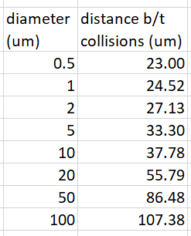We found that as we increase tube diameter, the distance between collisions increase as expected, which tells us that the frequency of collisions decreases. There seems to be a linear relationship between tube diameter and distance between collision, which can be seen in the figures below. Repeating the analysis with different iteration values gives us very similar values.

These observations allow us to predict collision frequency from just knowing the tube diameter through interpolation and may inform future design choices depending on the desired microtubule behavior and amount of interaction with the border wall.

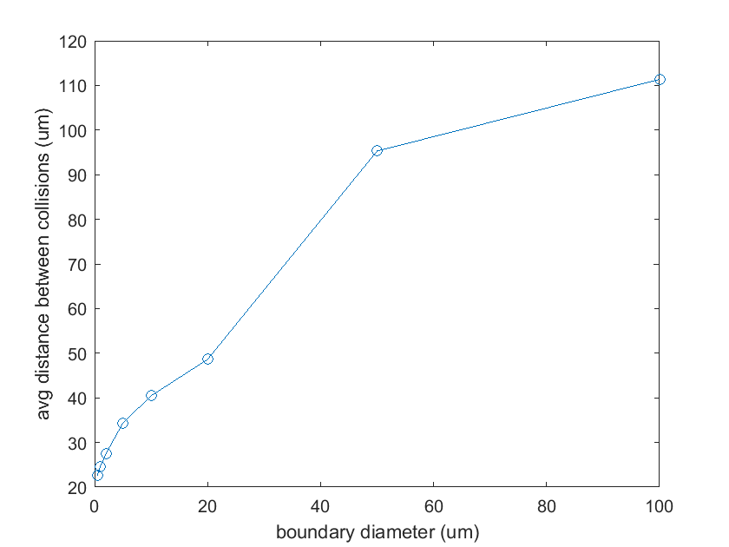

Figure: Shows the apparent linear relationship between boundary diameter and the average distance between microtubule collisions.

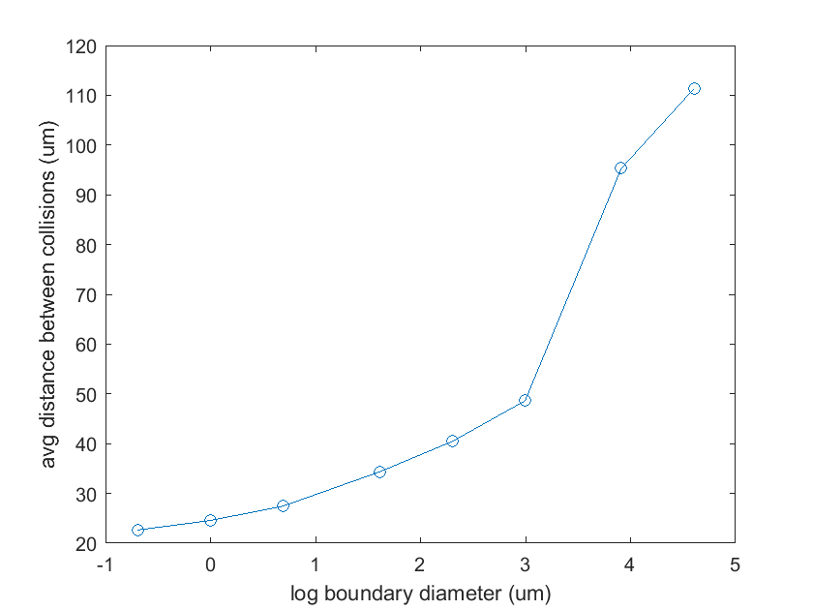

Figure: Shows the same figure as above but with boundary diameter plotted on a log-scale for better visualization.

# Appendix: MATLAB code

The main code for this project is in the following file “lab7a.m.” Each section of the code can be run independently given that the initial setup subsection is run to establish the necessary parameters.

All figure generated should look similar to the figures in the report but are expected to differ due to modelling a stochastic process.

The “MT.m” file is the function that determines the microtubule behavior.