**Instruments**

**便携式测风激光雷达**

便携式测风激光雷达采用窄线宽脉冲激光器作为发射光源，运用多普勒相干探测原理，来完成对大气平均水平风速的测量，以实现30～1000米高度范围内大气风场的测量。便携式激光测风雷达采用相干探测原理，利用稳频激光作为照射光束，通过接收激光束对大气中随风飘移气溶胶的散射回来的激光回波通过收发合一天线收集并送入相干光路中进行外差混频，对差频信号进行实时采样检波分析；对测量的数据进行风场反演计算，最后得到各个高度的风速、风向等信息。

型号：FC-II

测风范围：风向0~360°，风速1~40m/s

风速误差（标准偏差）：≤0.4m/s（V≤10 m/s,2min数据平均）；

≤3%V （V＞10 m/s,2min数据平均）

风向误差（标准偏差）：≤3°（V＞5m/s,2min数据平均）

垂直气流误差（标准偏差）：≤0.1 m/s

探测数据有效率：≥90%（探测高度≤1500m）

≥70%（探测高度≤800m）

数据探测周期：≤10s

工作波长：1550nm

垂直分辨率：50m

测量盲区：30m

厂家：北方激光研究院有限公司

**“UAT-2 超声风速温度仪（以下简称 UAT-2）和湍流专用局域网测量系统”（以下简称系统）**

UAT-2超声风速温度仪是中国科学院大气物理研究所研制的一款采样频率达到100Hz的大气湍流测量仪器。其实现了对三维风速和温度脉动场随时间高速变化的精准测量。UAT-2通过了国家气象计量站的风洞测试，完成了与国外采样频率为100Hz先进的超声风速温度仪—GILL R3的对比实验

湍流专用局域网测量系统以GPS授时信号为时间基准的主从分布式局网子系统，可对分布在局网系统各个节点上的 UAT-2实施实时、同步测量。保证分布在不同空间点的UAT-2采样的实时、同步，使测量数据在时间上可比。如此使得分布在不同空间的UAT-2的测量数据具有空间和时间的可比性，大大提高了UAT-2超声风速温度仪的测量精度，拓展了其应用的广度和深度。

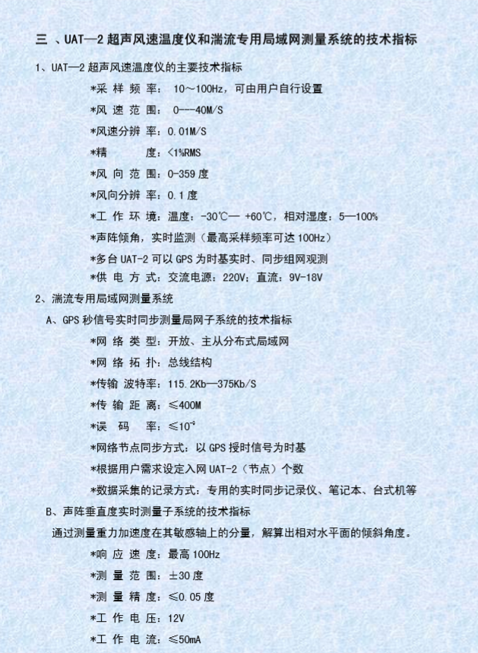

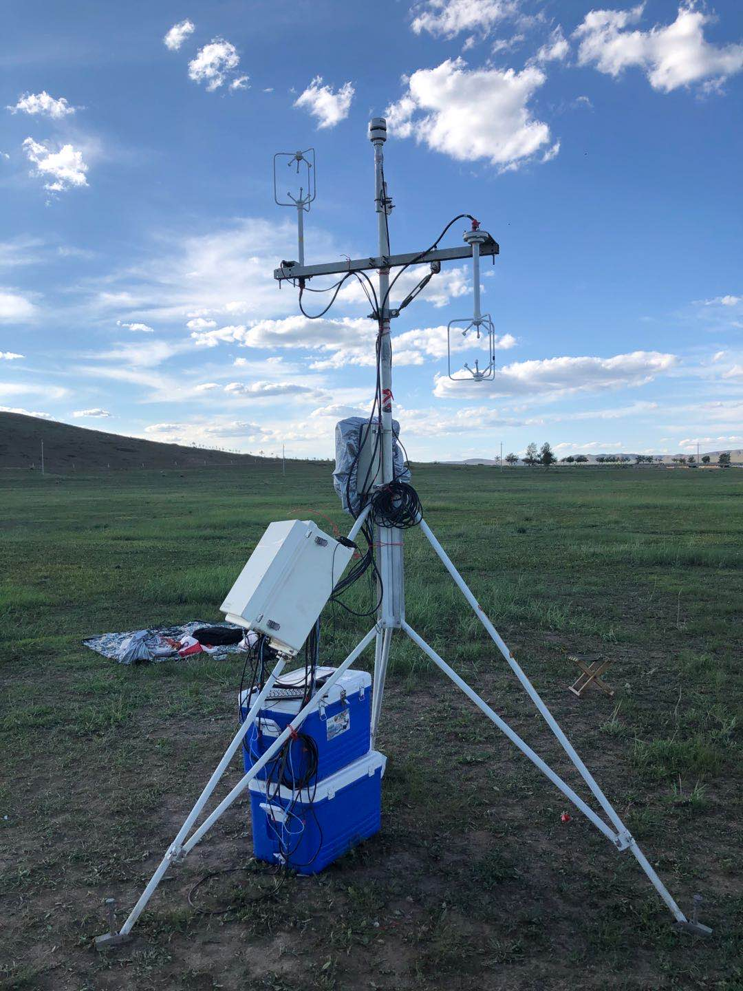

生产厂家：中国科学院大气物理研究所

位置：向下超声220 cm; 向上超声：316 cm；

温度湿度传感器：Airmar WS220WX

位置：330 cm。

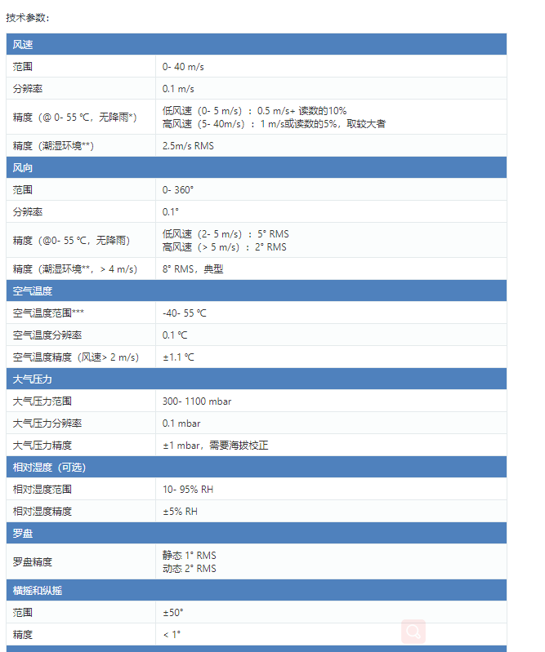

**CL-51云高仪**

维萨拉CL-51云高仪能够透过低空和中空云层测量高空卷云，或不良天气状况下的垂直能见度。CL-51采用脉冲二极管激光LIDAR(激光探测和测距)技术，沿着垂直或近乎垂直的方向发射短促、强大的激光脉冲。因云层降水或其他光线遮拉物所产生的激光反射(后向散 射)可被用来分析和确定云底的高度。

测量从地面开始

CL51所采用的增强型单镜头技术确保了它从绝对零高度测量起即具有杰出的性能。这得益于它在整个量程中所获得的强大而稳定的信号。CL51可同时探测三个云层。如果云底因降水或地面雾气的遮拦,它也可以测量垂直能见度。CL51能够提供全量程的后向散射廓线,这一信息为更进一步的边界层和大气分析提供了可能。

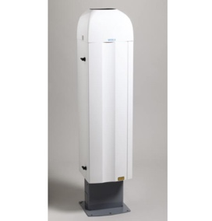

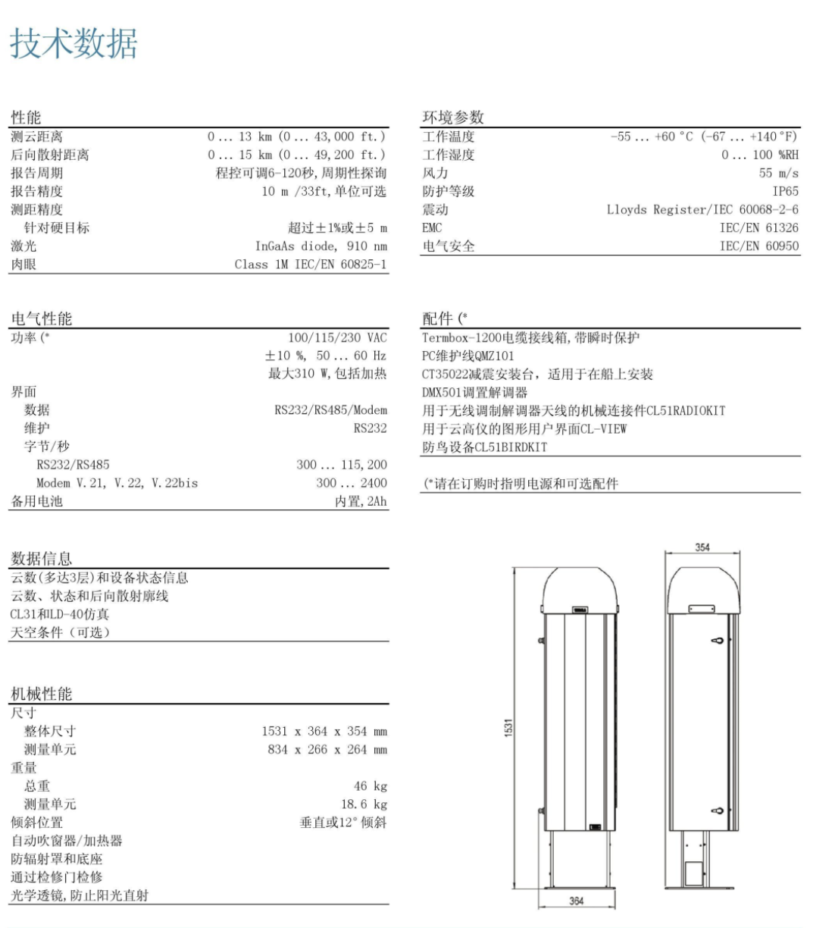

**CIMEL-376**

It operates in the visible (green) and in the near infrared NIR (red) with depolarization channels options for enhanced aerosol characterization.

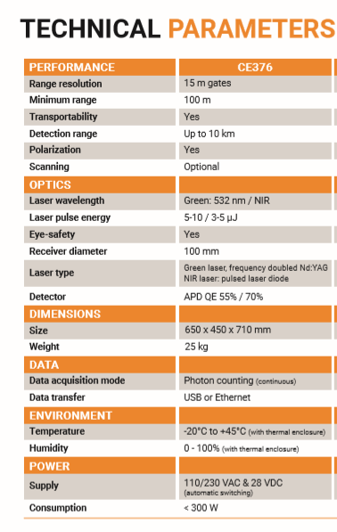

**The Portable Optical Particle Spectrometer (POPS)**

A light-weight, low-cost optical particle spectrometer for measurements of aerosol number concentrations and size distributions has been designed, constructed, and demonstrated. The spectrometer is suitable for use on small, unmanned aerial vehicles (UAVs). The spectrometer uses a 405 nm diode laser to count and size individual particles in the size range 140–3000 nm. A compact data system combines custom electronics with a single-board commercial computer. Power consumption is 7W at 9–15 V.

**Working Principle**

Individual aerosol particles in the sample ﬂow are pulled through an inlet nozzle, and pass through a laser beam where they elastically scatter light. A fraction of the scattered light is collected with a spherical mirror and directed to a photomultipler tube (PMT) that generates an electrical current proportional to the amount of detected light. The PMT signal is digitized and the maximum current associated with each detected particle is recorded by a microcomputer. This maximum detected signal for a given particle, hereafter referred to as a “scattering amplitude,” is a measure of the particle’s scattering cross section (i.e., optical size). (R. S. Gao et al.)

**Maintenance, Alignment and Calibration**

The mirror, particle filters and the pump were daily cleaned, and multi-pointed calibration (0–10,000 particles s-1) was made before the field campaign.

**Instrument specifications**

Instrument specifications are listed in Table 2, followed by discussion of the critical characteristics.

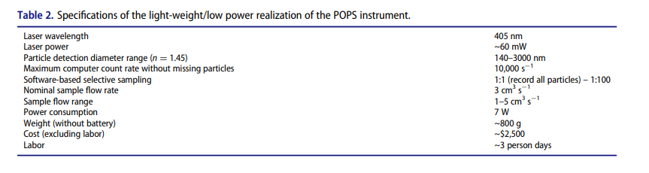

**Manufacture**

The POPS was originally developed by the Chemical Sciences Division of the US National Oceanic and Atmospheric Administration (NOAA) and is licensed to Handix Scientific LLC.

**自动气象站**

1 气压传感器

The CS106, manufactured by Vaisala, measures barometric pressure for the range of 500 to 1100 hPa (mBar). This range equates to from below sea level (as in a mine) to over 15,000 feet above sea level.

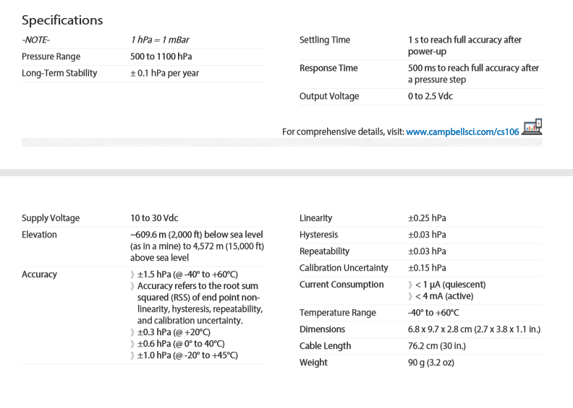

2 温湿度传感器

型号: HC2A-S3

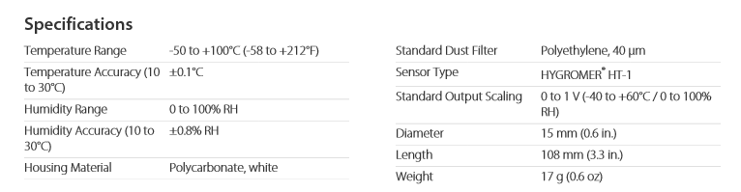

生产厂家：Campbell Scientific Companies (USA)

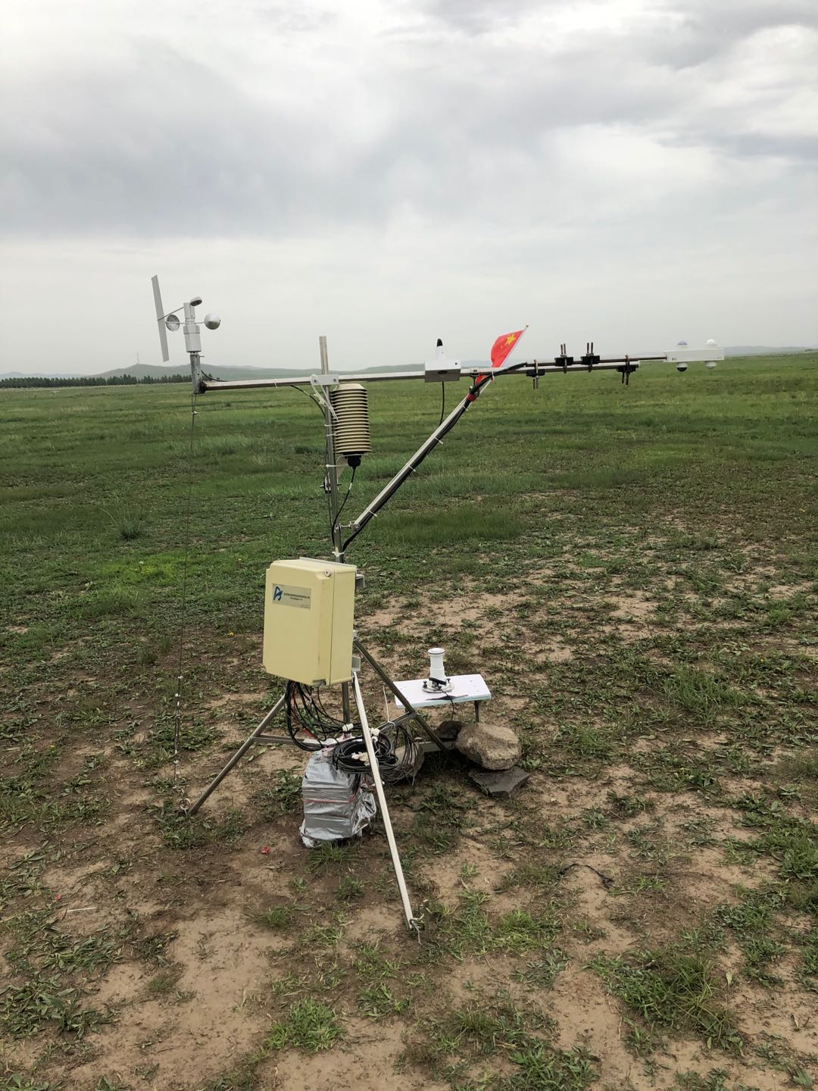

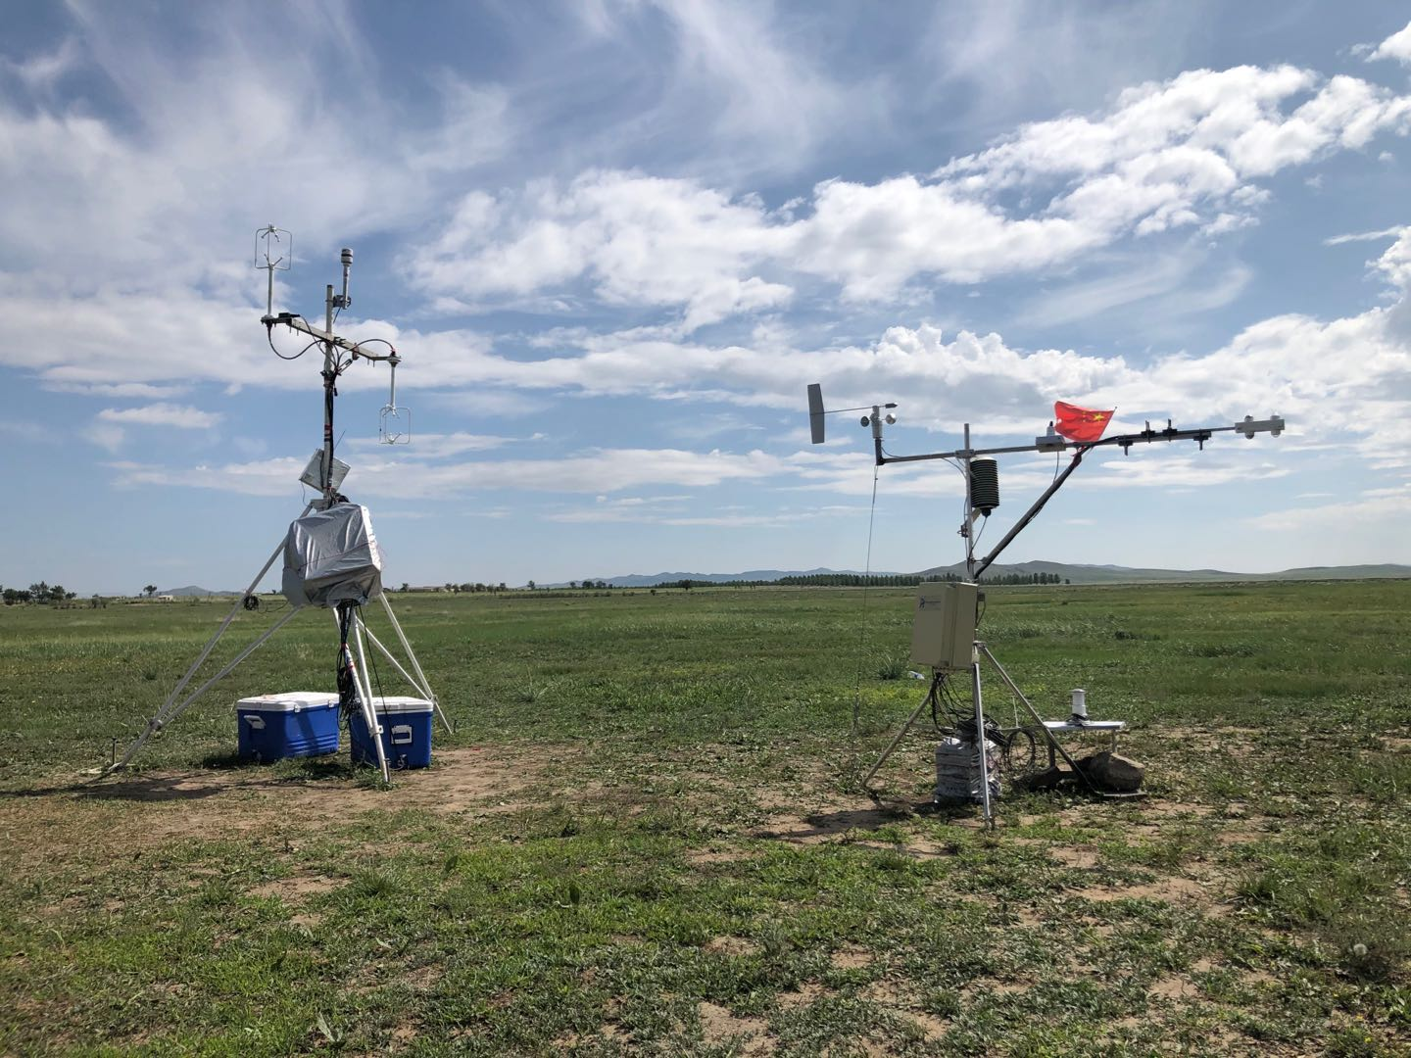

**Reference**

R. S. Gao, H. Telg, R. J. McLaughlin et al., 2016, A light-weight, high-sensitivity particle spectrometer forPM2.5 aerosol measurements. *Aerosol Science and Technology*. 50, NO. 1, 88–99. Doi: 10.1080/02786826.2015.1131809.

**Field site measurement**

In August of 2020, one intensive field campaign equipped with Unmanned Aerial Vehicle (UAV) was launched in Xilin Gol League, which is located in the flat aera in Northeast China. As shown in Fig. 1, the field measurement site (site A, 42°11′30″N, 114°56′38″E) was set up in a grassland area at the southern edge of Xilin Gol League on Zhengxiangbai Banner. Synchronous observation site (site B) was located at the northwest of site A about 500 m away. The surrounding area is mainly occupied by vast glassland and there are no residential or industrial areas from this field.

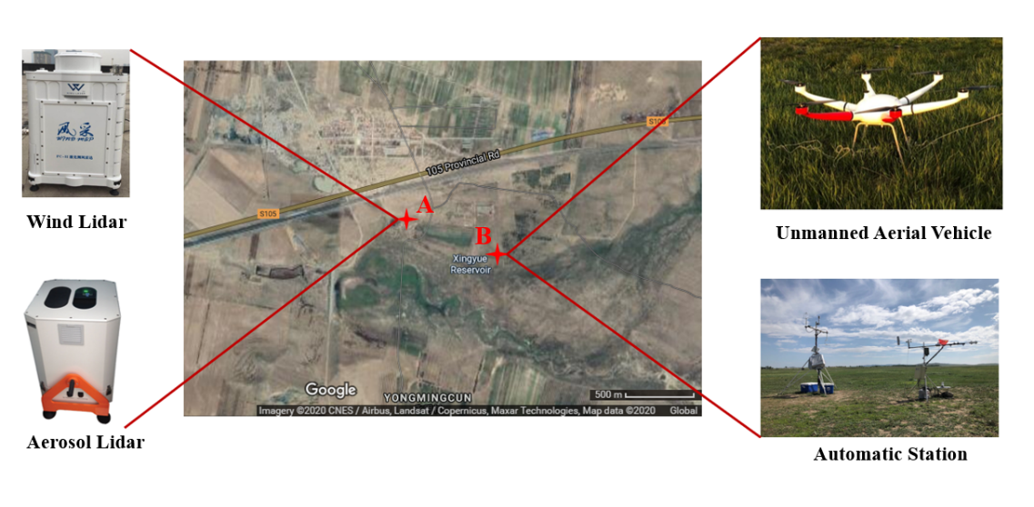

Fig. 1