1. Install python from [www.python.org](http://www.python.org) (I use python 3.7.9 but 3.8.x and 3.9.x should work too)

To check your installation, start windows command prompt by type “cmd“ in to the search box.

Then type python at dos prompt, you should see python starting.

1. Put the download files into a directory. Make sure you have subdirectory name transcripts to store grades and reports.
2. Login to reg.chula.ac.th and get the unofficial transcript. Highlight all text in the report and copy it (CTRL-C).

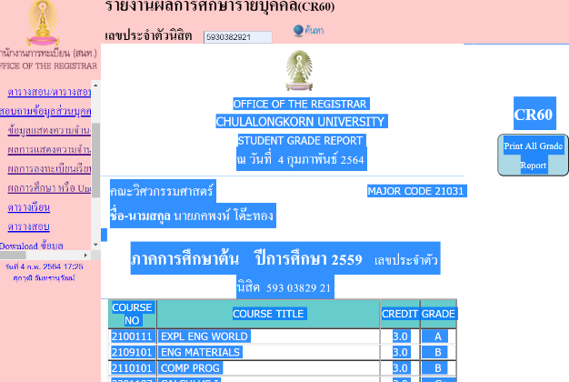

1. Paste into an empty file name ‘grade.txt’ in subdirectory ‘transcripts’. Save the file.
2. Run python program “1_grade_import.py” to import the grade and then “2_Graduation_Check.py” to check
3. To run python program you (see the picture below)
   1. Start the command prompt by type “cmd” in the search box
   2. Change current directory to the directory containing the two python scripts
   3. then type python 1_grade_import.py or python 2_Graduation_Check.py
   4. Or Start python first by typing python at the command prompt. Then in python interpreter type “exec(open('1_grade_import.py',encoding='UTF-8').read())” after the symbol “>>>” or “exec(open('2_Graduation_Check.py').read())” (Endcoding may be needed since the 1_grade_import.py contained thai characters)

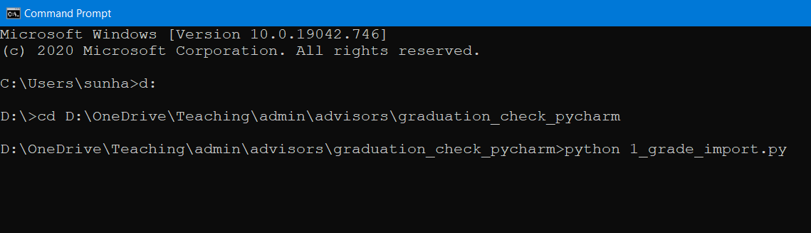

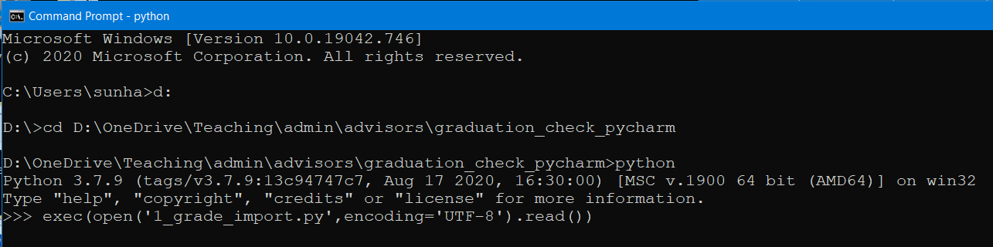

When you finish, the second method will exit out to python

1. For the file 1_grade_import.py, it will convert grades contained in “grade.txt” to <student id>.csv
2. For the file 2_graduation_check.py, you will need to input student id and program (ME59, AE59, etc) then the graduation check will start.
   1. All electives classes (Approves and Gen-Eds) can be marked as free electives by typing in the code at the beginning of its line.
   2. Type x to get a list of all missing required courses up to current semester.