**Annexure-01**

ADMIN

1. User permission set per module tab wise. Like:

**Asset**: 1. Add new Assets

2. View All Assets

3. Search/Report/View Assets

So permission set in every module created Tab Wise and ADD/EDIT/DELTE wise

EMPLOYEE:

1. “Project” dropdown list added in our new ERP: which have in our existing ERP (Please see below snapshot)

cid:image001.png@01D1746A.6AD51580

So please include this field in the report portion—DONE

2. One field reporting missing: in Advance search option Multiple IDs field missing:

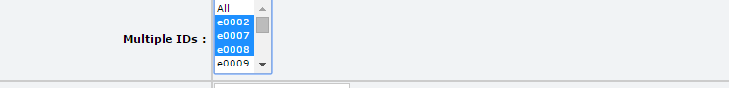

After selection multiple employee ID and search---DONE

3. Employee REJOIN option match with Leave, Attendance and must show on AAB history. -**CHECK?**

4. Non Staff also shown in the front notification panel/Dashboard (Which exits in our old erp system): **PENDING AND DONE?**

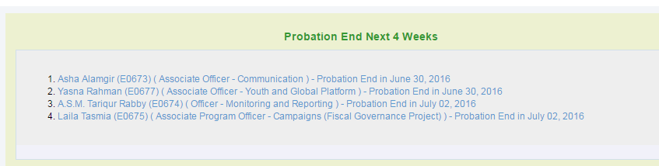

5. Individual Profile Printed option set to exact alignment. DONE

6. Staff Movement Edit option- Could be edit all field**— (Movement Type, Employee Type, Employee Term, Salary Grade, Salary Steps, Level)** DONE

7. All Report checking- **EMPLOYEE UP TO ERROR ON REPORT CHECK?**

8. Employee Print View (PDF VIEW) option should be match and printed. DONE

9. In any employee view option some of fields missing: please see below existing erp snapshot

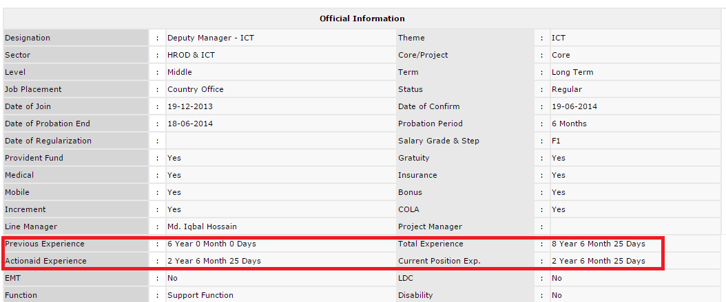

* Previous Experience- shown from Employee DB-DONE
* ActionAid Experience- Total ActionAid Experience (from Joining Date) DONE
* Total Experience- Previous+ ActionAid-DONE
* Current Position Experience- Current position (Always check vertical movement if any changes) hold how many year, month and days. **SHOWN BUT NOT CORRECT, HERE SHOULD BE SHOW IN LAST PROMOTION RANGE(Vertical Movement)**

10. Create Staff Movement field- Show the Assigned Project Dropdown field after Strategic Priorities DONE

11. Employee Report- Employee Up to Error report shown: **ERROR SHOWN ON REPORT**

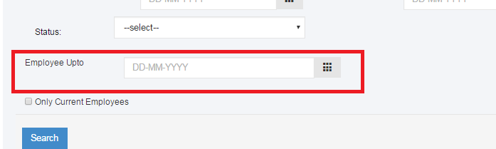

12. In View any employee- Date of Probation end and Probation period data did not show: DONE

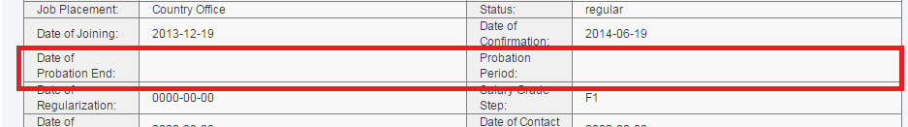

13. Excel Download Error Report (Report and Advance Report)—**ERROR (NOT YET DOWNLOADED AND PREVIOUSLY WHOLE EMPLOYEE DOWNLOADED)**

**** OVERALEL DESIGN(CSS) Works will be mentioned after fixing the issues. ******

13. Staff Movement report/Edit- Theme/Unit change with Directorate and Sector change with Strategic Priorities: DONE

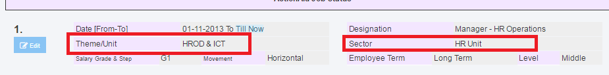

14. In Employee View option- Function (Professional Infor) did not show on the view form DONE

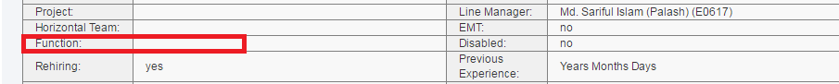

15. In Employee View option- below these field are not shown on the form **NOT EXACT**

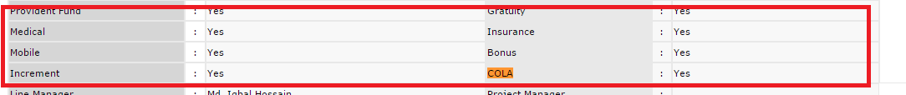

16. Staff Movement- Create Staff Movement Employee Type Change with below snapshot: **PENDING**

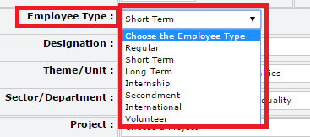

Only show a) Regular b) Short Term c) Long Term

17. In Employee View Option Age calculation did not shown whereas Date of Birth is given in DB—**DONE**

18. In Employee View option- Nominee Information Mobile/Phone will be replaced with Date of Birth and the is no share (Percentage) information DONE

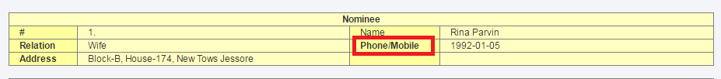

19. Employee View Form- Education does not shown **DONE**

20. Staff Movement- Duties not shown in report format (Staff movement view and AAB job status). **DONE**

21. Employee View Form-In Personal Information-Not shown (Marital Status, Mobile No2, Personal Email, Alternate email, Land Phone, Skype, Academic Background) DONE

22. Employee View Form-General Info/Official Information- Change Sector and Theme with Directorate and Strategic Priorities/Operational Priorities) DONE

23. Employee View Form-Change some text- Small letter in first character (Level: middle, Core/Project: project, Status: contract, EMT: yes, Disable: no, Rehiring: yes), Remove underscore (Term: long_term). Where find first Character in small letter it will change Capital Letter and remove underscore if any. DONE

24. All date format should be **Day-Month-Year. DONE**

25. Report- After export excel Employee ID (EMP ID) should be separate left column of employee name and also serial number shown (please see existing erp excel download) **ERROR SHOWN**

26. Any criteria set on search option these criteria must be shown and exist after search completion (Please see existing erp report) **PENDING**

27. “Duties” not shown in Staff movement (ActionAid Job Status) and employee view form. DONE

28. advance search- Project Sramik show two but redirect other users- DONE

29. Non-Staff Issue

* Date of Joining and Date of Contract end not saved after submit PENDING
* Strategic Priority/Operational Priority, Directorate and Assigned Project set in official information with Ajax searchable. DONE
* Mobile Number Field Create in Personal Information **PENDING**
* When edit any non-staff form it will show staff form (Whole Information), it will show only non-staff form fields. **PENDING**

Assets

1. Assets Warranty issue check- in View any asset the warranty from and to not shown:

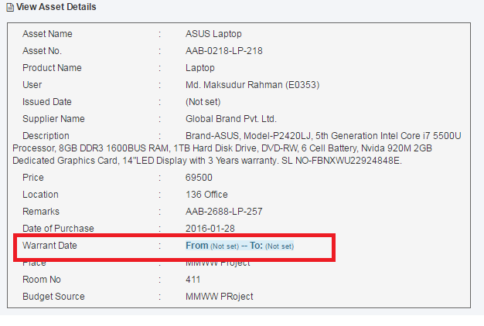

2. Add New Assets- Supplier tab always shows Global Brand Pvt. Ltd, blank shown:

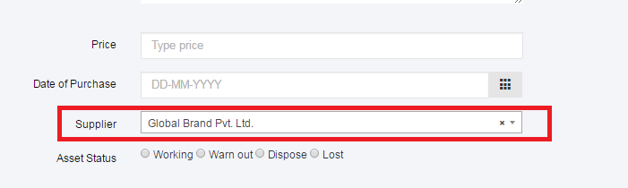

3. In excel export Issue date and Warranty date not exported option:

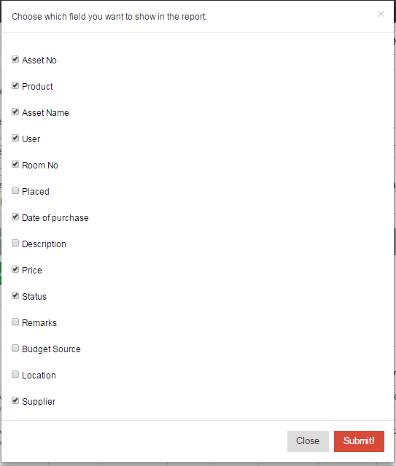

4. Reporting: From Date and To Date is not perfect reporting shown

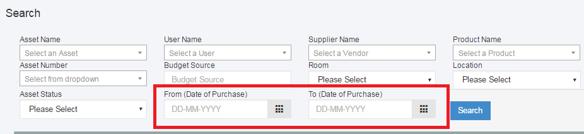

5. Reporting: Budget Source Field should be match with Location field: In Add Assets location is a text box and where we set type any value the value will shift to dropdown in reporting

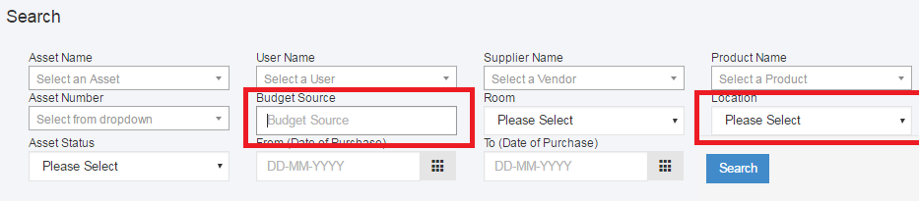

6. Title Changed Report instead of Search

7. After search any criteria the criteria will not set on searching criteria

1. Supplier View Option should be align like Asset view option: when print this is exact shown on View Asstes sample snapshot:

SUPPLIER

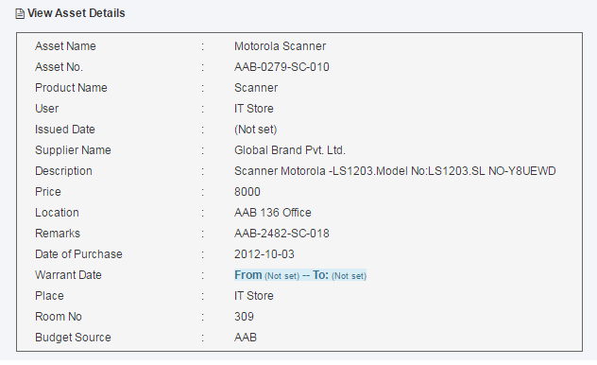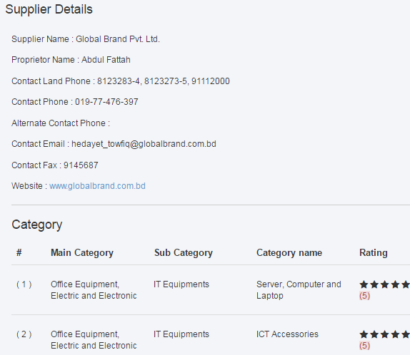

2. Search/Report/View All Assets: When normal users are login in to the supplier and when click on search/report/view all they are not able to edit/delete operation only View option are enable:

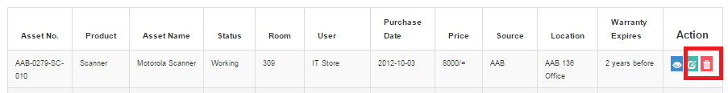

3. In Excel Export (Anywhere): all fields should be shown in pop up menu:

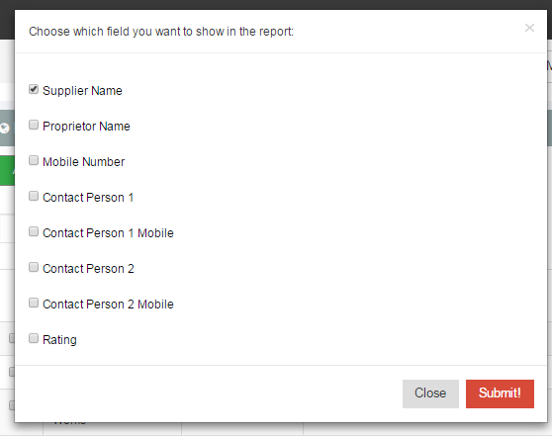

APPRAISAL

**\*\*\* First please Error free on existing report and functioning---**

1. Part-1: “Total Service Length at AAB” set automatically. —We Employee Database updated so now this value should come from Employee DB

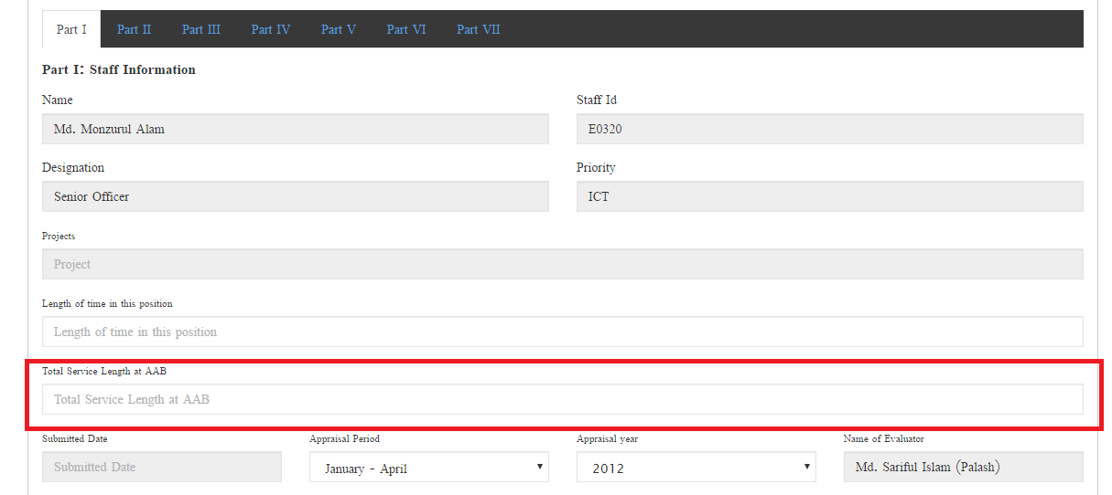

2. **“Submit to Line Manager”** button shift to right in every part of annual and periodic form:

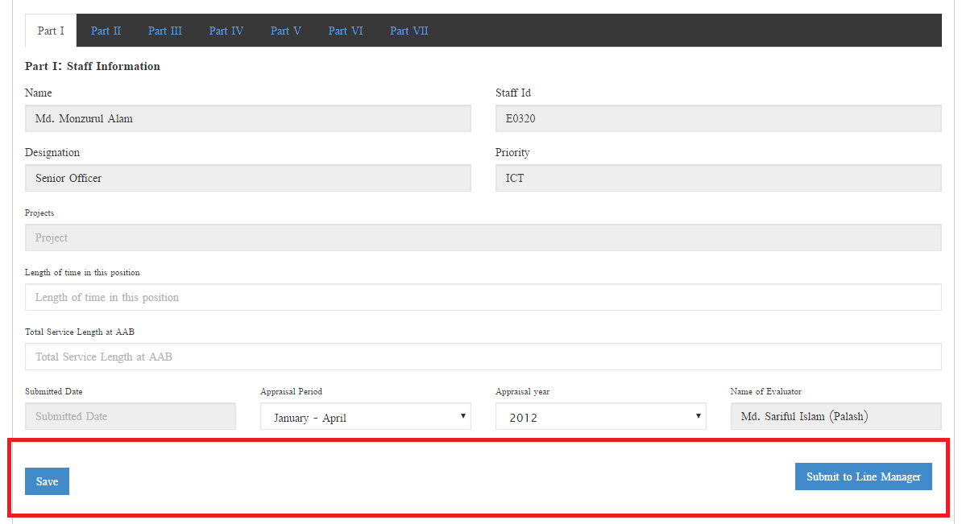

3. Appraisal period set condition: if click January-April and click Year: 2016 then part 2 automatically set of September-December, 2015 appraisal part-VII:

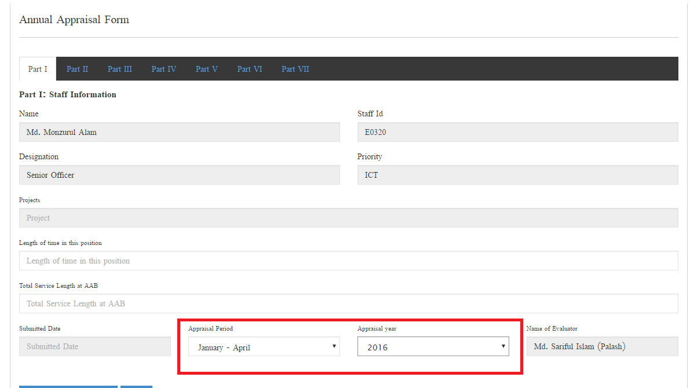

4. Line manager marking time Part-II Add option open, please remove Add option:

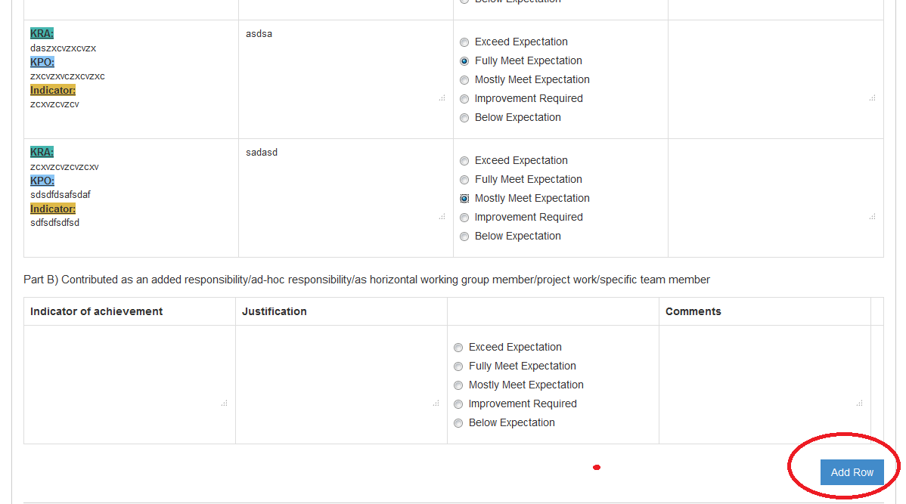

5. One row is missed when submitting the document in Part-III: Please add one row option in Part-III (Annual, Periodic) “**Green Initiative / Action / Practices**: Person has contributed on organization’s mandate on Green initiative.”

6. PDF /Doc exporting

7. Some text mentioned on Part-II & Part-IV and mandatory field:

In part-II: “**Weightage: Part A-80%, Part B-20%”**

In Part-IV: “**Weightage**: **Part II-60%, Part III-40%” (If possible fixed it)**

* Weightage fields are not exceeds 100%. E.g: If 1st one type 80 second one is must 20
* 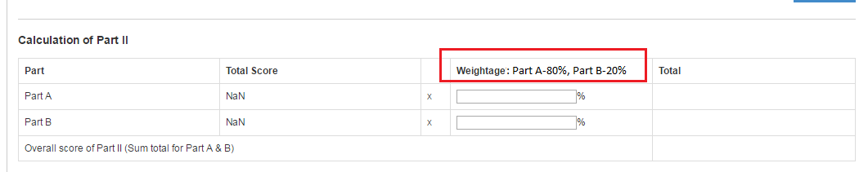
* 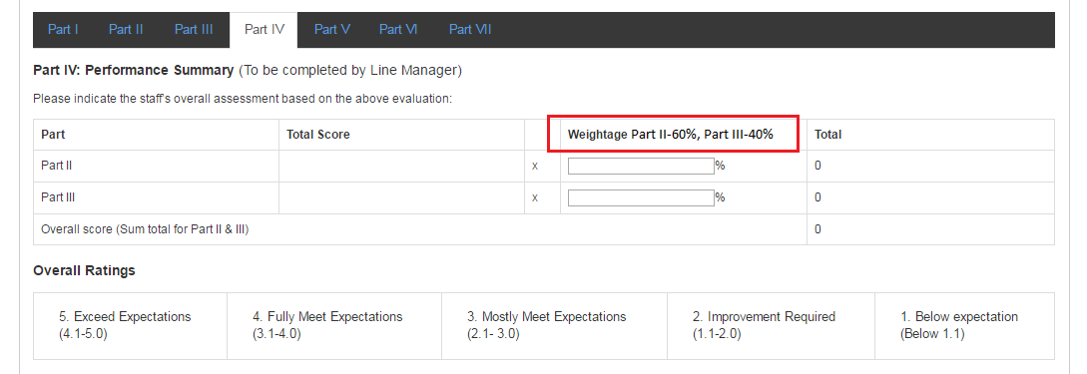

8. In Part II please rearrange the table format after getting value

9. Annual Form Part-VII Corrected both place same

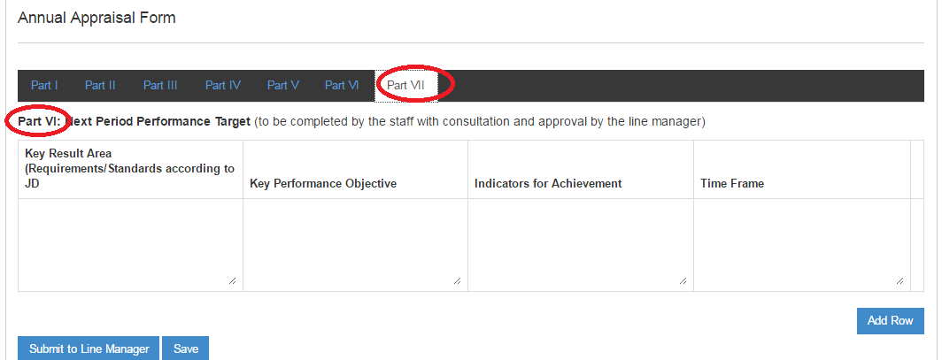

11. Replace text “Send to Emplyee Review” button with “Send to Employee” see below:

**Send to Employee**

(for any Comments)

12. Mandatory fields in last part (Annual + Periodic).

13. If line manager add something this portion will change color when subordinate review:

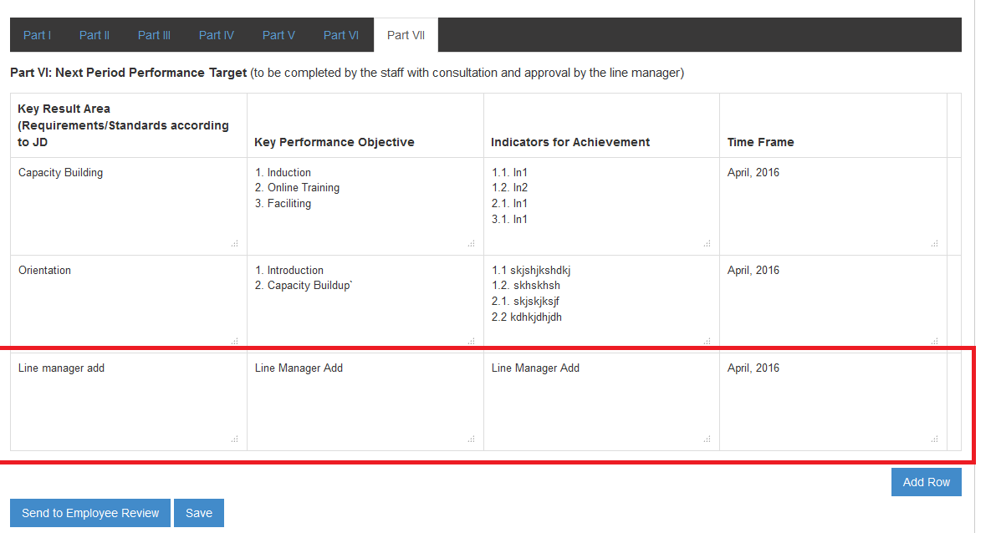

14. After review from Line manager, if any changes happened by subordinate it would not submit to HR. Again it should be verified by Line manager and changed portion are shown a different color:

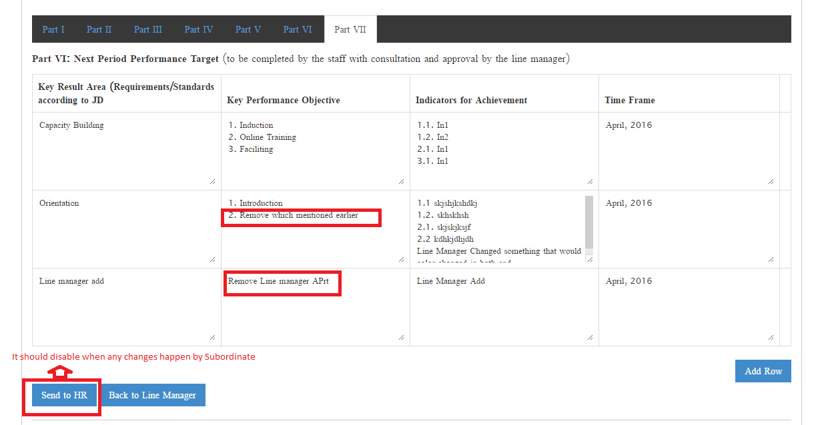

15. If there is an edit option so need to SAVE option in that position (After Line manager review the employee edit something)

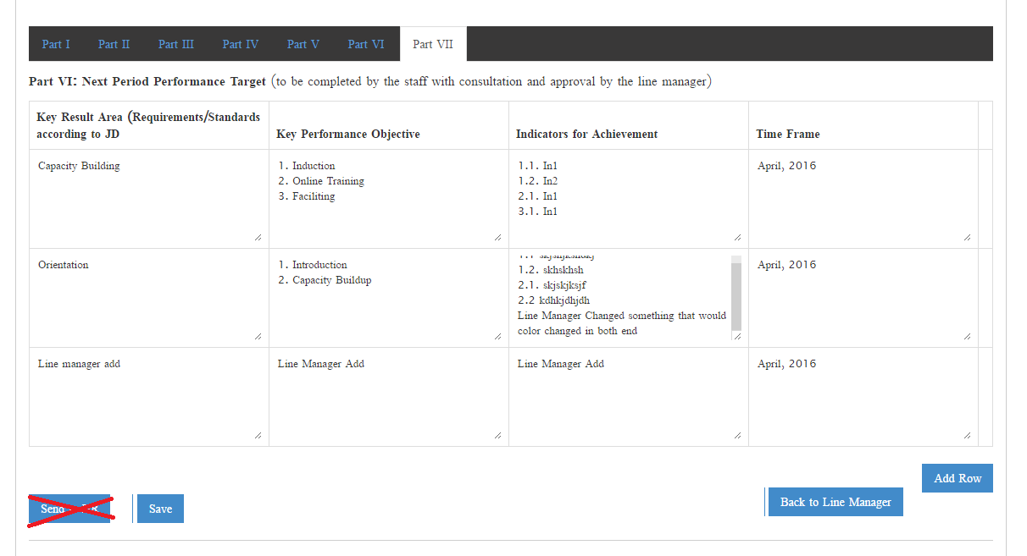

16. If save any appraisal (Last part-Target) then after open save appraisal the row will not deleted option:

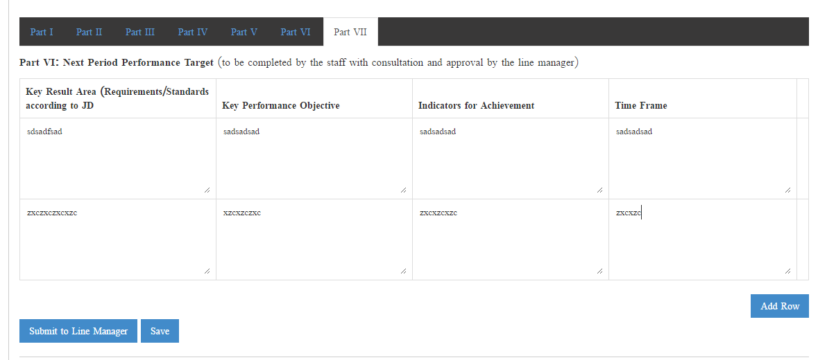

17. Email Notification.

18. Existing Reporting and more 3 reporting should be error free

19. Employee Add row option Part-II when Employee mentioned justification:

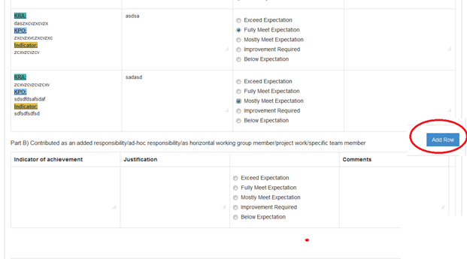

20. Annual Form-Part-V-Outcome of Performance Appraisal part, if line manager can select anyone the popup text box will appear and line manager will fillup the justification:

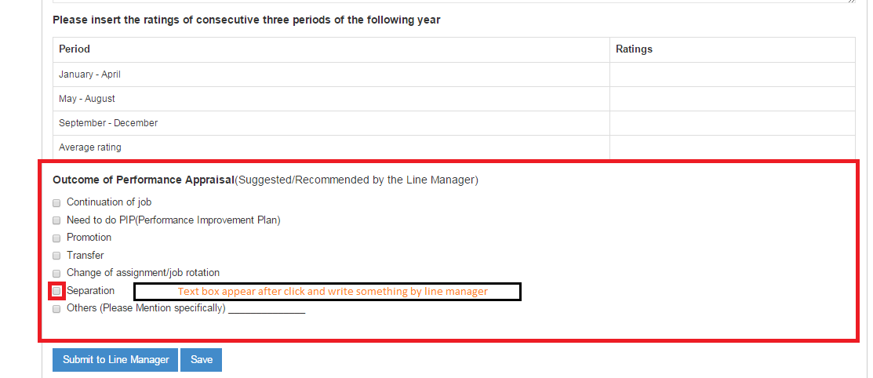

Add above this in part-III as a new row

**20. Reporting:**

1. List of Increment- To find out previous year increment list

**Search Option:**

|  |  |
| --- | --- |
| **Year** | Drop Down |
| **Quarter** | Drop Down (Q1/Q2/Q3) |
| **Status** | Increment Not Increment |

After select the above criteria below chart are generate:

|  |  |  |  |
| --- | --- | --- | --- |
| **ID** | **Name** | **Designation** | **Department** |
| E0617 | Md. Sariful Islam | Deputy Manager | ICT |
| E0627 | Abdul Koddus | Program Officer | RCB Project |

1. Outcome of Performance Appraisal List (Part-V)- Part-V in last portion which is “Outcome of Performance Appraisal (Suggested/Recommended by the Line Manager)” to generate a chart:

**Search Option:**

|  |  |
| --- | --- |
| **Year** | Drop Down |
| **Quarter** | Drop Down (Q1/Q2/Q3) |
| **Outcome of Performance Appraisal** | Drop Down (Where all options to be there including All) |

After select the above criteria below chart are generate:

|  |  |  |  |  |  |  |  |
| --- | --- | --- | --- | --- | --- | --- | --- |
| **SL** | **Name** | **Designation** | **Q1 Rating** | **Q2 Rating** | **Q3 Rating** | **Annual Rating** | **Outcome** |
| 01 |  |  |  |  |  |  | Seperation |
| 02 |  |  |  |  |  |  | Promotion |

1. Promotion Proposal Report-

|  |  |  |  |  |  |  |  |  |
| --- | --- | --- | --- | --- | --- | --- | --- | --- |
| **SL#** | **Name** | **Date of Joining** | **Total Year of Exp. (AAB)** | **Total Year of Exp. In this position** | **Education (Last 2)** | **Last Max 3 Years Annual Rating** | **Proposed Promotion previous year’s** | **SLT Consent** |
|  |  |  |  |  |  |  |  |  |

* Total year of Experience in this position- which is calculated by Grade
* Education- Recent Last two education will be shown here
* Last Max 3 years Annual Rating- Last maximum 3 years annual rating, if anyone have not 3 years there is a rest of year annual rating should be there
* Proposed Promotion Previous year-If previously proposed this person as a promotion but may not entitle so there is a shown record which year/quarter proposed as a promotion.
* SLT Consent- There is a decision when will be promotion effective, so this field set as a date format. If we set a specific date in specific person’s that will be shown in dashboard for reminding us.

RECRUITMENT

1. Restriction [offline]- Restriction Mechanism set after SAVE /Email (admin user Only edit/changes)-already talked with Abrar Bhai reference with our last occurrence.
2. After filter applicants[Offline] and shortlisted applicants- Top of the table shown number of applicants (How many applicants)

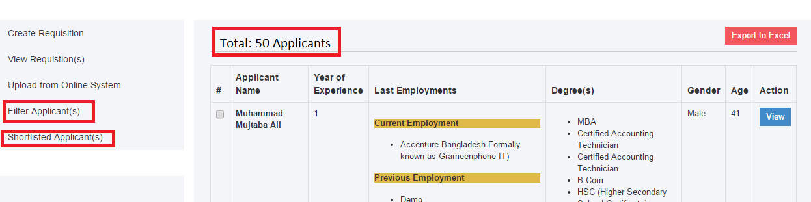

1. Same as shortlisted applicants:

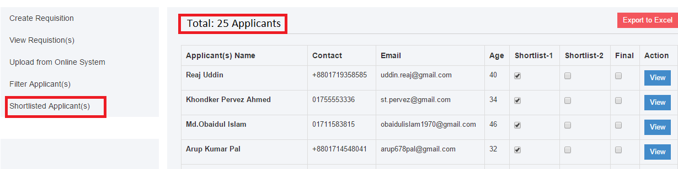

1. In CV view option [offline]- Training/Workshop panel showed zero and empty values:

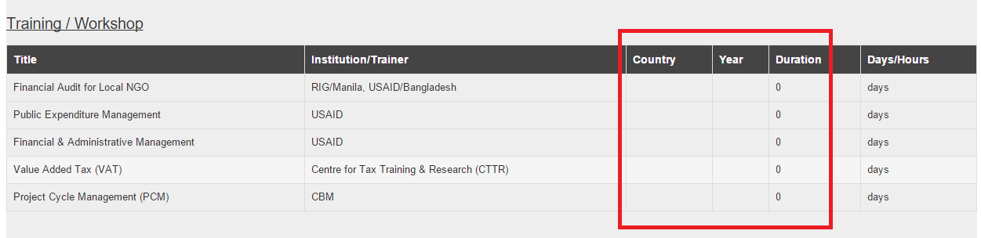

1. Filter Applicant [Offline]- Use Multiple Email Address option.
2. View Requisition[Offline]- table show actual position name instead of department.
3. Filter Applicants & Shortlisted applicants[Offline]- Show the number of applicants and selected post in top of the table:

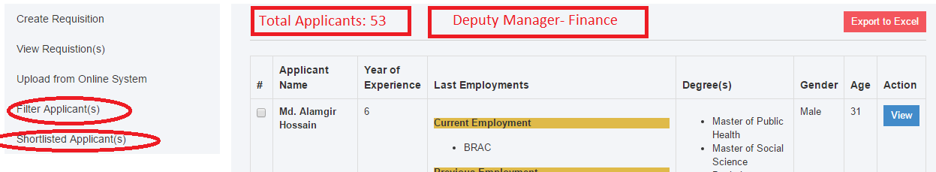

And

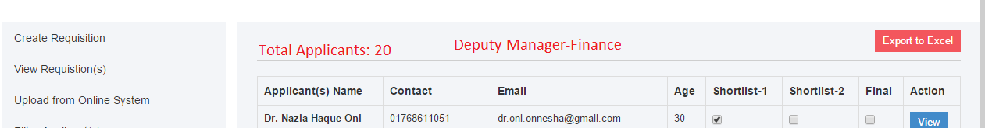

1. CV View [Offline]- Shown error on training/’workshop table: Missing Country , Year and duration shown zero value.

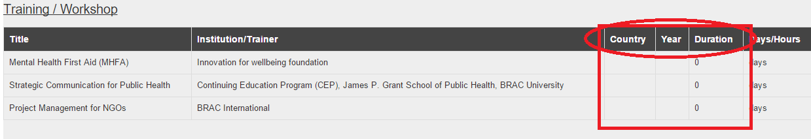

1. Date of Birth field [Online]- required filed and default it’s mm-dd-yyyyy. Applicants without fill-up this field they can’t apply .

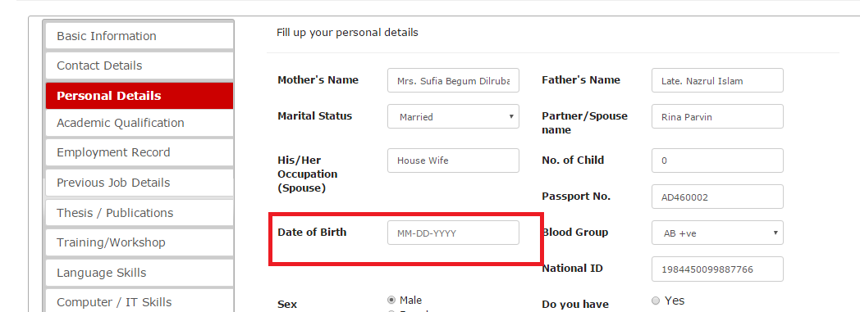

1. Reference [Online]- Mandatory Reference 1 and Reference 2 field. Without these applicant can’t apply.

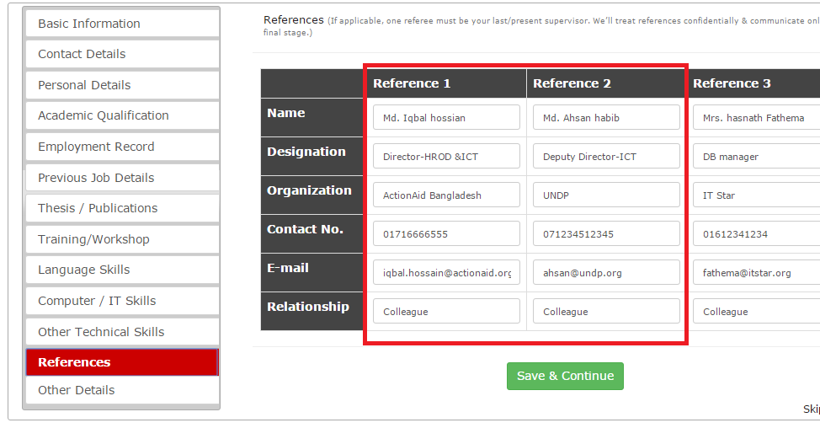

1. Previous Job Details [Online]- Date field year increase, there is a only 2006, increase to 1970.
2. Previous Job Details [Online]- Previous job details have contact field but when view CV contact field not shown, and also this is not showed in offline CV View.
3. Language skill [Online] field mandatory- Without this the applicant can’t apply.
4. PDF alignment-export pdf alignment

FINANCE

1. After check and identified bug if any

2. DD and BFTN form design

3. Reporting

**** OVERALEL DESIGN(CSS) Works will be mentioned after fixing the issues. ******

LEAVE

1. Submit button- After one click on the submit button the button will hide or second time submit not applicable during leave process time.

2. Leave notification on mail should be squeeze and one-page viewable format.

3. Leave Edit/delete option before approved

4. Employee Rejoin will not have calculated with leave automatically

5. 0.5 Leave not calculated automatically.

6. Outstation Report fully pending

7. Outstation Submit button should be restricted by one click- same as Leave Submit button

8. Outstation To (Date) Should be mandatory field

9. Leave Report- Date wise report should be formative, it looks employee wise and mentioned dated report only. And How many people are stay in office or leave from office during timeline it should be at-a-glance report generation.

10. Leave Report- Department wise leave report generate.

CONSULTANT:

1. In Consultant Edit option- Key expert area and ranking does not set which previously added
2. In Consultant Edit option- Email field have set ["[moinulcseduet@gmail.com](mailto:moinulcseduet@gmail.com)"] please correct this.
3. In Consultancy Edit Option- Key expert area have not set permanently
4. Report-PDF Export option please align with the form
5. Report- Email Address alignment set
6. Consultant At-A-Glance in dashboard
7. Consultancy Entry Form- Evaluation Report field missing

|  |  |  |
| --- | --- | --- |
| 2.12 | Evaluation Report: | Mark shown *[Receive-3.8]* + PDF View option *[Receive-2.27]* |

Because of “Evaluation form” not yet done so right now you only set a text box where we entry manually. After completion “Evaluation Form” the value will come automatically.

1. By Consultant-In View there is an EXPORT PDF option:

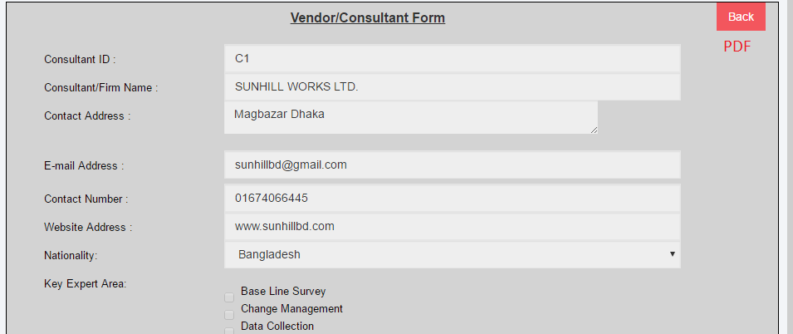

1. By Consultant- Export Excel- Option to all field there which entry form:

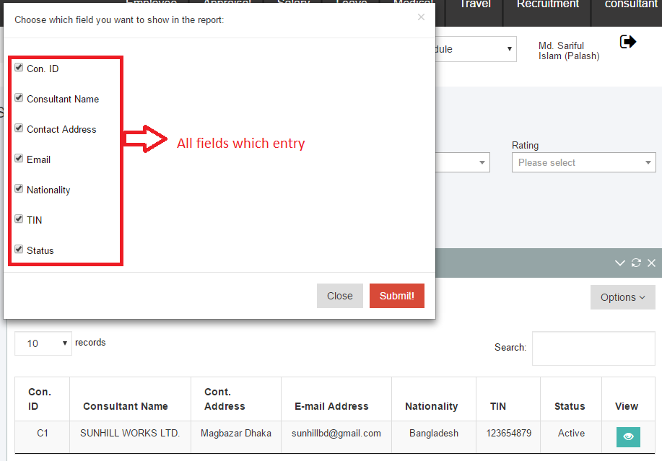

1. By Consultancy- Two Fields are added to search criteria: Dep/SP/Project: and Date From and To:

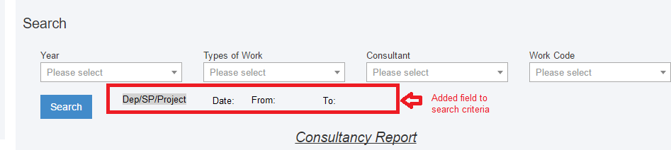

11. PDF export should be formatting with the forms.

12. By Consultancy- Export Excel- Option to all field there which entry form:

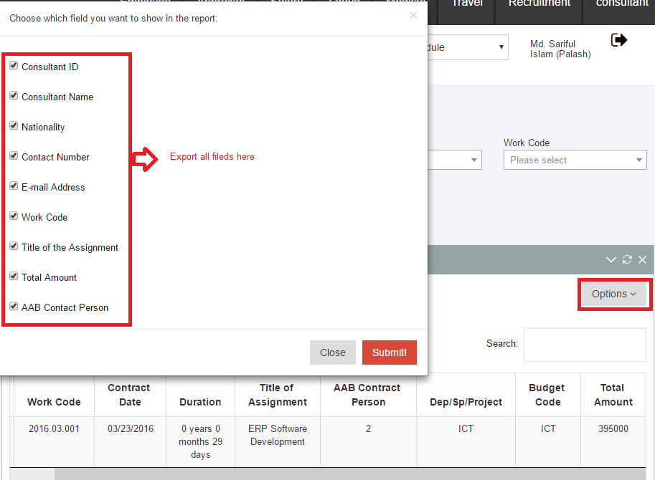

MEDICAL

1. Get an Medical Application Form-
   1. Title Text should be White:

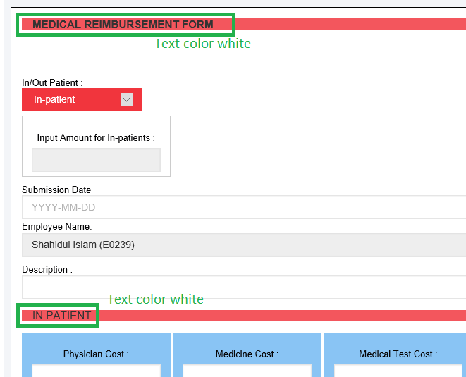

* 1. Float value didn’t receive in the amount box: Integer and float value exist

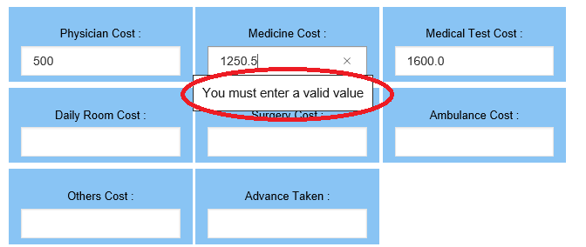

c. After completion the form user can print this form from their port and the form should align.

1. Report and Medical Report (Individual Users portal)-
   1. Total Reimbursement not shown which is existing medical module have:
   2. After Search Employee Name and Designation have in the top:

Existing:

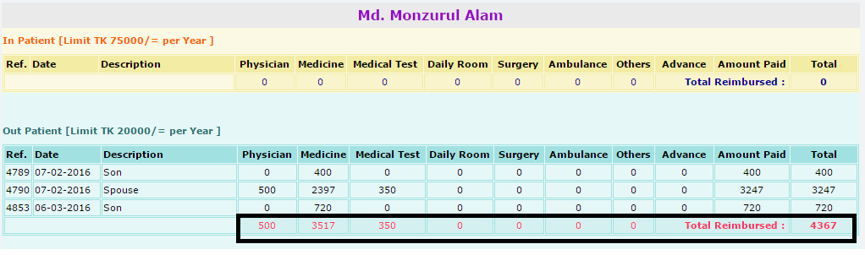

1. Export Excel also shown the title of Name of Employee and Designation
2. Edit/Delete option from admin panel- If any users submit wrong medical bill, it would be edit/delete from admin portal after search or report this users. Which only admin panel have: Also print this form from admin

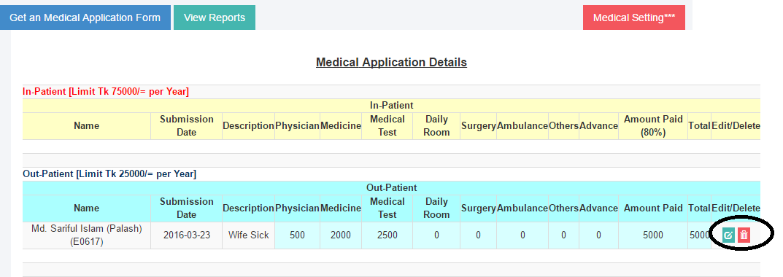

1. Report-All Employee: After search any criteria title should be in top of the field:

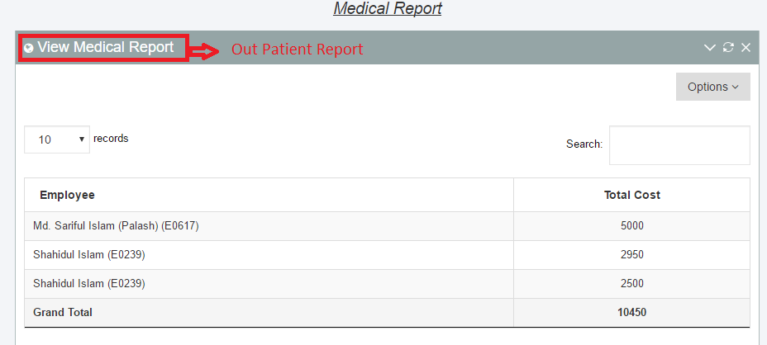

Also excel download on top of the title should be there.

Travel

FULLY PENDING-NEED TO DISCUSS and FIX IT

**** OVERALEL DESIGN(CSS) Works will be mentioned after fixing the issues. ******

ATTENDANCE

1. To more easier to shift assign on employee/volunteer/intern/etc.. **DONE**

First differentiate Staff (Employee) and non-staff(Volunter/Fellow/Intern/etc..) and there is a search option to find and easily select:

**Empoloyee**: **Non Staff:**

Search

Search

□ Md. Sariful Islam(E0617) □ Md. Murad(V0617)

□ Md. Asad(E0628) □ Md. Saiful(I0628)

1. **Attendance Report: DONE**
   1. **DAILY REPORT/Periodic/Job Card:** TotalFive Criteria are included in the all reports:
2. All Employee
3. Particular Employee
4. Directorate
5. Strategic Priority
6. Project
7. Designation

** Particular Employee:

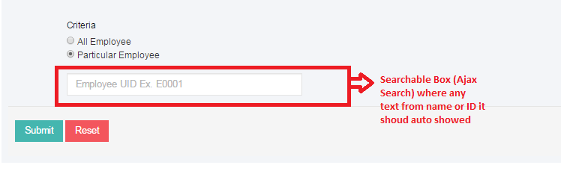

**** Late consideration set but in report there is no implication.

* 1. After search any criteria the report format should be align: **DONE**

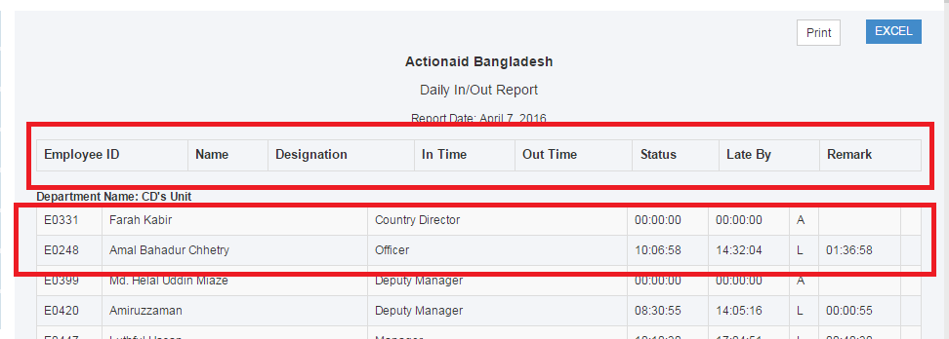

* 1. After set criteria there is a option to generate report only employee or non-staff separately. PENDING
  2. All report currently merges with Leave system and should be merge with outstation which you found in the leave module. **DONE**
  3. If anyone take leave but line manager not approved leave that scenario attendance record will show LEAVE. Please check it. **NOT CHECKED**
  4. Periodic report (In-Out) should be match with Daily(In-Out) report.
  5. Staff and Non-Staff report should be separate PENDING

*** Excel Export Report timing should be quick and faster. **DOUBT**

As per conversation you please assign Visitor ID coding in the ERP: **NOT CHECKED**

|  |  |  |
| --- | --- | --- |
| **Name** | **Starts** | **Value** |
| Visitor | R | 18 |

Also please change some points below:

1. Particular Department change with **“Particular Strategic Priority”** and assign dropdown value from employee database (Strategic Priorities dropdown) **DONE**
2. “Particular Project” dropdown value change with Assigned Project dropdown(Employee Database). Now it’s marge with Project Details dropdown **DONE**
3. Create an extra dropdown **“Particular Directorate”** in the report category field and came value from Employee database (Directorate dropdown). **DONE**

**** OVERALEL DESIGN(CSS) Works will be mentioned after fixing the issues. ******

**\*\*\* All Report (Every Individual Module) Button should be BUTTON instead of text link**