# 1 音频基础

OSS和ALSA两种驱动框架，linux下目前使用ALSA.

ALSA包括软件框架和硬件操作

双通道数据记录是交替的，。

wav文件格式：

头部和数据两部分。

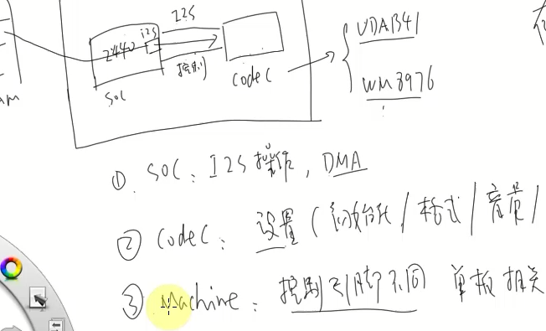

# 2 ALSA驱动框架分析(3.4.2内核)

sound/core/sound.c

与应用层接口

alsa_sound_init(void)

register_chrdev(major, "alsa", &snd_fops)

static const struct file_operations snd_fops = {

.owner = THIS_MODULE,

.open = snd_open,

.llseek = noop_llseek,

};

snd_open(struct inode *inode, struct file *file)//通用的open接口函数

mptr = snd_minors[minor];

file->f_op = fops_get(mptr->f_ops);

file->f_op->open(inode, file);

何处注册了snd_minors？

snd_minors结构体定义如下

static struct snd_minor *snd_minors[SNDRV_OS_MINORS];

从snd_minors数组中取出一个结构体。该结构体在哪里注册呢？从static定义知道结构体在本文件中，高亮snd_minors（F8）在本文件查找。找到注册地方

snd_register_device_for_dev（）

snd_minors[minor] = preg;

struct snd_minor {

int type; /* SNDRV_DEVICE_TYPE_XXX */

int card; /* card number */

int device; /* device number */

const struct file_operations *f_ops; /* file operations */

void *private_data; /* private data for f_ops->open */

struct device *dev; /* device for sysfs */

struct snd_card *card_ptr; /* assigned card instance */

};

snd_register_device_for_dev（）由谁调用？

一共有两处

sound/core.h里面的snd_register_device()创建声卡设备的控制接口

sound/core/pcm.c里面的snd_pcm_dev_register(struct snd_device *device)

创建声卡设备的数据流接口

分析sound/core.h分支，创建声卡设备的控制接口

snd_register_device()由谁调用？

sound/core/control.c里面的函数snd_ctl_dev_register（）调用

static int snd_ctl_dev_register(struct snd_device *device)

snd_register_device（）

snd_ctl_dev_register（）由snd_ctl_create（）函数设置

int snd_ctl_create(struct snd_card *card)

{

static struct snd_device_ops ops = {

.dev_free = snd_ctl_dev_free,

.dev_register = snd_ctl_dev_register,

.dev_disconnect = snd_ctl_dev_disconnect,

};

return snd_device_new(card, SNDRV_DEV_CONTROL, card, &ops);

}

snd_ctl_create由init.c (sound\core)里面的snd_card_create()函数调用

snd_ctl_create在特定的声卡文件里面调用

分析sound/core/pcm.c 创建声卡设备的数据流接口

static int snd_pcm_dev_register(struct snd_device *device)

snd_pcm_dev_register（）由_snd_pcm_new（）调用

static int _snd_pcm_new(struct snd_card *card, const char *id, int device,

int playback_count, int capture_count, bool internal,

struct snd_pcm **rpcm)

🡪static struct snd_device_ops ops = {

.dev_free = snd_pcm_dev_free,

.dev_register = snd_pcm_dev_register,

.dev_disconnect = snd_pcm_dev_disconnect,

};

_snd_pcm_new 由snd_pcm_new调用的

int snd_pcm_new(struct snd_card *card, const char *id, int device,

int playback_count, int capture_count, struct snd_pcm **rpcm)

{

return _snd_pcm_new(card, id, device, playback_count, capture_count,

false, rpcm);

}

snd_pcm_new 是由具体的声卡驱动调用的

由分析知道一个声卡要创建至少两种逻辑设备一个是控制设备，一个是数据流设备。

分别由snd_ctl_create（）和snd_pcm_new（）设置

分析snd_ctl_create流程

snd_ctl_create

.dev_register = snd_ctl_dev_register,

snd_device_new(card, SNDRV_DEV_CONTROL, card, &ops);

snd_device_new（）最终会导致snd_ctl_dev_register被调用

snd_ctl_dev_register(struct snd_device*device)

sprintf(name, "controlC%i", cardnum);//创建的控制设备的名字

snd_register_device(SNDRV_DEVICE_TYPE_CONTROL, card, -1,

&snd_ctl_f_ops, card, name))

int snd_register_device_for_dev(int type, struct snd_card *card, int dev,

const struct file_operations *f_ops,

void *private_data,

const char *name, struct device *device)

preg = kmalloc(sizeof *preg, GFP_KERNEL);

preg->type = type;

preg->card = card ? card->number : -1;

preg->device = dev;

preg->f_ops = f_ops;

preg->private_data = private_data;

snd_minors[minor] = preg;

preg->dev = device_create(sound_class, device, MKDEV(major, minor),

private_data, "%s", name);

static const struct file_operations snd_ctl_f_ops =

{

.owner = THIS_MODULE,

.read = snd_ctl_read,

.open = snd_ctl_open,

.release = snd_ctl_release,

.llseek = no_llseek,

.poll = snd_ctl_poll,

.unlocked_ioctl = snd_ctl_ioctl,

.compat_ioctl = snd_ctl_ioctl_compat,

.fasync = snd_ctl_fasync,

};

分析snd_pcm_new流程

int snd_pcm_new(struct snd_card *card, const char *id, int device,

int playback_count, int capture_count, struct snd_pcm **rpcm)

_snd_pcm_new(card, id, device, playback_count, capture_count,

false, rpcm);

.dev_register = snd_pcm_dev_register,

snd_device_new(card, SNDRV_DEV_PCM, pcm, &ops))

snd_device_new（）会导致snd_pcm_dev_register（）被调用

snd_pcm_dev_register（）

switch (cidx) {

case SNDRV_PCM_STREAM_PLAYBACK:

//播放设备名字

sprintf(str, "pcmC%iD%ip", pcm->card->number, pcm->device);

devtype = SNDRV_DEVICE_TYPE_PCM_PLAYBACK;

break;

case SNDRV_PCM_STREAM_CAPTURE:

//录音设备的名字

sprintf(str, "pcmC%iD%ic", pcm->card->number, pcm->device);

devtype = SNDRV_DEVICE_TYPE_PCM_CAPTURE;

break;

}

for (cidx = 0; cidx < 2; cidx++) //注册两个设备一个播放设备一个录音设备

snd_register_device_for_dev(devtype, pcm->card,

pcm->device,

&snd_pcm_f_ops[cidx],

pcm, str, dev);

preg = kmalloc(sizeof *preg, GFP_KERNEL);

preg->type = type;

preg->card = card ? card->number : -1;

preg->device = dev;

preg->f_ops = f_ops;

preg->private_data = private_data;

snd_minors[minor] = preg;

preg->dev = device_create(sound_class, device, MKDEV(major, minor),

private_data, "%s", name);

const struct file_operations snd_pcm_f_ops[2] = {

{

.owner = THIS_MODULE,

.write = snd_pcm_write,

.aio_write = snd_pcm_aio_write,

.open = snd_pcm_playback_open,

.release = snd_pcm_release,

.llseek = no_llseek,

.poll = snd_pcm_playback_poll,

.unlocked_ioctl = snd_pcm_playback_ioctl,

.compat_ioctl = snd_pcm_ioctl_compat,

.mmap = snd_pcm_mmap,

.fasync = snd_pcm_fasync,

.get_unmapped_area = snd_pcm_get_unmapped_area,

},

{

.owner = THIS_MODULE,

.read = snd_pcm_read,

.aio_read = snd_pcm_aio_read,

.open = snd_pcm_capture_open,

.release = snd_pcm_release,

.llseek = no_llseek,

.poll = snd_pcm_capture_poll,

.unlocked_ioctl = snd_pcm_capture_ioctl,

.compat_ioctl = snd_pcm_ioctl_compat,

.mmap = snd_pcm_mmap,

.fasync = snd_pcm_fasync,

.get_unmapped_area = snd_pcm_get_unmapped_area,

}

};

何处创建设备类

根据device_create(sound_class, device, MKDEV(major, minor),private_data, "%s", name);可知是在sound_class类下面创建的设备，何处创建？

搜索sound_class找到如下

init_soundcore in sound_core.c (sound) : \

sound_class = class_create(THIS_MODULE, "sound");

init_soundcore(void) //soundcore.c

sound_class = class_create(THIS_MODULE, "sound");

创建的逻辑设备的名字和作用

|  |  |
| --- | --- |
| controlC0 -->  midiC0D0 -->  pcmC0D0c --〉  pcmC0D0p --〉  seq --〉  timer --〉 | 用于声卡的控制，例如通道选择，混音，麦克风的控制等 用于播放midi音频 用于录音的pcm设备 用于播放的pcm设备 音序器 定时器 |

怎么写ALSA声卡驱动

1. snd_crad_create
2. 初始化：创建逻辑设备

snd_pcm_new

1. snd_card_register

# 2 ASOC (ALSA system on chip)

这是声卡驱动的一个框架，分为三层

1. machine:单板相关的内容。抽象为snd_soc_card

表明platform是哪一个，cpu dai接口是哪个，DMA是哪一个

codec是哪一个 codec dai接口是哪一个

1. platform：

CPU DAI：设置接口snd_soc_dai_driver

DMA:传数

1. codec

DAI

控制接口

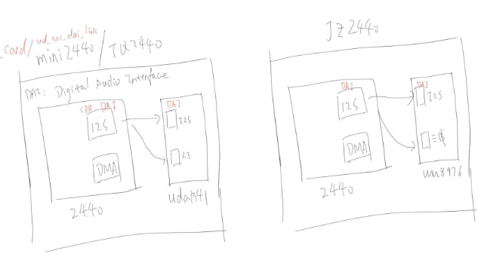

分析s3c2440的uda134x驱动

s3c24xx_uda134x.c

定义一个平台设备驱动

static struct platform_driver s3c24xx_uda134x_driver = {

.probe = s3c24xx_uda134x_probe,

.remove = s3c24xx_uda134x_remove,

.driver = {

.name = "s3c24xx_uda134x",

.owner = THIS_MODULE,

},

};

module_platform_driver(s3c24xx_uda134x_driver);//注册驱动

查找平台设备

搜索"s3c24xx_uda134x"

在mach-mini2440.c中找到

static struct platform_device mini2440_audio = {

.name = "s3c24xx_uda134x",

.id = 0,

.dev = {

.platform_data = &mini2440_audio_pins,

},

};

s3c24xx_uda134x.c

static struct snd_soc_card snd_soc_s3c24xx_uda134x = {

.name = "S3C24XX_UDA134X",

.owner = THIS_MODULE,

.dai_link = &s3c24xx_uda134x_dai_link,

.num_links = 1,

};

static struct snd_soc_ops s3c24xx_uda134x_ops = {

.startup = s3c24xx_uda134x_startup,

.shutdown = s3c24xx_uda134x_shutdown,

.hw_params = s3c24xx_uda134x_hw_params,

};

static struct snd_soc_dai_link s3c24xx_uda134x_dai_link = {

.name = "UDA134X",

.stream_name = "UDA134X",

.codec_name = "uda134x-codec",//用哪一个codec

.codec_dai_name = "uda134x-hifi",//codec芯片里哪一个DAI

.cpu_dai_name = "s3c24xx-iis",//2440的DAI接口

.ops = &s3c24xx_uda134x_ops,

.platform_name = "samsung-audio",//DMA

};

分析s3c24xx_uda134x_probe（）函数

//分配一个soc-audio设备

s3c24xx_uda134x_snd_device = platform_device_alloc("soc-audio", -1);

platform_set_drvdata(s3c24xx_uda134x_snd_device,

&snd_soc_s3c24xx_uda134x);

platform_device_add_data(s3c24xx_uda134x_snd_device, &s3c24xx_uda134x, sizeof(s3c24xx_uda134x));

ret = platform_device_add(s3c24xx_uda134x_snd_device);

查找soc-audio定义

soc-core.c中找到如下和soc相关的平台设备驱动

static struct platform_driver soc_driver = {

.driver = {

.name = "soc-audio",

.owner = THIS_MODULE,

.pm = &snd_soc_pm_ops,

},

.probe = soc_probe,

.remove = soc_remove,

};

static int soc_probe(struct platform_device *pdev)

struct snd_soc_card *card = platform_get_drvdata(pdev);

card->dev = &pdev->dev;

ret = snd_soc_register_card(card);//在此处注册

抽象为snd_soc_card

CPU DAI

查找s3c24xx-iis，找到CPU DAI,找到驱动

static struct platform_driver s3c24xx_iis_driver = {

.probe = s3c24xx_iis_dev_probe,

.remove = __devexit_p(s3c24xx_iis_dev_remove),

.driver = {

.name = "s3c24xx-iis",

.owner = THIS_MODULE,

},

};

struct platform_device s3c_device_iis = {

.name = "s3c24xx-iis",

.id = -1,

.num_resources = ARRAY_SIZE(s3c_iis_resource),

.resource = s3c_iis_resource,

.dev = {

.dma_mask = &samsung_device_dma_mask,

.coherent_dma_mask = DMA_BIT_MASK(32),

}

};

s3c24xx_iis_dev_probe

snd_soc_register_dai(&pdev->dev, &s3c24xx_i2s_dai);

//iis接口支持的格式通道数等

static const struct snd_soc_dai_ops s3c24xx_i2s_dai_ops = {

.trigger = s3c24xx_i2s_trigger,

.hw_params = s3c24xx_i2s_hw_params,

.set_fmt = s3c24xx_i2s_set_fmt,

.set_clkdiv = s3c24xx_i2s_set_clkdiv,

.set_sysclk = s3c24xx_i2s_set_sysclk,

};

static struct snd_soc_dai_driver s3c24xx_i2s_dai = {

.probe = s3c24xx_i2s_probe,

.suspend = s3c24xx_i2s_suspend,

.resume = s3c24xx_i2s_resume,

.playback = {

.channels_min = 2,//支持的最小通道数

.channels_max = 2, //支持的最大通道数

.rates = S3C24XX_I2S_RATES,//采样频率48KHZ

.formats = SNDRV_PCM_FMTBIT_S8 | SNDRV_PCM_FMTBIT_S16_LE,},//数据格式8位还是16位

.capture = {

.channels_min = 2,//

.channels_max = 2,

.rates = S3C24XX_I2S_RATES,

.formats = SNDRV_PCM_FMTBIT_S8 | SNDRV_PCM_FMTBIT_S16_LE,},

.ops = &s3c24xx_i2s_dai_ops,

};

DMA

搜索"samsung-audio"

# ALSA-lib 学习