Step_1:

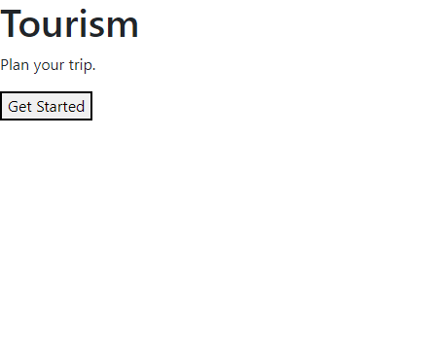

Step_2:click on Get Started

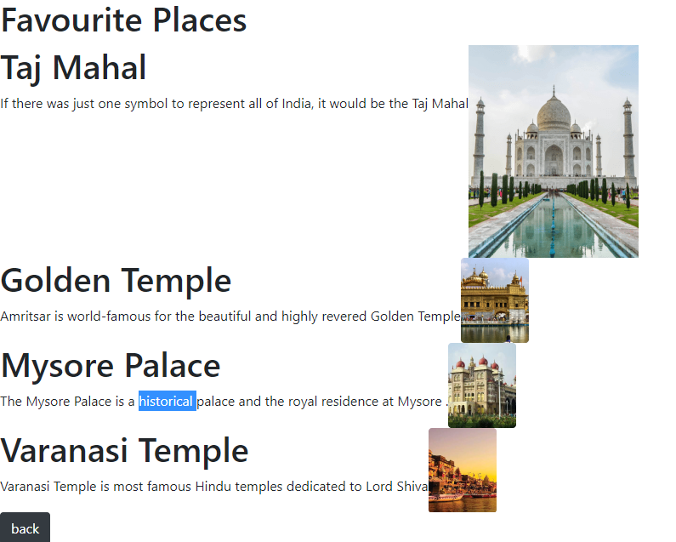

Step_3:Choose the place to visit , get the information after that click on back to get Favorite place.

