**Manual Testing Using Jira**

Jira Link: <https://kondapallivyshnavi.atlassian.net/projects/CP?selectedItem=com.atlassian.plugins.atlassian-connect-plugin:com.thed.zephyr.je__main-project-page#!/v2/testCases?projectId=10099>

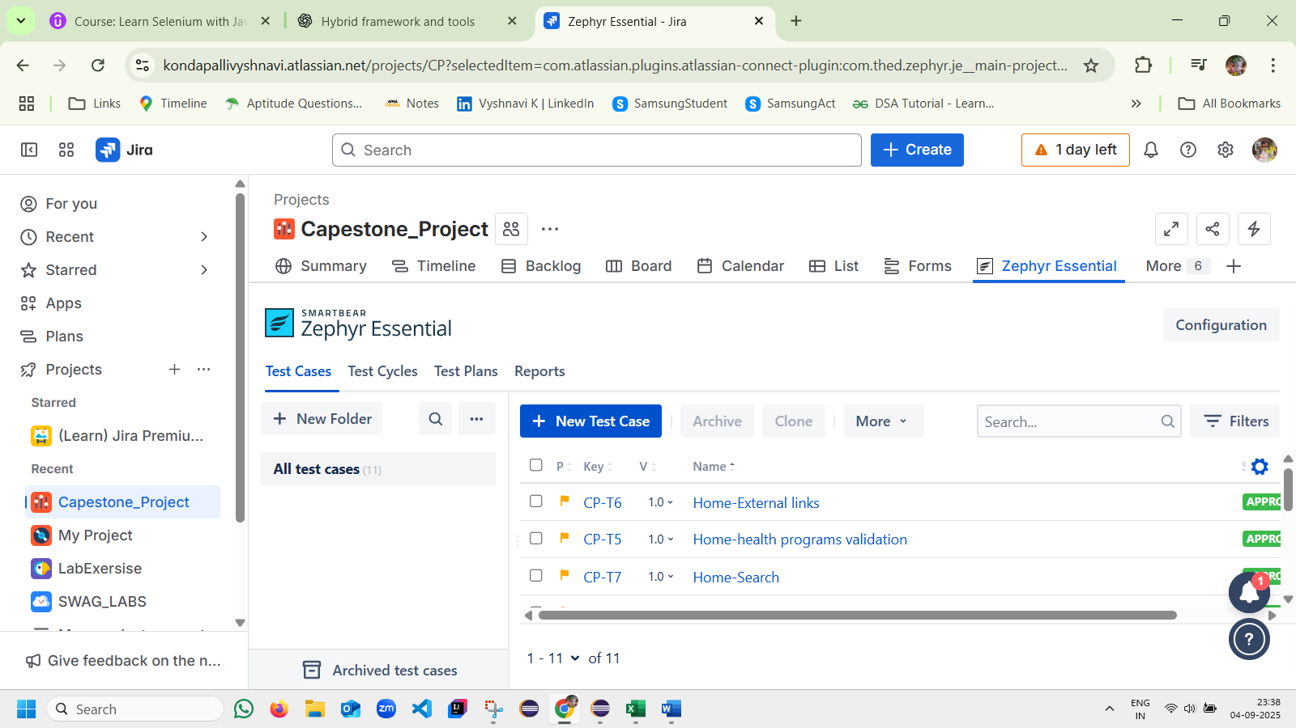

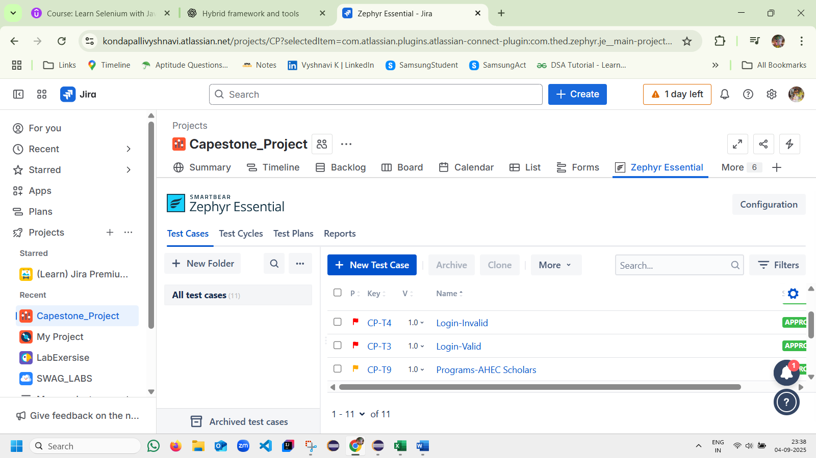

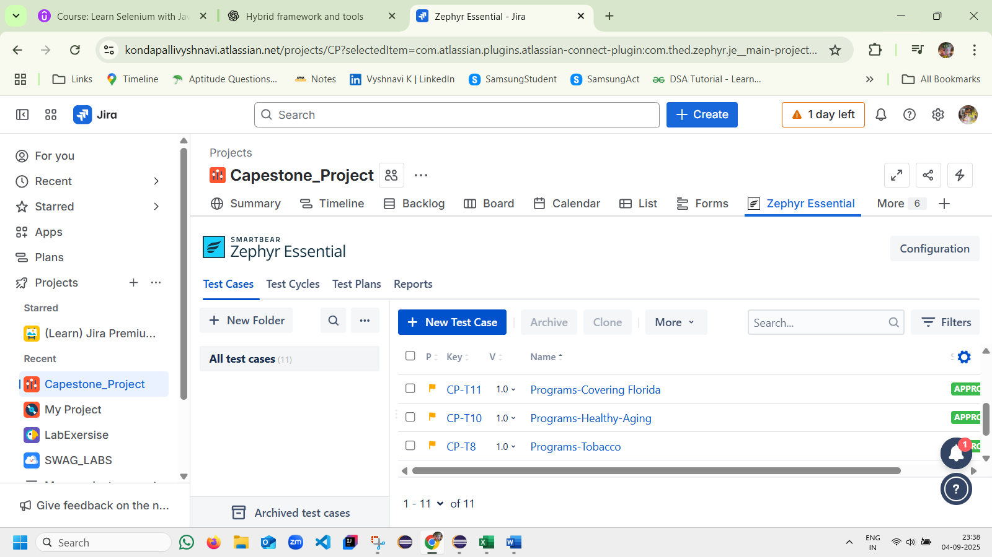

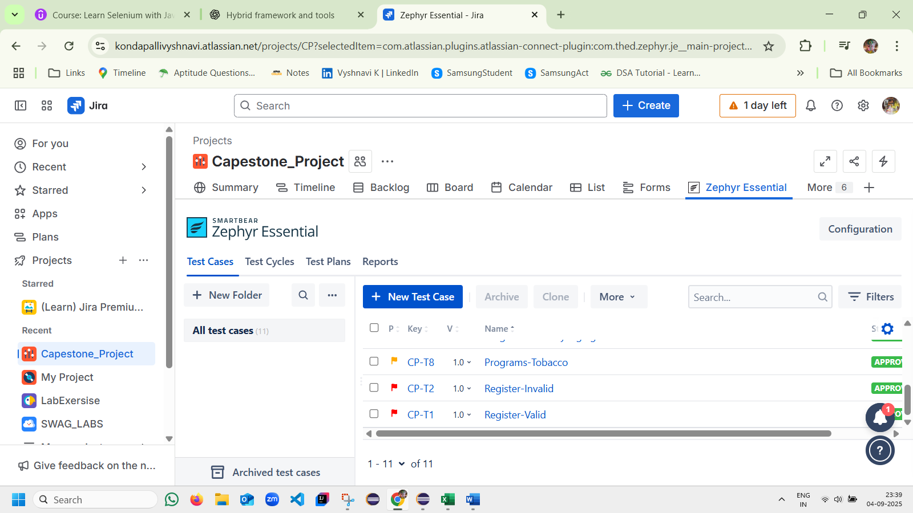

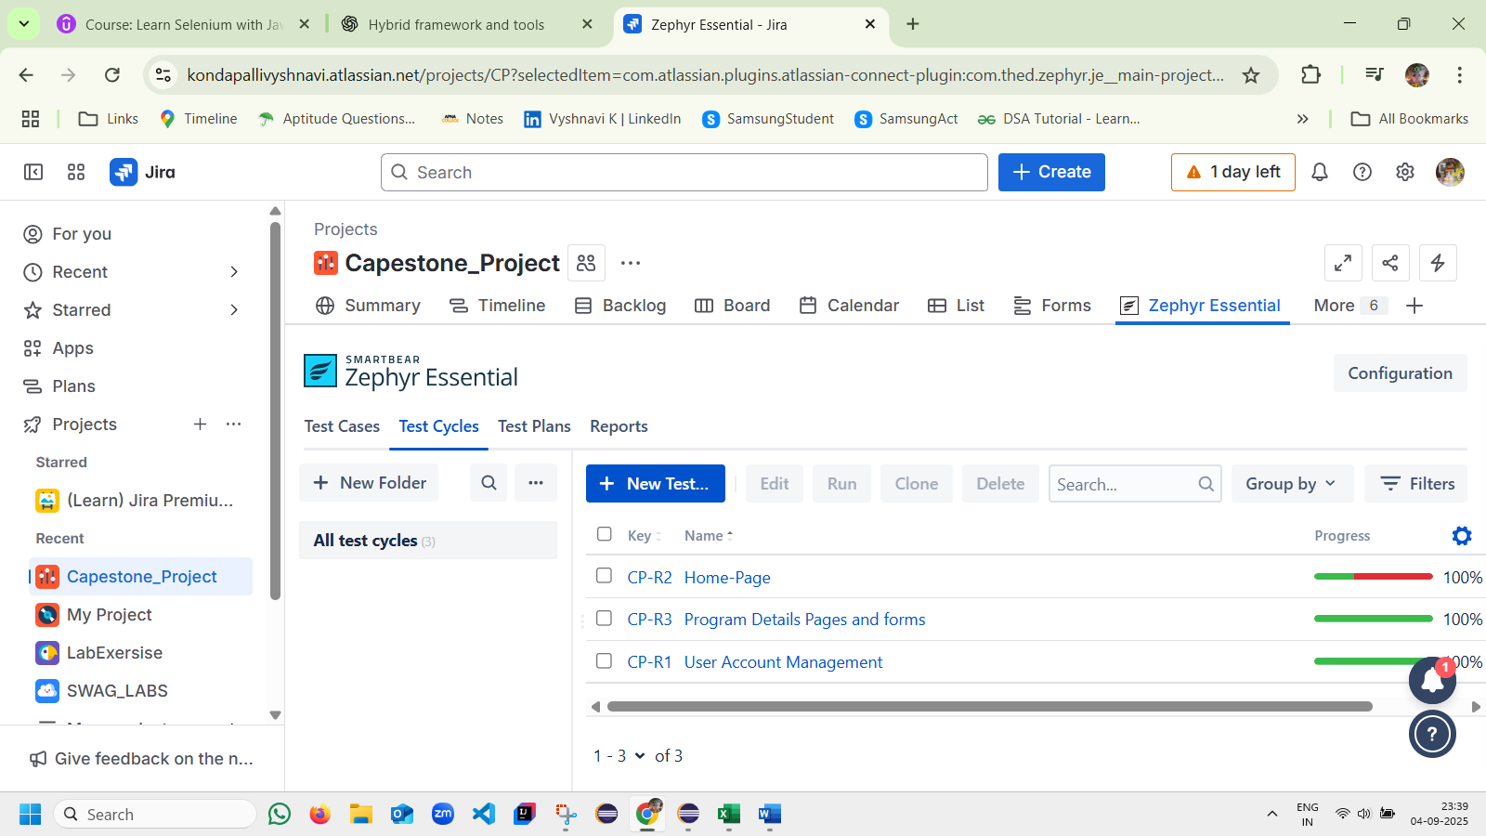

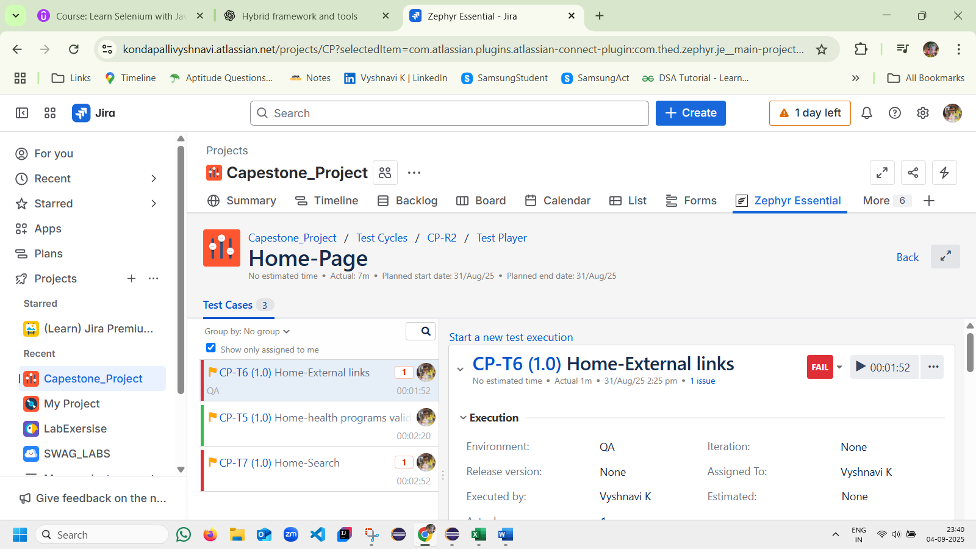

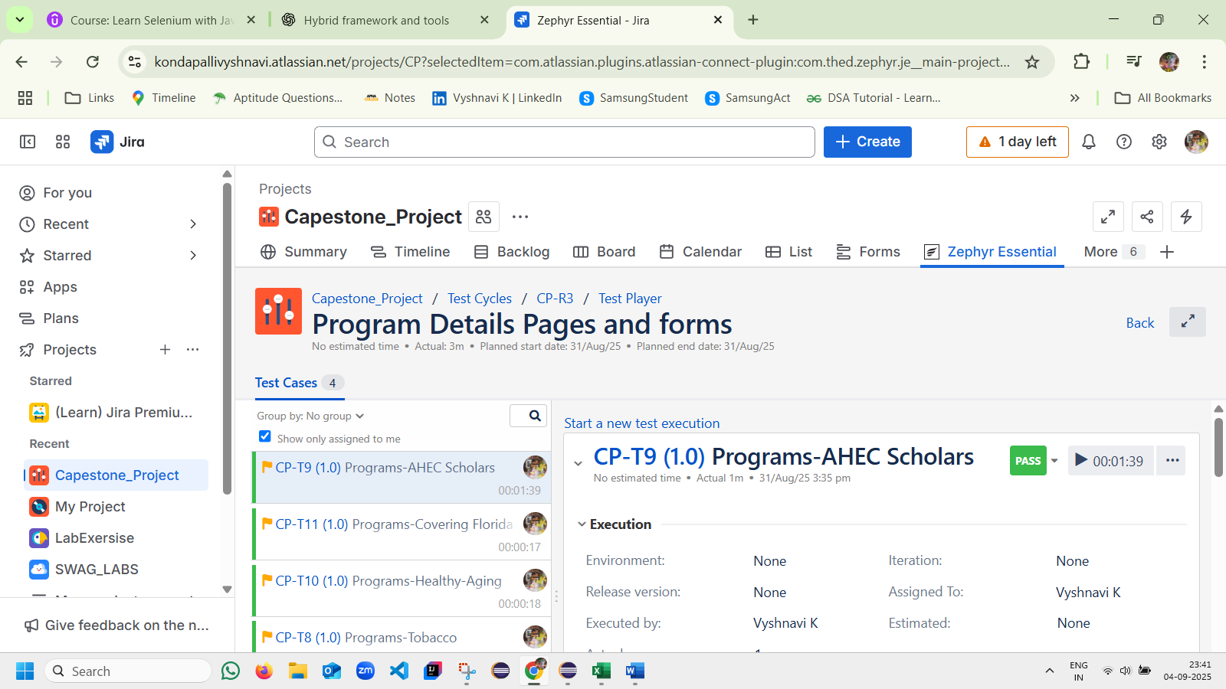

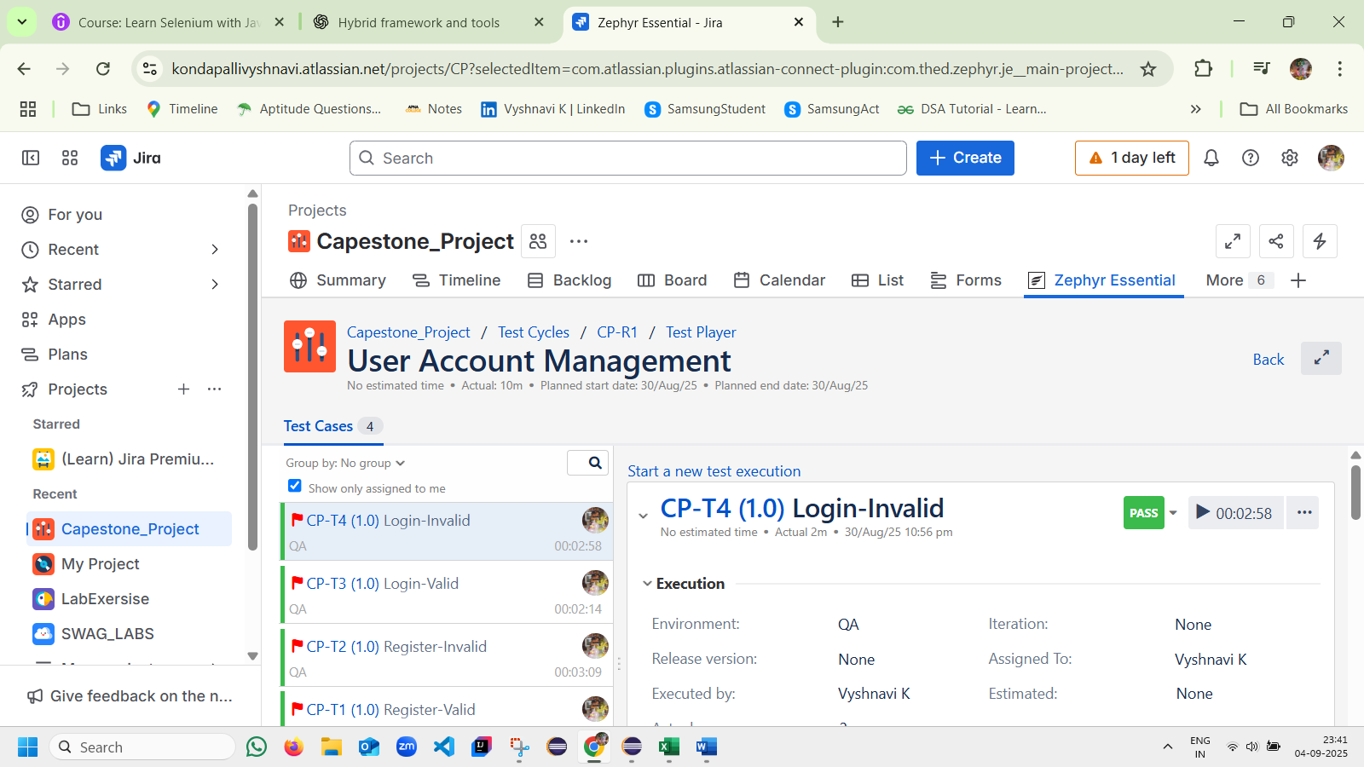

**Reports and Screenshots attached.**