First guided capstone project
Project Title: Predicting ticket prices for Big Mountain resort
Problem statement: Big Mountain Resort, a ski resort located in Montana offers spectacular views of Glacier National Park and Flathead National Forest, with access to 105 trails. Every year about 350,000 people ski or snowboard at Big Mountain. This mountain can accommodate skiers and riders of all levels and abilities. Big Mountain Resort has recently installed an additional chair lift to help increase the distribution of visitors across the mountain which increased their operating costs by $1,540,000 this season. Management wants to monitor the ticket price either by cost cut and without having to reduce ticket prices or improve their offering so that they can increase their ticket prices even more.
Data Wrangling: We used the Ski Resort dataset containing 330 rows and 27 columns across the U.S., with features including vertical drop, skiable area, snow-making capability, number of lifts, Weekday and weekend process.
- Categorical and Numeric features were inspected, analysed and encoded.
- Missing values were dropped. The ticket prices from some 16% of the resorts were missing. 14% of the resorts were missing both ticket price. Dropping the rows with no price data as these rows are of no use.
- New features engineered: resorts_per_state, state_total_skiable_area_ac, state_total_days_open, state_total_terrain_parks, and state_total_nightskiing_ac and got a new data frame named state_summary, which is merged later with usa_states on states columns.
- Target features were AdultWeekend and AdultWeekday, as we are analysing the ticket prices here. Weekend prices have the least missing values, so dropping the adultweekday row.
- Final dataset contains 277 rows and 25 columns which still have some missing values.
Exploratory data analysis: Introducing new features: resorts_per_100kcapita and resorts_per_100kcapita which by the name suggesting the density of the resorts relative to state population and size.
- To further explore the data, we applied PCA to disentangle the relationships between features. Getting a new data frame state_pca_x with 35 rows and 9 columns.
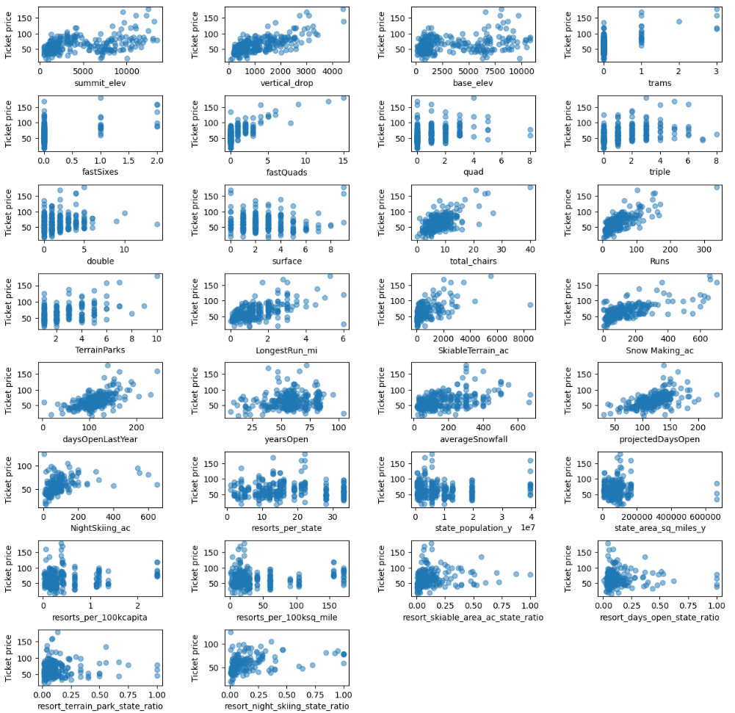
Figure 1. Scatterplots of numeric features against ticket price
- As the target feature here is ticket price, so grouping the data by state on AdultWeekend column and concatenating it with pca_df which contains PC1 and PC2 components, gives us a new data frame named pca_df.
- New features engineered in ski_data: resort_skiable_area_ac_state_ratio, resort_days_open_state_ratio, resort_terrain_park_state_ratio, resort_night_skiing_state_ratio.
- Key drivers of ticket pricing observed were: There is a strong positive correlation with vertical drop, fastquads, runs and total chairs.
- As we have number of various chairs and number of runs, but not their ratio, so introducing new features
: total_chairs_runs_ratio, total_chairs_skiable_ratio, fastQuads_runs_ratio, fastQuads_skiable_ratio and plotting the scatter plot of new features.
Model Preprocessing with feature engineering:
- We divided the data into 70/30 ratio of train and test splits to evaluate model performance.
- We calculated coefficient of determination, mean absolute error, mean squared error from sklearn metrics.
- We imputed missing values with median and mean.
- Introducing pipeline for linear regression model which performs all the steps from replacing missing values, scaling the data to zero mean and unit variance and training a linear regression model.
- We used a Random Forest Regressor as the final model after testing Linear Regression. Preprocessing included scaling, PCA for visualization, and mean imputation. The random forest model has a lower cross-validation mean absolute error by almost $1. It also exhibits less variability.
Algorithms used to build the model with evaluation metric:
Algorithm used to build the models was defining the pipelines which performs the following steps:
- replace missing values with the median for each feature
- scale the data to zero mean and unit variance
- train a linear regression model/random forest regressor
The following models were trained, cross-validated, and evaluated using Mean Absolute Error (MAE) as the primary metric.
Winning model and scenario modelling: Modelled Price for Big Mountain: $97.85, but the actual Price: $81.00. This significant gap suggests the resort is underpriced by ~$17, despite having superior facilities.
Big Mountain was reviewing some potential scenarios for either cost cuttings or increasing revenues which were:
- Permanently closing down up to 10 of the least used runs. This doesn't impact any other resort statistics: According to the model, if they close more than one run this will reduce ticket price, which could mean a revenue loss.
- Increase the vertical drop by adding a run to a point 150 feet lower down but requiring the installation of an additional chair lift to bring skiers back up, without additional snow making coverage: This scenario increases support for ticket price by $2.36. Over the season, this could be expected to amount to $4136364
- Same as number 2, but adding 2 acres of snow making cover: This gives the same profit as given by scenario 2.
- Increase the longest run by 0.2 mile to boast 3.5 miles length, requiring an additional snow making coverage of 4 acres: This scenario makes no difference in profit at all.
Pricing recommendation:
The actual price for Big Mountain Resort is $81.0, but modelling suggests a ticket price of $97.85, which suggests there is still room to increase the ticket prices, given big mountains strong facilities offerings. But increasing ticket prices by $16.85 doesn’t seem suitable. Rather we can expect the ticket price to be increase by $5-$7 making the ticket price somewhere between $85-$87 would be a better choice and it will cover the cost of new chair lift and will be in market competition too.
Conclusion and Future scope of work
The data focused only on ticket price for modelling ticket price. This could lead to lack of information from other factors, such as maintenance costs, staff expenses and some other notable factors. We had information on operating costs of the new chair lift, but some other information cost such as maintenance cost, food and beverages supply and/or staff expenses would be useful in modelling the ticket prices here.
Yes, Big Mountain's modelled ticket price is 97.85 which seems pretty high than its actual price which is 81.0. This could be due to whether big mountain is undervaluing its offerings or they are not focusing on features where customers want to pay more. To decide a profitable ticket price without losing market competitiveness we can discuss with stake holders and/or compare price with other big-league resorts. To make this model we can create an interactive dashboard for stakeholders or business leaders giving proper documentation where they can input and see the changes in features according to the trend.

