MOVIE SUCCESS PREDICTOR
EXPLORATORY DATA ANALYSIS (EDA) REPORT
Dataset: IMDb 5000 Movie Dataset

1. Introduction
Exploratory Data Analysis (EDA) is an important stage of the Movie Success Predictor project. It helps us understand the dataset, identify patterns, examine relationships between attributes, and discover unusual values before developing a machine learning model.
The main objective of our EDA is to understand which movie characteristics may influence gross revenue. Since our project aims to predict movie revenue, the gross attribute is considered the target variable.

2. Objectives of EDA
The main objectives of performing EDA are:
- Understand the distribution of different movie attributes.
- Identify missing values and potential outliers.
- Study relationships between important attributes.
- Identify patterns in movie budgets and gross revenue.
- Understand how movie popularity and other characteristics relate to revenue.
- Identify useful attributes for feature selection and machine learning.

3. EDA Techniques Used
We performed three major types of Exploratory Data Analysis.

A. Univariate Analysis
Univariate analysis examines one variable at a time to understand its distribution and characteristics. The visualisations include:
- Budget distribution histogram.
- Gross revenue distribution histogram.
- Movie duration distribution.
- IMDb score distribution.
- Boxplots for budget, gross revenue and duration.
- Genre distribution.
- Country distribution.
- Content rating distribution.

B. Bivariate Analysis
Bivariate analysis examines the relationship between two variables. It helps us understand how one movie attribute is associated with another. The important comparisons include:
- Budget vs Gross Revenue.
- Duration vs Gross Revenue.
- IMDb Score vs Gross Revenue.
- Director Facebook Likes vs Gross Revenue.
- Actor Facebook Likes vs Gross Revenue.
- Movie Facebook Likes vs Gross Revenue.
- Budget vs IMDb Score.
- Release Year vs Gross Revenue.

C. Multivariate Analysis
Multivariate analysis examines relationships among multiple variables simultaneously. We use correlation analysis and heatmaps to understand how numerical attributes are related to each other and identify potentially useful features for prediction.
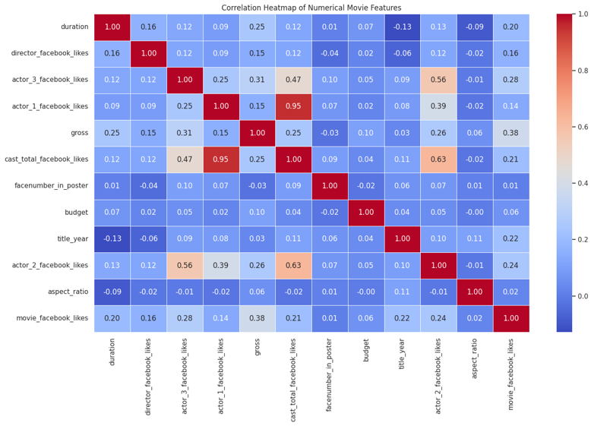
Figure 4: Correlation heatmap of numerical movie features
The heatmap shows that gross revenue has its strongest correlations with movie Facebook likes (0.38) and actor 3 Facebook likes (0.31), followed by actor 2 Facebook likes (0.26), duration (0.25) and total cast Facebook likes (0.25). Budget shows only a weak correlation with gross revenue (0.10). Actor 1 Facebook likes and total cast Facebook likes are almost perfectly correlated (0.95), which indicates redundancy that should be considered during feature selection.

4. Important Observations from EDA

1. Gross Revenue Distribution
The gross revenue histogram shows a positively skewed distribution. Most movies fall within lower revenue ranges, while a small number of movies generate exceptionally high revenue.
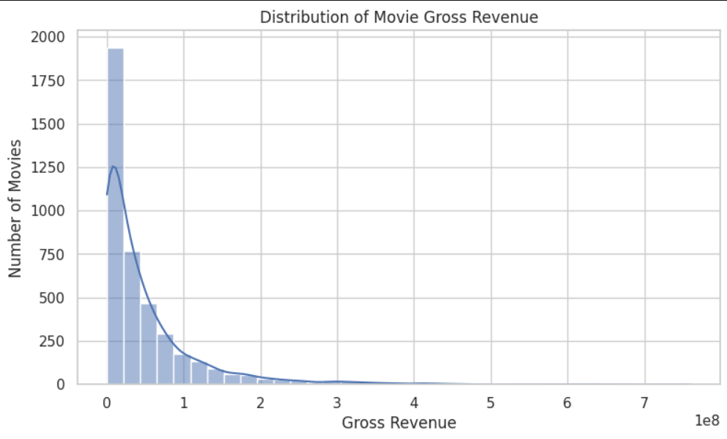
Figure 1: Distribution of movie gross revenue

2. Movie Budget Distribution
The budget boxplot shows that movie production budgets vary significantly. Some movies have exceptionally high budgets compared with the majority of movies. These are identified as potential outliers.

3. Budget vs Gross Revenue
The scatter plot helps us examine whether movies with higher production budgets tend to generate higher revenue. However, a high budget does not guarantee high revenue.

4. Popularity vs Gross Revenue
The scatter plots involving Facebook likes help us investigate whether director, actor and movie popularity are associated with revenue. These attributes may provide useful information, but popularity alone cannot explain a movie’s financial performance.

5. Genre and Movie Characteristics
Genre, country, content rating and release year comparisons help us understand differences between movie categories and identify patterns that may be useful for prediction.
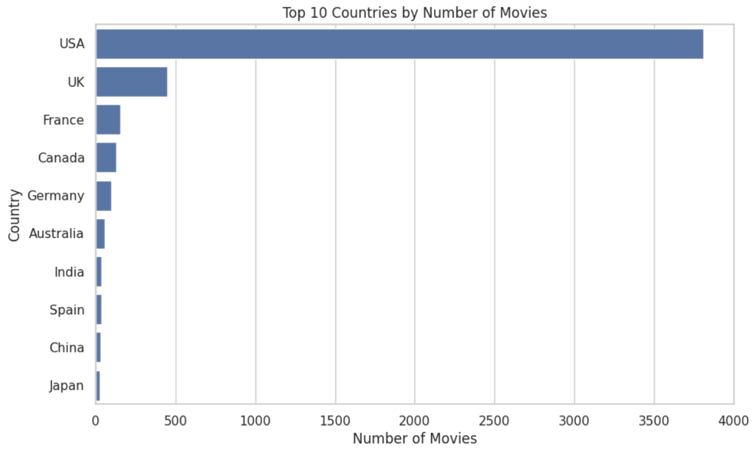
Figure 3: Top 10 countries by number of movies
The country distribution is strongly dominated by the USA, followed by the UK, while France, Canada, Germany and the remaining countries contribute far fewer movies.

5. Axis Scaling Used in Visualisations
Some movie attributes, particularly budget and gross revenue, have very wide numerical ranges. Therefore, different scaling techniques are used to improve visual clarity.
- Logarithmic Scaling: Used for budget and gross revenue to display small and large values more clearly.
- Symmetric Logarithmic Scaling: Used for Facebook likes because the values may include zero.
- Linear Scaling: Used for attributes such as movie duration and release year where appropriate.
Budget and gross revenue are represented in US Dollars (USD), with values displayed in millions for easier interpretation. Scaling changes the way values are displayed in graphs; it does not change the original dataset values.

6. Outlier Analysis
Outliers are observations that differ significantly from the majority of the dataset. We use boxplots and the Interquartile Range (IQR) method to identify potential outliers in numerical attributes such as budget and gross revenue.
The IQR method uses the first quartile (Q1), third quartile (Q3), and interquartile range to identify unusual observations.
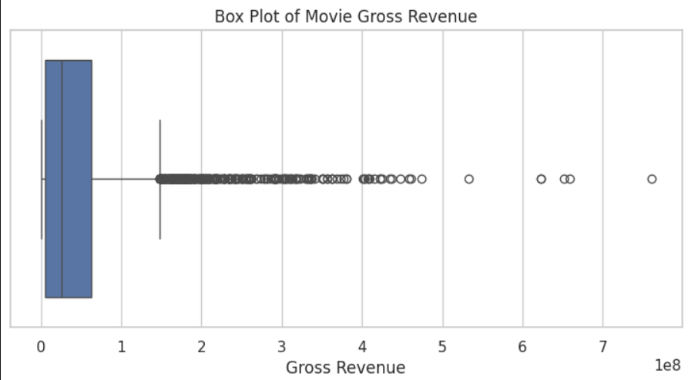
Figure 2: Box plot of movie gross revenue
The box plot shows that most movies lie within a compact range, with a long tail of high-revenue outliers extending beyond the upper whisker. However, not every outlier is an error. Some movies genuinely have extremely high production budgets or gross revenues. Therefore, these values should be investigated before deciding whether to remove them.

7. EDA Questions and Answers

Q1. Are movie revenues evenly distributed?
No. Most movies generate relatively lower revenue, while a smaller number generate very high revenue. This indicates a right-skewed distribution.

Q2. Are there outliers in the dataset?
Yes. Budget and gross revenue contain potential outliers, which are identified using boxplots and the IQR method.

Q3. Does a higher movie budget guarantee higher revenue?
No. A higher production budget does not always result in higher gross revenue. Other factors, such as genre, popularity and audience response, may also influence financial performance.

Q4. Do Facebook likes determine movie success?
No. Facebook likes can indicate popularity and audience engagement, but they cannot independently determine the financial success of a movie.

Q5. Why do we use logarithmic scaling?
Logarithmic scaling makes graphs easier to understand when numerical values have very large differences. It helps display both smaller and larger values clearly.

Q6. Why is correlation analysis important?
Correlation analysis helps identify relationships between numerical attributes and understand which features may be useful for predicting gross revenue.

8. Importance of EDA in Our Project
EDA helps us understand the factors that may influence movie revenue before developing our prediction model. Through visualisations and statistical analysis, we can identify important attributes, understand data distributions, detect potential outliers and examine relationships between variables.
The findings from EDA will support the next stages of our project:
- Feature selection to identify relevant attributes.
- Dimensionality reduction to simplify the dataset.
- Machine learning model development.
- Evaluation of prediction performance.

9. Conclusion
Exploratory Data Analysis provided a better understanding of the IMDb 5000 Movie Dataset. Through univariate, bivariate and multivariate analysis, we examined the distributions of movie attributes, identified potential outliers and explored relationships between production budgets, gross revenue, popularity and other movie characteristics.
The analysis indicates that movie revenue is influenced by multiple factors rather than a single attribute. These findings provide a foundation for selecting relevant features and developing our Movie Success Predictor model.
The main outcome of EDA is to transform raw movie data into meaningful insights that support the development of an effective gross revenue prediction system.

