MOVIE SUCCESS PREDICTOR
Dataset Analysis and Predictive Insights Report

1. Executive Summary
This report examines a cleaned movie dataset containing 5,043 movie records and 28 attributes. The data combines movie details, cast and director popularity indicators, audience engagement, release information, box-office gross, production budget and IMDb ratings. The aim is to understand which available features may be useful for a movie-success prediction model.
The average IMDb score is 6.44, while the median is 6.6. The records cover release years from 1916 to 2016. IMDb vote count has the strongest positive linear relationship with IMDb score among the selected numeric features (r = 0.41). These relationships are useful signals, but they do not prove that any one feature causes a movie to succeed.

2. Project Objectives
- Summarise the size, structure and main variables in the dataset.
- Explore rating patterns, release-year coverage and key numeric relationships.
- Identify data-quality considerations before building a prediction model.
- Recommend a practical workflow for training and evaluating a movie-success classifier or regressor.

3. Dataset Overview
The dataset includes fields such as movie_title, director_name, genres, country, language, title_year, duration, budget, gross, imdb_score, num_voted_users, review counts and social-media likes. It contains both categorical and numeric features, making it suitable for exploratory data analysis and supervised learning after the prediction target is clearly defined.
Rows: 5,043 | Columns: 28 | Release-year range: 1916–2016 | Missing cells detected in the supplied file: 0

4. Exploratory Data Analysis

4.1 IMDb Rating Distribution
The mean IMDb score is 6.44 and the median is 6.6. The distribution below shows how ratings are spread across the dataset. A concentration around the middle-to-upper rating range would indicate that most films receive moderate rather than extreme scores. The score alone represents audience/critic reception and should not automatically be treated as commercial success.
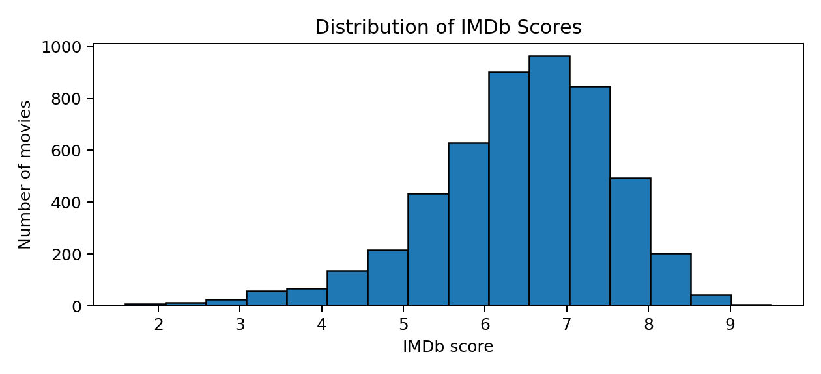

4.2 Release-Year Coverage
The dataset spans 1916–2016. The number of records varies by year, so the dataset may not represent every year equally. A model can learn patterns that reflect the period and coverage of the source data, rather than universal movie-industry trends. The release-year chart is useful for spotting uneven coverage.
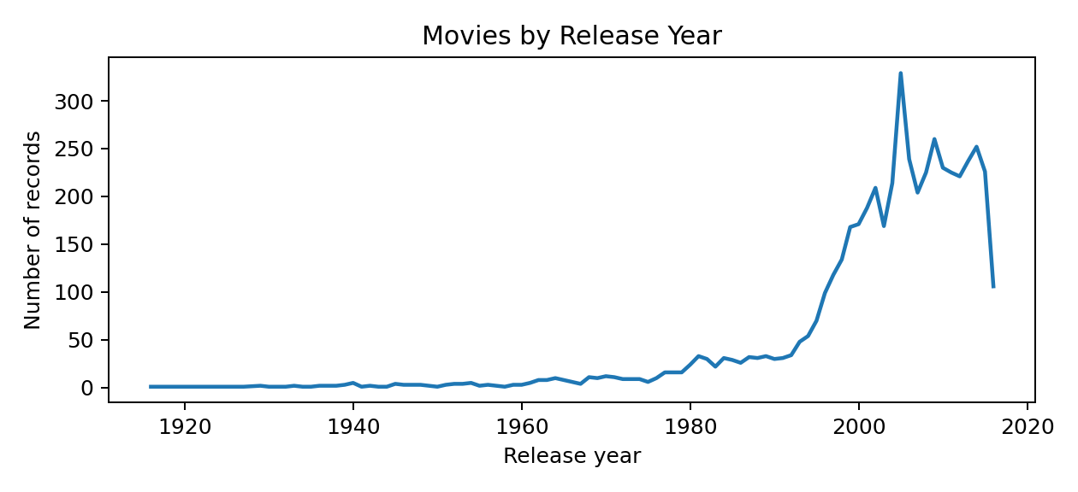

5. Feature Relationships and Interpretation
Pearson correlation measures the strength and direction of a linear relationship between two numeric variables. Values closer to +1 indicate a stronger positive linear relationship, values near 0 indicate little linear relationship, and values closer to −1 indicate a negative linear relationship. Correlation does not establish causation.
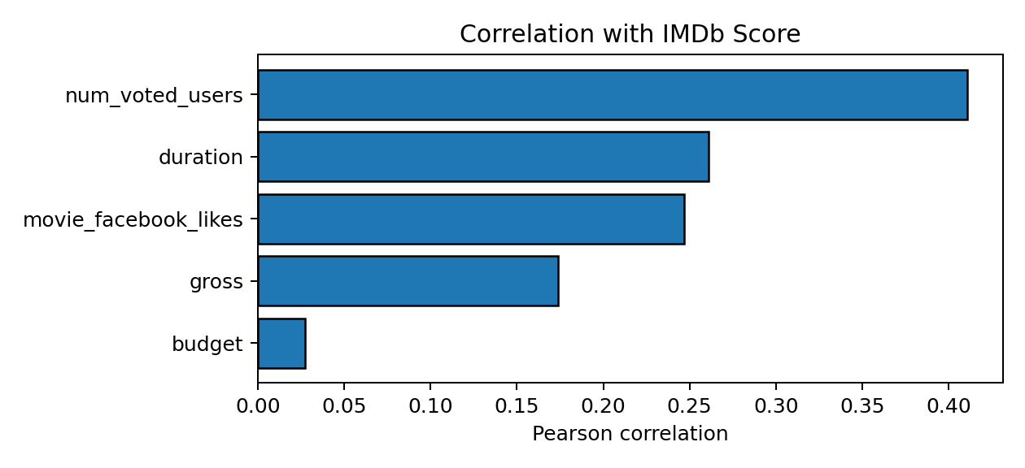

5.1 Key Findings
- Audience participation: IMDb vote count is positively correlated with score (r = 0.41), the strongest association among the selected variables.
- Runtime: duration has a weaker positive association with score (r = 0.26); longer films are not necessarily better.
- Online engagement: movie Facebook likes show a positive association (r = 0.25), potentially reflecting visibility and fan interest.
- Box office and budget: gross revenue (r = 0.17) and budget (r = 0.03) have weaker linear relationships with IMDb score in this dataset.

5.2 Data Profile Notes
The most frequent country is USA (3,812 records). The most frequent exact genre label is “Drama” (236 records). Genre combinations are stored as text joined with separators, so a more detailed genre analysis should split these into separate binary genre indicators.

6. Data Preparation and Modelling Plan

6.1 Recommended Preparation
- Define “success” before modelling: for example, IMDb score above a chosen threshold, or commercial success based on revenue relative to budget. These targets answer different questions.
- Check missing values, duplicates, impossible values and extreme outliers. The supplied file has no blank cells according to a basic null check, but zeros and placeholder values may still represent missing or unknown information.
- Use log transformations for highly skewed financial variables such as budget and gross; inspect outliers before deciding whether to cap or exclude them.
- Encode categorical fields such as genres, country, language and content rating. Avoid using raw movie titles or URLs as predictive features unless there is a clear reason.
- Scale numeric features when required by the selected algorithm, and fit all preprocessing only on the training data to prevent data leakage.

6.2 Model and Evaluation
For a numeric IMDb score target, begin with Linear Regression or Random Forest Regressor and evaluate using MAE, RMSE and R². For a binary success label, try Logistic Regression and Random Forest Classifier, using precision, recall, F1-score and ROC-AUC. Split the data into training and test sets; if the intended use is to predict future releases, a chronological split by release year is more realistic than a purely random split.

7. Limitations
The dataset is observational and may contain selection bias, inconsistent financial reporting and older records. Budget and gross may use different currencies or reporting conventions, and some engagement metrics may have been collected after a movie became popular. If these post-release signals are used, the model may describe popularity rather than predict success before release. The dataset also does not, by itself, establish a universal definition of success.

8. Conclusion
The cleaned movie dataset provides a useful starting point for a movie-success prediction project. Initial analysis suggests that audience vote count and engagement indicators are more closely associated with IMDb ratings than budget alone. The next step is to choose a clear target, verify data quality and build a baseline model with leakage-aware evaluation. Results should be reported as estimates, not guarantees of a film’s future performance.
Source: User-provided file, cleaned_movie_success_predictor.csv. All descriptive statistics and charts in this report were calculated from that file.

