DATA ANALYSIS REPORT
Movie Success: Feature-Engineered Dataset
Target definition, feature signal, engineered-feature value and a leakage-free baseline

1. Introduction and Objective
This report analyses movies_success_feature_engineered.csv, a prepared dataset for predicting whether a movie is successful. It aims to (i) describe the structure and preprocessing of the data, (ii) establish exactly how the success label is defined, (iii) identify which features carry signal, (iv) test whether the three engineered columns add any value, and (v) give a reliable baseline for how well success can be predicted.

2. Dataset Overview
The file contains 4,998 movies and 31 columns, all numeric, with no missing values and no duplicate rows. Apart from imdb_score and the target success, every column lies between 0 and 1, so the data has been min-max scaled. Text fields such as director_name, actor names, movie_title and plot_keywords have been converted to numbers; their values are exact multiples of 1/(maximum count - 1) (director_name, for instance, moves in steps of 1/128), which indicates frequency encoding, meaning the value reflects how often that name or title appears. The compact range of budget and gross also suggests a log transformation before scaling, although this cannot be confirmed from the file.
Attribute | Value
Rows x columns | 4,998 x 31 (all numeric)
Scaling | Min-max scaled to 0-1, except imdb_score and success
Engineered columns | production_company, release_month, marketing_budget
Target | success (1 = successful, 0 = not successful)
Missing values / duplicates | 0 / 0

3. Target Definition and Class Balance
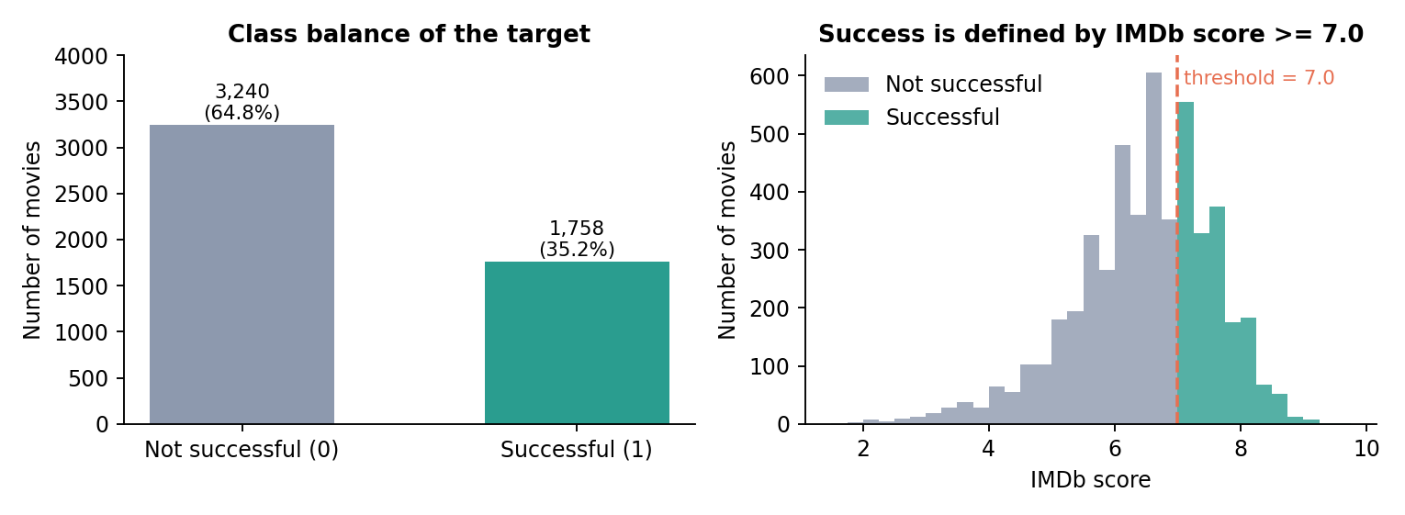
Figure 1. Class balance (left) and IMDb score distribution coloured by class, with the 7.0 threshold (right).
Of the 4,998 movies, 1,758 (35.2%) are labelled successful and 3,240 (64.8%) are not, so a model that always predicts "not successful" is right 64.8% of the time. More importantly, the label is a direct function of the IMDb score: in all 4,998 rows, success equals 1 exactly when imdb_score is 7.0 or higher. Successful movies score between 7.0 and 9.5 (mean 7.54) and the rest between 1.6 and 6.9 (mean 5.84).
Leakage warning: because imdb_score defines the target, it must be excluded from any predictive model. Including it produces a perfect but meaningless AUC of 1.000. Everything in the modelling section below leaves it out.

4. Feature Distributions
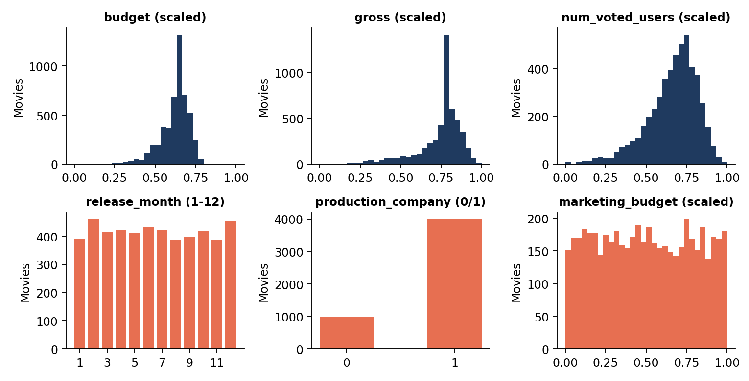
Figure 2. Distributions of three real features (blue) and the three engineered features (orange).
The scaled real features (budget, gross, num_voted_users) are concentrated in the upper half of the 0-1 range with a longer tail toward low values. The engineered columns look very different. release_month is almost evenly spread, with 387 to 461 movies in each month; marketing_budget is flat across its range with 4,998 distinct values, and a Kolmogorov-Smirnov test cannot distinguish it from a uniform distribution (p = 0.58); production_company is binary, with 4,000 movies coded 1 and 998 coded 0.

5. Relationship Between Features and Success
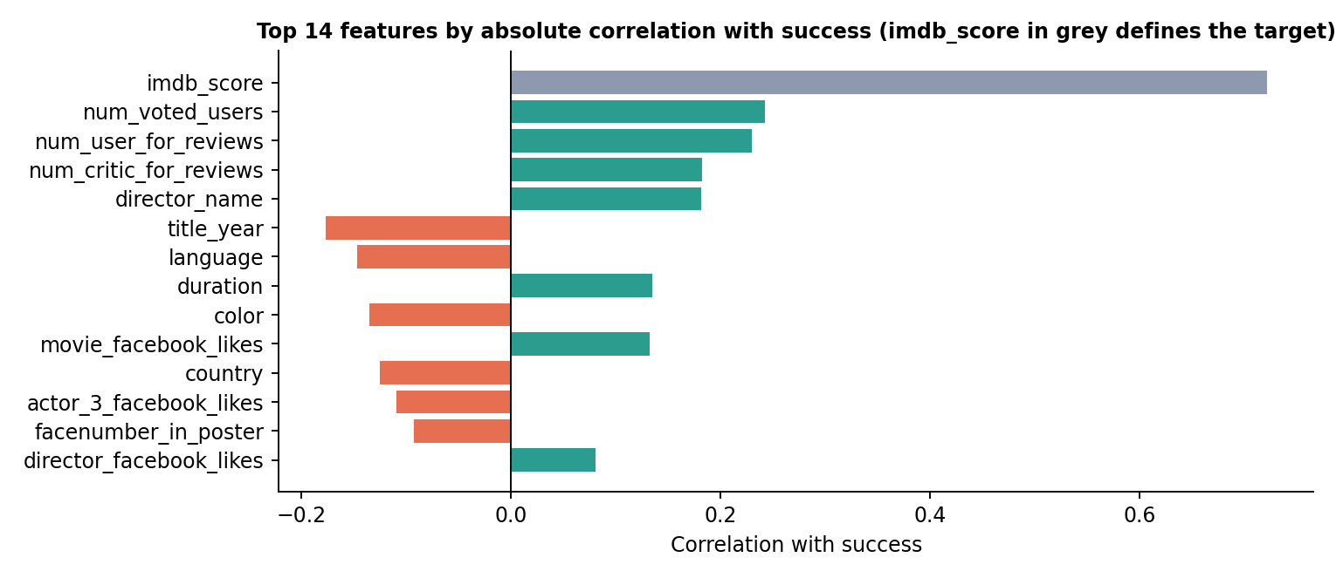
Figure 3. Features with the largest absolute correlation with success.
- Engagement counts lead: num_voted_users (r = 0.24), num_user_for_reviews (0.23) and num_critic_for_reviews (0.18) show that widely discussed movies are more often successful.
- Director experience and age: director_name (0.18, a film-count measure under frequency encoding) is positive, while title_year (-0.18) shows that more recent movies are slightly less likely to be successful.
- Weak overall: apart from imdb_score, no single feature exceeds 0.25. Signs for language, color and country depend on how the categories were encoded, so only their magnitudes should be read.

6. Do the Engineered Features Help?
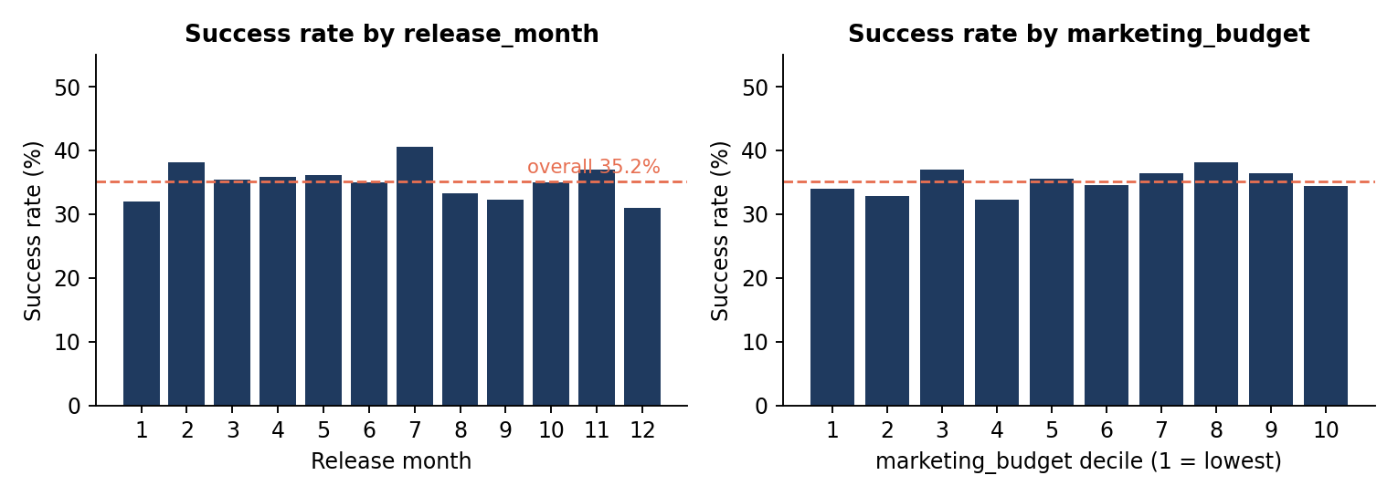
Figure 4. Success rate by release month (left) and by marketing budget decile (right) against the 35.2% overall rate.
Neither feature separates successful from unsuccessful movies. Success rates range only from 31.0% to 40.6% across months (chi-square p = 0.17, not significant) and from 32.3% to 38.2% across marketing deciles, with no upward trend. marketing_budget is essentially unrelated to budget and gross (correlation below 0.01), and production_company has a weak 35.8% vs 32.8% success rate between its two groups. A Random Forest scores an AUC of 0.887 without the three engineered columns and 0.884 with them, so they add nothing measurable.
Interpretation: a flat uniform marketing budget unrelated to anything else, and an evenly spread release month, behave like randomly generated values rather than real records. Their origin should be checked before they are trusted in any analysis.

7. Predictive Baseline (without imdb_score)
Three classifiers were trained on all features except imdb_score and success, using stratified 5-fold cross-validation, default settings and a 0.5 threshold.
Model | ROC AUC | Accuracy | F1 (successful)
Majority-class baseline | 0.500 | 0.648 | -
Logistic Regression | 0.813 | 0.770 | 0.608
Gradient Boosting | 0.876 | 0.806 | 0.688
Random Forest | 0.884 | 0.816 | 0.711
Random Forest without engineered columns | 0.887 | 0.817 | 0.713
Random Forest WITH imdb_score (leakage) | 1.000 | 1.000 | 1.000

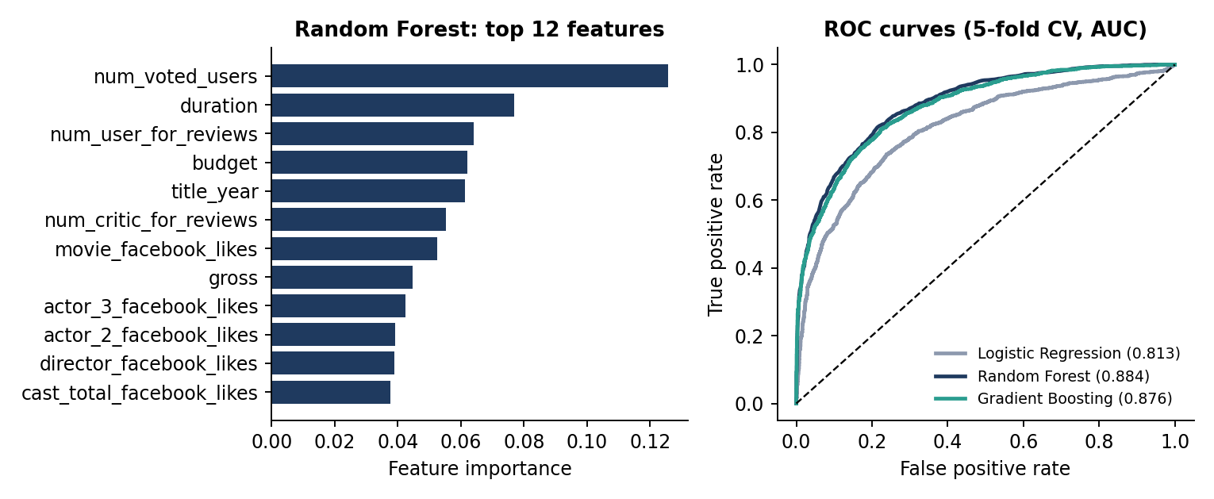
Figure 5. Random Forest feature importance (left) and ROC curves of the three honest models (right).
Random Forest is the best honest model, with an AUC of 0.884 and 81.6% accuracy, about 16.8 points above the baseline. It finds 1,128 of the 1,758 successful movies (recall 64.2%) with 79.6% precision, and misses 630. The non-linear models clearly outperform logistic regression, which points to interactions the linear model cannot capture. The most important features are num_voted_users, duration and num_user_for_reviews. Note that votes, reviews, gross and Facebook likes are only known after a movie is released, so this model estimates how audience reception relates to success rather than forecasting it in advance.

8. Conclusions and Recommendations
- Remove imdb_score from all modelling; it fully determines the label and would invalidate any results.
- Treat release_month, marketing_budget and production_company with caution: they show no signal and look synthetic, so confirm their source or drop them.
- A tree-based model reaches an AUC of about 0.88; handle the 65/35 imbalance with class weights or threshold tuning to lift recall on successful movies.
- For a true pre-release predictor, restrict features to information available before launch (budget, cast and director measures, genre, duration, release timing) and rebuild the baseline.

