DATA ANALYSIS REPORT
Movie Success: PCA Dataset Analysis
Variance structure, signal strength and predictive performance of 23 principal components

1. Introduction and Objective
This report analyses movie_success_pca.xlsx, a dataset in which each movie has already been transformed by Principal Component Analysis (PCA) and labelled as successful or not. The objectives are to (i) describe the dataset and its class balance, (ii) understand how information is distributed across the 23 components, (iii) measure which components carry signal about success, and (iv) establish a baseline for how well success can be predicted from these components alone.

2. Dataset Overview
The file holds 3,998 movies and 24 columns: 23 principal components (PC1 to PC23) and a binary target column, success. There are no missing values and no duplicate rows. As expected for PCA scores, every component is centred at zero, and no two components are correlated with each other (the largest absolute pairwise correlation is about 1.6 x 10^-15, i.e. zero).
Attribute | Value
Movies (rows) | 3,998
Predictors | 23 principal components (PC1 - PC23), mean 0
Target | success (1 = successful, 0 = not successful)
Class split | 2,592 not successful (64.8%) / 1,406 successful (35.2%)
Missing values / duplicates | 0 / 0

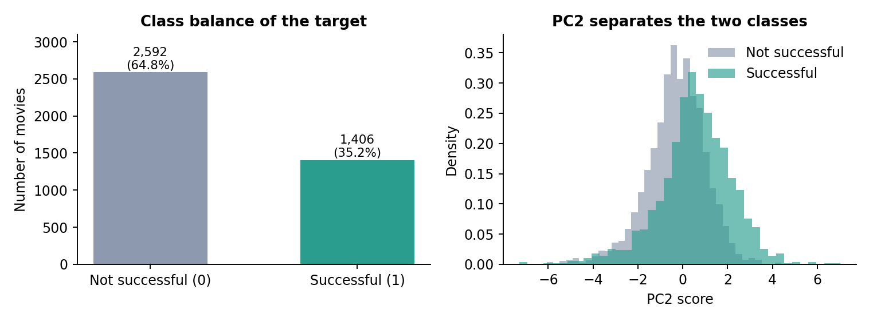
Figure 1. Class balance of the target (left) and the PC2 score distribution by class (right).
Roughly one movie in three is labelled successful, so the classes are moderately imbalanced and a model that always predicts "not successful" would already be right 64.8% of the time. This is the accuracy figure any model must clearly beat. The right-hand panel previews a key finding: successful movies are shifted toward higher PC2 scores.
Important limitation: the file contains the component scores only, without the loadings or the original features. The components can therefore be ranked and compared statistically, but not interpreted in business terms (for example, "PC2 reflects budget and popularity" cannot be confirmed from this file).

3. Variance Structure
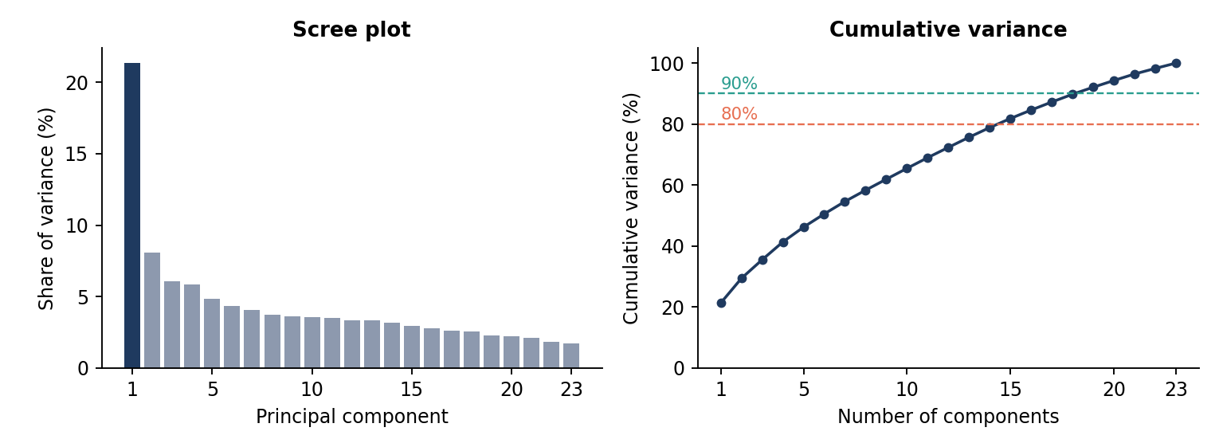
Figure 2. Scree plot (left) and cumulative share of variance (right) across the 23 components.
Information is concentrated in the first component. PC1 alone carries 21.3% of the variance among the retained components, PC2 adds 8.1% and PC3 adds 6.1%. After PC2 the curve flattens into a long tail of components that each contribute between roughly 1.7% and 6%. Five components cover 46.2% of the variance, ten cover 65.5%, fifteen cover 81.8% and nineteen cover 92.1%. There is no sharp "elbow" beyond PC2, so the data cannot be compressed much further without discarding a meaningful share of the variance. These percentages are measured relative to the 23 retained components only.

4. Relationship Between the Components and Success
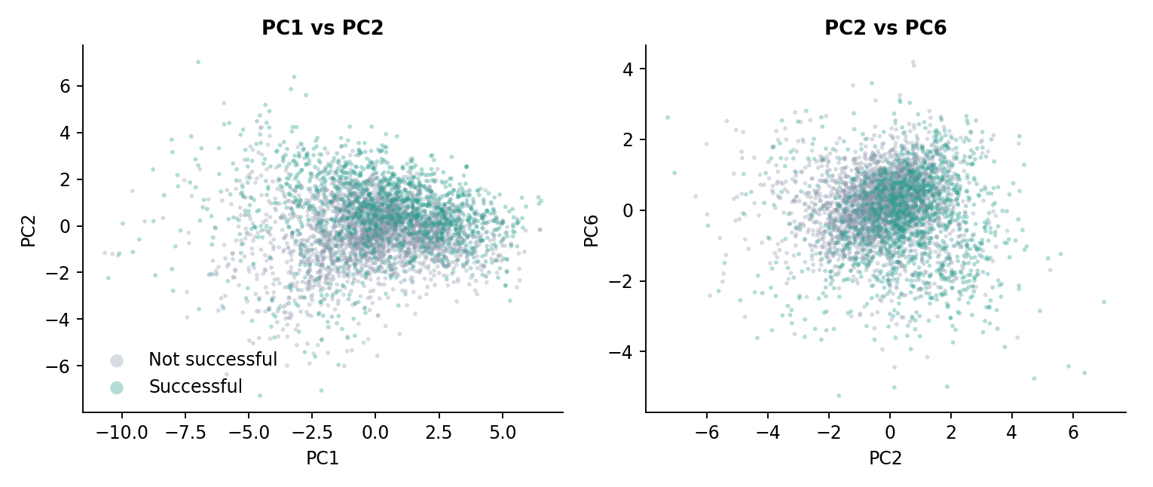
Figure 3. Movies plotted on PC1 vs PC2 (left) and PC2 vs PC6 (right), coloured by success.
The scatter plots show a visible but overlapping separation. Successful movies concentrate toward higher PC2 values (upper part of the left plot) and lower PC6 values (lower part of the right plot), but the two classes overlap heavily, so no single pair of components separates them cleanly.
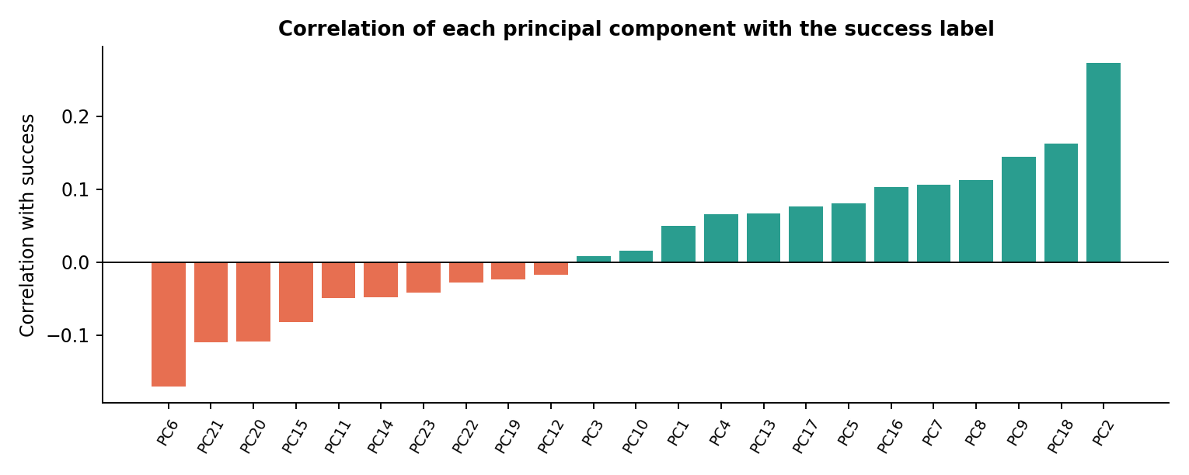
Figure 4. Correlation of each principal component with the success label, sorted from lowest to highest.
Component | Mean (successful) | Mean (not successful) | Correlation | p-value
PC2 | +0.558 | -0.303 | +0.273 | 1.3e-60
PC6 | -0.255 | +0.138 | -0.171 | 1.1e-22
PC18 | +0.186 | -0.101 | +0.162 | 5.3e-22
PC9 | +0.196 | -0.106 | +0.144 | 3.0e-18
PC8 | +0.156 | -0.085 | +0.113 | 4.3e-13

- Signal is spread thin. The strongest single relationship is PC2 at 0.27; no component exceeds 0.3. Welch t-tests find 18 of 23 components differ significantly between the classes at the 5% level (15 after a Bonferroni correction), with PC3, PC10, PC12, PC19 and PC22 showing no detectable difference.
- Variance is not predictive power. PC1, the largest component, correlates only 0.05 with success, while smaller components such as PC6, PC9 and PC18 are more informative. Truncating components purely by variance would therefore discard useful signal.

5. Predictive Baseline
To judge how much of the success label the components can explain, three standard classifiers were fitted on all 23 components using stratified 5-fold cross-validation with default settings and no hyperparameter tuning. Results are pooled out-of-fold predictions at a 0.5 threshold.
Model | ROC AUC | Accuracy | F1 (successful)
Majority-class baseline | 0.500 | 0.648 | -
Logistic Regression | 0.807 | 0.765 | 0.606
Gradient Boosting | 0.817 | 0.768 | 0.623
Random Forest | 0.826 | 0.774 | 0.633

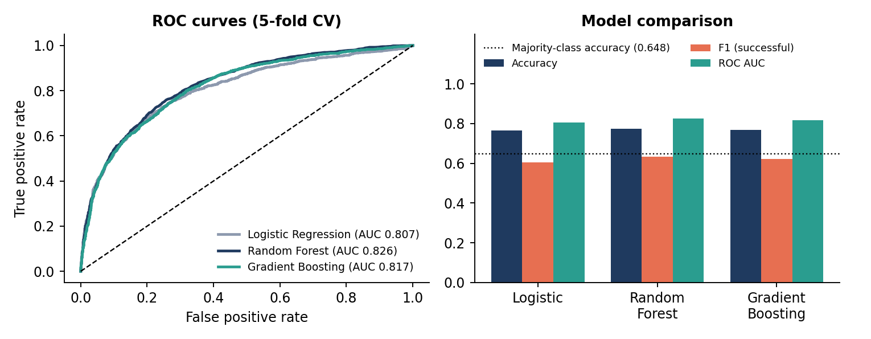
Figure 5. ROC curves (left) and metric comparison against the majority-class baseline (right).
All three models perform similarly, with Random Forest slightly ahead (AUC 0.826, accuracy 77.4%, about 12.6 points above the baseline). Using only the first two components gives an AUC of about 0.69, ten components about 0.76 and all 23 about 0.81 with logistic regression, confirming that the full set is worth keeping. The Random Forest confusion matrix shows the main weakness: it correctly identifies 781 of 1,406 successful movies (recall 55.5%, precision 73.7%) and misses 625, so it is cautious about labelling a movie a success.

6. Conclusions and Recommendations
- The dataset is clean and well formed, with a moderate 65/35 class imbalance that should be handled with class weights or threshold tuning to improve recall on successful movies.
- Keep all 23 components; success-related signal sits in many small components, not in the high-variance ones.
- A first-pass model already reaches an AUC of about 0.83, a real but modest improvement over guessing, so tuning, additional features or the original un-transformed variables are likely needed for stronger predictions.
- For interpretability, obtain the PCA loadings or original features so that the influential components (PC2, PC6, PC18, PC9, PC8) can be linked back to real movie attributes.

