EXPLORATORY DATA ANALYSIS REPORT
Movie Success Predictor
What 4,998 films reveal about ratings, revenue and audience engagement

1. Introduction and Objective
This report summarises the exploratory data analysis (EDA) carried out in the Movie Success Predictor notebook. The goal of the notebook is to understand the structure, quality and behaviour of a movie-metadata dataset before any predictive model is built. Success is examined mainly through two target-like variables: the IMDb score (critical and audience reception) and gross revenue (commercial performance).
The analysis covers data loading and inspection, quality checks (missing values, duplicates, zeros), descriptive statistics, distributions, outlier detection, correlations, and three focused views: budget versus gross, genre popularity, and the spread of IMDb scores.

2. Dataset Overview
The dataset (movie_metadata_no_duplicates.csv) contains 4,998 movies described by 28 columns. Of these, 16 are numeric (for example budget, gross, duration, imdb_score and several Facebook-likes counts) and 12 are text fields such as director and actor names, genres, plot keywords, language, country and content rating. Releases span 1916 to 2016, with the median film released in 2005 and the bulk of titles coming from the last two decades.
Attribute | Value
Rows x columns | 4,998 x 28
Release years covered | 1916 - 2016 (median 2005)
Colour vs black-and-white | 4,791 colour / 207 black-and-white
Language | English 4,676 (about 94%); French 73; Spanish 40; Hindi 28
Most frequent genre combinations | Drama (235), Comedy (205), Comedy|Drama (189)

3. Data Quality Assessment
The dataset is structurally clean: there are no missing values in any of the 28 columns and no fully duplicated rows. The main quality concern is the large number of zeros in the social-media style numeric fields, which most likely represent "not recorded" rather than a true zero.
Column | Zero values | Share of rows
movie_facebook_likes | 2,162 | 43.3%
facenumber_in_poster | 2,136 | 42.7%
director_facebook_likes | 897 | 17.9%
actor_3_facebook_likes | 89 | 1.8%
actor_2_facebook_likes | 55 | 1.1%

Points worth flagging: (i) the absence of nulls combined with values such as 371.5 in count columns suggests that imputation (for example median fill) was applied before the file was shared; (ii) some titles still repeat (King Kong, Home and Ben-Hur appear three times each) and share the same IMDb link, so near-duplicate records may exist even though no row is an exact copy; (iii) the director and third-actor frequency tables show unusually large counts for single names (Steven Spielberg 129 films, Ben Mendelsohn 31), which are worth verifying against the source.

4. Descriptive Statistics
Key numeric variables are summarised below. Gross revenue and budget are strongly right-skewed: the mean sits well above the median, and the maximum is many times larger than the 75th percentile. IMDb scores, in contrast, are centred and fairly symmetric.
Variable | Mean | Median | Std. dev. | Min | Max
imdb_score | 6.44 | 6.60 | 1.12 | 1.6 | 9.5
duration (min) | 107.2 | 103 | 25.2 | 7 | 511
gross (USD) | 44.3 M | 25.5 M | 62.3 M | 162 | 760.5 M
budget | 37.8 M | 20.0 M | 196.7 M | 218 | 12.2 B
num_voted_users | 83,470 | 34,260 | 138,087 | 5 | 1.69 M
num_critic_for_reviews | 139.6 | 110 | 120.9 | 1 | 813

5. Distributions of Key Attributes
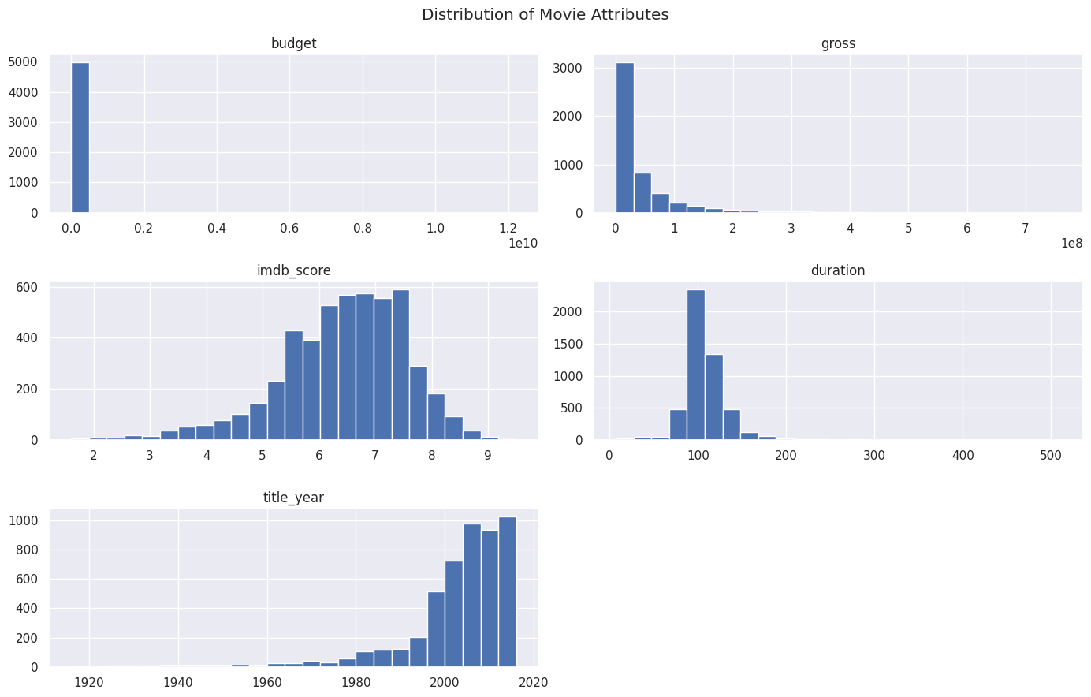
Figure 1. Histograms of budget, gross, IMDb score, duration and release year.
- Budget and gross: both pile up near zero with a long right tail. The budget histogram is dominated by a handful of extreme values (up to 1.2 x 10^10), so almost all films fall in a single bar.
- IMDb score: approximately bell-shaped but slightly left-skewed, peaking between 6.5 and 7.5, with few films below 4 or above 8.5.
- Duration: tightly clustered around 90-120 minutes; a small number of very long films stretch the axis out to 500 minutes.
- Release year: the dataset is heavily weighted toward recent films, with roughly 1,000 titles in each of the latest bins, so conclusions mainly describe modern cinema.

6. Outlier Detection
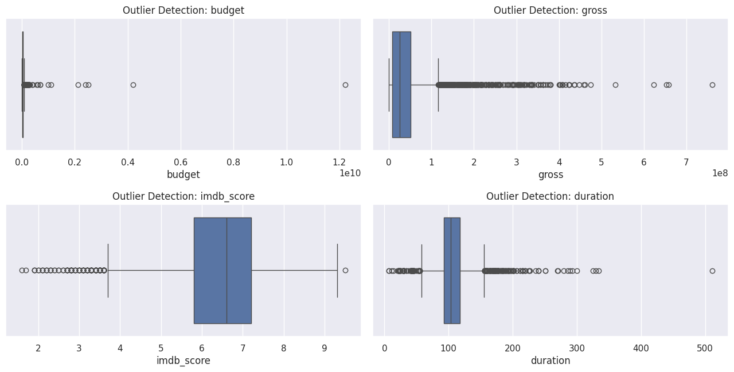
Figure 2. Box plots for budget, gross, IMDb score and duration.
Box plots confirm that gross and budget contain many high-value outliers. The budget outliers are the most extreme: a few records sit orders of magnitude above the rest, and the minimum budget (218) and minimum gross (162) are implausibly small for feature films. These patterns point to values recorded in different currencies or with unit errors, and they should be cleaned or capped before modelling. IMDb score outliers lie on the low side (below roughly 3.7), representing genuinely poorly rated films and arguably worth keeping. Duration outliers appear at both ends, from shorts of under an hour to a single film of more than 500 minutes.

7. Correlation Analysis
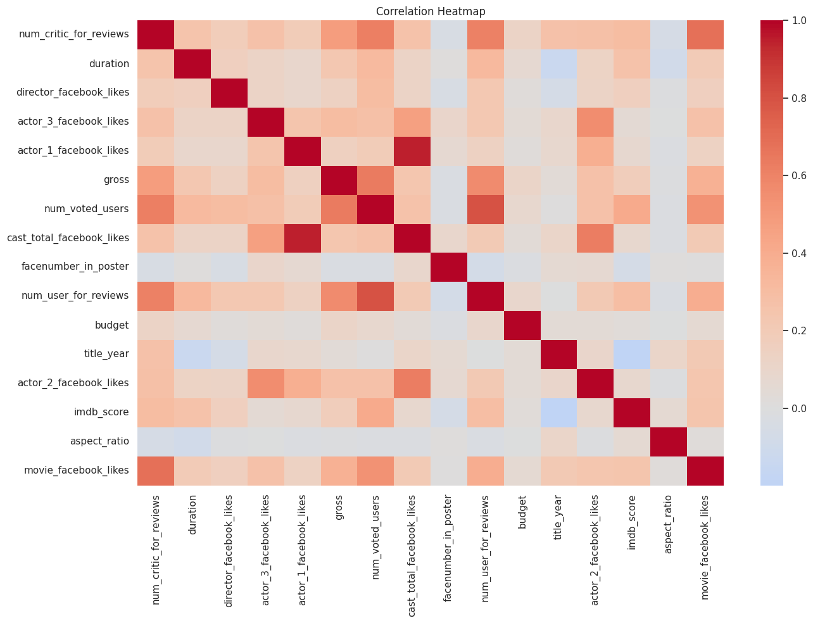
Figure 3. Correlation heatmap of all numeric variables.
- Strongest relationships are between engagement counts: num_voted_users with num_user_for_reviews (about 0.8) and num_critic_for_reviews (about 0.6), and actor_1_facebook_likes with cast_total_facebook_likes (above 0.9, close to redundant).
- Gross revenue is most associated with num_voted_users and num_user_for_reviews (roughly 0.5 - 0.6), meaning widely seen films attract more votes and revenue together.
- IMDb score shows only a moderate link with num_voted_users (around 0.4) and a mild negative link with title_year, suggesting older films tend to be rated slightly higher.
- Budget appears almost uncorrelated with everything, which is an artefact of its extreme outliers rather than evidence that spending does not matter.

8. Budget vs Gross, Genres and Ratings
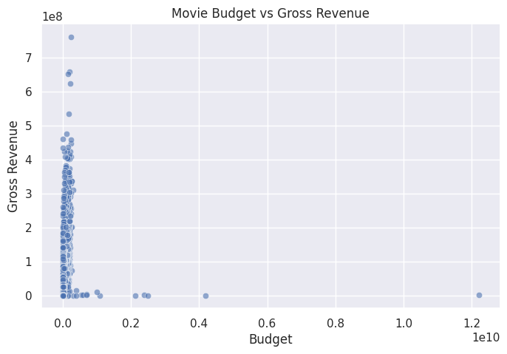  Figure 4. Budget vs gross revenue. | 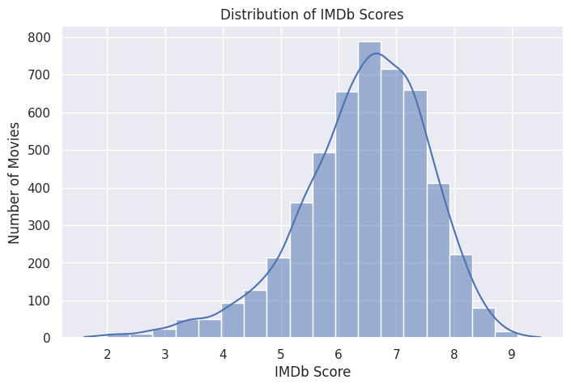  Figure 5. Distribution of IMDb scores.
Budget vs gross. The scatter plot shows no clear linear relationship: nearly all films cluster at low budgets while gross varies widely, and the few very-high-budget points earn almost nothing, again pointing to currency or data-entry issues. A log scale and a currency-cleaned budget would give a far more useful view.
IMDb scores. Scores follow a near-normal curve with a mean of 6.44 and median of 6.6; half of all films fall between 5.8 and 7.2, so high scores of 8 and above are relatively rare.
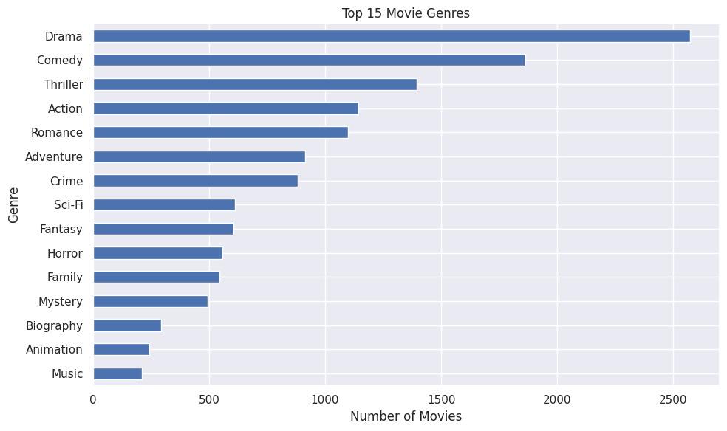
Figure 6. Top 15 genres by number of movies.
Drama is the most common genre (roughly 2,500 films), followed by Comedy, Thriller, Action and Romance. Niche genres such as Animation, Biography and Music sit at the bottom of the top 15, each with only a few hundred titles.

9. Key Findings and Next Steps
- The data is complete and unique at row level, but zeros in the likes columns and extreme budget values need treatment.
- Audience engagement (votes and reviews) is the strongest signal for both revenue and rating, making it a promising feature set.
- Skewed variables (budget, gross) should be log-transformed, and budget values should be standardised to a single currency before modelling.
- Highly correlated features, such as actor_1 likes and total cast likes, should be reduced to limit multicollinearity.
- Recommended next stage: feature engineering (genre encoding, decade, log budget), then baseline models for IMDb score and gross revenue.

