NIT6160 Data Warehousing and Mining
Project – Health Dataset Analysis and Prediction
Predicting Cardiovascular Disease from Clinical, Demographic and Lifestyle Factors using Machine Learning
Student name: Sunil Sapkota
Student ID: [enter student ID]
Term H8W4, 2026

Table of Contents
1. Introduction
2. Task 1 – Dataset Selection
3. Task 2 – Literature Survey and Research Questions
3.1 Literature survey
3.2 Research questions
4. Task 3 – Data Exploration
4.1 Structure and missing data
4.2 Central tendency and dispersion
4.3 Data quality and outliers
4.4 Pre-processing
5. Task 4 – Data Visualisation
6. Task 5 – Machine Learning Models and Performance Evaluation
6.1 Model selection and justification
6.2 Data splitting and tuning
6.3 Test-set evaluation
6.4 Feature importance
6.5 Model comparison and selection
7. Task 6 – Interpretation, Discussion and Conclusion
7.1 Summary of findings
7.2 Implications
7.3 Limitations
7.4 Future research directions
7.5 Conclusion
References

1. Introduction
Cardiovascular diseases (CVDs) are the leading cause of death worldwide. The World Health Organization estimates that they cause about 17.9 million deaths each year, roughly 32% of all global deaths [1]. Most of these deaths are linked to modifiable risk factors such as high blood pressure, raised cholesterol, obesity, physical inactivity and tobacco use. Identifying at-risk individuals early from routinely collected measurements is therefore a high-value use of data mining in healthcare.
This project applies a complete machine learning workflow to a public cardiovascular dataset of 70,000 patient examinations [2]. The workflow covers data selection, literature-informed research questions, exploratory analysis, data quality assessment and pre-processing, visualisation, supervised classification with three tuned models, and interpretation of feature importance. The objectives are (i) to identify the demographic, clinical and lifestyle factors most strongly associated with CVD, and (ii) to build and compare models that predict the presence of CVD, weighing predictive performance against interpretability. All analysis was performed in Python (pandas, scikit-learn [8], matplotlib/seaborn) in the accompanying Jupyter Notebook.

2. Task 1 – Dataset Selection
The Cardiovascular Disease dataset published on Kaggle by S. Ulianova [2] was selected. It contains 70,000 records and 11 input features, which the dataset owner groups into three types: objective (factual) information, results of a medical examination, and information given by the patient. The binary target cardio indicates the presence (1) or absence (0) of cardiovascular disease. The dataset covers every variable group suggested in the brief, namely demographics, clinical measurements, lifestyle factors and a health outcome. It is large enough for reliable cross-validation, and it has a balanced target.
Table 1. Variables in the Cardiovascular Disease dataset
Group | Variable | Description / encoding
Demographic | age | Age in days (converted to years: 29.6–64.9)
Demographic | gender | 1 = female, 2 = male
Objective | height, weight | Height (cm), weight (kg)
Clinical | ap_hi, ap_lo | Systolic and diastolic blood pressure (mmHg)
Clinical | cholesterol | 1 = normal, 2 = above normal, 3 = well above normal
Clinical | gluc | Glucose: 1 = normal, 2 = above normal, 3 = well above normal
Lifestyle (self-reported) | smoke, alco, active | Smoking, alcohol intake, physical activity (0/1)
Outcome | cardio | Presence of cardiovascular disease (0/1)

The file uses a semicolon delimiter and includes an id column, which was dropped. The dataset was shown to the lecturer for confirmation of its suitability, as the brief requires.

3. Task 2 – Literature Survey and Research Questions

3.1 Literature survey
Bhatt et al. (2023) [3] used the same 70,000-record Kaggle dataset. They applied k-modes clustering (Huang initialisation) to group patients before classification, then trained Decision Tree, Random Forest, XGBoost and Multilayer Perceptron models tuned with GridSearchCV on an 80:20 split. They reported accuracies of 86–87% and AUC of about 0.95, with the MLP highest at 87.28% under cross-validation. These results are much higher than most other studies of this dataset report, which suggests that their clustering and pre-processing pipeline strongly shapes the reported performance. It is a reminder that results must be compared on equal pre-processing terms.
Kahraman (2025) [4] merged the 70,000-sample CVD dataset with the CDC-derived Diabetes Health Indicators dataset on common features, producing 311,710 records after cleaning. Ten models were compared, including Random Forest, gradient boosting variants, a deep neural network and a voting ensemble, all tuned with GridSearchCV. CatBoost achieved the highest AUC (about 0.94). The study shows that integrating data sources and using boosted tree ensembles can raise performance, and that tree-based ensembles generally outperform linear baselines on this kind of tabular health data.
Ramesh et al. (2025) [5] carried out a comparative analysis on 68,119 cleaned records of the same CVD data. They used Logistic Regression mainly to identify risk factors and CatBoost for prediction. CatBoost reached an accuracy of 0.734 with very good probability calibration (expected calibration error 0.0064, Brier score 0.182). Their result after careful outlier cleaning is very close to the ~73–74% accuracy obtained in this project. It highlights that calibrated, interpretable risk estimates matter as much as raw accuracy in clinical use.
Clinically, the large meta-analysis by Lewington et al. [6] of one million adults showed that vascular mortality rises steadily with usual blood pressure at every age, without a lower threshold. This provides strong prior evidence that blood pressure should be a dominant predictor.
Research gap. Reported accuracies on this dataset range from about 72% to over 87%, largely because of undocumented differences in outlier handling and pre-processing. There is a need for a transparent pipeline with clinically justified cleaning rules, cross-validated tuning, and an explicit comparison of interpretable and complex models.

3.2 Research questions
- RQ1. What are the most significant factors associated with the presence of cardiovascular disease?
- RQ2. Is there a relationship between demographic factors (age, gender) and CVD?
- RQ3. How do lifestyle factors (smoking, alcohol intake, physical activity) relate to CVD?
- RQ4. Which variables contribute most to the predictive accuracy of the machine learning models?
- RQ5. Can machine learning models effectively predict CVD, and which model offers the best balance of accuracy and interpretability?

4. Task 3 – Data Exploration

4.1 Structure and missing data
The dataset was loaded with pandas: 70,000 rows × 13 columns, all numeric (11 integer, weight float). The file is loaded through a validating load_data() function that checks the column schema, numeric types, unique ids and that the target contains only 0/1, so a wrong file or separator fails immediately. There are no missing values, and there are 24 duplicate records once id is ignored. There are 41 repeated predictor profiles, 17 of which carry conflicting labels (identical inputs, different outcome). The target is perfectly balanced: 35,021 without CVD and 34,979 with CVD, i.e. 50.0% each. Women make up 65% of records. Gender code 2 has the higher mean height (169.9 cm vs 161.4 cm), which confirms that 2 = male.

4.2 Central tendency and dispersion
Table 2. Central tendency and dispersion of continuous variables (raw data)
Variable | Mean | Median | Std | Min | Max | IQR | Skew
Age (years) | 53.30 | 53.9 | 6.76 | 29.6 | 64.9 | 10.0 | -0.31
Height (cm) | 164.36 | 165.0 | 8.21 | 55 | 250 | 11.0 | -0.64
Weight (kg) | 74.21 | 72.0 | 14.40 | 10 | 200 | 17.0 | 1.01
Systolic BP (ap_hi) | 128.82 | 120.0 | 154.01 | -150 | 16,020 | 20.0 | 85.30
Diastolic BP (ap_lo) | 96.63 | 80.0 | 188.47 | -70 | 11,000 | 10.0 | 32.11

Age is roughly symmetric, and its mean and median are close. Weight is moderately right-skewed. The blood pressure variables are the critical finding. Their medians (120/80 mmHg) are clinically normal, but their standard deviations exceed 150 mmHg, with skewness of 85 and 32 and kurtosis above 1,400. These extreme values come from a small number of impossible readings: negative pressures, values in the thousands (probably typing errors such as 1200 for 120), and diastolic readings above systolic. The categorical variables are dominated by the 'normal' level (cholesterol 74.8% normal, glucose 85.0% normal), and only 8.8% of people report smoking and 5.4% report drinking alcohol.

4.3 Data quality and outliers
Table 3. Implausible values detected
Rule | Rows | % of data
Systolic BP outside 80–250 mmHg | 247 | 0.35
Diastolic BP outside 40–160 mmHg | 1,025 | 1.46
Diastolic > systolic | 1,234 | 1.76
Height outside 120–220 cm | 53 | 0.08
Weight outside 30–200 kg | 7 | 0.01

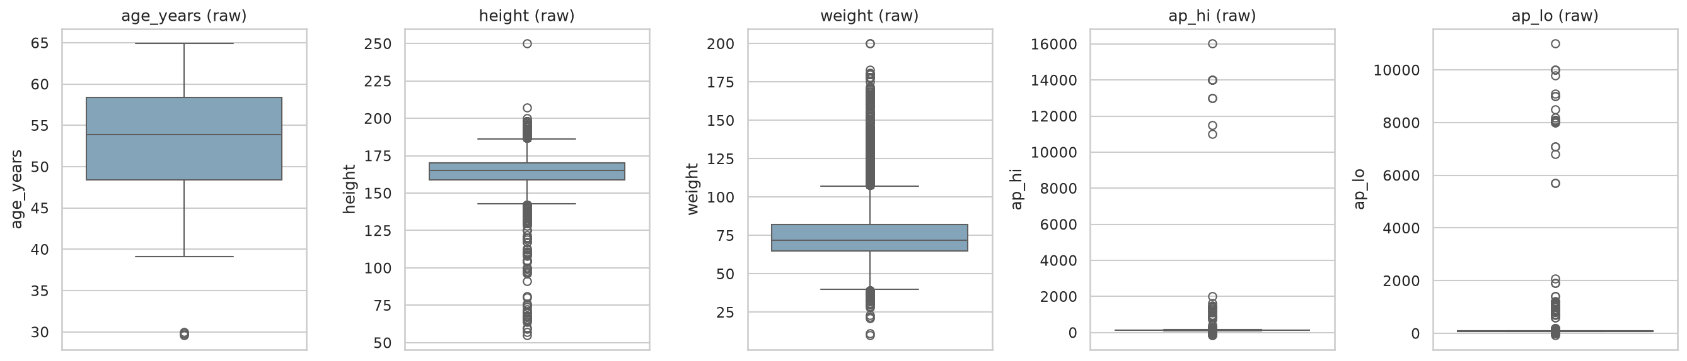
Figure 1. Box plots of raw continuous variables, showing extreme blood pressure outliers
All rules are implemented once, in a quality_flags() function with the limits held in a single configuration constant, so the audit and the cleaning step use exactly the same definitions. The data therefore has a hidden quality problem. Nothing is missing, but some values are invalid. A purely statistical 1.5×IQR rule would flag 4,632 diastolic and 1,435 systolic values, many of them genuine hypertensive patients, who are exactly the high-risk cases the model needs to learn from. Clinical plausibility rules were therefore used instead of IQR trimming.

4.4 Pre-processing
- Removed 24 duplicate records.
- Removed 1,334 records with implausible blood pressure (systolic 80–250, diastolic 40–160, systolic ≥ diastolic).
- Removed 59 records with implausible height, weight or BMI (height 120–220 cm, weight 30–200 kg, BMI 10–70).
- Engineered features: age in years, BMI = weight / height², pulse pressure = systolic − diastolic, and gender recoded as a binary male variable.
- Standardised features with StandardScaler inside a scikit-learn Pipeline, so that scaling is fitted only on training folds and does not leak test information.
These steps are wrapped in a single clean() function that returns a log of how many rows each rule removed and asserts that every rule holds on its output. The limits were fixed in advance from clinical plausibility, not chosen to improve model scores.
The cleaned dataset retains 68,583 records (97.98%), and the target stays balanced (49.5% CVD). After cleaning, systolic BP has mean 126.7 mmHg (SD 16.7) and diastolic has mean 81.3 mmHg (SD 9.4), which are realistic population values. Mean BMI is 27.5 kg/m² (overweight range).

5. Task 4 – Data Visualisation
Figure 2 compares the distributions of each continuous variable between patients with and without CVD. The CVD group is visibly shifted towards older age, higher weight and BMI, and especially higher systolic and diastolic blood pressure. The BP histograms are 'spiky' because readings are rounded to multiples of 10 mmHg, a measurement artefact that is worth noting. Height shows almost no separation.
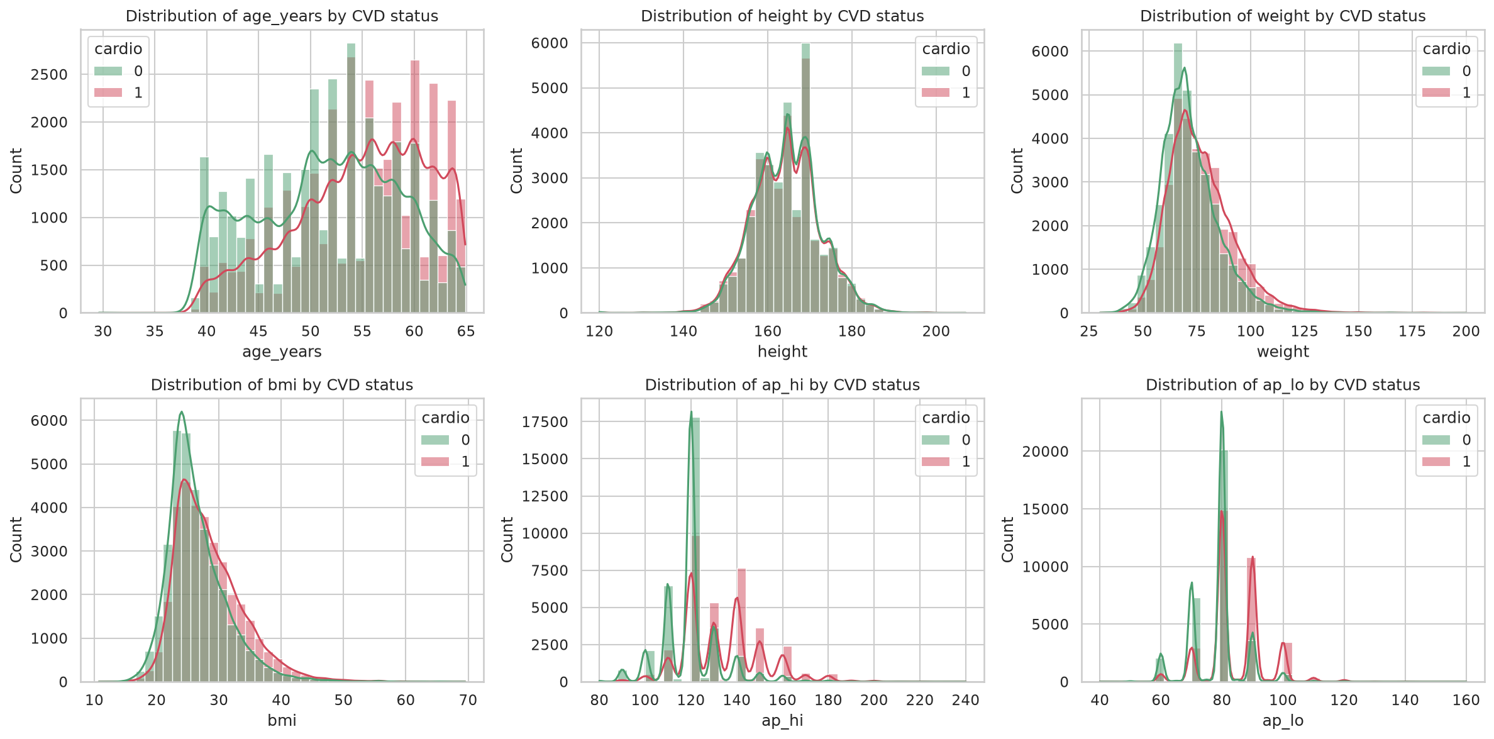
Figure 2. Distributions of continuous variables by CVD status (green = no CVD, red = CVD)
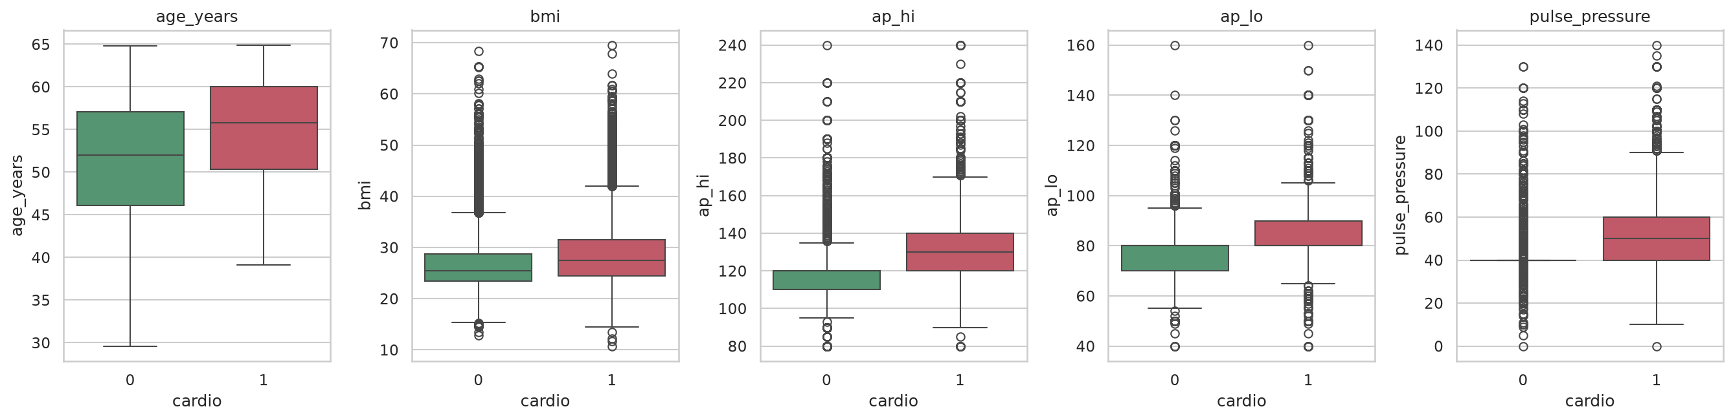
Figure 3. Box plots of key continuous variables by CVD status (cleaned data)
Figure 4 shows CVD prevalence by categorical factor. Cholesterol has a clear dose-response pattern (43.5% → 59.6% → 76.2%), and glucose has a weaker one (47.6% → 58.9% → 61.8%). Gender makes almost no difference (49.2% vs 50.0%). Physical activity is mildly protective (53.3% inactive vs 48.5% active). Smoking (46.8% vs 49.7%) and alcohol (47.7% vs 49.6%) show slightly lower prevalence among users, a counter-intuitive pattern discussed in Section 7.
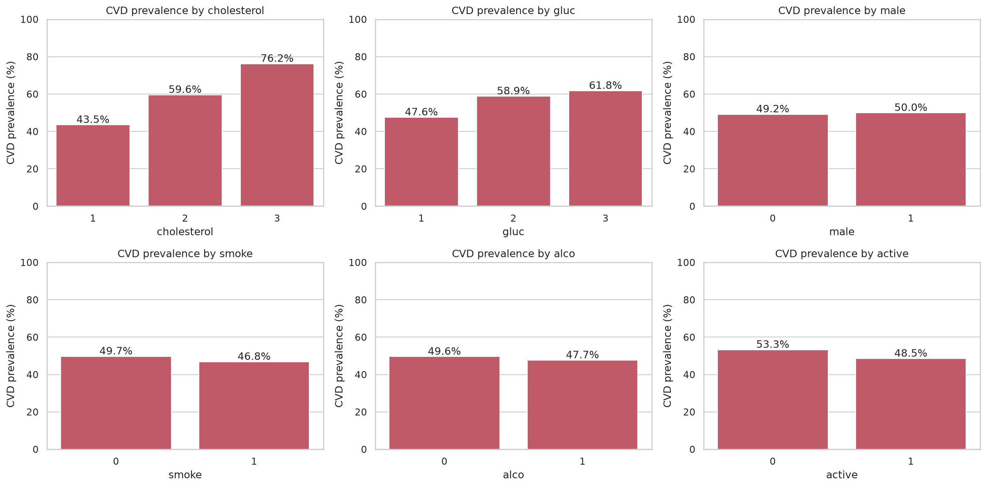
Figure 4. CVD prevalence (%) by cholesterol, glucose, gender and lifestyle factors
The line graphs in Figure 5 show strong monotonic trends. CVD prevalence rises from about 24% at age ≤ 40 to about 67% at 60–65, and from 40% at normal BMI to 69% at BMI ≥ 40. Prevalence by systolic BP band is even steeper: 23% below 120 mmHg, 36% at 120–129, 60% at 130–139, 83% at 140–159 and 86% at ≥ 160 mmHg.
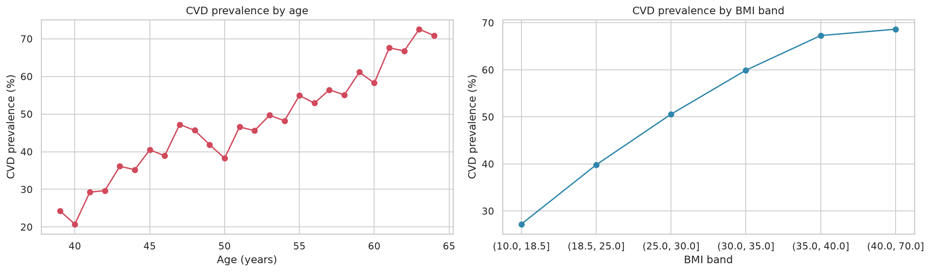
Figure 5. CVD prevalence trend by age and by BMI band
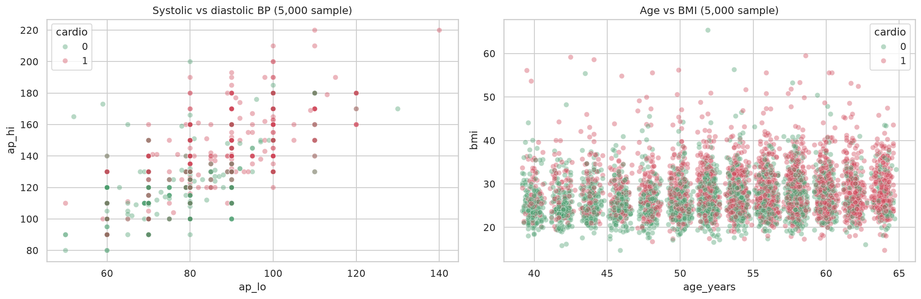
Figure 6. Scatter plots: systolic vs diastolic BP and age vs BMI (random sample of 5,000)
The scatter plot of systolic against diastolic BP (Figure 6) shows the two are strongly related (r = 0.73), and CVD cases concentrate in the upper-right region. The correlation matrix (Figure 7) confirms the ranking of linear associations with the target: systolic BP (0.43), diastolic BP (0.34), pulse pressure (0.34), age (0.24), cholesterol (0.22), BMI (0.19) and weight (0.18). Lifestyle variables and gender have correlations below 0.04. Statistical tests showed that all clinical variables and age differ significantly between groups (Mann–Whitney U, p < 0.001; rank-biserial effect 0.50 for systolic BP). Gender is not significant (χ², p = 0.06).
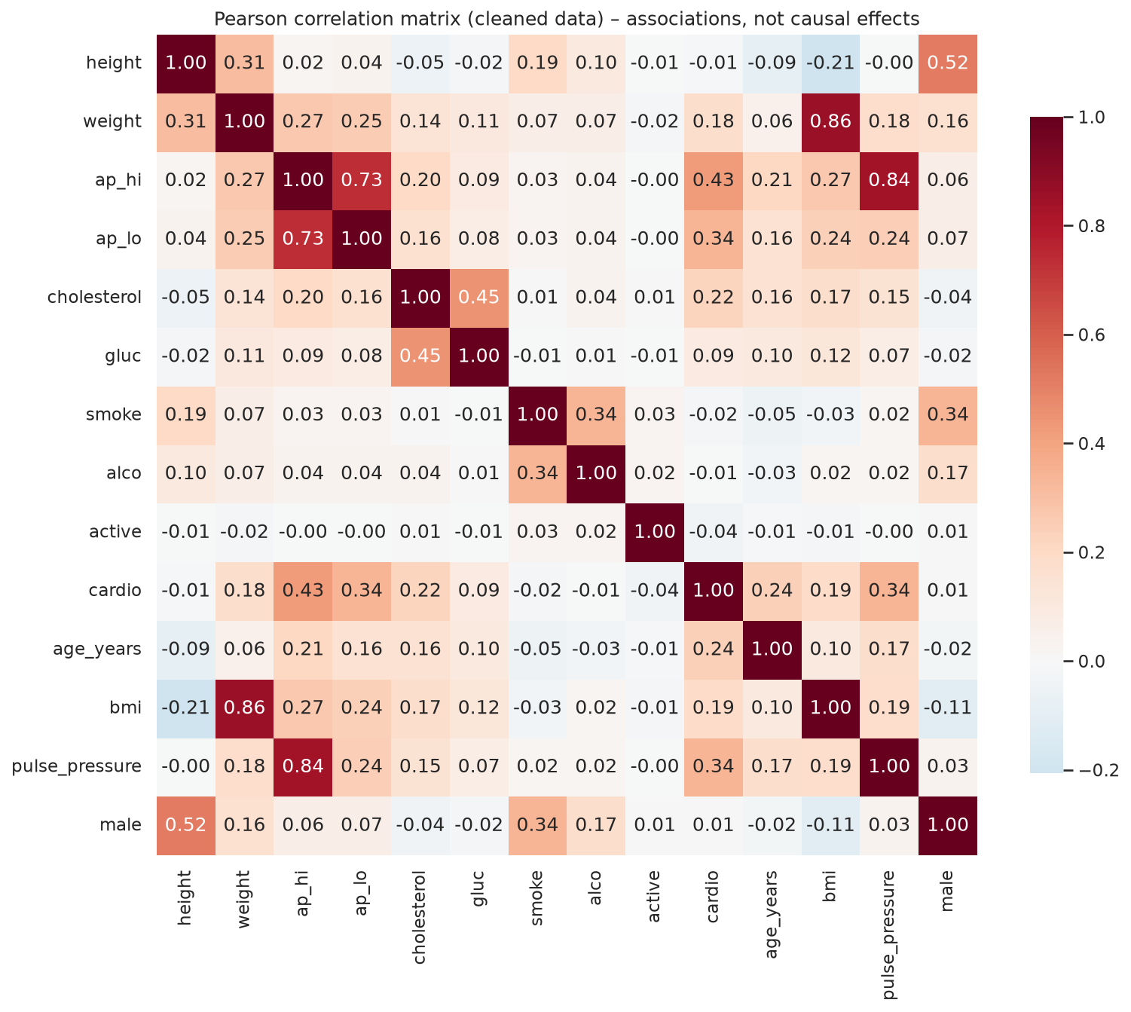
Figure 7. Pearson correlation matrix of the cleaned features and target

6. Task 5 – Machine Learning Models and Performance Evaluation

6.1 Model selection and justification
- Logistic Regression (LR) – an interpretable linear baseline for binary classification. Its standardised coefficients translate into odds ratios that clinicians can understand.
- Random Forest (RF) [7] – an ensemble of decision trees that captures non-linear relationships and interactions (e.g. age × blood pressure). It is robust to residual outliers and provides feature importances.
- Neural Network (Multilayer Perceptron, MLP) – a flexible non-linear model suited to the large sample size. It is the least interpretable of the three and tests whether extra complexity is worthwhile.
A kernel Support Vector Machine was considered but not used. Its training cost grows roughly quadratically with sample size, which makes cross-validated tuning on about 55,000 training rows impractical.

6.2 Data splitting and tuning
The cleaned data was split 80/20 with stratification and grouping (StratifiedGroupKFold; 54,867 training, 13,716 test records), preserving the 49.5% CVD rate in both sets. Records with an identical predictor profile share a group, so the same inputs can never appear in both training and test data; the code asserts this. The test set was used once, after all tuning was finished. Hyperparameters were tuned on the training set only, using 5-fold stratified group cross-validation with ROC-AUC as the selection metric. LR used GridSearchCV over regularisation strength C ∈ {0.001 … 10} and L1/L2 penalty. RF and MLP used RandomizedSearchCV over tree depth, number of trees, minimum leaf size and features per split (RF), and over hidden layer sizes, L2 penalty alpha and learning rate (MLP, with early stopping).
Table 4. Best hyperparameters and cross-validated ROC-AUC
Model | Best hyperparameters | CV ROC-AUC
Logistic Regression | C = 0.001, L2 penalty (liblinear) | 0.7919
Random Forest | 300 trees, max_depth = 10, min_samples_leaf = 20, max_features = 0.5 | 0.8009
Neural Network (MLP) | hidden layers (64, 32), alpha = 0.1, learning rate = 0.003 | 0.8005

Table 5. 5-fold cross-validation on training set (mean ± standard deviation)
Model | Accuracy | Precision | Recall | F1 | ROC-AUC
Logistic Regression | 0.728 ± 0.003 | 0.755 ± 0.004 | 0.666 ± 0.005 | 0.708 ± 0.003 | 0.792 ± 0.002
Random Forest | 0.735 ± 0.003 | 0.754 ± 0.005 | 0.689 ± 0.006 | 0.720 ± 0.003 | 0.801 ± 0.002
Neural Network (MLP) | 0.735 ± 0.003 | 0.750 ± 0.005 | 0.695 ± 0.013 | 0.722 ± 0.005 | 0.801 ± 0.002

The very small standard deviations (about 0.002–0.013) show that the models are stable across folds and are not overfitting to particular subsets of the data.

6.3 Test-set evaluation
Table 6. Performance on the held-out test set (13,716 records)
Model | Acc. | Prec. | Recall | F1 | AUC | AP | Brier
Dummy (prior) | 0.505 | 0.000 | 0.000 | 0.000 | 0.500 | 0.495 | 0.250
Logistic Regression | 0.726 | 0.755 | 0.662 | 0.705 | 0.788 | 0.771 | 0.188
Random Forest | 0.735 | 0.755 | 0.689 | 0.720 | 0.798 | 0.783 | 0.182
Neural Network (MLP) | 0.731 | 0.733 | 0.717 | 0.725 | 0.797 | 0.777 | 0.183

Acc. = accuracy, Prec. = precision, AUC = ROC-AUC, AP = average precision. Average precision summarises the precision–recall curve, and the Brier score is the mean squared error of the predicted probabilities (lower is better calibrated). The dummy classifier, which always predicts the training prevalence, gives the floor every model must beat: all three models improve on it by a wide margin.
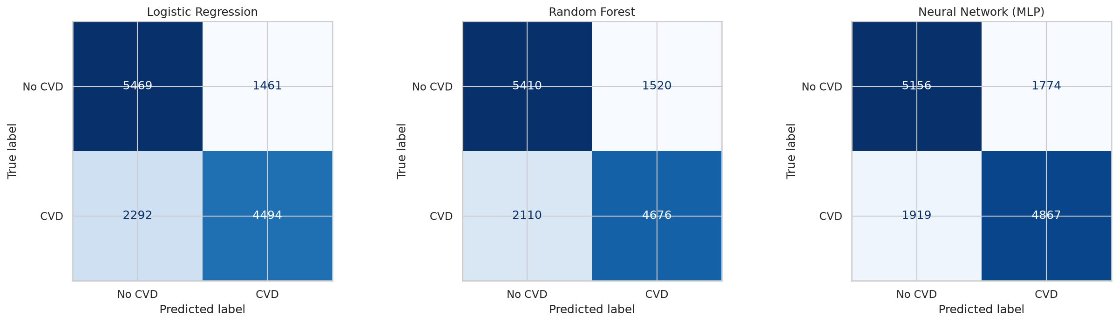
Figure 8. Confusion matrices on the test set
Test results closely match the cross-validation estimates, which confirms that the models generalise. Logistic Regression and Random Forest have higher precision (0.75) than recall (0.66–0.69). In other words, they miss more CVD cases (false negatives) than they wrongly flag healthy patients. The MLP is more balanced (precision 0.73, recall 0.72). The confusion matrices show this asymmetry. This is consistent with the overlap in the data: many CVD patients have normal recorded blood pressure and cholesterol, so their disease cannot be detected from these features alone.
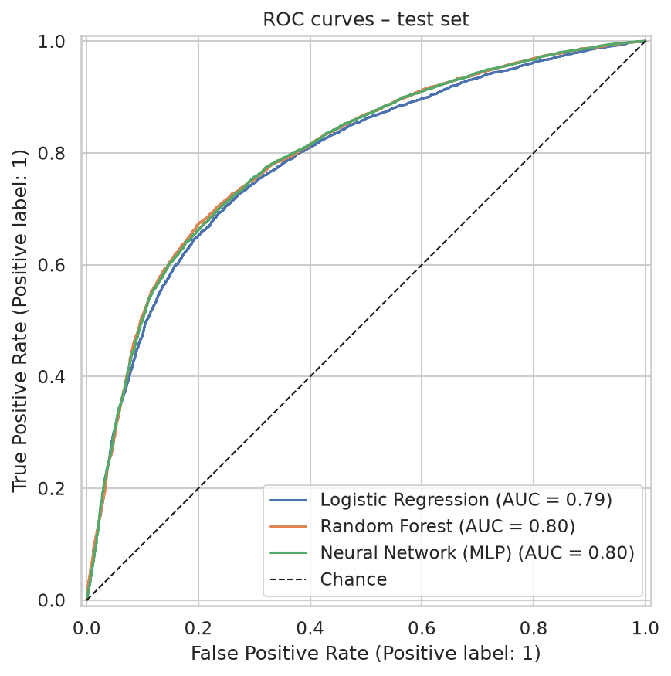
Figure 9. ROC curves of the three tuned models on the test set
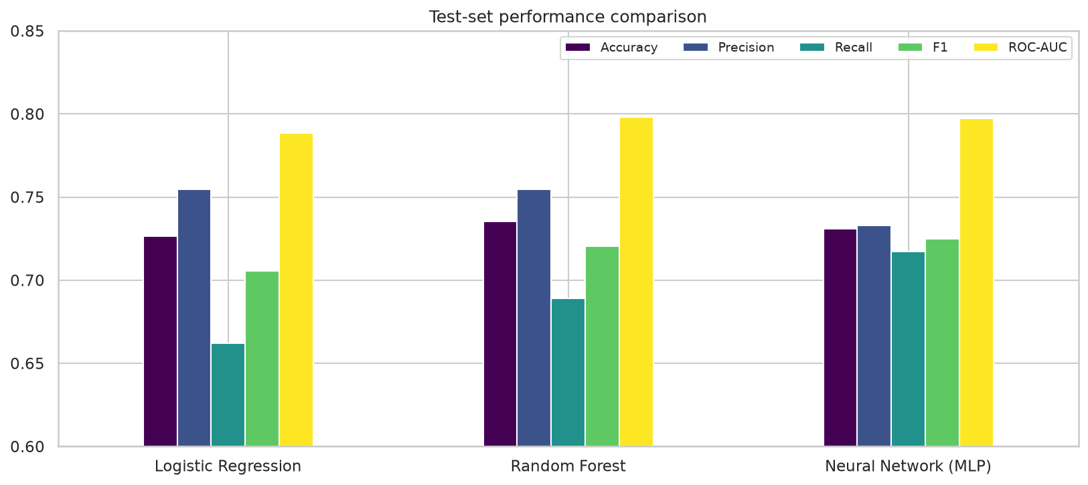
Figure 10. Comparison of test-set metrics across models

6.4 Feature importance
Table 7. Logistic Regression standardised coefficients (odds ratio per 1 SD increase)
Feature | Coefficient | Odds ratio
Systolic BP (ap_hi) | 0.425 | 1.53
Diastolic BP (ap_lo) | 0.361 | 1.43
Age (years) | 0.320 | 1.38
Pulse pressure | 0.315 | 1.37
Cholesterol | 0.293 | 1.34
Physically active | -0.088 | 0.92
Weight | 0.081 | 1.08
BMI | 0.075 | 1.08
Alcohol | -0.046 | 0.96
Glucose | -0.041 | 0.96
Smoking | -0.033 | 0.97
Male, height | ≈ 0.000 | 1.00

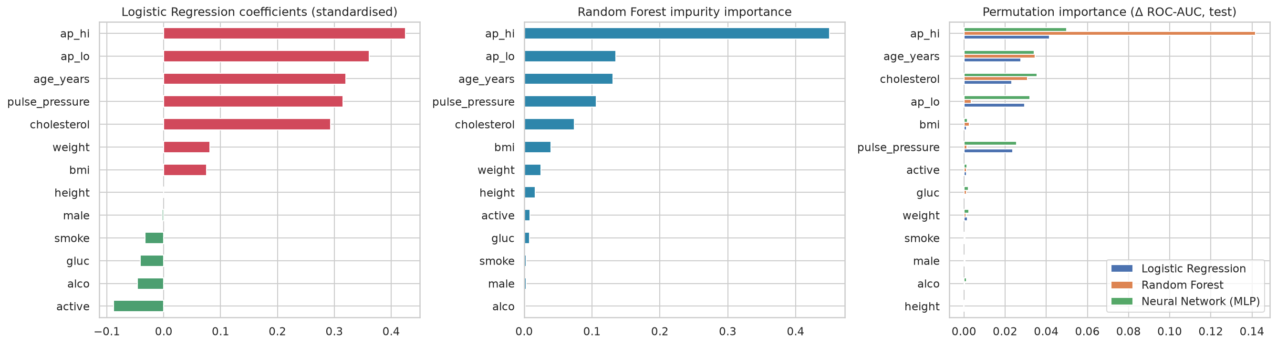
Figure 11. Feature importance: LR coefficients, RF impurity importance and permutation importance (drop in test ROC-AUC)
All three importance methods agree on the ranking. Systolic BP dominates: permuting it reduces test ROC-AUC by 0.14 for RF, 0.05 for the MLP and 0.04 for LR. It is followed by age, cholesterol and diastolic BP / pulse pressure. The lifestyle variables, gender and height contribute almost nothing. The tuned Logistic Regression is strongly regularised (C = 0.001), which spreads the weight across the three correlated blood pressure variables (systolic, diastolic and pulse pressure, which is their difference) instead of concentrating it on one. Their combined effect is what matters, which is why the importance values for these variables must be read together.

6.5 Model comparison and selection
Random Forest achieved the best test accuracy (0.735), ROC-AUC (0.798) and Brier score (0.182). The MLP was practically tied (ROC-AUC 0.797) and had the highest recall (0.717) and F1 (0.725). Logistic Regression trailed by about one percentage point in accuracy and 0.010 in AUC. Random Forest is selected as the final predictive model because it performs best, needs no feature scaling, and is robust to the remaining noise. However, the small gap means that Logistic Regression is a defensible alternative where transparency is the priority, because its odds ratios can be explained directly to clinicians and patients. The MLP adds complexity and reduces interpretability without a measurable gain, so it is not preferred.

7. Task 6 – Interpretation, Discussion and Conclusion

7.1 Summary of findings
- RQ1 – Significant factors: Systolic blood pressure is the strongest factor associated with CVD, followed by diastolic BP/pulse pressure, age, cholesterol, BMI/weight and glucose. All are significant at p < 0.001. This agrees with the clinical evidence that risk rises continuously with blood pressure [6].
- RQ2 – Demographics: Age is strongly associated with CVD (prevalence rises from 24% to 67%, and each extra 6.8 years multiplies the odds by about 1.38). Gender shows no significant association in this dataset.
- RQ3 – Lifestyle: Physical activity is weakly protective. Smoking and alcohol show tiny, counter-intuitive negative associations. These most likely reflect self-report bias (under-reporting), confounding (smokers here are 22% of men but only 2% of women) and reverse causation (diagnosed patients quitting). They should not be read as protective effects.
- RQ4 – Predictive contribution: Systolic BP, age, cholesterol and diastolic BP provide nearly all of the predictive power. The lifestyle variables add almost nothing.
- RQ5 – Model performance: The tuned models predict CVD with about 73–74% accuracy and an AUC of about 0.80. This is a moderate but realistic level, consistent with studies that apply rigorous cleaning [5]. Random Forest is best, but Logistic Regression is nearly as accurate and far more interpretable.

7.2 Implications
The findings support prevention strategies that focus on blood pressure control, cholesterol management and weight reduction, especially for people over 50. Because the strongest predictors are cheap, routine measurements, a model like this could serve as a low-cost screening tool in primary care or community health programmes, flagging patients for follow-up investigation. With a recall of about 0.69 (Random Forest), roughly one in three CVD cases would be missed at the default threshold. For screening, the decision threshold should be lowered to favour recall, accepting more false positives in exchange for fewer missed cases.

7.3 Limitations
- Data quality: about 2% of records contained impossible values, which raises doubts about how accurately the remaining values were entered. Blood pressure readings are rounded to 10 mmHg.
- Coarse and self-reported variables: cholesterol and glucose are 3-level categories rather than laboratory values. Smoking, alcohol and activity are binary self-reports that are prone to bias.
- Unknown provenance: the population, collection method and definition of 'CVD' are not documented, so the results may not generalise to other populations. Women make up 65% of the sample.
- Cross-sectional design: the associations found are not causal, and the outcome may already have influenced behaviour (reverse causation).
- Missing predictors: the performance ceiling of about 73–74% suggests that important information, such as family history, medication, lipid sub-fractions and ECG findings, is absent. The very high accuracies reported elsewhere [3] could not be reproduced with standard pre-processing.

7.4 Future research directions
- Add richer clinical and longitudinal data, and validate the model externally on populations from other countries.
- Evaluate gradient-boosted models (XGBoost, LightGBM, CatBoost), which performed well in [4], [5], together with threshold optimisation and probability calibration.
- Apply SHAP-based explanations for patient-level interpretability, and use unsupervised clustering to discover risk phenotypes.

7.5 Conclusion
This project showed that, after careful data quality assessment and clinically justified cleaning, machine learning can predict cardiovascular disease from routine measurements with about 74% accuracy and a ROC-AUC of about 0.80, using a reproducible pipeline with validated loading, documented exclusion rules and a leakage-safe group split. Blood pressure, age and cholesterol are the key drivers. Random Forest gave the best performance, but a simple Logistic Regression achieved nearly identical results with far greater interpretability. In healthcare, transparent models can therefore be just as useful as complex ones.

References
[1] World Health Organization, “Cardiovascular diseases (CVDs),” Fact sheet, Jun. 2021. [Online]. Available: https://www.who.int/news-room/fact-sheets/detail/cardiovascular-diseases-(cvds)
[2] S. Ulianova, “Cardiovascular Disease dataset,” Kaggle, 2019. [Online]. Available: https://www.kaggle.com/datasets/sulianova/cardiovascular-disease-dataset
[3] C. M. Bhatt, P. Patel, T. Ghetia, and P. L. Mazzeo, “Effective heart disease prediction using machine learning techniques,” Algorithms, vol. 16, no. 2, Art. no. 88, Feb. 2023, doi: 10.3390/a16020088.
[4] A. Kahraman, “Machine learning techniques for improved prediction of cardiovascular diseases using integrated healthcare data,” Frontiers in Artificial Intelligence, vol. 8, Art. no. 1694450, Dec. 2025, doi: 10.3389/frai.2025.1694450.
[5] R. S. Ramesh, R. T. S. Udupa, M. J, and K. K. S. Kushi, “Cardiovascular disease prediction using machine learning: A comparative analysis,” arXiv preprint arXiv:2507.21898, Jul. 2025.
[6] S. Lewington, R. Clarke, N. Qizilbash, R. Peto, and R. Collins, “Age-specific relevance of usual blood pressure to vascular mortality: A meta-analysis of individual data for one million adults in 61 prospective studies,” The Lancet, vol. 360, no. 9349, pp. 1903–1913, 2002.
[7] L. Breiman, “Random forests,” Machine Learning, vol. 45, no. 1, pp. 5–32, 2001.
[8] F. Pedregosa et al., “Scikit-learn: Machine learning in Python,” Journal of Machine Learning Research, vol. 12, pp. 2825–2830, 2011.

