**Project**: Test Automation for Gurukula website

**Tools used:** Java + Selenium + TestNG +log4j

**1 .Framework**

I have used a simple method to create framework. It uses Page Object Model. By using the page object model we can make non-brittle test code and reduce or eliminate duplicate test code. Beside of that it improves the readability and allows us to create interactive documentation.

The structure is as follows.

1. Framework Package: In this page we can specify all the actions that will be used for interacting with browser and also some helper functions that can be reused.
2. Pages Package: Here , we can specify each pages separately.So each page can have its own methods and Locators.
3. Test Package: Here, we can write the Test cases needed by using the method we already wrote for each pages.
4. Log4j.xml is used for logging purpose.
5. TestNG is used for Reporting , providing data and also for parallel execution

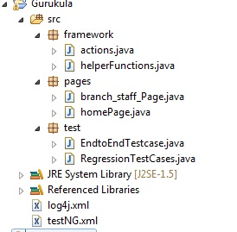

**2. TestNG FIle**

The TestNG Xml is as follows

In TestNG XML file ,

* you can specify the browser (firefox, chrome ,IE)
* You can pass username and password
* You can also pass the row number which you want to Edit, View or Delete in Gurukal website
* In classes ,you can specify all the test case file
  + Eg: test.EndtoEndTestcase ,test.Regressiontestcase

After Setting all the values , you can just right click the XML file and Select Run as TestNG suite.

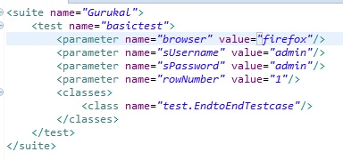

3. **Logs & Reports**

* The logs will be auto generated in main folder of project (log4j.xml)
* Reports will be generated in test-output folder in the main project folder (index.html, emailable-report.html ) generated by TestNG