# Dear Prof. Plum,

I hope that you are doing better than me. On ***7th April, 2022***, there is a special environment friendly party at AP0021, Kalmfins Block, Jamupa City

Please bring somethign to eat 😀. Some ideas:

* Bread and Wine
* Cake
* Emrosia
* Somras
* Nectar

### Please see below invitation image.

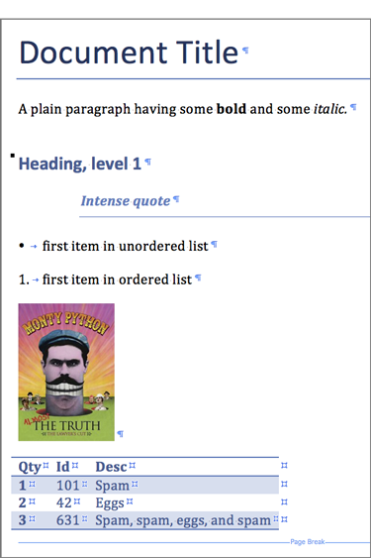

Tit for tats.

# Dear Miss Scarlet,

I hope that you are doing better than me. On ***7th April, 2022***, there is a special environment friendly party at AP0021, Kalmfins Block, Jamupa City

Please bring somethign to eat 😀. Some ideas:

* Bread and Wine
* Cake
* Emrosia
* Somras
* Nectar

### Please see below invitation image.



Tit for tats.

# Dear Col. Mustard,

I hope that you are doing better than me. On ***7th April, 2022***, there is a special environment friendly party at AP0021, Kalmfins Block, Jamupa City

Please bring somethign to eat 😀. Some ideas:

* Bread and Wine
* Cake
* Emrosia
* Somras
* Nectar

### Please see below invitation image.



Tit for tats.

# Dear James Bond,

I hope that you are doing better than me. On ***7th April, 2022***, there is a special environment friendly party at AP0021, Kalmfins Block, Jamupa City

Please bring somethign to eat 😀. Some ideas:

* Bread and Wine
* Cake
* Emrosia
* Somras
* Nectar

### Please see below invitation image.



Tit for tats.

# Dear Robocop,

I hope that you are doing better than me. On ***7th April, 2022***, there is a special environment friendly party at AP0021, Kalmfins Block, Jamupa City

Please bring somethign to eat 😀. Some ideas:

* Bread and Wine
* Cake
* Emrosia
* Somras
* Nectar

### Please see below invitation image.



Tit for tats.