**SKF**

https://www.skf.com/in

1. Home Page

1. Hit Products to go to the product page.

1. Hit Vehicle Aftermarket

1. Hit Find Out More that navigates to the Vehicle Info Page:

1. Vehicle Info Page

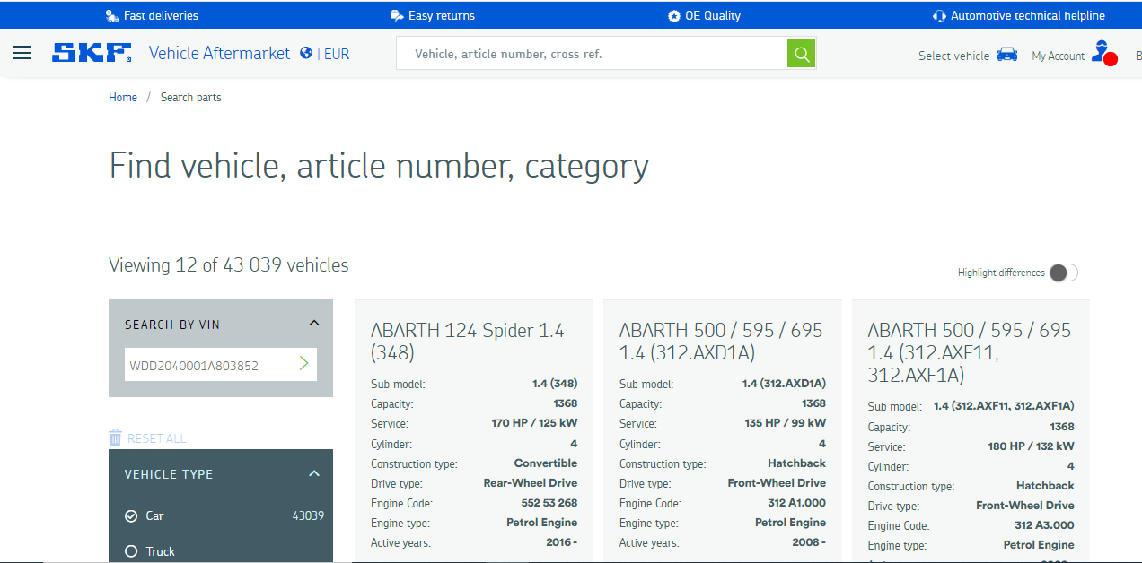

1. Select Vehicle Type, Manufacturer to view the application as you see on the right side.

1. Under the Vehicle Info you can see the products.

1. Scrap the data as given below from the circled info above.

|  |  |  |  |  |  |  |  |  |  |  |  |  |
| --- | --- | --- | --- | --- | --- | --- | --- | --- | --- | --- | --- | --- |
| **Make** | **Model** | **Sub model** | **Capacity** | **Service** | **Cylinder** | **Construction type** | **Drive type** | **Engine Code** | **Engine type** | **Active years** | **Part Description** | **Partno** |
| ABARTH | 124 Spider 1.4 (348) | 1.4 (348) | 1368 | 170 HP / 125 kW | 4 | Convertible | Rear-Wheel Drive | 552 53 268 | Petrol Engine | 2016 -2022 | Universal boot kit with Ear Clamps | VKJP 01001 S |
| ABARTH | 124 Spider 1.4 (348) | 1.4 (348) | 1368 | 170 HP / 125 kW | 4 | Convertible | Rear-Wheel Drive | 552 53 268 | Petrol Engine | 2016 -2022 | Universal boot kit | VKJP 01001 |

1. Repeat the same for other Vehicles and vehicle types.