**A**

**Summer Training Project Report**

**On**

**“THE MOVIES-MUSIC ZONE" Using HTML5 and CSS”**



**Guided by**

Mr. Rahul Sharma

Research Scientist

RRSCW-ISRO, Jodhpur

**Submitted by**

Pooja Mehta(III yr IT)

Govt. Women Engg. College,Ajmer

Bhupesh Mathur(III yr CS)

Swami Keshavnand Institute of Technology Management and Gramothan, Jaipur

Sunil Jhamnani(III yr EC)

Swami Keshavnand Institute of Technology Management and Gramothan, Jaipur

Preeti Pareek(III yr IT)

Govt. Women Engg. College,Ajmer

Sushila Saharan(III yr IT)

Govt. Women Engg. College,Ajmer

Kiran Choudhary(III yr IT)

Govt. Women Engg. College,Ajmer

Teena Sharma(III yr IT)

Govt. Women Engg. College,Ajmer

Yash Pal Singh(III yr ME)

Swami Keshavnand Institute of Technology Management and Gramothan, Jaipur

Chandra Shekhar Gehlot(III yr EC)

Jodhpur Institute of Engg. and Technology,Jodhpur

Contents

**1 Introduction** 5

1.1 A Brief History . . . . . . . . . . . . . . . . . . . . . . . . . . . . . . . . . 5

1.2 Projects undertaken . . . . . . . . . . . . . . . . . . . . . . . . . . . . . 6

**2 Remote Sensing** 7

2.1 Data acquisition techniques . . . . . . . . . . . . . . . . . .. . . . . 8

2.1.1 Applications of remote sensing data . . . . . . . . . . . . . . 8

2.1.2 Geodetic . . . . . . . . . . . . . . . . . . . . . . . . . . . . . . . . . . . 9

2.1.3 Acoustic and near-acoustic . . . . . . . . . . . .. . . . . . . . . 9

2.2 Data processing . . . . . . . . . . . . . . . . . . . . . . . . . . . . . . . 9

**3 Digital Image Processing** 11

3.1 What is an Image . . . . . . . . . . . . . . . . . . . . . . . . . . . . . 11

3.2 Image Processing Technique . . . . . . . . . . . . . . . . . . . . 12

3.2.1 Image Restoration . . . . . . . . ....... . . . . . . . . . . . . . . . 12

3.2.2 Image Enhancement . . . . . . . . . .. . . . . . . . . . . . . . . . 12

3.2.3 Information Extraction . . . . . . . . . . . . . . . . . . . . . . . . 13

**4 Global Positioning System(GPS)** 13

4.1 Principle of GPS . . . . . . . . . . . . . . . . . . . . . . . . . . . . . 14

4.1.1 Measuring signal transit time . . . . . . . . . . . . . . . . . . . 14

**5 Graphical Information System (GIS)** 16

5.1 GIS techniques and technology . . . . . . .. . . . . . . . . . . . . 16

5.1.1 Relating information from different sources . . . . . . . . . 17

5.1.2 GIS Uncertainties . . . . . . . . . . . . . . . . . . . . . . . . . . . . . 17

5.2 Data representation . . . . . . . . . . . . . . . . . . . . . . . . . . . . . 18

5.2.1 Raster . . . . . . . . . . . . . . . . . . . . . . . . . . . . . . . . . . . . . .18

5.2.2 Vector . . . . . . . . . . . . . . . . . . . . . . . . . . . . . . . . . . . . . .19

**6 Software Developement** 20

6.1 Software Development Process . . . . . . . . . . . . . . . .. . . 20

6.2 Software development activities . . . . . . . . . . . . . . . . .. ..21

6.2.1 Planning . . . . . . . . . . . . . . . . . . . . . . . . . . . . . . . . . . . .21

6.2.2 Implementation, testing and documenting . . . . . . . . . . 21

6.2.3 Deployment and maintenance . . . . . . . . . . . . . . . . . . 22

**7 Project Overview**  22

7.1 objective. .. . . . . . . . . . . ... . . . . . . . . . . . . . .. . . . . . . . . .22

7.2 Software and Hardware Requirements . . . . .. . .. . ... . . . 22

7.2.1.Software Required. . . . . . . . . . . . . . . . . . . . .. . . . . . . . 22

7.3.Overview of Programming Language. . . . .. . . . . . . . . . . 23

7.4Source Code ................................................................... 25

7.5 Screen Shots. . . .. ..........................................................

7.6.Conclusion.......................................................................

**1.INTRODUCTION**

Indian Space Research Organization (ISRO) is an esteemed organization responsible for space research, which is controlled by the government of India and has over the years attained an enviable position of being one of the most prestigious and leading space research organizations in the world.

ISRO till date has successfully conducted different kinds of operations under the guidance of the Indian scientific community. In the last four decades they have been serving Indian and foreign clients with the help of their launch vehicle fleet. ISRO has over the years built many field installations and works together with the international space research community on many important bilateral and multilateral research agreements.

**1.1 A Brief History**

ISRO was established in the year 1969 to focus the talent of Indian researchers into advancing the space program. There were several fledgling projects that formed the base for setting up the ISRO like the INCOSPAR (Indian Committee for Space Research) guided by Prof Sarabhai and the Tata Institute of Fundamental research (TIFR) and the

Rohini Sounding Rocket (RSR) program. The success of the fledgling projects laid the cornerstone and foundation for the formation of the ISRO in 1969.

Initially, there were trying times with the Indian government being unable to focus on solely on expanding the space project. The ISRO however did manage to get active support from the government when the Indian government started a Space Commission and handed over the running of the entire space program to the Department of Space

(DoS) in 1972. ISRO came under the DoS management on 1st June 1972. It is the primary research and development body of the DoS.

During the initial stages of the formation of ISRO, the socio-political conditions from hostile neighbors and the prevailing economic conditions during 1960-1970, forced India to initiate its own launch vehicle programs. It successfully developed rocket programs

and by 1980, the first Satelite launch vehicle SLV was created.

The Indian space research program set a precedent for the space community in 2008 when it became the first country to launch ten satellites on a single rocket in the year 2008.

**1.2 Projects undertaken**

The initial projects of ISRO formed the back bone of the organization and are still well remembered. A quick recap of what the ISRO was able to achieve over the years in the form of launch vehicles and satellites are:

1. The Satellite Launch Vehicle (SLV) was created to launch multiple rockets and could reach a height of 500 km with a payload of 40 kgs. It was released in 1979 and the project was decommissioned in 1983.

2. The INSAT series were launched by the ISRO to reduce dependence on foreign satellites and to increase local telecommunication, broadcasting and search and rescue needs.

3. The Augmented Satellite Launch Vehicle (ASLV) was started in the year 1987.

4. The IRS series of satellites was ideal for remote sensing and was expressly created for dealing with civilian use of remote sensing.

5. The Polar Satellite Launch Vehicle (PSLV) is still in use to launch satellites into space.

6. The Geosynchronous Satellite Launch Vehicle (GSLV) is used to launch Indias geosynchronous satellites into space for geostationary orbits. At present, this is one of the ISROs heaviest satellite launch vehicle and probably the favorite too. It has a payload mass rof about 2500 kg capacity.

7. The GSAT series of satellites, the KALPANA-1 were all launched with the Polar Satellite Launch Vehicle.

8. The Geosynchronous Satellite Launch Vehicle Mark-III (GSLV III) is now under active research and development to help get heavy satellites into space and geostationary orbits. Its first flight is scheduled to be launched in 2010 and has a lift capacity of about 5000Kg.

**2.Remote Sensing**

Remote sensing is the small or large-scale acquisition of information of an object or phenomenon, by the use of either recording or real-time sensing device(s) that are wireless, or not in physical or intimate contact with the object (such as by way of aircraft,

spacecraft, satellite, buoy, or ship).Thus, Earth observation or weather satellite collection platforms, ocean and atmospheric observing weather buoy platforms, the monitoring of a parolee via an ultrasound identification system, Magnetic Resonance Imaging (MRI), Positron Emission Tomography (PET), X-radiation (X-RAY) and space probes

are all examples of remote sensing.

The term Remote Sensing is commonly restricted to methods that employ electromagnetic energy as means of detecting and measuring target characteristics.

There are two kinds of remote sensing-

1. Active Remote Sensing - It uses its own source of EM energy in order to scan objects and areas whereupon a sensor then detects and measures the radiation that is reflected or backscattered from the target.

2. Passive Remote Sensing - It uses sun as a source of EM energy and records the energy that is naturally radiated or reflected from the objects.

**2.1 Data acquisition techniques**

The basis for multi-spectral collection and analysis is that of examined areas or objects that reflect or emit radiation that stand out from surrounding areas.

**2.1.1 Applications of remote sensing data**

1. Conventional radar is mostly associated with aerial traffic control, early warning, and certain large scale meteorological data. Doppler radar is used by local law enforcements’ monitoring of speed limits and in enhanced meteorological collection such as wind speed and direction within weather systems. Other types of active collection includes plasmas in the ionosphere.

2. Laser and radar altimeters on satellites have provided a wide range of data. By measuring the bulges of water caused by gravity, they map features on the seafloor to a resolution of a mile or so. By measuring the height and wave-length of ocean waves, the altimeters measure wind speeds and direction, and surface ocean currents and directions.

3. Light detection and ranging (LIDAR) is well known in the examples of weapon ranging, laser illuminated homing of projectiles. LIDAR is used to detect and measure the concentration of various chemicals in the atmosphere, while airborne LIDAR can be used to measure heights of objects and features on the ground more accurately than with radar technology.

4. Radiometers and photometers are the most common instrument in use, collecting reflected and emitted radiation in a wide range of frequencies. The most common are visible and infrared sensors, followed by microwave, gamma ray and rarely,ultraviolet. They may also be used to detect the emission spectra of various chemicals,

providing data on chemical concentrations in the atmosphere.

5. Stereographic pairs of aerial photographs have often been used to make topographic maps by imagery and terrain analysts in trafficability and highway departments for potential routes.

**2.1.2 Geodetic**

Overhead geodetic collection was first used in aerial submarine detection and gravitational data used in military maps. This data revealed minute perturbations in the Earth’s gravitational field (geodesy) that may be used to determine changes in the mass distribution of the Earth, which in turn may be used for geological or hydrological studies.

**2.1.3 Acoustic and near-acoustic**

1. Passive- Sonar is used for detecting, ranging and measurements of underwater objects and terrain.

2. Seismograms taken at different locations can locate and measure earthquakes (after they occur) by comparing the relative intensity and precise timing.

3. Active- pulses are used by geologists to detect oil fields.

**2.2 Data processing**

Generally speaking, remote sensing works on the principle of the inverse problem. While the object or phenomenon of interest (the state) may not be directly measured, there exists some other variable that can be detected and measured (the observation), which may be related to the object of interest through the use of a data-derived computer model. The common analogy given to describe this is trying to determine the type of animal from its footprints.

The quality of remote sensing data consists of its spatial, spectral, radiometric and temporal resolutions.

Spatial resolution- The size of a pixel that is recorded in a raster image - typically pixels may correspond to square areas ranging in side length from 1 to 1,000 metres (3.3 to 3,280 ft).

Spectral resolution-The wavelength width of the different frequency bands recorded- usually, this is related to the number of frequency bands recorded by the platform.

Current Landsat collection is that of seven bands, including several in the infra-red spectrum, ranging from a spectral resolution of 0.07 to 2.1 m. The Hyperion sensor on Earth Observing-1 resolves 220 bands from 0.4 to 2.5 m, with a spectral resolution of 0.10 to 0.11 m per band.

Radiometric resolution- The number of different intensities of radiation the sensor is able to distinguish. Typically, this ranges from 8 to 14 bits, corresponding to 256 levels of the gray scale and up to 16,384 intensities or ”shades” of colour, in each band.

Temporal resolution- The frequency of flyovers by the satellite or plane, and is only relevant in time-series studies or those requiring an averaged or mosaic image as in deforesting monitoring. This was first used by the intelligence community where repeated coverage revealed changes in infrastructure, the deployment of units or the modification/

introduction of equipment. Cloud cover over a given area or object makes it necessary to repeat the collection of said location.

In addition, images may need to be radiometrically and atmospherically corrected.

Radiometric correction gives a scale to the pixel values, e.g. the monochromatic scale of 0 to 255 will be converted to actual radiance values.

Atmospheric correction eliminates atmospheric haze by rescaling each frequency band so that its minimum value (usually realised in water bodies) corresponds to a pixel value of 0. The digitizing of data also make possible to manipulate the data by changing grayscale values.

Interpretation is the critical process of making sense of the data. The first application was that of aerial photographic collection which used the following process; spatial measurement through the use of a light table in both conventional single or stereographic coverage, added skills such as the use of photogrammetry, the use of photomosaics, repeat coverage, Making use of objects’ known dimensions in order to detect modifications.

Image Analysis is the recently developed automated computer-aided application which is in increasing use.

Object-Based Image Analysis (OBIA) is a sub-discipline of GIScience devoted to partitioning remote sensing (RS) imagery into meaningful image-objects, and assessing their characteristics through spatial, spectral and temporal scale.

**3.Digital Image Processing**

The data recorded by remote sensing satelite sensors are analogue electrical signals with voltage variations(related to the physical variations) measured in different spectral bands,which are then transformed into digital values.

The processing of the digital format data for various applications is known as Digital Image Processing.

**3.1 What is an Image**

An image may be defined as a two-dimensional function, f(x, y), where x and y are spatial (plane) coordinates, and the amplitude of f at any pair of coordinates (x, y) is called the intensity or gray level of the image at that point. When x, y, and the amplitude values of f are all finite, discrete quantities, we call the image a digital image.The field of digital image processing refers to processing digital images by means of a digital computer.

A digital image is composed of a finite number of elements, each of which has a particular location and value. These elements are referred to as picture elements, image elements, pels, and pixels. Pixel is the term most widely used to denote the elements of a digital image.

**3.2 Image Processing Technique**

Image processing methods may be grouped into three major functional categories.

**3.2.1 Image Restoration**

Image restoration refers to removal or minimization of degradations in an image. This includes de-blurring of images degraded by the limitations of a sensor or its environment, noise filtering, and correction of geometric distortion or non-linearity due to sensors. Image is restored to its original quality by inverting the physical degradation

phenomenon such as defocus, linear motion, atmospheric degradation and additive noise.Image restoraion produces a corrected image that is as close as possible to the radiant energy characteristics of original scene.

**3.2.2 Image Enhancement**

Some times images obtained from satellites and conventional and digital cameras lack in contrast and brightness because of the limitations of imaging sub systems and illumination conditions while capturing image.Images may have different types of noise. The

aim of image enhancement is to accentuate certain image features for subsequent analysis or for image display. Examples include contrast and edge enhancement, pseudocoloring, noise filtering, sharpening, and magnifying.The enhancement process itself does not increase the inherent information content in the data. It simply emphasizes certain specified image characteristics. Enhancement algorithms are generally interactive and application-dependent.

**3.2.3 Information Extraction**

It utilizes the decision-making capability of the computer to recognize and classify pixels on the basis of their digital signatures.

a. P roducing principal-component images

b. P roducing ratio images

c. Multispectral classification

d. P roducing change-detection images

4.Global Positioning System(GPS)

GPS is actually navigation system with Timing And Ranging Global Positioning System, NAVSTARGPS. Basically GPS is a device which is used for navigation purpose.The ancient a less precise device was commonly used i.e. compass for the navigation purpose. There are other methods also to navigate in ancient days i.e. with the help of

stars, the ptomley map, but for the sake of accuracy. So these methods are rarely used by the civilians.

Using the Global Positioning System (GPS used for positioning at any point on globe) two values can be found.

1. Ones exact location within the range of 20m to 1mm.

2. The precise time (Universal Time Coordinated, UTC) accurate to within a range of 60ns to approx. 5ns.

Speed and direction of travel can be derived from these co-ordinates and time can also be derived from it. The time and co-ordinates are determined by the help of 28 satellites.

GPS receivers are used in determining position, location, navigation, surveying and determining the time and is used by government as well as civilians.

It was developed by the U.S. Department of Defense (DoD) and can be used both by civilians and military Personnel. There are two types of signals in terms of use

a. SPS (Standard Positioning Service)-can be used by general public(civilians)

b. PPS (Precise Positioning Service)-can only used by authorized government agencies.

Figure 4.1: How it shows position.

**4.1 Principle of GPS**

**4.1.1 Measuring signal transit time**

At some time or other during a stormy night you have almost certainly attempted to work out how far away you are from a flash of lightning. The distance can be established quite easily distance = the time the lightning flash is perceived (start time) until the thunder is

heard (stop time) multiplied by the speed of sound (Approx. 330 m/s). The difference between the start and stop time is termed as transit time.

Distance = transit time * the speed of sound the GPS also works on the same principle, to determine the position we should have transit time.

Generation of GPS signal transit time 28 satellites inclined at 55 to the equator orbit the Earth every 11 hours and 58 minutes at a height of 20,180 km on 6 different orbital planes. Each one of the satellite has

four atomic clock placed on its board, Atomic clocks are currently the most precise instruments known, losing a maximum of one second every 30,000 to 1,000,000 years, and for making them more accurate they are regularly updated and synchronized from various point of earth. Each satellite transmits its exact position and its precise on board

clock time to Earth at a frequency of 1575.42 MHz. These signals are transmitted at the speed of light (300,000 km/s) and therefore require approx. 67.3 ms to reach a position on the Earths surface located directly below the satellite. The signals require a further 3.33 us for each excess kilometer of travel. If you wish to establish your position on

land (or at sea or in the air), all you require is an accurate clock. By comparing the arrival time of the satellite signal with the on board clock time the moment the signal was emitted, it is possible to determine the transit time of that signal.

The distance S to the satellite can be determined by using the known transit time t:

distance=travel time*the speed of light

S=t*c

Determining the position on a plane

Suppose you are walking on a highway and want to know your exact position. Two satellites are orbiting around the earth by using the signal transit time we have the position of the satellite and thus satellite make a radius r1 and radius r2. If the position above the satellites is excluded, the location of the receiver is at the exact point where the two circles intersect beneath the satellites. Two satellites are sufficient to determine a position on the X/Y.

Now consider real life example which is actually in 3-Dimensional in which we require 3 satellites for determining position. The position will be that where the three spheres

will intersect.

Figure 4.2: Determining the position on a plane

Determining 3-D position

For finding these four values we are going to require four independent equations. There are 28 satellites on the orbit which is not geostationary and they are distributed around

the earth in such a way that at least four satellites are visible at any position on the earth.

These satellites might have time error but then also they give position around 1-10m of accuracy.

After getting the position the doubt which arises is about how to constantly determine that position as both earth and satellites are moving with different speed the answer is that there are around 4-10 satellites over that point so any point on the earth can be visible by there.

**5.Graphical Information System (GIS)**

A geographic information system (GIS), geographical information system, or geospatial information system is a system designed to capture, store, manipulate, analyze, manage and present all types of geographically referenced data. In the simplest terms, GIS is the merging of cartography, statistical analysis, and database technology. GIS may be used in archaeology, geography, cartography, remote sensing, land surveying, natural resource management, precision agriculture, photogrammetry, urban planning, emergency

management, environmental contamination, landscape architecture, navigation, aerial video and localized search engines. Therefore, in a general sense, the term describes any information system that integrates, stores, edits, analyzes, shares and displays geographic information for informing decision making. GIS applications are tools that allow users to create interactive queries (user-created searches), analyze spatial information, edit data, maps, and present the results

of all these operations.

**5.1 GIS techniques and technology**

Modern GIS technologies use digital information, for which various digitized data creation methods are used. The most common method of data creation is digitization,where a hard copy map or survey plan is transferred into a digital medium through the use of a computer-aided design (CAD) program, and geo-referencing capabilities. With the wide availability of ortho-rectified imagery (both from satellite and aerial sources), heads-up digitizing is becoming the main avenue through which geographic data is extracted.

Heads-up digitizing involves the tracing of geographic data directly on top of the aerial imagery instead of by the traditional method of tracing the geographic form on a separate digitizing tablet (heads-down digitizing).

**5.1.1 Relating information from different sources**

GIS uses spatio-temporal (space-time) location as the key index variable for all other information. Just as a relational database containing text or numbers can relate many different tables using common key index variables, GIS can relate otherwise unrelated information by using location as the key index variable. The key is the location and/or

extent in space-time.

Any variable that can be located spatially, and increasingly also temporally, can be referenced using a GIS. Locations or extents in Earth space-time may be recorded as dates/times of occurrence, and x, y, and z coordinates representing, longitude, latitude, and elevation, respectively. These GIS coordinates may represent other quantified systems of temporo-spatial reference. Units applied to recorded temporal-spatial data can vary widely (even when using exactly the same data, see map projections), but all Earthbased spatial-temporal location and extent references should, ideally, be relatable to one another and ultimately to a real physical location or extent in space-time.

**5.1.2 GIS Uncertainties**

GIS accuracy depends upon source data, and how it is encoded to be data referenced. Land Surveyors have been able to provide a high level of positional accuracy utilizing the GPS derived positions. the high-resolution digital terrain and aerial imagery, the powerful computers, Web technology, are changing the quality, utility, and expectations

of GIS to serve society on a grand scale, but nevertheless there are other source data that has an impact on the overall GIS accuracy like: paper maps that are not found to be very suitable to achieve the desired accuracy since the aging of maps affects their dimensional stability.

**5.2 Data representation**

GIS data represents real objects with digital data determining the mix. Real objects can be divided into two abstractions: discrete objects and continuous fields (such as rainfall amount, or elevations). Traditionally, there are two broad methods used to store data in a GIS for both kinds of abstractions mapping references: raster images and vector.

Points, lines, and polygons are the stuff of mapped location attribute references. A new hybrid method of storing data is that of identifying point clouds, which combine threedimensional points with RGB information at each point, returning a 3D color image.

GIS Thematic maps then are becoming more and more realistically visually descriptive of what they set out to show or determine.

**5.2.1 Raster**

A raster data type is, in essence, any type of digital image represented by reducible and enlargeable grids. Anyone who is familiar with digital photography will recognize the Raster graphics pixel as the smallest individual grid unit building block of an image, usually not readily identified as an artifact shape until an image is produced on a very

large scale. A combination of the pixels making up an image color formation scheme will compose details of an image, as is distinct from the commonly used points, lines, and polygon area location symbols of scalable vector graphics as the basis of the vector model of area attribute rendering. While a digital image is concerned with its output

blending together its grid based details as an identifiable representation of reality, in a photograph or art image transferred into a computer, the raster data type will reflect a digitized abstraction of reality dealt with by grid populating tones or objects, quantities,

cojoined or open boundaries, and map relief schemas. Aerial photos are one commonly used form of raster data, with one primary purpose in mind: to display a detailed image on a map area, or for the purposes of rendering its identifiable objects by digitization.

Additional raster data sets used by a GIS will contain information regarding elevation, a digital elevation model, or reflectance of a particular wavelength of light, Landsat, or other electromagnetic spectrum indicators.

**5.2.2 Vector**

In a GIS, geographical features are often expressed as vectors, by considering those features as geometrical shapes. Different geographical features are expressed by different types of geometry:

Points-Zero-dimensional points are used for geographical features that can best be expressed by a single point reference in other words, by simple location. Examples include wells, peaks, features of interest, and trailheads. Points convey the least amount of information of these file types. Points can also be used to represent areas when displayed at a small scale. For example, cities on a map of the world might be represented by points rather than polygons. No measurements are possible with point features.

Lines-One-dimensional lines or polylines are used for linear features such as rivers, roads, railroads, trails, and topographic lines. Again, as with point features, linear features displayed at a small scale will be represented as linear features rather than as a polygon. Line features can measure distance. Polygon -Two-dimensional polygons are used for geographical features that cover a particular area of the earth’s surface. Such features may include lakes, park boundaries, buildings, city boundaries, or land uses. Polygons convey the most amount of informationof the file types. Polygon features can measure perimeter and area.

**6.Software Developement**

Software development is the development of a software product. The term software development may be used to refer to the activity of computer programming, which is the process of writing and maintaining the source code, but in a broader sense of the term

it includes all that is involved between the conception of the desired software through to the final manifestation of the software, ideally in a planned and structured process.

Therefore, software development may include research, new development, prototyping, modification, reuse, re-engineering, maintenance, or any other activities that result in software products.

Software can be developed for a variety of purposes, the three most common being to meet specific needs of a specific client/business (the case with custom software), to meet a perceived need of some set of potential users (the case with commercial and open source software), or for personal use (e.g. a scientist may write software to automate a

mundane task). Embedded software development, that is, the development of embedded software such as used for controlling consumer products, requires the development process to be integrated with the development of the controlled physical product.

**6.1 Software Development Process**

A software development process, also known as a software development life cycle (SDLC), is a structure imposed on the development of a software product. Similar terms include software life cycle and software process. It is often considered a subset of systems development life cycle. There are several models for such processes,

each describing approaches to a variety of tasks or activities that take place during the process. Some people consider a lifecycle model a more general term and a software development process a more specific term.

**6.2 Software development activities**

**6.2.1 Planning**

An important task in creating a software product is extracting the requirements or requirements analysis. Customers typically have an abstract idea of what they want as an end result, but not what software should do. Incomplete, ambiguous, or even contradictory requirements are recognized by skilled and experienced software engineers at this point. Frequently demonstrating live code may help reduce the risk that the requirements are incorrect.

Once the general requirements are gathered from the client, an analysis of the scope of the development should be determined and clearly stated. This is often called a scope document.

**6.2.2 Implementation, testing and documenting**

Implementation is the part of the process where software engineers actually programthe code for the project. Software testing is an integral and important phase of the software development process.

This part of the process ensures that defects are recognized as soon as possible. Documenting the internal design of software for the purpose of future maintenance and enhancement is done throughout development. This may also include the writing of an API, be it external or internal. It is very important to document everything in the project.

**6.2.3 Deployment and maintenance**

**D**eployment starts after the code is appropriately tested, is approved for release and soldor otherwise distributed into a production environment.Software Training and Support is important and a lot of developers fail to realizethat. It would not matter how much time and planning a development team puts intocreating software if nobody in an organization ends up using it. People are often resistantto change and avoid venturing into an unfamiliar area, so as a part of the deploymentphase, it is very important to have training classes for new clients of your software.Maintaining and enhancing software to cope with newly discovered problems or newrequirements can take far more time than the initial development of the software. It maybe necessary to add code that does not fit the original design to correct an unforeseenproblem or it may be that a customer is requesting more functionality and code can beadded to accommodate their requests.

**7.Project Overview**

**7.1Project Objective**

The project was initially started with a main aim of learning to build Rich Internet static website using HTML5 and CSS3.The main objective of the project is to explore the latest features provided by HTML. It is a very easy and convenient way to develop a website. It is very user friendly platform for creating a static website.

**7.2 Software Requirement and Hardware**

**7.2.1Software Requirement** : Google Chrome, Mozilla Firefox, Adobe Dreamviewer

**7.3Overview of Programming Language**

HTML5 : HTML5 is the newest hyper text markup language for websites from the World Wide Web Consortium (W3C). The first draft was made public in 2008, but not much happened until 2011. In 2011, HTML5 was released and people started writing about it and using it, but the support in different browsers was still poor. Today all major browsers (Chrome, Safari, Firefox, Opera, IE) offer HTML5 support, therefore the newest HTML technology can be used at its best today. HTML5 works with CSS3 and is still in development. W3C plans to release a stable version next year, but it still looks like this is a long shot. Since its release, HTML5 has been in continuous development, with the W3C adding more and more impressive features, therefore it seems quite unlikely that HTML5′s development will end soon, which is not necessarily a bad thing.

HTML5 is the successor of HTML 4.01, released for the first time in 1999. The internet has changed significantly since 1999 and it seemed like the creation of HTML5 was necessary. The new markup language was developed based on pre-set standards:

* New features should be based on HTML, CSS, DOM, and JavaScript.
* The need for external plugins (like Flash) needs to be reduced.
* Error handling should be easier than in previous versions.
* Scripting has to be replaced by more markup.
* HTML5 should be device-independent.
* The development process should be visible to the public.

**What’s new?**

HTML5 was created to make the coding process easier and more logical. You will see a bit later that many syntaxes are now deprecated and soon to be kicked out through the back door. The unique and impressive features HTML5 comes with are in the multimedia department. Many of the features it comes with have been created with the consideration that users should be able to run heavy content on low-powered devices. The syntactic features include the new <video>, <audio> and <canvas> elements, but also integration of vector graphics content (what we knew before as being the <object> tags). This means that multimedia and graphic content on the web will be handled and executed easier and faster, without the need of plugins or APIs.

There are a bunchload of new syntaxes added, but below I will name and describe the most important. The rest of them can always be found in W3C’s [**HTML5 section**](http://www.w3schools.com/html/html5_new_elements.asp).

* **<article>** – this tag defines an article, a user comment or a post, so an independent item of content
* **<aside>** – the *aside* tag marks content aside from the page content, which for example could be a lateral sidebar
* **<header>**, **<footer>** – you won’t need to manually name IDs for headers and footers, as now you have a pre-defined tag for them
* **<nav>** – the navigation can now be placed in the markup in between the *nav* tags, which will automatically make your lists act like navigation
* **<section>** – this is another important new syntax, as it can define any kind of sections in your document. It works pretty much like a *div* which separates different sections.
* **<audio>**, **<video>** – these two obviously mark sound or video content, which will now be easier to run by devices.
* **<embed>** – this new tag defines a container for interactive content (plugin) or external application
* **<canvas>** – the *canvas* tag is quite exciting, as it allows drawing graphics via scripting (mostly JavaScript, but some others can be employed as well)

What is important to remember is that the new HTML5 tags do not always work as the ones before. For example, the *header* and *footer* tags will not only mark the start and the end of a page, but also the start and the end of each *section* you have. This means that these two tags are likely to be used more than once in the whole page. In the illustration below can you see what I mean.

**7.4 Source Code**

**7.5 Screenshots** :

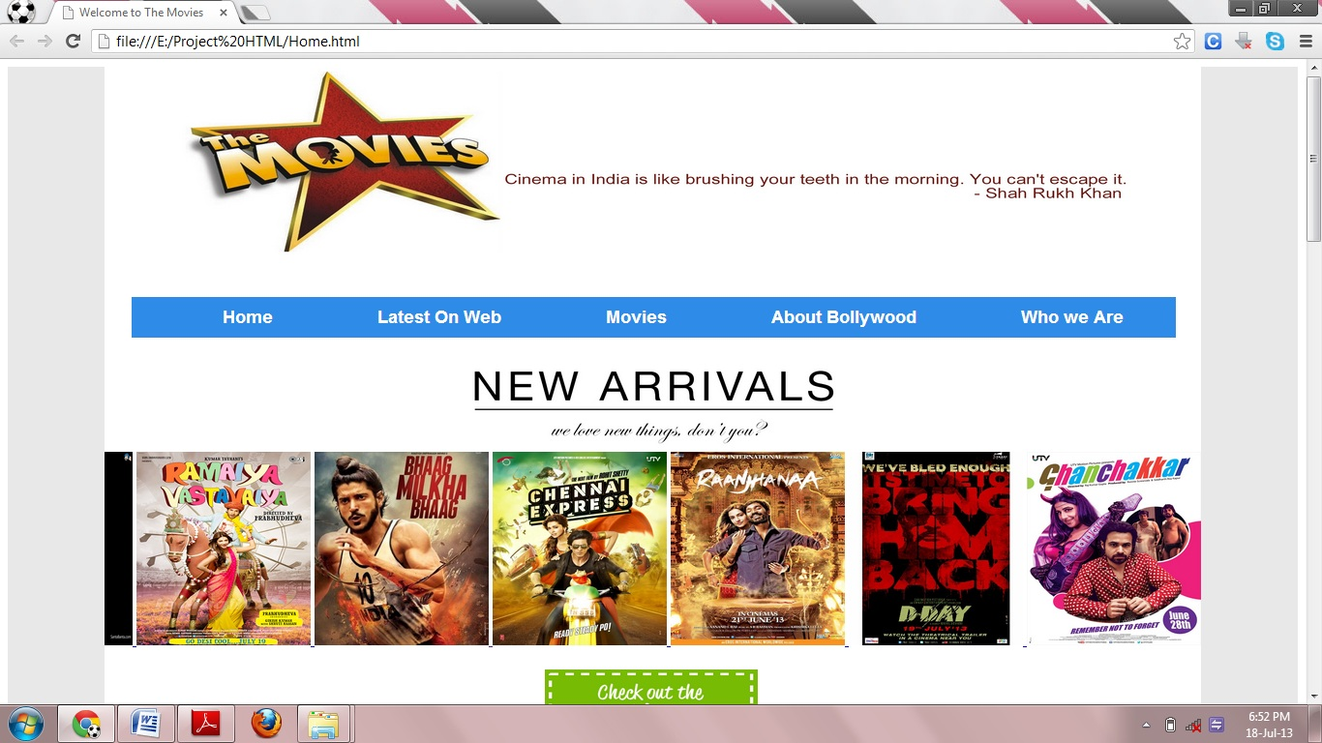

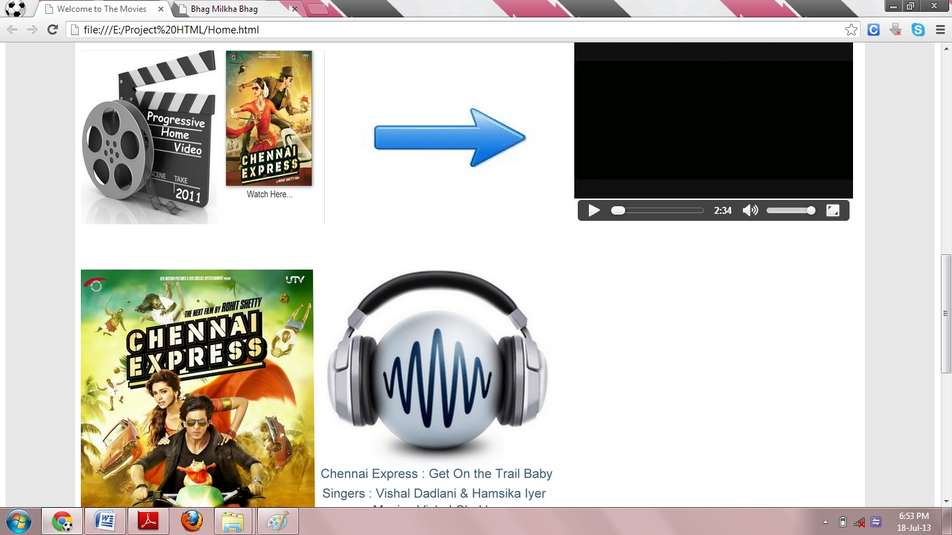

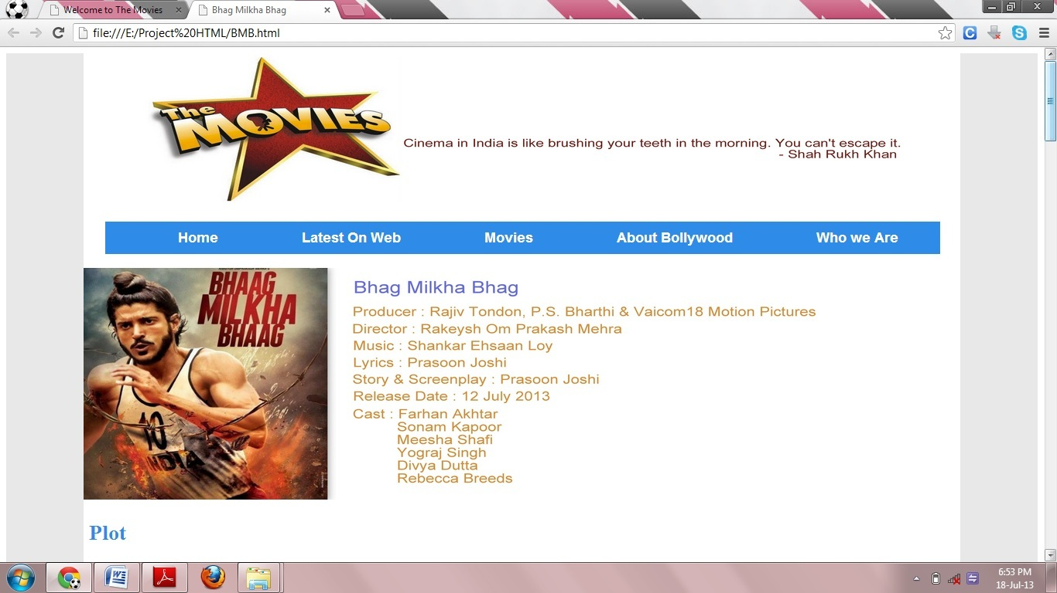

**7.6 Conclusion** :

HTML5 is the powerful technology for creating and developing a website with various new tags introduced. It is the best convenient option available for a website designing.

**7.7 Source code :**

**Index page :**

<html>

<head>

<title>Welcome to The Movies</title>

<style>

body

{

border-left: 100px solid #000000;

border-color:#E8E8E8;

border-right: 100px solid #000000;

border-color:#E8E8E8;

border-bottom:100px solid #000000;

border-color:#E8E8E8;

}

</style>

<style>

#coolMenu

{

float: left;

}

#coolMenu > li

{

float: left;

}

#coolMenu li a {

display: block;

height: 2em;

line-height: 2em;

padding: 3 3em;

text-decoration: none;

}

#coolMenu ul

{

position: absolute;

display: none;

z-index: 999;

list-style:none;

}

#coolMenu ul li a

{

width: 160px;

}

#coolMenu li:hover ul

{

display: block;

}

#coolMenu

{

margin-left:28px;

font-family: Arial;

font-size: 18px;

background: #2f8be8;

list-style:none;

}

#coolMenu > li > a

{

color: #fff;

font-weight: bold;

}

#coolMenu > li:hover > a {

background: #f09d28;

color: #000;

}

#coolMenu ul

{

background: #f09d28;

}

#coolMenu ul li a {

color: #000;

}

#coolMenu ul li:hover a {

background: #ffc97c;

}

#coolMenu li.current_page_item a

{

background-color: #f09d28;

box-shadow: 0 0 0 1px rgba(255,255,255,0.05), inset 0 0 0.25em 0 rgba(0,0,0,0.25);

}

</style>

<style>

h1, h2

{

color:#300;

}

h3

{

color:#2f8be8;

}

p

{

font:Arial;

font-size:25pt;

color:FF0000;

}

</style>

<body>

<center>

<a href="index.html">

<img src="Images/icon1.jpg" width="1000" height="200">

</a>

</center>

<br>

<ul id="coolMenu">

<li class="current_page_item"><a href="index.html">Home</a></li>

<li><a href="index.html#Latest">Latest On Web</a></li>

<li>

<a>Movies</a>

<ul>

<li><a href="LT.html" target="_blank">Lootera</a></li>

<li><a href="RV.html"target="_blank">Ramaiya Vastavaya</a></li>

<li><a href="BMB.html"target="_blank">Bhag Milkha Bhag</a></li>

<li><a href="CE.html"target="_blank">Chennai Express</a></li>

<li><a href="RN.html"target="_blank">Ranjhana</a></li>

<li><a href="DD.html"target="_blank">D-Day</a></li>

<li><a href="GC.html"target="_blank">Ghanchakkar</a></li>

<li><a href="IS.html"target="_blank">Issaq</a></li>

</ul>

</li>

<li><a href="Bolly.html">About Bollywood</a></li>

<li><a href="Who.html">Who we Are</a></li>

</ul>

<center>

<img src="Images/newarrivals.jpg" width="450" height="100">

</center>

<marquee behavior="scroll" direction="left">

<a href="LT.html">

<img src="Images/Movies/movie1.jpg" width="180" height="200" alt="Image" />

</a>

<a href="RV.html">

<img src="Images/Movies/movie2.jpg" width="180" height="200" alt="Image" />

</a>

<a href="BMB.html">

<img src="Images/Movies/movie3.jpg" width="180" height="200" alt="Image" />

</a>

<a href="CE.html">

<img src="Images/Movies/movie4.jpg" width="180" height="200" alt="Image" />

</a>

<a href="RN.html">

<img src="Images/Movies/movie5.jpg" width="180" height="200" alt="Image" />

</a>

<a href="DD.html">

<img src="Images/Movies/movie6.jpg" width="180" height="200" alt="Image" />

</a>

<a href="GC.html">

<img src="Images/Movies/movie7.jpg" width="180" height="200" alt="Image" />

</a>

<a href="IS.html">

<img src="Images/Movies/movie8.jpg" width="180" height="200" alt="Image" />

</a>

</marquee>

<center>

<br>

<a>

<img id="Latest" src="Images/new1.png" width="220" height="100">

</a> <br>

</center>

<br>

&nbsp; <img src="Images/T1.jpg" width="350" height="250">

<img src="Images/arrow.jpg" width="350" height="250">

<video &nbsp; width="400" height="300" controls poster="Movies/DD/Videos/DTrailer.jpg">

<source src="Movies/DD/Videos/Dtrailer.mp4" type="video/mp4">

<source src="Movies/DD/Videos/Dtrailer.ogv" type="video/ogg">

<source src="Movies/DD/Videos/Dtrailer.webm" type="video/webm">

Your browser does not support the video tag.

</video>

<br>

&nbsp; <img src="Images/T2.jpg" width="350" height="250">

<img src="Images/arrow.jpg" width="350" height="250">

<video &nbsp; width="400" height="300" controls poster="Movies/CE/Videos/CETrailer.jpg">

<source src="Movies/CE/Videos/CETrailer.mp4" type="video/mp4">

<source src="Movies/CE/Videos/CETrailer.ogv" type="video/ogg">

<source src="Movies/CE/Videos/CETrailer.webm" type="video/webm">

Your browser does not support the video tag.

</video>

<br>

<br>

<br>

<br>

&nbsp; <img src="Images/M1.jpg" height="450" height="350">

&nbsp; &nbsp;&nbsp; &nbsp;&nbsp; &nbsp;<audio controls>

<source src="Movies/CE/Audios/01.ogg" type="audio/ogg">

<source src="Movies/CE/Audios/01.mp3" type="audio/mpeg">

Your browser does not support the audio element.

</audio>

<br>

<br>

&nbsp; &nbsp;<img src="Images/M2.jpg" height="400" height="350">

&nbsp; &nbsp;&nbsp; &nbsp;&nbsp; &nbsp;<audio controls>

<source src="Movies/BMB/Audios/02.oga" type="audio/ogg">

<source src="Movies/BMB/Audios/02.mp4" type="audio/mp4">

Your browser does not support the audio element.

</audio>

<div id="footer" style="background-color:#FFA500;clear:both;text-align:center;">

Copyright &copy; The Movies</div>

</body>

</head>

</html>