

Software Requirements Specifications for

EmployeePortal

**3-Nov-2021**

**Version 0.1**

**Prepared By   
Vendor Company**

**Change History**

|  |  |  |  |
| --- | --- | --- | --- |
| **Date** | **Version** | **Description** | **Updated By** |
| 11 Nov 2021 | 0.1 | Initial Draft | Yogesh Dahake |

**Document Approvals**

|  |  |  |
| --- | --- | --- |
| **Name** | **Role** | **Signature** |
| John Smith | Business Team/Product Owner |  |

**Table of Contents**

1 Introduction 4

1.1 Purpose 4

1.2 Document Conventions 4

1.3 Project Scope 4

1.4 Intended Audience 4

1.5 References 4

2 System Description 5

2.1 Current System: 5

2.2 Proposed System: 5

2.3 Proposed System High level design: 5

3 Functional Requirements 6

3.1 System Features 6

3.1.1 System Feature 1: New Joinee onboarding form. 7

3.1.2 System Feature 2: Detail Verification of New Joinee details. 7

3.2 Use Cases: 7

3.2.1 Use Case 1 7

3.2.1.1 Use Case Diagrams 8

3.2.1.2 Activity Diagram: 9

3.2.1.3 Sequence Diagram 9

3.2.1.4 Entity Relationship diagram 10

3.2.2 Use Case 2 10

3.2.2.1 Entity Relationship Diagrams 10

3.2.3 Data Dictionary 12

3.2.3.1 New Joinee 12

3.2.3.2 Entity 2 12

4 External Interface Requirements 12

5 Technical Requirements (Nonfunctional) 12

5.2 Performance 12

5.3 Scalability 12

5.4 Security 12

5.5 Maintainability 13

5.6 Usability 13

5.7 Multi lingual Support 13

5.8 Auditing and Logging 14

5.9 Availability 14

6 Open Issues 14

6.1 Issue:1: Internet Explorer support. 14

# Introduction

## Purpose

<Provide here the detailed purpose of the document>

The purpose of this document is to describe the business requirements in details which are necessary for the implementation of the application. All the business requirement must be reflected in a version of this document in order to be included in the final implementation. This document also details out the nonfunctional and technical requirements.  
Also necessary technical designs which will include each of the business requirements.

## Document Conventions

<Indicate the abbreviations used or any special document conventions used for capturing the requirements>  
This document uses the following conventions.

|  |  |
| --- | --- |
| DB | Database |
| DDB | Distributed Database |
| ER | Entity Relationship |

## Project Scope

<Provide the exact project scope indicating project boundaries. This can also include the purpose of the software project, its benefits and overall goals. In the case of a software product, this should contain product vision. If you are aware of features that should go into a future version, list them here or add a new section on “Features for Future Releases>

This project is a one stop onboarding application which allow the HR people to onboard the new joiner efficiently and effectively this project also integrates internally with Finance, Security, Project team applications and will internally initiate all the required process which needs to be carried out when the new joiner joins the firm. This application will make the onboarding process transparent and will bring visibility on this process.

## Intended Audience

<Provide the intended Audience of the project application>  
This project is a prototype for the new Joinee onboarding system and it is restricted and used for the firm internal purpose and only accessible within the company virtual network. This project is useful for the HR community and other related departments and New Joinee employees

## References

*<This should contain links to all external documents and web resources referred in the requirements. Sometimes prototypes or product vision are specified in a separate document. Link them here. Also ensure that you link to the correct version>*

* <https://dailyneeds.com/projects>
* Fundamental of database system.

# System Description

<This section can contain a detailed overview of the software system being built. It can contain a subsection detailing the existing system followed by the proposed system details. If relevant, this section can also contain business details such as organizational hierarchy. Basically, provide everything that is necessary to understand the Functional Requirements section which follows this.>

## Current System:

<Provide how the current system is working in details>  
Currently when the User joined the firm during the onboarding process the HR community will fill out the big form contains all his academic, personal and finance information and they will review this information for its correctness and then this information will be digitalized and segregated as per the requirements of each department and passed to them via emails to trigger the further steps.

## Proposed System:

<Provide how the proposed system should work>  
There should be unified application which will have a form which needs to be filled by the new Joinee it will have the basic validations in place. Once this form is submitted by the User it will go to the particular HR person who was assisting the new Joinee during his onboarding process for his verifications once HR form sign off or approve that form then application should trigger the IT team, Finance, Security, project teams individuals process and provide the up-to-date status in the application for each process till its completion.

Proposed System can be a one stop destination for New Joinee and HR people where new Joinee can see the progress of his onboarding process also he can raise any issues which he is encountering with his IT assets or anything within the firm.HR people will have the provision to download the Reports which can have the number of people onboarded their skillsets. System can be extended from HR side from hiring perspective.

## Proposed System High level design:

<Provide the high-level design for the system, use flow diagram to describe>

# Functional Requirements

<This section contains system requirements followed by various requirement models which can be used for detailed design. Here you can use use-case diagram, Activity diagrams, sequence diagrams, process flow diagrams, data flow diagrams, whatever which describe clearly the requirements>

## System Features

<This section specifies the high-level system features required in the software product.>

### System Feature 1: New Joinee onboarding form.

*<Explain in high level each system feature>*

### System Feature 2: Detail Verification of New Joinee details.

## Use Cases:

*<Provide all the necessary use case, activity, sequence and entity relationship diagram which shows how the actor interacts with the application>*

### Use Case 1

<This provides a detailed description of the use case. Usually, it is captured in the following table format. Add more rows or removing rows depending on your specific requirement.>

|  |  |
| --- | --- |
| **ID** | *<Unique ID as per company convention > CR-01* |
| **Description** | *<Specify the detail description of the use case>*  *New Joinee details entry form* |
| **Actors** | *<Specify various actors who will invoke this use case> New Joinee User* |
| **Preconditions** | *<Provide preconditions if any which should be satisfied before this use case invokes>*  *User Should Login with the credential generated by the HR for the first time.* |
| **Basic Steps** | *< Step by step flow of the use case>*  *1.User Should login to the application*  *2. Post login He will see the Fill New Joinee Form.*  *3.Inside form there will be different sections for entering personal Details, Academic details, financial details and so on* |
| **Exception case** | *<Specify exception case here for example if the New Joinee employee doesn’t have the previous employer leaving certificate> If User doesn’t have the Previous employer leaving certificate, then he should have option to upload it later* |
| **Business validations/Rules** | *<If business rules are already specified in the system features section, provide a link. Otherwise specify the rules.> User Credentials need to be validated.*  *Bank details should be verified automatically for its correctness*  *Basic validations for format and numbers for each field.* |
| **Postconditions** | *<Provide the post conditions if any after the use case executed>* |

### Use Case Diagrams

<Here Provide as many diagrams as possible which will clearly explain the usecase>  
<Use case diagrams depicting how various actors interact with the software system.>

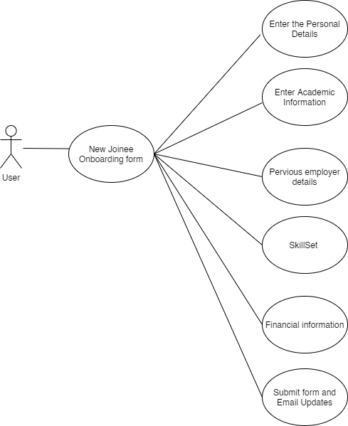

### Activity Diagram:

*<Activity diagram for depicting the control flow from a start point to a finish point showing the various decision paths that exist while the activity is being executed.>*  
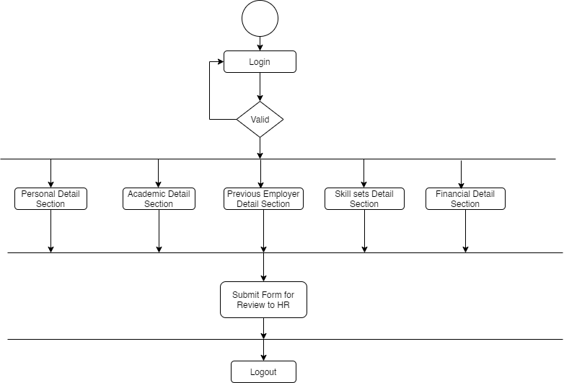

### Sequence Diagram

*<Sequence diagram for the sequence of messages exchanged between the objects needed to carry out the functionality>*

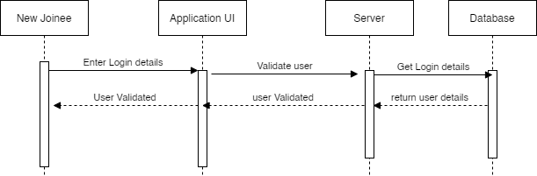

### Entity Relationship diagram

*<Entity Relation ship diagram for a graphical representation that depicts relationships among people, objects, places, concepts or events within system>*

### 

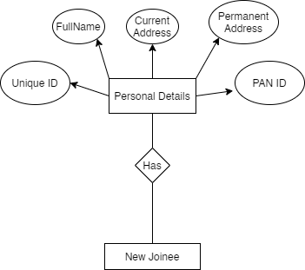

### Use Case 2

### 3.2.2.1 Entity Relationship Diagrams

*<One or diagrams to depict all the entities in the system and their relationships. You can use different notations for ER diagrams. Following is a very simple ER diagram in Crow's notation.>*



### Data Dictionary

### 3.2.3.1 New Joinee

*<A brief description of the entity followed by a table containing all its attributes as shown below. >*

|  |  |  |  |
| --- | --- | --- | --- |
| **Attribute** | **Type** | **Optional?** | **Notes** |
| *<Attribute Name>* | *<Data type of the attribute>* | *<Y or N>* | *<Explain any specific restrictions or rules applicable on this attribute>* |
| First name | String | N | Contains the first name of the NewJoinee |

### Entity 2

# External Interface Requirements

*<Provide sub sections for each external interface. Identify all the input and output from the external interfaces.>*

# Technical Requirements (Nonfunctional)

*<Please note that all the following subsections may not be applicable for a system. Sometimes you will have to add additional sections (for example, Legal requirements)>*

|  |  |
| --- | --- |
| Software used | Description |
| Operating system | Windows |
| Database | Microsoft SQL Server |
| Front end Framework | React JS, Bootstrap |

## Performance

*<For example, what is the response time required?>*

Application should work with 100 Concurrent users at a time.

Each page should load or submit within 2 secs.

## Scalability

*<For example, how many users the system should support after two years of operation?>*

Application to be scalable to different company geo locations and should support up to 500 users

## Security

*<For example, is data encryption required?>*

All the API request should be secure and encrypted

## Maintainability

## Usability

Application can be used in browsers like IE, Chrome, Edge

## Multi lingual Support

*<What are the languages that software system should support?>*

There should be option to convert change application language.

## Auditing and Logging

*<Any auditing and logging require ements should be mentioned here>*

## Availability

*<For example, is any kind of downtime acceptable or required?>*

# 6 Open Issues

*<There could be open issues even at the end of the requirements elicitation. List of all of them here so it can be tracked and closed later. Some of these issues may later become project risks as well.>*

# 6.1 Issue:1: Internet Explorer support.

*<Describe the issue here>*

Currently some of the feature of the application is not working in the internet explorer application