Merge Sort

package com.javastack.datastructures.sorting;
import java.util.Arrays;
public class MergeSort {
public static void main(String[] args) {
int[] nums = {1, 3, 5, 7, 9, 0, 2, 4, 6, 8};
System.out.println(Arrays.toString(sortArray(nums)));
}
public static int[] mergeSort(int[] nums, int l, int r) {
if(l==r) return new int[]{nums[l]};
int mid = (l + r) / 2;
int[] left = mergeSort(nums, l, mid);
int[] right = mergeSort(nums, mid + 1, r);
return merge(left, right);
}
public static int[] merge(int[] nums1, int[] nums2) {
int m = nums1.length, n = nums2.length;
int[] res =new int[m+n];
int p1 =0, p2 =0;
for(int i=0; i<m+n; i++){
int first = (p1==m) ? Integer.MAX_VALUE : nums1[p1];
int second = (p2==n) ? Integer.MAX_VALUE : nums2[p2];
if(first <= second)
{
res[i] = first; p1++;
}
else
{
res[i] = second; p2++;
}
}
return res;
}
public static int[] sortArray(int[] nums) {
return mergeSort(nums, 0, nums.length - 1);
}
}

Quick Sort
import java.util.Arrays;
public class QuickSort {
public static void main(String[] args) {
int[] nums = {1, 3, 5, 7, 9, 0, 2, 4, 6, 8};
System.out.println(Arrays.toString(sortArray(nums)));
}
public static void quickSort(int[] nums, int start, int end) {
if(start>=end) return;
int i=start, l =start, r =end, pivot = nums[end];
while (i<=r)
{
if(nums[i] < pivot) {
swap(nums, i, l);
i++; l++;
}
else if(nums[i] > pivot) {
swap(nums, i, r);
r--;
}
else i++;
}
quickSort(nums, start, l-1);
quickSort(nums, r+1, end);
}
public static void swap(int[] nums, int p1, int p2)
{
int temp = nums[p1];
nums[p1] = nums[p2];
nums[p2] = temp;
}
public static int[] sortArray(int[] nums)
{
quickSort(nums,0,nums.length-1);
return nums;
}
}

Permutations
package com.javastack.datastructures.test;
import java.util.ArrayList;
import java.util.List;
public class Permutations
{
public static void main(String[] args) {
String str = "abc";
System.out.println(permute(str));
}
private static List<List<Character>> permute(String str)
{
char[] chars = str.toCharArray();
List<List<Character>> permutations = new ArrayList<>();
List<Character> output = new ArrayList<>();
for(int i=0;i< chars.length;i++) output.add(null);
recursive(chars,0, output,permutations);
return permutations;
}
private static void recursive(char[] chars,int i,
List<Character> output,
List<List<Character>> permutations)
{
if(i==chars.length)
{
permutations.add(new ArrayList<>(output));
return;
}
for (int j = 0;j < chars.length ;j++)
{
if(output.get(j)==null)
{
output.set(j,chars[i]);
recursive(chars, i + 1, output, permutations);
output.set(j,null);
}
}
}
}

Binary Search for sorted arrays
public class BinarySearch {
public static void main(String[] args) {
int[] arr = {1, 2, 2,3, 4, 5, 6, 7, 8, 9, 10};
int target = 1;
System.out.println(binarySearch(arr, target));
}
public static int binarySearch(int[] arr, int target) {
int left = 0, right = arr.length - 1;
while(left<=right)
{
int mid = (left+right)/2;
if(arr[mid]==target) return mid;
else if(arr[mid]<target) left = mid+1;
else right = mid-1;
}
return -1;
}
}

Find min value on the roated array
public class FindMinonRoatatedArray
{
public static void main(String[] args) {
int[] arr = {3,4,5,1,2};
System.out.println(findMin(arr));
}
private static int findMin(int[] arr) {
int left = 0, right = arr.length - 1;
int answer = arr[0];
while(left <= right)
{
int mid = (left+right)/2;
if(arr[mid]>=arr[0])
{
left = mid+1;
}
else{
answer = arr[mid];
right = mid-1;
}
}
return answer;
}
}

Find Closest Number in sorted Array
package com.javastack.datastructures.search;
public class FindClosest
{
public static void main(String[] args) {
int[] nums = {-5, -2, 0, 4, 6, 10};
int target = 5;
System.out.println(findClosest(nums, target));
}
private static int findClosest(int[] nums, int target) {
int left = 0, right = nums.length - 1;
if(target < nums[left]) return nums[left];
if(target > nums[right]) return nums[right];
while(left<=right)
{
int mid = (left+right)/2;
if(nums[mid]==target) return nums[mid];
else if(nums[mid]<target) left = mid+1;
else right = mid-1;
}
// At this point, right < left
// closest may be nums[left] or nums[right]
if (Math.abs(nums[left] - target) < Math.abs(nums[right] - target)) {
return nums[left];
}
return nums[right];
}
}

Reverse a linked List (both pointers in forward direction)
private static ListNode reverseList(ListNode head) {
ListNode left = null, ptr = head, right = null;
while (ptr != null) {
right = ptr.next; // temp variable
ptr.next = left;
left = ptr;
ptr = right;
}
return left;
}

Finding middle node of the linked list in a single pass
private static ListNode middleNode(ListNode head) {
ListNode slow = head, fast = head;
while (fast != null && fast.next != null) {
slow = slow.next;
fast = fast.next.next;
}
return slow;
}

Linked List Cycle Detection
private static boolean hasCycle(ListNode head) {
ListNode slow = head, fast = head;
while (fast != null && fast.next != null) {
slow = slow.next;
fast = fast.next.next;
if (slow == fast) { // detect cycle
return true;
}
}
return false;
}

Find the fist node in cycle detection
// Find the node at which cycle begins (if any)
public static ListNode detectCycleStart(ListNode head) {
if (head == null) return null;
ListNode slow = head;
ListNode fast = head;
boolean cycle = false;
while (fast != null && fast.next != null) {
slow = slow.next;
fast = fast.next.next;
if (slow == fast) {
cycle = true;
break;
}
}
if (!cycle) return null; // no loop
// Reset slow to head; keep fast at meeting point
slow = head;
while (slow != fast) {
slow = slow.next;
fast = fast.next;
}
// Where they meet is the start of the cycle
return slow;
}

If string is valid parenthesis time(o(n)) and space o(n) stack
public static void main(String[] args) {
System.out.println(ValidParenthesisUsingStack.isValid("()")); // true
System.out.println(ValidParenthesisUsingStack.isValid("(]"));// false
System.out.println(ValidParenthesisUsingStack.isValid("([)]"));// false
System.out.println(ValidParenthesisUsingStack.isValid("{[]}"));// true
}
public static boolean isValid(String s) {
Stack<Character> stack = new Stack<>();
for(char ch : s.toCharArray()) {
if(ch=='(' || ch=='{' || ch=='[')
{
stack.push(ch);
}
else
{
if(stack.size()==0) return false;
char top = stack.pop();
if(ch==')' && top!='(') return false;
if(ch=='}' && top!='{') return false;
if(ch==']' && top!='[') return false;
}
}
if (stack.size() > 0) return false;
return true;
}

Binary Tree
import java.util.ArrayList;
import java.util.List;
public class BinaryTree
{
public static List<Integer> result = new ArrayList();
public static void main(String[] args) {
// Manual construction of a binary tree
TreeNode root = new TreeNode(10);
root.left = new TreeNode(20);
root.right = new TreeNode(30);
root.left.left = new TreeNode(40);
root.left.right = new TreeNode(50);
root.left.right.left = new TreeNode(70);
root.right.right = new TreeNode(60);
// Test pre-order traversal
System.out.println("Pre-order traversal:");
result.clear();
dfsPreOrder(root);
System.out.println(result); // [10, 20, 40, 50, 70, 30, 60]
// Test in-order traversal
System.out.println("In-order traversal:");
result.clear();
dfsInOrder(root);
System.out.println(result); // [20, 40, 50, 70, 10, 30, 60]
// Test post-order traversal
System.out.println("Post-order traversal:");
result.clear();
dfsPostOrder(root);
System.out.println(result); // [20, 40, 50, 70, 30, 60, 10]
}
public static void dfsPreOrder(TreeNode root) {
if(root==null) return;
result.add(root.val); // pre-order
dfsPreOrder(root.left);
dfsPreOrder(root.right);
}
public static void dfsInOrder(TreeNode root)
{
if(root==null) return;
dfsPreOrder(root.left);
result.add(root.val); // In-order
dfsPreOrder(root.right);
}
public static void dfsPostOrder(TreeNode root)
{
if(root==null) return;
dfsPreOrder(root.left);
dfsPreOrder(root.right);
result.add(root.val); // Post-order
}
}
Level Order using BFS
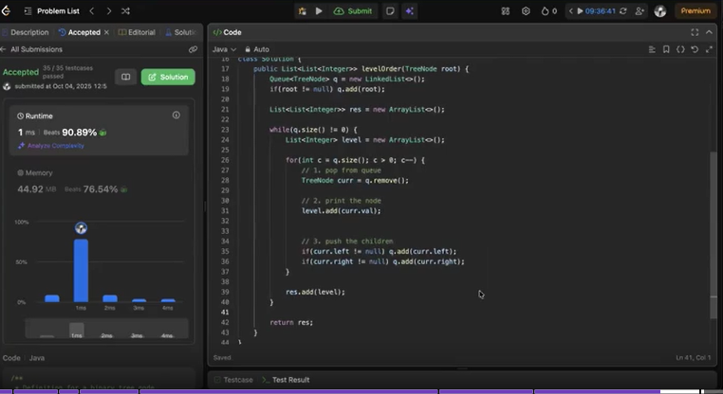

Height of the binary tree
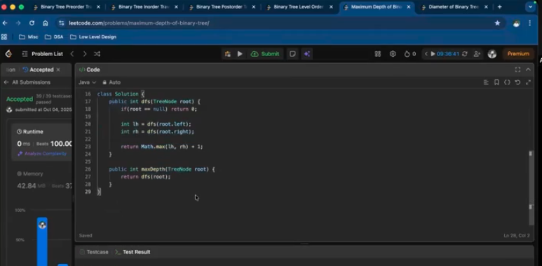

Diameter of a binary tree
