Problem Statement  
WAP that uses the Digital Differential Analyzer (DDA) algorithm to draw a straight line between two user-defined points, in a graphics window.

Background theory

The DDA line drawing algorithm offers an effective method for rendering lines in computer graphics by computing intermediate pixel positions. It handles all types of slopes efficiently and produces a smooth approximation of a straight line. This lab provided valuable insight into how mathematical concepts can be practically applied to pixel-level graphics programming using C++.

Algorithm

1. Begin with the coordinates of the start and end points: (x1, y1) and (x2, y2).
2. Compute the change in each direction:  
   dx = x2 - x1  
   dy = y2 - y1
3. Determine the total number of steps to take by finding the greater of the absolute values of dx and dy:  
   steps = max(|dx|, |dy|)
4. Calculate the amount to increment x and y in each step:  
   x_inc = dx / steps  
   y_inc = dy / steps
5. Initialize the current position at (x, y) = (x1, y1). For each step, repeat the following:
6. Plot the current point (x, y) using a pixel-drawing function.
7. Add x_inc to x and y_inc to y.
8. Optionally introduce a short delay to make the drawing visible.

Flowchart

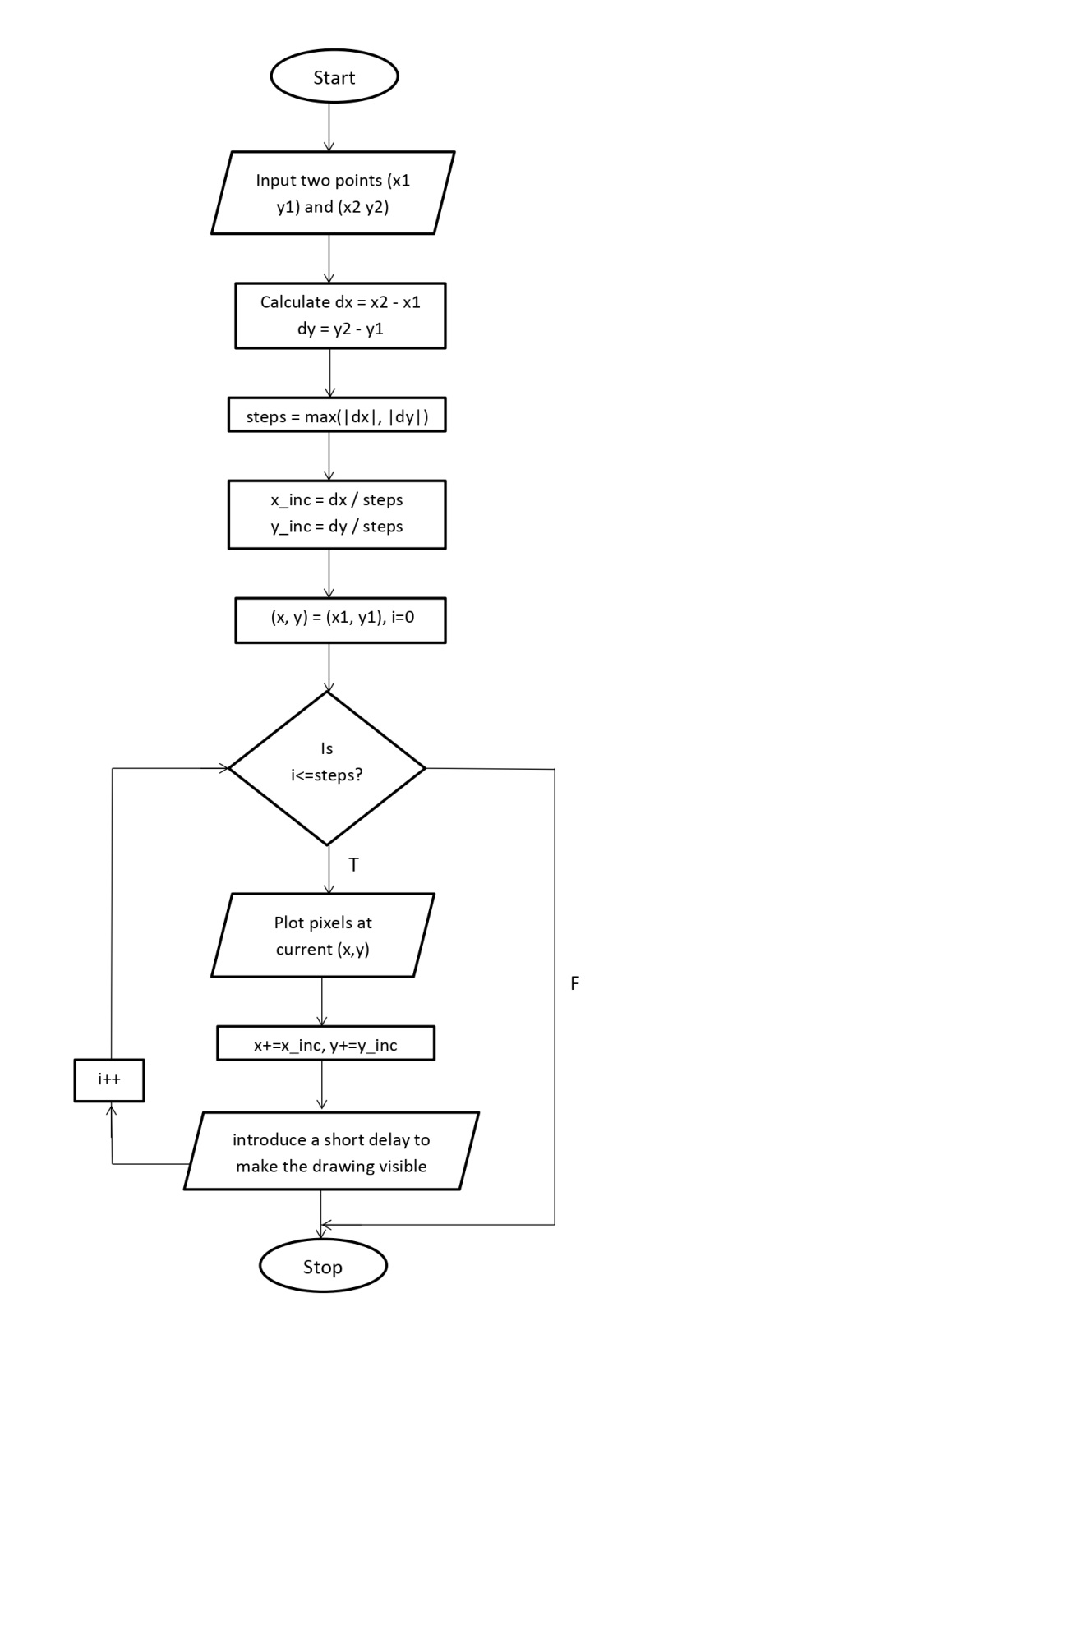

Source code

#include <iostream>

#include <cmath>

#include <graphics.h>

using namespace std;

void drawLineDDA(int x1, int y1, int x2, int y2) {

float x_inc, y_inc, x, y, steps;

int dx = x2 - x1;

int dy = y2 - y1;

steps = (abs(dx) > abs(dy)) ? abs(dx) : abs(dy);

x_inc = dx / steps;

y_inc = dy / steps;

x = x1;

y = y1;

for (int i = 0; i <= steps; i++) {

putpixel(round(x), round(y), WHITE);

x += x_inc;

y += y_inc;

delay(10);

}

}

int main() {

int gd = DETECT, gm;

initgraph(&gd, &gm, NULL);

int x1, y1, x2, y2;

cout << "Enter the coordinates of the first point (x1 y1): ";

cin >> x1 >> y1;

cout << "Enter the coordinates of the second point (x2 y2): ";

cin >> x2 >> y2;

drawLineDDA(x1, y1, x2, y2);

getch();

closegraph();

return 0;

}

Sample input and output

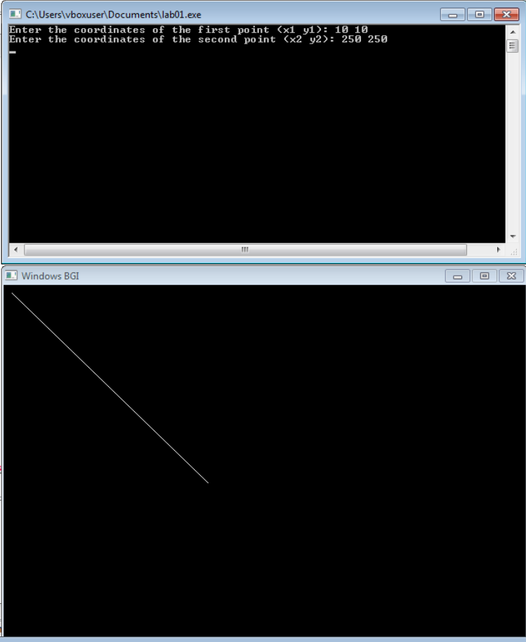

Conclusion

We can conclude that the DDA line drawing algorithm offers an effective method for rendering lines in computer graphics by computing intermediate pixel positions. It handles all types of slopes efficiently and produces a smooth approximation of a straight line. This lab provided valuable insight into how mathematical concepts can be practically applied to pixel-level graphics programming using C++.