Project Report: Hearing Aid Using Digital Signal Processing

# Abstract

This project presents a software-based digital hearing aid built using Altair Compose and Altair Embed. It simulates and processes audio signals using Digital Signal Processing (DSP) techniques such as filtering, gain control, and Power Spectral Density (PSD) analysis. The system targets the enhancement of speech clarity for hearing-impaired individuals, addressing common hearing aid limitations like poor noise reduction and delayed audio response. The processed audio is exported as `.wav` files and analyzed in real-time using spectrum plots.

# 1. Problem Statement

Despite advancements in hearing aids, several critical shortcomings still exist:

- High latency in sound processing.

- Poor noise reduction in dynamic environments.

- Lack of personalization.

- Feedback (whistling) due to poor suppression.

- No 3D sound experience.

- Manual tuning not user-friendly for elderly users.

This project aims to overcome these limitations using DSP techniques via software.

# 2. Objectives

- Simulate a digital hearing aid entirely in software.

- Apply DSP filters (low-pass, high-pass, bandpass) to improve clarity.

- Implement adaptive gain to enhance speech-specific frequencies.

- Analyze output using Power Spectral Density.

- Visualize signal flow and processing via Altair Embed.

# 3. Tools and Technologies Used

Altair Compose: Signal processing (audio read/write, filtering, PSD)

Altair Embed: Real-time block diagram simulation and visualization

.WAV Format: Used for both input and output audio signals

# 4. Methodology

In Altair Compose:

- Import raw `.wav` voice signals.

- Normalize audio and apply bandpass filters and adaptive gain.

- Generate processed `.wav` files.

- Run PSD analysis to visualize clarity and noise levels.

In Altair Embed:

- Load the processed `.wav` output.

- Apply additional 100 Hz High-Pass Butterworth Filter.

- Use PSD blocks and Spectrum Display to observe frequency behavior.

- Confirm improvements visually.

# 5. Features / Innovations

- Full software implementation.

- DSP-based noise reduction.

- Real-time spectrum analysis.

- Customizable filtering.

- Modular and extendable design.

# 6. Results

- Processed audio files showed improved speech clarity.

- PSD plots confirmed reduction of unwanted noise.

- Filtering effectiveness visualized in Altair Embed.

# 7. Challenges Faced

Challenge: Background noise distortion

Solution: Used bandpass filtering and adaptive gain

Challenge: No real-time input

Solution: Used pre-recorded .wav files

Challenge: PSD complexity

Solution: Focused on human speech frequency bands

Challenge: Filter tuning

Solution: Trial and error

Challenge: No clarity benchmark

Solution: Used PSD and audio playback

# 8. Feasibility and Benefits

- Cost-effective: No hardware required for prototyping.

- Educational: Demonstrates DSP concepts clearly.

- Scalable: Future integration with embedded systems.

- Extendable: Can add AI, IoT, or Bluetooth modules.

# 9. Future Scope

- Real-time processing with DSP chips.

- Mobile app interface for profile selection.

- AI for adaptive filtering.

- IoT for monitoring and updates.

- Wearable prototypes with wireless streaming.

# 10. Conclusion

The DSP-based digital hearing aid system successfully demonstrates real-time signal enhancement using Altair Compose and Altair Embed. It improves clarity for hearing-impaired users through filtering, gain control, and spectral analysis—offering a scalable and educational platform for future innovation.

# Appendices

- Screenshots from Compose (signal plots)

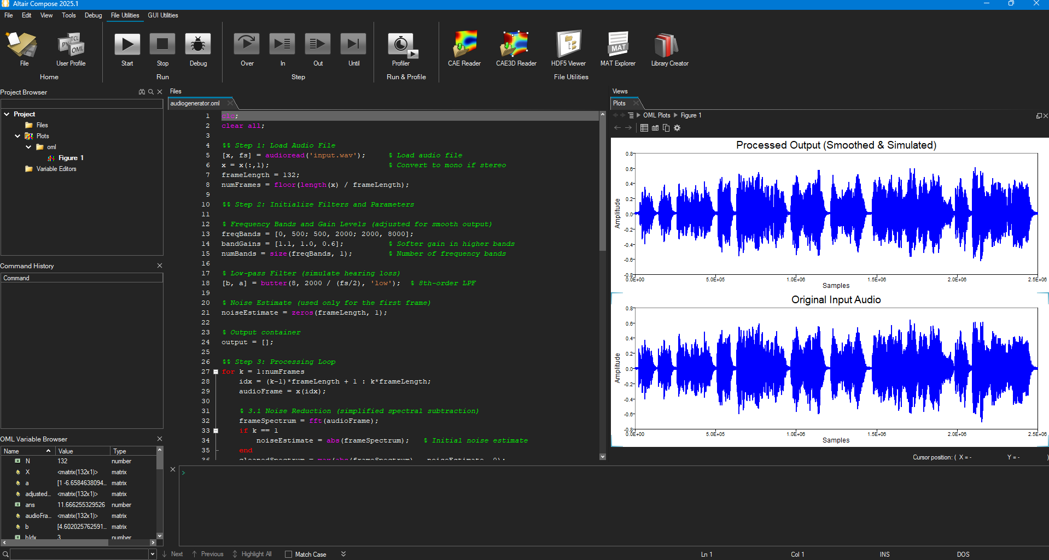

- PSD comparisons

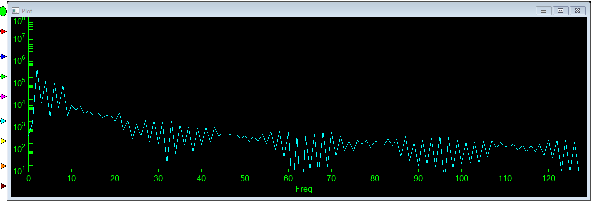

- Embed block diagrams

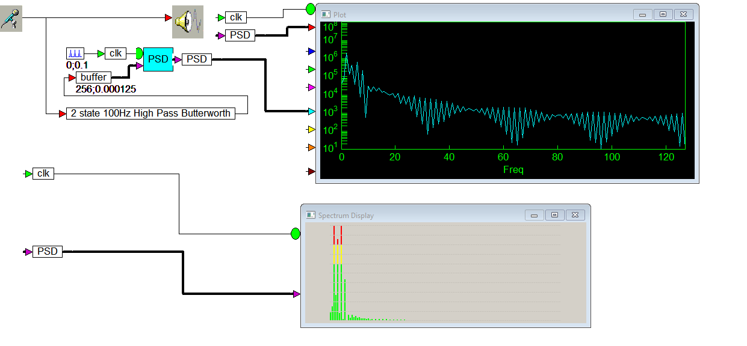

- Sample .wav files (original and processed)

