1. **Create one VPC in N.virginia region.**

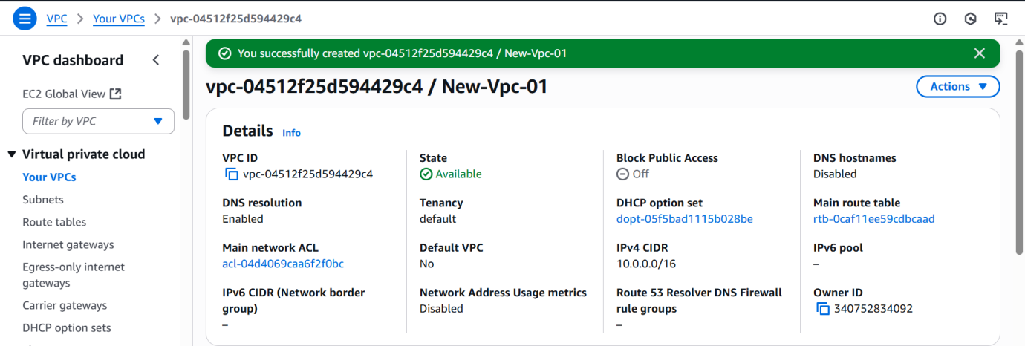

1. **Create two subnets. One Public subnet and one private subnet.**

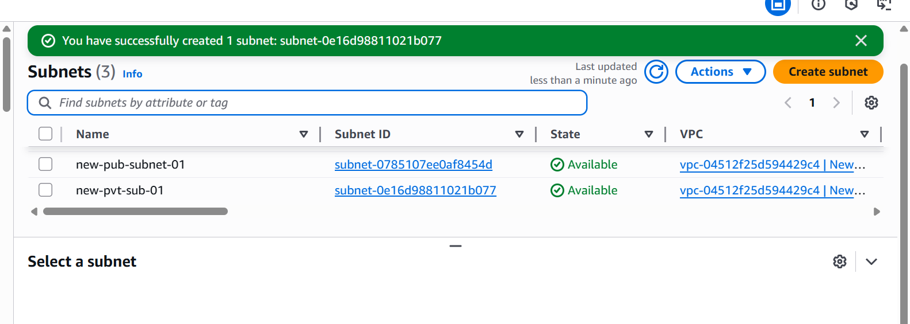

**3.Provide the IGW to the vpc.**

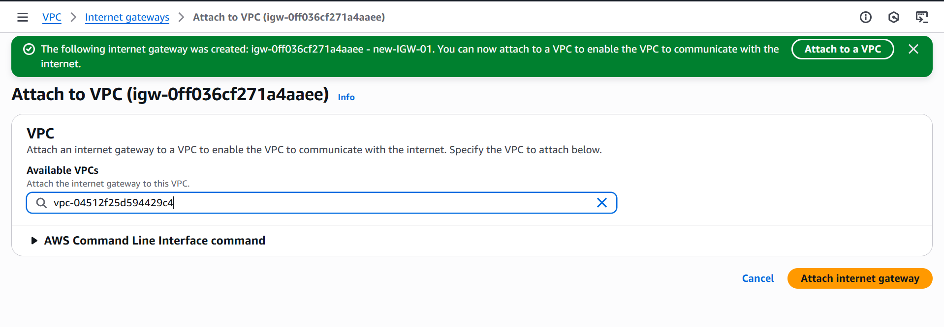

**4. Create One public RT and one private RT.**

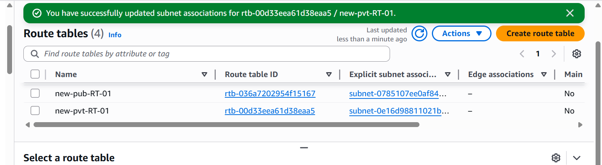

1. **Deploy NAT gateway on public subnet and attach the NAT gatewat to private subnet.**

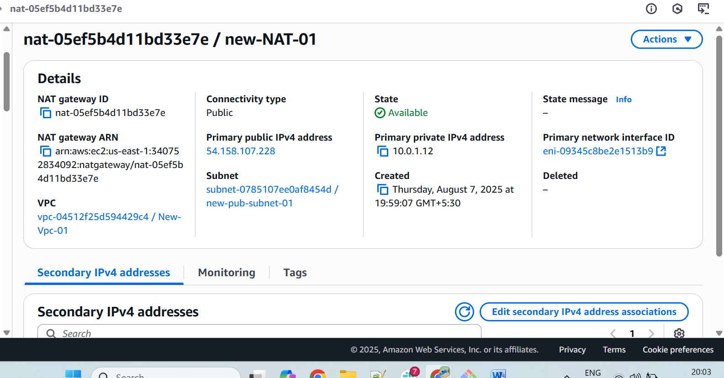

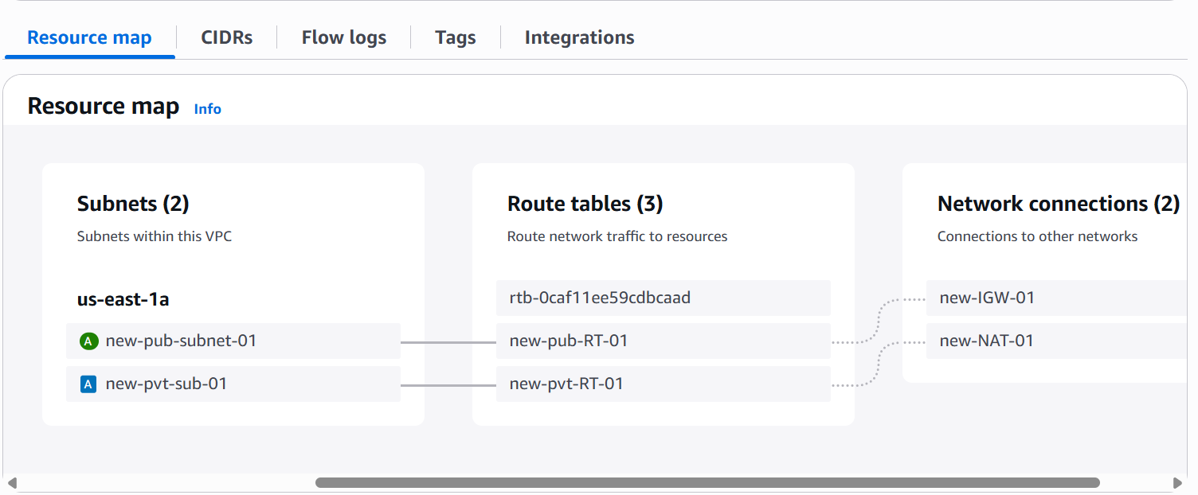

**6. Create Two instances,one in public subnet and one in private subnet.**

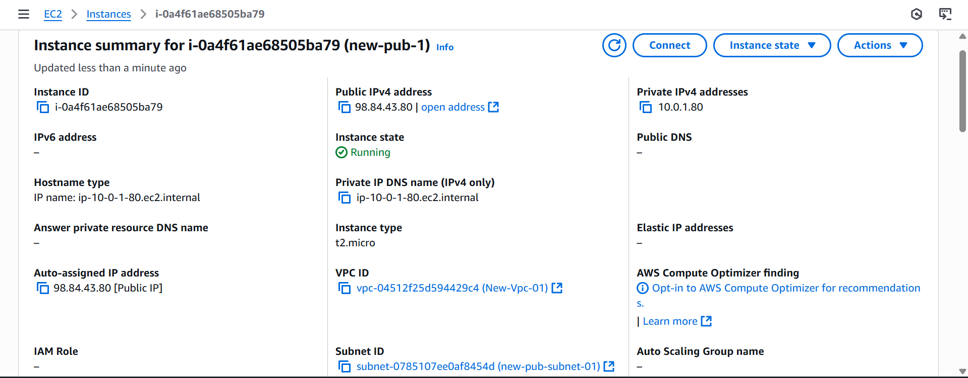

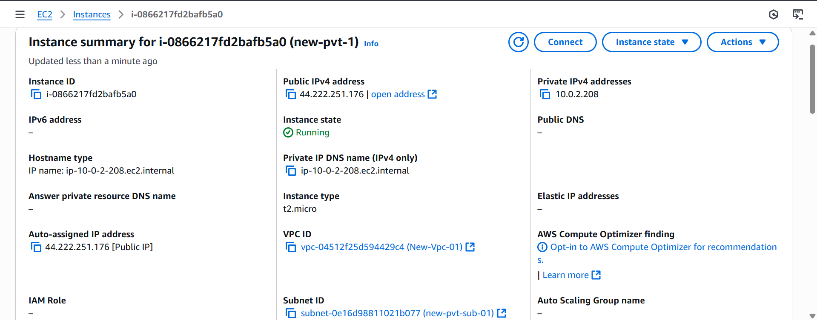

**7. Deploy Apache server on both the ec2 instances with sample index.html file.**

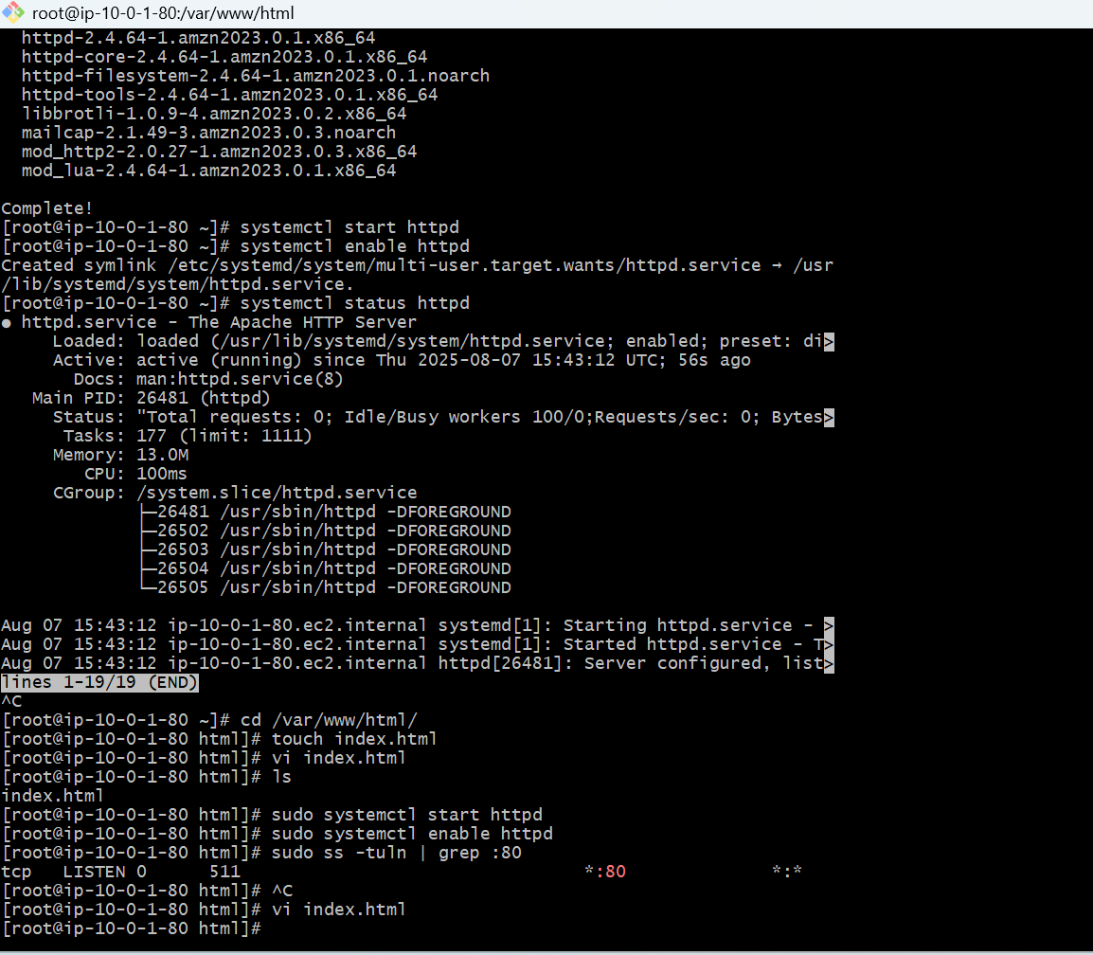 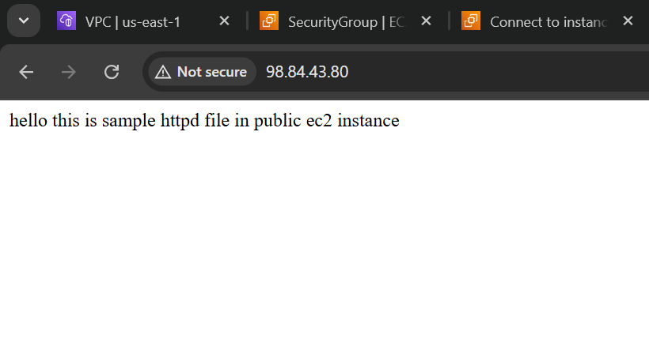

Private ec2

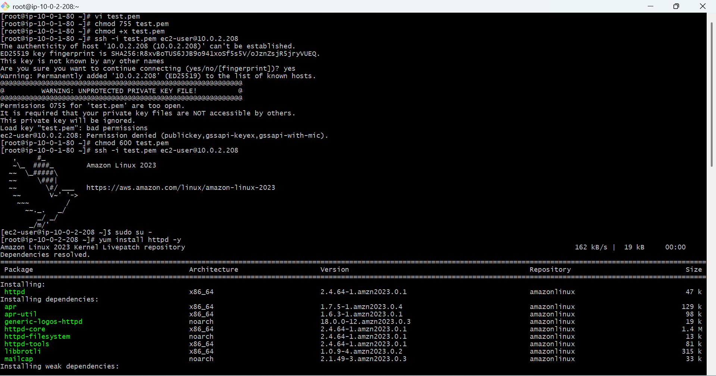

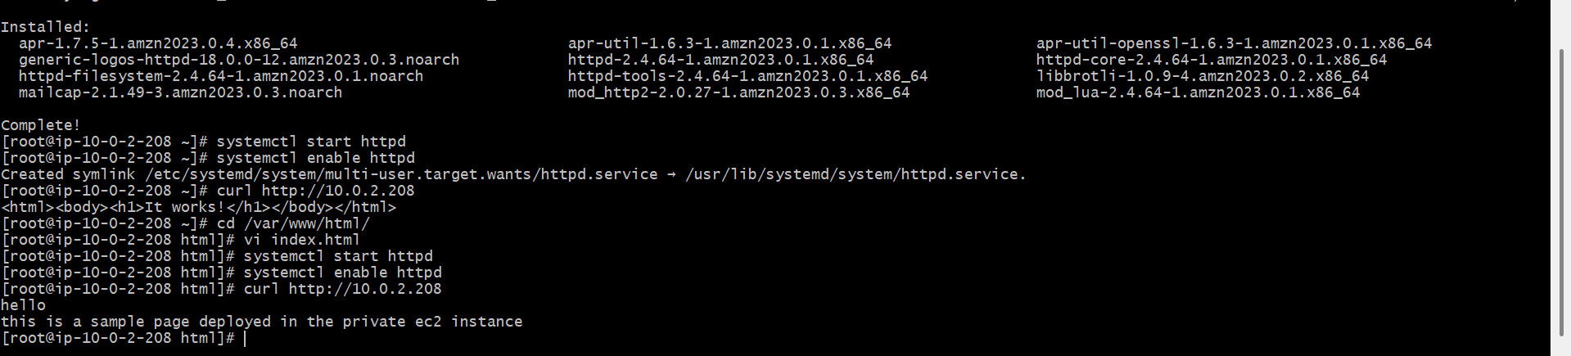

**8. Create one application load balancer and attach the load balancer to both the ec2 instances.**

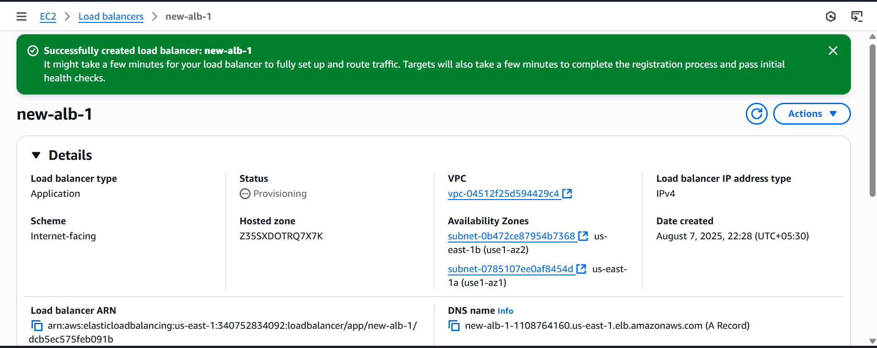

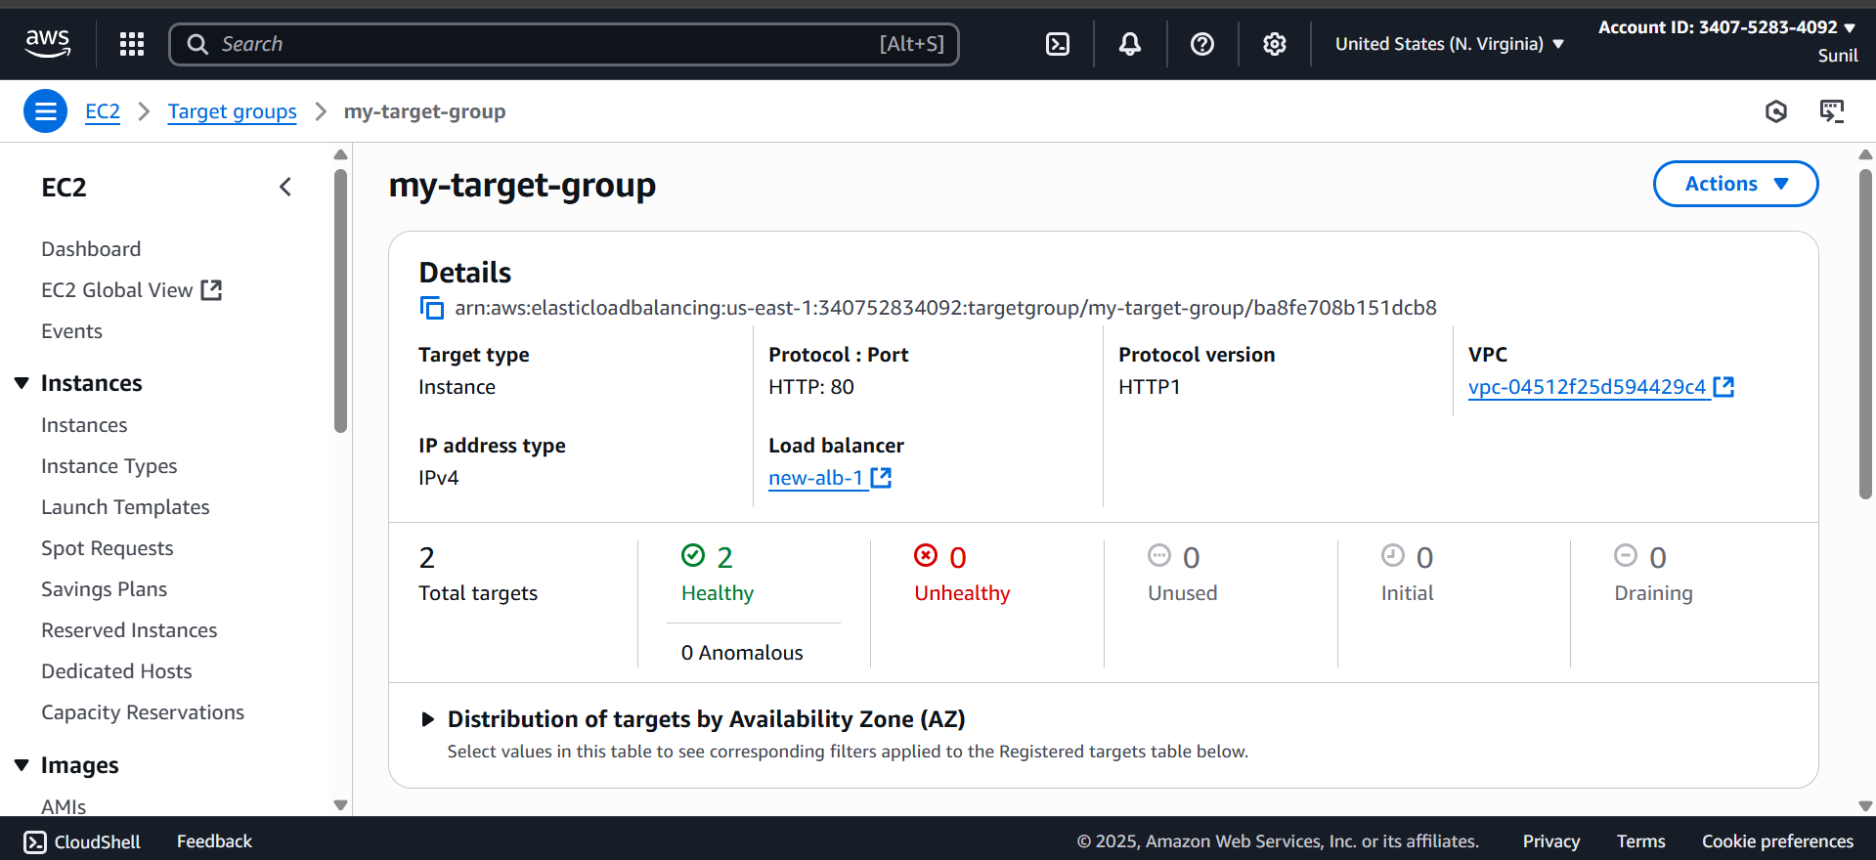

**9. Store Application load balancer logs to s3.**

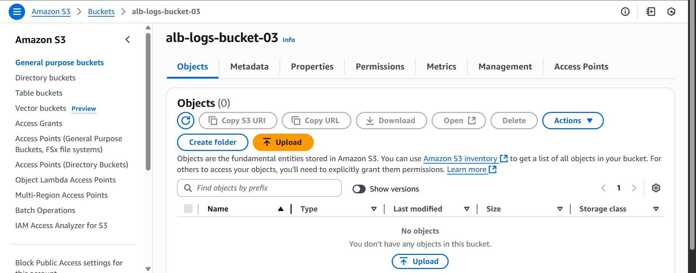

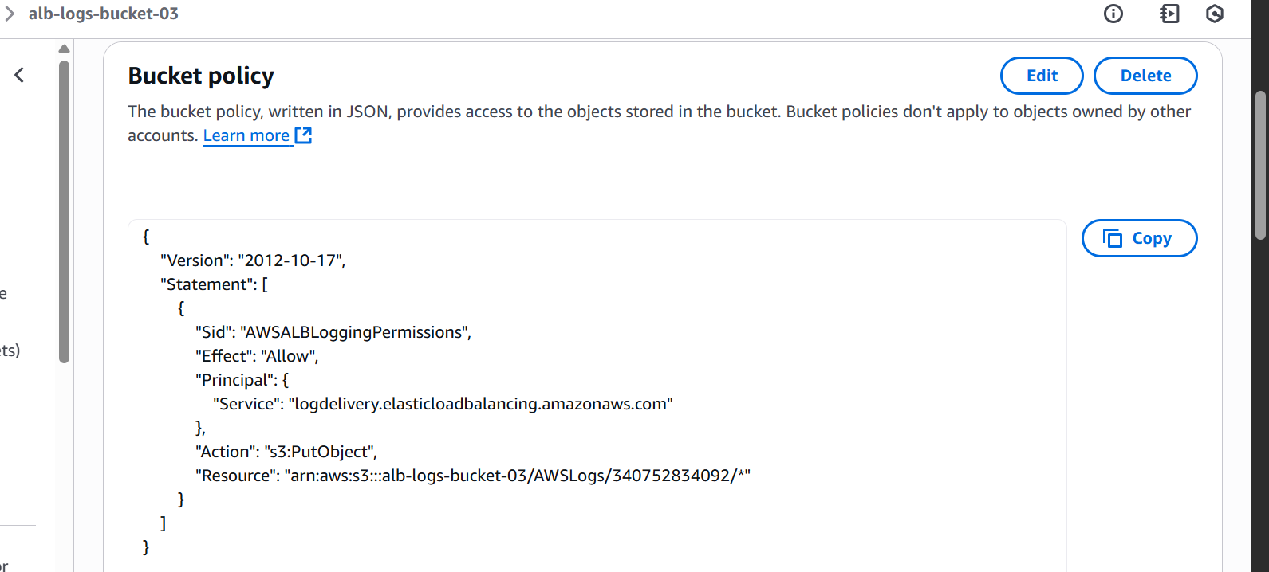

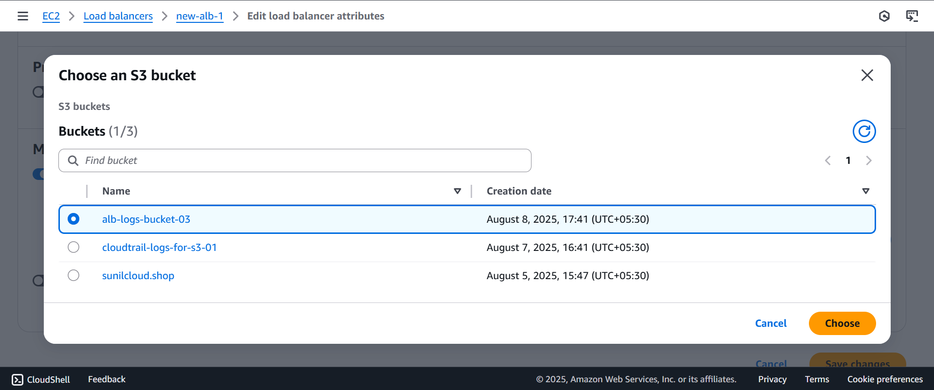

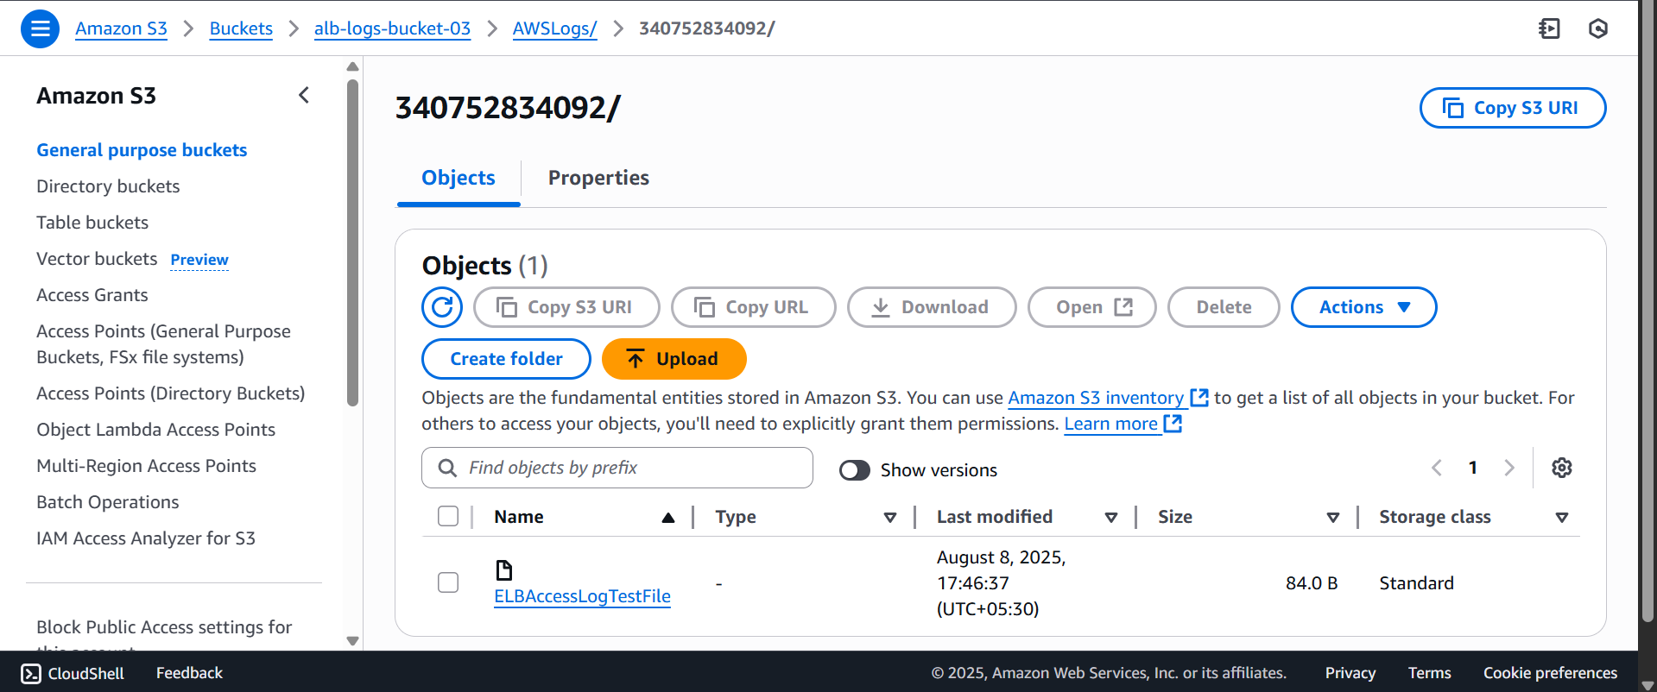

**10. Store the VPC flow logs to CloudWatch group.**

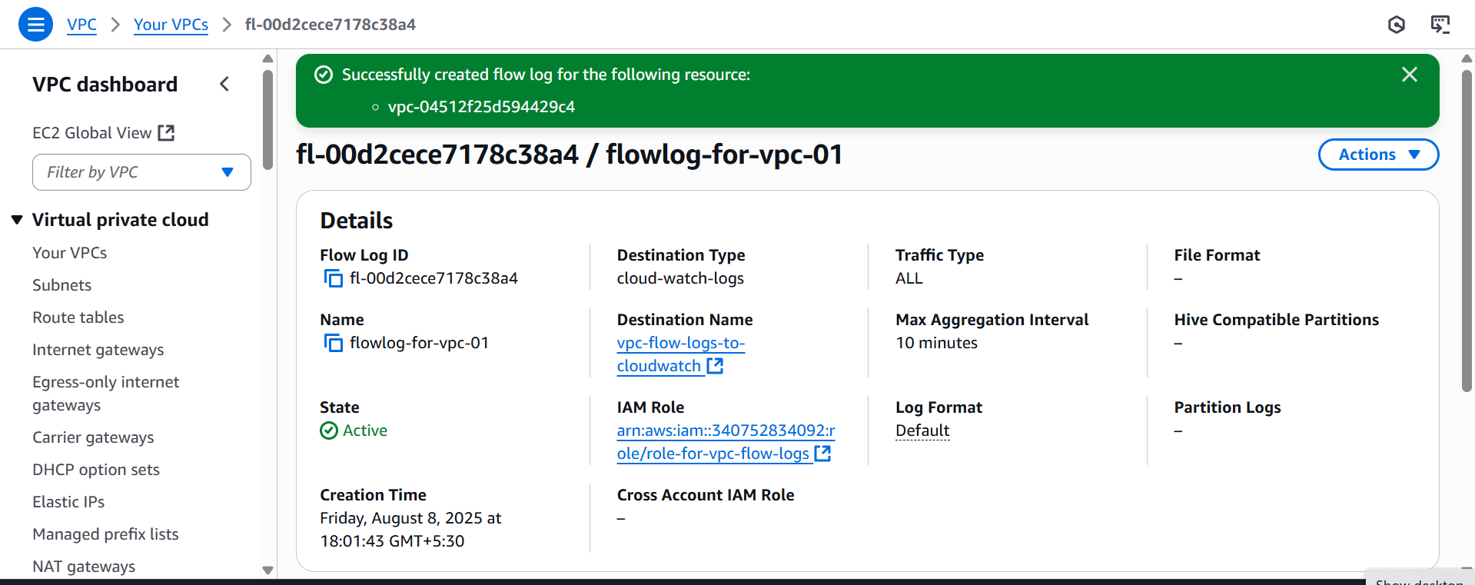

**11. Create Monitoring Dashboards to monitor CPU utilization and to monitor Apache service.**

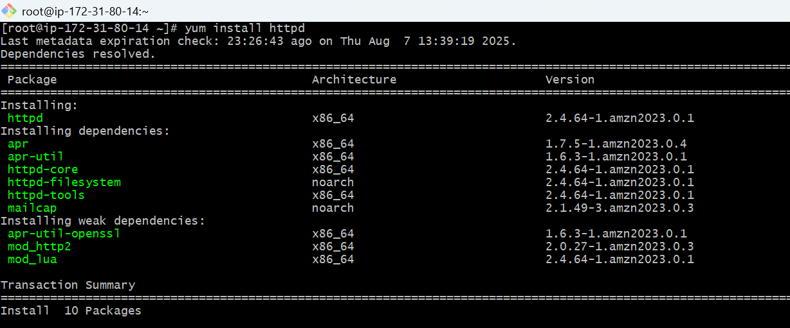

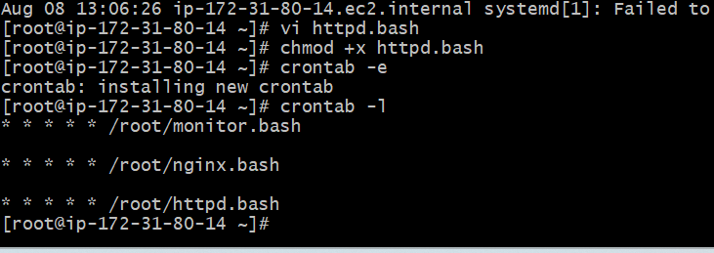

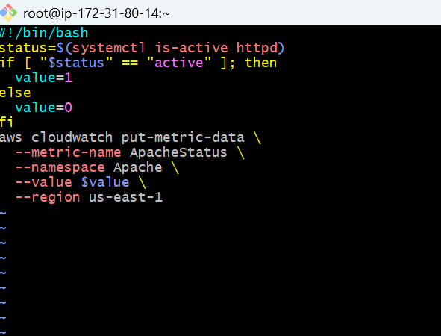

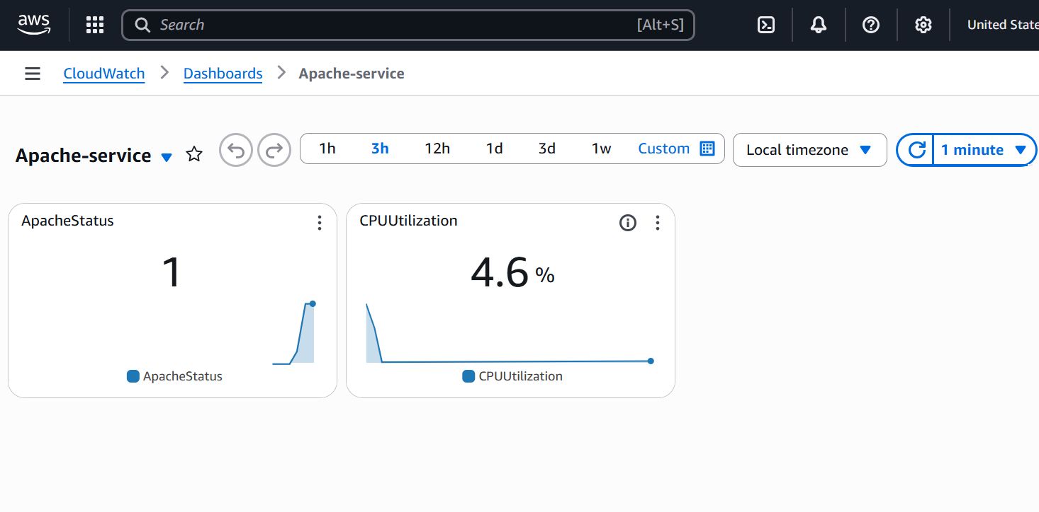

**12. CPU utilizations more than 70% then it should triggered Autoscaling and launch new instance.**

Step 1: Create a Launch Template

**EC2 Dashboard → Launch Templates**

**Create launch template**

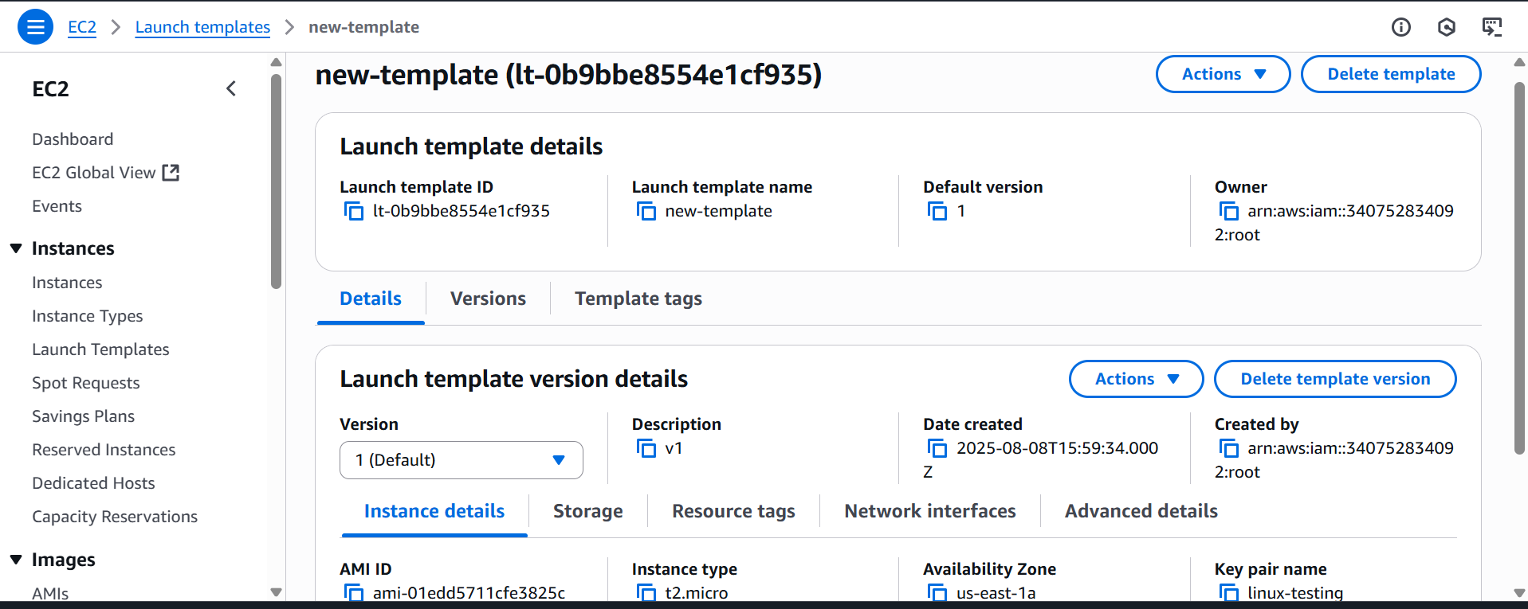

Step 2: Create an Auto Scaling Group (ASG)

Go to **EC2 Dashboard** → **Auto Scaling Groups**

Click **Create Auto Scaling group**

Click **Next** through the remaining steps and click **Create Auto Scaling group**

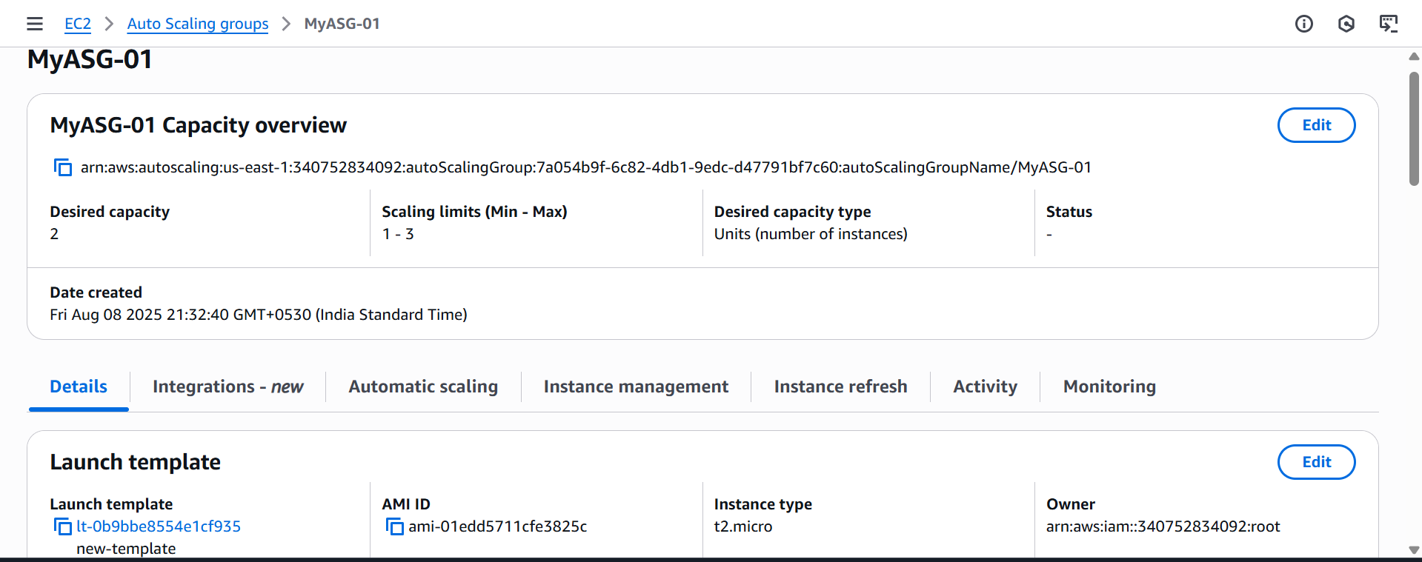

**Step 3: Add a Target Tracking Policy (CPU > 70%)**

After the ASG is created:

1. Go to **Auto Scaling Groups**
2. Select your **ASG**
3. Click the **Automatic Scaling** tab
4. Choose **Target tracking scaling policy**

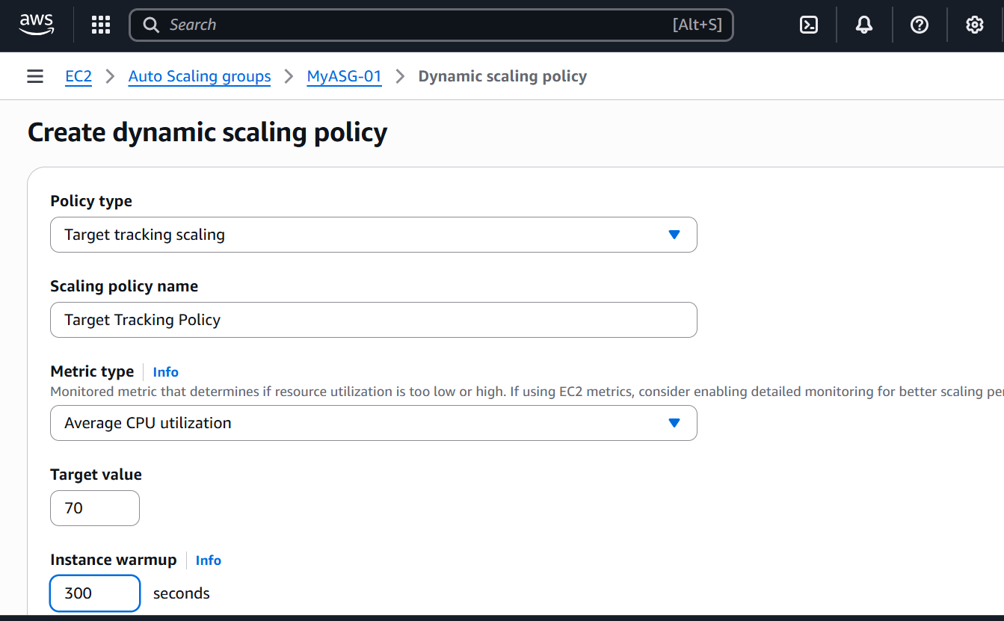

**test if your Auto Scaling Group (ASG) triggers on high CPU usage**,

**Manually trigger high CPU usage** on an EC2 instance in your Auto Scaling Group.

Verify that **Auto Scaling launches a new instance**.

Connect to Your EC2 Instance

Go to EC2 Console → Instances

Find an instance managed by your ASG

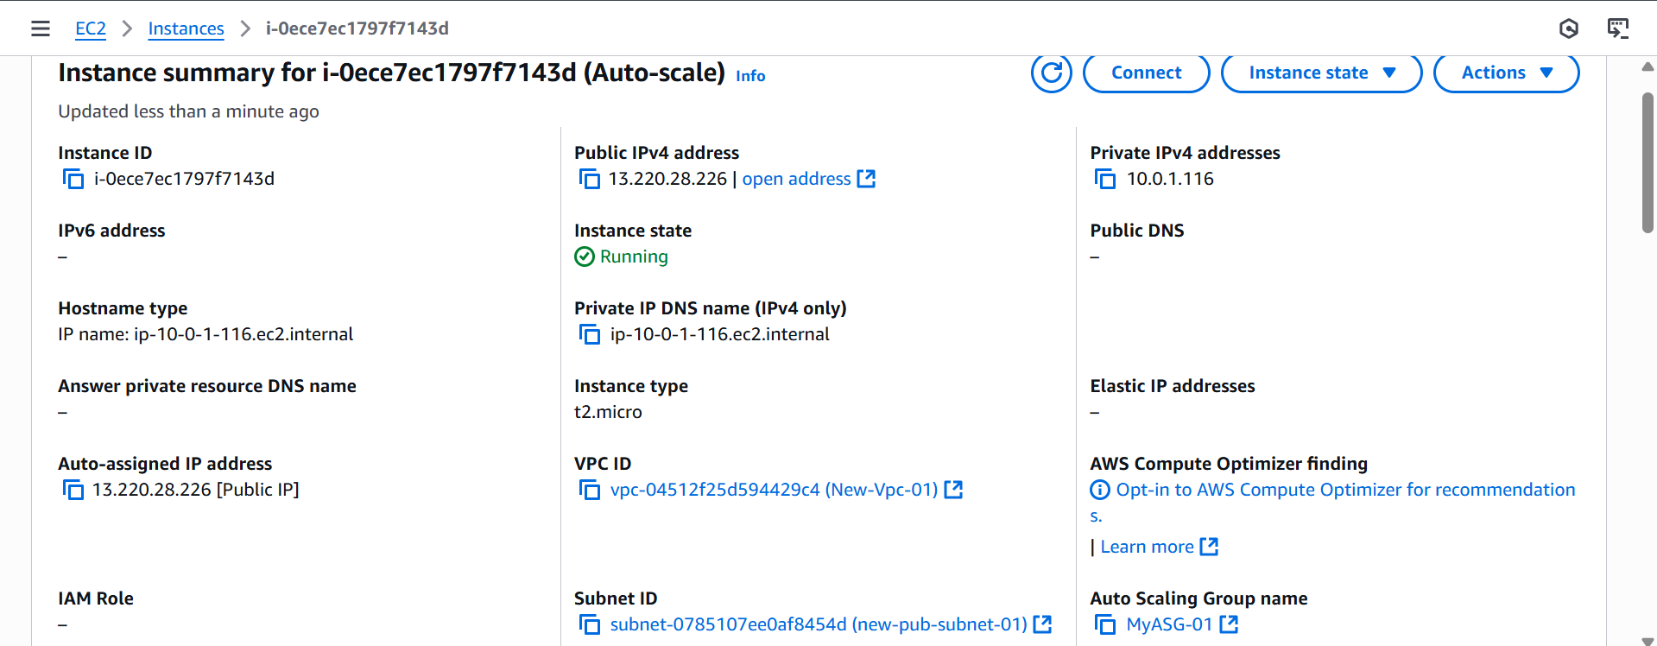

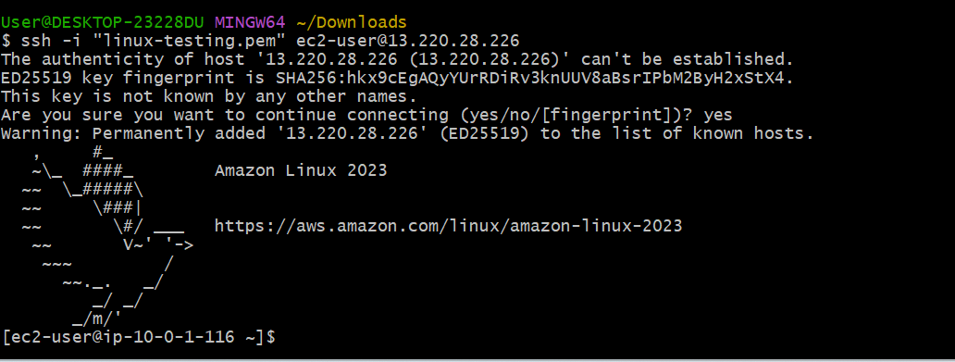

**Manually trigger high CPU usage** on an EC2 instance in your Auto Scaling Group.

sudo yum install -y stress

stress --cpu 2 --timeout 600

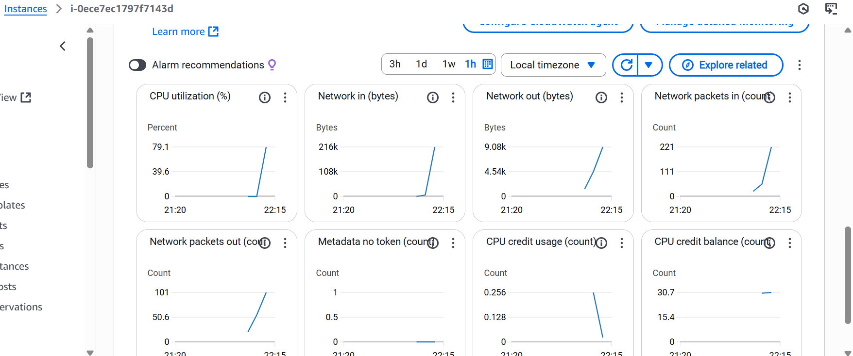

When average CPU > 70%, AWS will **add instances**

When **CPU Utilization > 70%**, AWS Auto Scaling should **launch a new EC2 instance**s

