1. Launch one ec2 using Amazon Linux 2 image and add script in user data to install Apache.

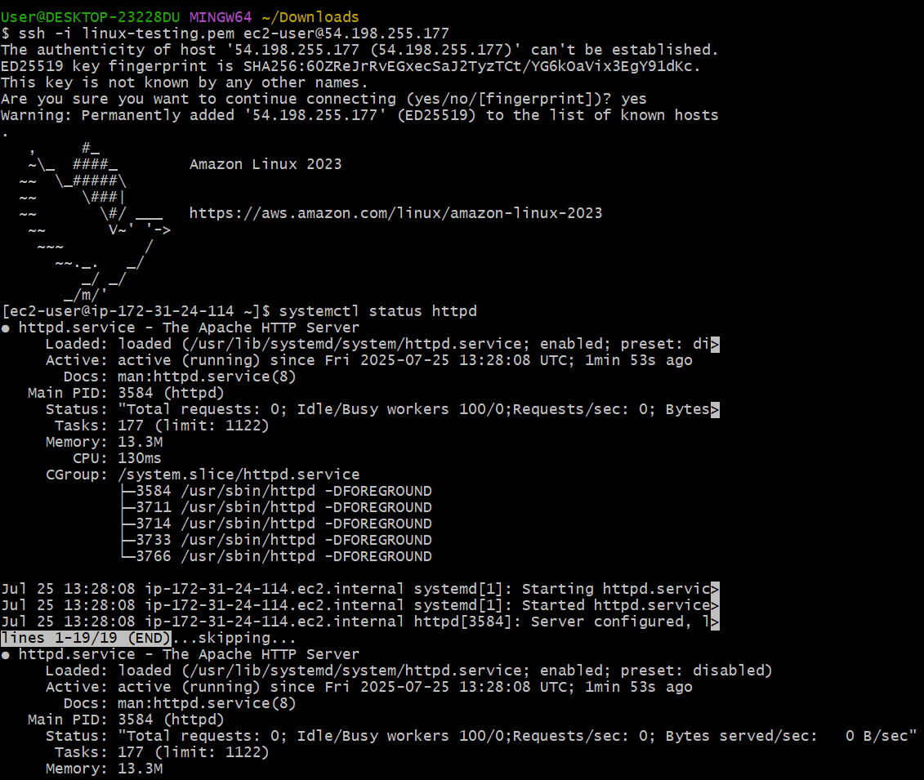

1. Launch one ec2 using Ubuntu image and add script in user data to install Nginx.

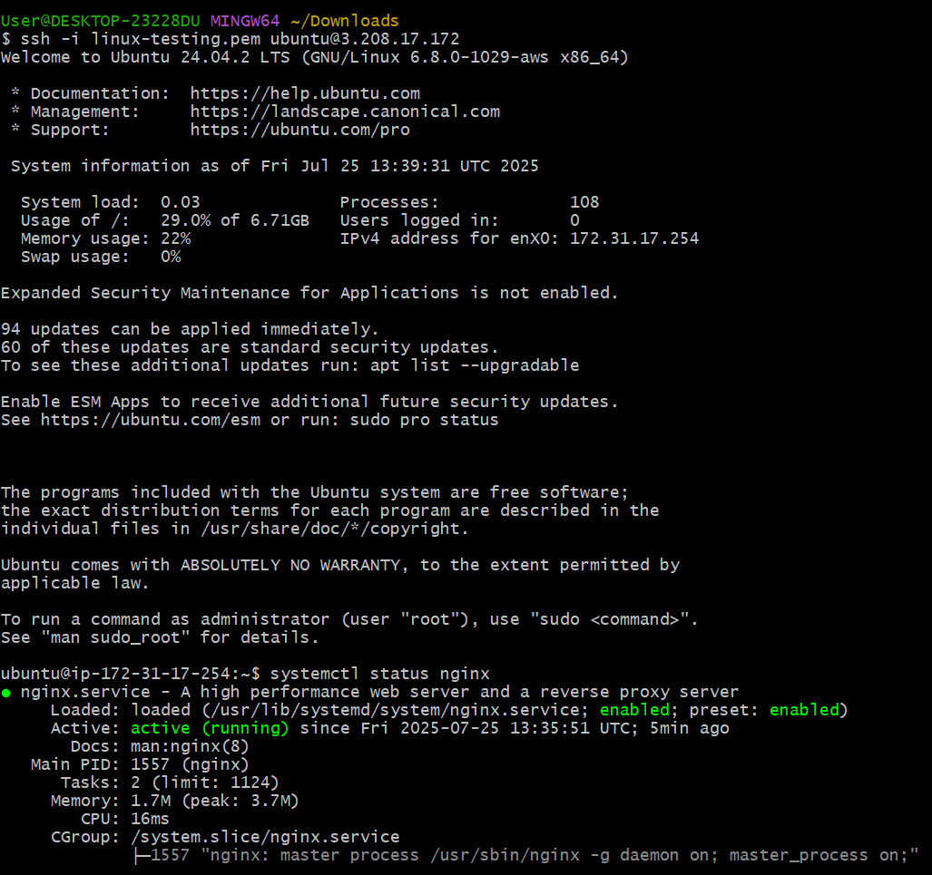

1. Launch one windows server and install tomcat in windows.

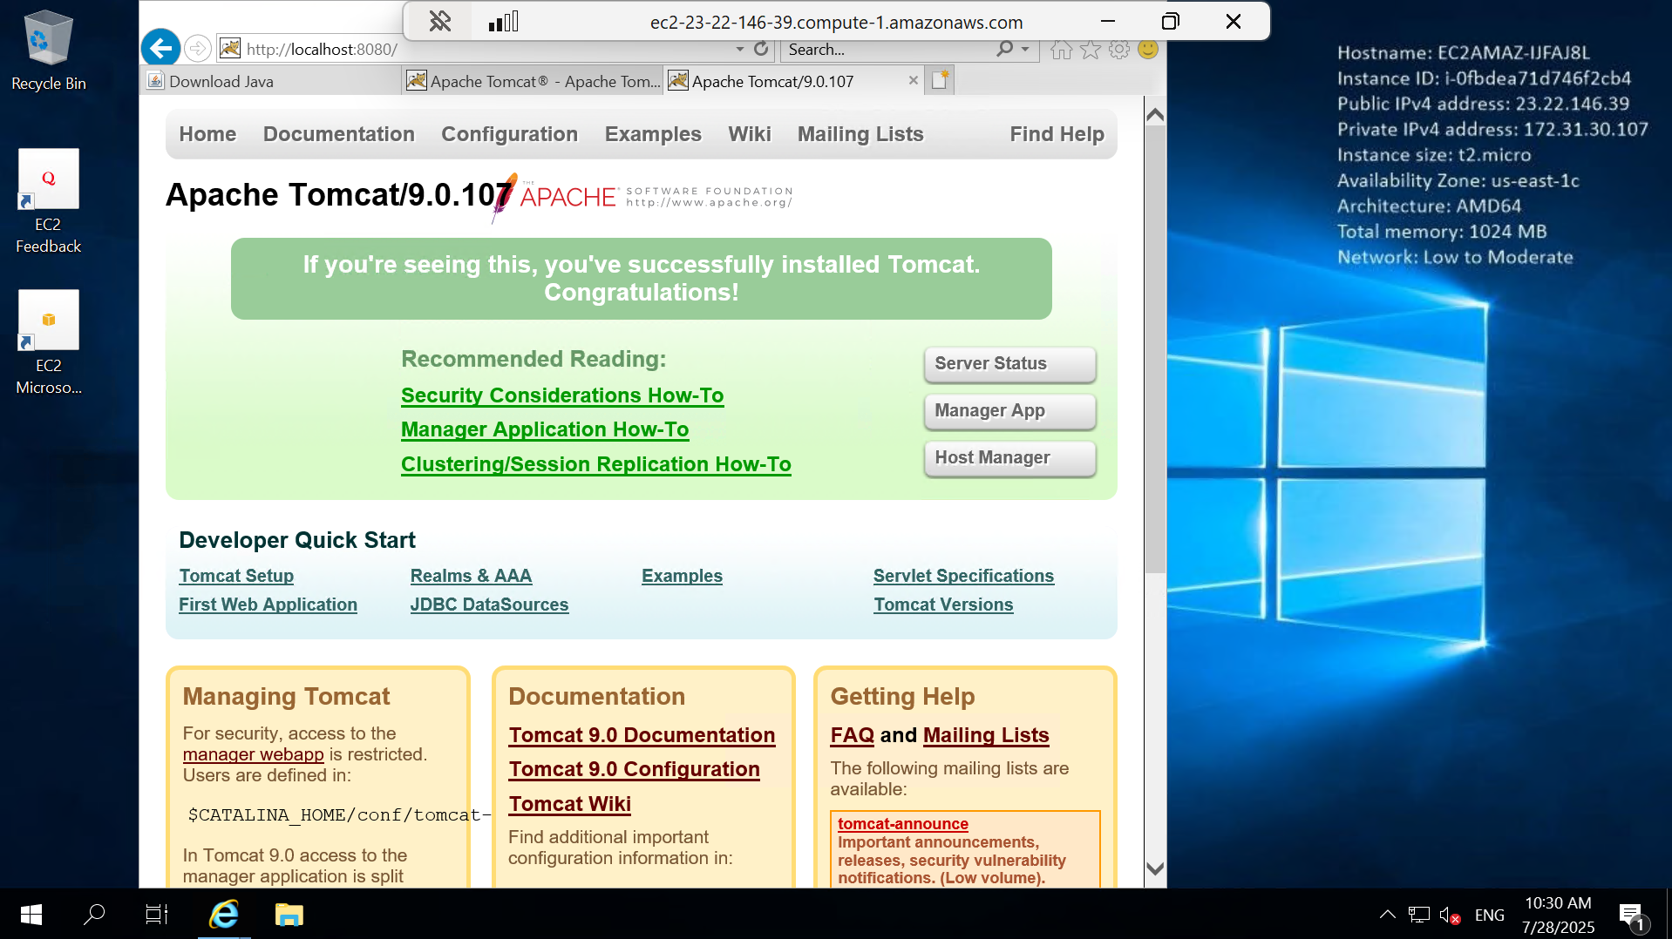

4) Take snapshot of the instane created in Task 1.

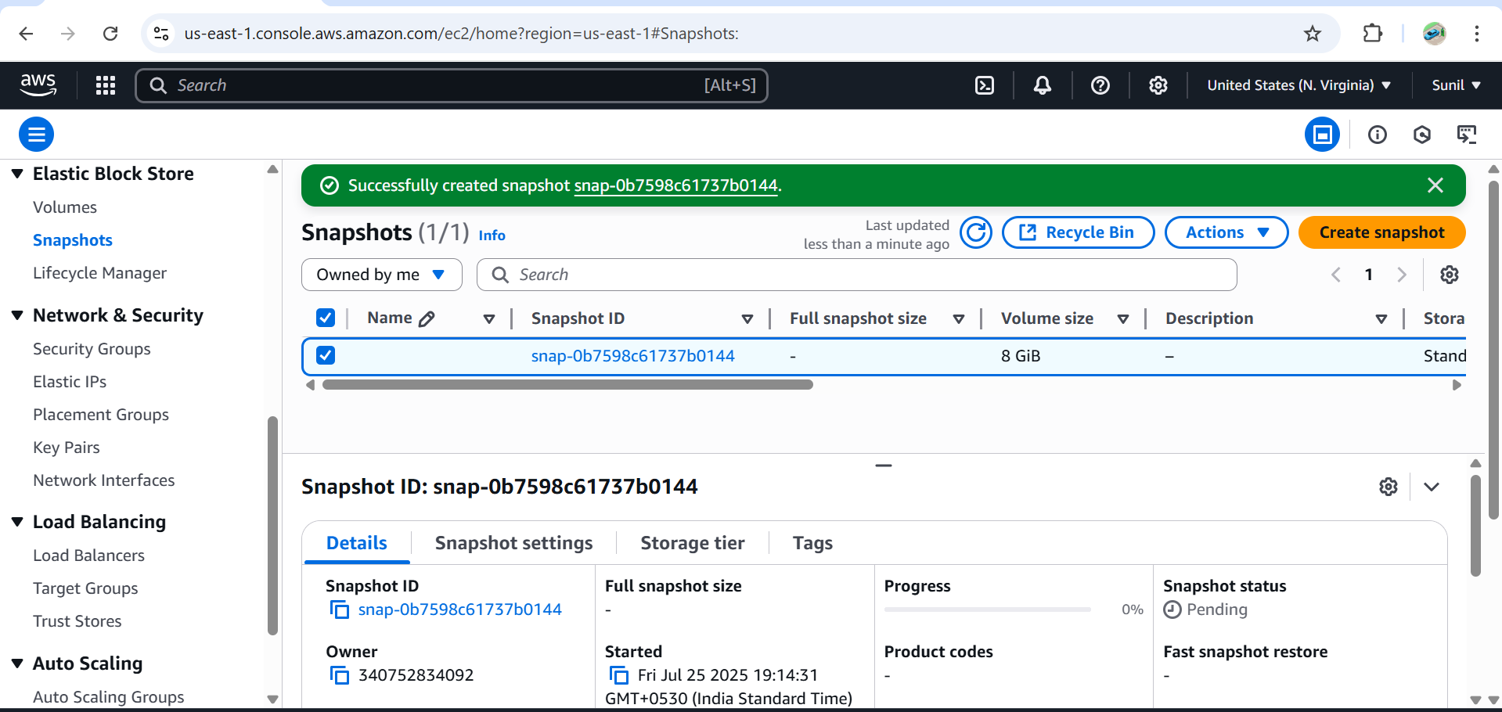

5) Assign password less authentication for ec2 created on Task 2.

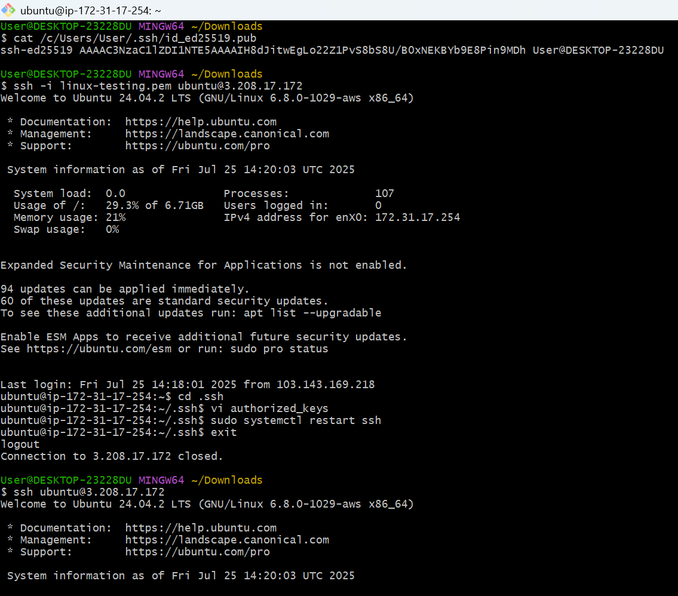

6) Launch any ec2 using spot purchasing option.

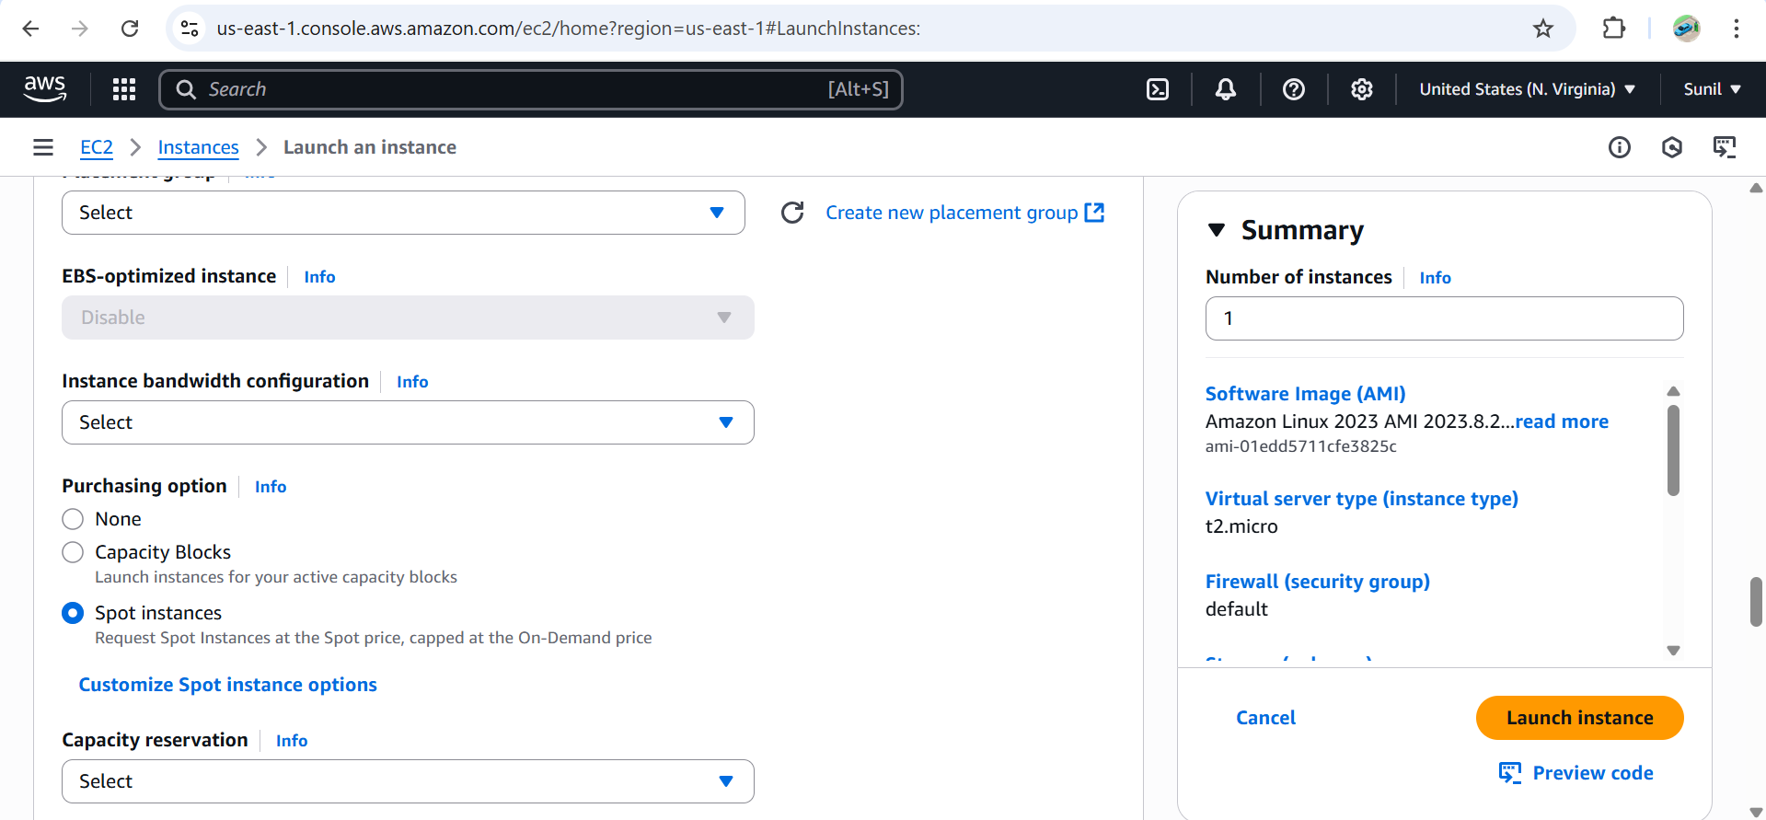

7) Enable Termination policy on ec2 created in Task 2.

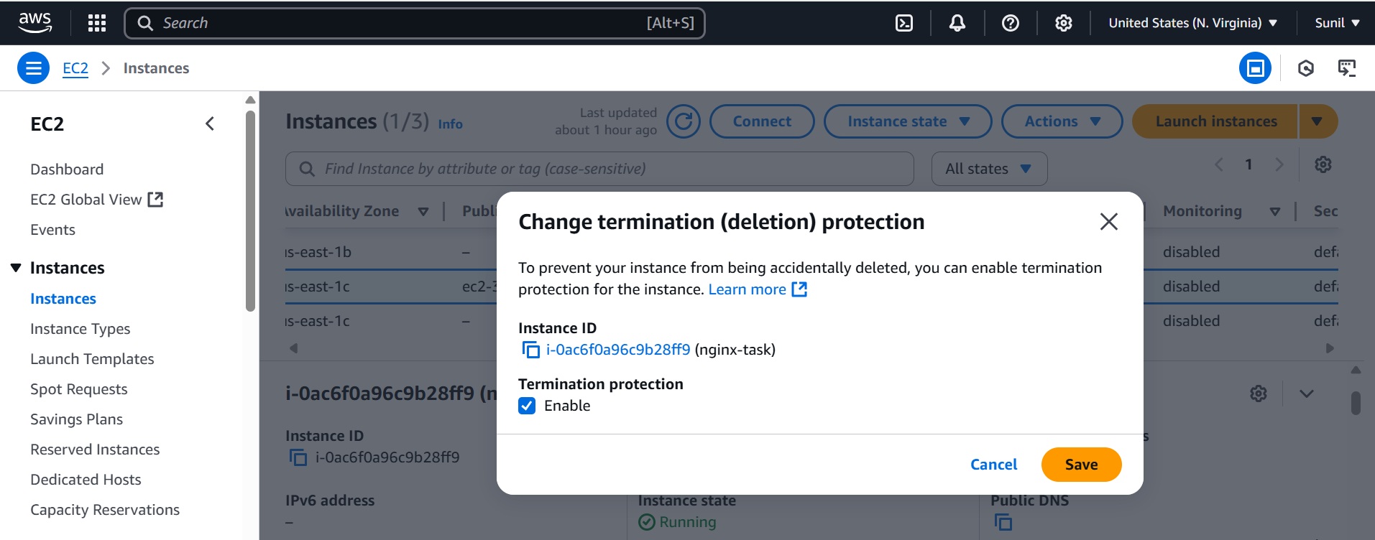

8) Launch one ec2 using Aws CLI.

sudo yum install awscli –y

**🔹 Go to AWS Console:**

1. Open IAM Console
2. Click **Users**
3. Select your **IAM username**
4. Go to **Permissions** tab
5. Click **Add permissions** → **Attach policies directly**

**🔹 Choose one of these:**

* ✅ **AmazonEC2FullAccess** *(quick setup — for full EC2 access)*

And also create an access key and secret key for aws cli to configure------

aws configure

You will be prompted to enter:

* AWS Access Key ID
* AWS Secret Access Key
* Default region (e.g., us-east-1)
* Default output format (json is recommended)

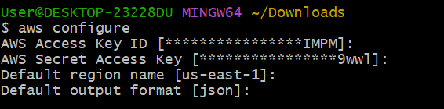

aws ec2 describe-images \

--region us-east-1 \

--output json \

--owners amazon \

--filters "Name=name,Values=amzn2-ami-hvm-*-x86_64-gp2" \

--query "Images | sort_by(@, &CreationDate) | [-1].ImageId" \

--output text

--------------------------------------------------------------------------------------------------------------------------------------

### Example Output:

If it works, you’ll get: ami-0abcdef1234567890

Then you can proceed:

Change the below details according to your system or you can keep your existing configurations

### Launch instance:

aws ec2 run-instances \

--image-id ami-0abcdef1234567890 \

--count 1 \

--instance-type t2.micro \

--key-name my-existing-key \

--security-group-ids sg-xxxxxxxxxxxxxxx \

--region us-east-1

