**Ansible-01**

**1.Watch ansible-01 video and write down notes.**

**2.Setup one master and two worker nodes in ansible.**

Step-by-Step Setup: Ansible with 1 Master + 2 Workers (Ubuntu EC2)

**1.Launch EC2 Instances**

* Go to **AWS EC2** console.
* Launch **3 Ubuntu AMI** instances (latest Ubuntu 22.04 or 20.04).
  + 1 for **master (control)**
  + 2 for **workers (managed nodes)**
* Use the **same key pair** (e.g., mykey.pem) for all three.
* Security Group: Allow at least **SSH (port 22)** between them.

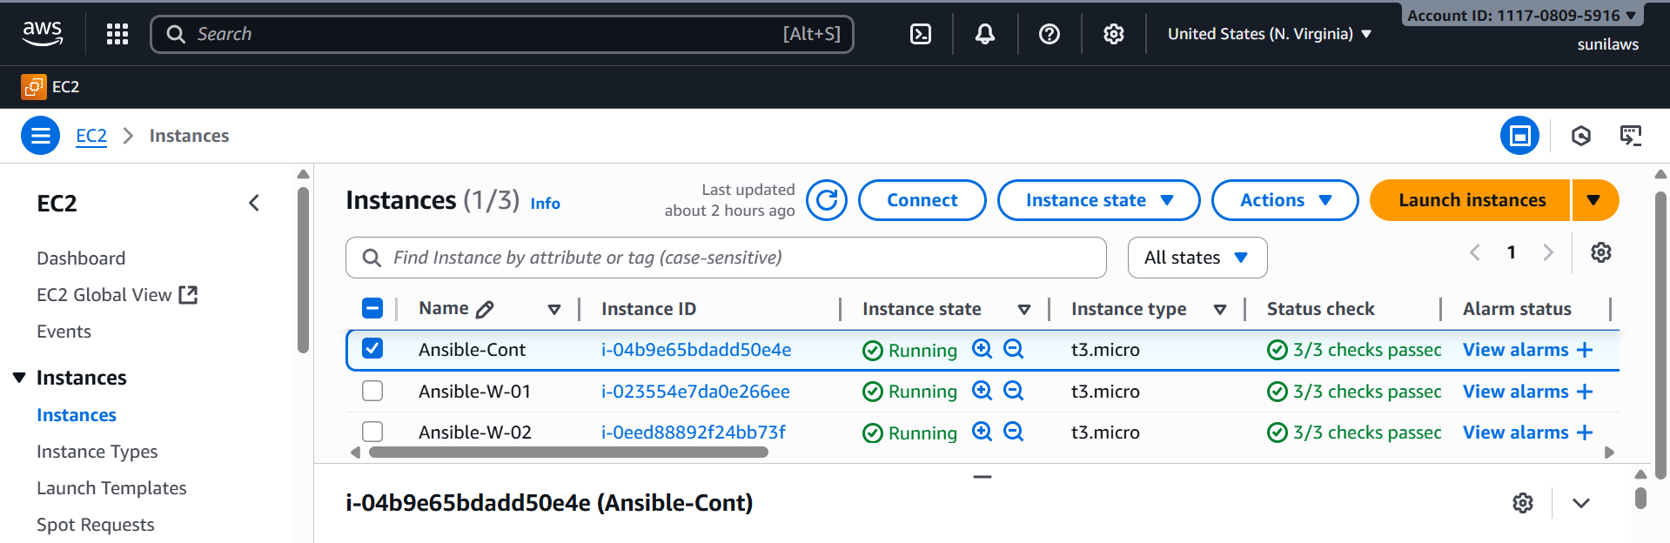

Step-2

Connect to Master (Control Node)

ssh -i mykey.pem ubuntu@<MASTER_PUBLIC_IP>

sudo apt update -y

sudo apt install ansible –y

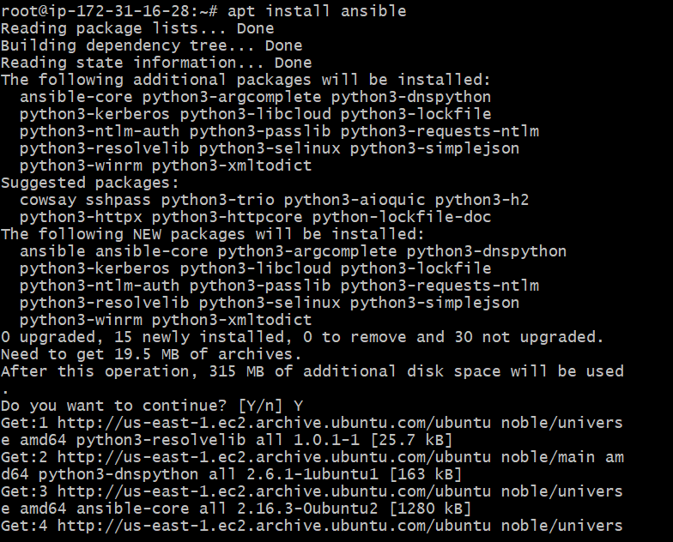

check the ansible version

ansible --version

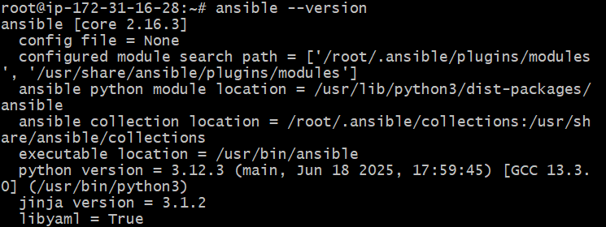

**Here we have no cfg file by default**

By default, **Ubuntu does not create /etc/ansible/ansible.cfg or /etc/ansible/hosts anymore** — instead, you’re expected to **create your own config and inventory** in your project directory.

sudo mkdir -p /etc/ansible

sudo vi /etc/ansible/ansible.cfg

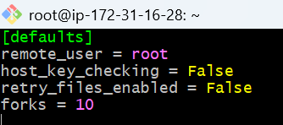

**After creating the cfg file create a hosts file also**

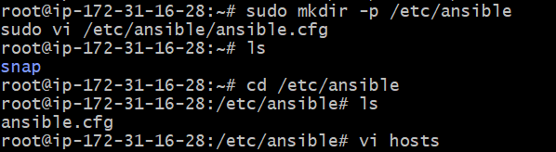



**And in hosts file add the workers vi hosts**

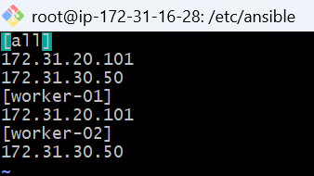

**And check**

**ansible all -m ping**



**Permission denied (publickey).**

**means Ansible is trying to connect with the ubuntu user, but the SSH key is missing or not set up properly between your master (control node) and the worker nodes.**

Fix SSH Access Between Master and Workers

**Do ssh-kegen from Master server**

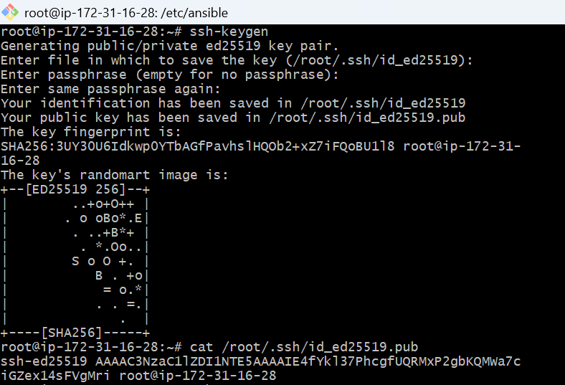

ssh-ed25519 AAAAC3NzaC1lZDI1NTE5AAAAIE4fYkl37PhcgfUQRMxP2gbKQMWa7ciGZex14sFVgMri root@ip-172-31-16-28

**Copy the key and go to worker-01 &worker-02 servers**

**Do cd .ssh/**

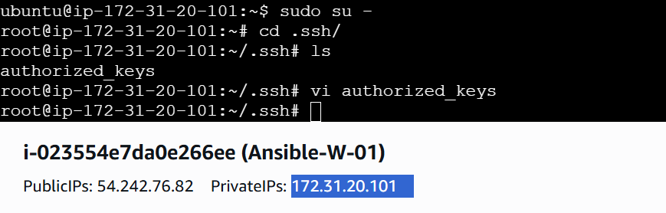

**In vi authorized_keys paste the copied key in both the worker servers and save**

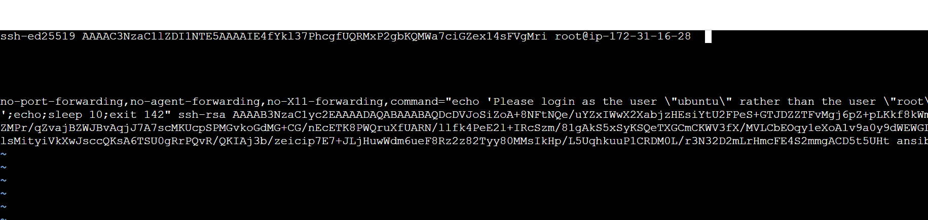

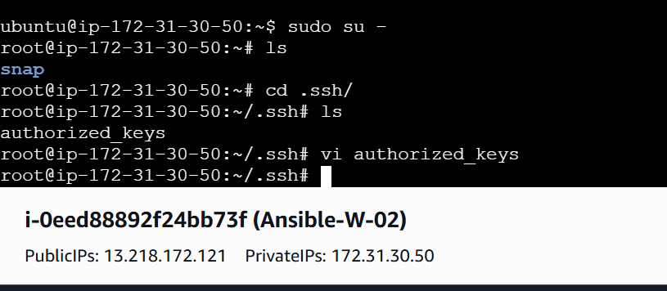

**Check for**

**ansible all -m ping**

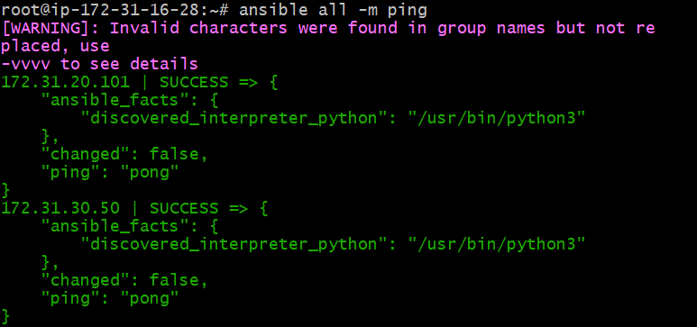

**3.Execute the adhoc command shared in #dvps-cloud-documents-14 Channel.**

ansible all -m ping 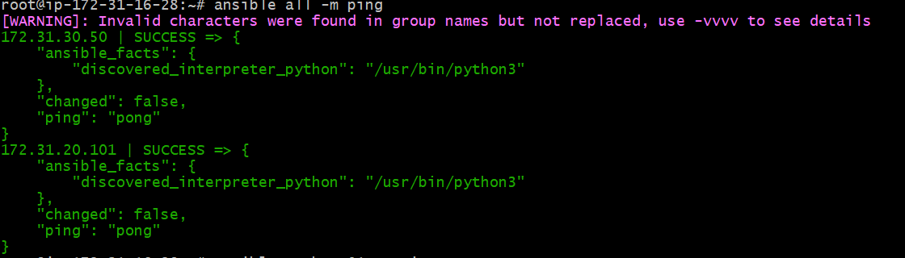

ansible worker-01 -m ping

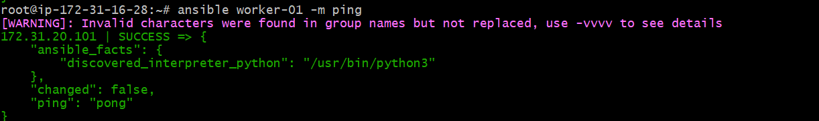

ansible worker-01 -m ping –vvvv

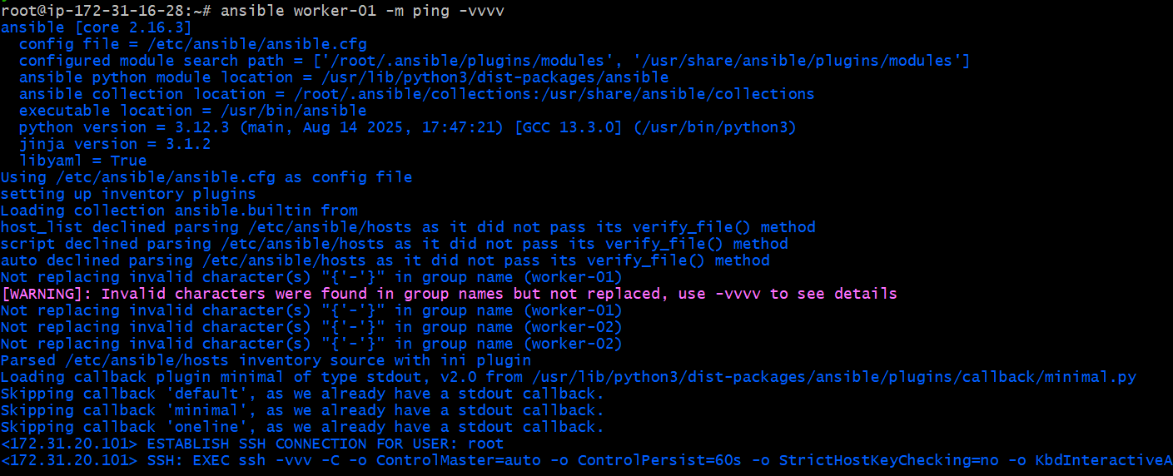

ansible all -m uptime

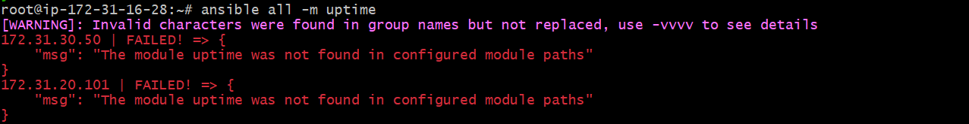

ansible all -m shell -a uptime 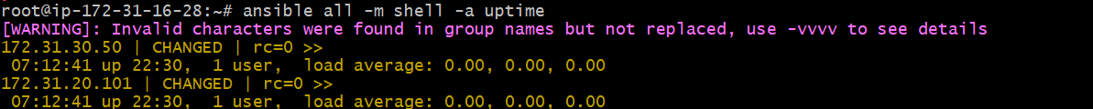

ansible all -m shell -a "mkdir Ansible-controller"

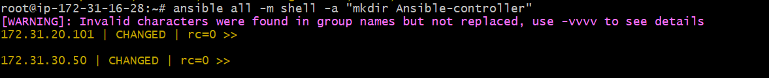

ansible all -m shell -a "ps -ef" 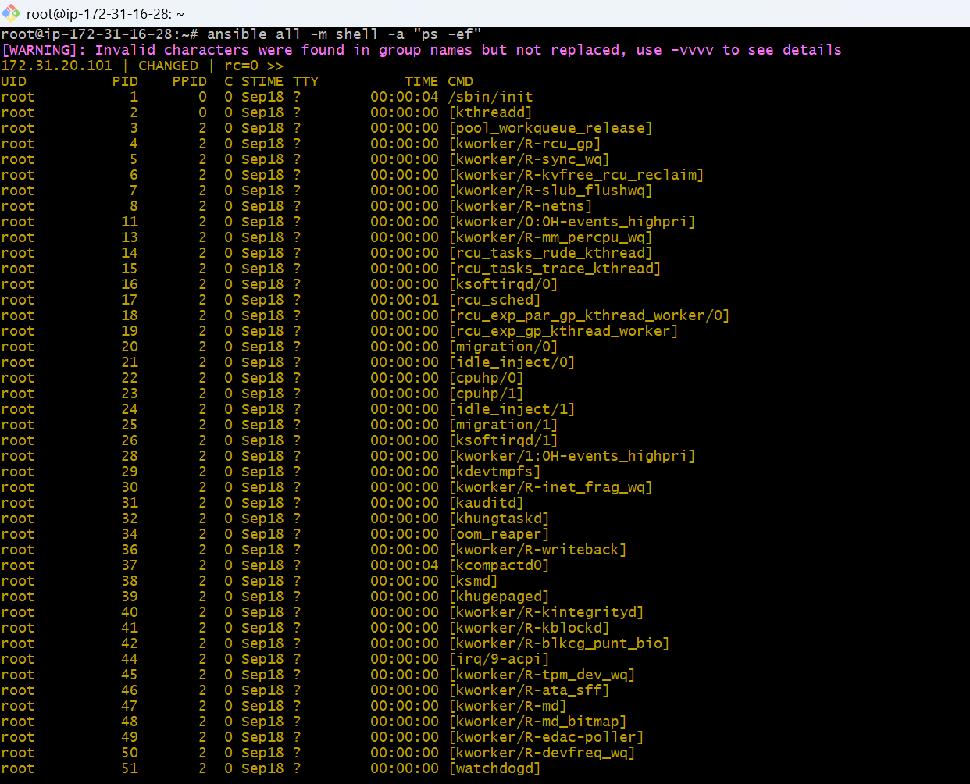

ansible -i /root/sunil_inventory sunil -m ping

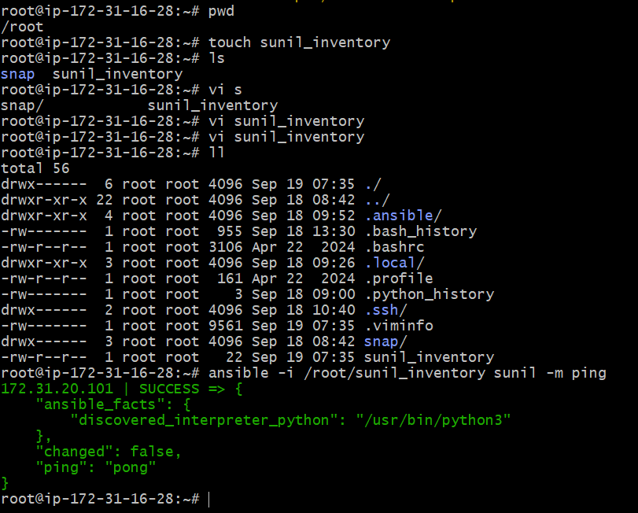

# How to gather facts of slave machine

ansible all -m setup

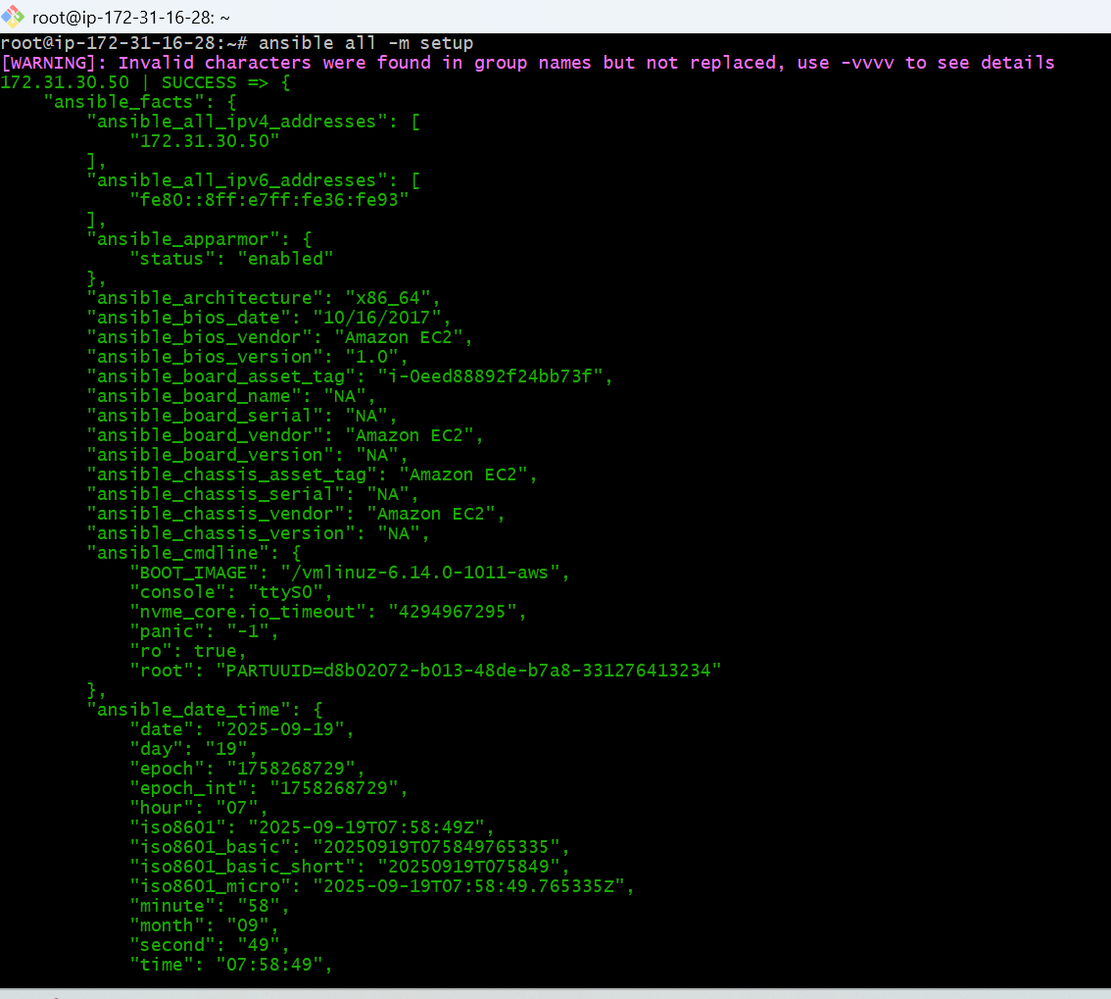# Install a package using yum command

ansible all -m yum -a "name=httpd state=installed"

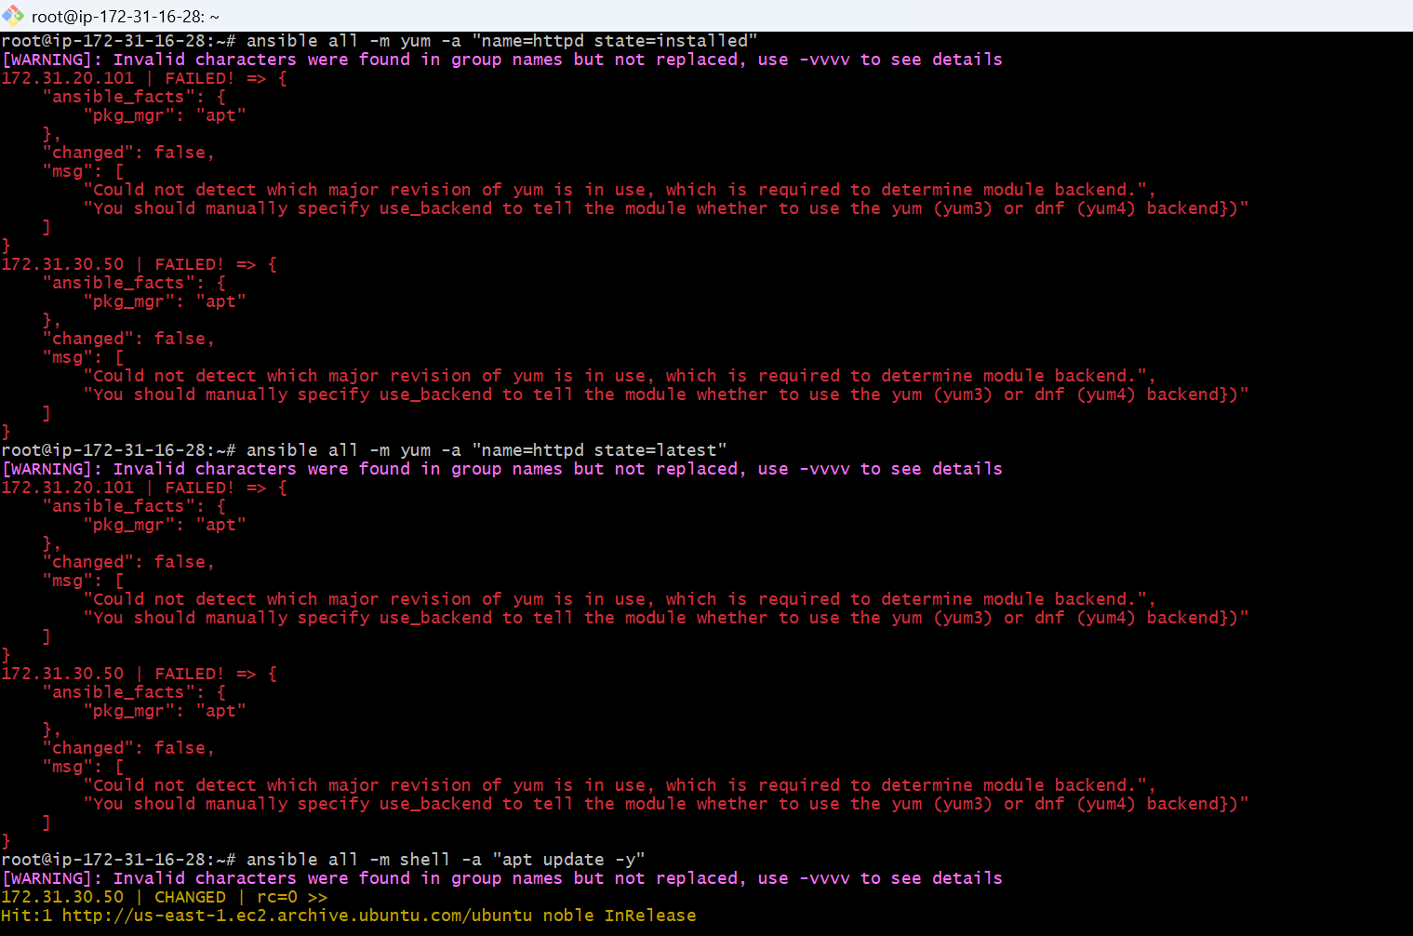

ansible all -m apt -a "name=apache2 state=latest"s

