1. **Launch one ec2 instance using amazon linux**

AWS Console → EC2 → Launch Instance → Choose **Amazon Linux 2 AMI (HVM)**.

Choose instance type (t2.micro for testing).

Create / select a Key pair (.pem) — download it.

Create / select a Security Group allowing:

Click Launch

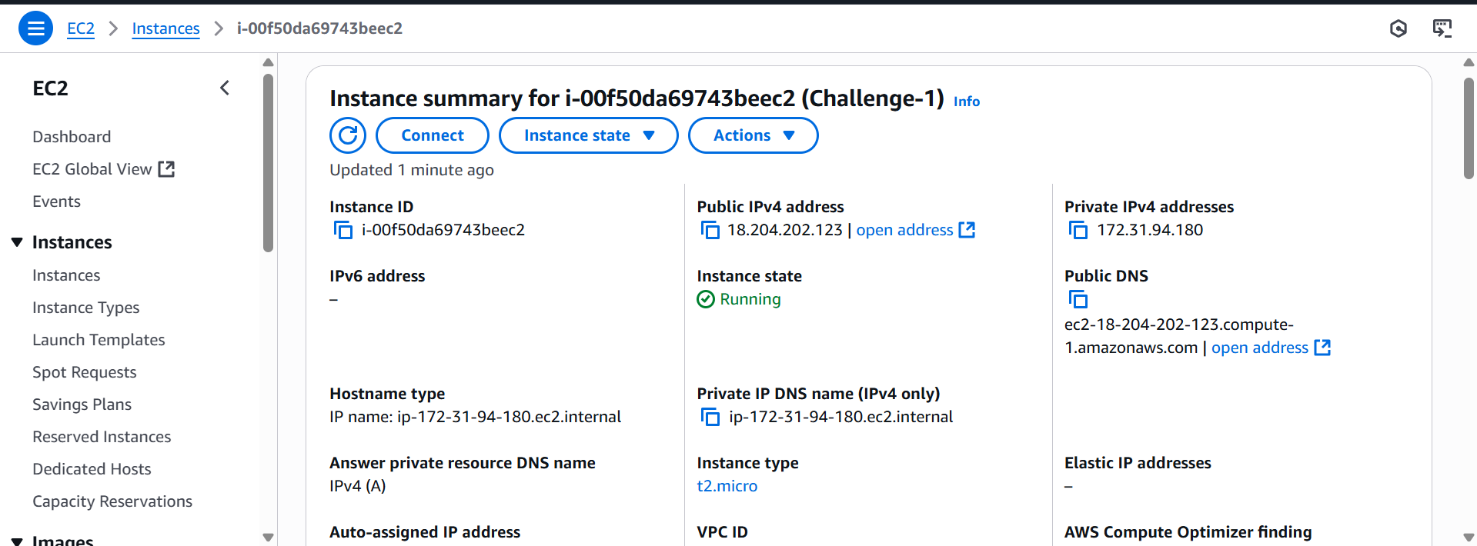

Step -2

SSH into the instance

ssh -i my-key.pem ec2-user@<PUBLIC_IP>

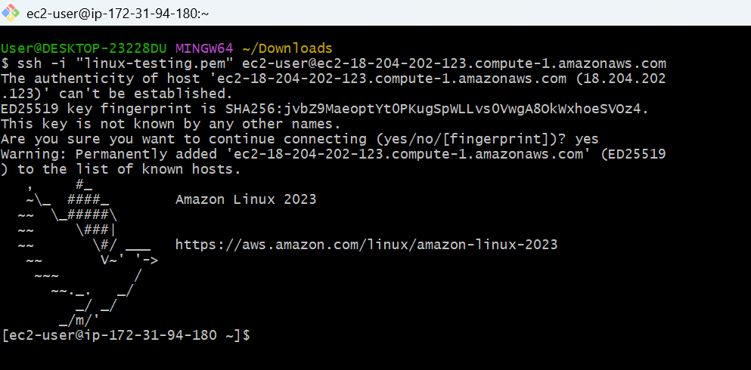

1. **Install Docker**

Install Docker

yum install docker

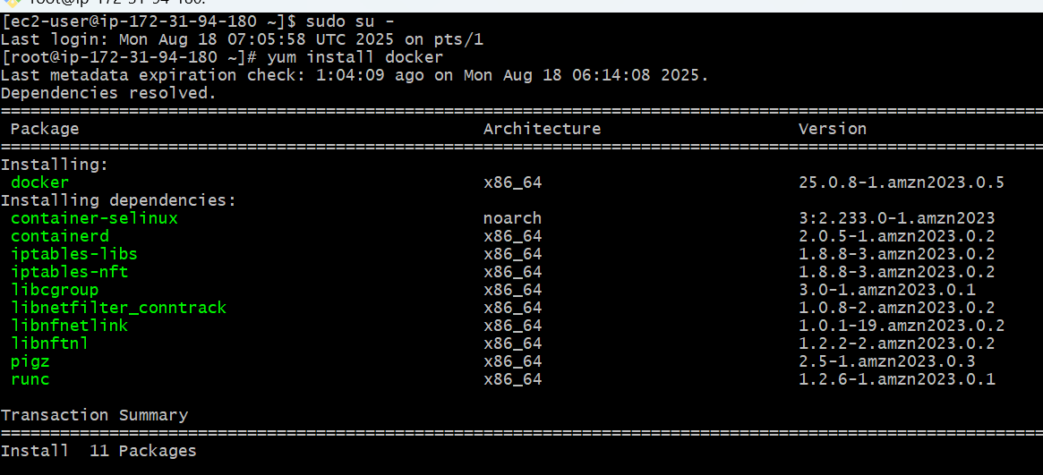

Start and Enable Docker

sudo systemctl start docker

sudo systemctl enable docker

Verify Installation

docker –version

Test by running:

sudo docker run hello-world

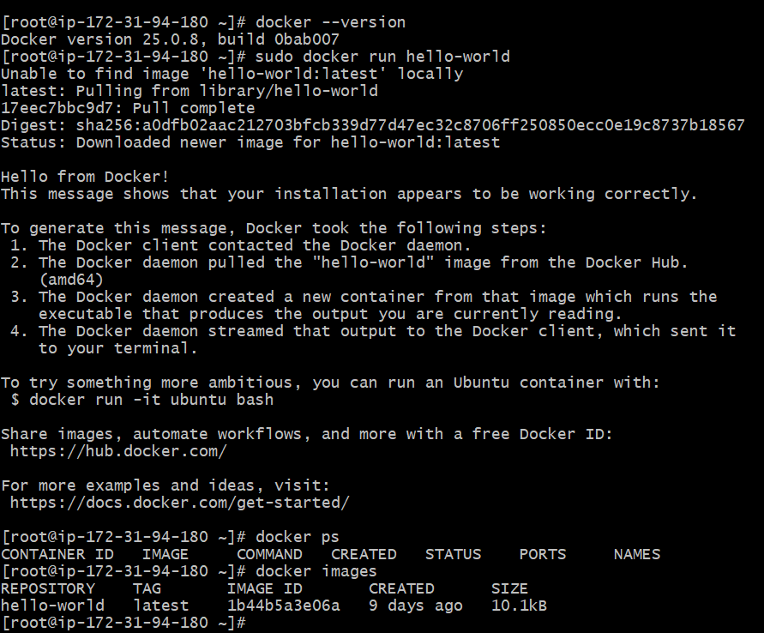

1. **Install Jenkins**

Install Java (required by Jenkins)

sudo dnf install -y java-17-amazon-corretto

Verify java

java –version

. Add Jenkins Repository

sudo wget -O /etc/yum.repos.d/jenkins.repo \

https://pkg.jenkins.io/redhat-stable/jenkins.repo

sudo rpm --import <https://pkg.jenkins.io/redhat-stable/jenkins.io-2023.key>

Install Jenkins

sudo yum install -y Jenkins

**Start and Enable Jenkins Service**

sudo systemctl start jenkins

sudo systemctl enable Jenkins

Check status:

systemctl status jenkins

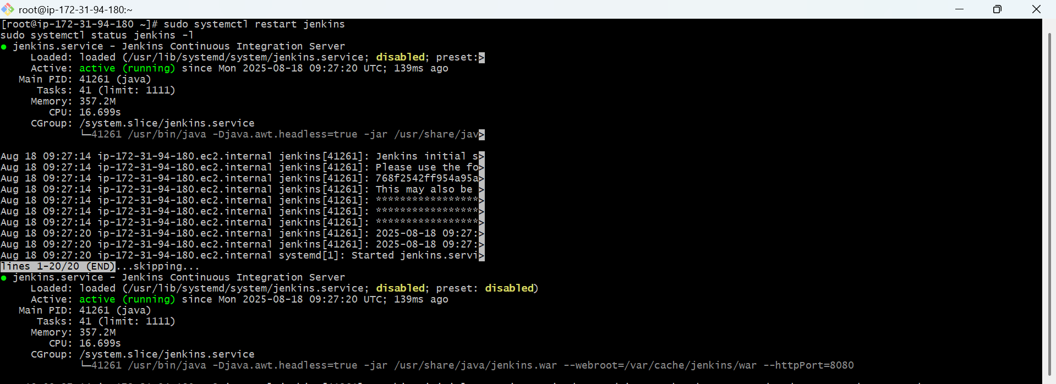

**Access Jenkins in Browser**

**http://<your-ec2-public-ip>:8080**

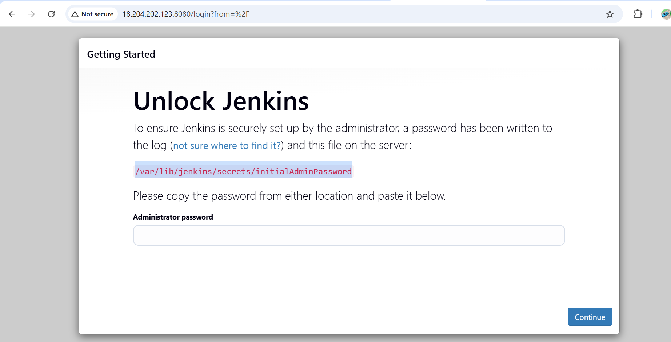

Get the Initial Admin Password

sudo rpm --import <https://pkg.jenkins.io/redhat-stable/jenkins.io-2023.key>

sudo cat /var/lib/jenkins/secrets/initialAdminPassword

Copy the long alphanumeric string.



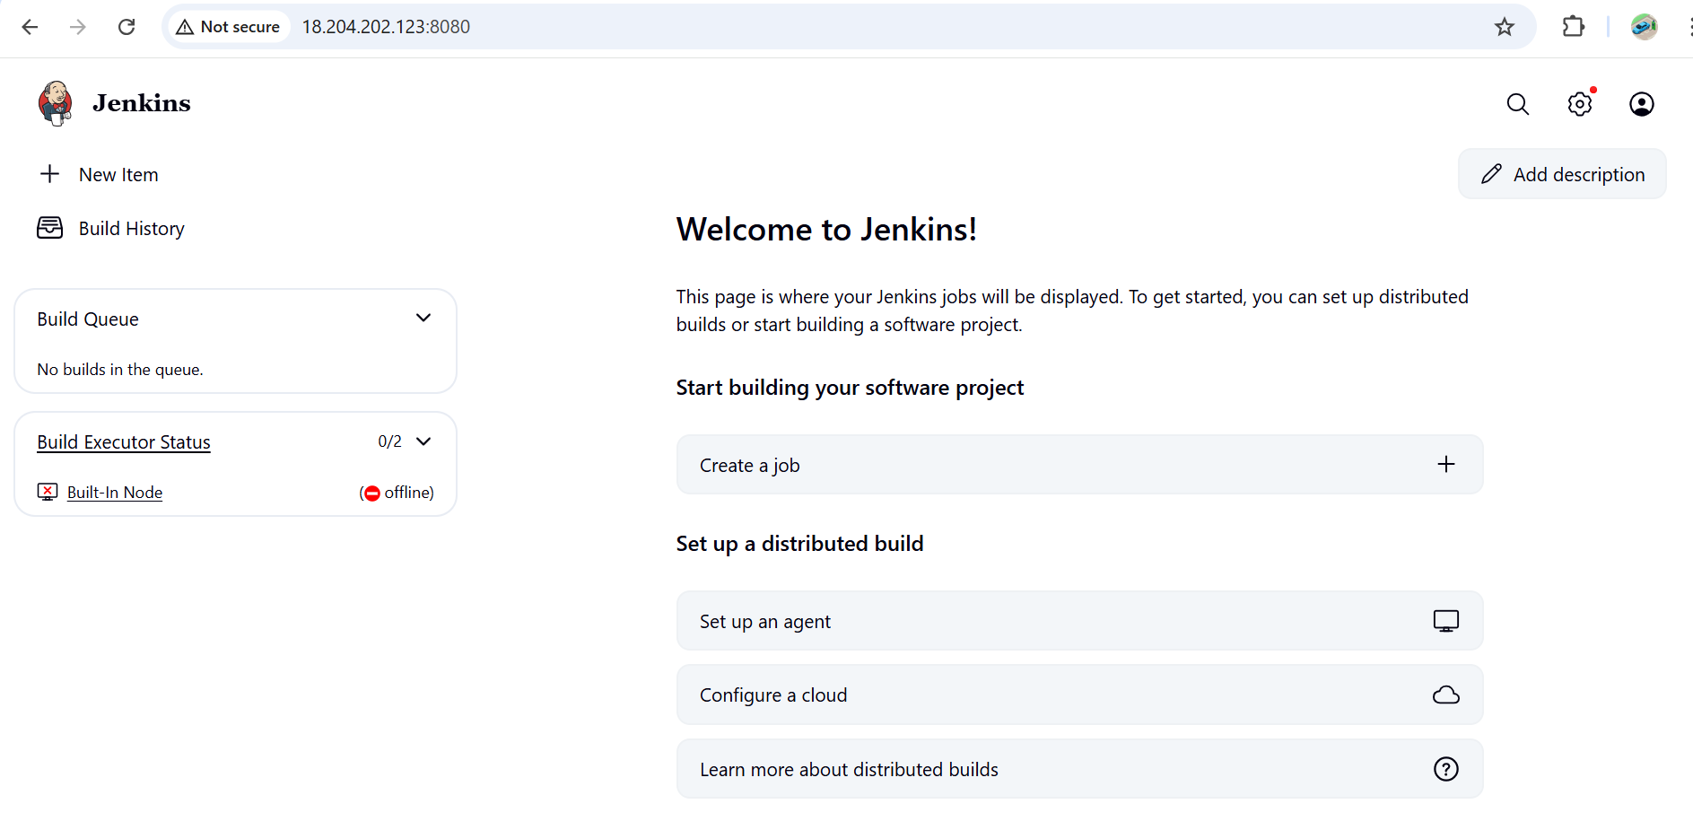

1. **Install apache**

* # Update packages
* sudo yum update -y
* # Install Apache (called httpd)
* sudo yum install -y httpd
* # Enable and start Apache
* sudo systemctl enable httpd
* sudo systemctl start httpd
* # Check status
* systemctl status httpd

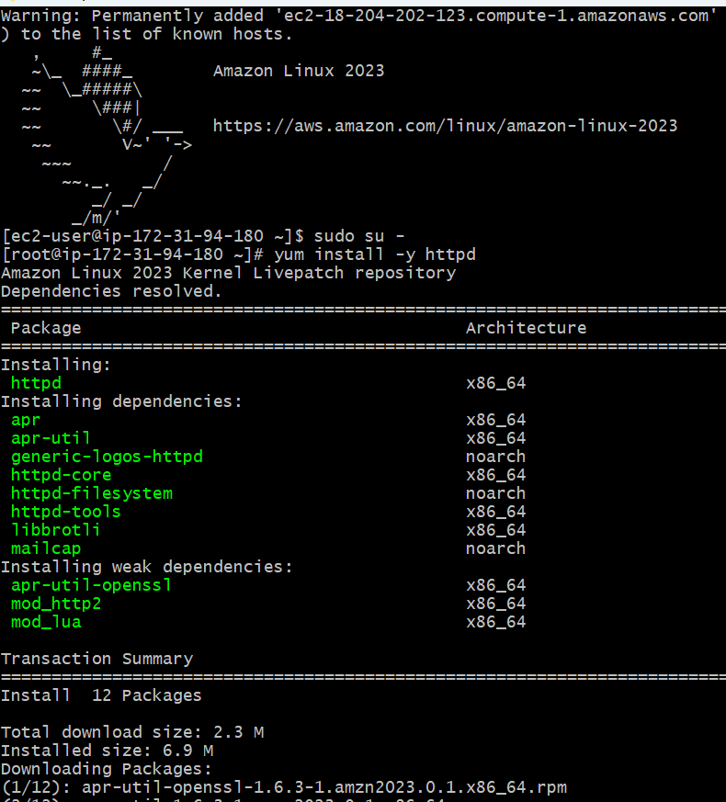 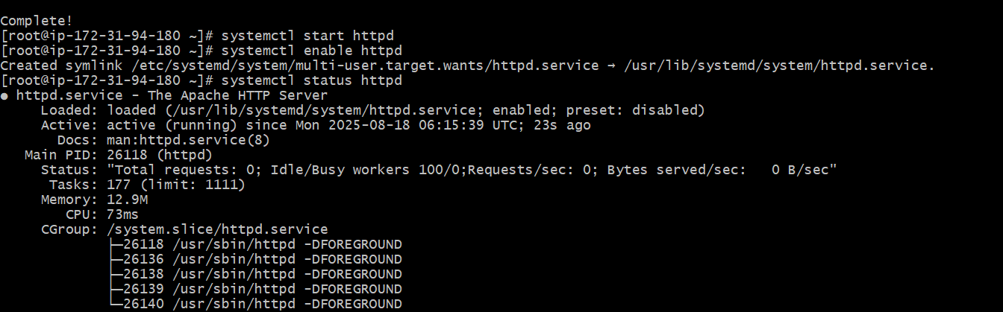

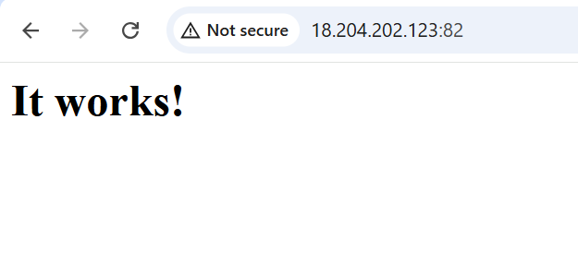

1. **Install nginx**

* # Install Nginx
* sudo yum install -y nginx
* # Enable and start Nginx
* sudo systemctl enable nginx
* sudo systemctl start nginx
* # Check status
* systemctl status nginx

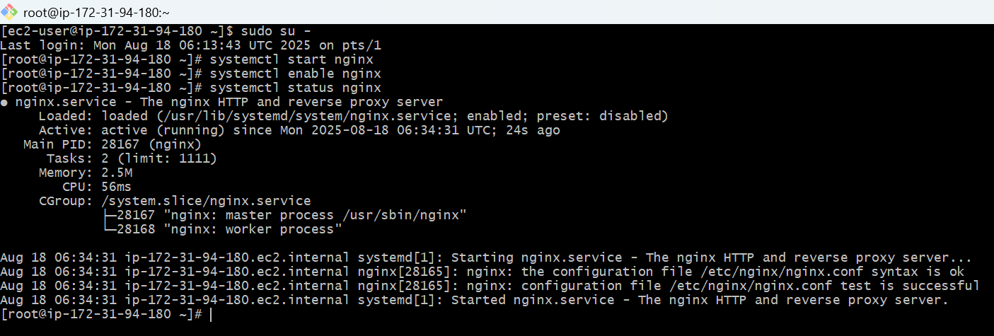

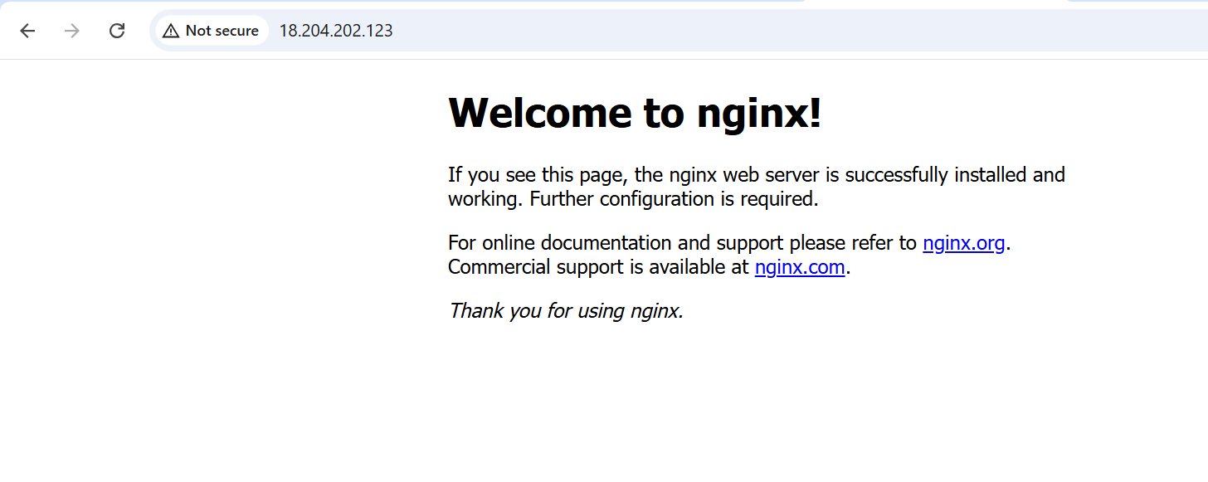

1. **Install Apache Tomcat**

you **must install Java before Tomcat**, because **Apache Tomcat is a Java-based application server**.

yum install java

to check the java version

java --version

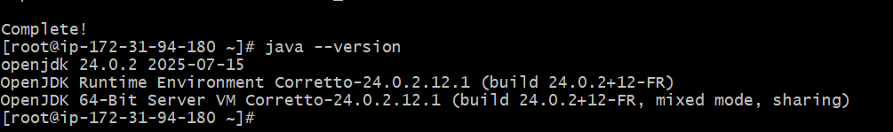

# Go to /opt (or any preferred directory)

cd /opt

# Download Tomcat (example: Tomcat 10)

wget <https://dlcdn.apache.org/tomcat/tomcat-11/v11.0.10/bin/apache-tomcat-11.0.10.tar.gz>

# Extract files

tar -xvzf apache-tomcat-11.0.10.tar.gz

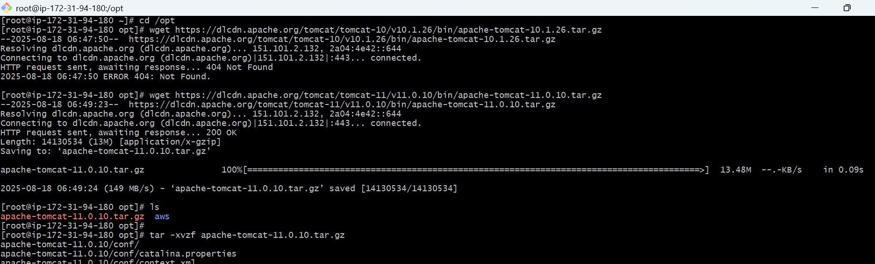

# Rename folder for convenience

mv apache-tomcat-11.0.10.tar.gz tomcat

# Go inside Tomcat bin directory

cd /opt/tomcat/bin

# Start Tomcat

./startup.sh

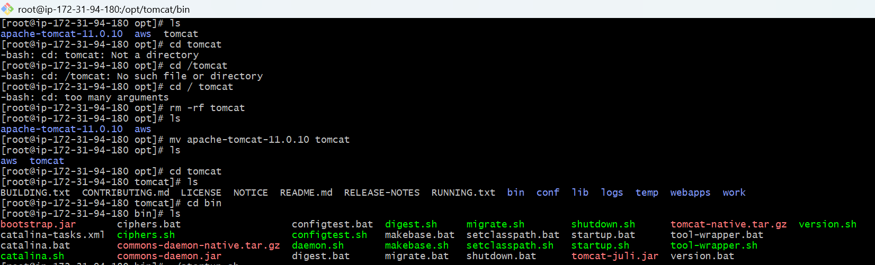

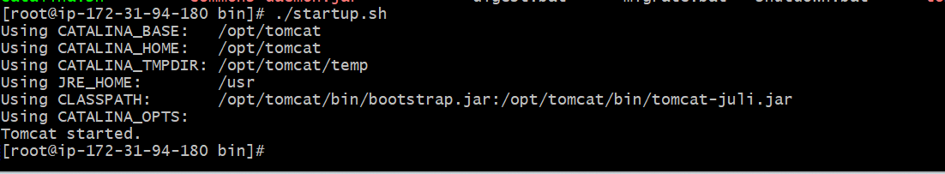

**Tomcat runs by default on port 8080.  
Test: Open browser → http://<server-ip>:8080**

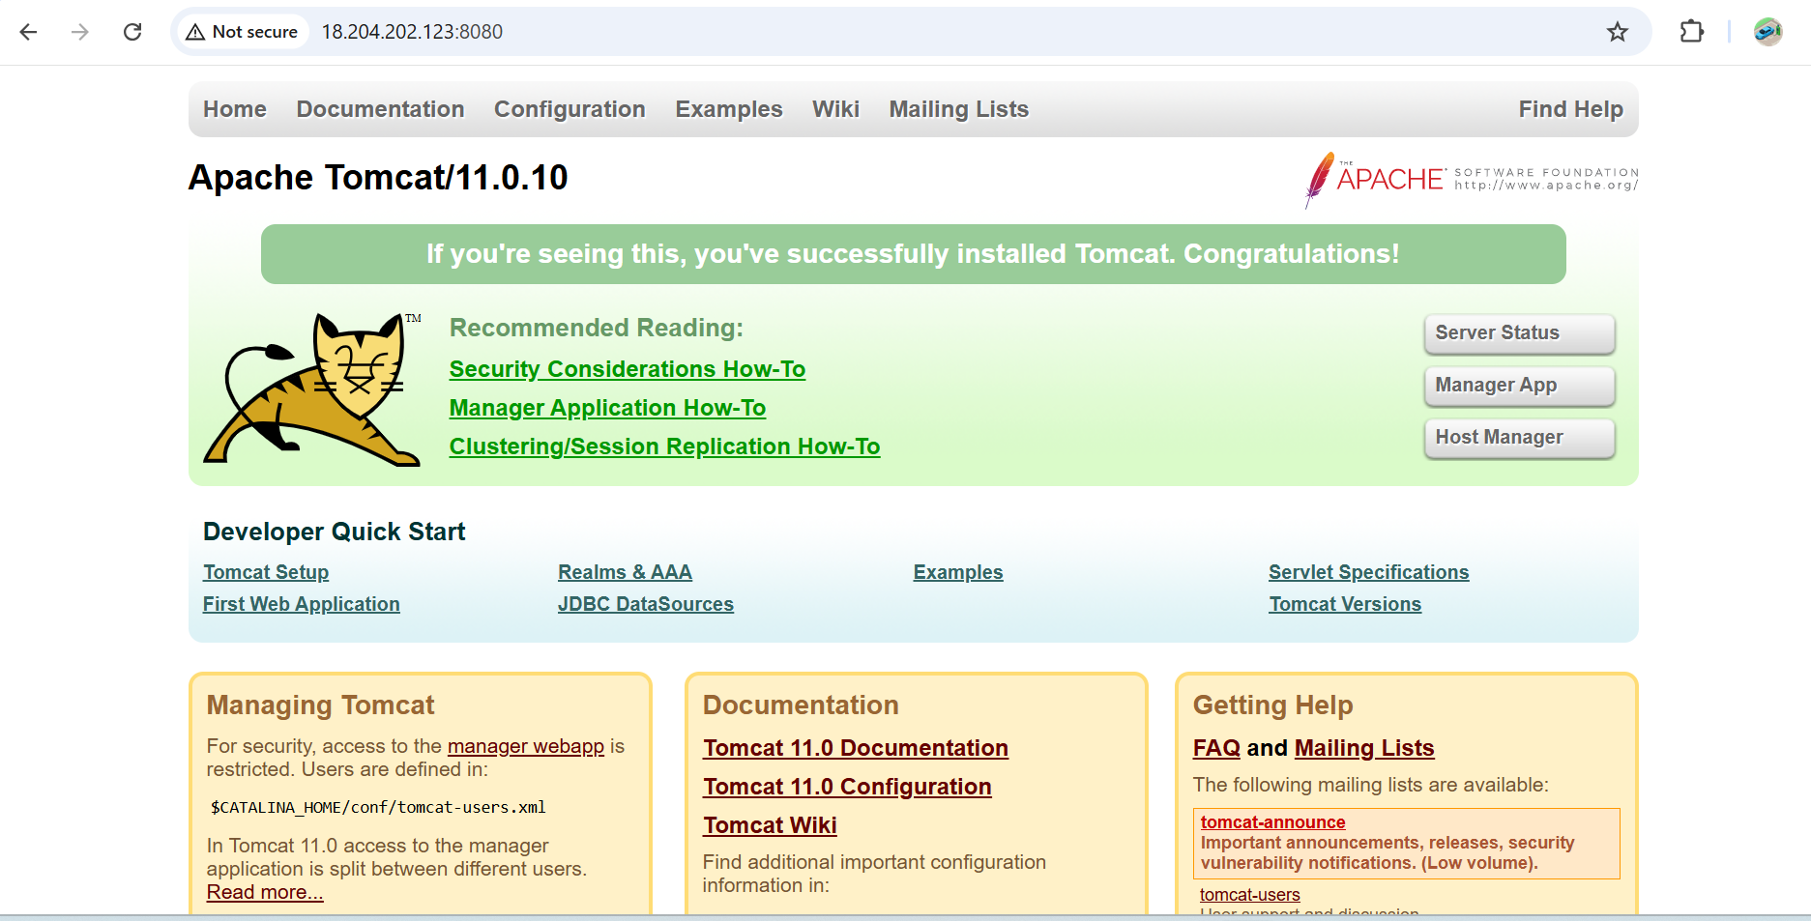

**To change port no:-**

vi server.xml

