**Jenkins-1**

**1) Install Jenkins and run Jenkins on port number 8081.**

Step-1. Install Java

(Jenkins requires Java)

sudo dnf install -y java-17-amazon-corretto

Verify java

java –version

Step-2. Add Jenkins Repository

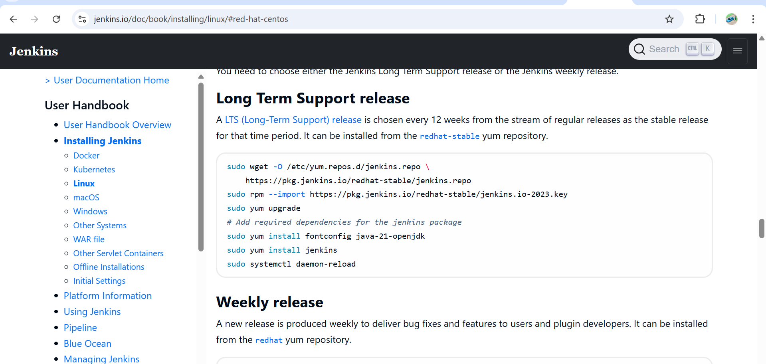

sudo wget -O /etc/yum.repos.d/jenkins.repo \

https://pkg.jenkins.io/redhat-stable/jenkins.repo

sudo rpm --import <https://pkg.jenkins.io/redhat-stable/jenkins.io-2023.key>

Install Jenkins

sudo yum install jenkins -y

**Start and Enable Jenkins Service**

sudo systemctl start jenkins

sudo systemctl enable Jenkins

Check status:

systemctl status Jenkins

**Step 3: Change Jenkins Port to 8081**

By default Jenkins runs on **8080**, so we edit its systemd config:

Now go to → sudo vi /usr/lib/systemd/system/jenkins.service

Update → Environment="JENKINS_PORT=8081"

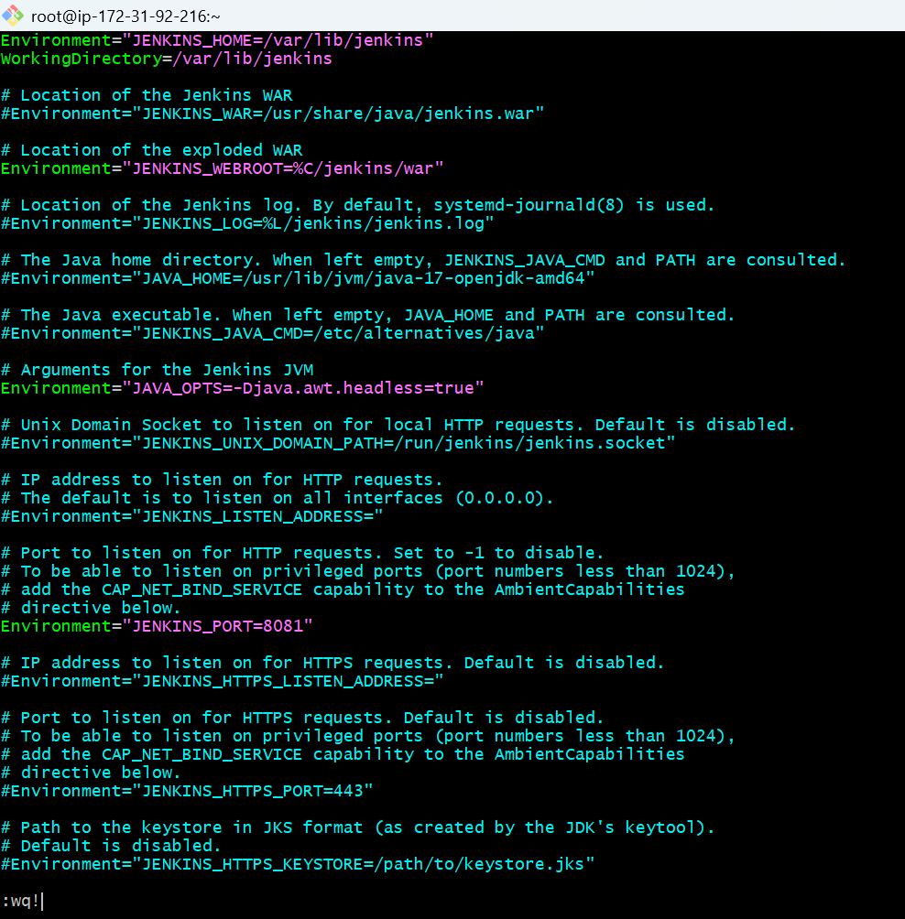

sudo systemctl daemon-reexec

sudo systemctl daemon-reload

sudo systemctl restart Jenkins

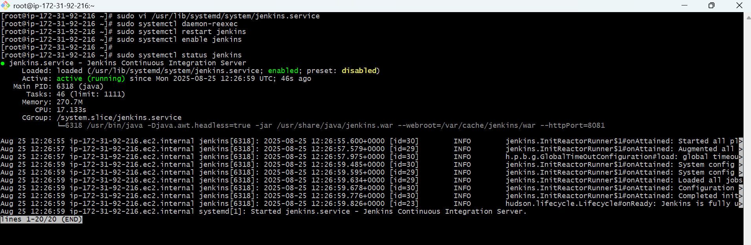

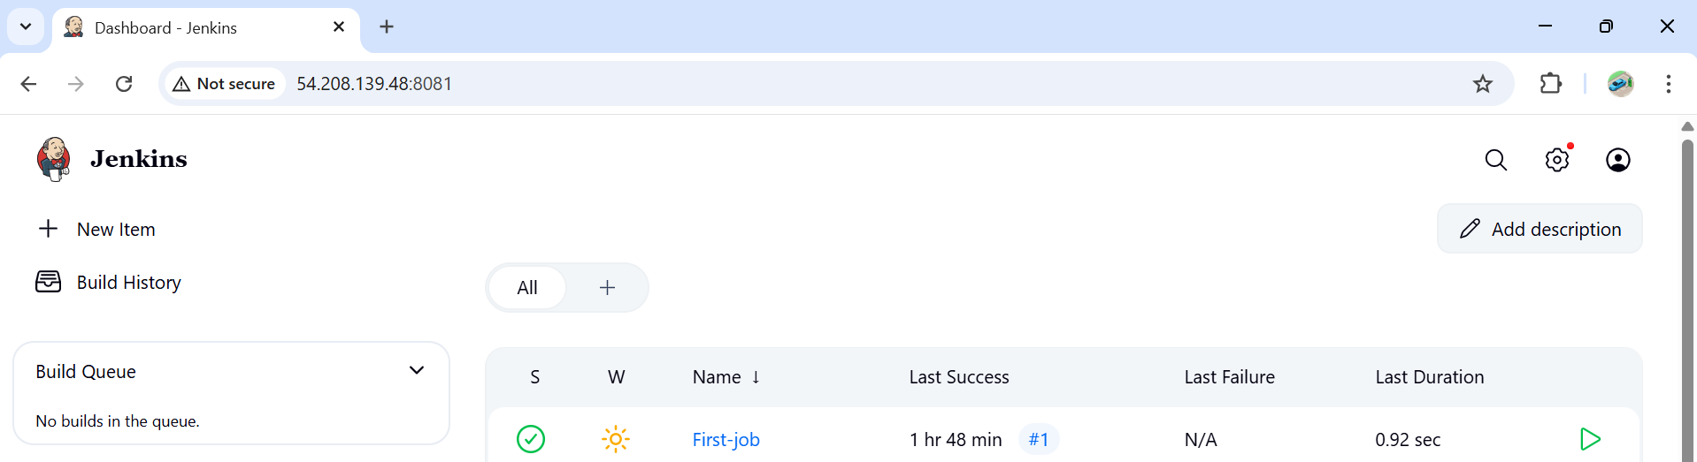

**2) Secure Jenkins server**

Securing Jenkins Server

Step -1. Change Default Admin Password

First login: Jenkins asks for the **initial admin password**

/var/lib/jenkins/secrets/initialAdminPassword

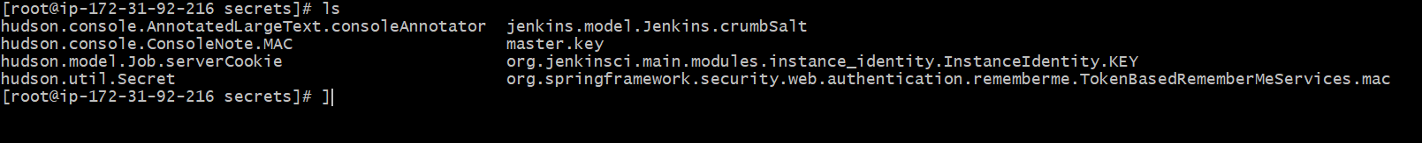

Create a **new admin user**, then **disable or delete** the default admin if possible.

**3) Create users called DevOps, Testing in Jenkins with Limited access.**

Create Limited Access Users in Jenkins

## ****Step 1: Install Role-Based Authorization Plugin****

1. Go to **Manage Jenkins → Plugins → Available Plugins**.
2. Search for **Role-based Authorization Strategy** and install it.
3. Restart Jenkins after installation.

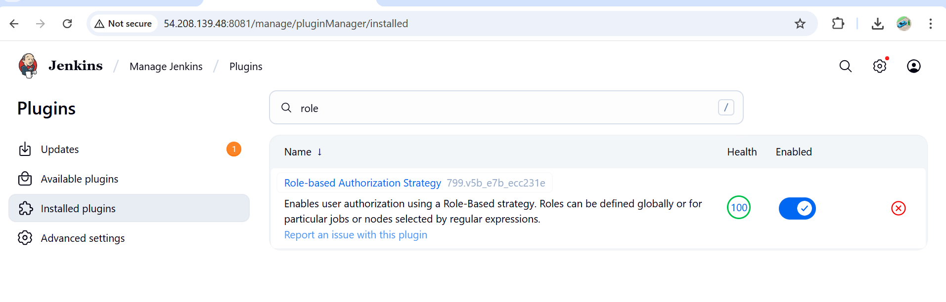

### ****Steps to Create Users in Jenkins****

1. **Log in to Jenkins** as an administrator.
2. From the left menu, go to:  
   **Manage Jenkins → Security → Manage Users**.
3. Click **Create User**.
4. Enter details for each user:
   * **Username**: DevOps
   * **Password**: (choose a strong one)
   * **Full Name**: DevOps

Repeat for user Testing.

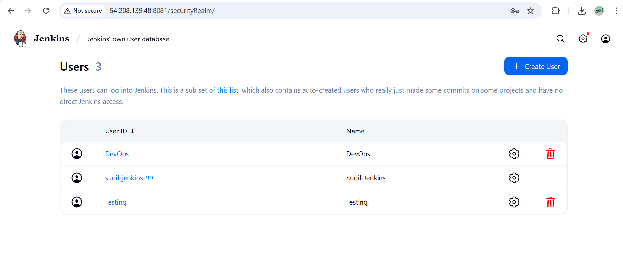

After creating users

Go to

Manage jenkins – security

In authorization select –project based matrix

And give the limited access

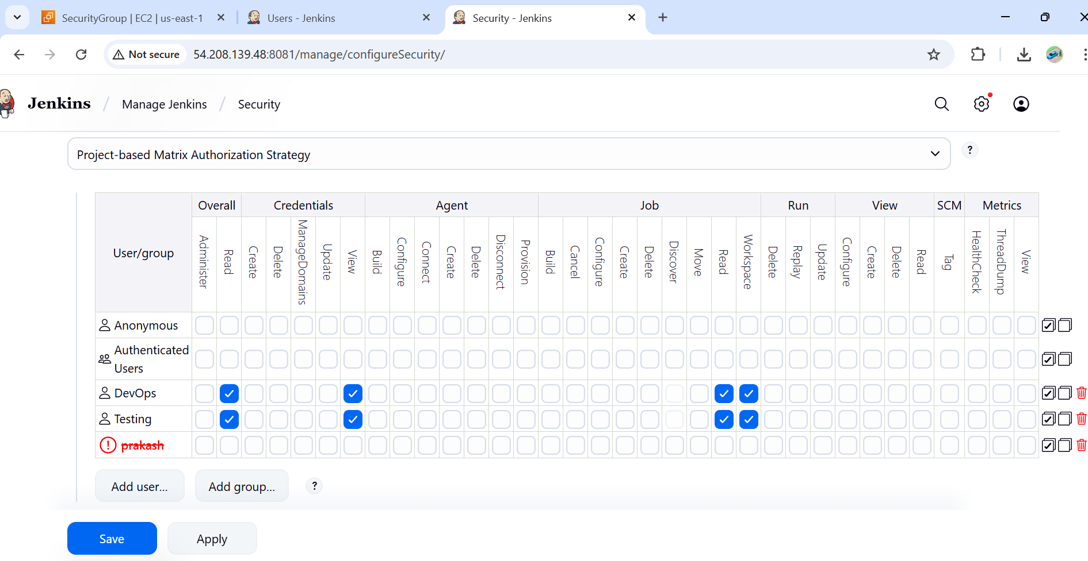

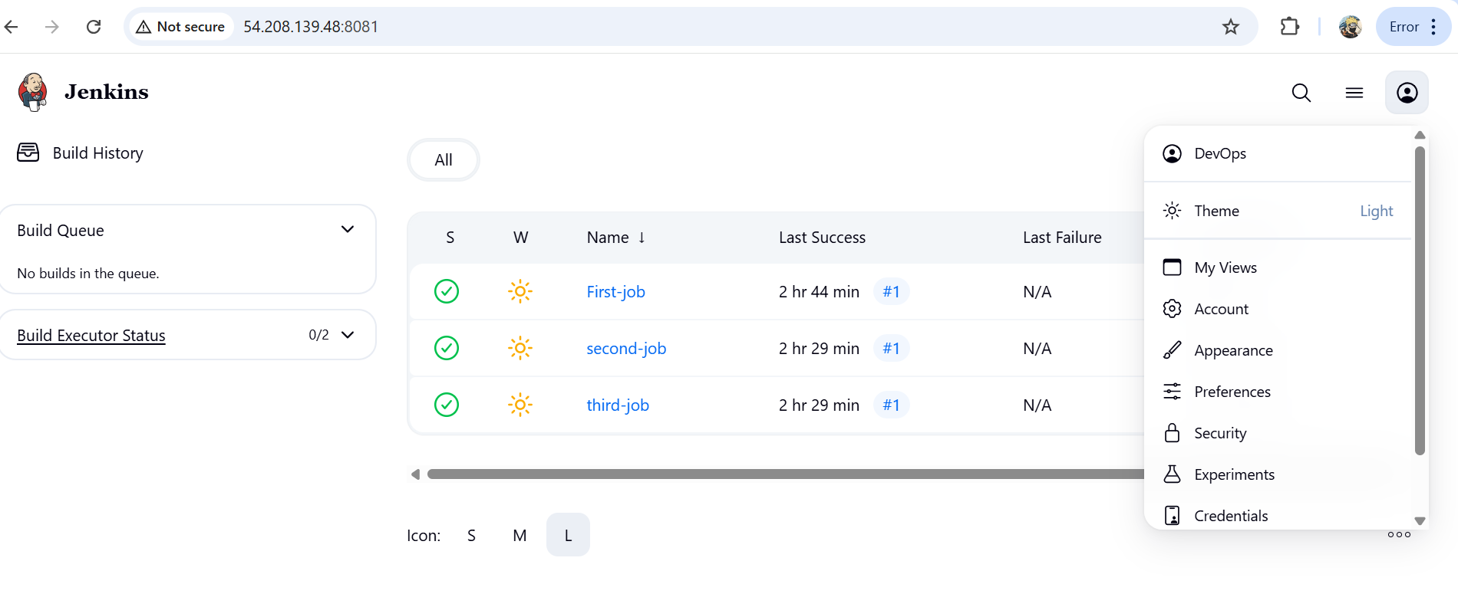

**4) Configure labels and restrict the jobs to execute based on label only.**

Step 1 : Assign Labels to Nodes

Go to manage Jenkins – system

In labels give any label name

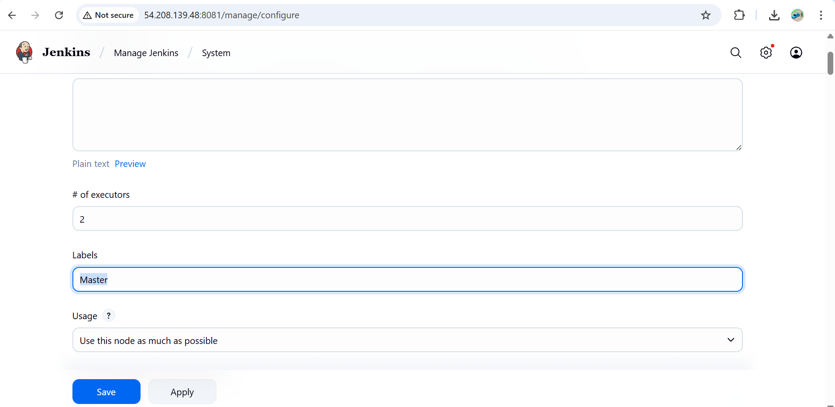

Step 2: Restrict Job to Run on a Label

1. Open the Jenkins job (Freestyle or Pipeline).
2. Click **Configure**.
3. Under **General**, check **Restrict where this project can be run**.
4. In the text box, enter the **label** (e.g., Master).
5. Save.

Now this job will **only run on nodes with that label**.

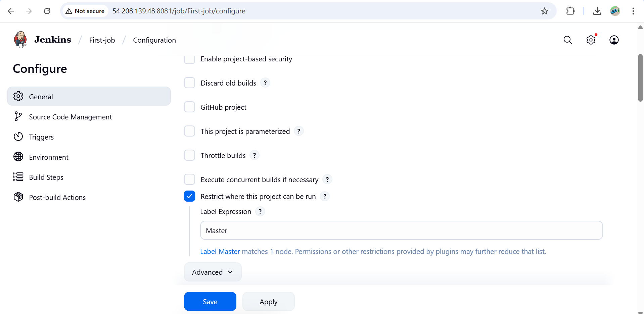

**5) Create Three sample jobs using the below URL.** [**https://github.com/betawins/Techie_horizon_Login_app.git**](https://github.com/betawins/Techie_horizon_Login_app.git)

Step 1: Pre-Requisites

Jenkins server should have **Git installed**

yum install git

(git --version).

Step 2: Create 3 Sample Jobs

Job 1:

Go to **New Item → Freestyle Project → Name: Sample-Job-1**.

Under **Source Code Management → Git**, enter repo URL:

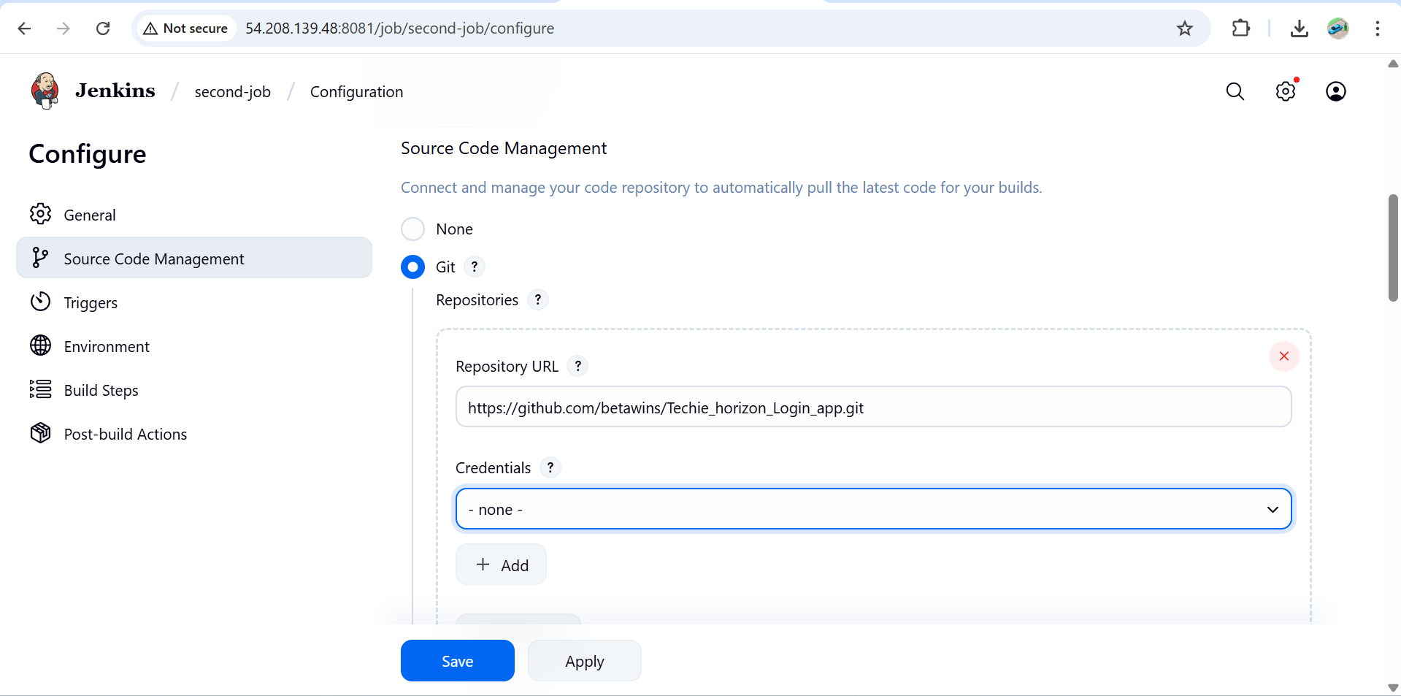

Save & Build.

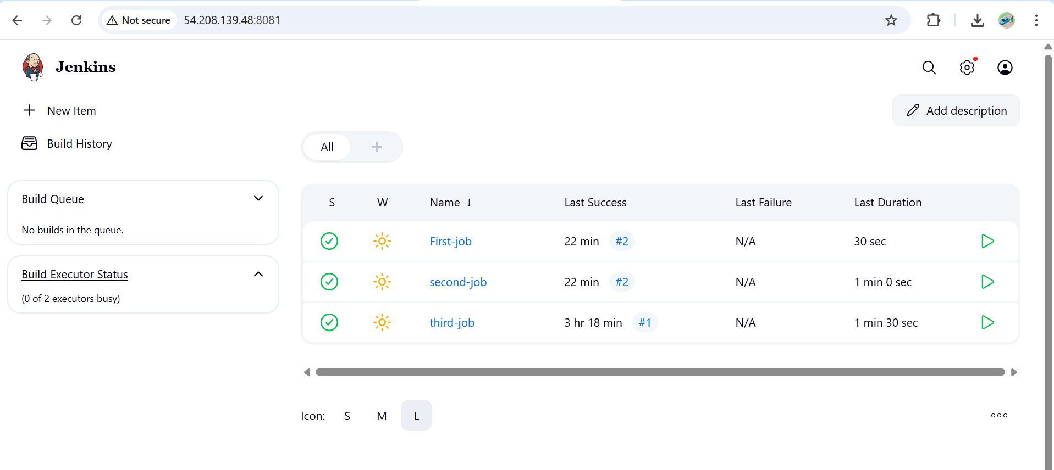

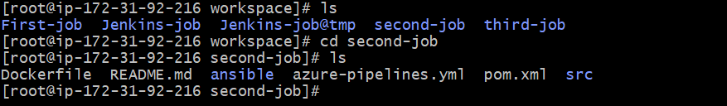

**6) Create one Jenkins job using git hub Private repository.**

**Step 1: Generate GitHub Credentials**

1. Go to **GitHub → Settings → Developer settings → Personal Access Tokens → Tokens (classic)**.
2. Generate a token with permissions:
3. Copy the token.

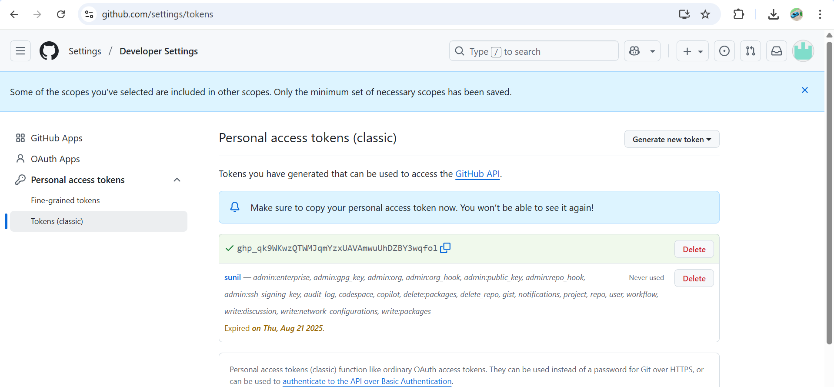

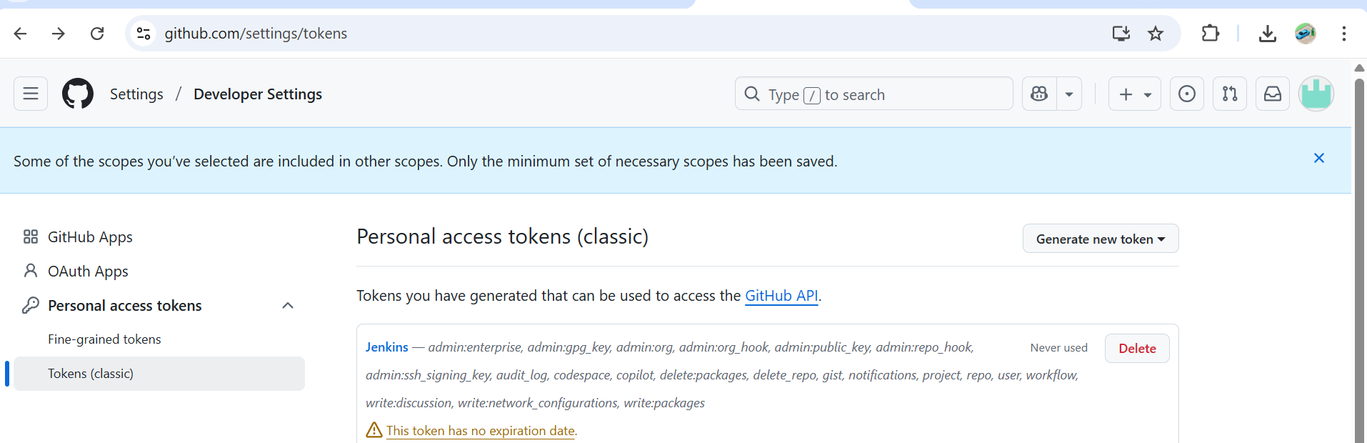

## ****Step 2: Add Credentials to Jenkins****

1. In Jenkins → **Manage Jenkins → Credentials → (Global)**.
2. Click **Add Credentials**:
   * **Kind:** Username with password
   * **Username:** GitHub username or token
   * **Password:**
   * **ID:** github-private (ex)

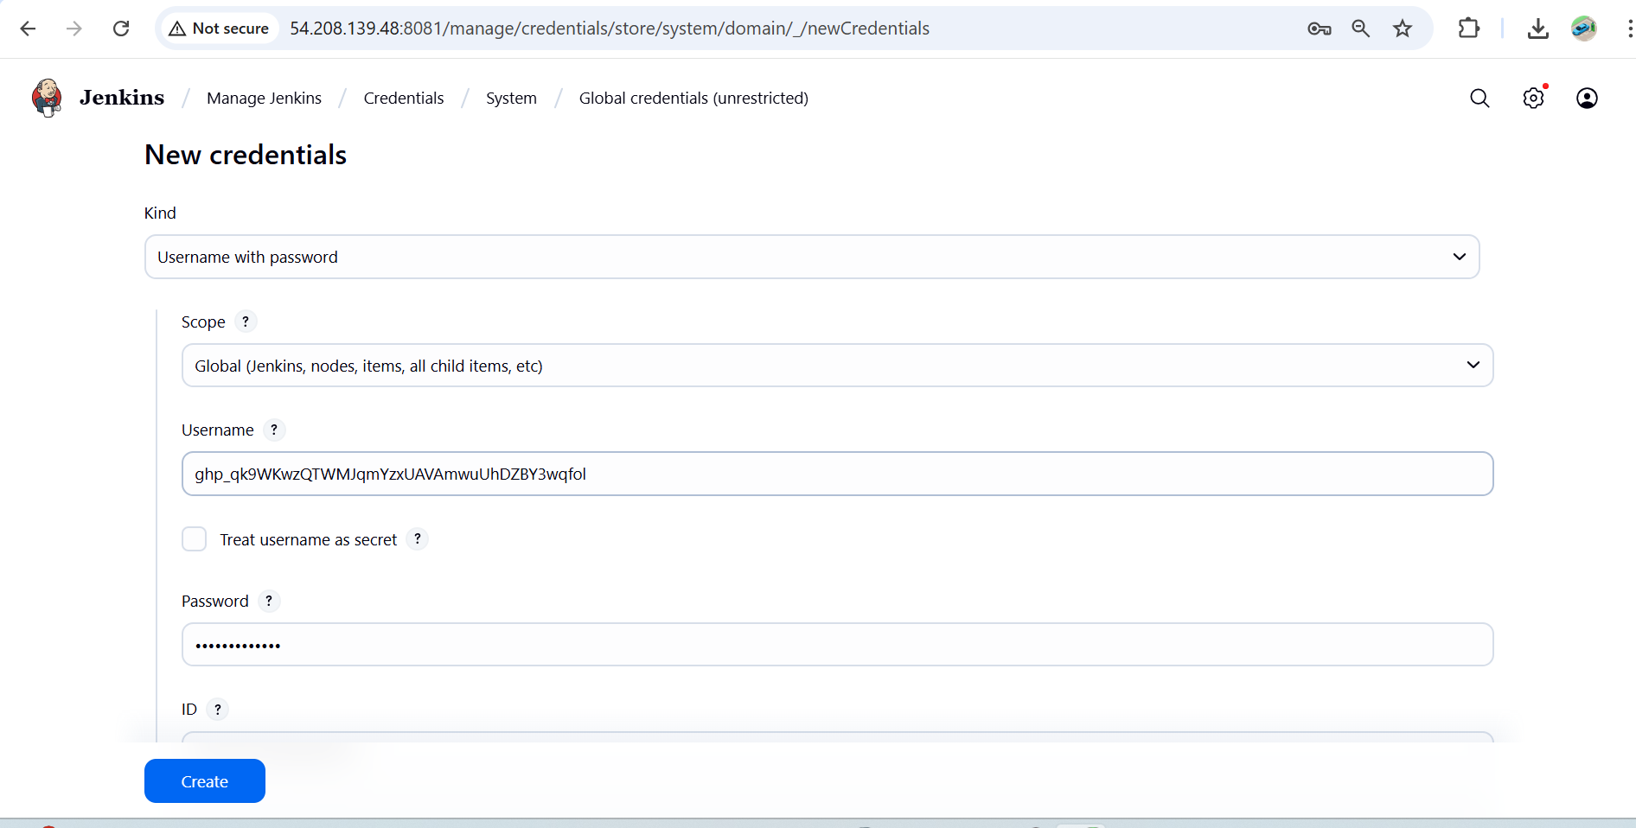

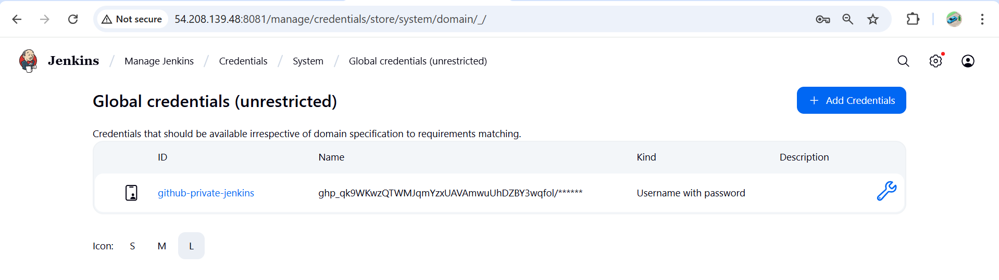

## ****Step 3: Create Jenkins Job****

1. **New Item → Freestyle Project → Name: Private-Repo-Job**.
2. Under **Source Code Management → Git**:
   * Repository URL:

