**Terraform-01**

1. **Install Terraform on your PC**

**Step 1: Download Terraform**

1. Go to the official Terraform download page:  
    https://developer.hashicorp.com/terraform/downloads
2. Under **Windows**, download the **64-bit ZIP file**.  
   (It will be something like terraform_1.x.x_windows_amd64.zip)

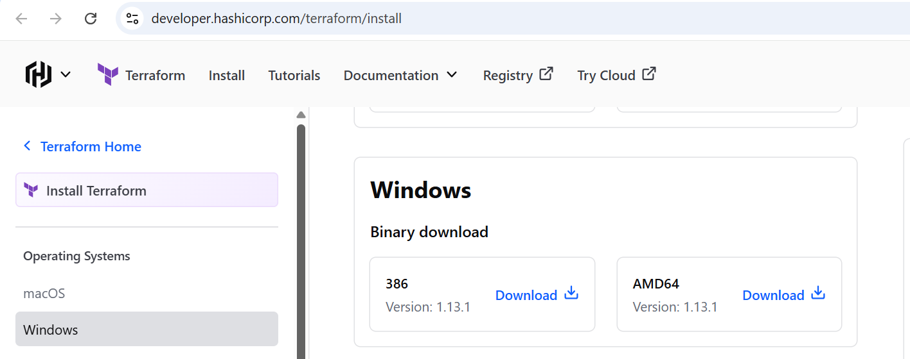

**Step 2: Extract the Terraform Executable**

1. Right-click the downloaded .zip file → **Extract All**.
2. Inside, you will see a single file: terraform.exe.
3. Move terraform.exe to:
4. C:\Program Files\Terraform

*(Create this folder manually if it doesn’t exist.)*

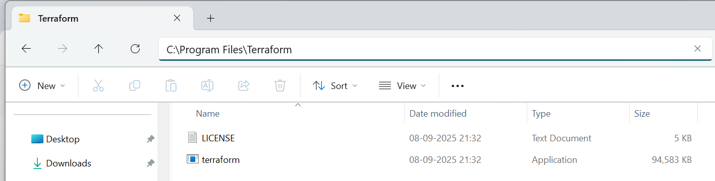

**Step 3: Add Terraform to System PATH**

This makes Terraform available from **anywhere in Command Prompt or PowerShell**.

1. Go to search and check for Edit Environment Variable
2. Go to **Advanced** tab → click **Environment Variables**.

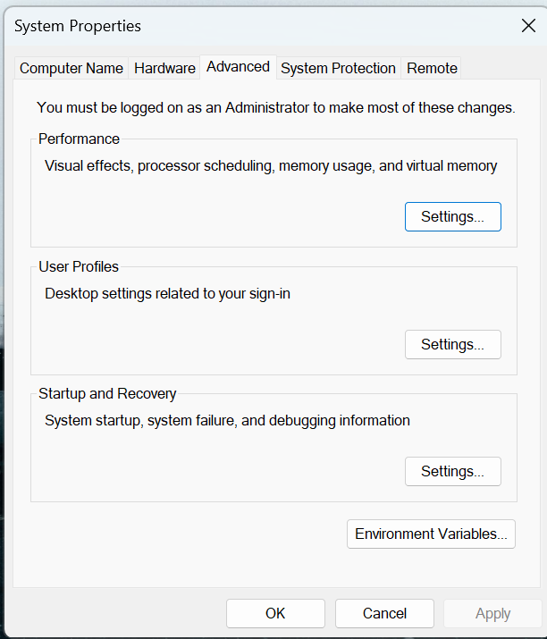

1. In **System variables**, scroll and select **Path** → click **Edit**.

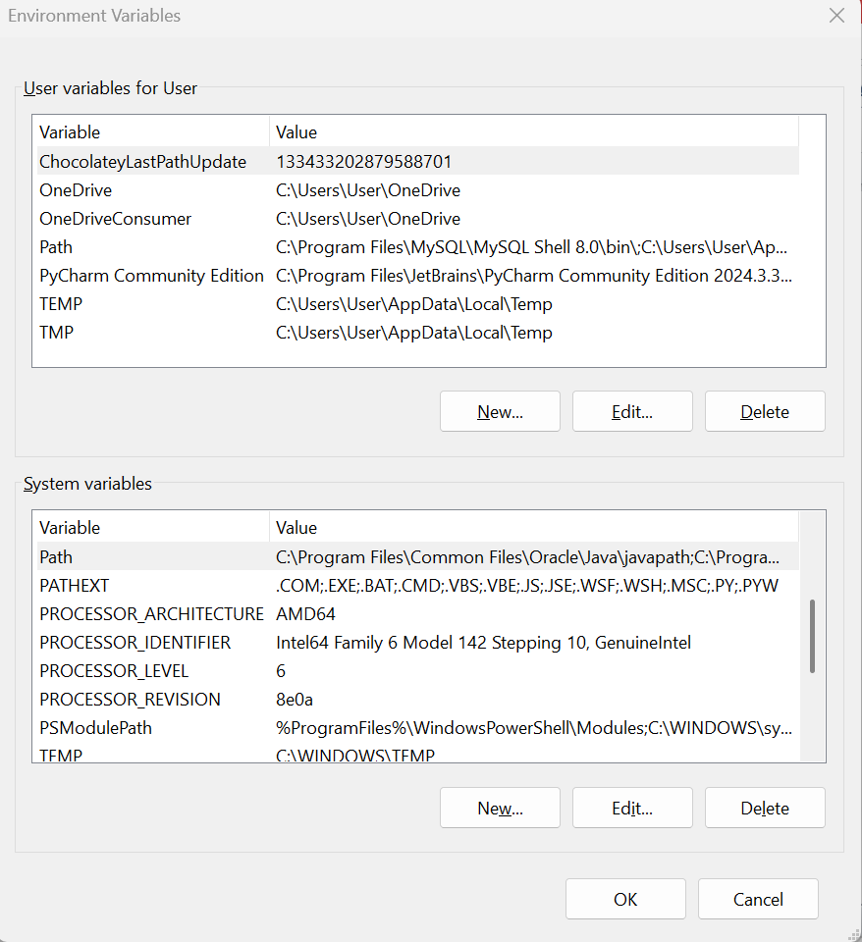

1. Click **New** and add:
2. C:\Program Files\Terraform

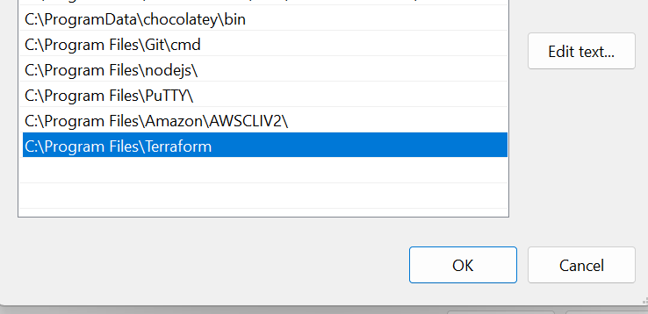

1. Click **OK** on all windows to save.

**Step 4: Verify Installation**

1. Open Git bash and
2. Run: and check the version of terraform
3. terraform -version
4. You should see Terraform’s installed version (e.g., Terraform v1.13.1)

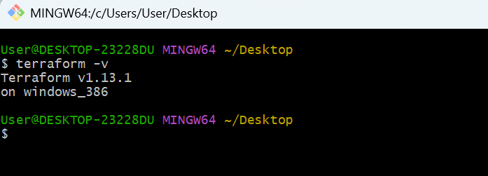

1. **Execute all the templates shown in video.**

**Step 1: Create Your First Terraform Project**

Make a new folder for your project (example: terra).

And open the folder it in the vs code

Inside the folder , create your first Terraform file:

In VS Code → **File → New File → save as main.tf**.

Write a smaple content in it

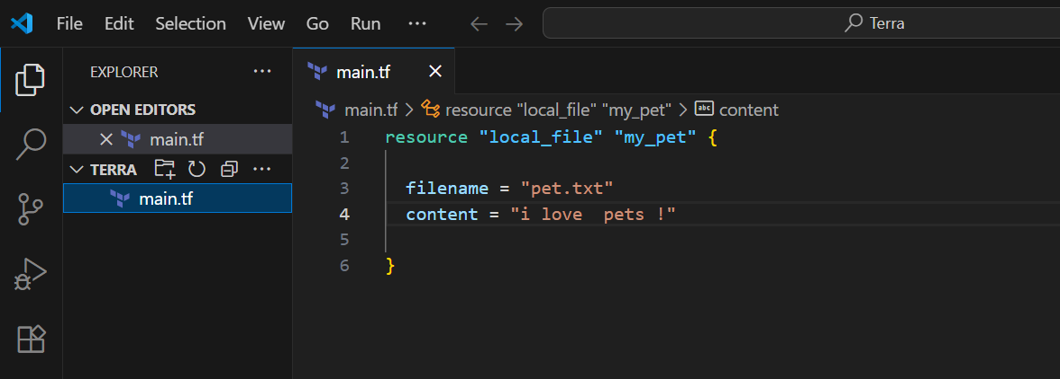

**Step 2: Run Terraform Commands**

Initialize Terraform

**terraform init**

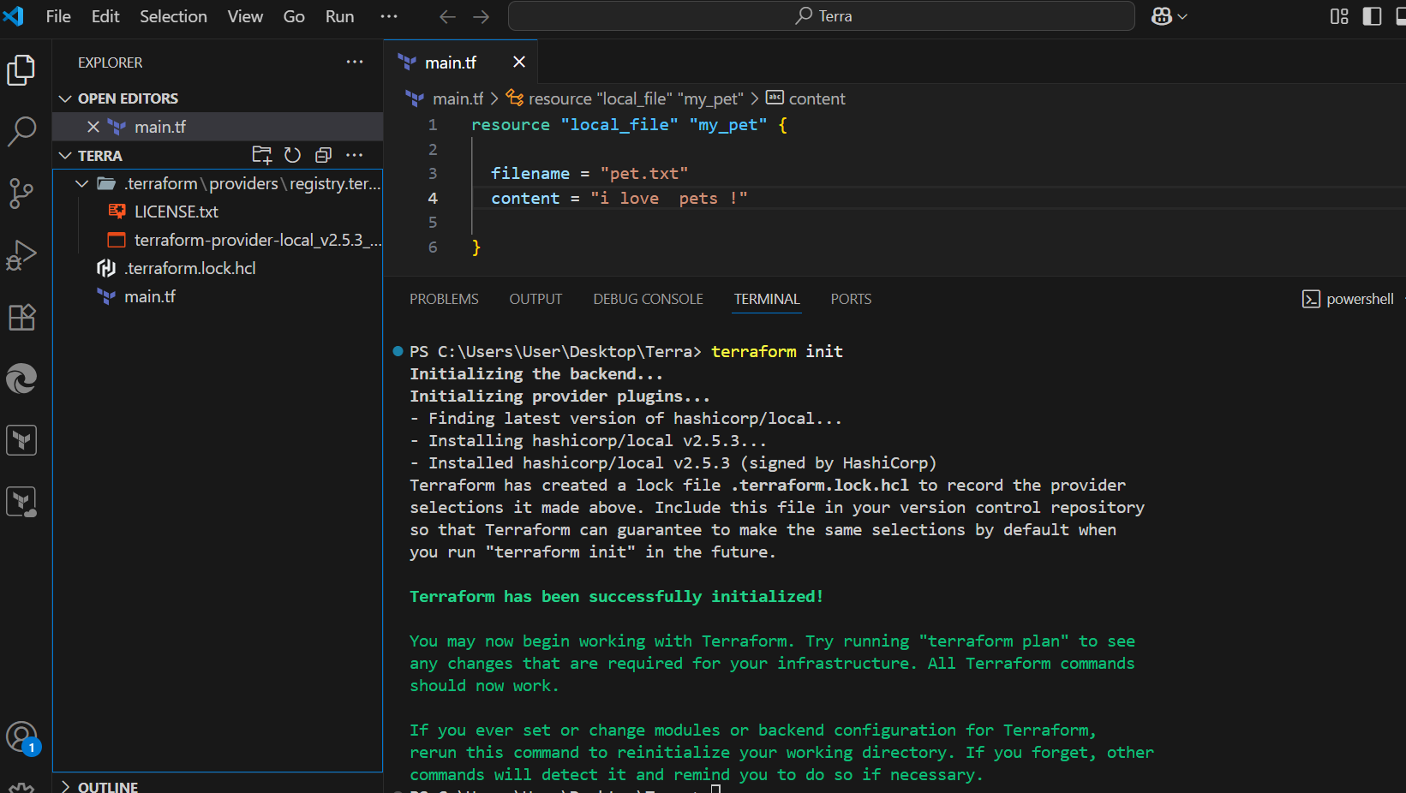

See what will be created:

**terraform plan**

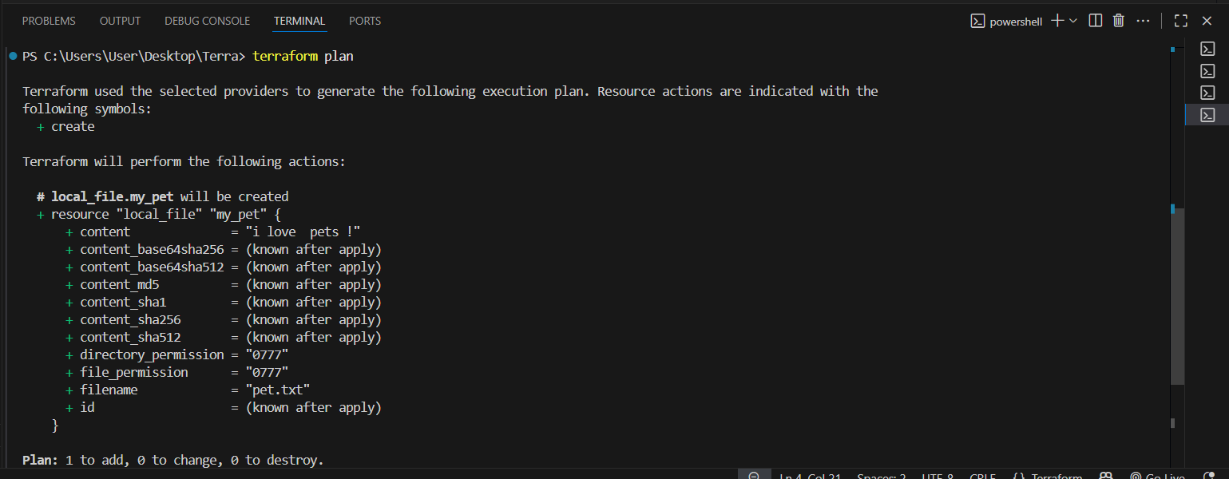

Apply changes (actually create resources):

**terraform apply**

Type yes when asked.

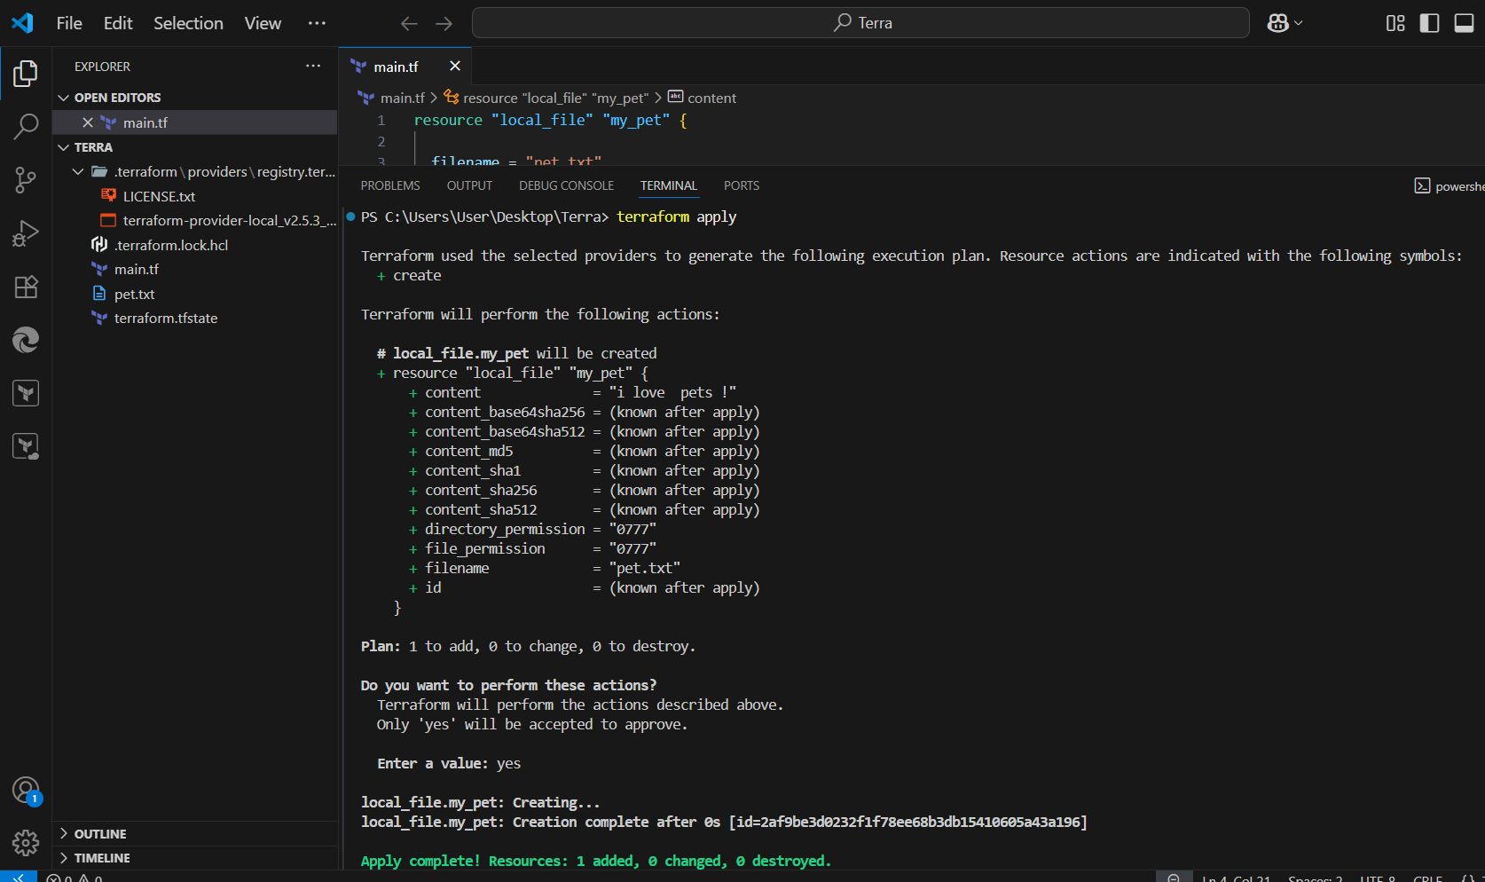

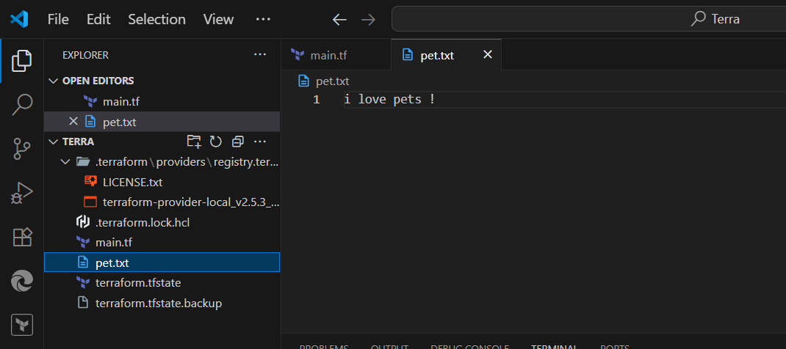

Destroy resources when finished:

**terraform destroy**

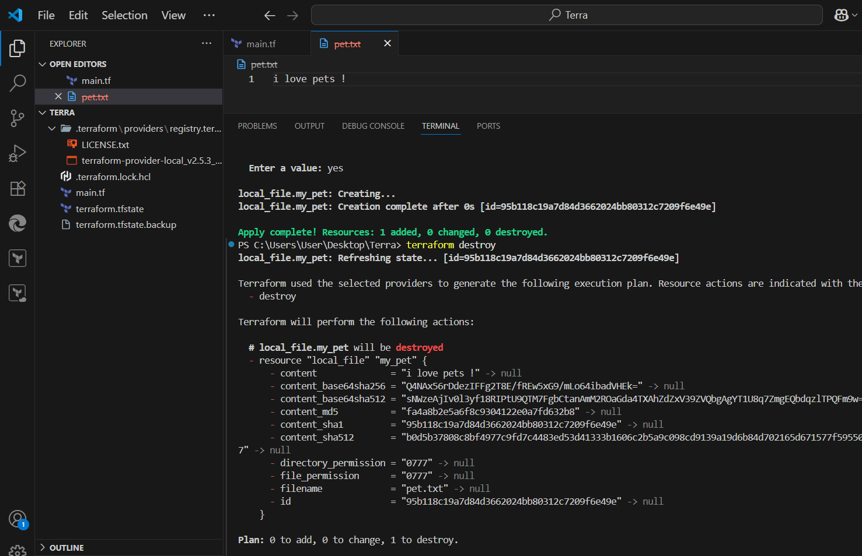

Created one more resource

Terraform init

apply

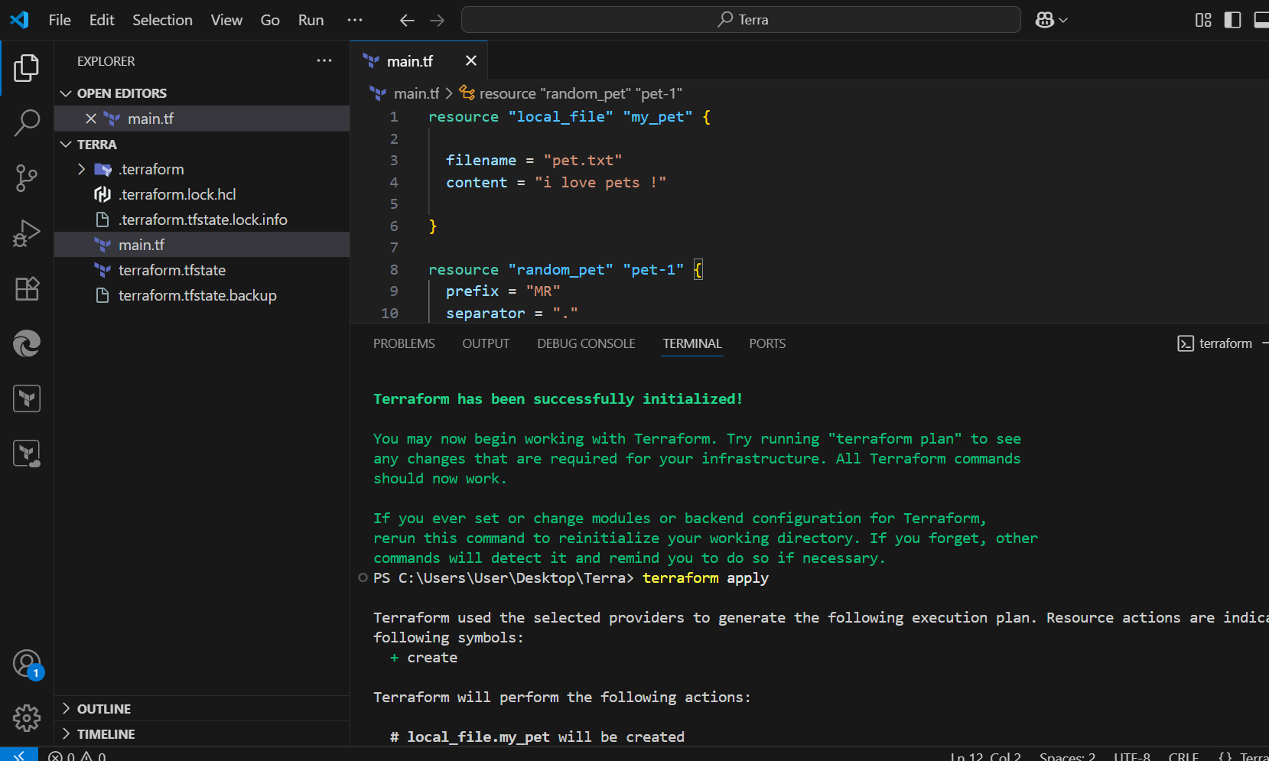

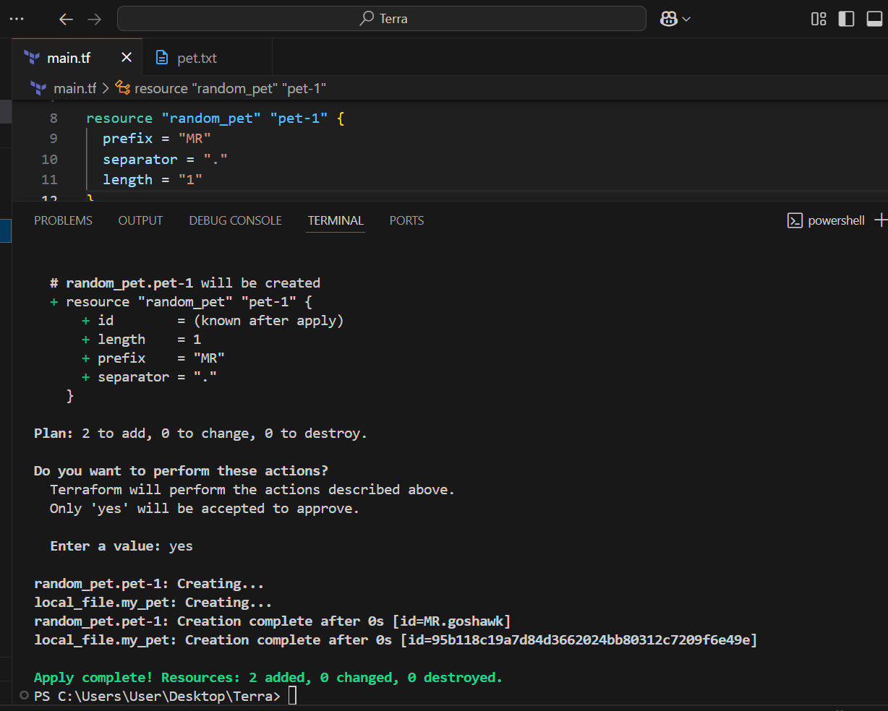

Terraform fmt

Will format or organize your code.

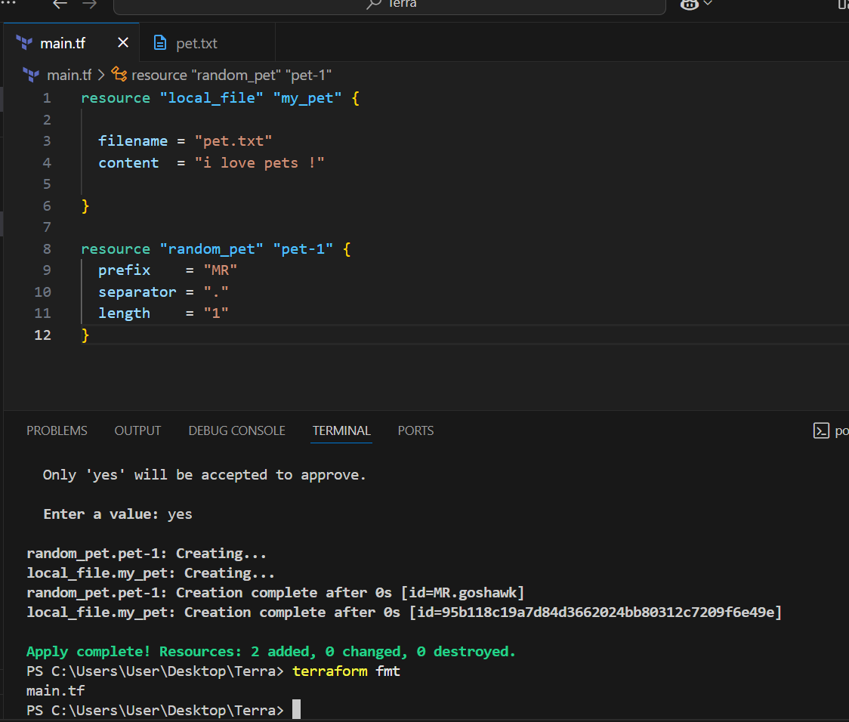

**3) Note down below points,**

**Terraform Init**

Command: terraform init

* Purpose:
  + Initializes a Terraform working directory.
  + Downloads required **providers** and **modules**.
  + Creates a hidden .terraform folder to manage plugins.
* You must run this **once per project** (or after changing providers).

**Terraform Plan**

Command: terraform plan

Purpose:

* Shows the **execution plan** before making any changes.
* Compares your configuration (.tf files) with the real infrastructure.
* Helps verify what will be created, modified, or destroyed.

Safe to run multiple times (doesn’t change resources).

**Terraform Apply**

Command: terraform apply

Purpose:

* Executes the actions from the **plan**.
* Actually **creates, updates, or deletes** resources.
* Terraform will ask for confirmation (yes) before applying.

After running, infrastructure is live.

**Terraform Provider**

A **plugin** that lets Terraform interact with cloud platforms, SaaS, or APIs.

Example providers: aws, azurerm, google, kubernetes, docker.

**4).Integrate a sample Terraform template in Jenkins.**

## Prerequisites

1. **Jenkins server** up and running.
2. **Terraform installed** on Jenkins node/agent (terraform -v should work).
3. **AWS credentials** (or whichever cloud provider you want) configured in Jenkins:
   * Best practice: store them as **Jenkins credentials** (e.g., AWS Access Key + Secret Key).
4. A **Git repo** containing Terraform code (for example: main.tf).

Install terraform plugin

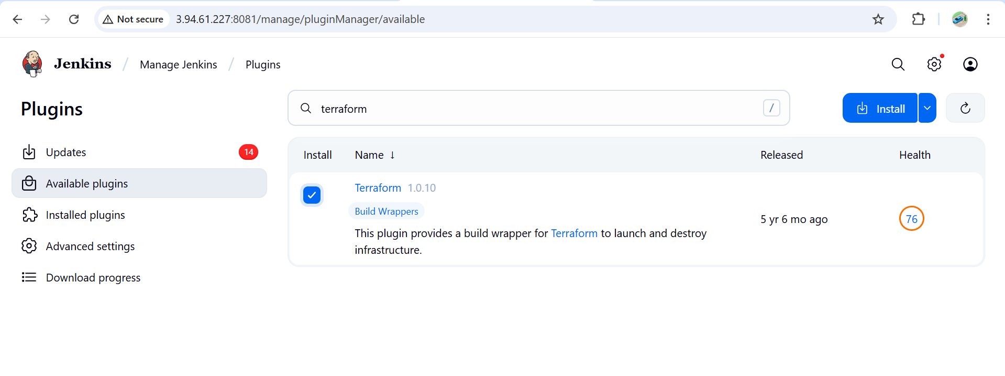

**Step-1 : In Jenkins server install terraform**  
wget   
https://releases.hashicorp.com/terraform/1.9.8/terraform_1.9.8_linux_amd64.zip

unzip terraform_1.9.8_linux_amd64.zip

sudo mv terraform /usr/local/bin/

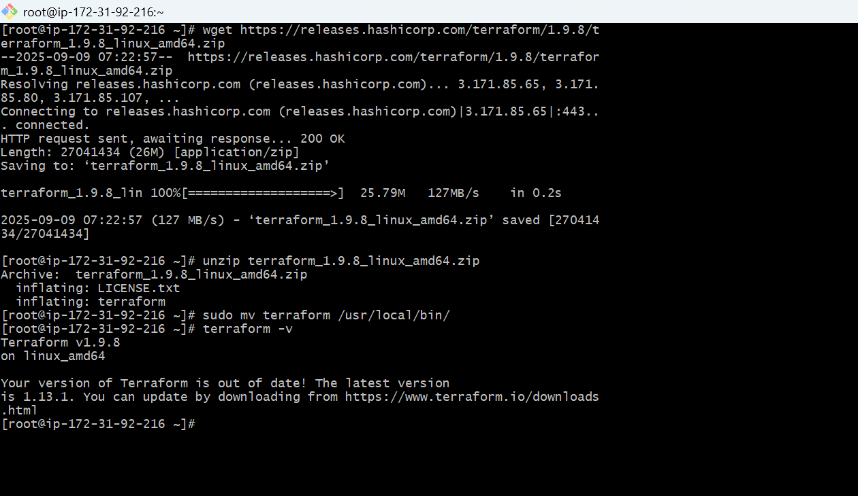

**Create and add credentials of AWS in Jenkins Credentials**

**Create access keys, Access-Key, Secret-key**

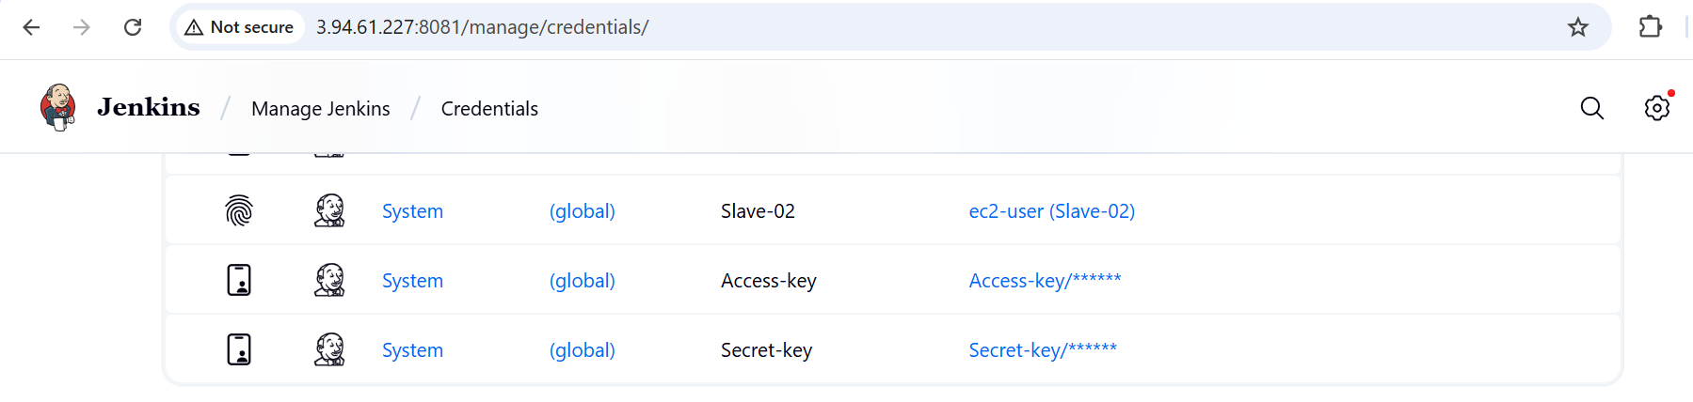

**In Jenkins tools added terrform**

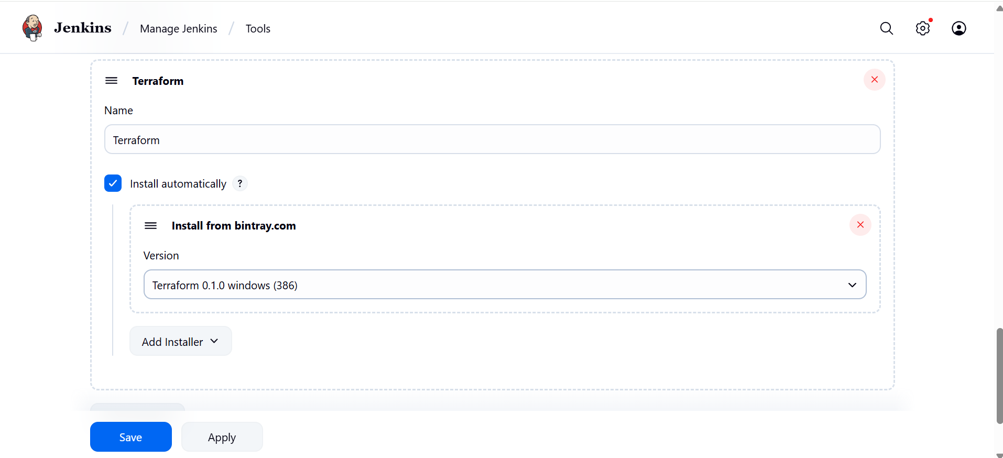

**Create a New repo in git hub and and 2 new files main.tf and Jenkinfile in the git hub repo**

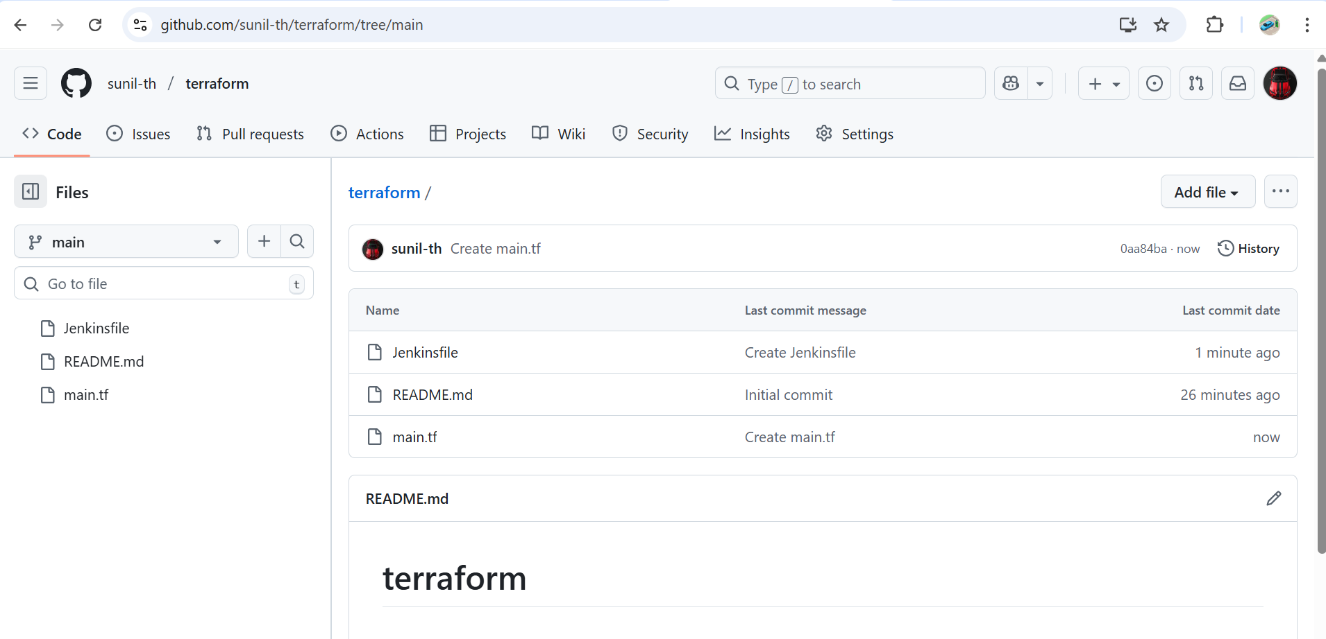

**Create a new item terraform job.in Jenkins**

**And select the pipeline and the git hub url and the branch in the configurations**

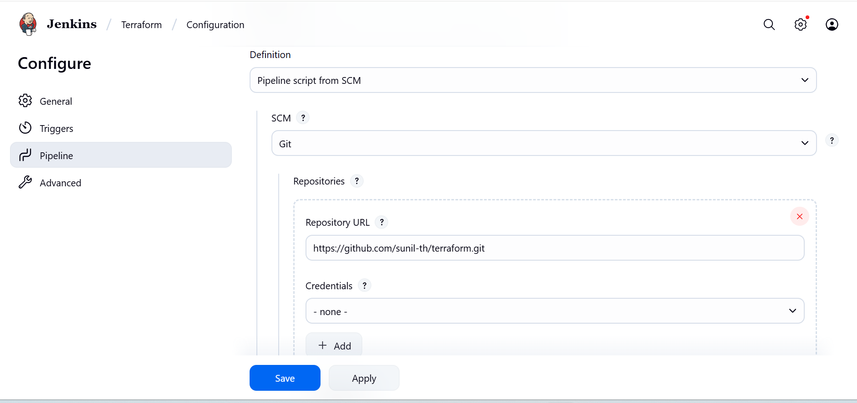

**Save and build the job**

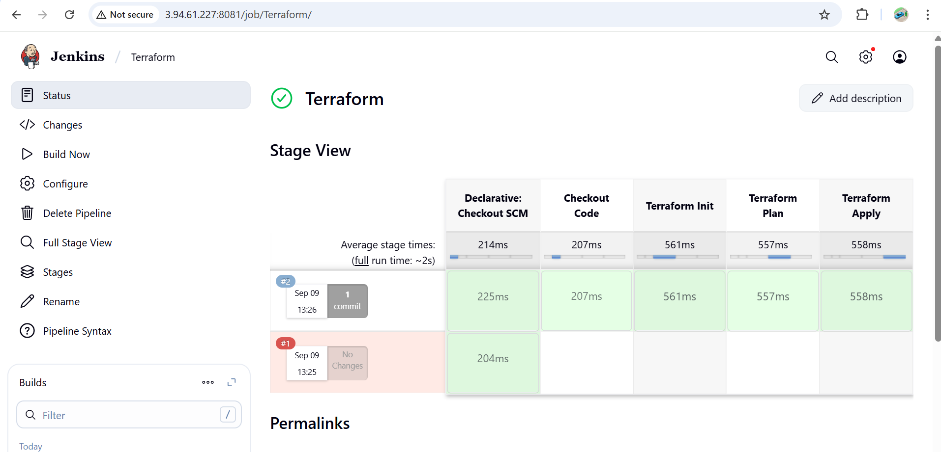

**check in jenkins ec2 workspace.**

