**Terraform-06**

**1.Watch the Terraform-06 video.**

**2.Execute the script shown in the video.**

Terraform Modules:

=================

Modules is a collection of configuration files in a directory.

For example if we want to create two ec2 for different environemnts

then i can create a directory for aws-instance configuration.

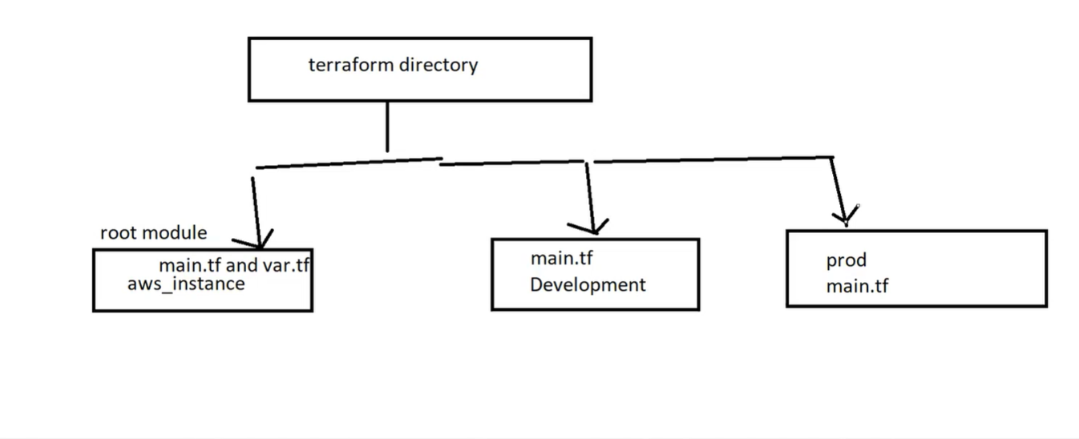

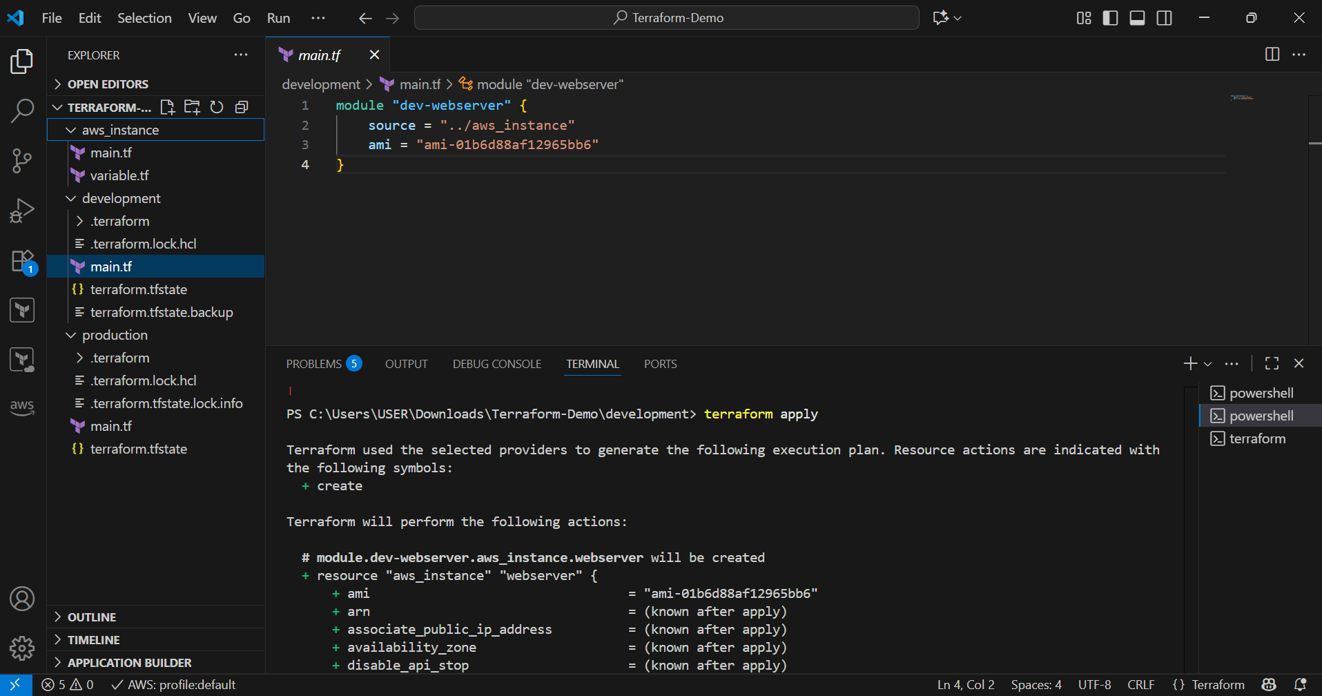

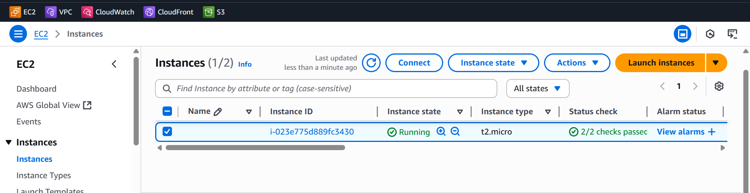

Terraform workspaces:

====================

Workspace can be used if we have multiple project/environments using the same configuration.

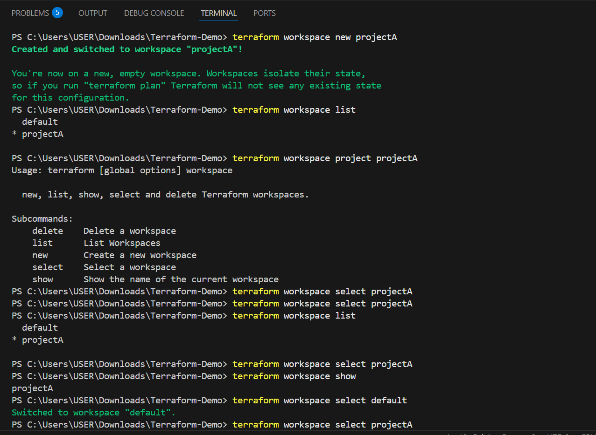

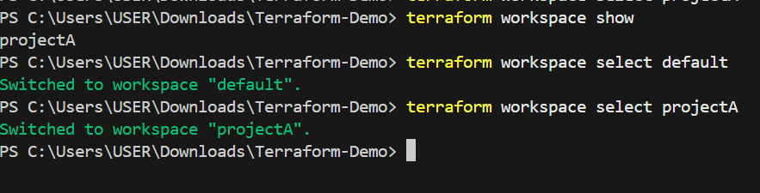

Workspace commands:

==================

terraform workspace new projectA --> to create a workspace names projectA

terraform workspace list --> to list the workspaces available

terraform workspace selecr projectA --> to swtich to specific workspace

when using workspaces state files will be created in the main directory

under a forlder "terraform.tfstate.d"

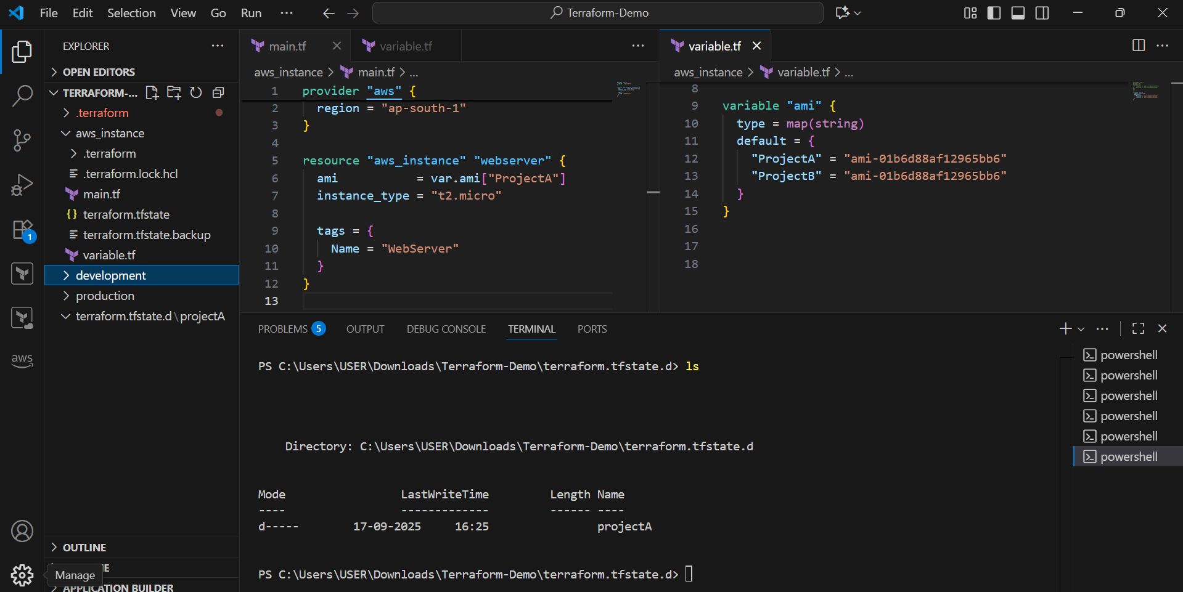

**3.Provision EC2, S3, and VPC using Terraform modules.**

**structure** step by step with re-usable modules.

provision **EC2, S3, and VPC using Terraform modules**.

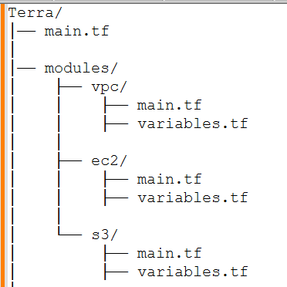

**Main.tf**

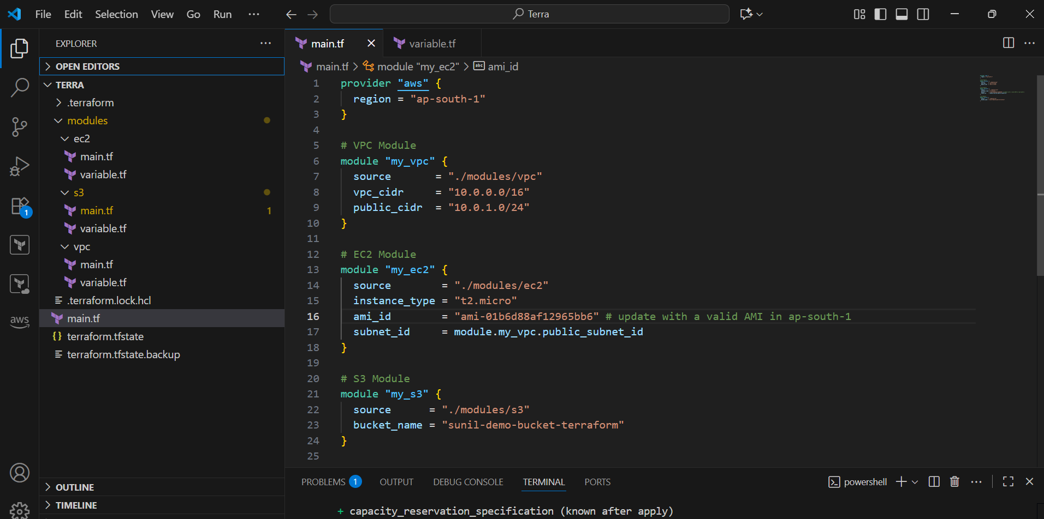

VPC Module (modules/vpc/main.tf,variable.tf)

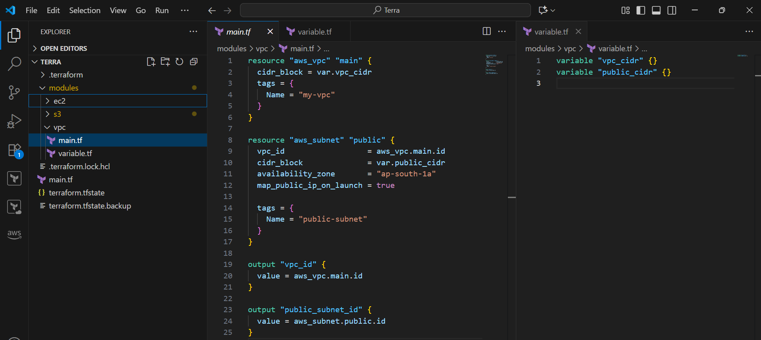

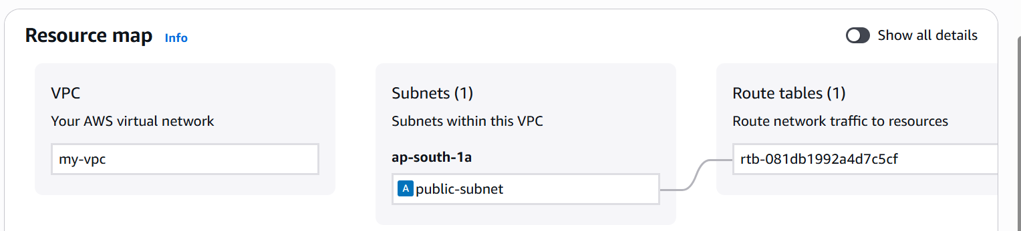

**EC2 Module (modules/ec2/main.tf)**

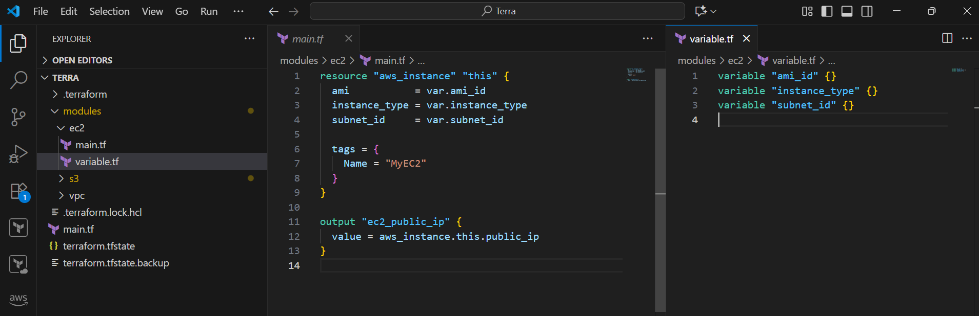

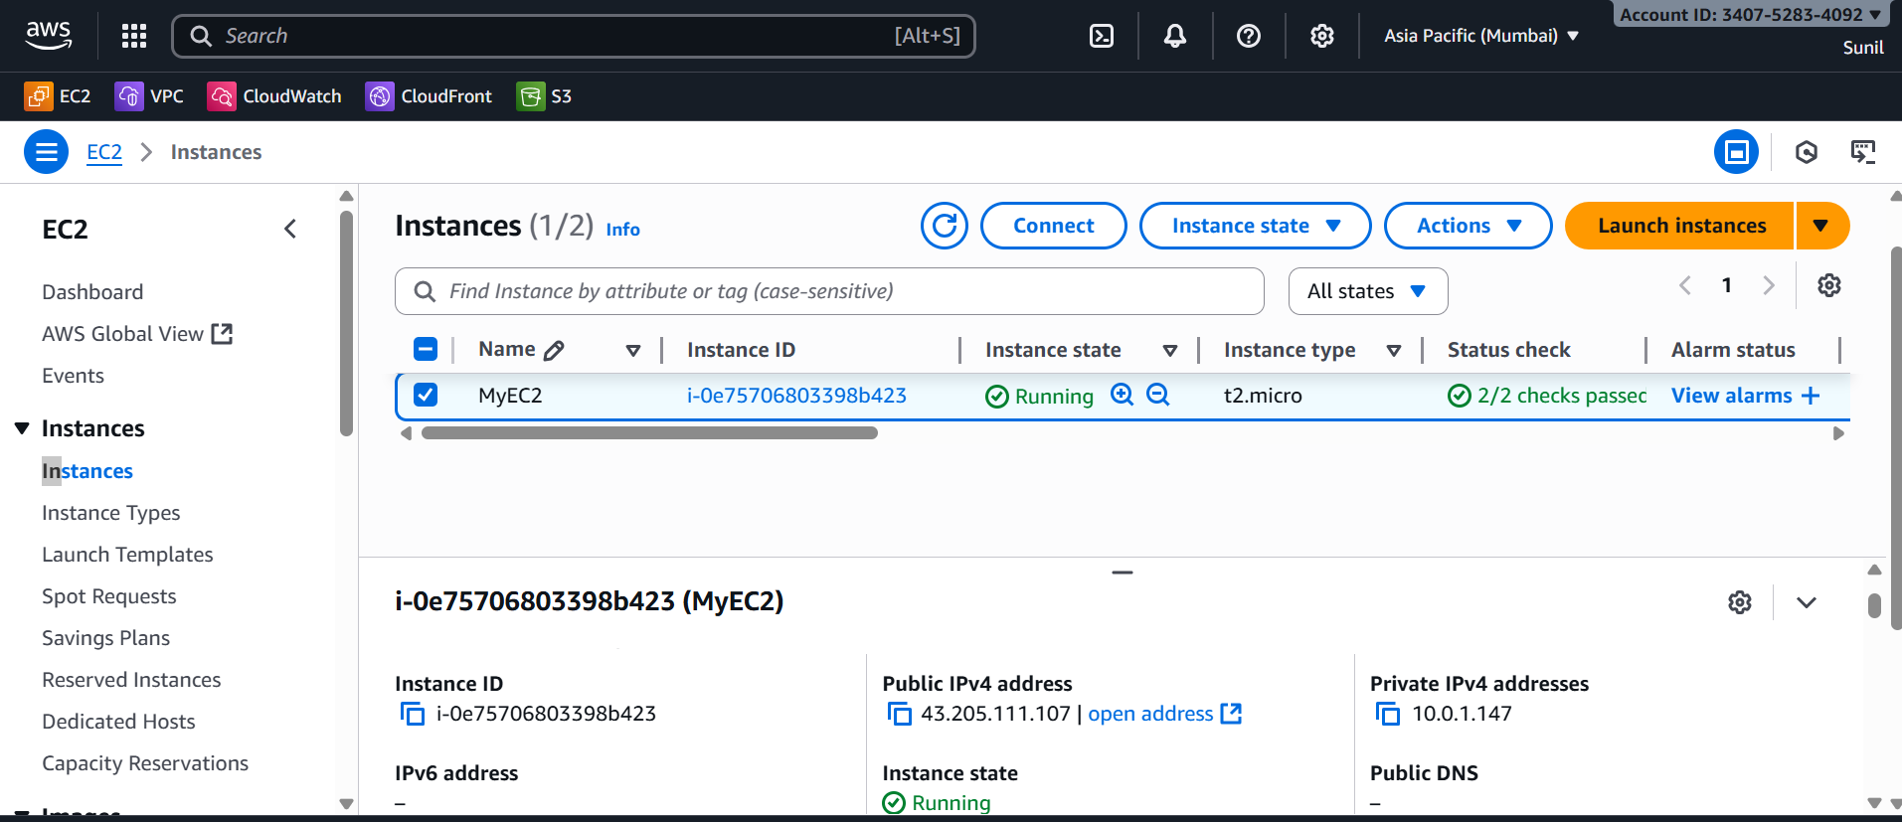

S3 Module (modules/s3/main.tf)

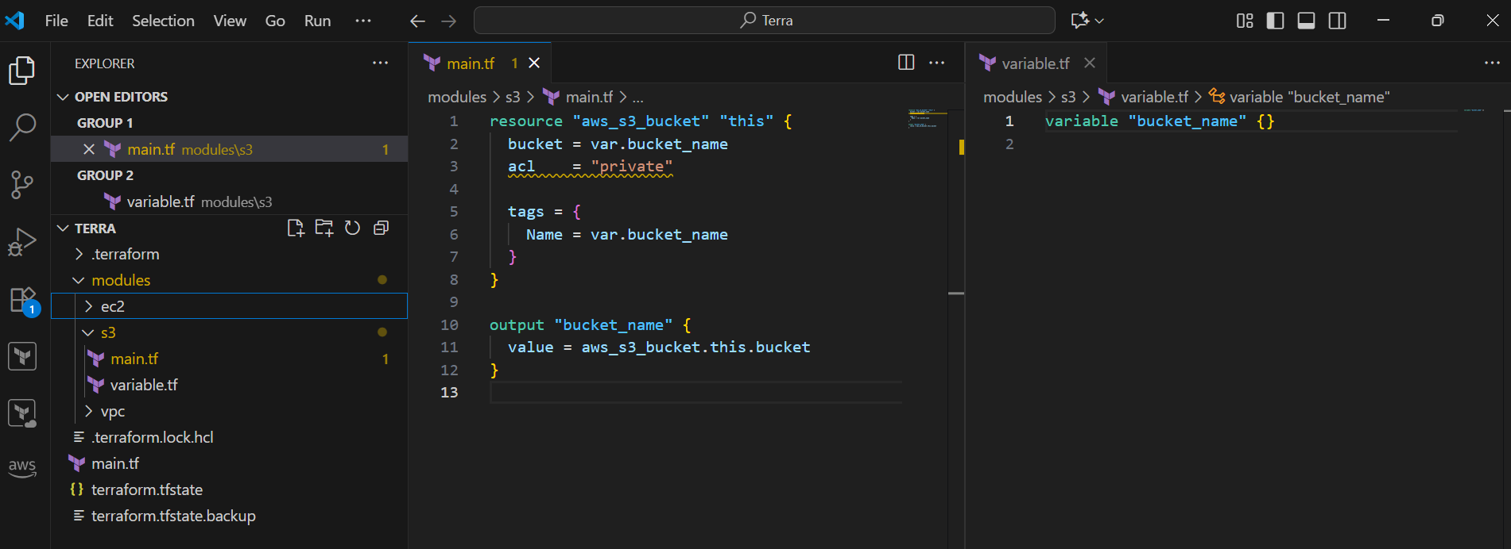

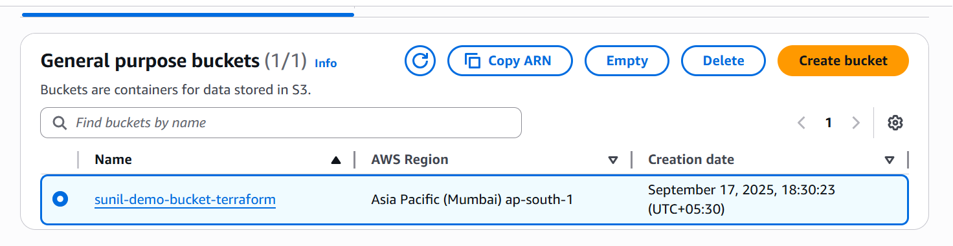

**4.Provision EC2 for 3 different environments (Dev, Staging, and Prod) using Terraform workspaces.**

### ****Step 1: Initialize Workspaces****

First create 3 workspaces:

terraform workspace new dev

terraform workspace new staging

terraform workspace new prod

Verify:

terraform workspace list

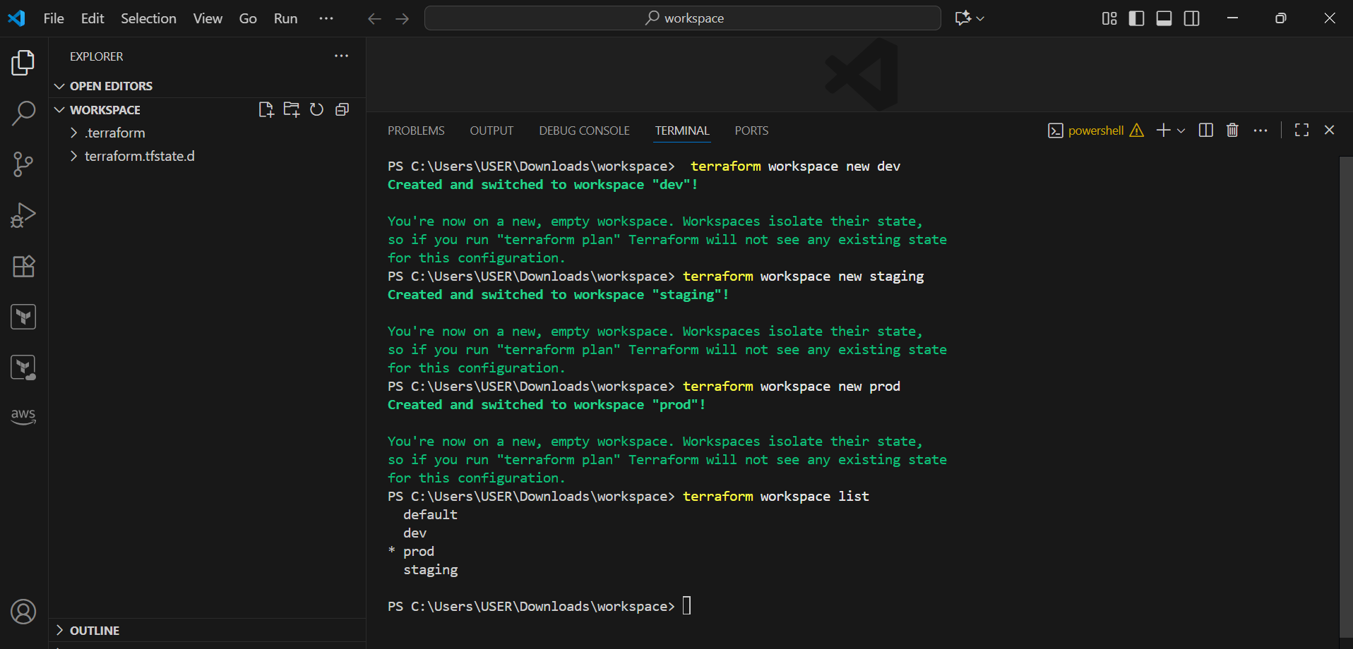

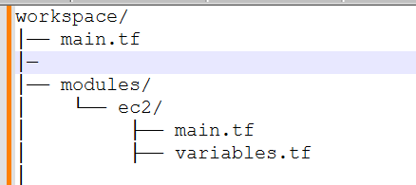

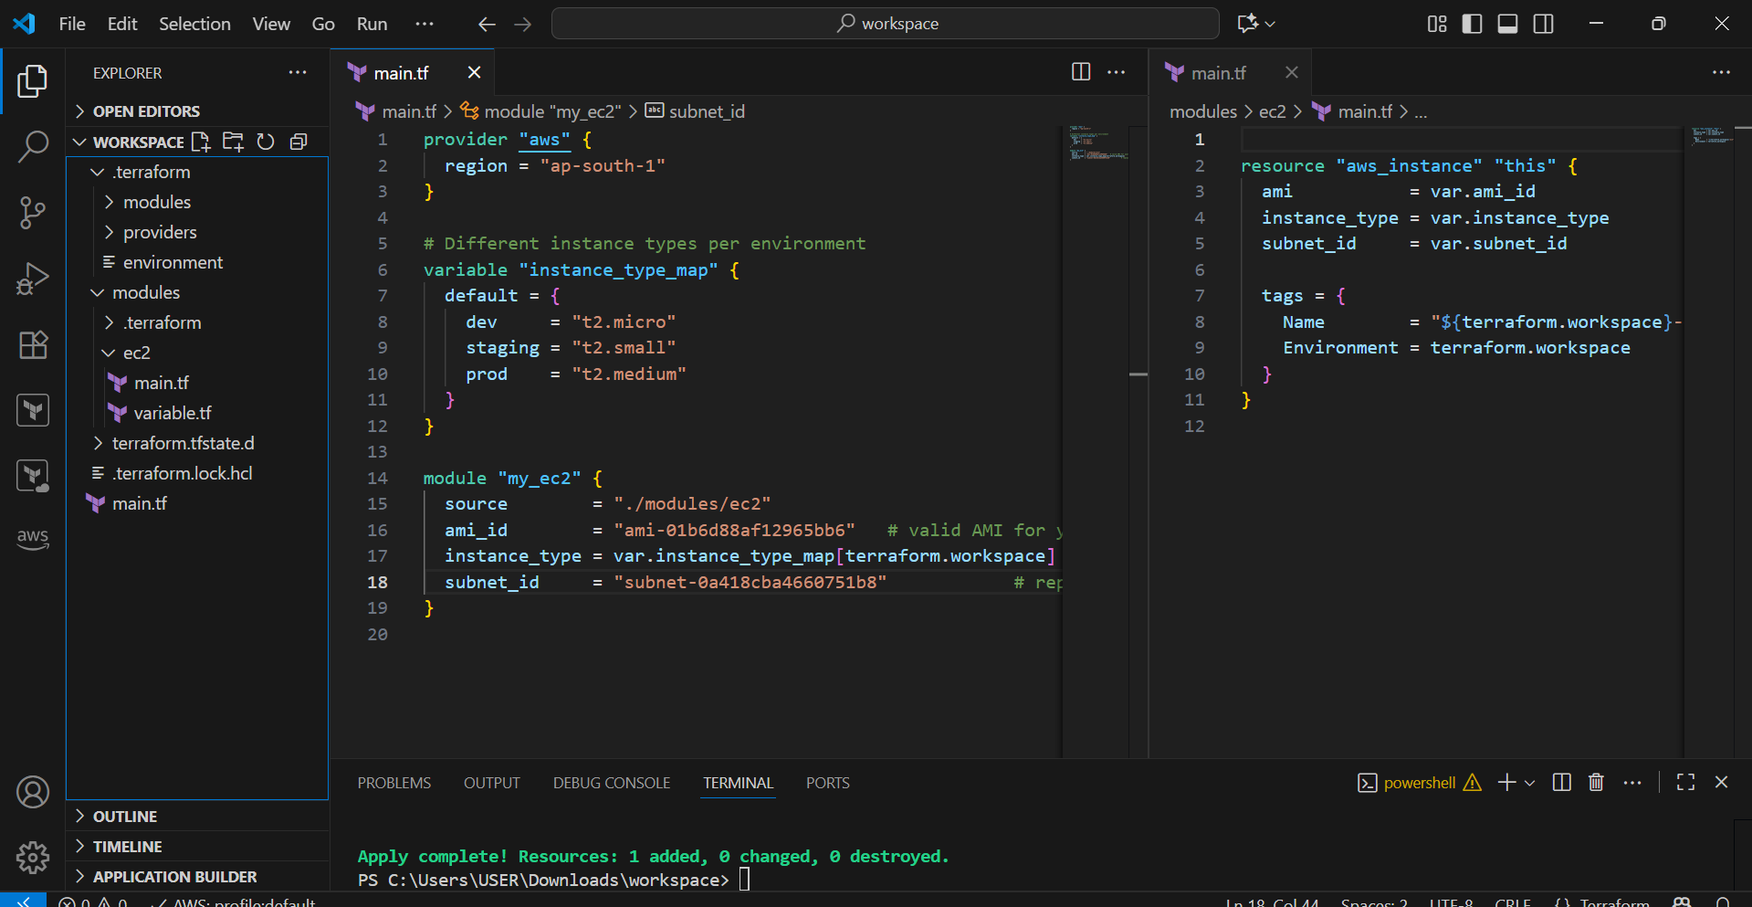

**terraform workspace select dev**

**terraform apply -auto-approve**

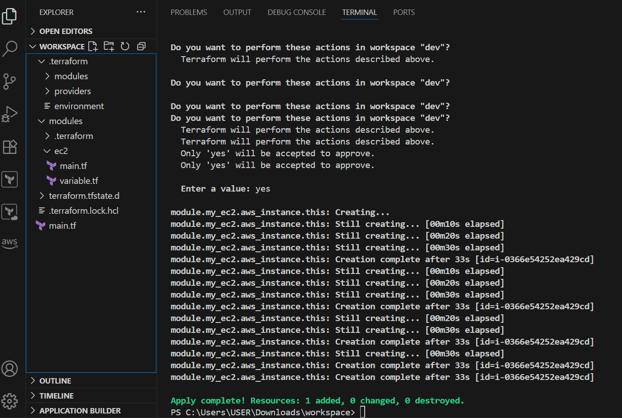

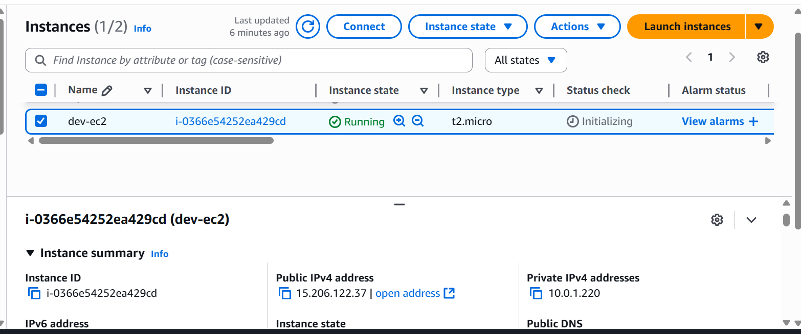

**Similarly do the same process for staging and prod**

terraform workspace select staging

terraform apply -auto-approve

terraform workspace select prod

terraform apply -auto-approve