Docker-01
1.Setup a virtual machine using Ubuntu image.

Step 1: Download Requirements
- Download VirtualBox: https://www.virtualbox.org/wiki/Downloads
- Download Ubuntu ISO: https://ubuntu.com/download/desktop
  - Choose Ubuntu 22.04 LTS (Long Term Support) (recommended).

Step 2: Choose Your Virtualization Tool
You need software to run a VM. Popular options:
- VirtualBox (Free, easy to use)

Step 3: Create a New Virtual Machine
- Open VirtualBox.
- Click New → Give a name (e.g., Ubuntu-VM).
- Choose:
  - Type: Linux
  - Version: Ubuntu (64-bit)
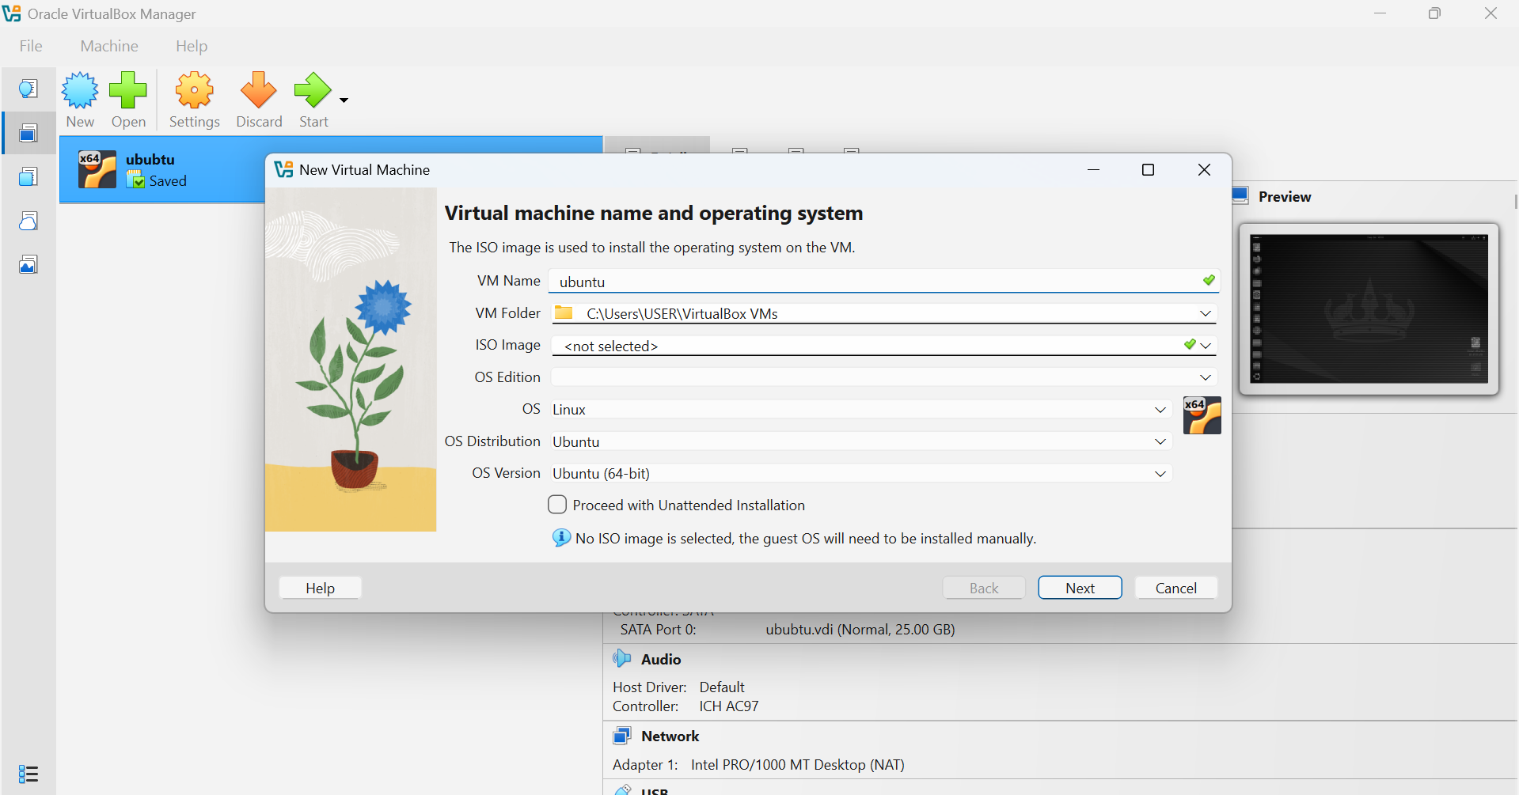
- Assign RAM: at least 2 GB (4 GB recommended).
- Create a Virtual Hard Disk:
  - Select VDI (VirtualBox Disk Image).
  - Choose Dynamically allocated.
  - Size: 20 GB or more.
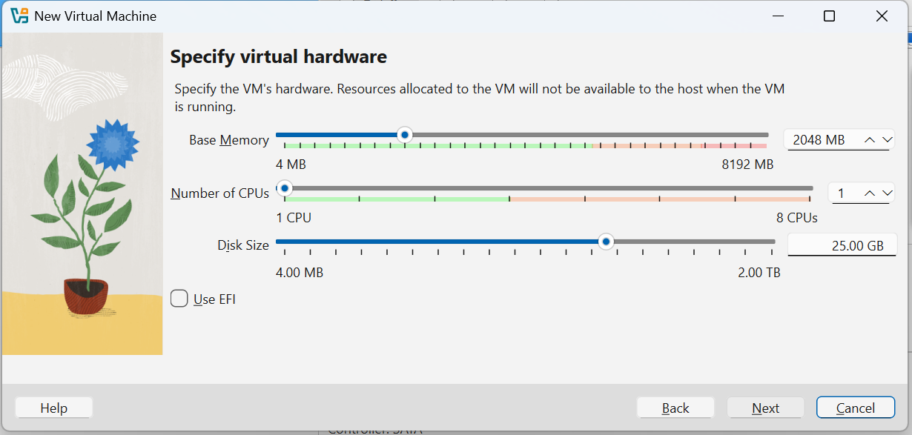

Step 4: Start the VM & Install Ubuntu
- Click Start.
- VM boots from ISO → Select Install Ubuntu.
- Follow setup wizard:
  - Language & Keyboard layout
  - Normal installation (includes utilities & browser)
  - Install updates and third-party software → Check ✅
  - Disk setup → Use entire virtual disk
  - Create username & password
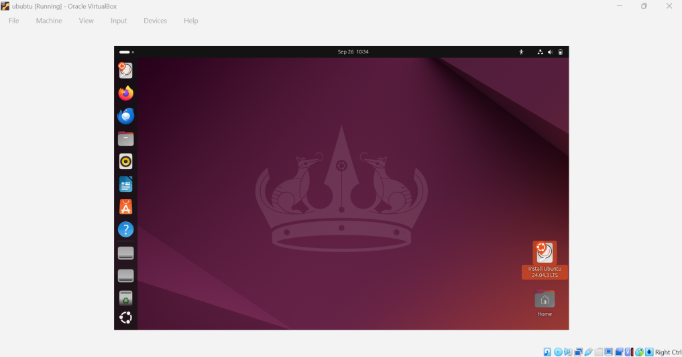

2.Install docker on ec2.

Step 1: Launch EC2 Instance
- In AWS Console → Launch Instance.
- Select Amazon Linux 2 AMI (
- Instance type: t2.large.
- Launch.
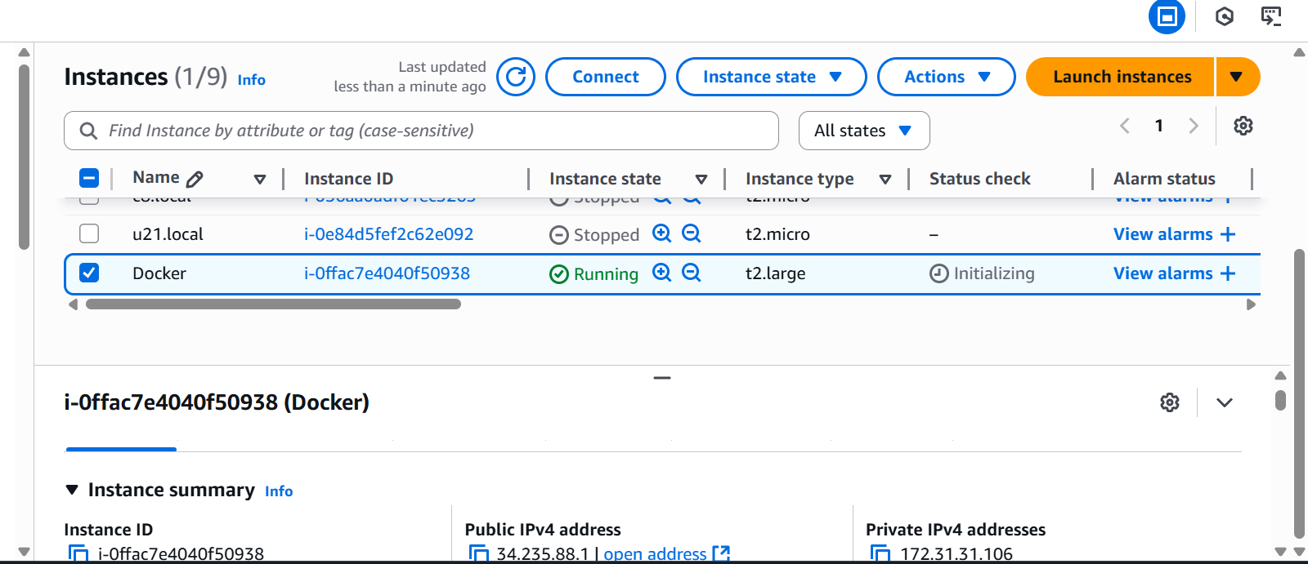

Step 2: Connect to EC2
From your local terminal:
ssh -i ec2-key.pem ec2-user@<EC2_PUBLIC_IP>
sudo yum update –y
# Install docker
sudo yum install docker

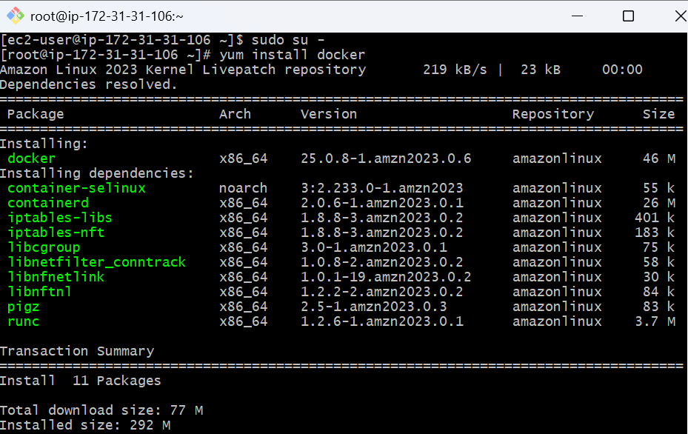
# Start docker service
sudo systemctl start docker
# Enable docker on boot
sudo systemctl enable docker
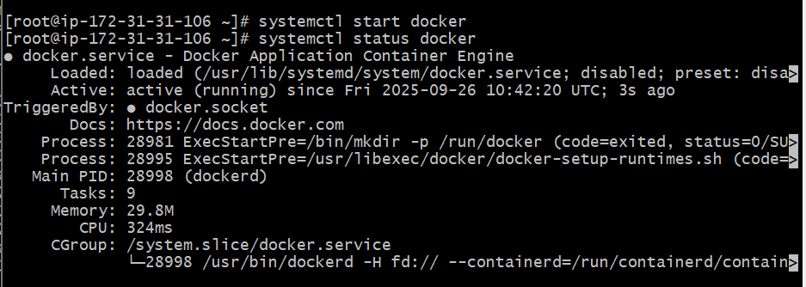docker --version
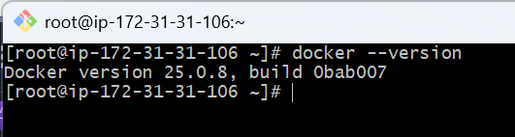

3.Pull 5 docker images. (nginx, Apache tomcat, ubuntu, Jenkins, SonarQube)
Step 1: Make sure Docker is running
docker --version
sudo systemctl status docker

Step 2: Pull Images
Run these commands one by one

# Nginx
docker pull nginx:latest
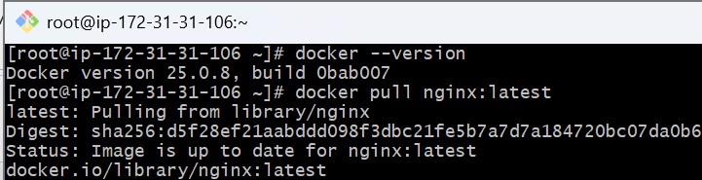
# Apache Tomcat
docker pull tomcat:latest
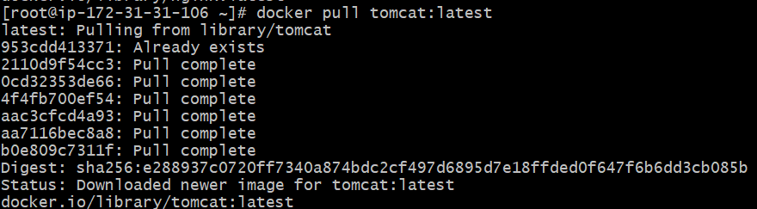
# Ubuntu
docker pull ubuntu:latest
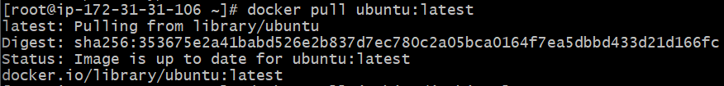
# Jenkins
docker pull jenkins/jenkins:lts

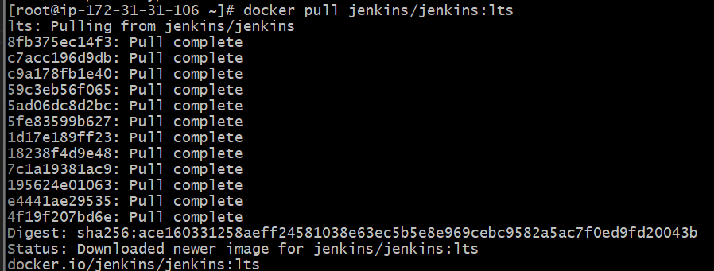
# SonarQube
docker pull sonarqube:latest
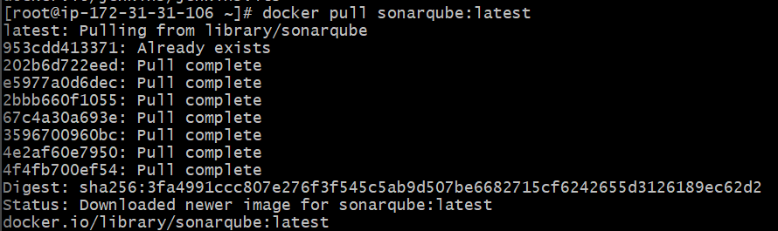

Step 3: Verify Images
After pulling, check your local Docker images:
docker images
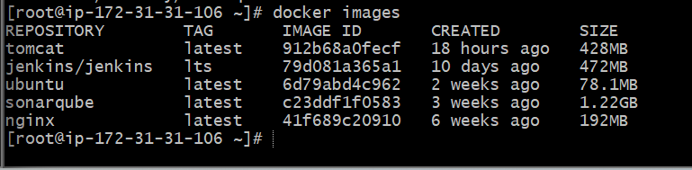

4.Run nginx container and expose on port 81.

Step 1: Make sure Docker is running
sudo systemctl start docker
sudo systemctl enable docker

Step 2: Run Nginx container on port 81
docker run -d --name mynginx -p 81:80 nginx
- -d → detached mode (runs in background)
- --name mynginx → container name
- -p 81:80 → maps host port 81 → container port 80 (Nginx default)

Step 3: Verify container is running
docker ps

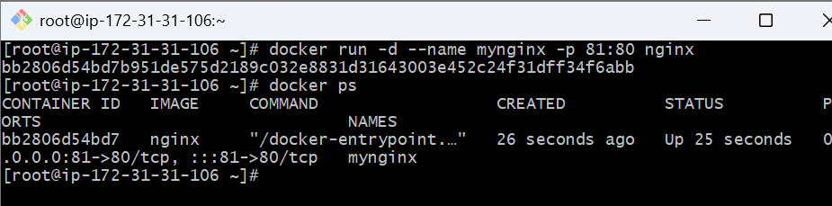

Step 4: Test in browser
Open:
http://<EC2_PUBLIC_IP>:81
You should see the Nginx Welcome Page
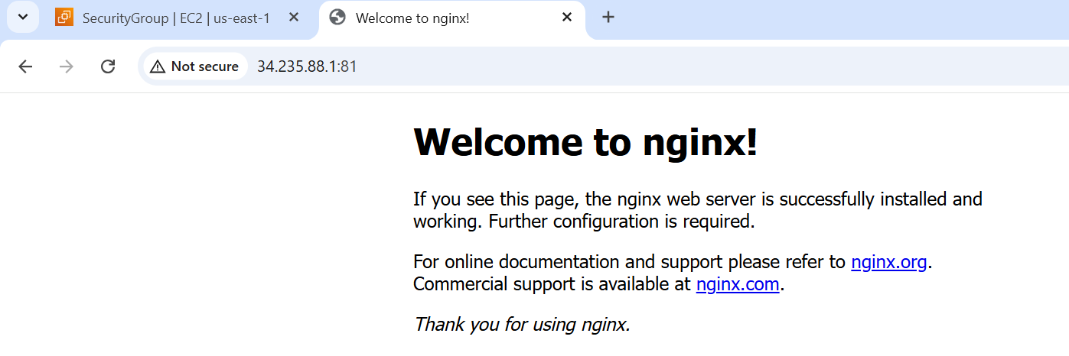

5.Delete the Apache tomcat image from local.

Step 1: Check existing images
docker images

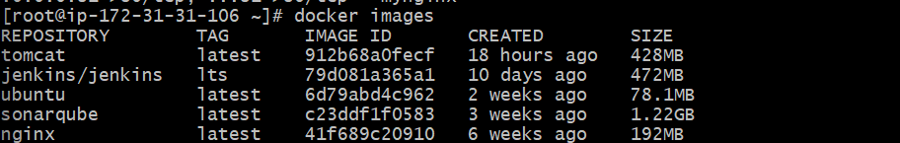

Step 2: Remove the Tomcat image
First, stop and remove any container using Tomcat:
docker stop mytomcat
docker rm mytomcat
Then remove the image:
docker rmi tomcat:latest

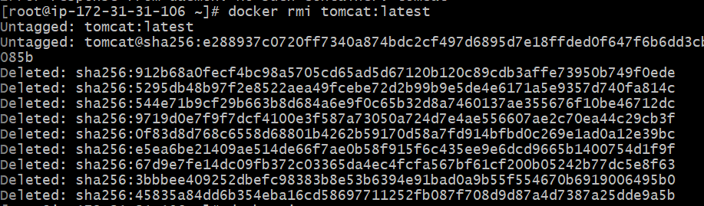

Step 3: Verify
docker images
Now, tomcat should be gone, only other images remain
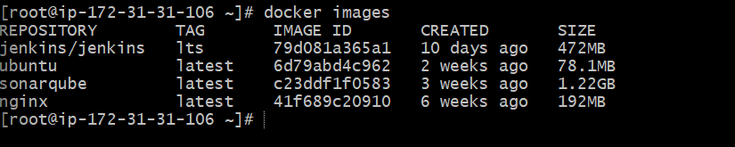

6.Inspect the Jenkins image, SonarQube image.

Step 1: Inspect Jenkins Image
docker inspect jenkins/jenkins:lts

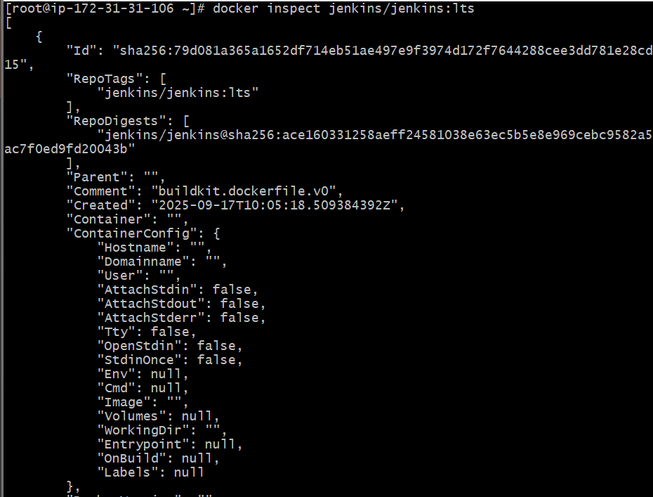
To see only exposed ports:
docker inspect --format='{{json .Config.ExposedPorts}}' jenkins/jenkins:lts

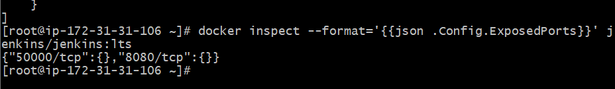
7.Run Jenkins container and run one sample job.

Step 1: Run Jenkins Container
docker run -d \
--name myjenkins \
-p 8080:8080 -p 50000:50000 \
jenkins/jenkins:lts
- 8080 → Web UI port
- 50000 → For agent communication
- Container runs in background (-d)

Step 2: Get Jenkins Admin Password
Check logs:
docker logs myjenkins
Look for a line like:
*************************************************************
Jenkins initial setup is required. An admin user has been created...
Admin password: 1234567890abcdef

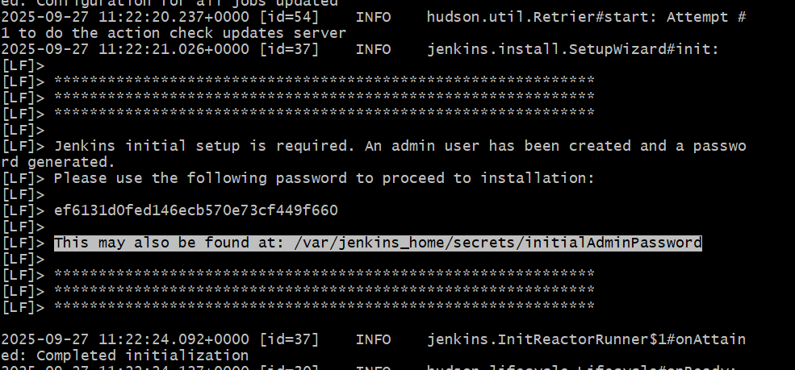

Method 2: Exec into the Container & Read File
The file path is /var/jenkins_home/secrets/initialAdminPassword.
Run:
docker exec -it myjenkins cat /var/jenkins_home/secrets/initialAdminPassword
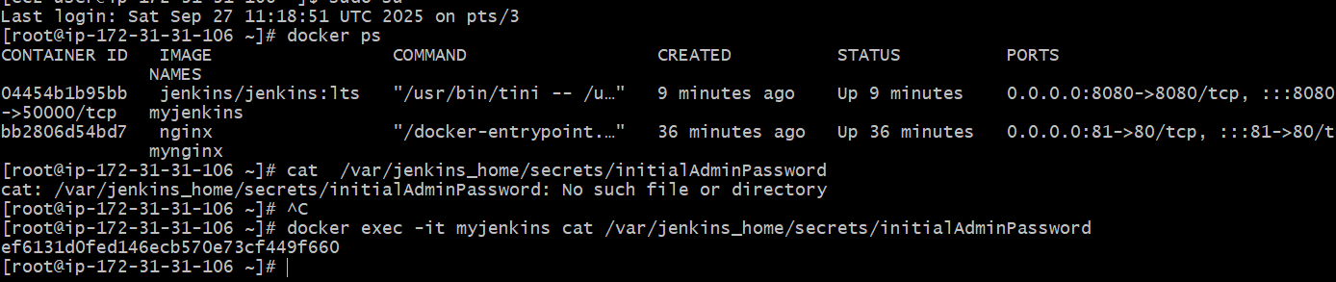

Step 3: Access Jenkins UI
- In AWS Security Group, allow inbound rule for port 8080.
- Open in browser:
http://<EC2_PUBLIC_IP>:8080
- Enter the admin password you copied.
- Choose Install Suggested Plugins.
- Create a new admin user.

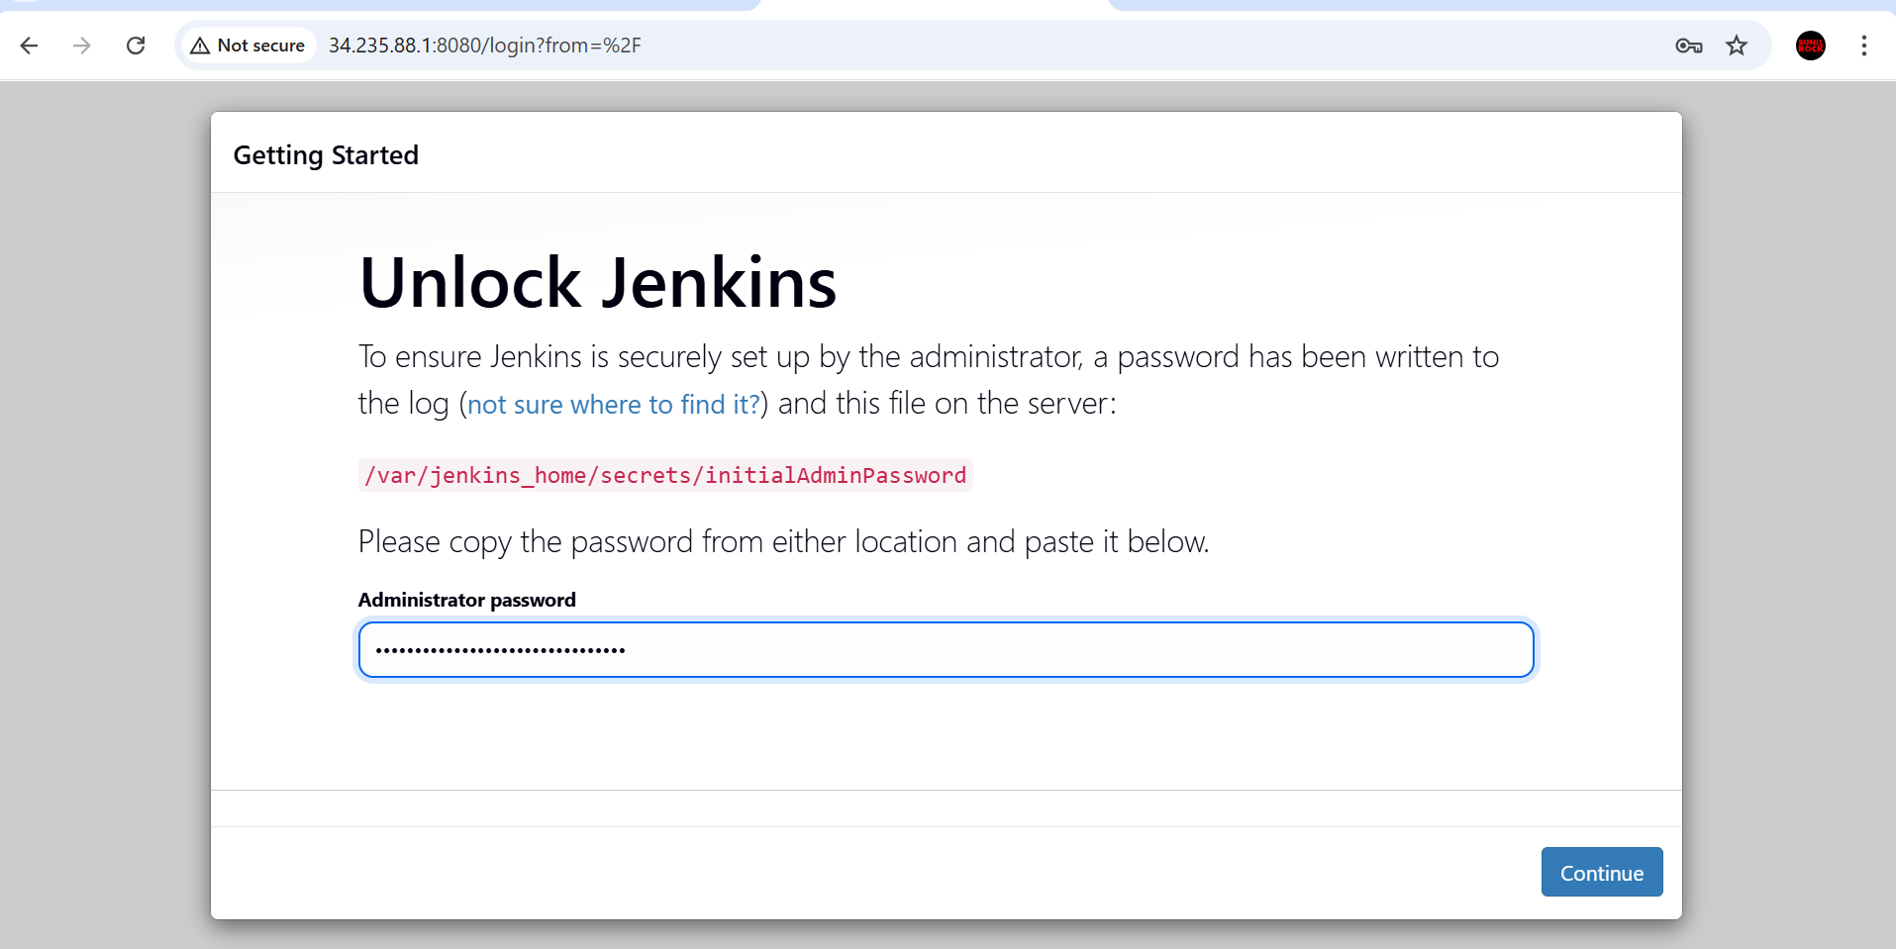

Step 4: Create a Sample Job
- From Jenkins dashboard → New Item.
- Enter name: sample-job.
- Select Freestyle project → OK.
- In Build section → Add build step → Execute shell.
- Enter command (example):
- echo "Hello, Jenkins is running successfully on Docker!"

