Docker-02
1.Create a tomcat container on 8080 and deploy sample application in tomcat.

1. Pull Tomcat Image
docker pull tomcat:latest

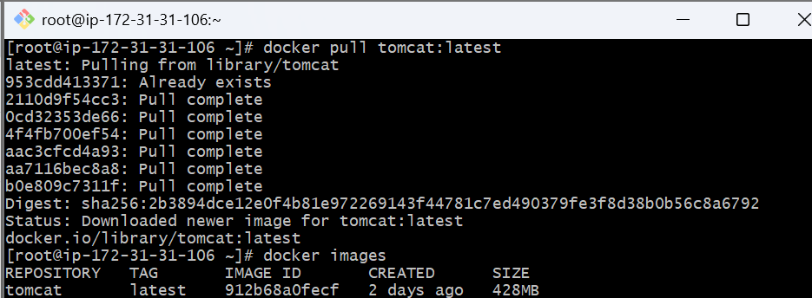

2. Run Tomcat Container on Port 8080
docker container run -itd -p 8080:8080 tomcat:latest
Check if it’s running:
docker ps

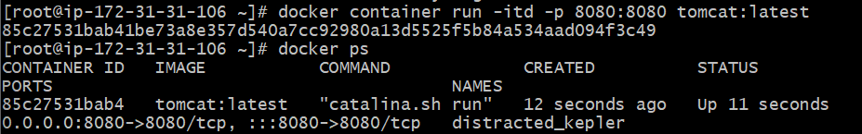

3. Deploy Sample Application (WAR file)
Let’s use the official Tomcat sample app (sample.war).
Use this command to go in to tomcat container
docker exec -it 85c27531bab4 /bin/bash
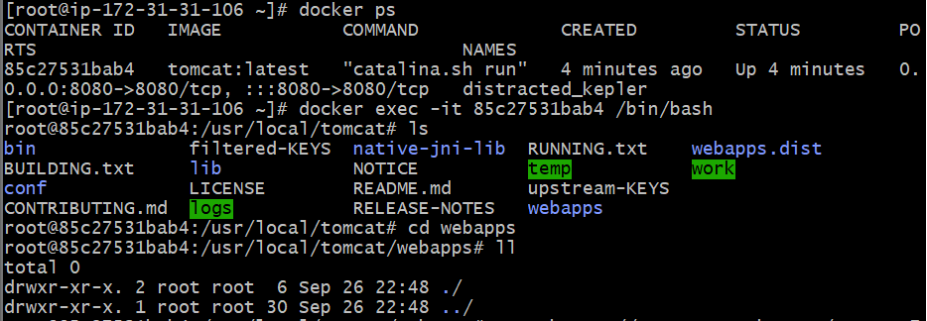
apt update && apt install -y wget
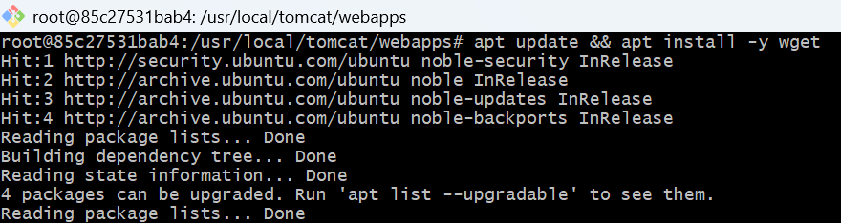
wget https://tomcat.apache.org/tomcat-6.0-doc/appdev/sample/sample.war
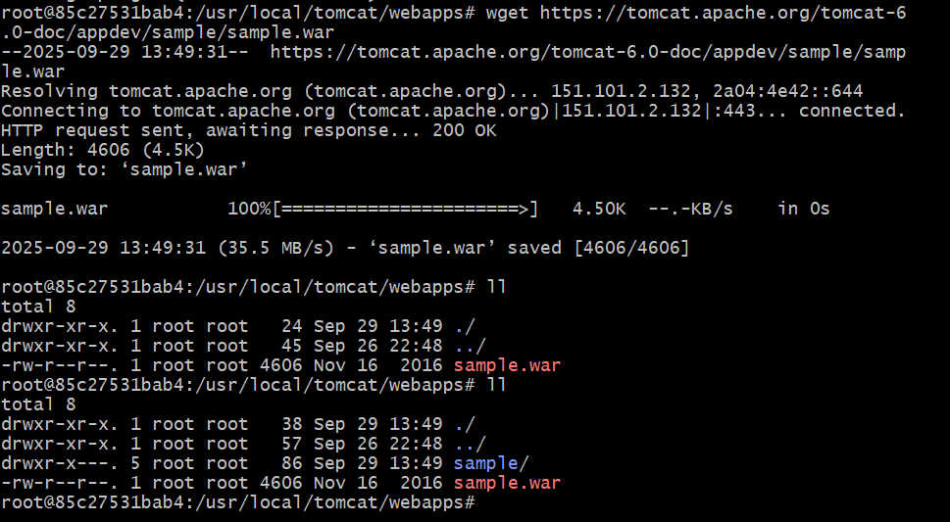

4. Verify Deployment
Open:
http://<your-server-ip>:8080/sample
You’ll see the sample Tomcat application running. 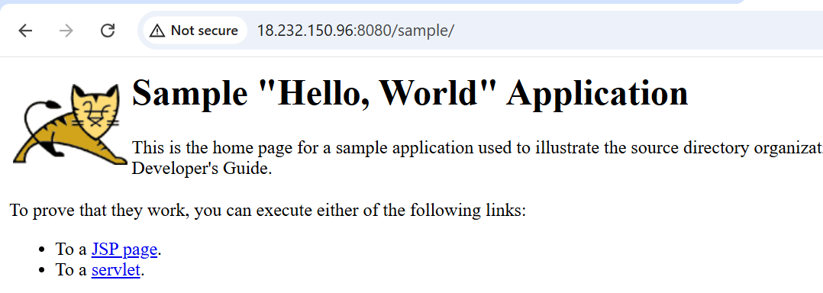
2.Create volume and deploy tomcat container on port 8081.

1. Create a Docker Volume
docker volume create tomcat_data
This creates a named volume tomcat_data.
/var/lib/docker/volumes
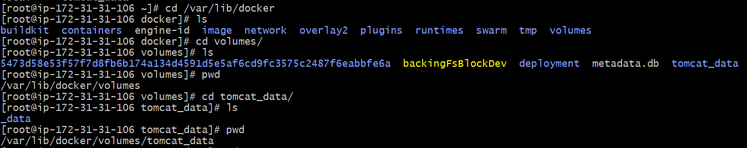
2. Deploy Sample Application
Insde the /var/lib/docker/volumes/tomcat_data/_data
Deploy the sample war file in _data
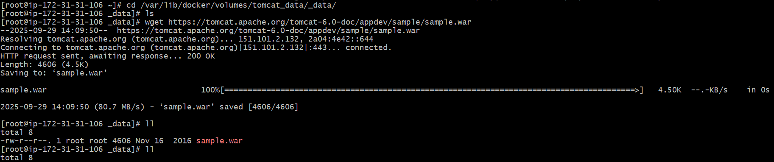

3. Run Tomcat Container on Port 8089 with Volume

docker container run -itd -p 8089:8080 -v /var/lib/docker/volumes/tomcat_data/_data:/usr/local/tomcat/webapps tomcat:latest

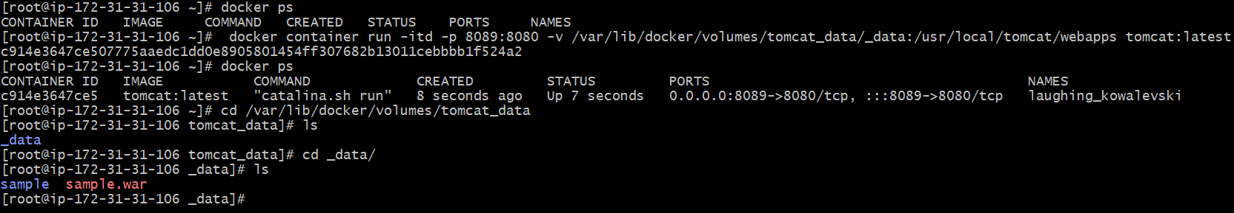
Sample app:
http://<your-server-ip>:8089/sample

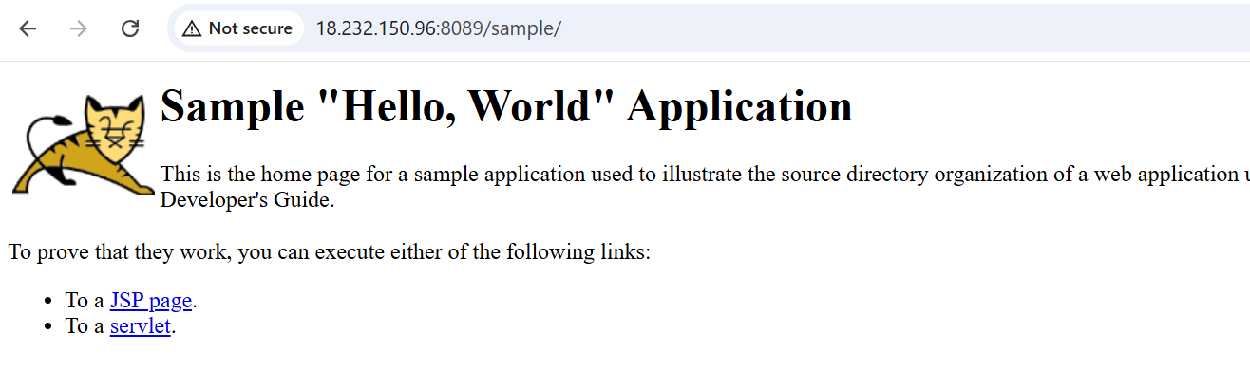

3.Limit the nginx container to 500 MB.

docker run -itd -p 85:80 --memory=500m nginx

Breakdown:
- -i → interactive mode.
- -t → allocates a pseudo-TTY.
- -d → runs in detached mode (in background).
- -p 85:80 → maps host port 85 → container port 80.
- --memory=500m → limits container memory to 500 MB.
- nginx → image name (latest by default).

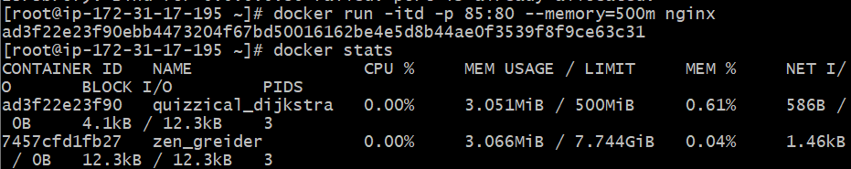

4.Create a sample docker file using below instructions.
a.Base module as amazonlinux:latest
b.Maintainer you name
c.Install nginx
d.COPY one index.html file to image
e.Expose on port 80
f.Command to start the nginx container

- Create a file named Dockerfile with the above contents.
Vi docker file
- Place your index.html in the same directory as the Dockerfile.
Create a index.html file
vi index.html
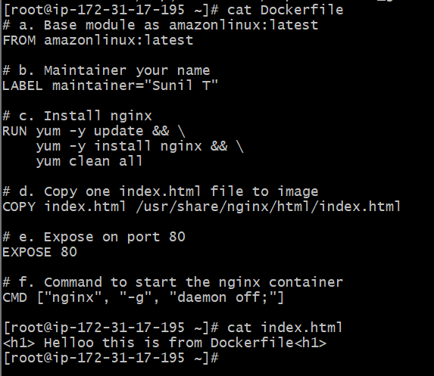
- Build the image:
docker build -t my-nginx .

- Run the container:
docker run -d -p 8080:80 my-nginx

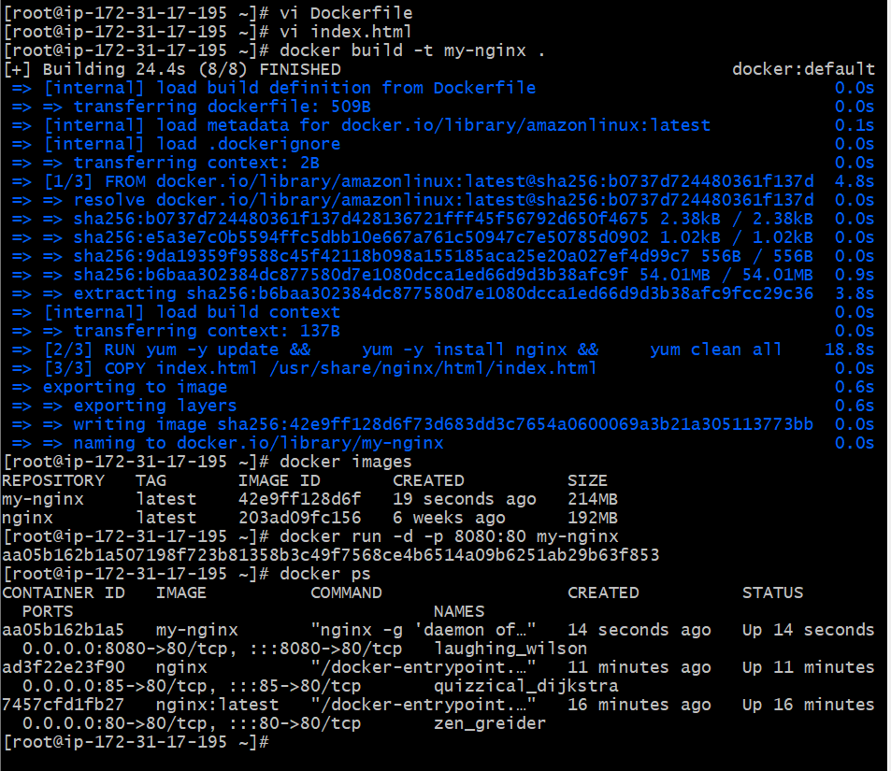
Access it in browser:
http://<EC2-Public-IP>:8080

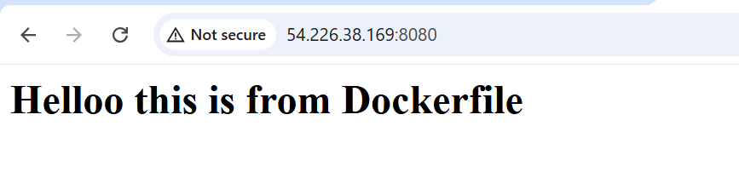

5.Push image to Docker hub

1.Log in to Docker Hub
docker login

Enter your Docker Hub username and password when prompted.
(If you don’t have an account → create one here.)

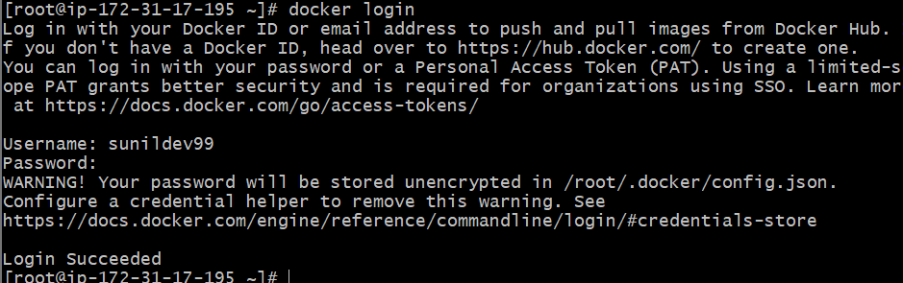

2. Tag your image
Suppose you built the image as my-nginx. You need to tag it with your Docker Hub username and repo name:
Docker tag my-nginx <your-dockerhub-username>/my-nginx:latest
docker tag my-nginx sunildev99/my-nginx:latest
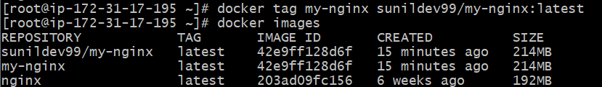

3.Push the image
docker push <your-dockerhub-username>/my-nginx:latest

docker push sunildev99/my-nginx:latest

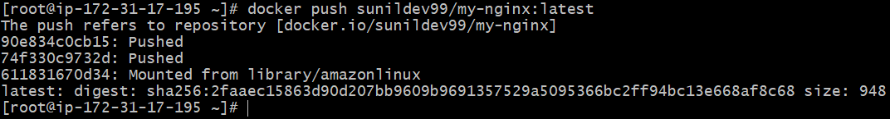

Verify on Docker Hub
Go to your Docker Hub profile → Repositories → you’ll see my-nginx.
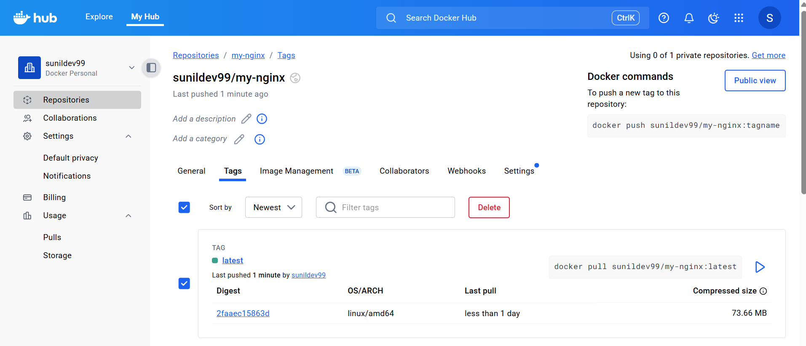

6.push image to AWS ECR
1.Aws configure

2.Create an ECR Repository

aws ecr create-repository --repository-name my-nginx --region us-east-1

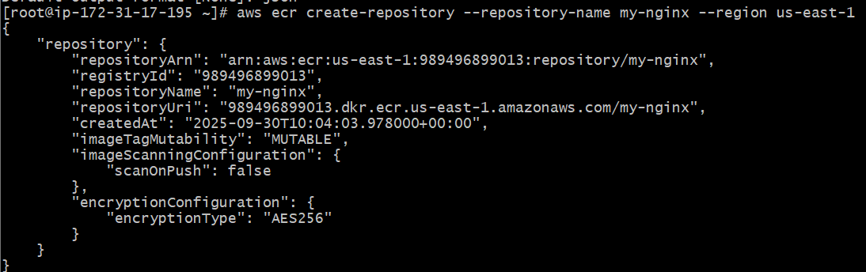

It will create an ECR Repo in aws
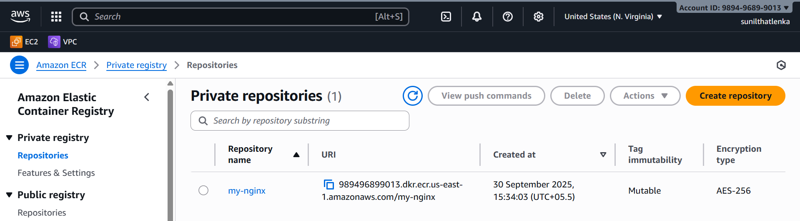

2 Authenticate Docker with ECR
Run the following command to get a login password and pipe it to Docker:
Replace the command with your ecr repo uri
aws ecr get-login-password --region us-east-1 | docker login --username AWS --password-stdin 989496899013.dkr.ecr.us-east-1.amazonaws.com/my-nginx
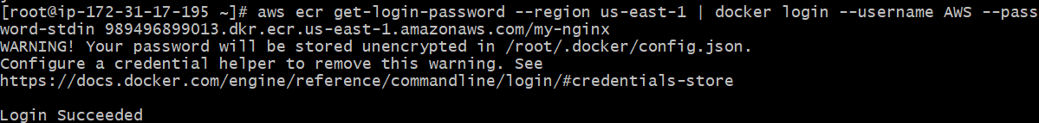

3 Tag Your Local Image
If your image is my-nginx, tag it with the ECR repo URI:
docker tag my-nginx:latest 989496899013.dkr.ecr.us-east-1.amazonaws.com/my-nginx
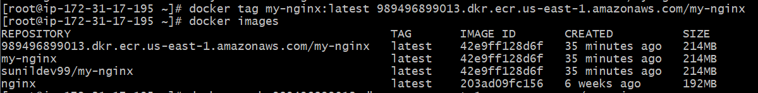
4 Push Image to ECR
docker push 989496899013.dkr.ecr.us-east-1.amazonaws.com/my-nginx

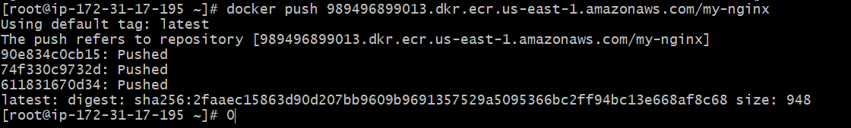

5 Verify
You can verify the image in AWS Console → ECR → Repositories → my-nginx.

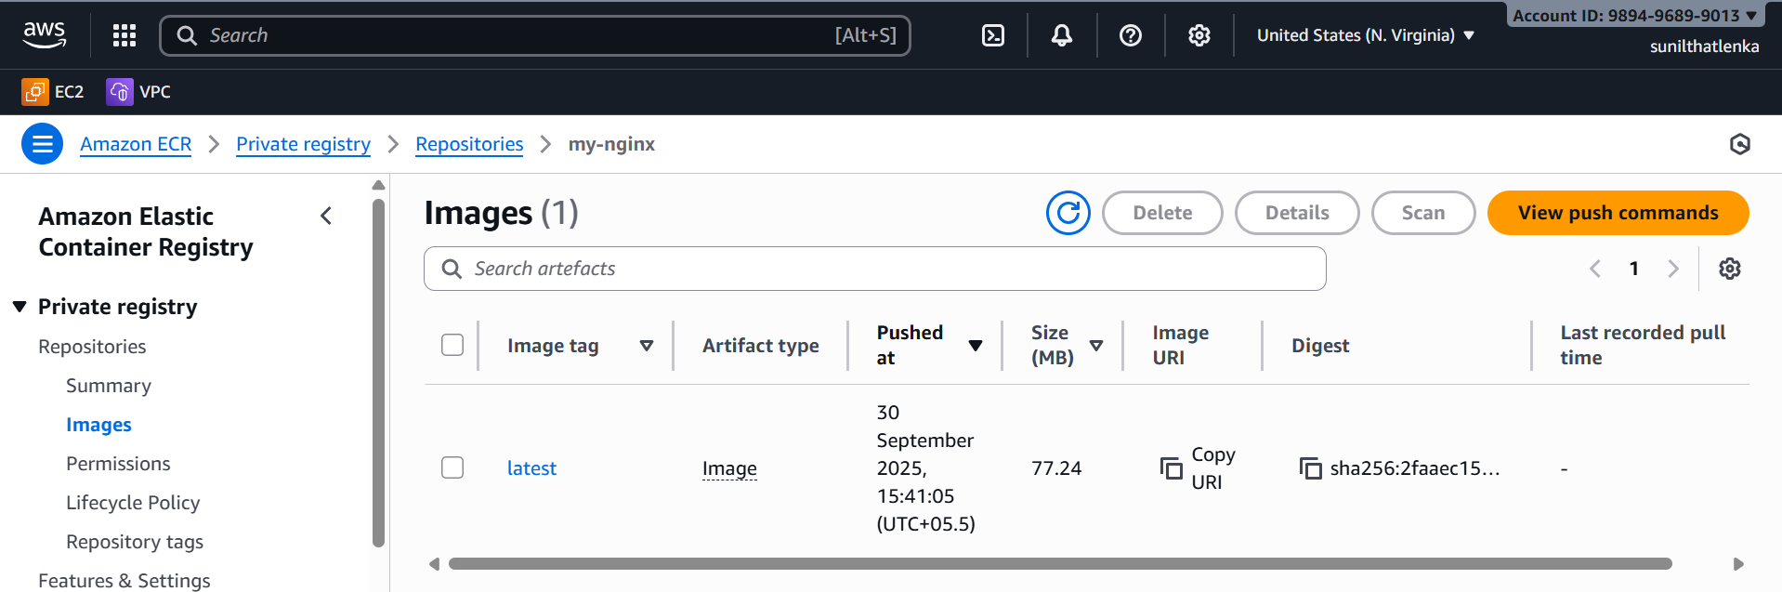

Or via CLI:
aws ecr list-images --repository-name my-nginx --region us-east-1

