Docker-03
1.Create a image from running container.

Step 1: List running containers
docker ps
This will show all currently running containers.

tep 2: Commit the running container as an image
Use this command:
docker commit <container_id_or_name> <new_image_name>:<tag>

Step 3: Verify the new image
docker images
You should see your new image listed:
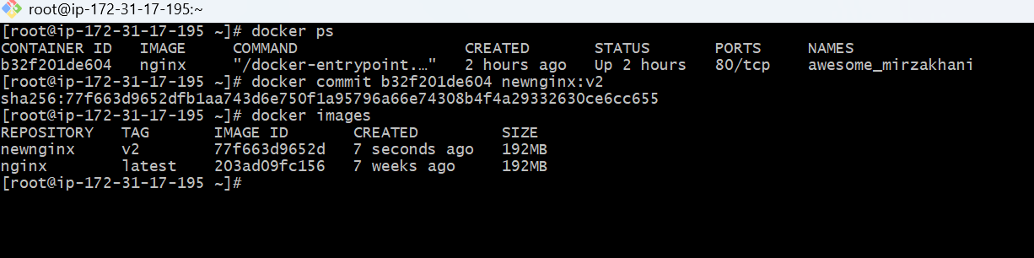

2.Copy image from local machine to docker server and load the image.
pull any docker image in your local machine and push to your docker server
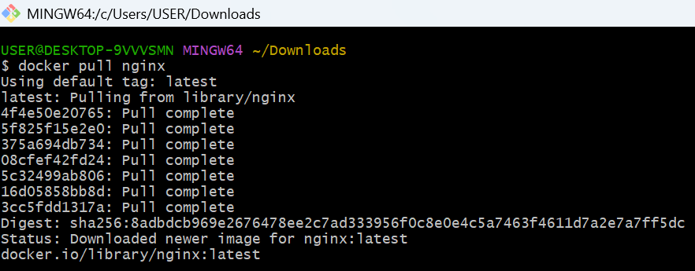

Step 1: Check your local image
Run this on your local machine:
docker images
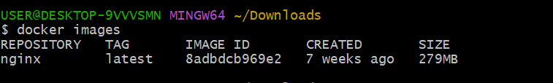

Step 2: Save the image to a .tar file
Save your local Nginx image:
docker save -o nginx.tar nginx:latest
✅ This creates a file named nginx.tar in your current directory.
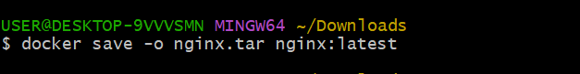

Step 3: Copy the image to your remote Docker server
Use scp to transfer the file.
If you connect with a key pair:
scp -i /path/to/key.pem nginx.tar ec2-user@<remote-server-ip>:/home/ec2-user/
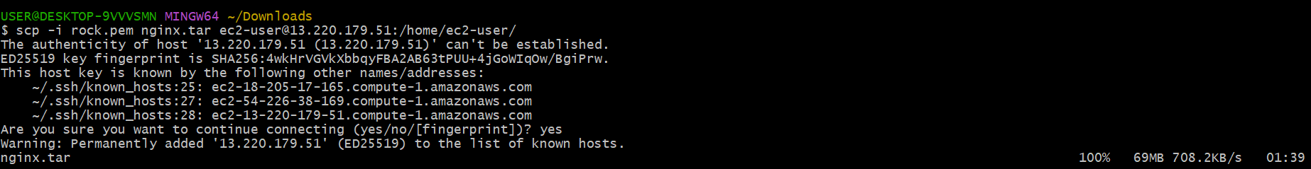

Step 4: SSH into your Docker server
ssh -i /path/to/key.pem ec2-user@<remote-server-ip>

Step 5: Load the image on the server
Once inside the remote server:
docker load -i nginx.tar
You’ll see output similar to:
Loaded image: nginx:latest

Step 6: Verify the image is available
docker images

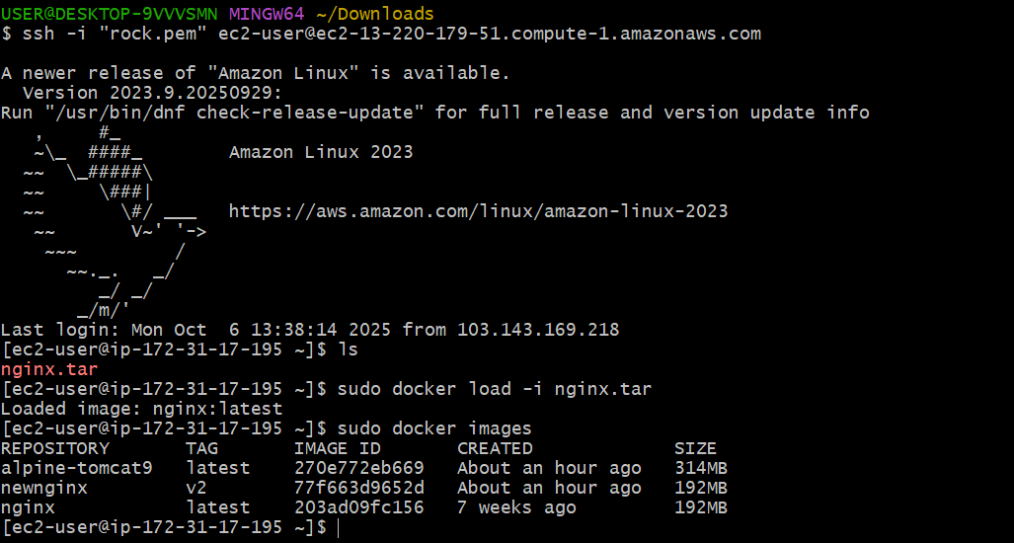

3.Create Docker image using alpine and customize with tomcat.

Step 1: Create a project directory
mkdir alpine-tomcat
cd alpine-tomcat

Step 2: Create a Dockerfile
Create a file named Dockerfile inside this directory:
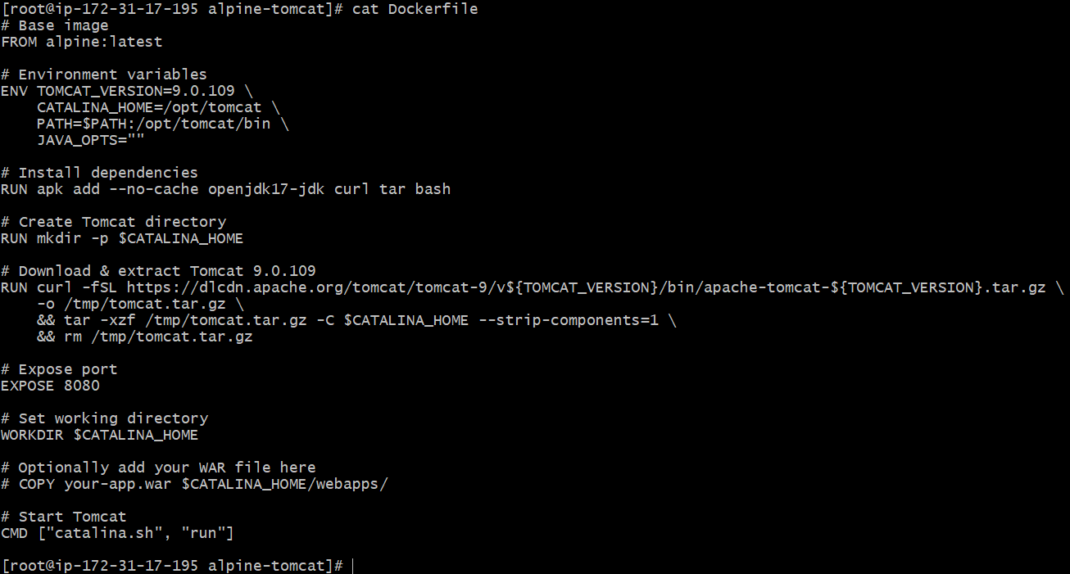

Step 3: Build the Docker image
Run the following command to build your image:
docker build -t alpine-tomcat:latest .
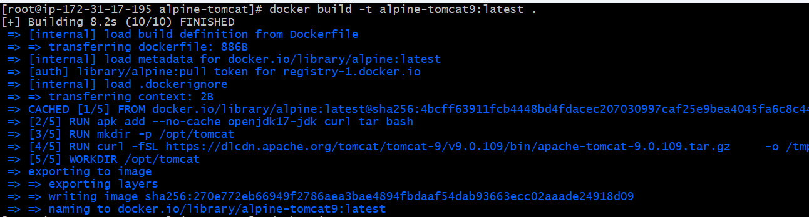

Step 4: Verify image and Run the Tomcat container
docker images
After the image builds successfully, run it:
docker run -itd -p 8085:8080 alpine-tomcat9

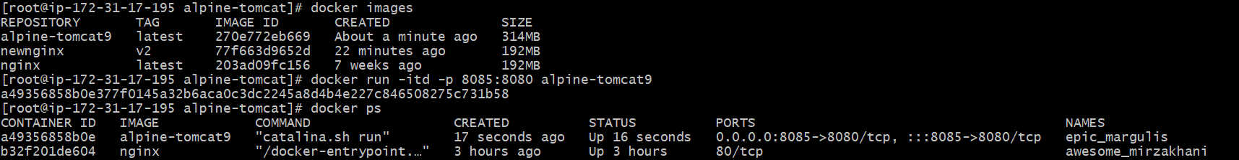

Step 5: Verify
Then open your browser and go to:
http://<your_docker_host>:8085
You should see the Apache Tomcat welcome page 🎉

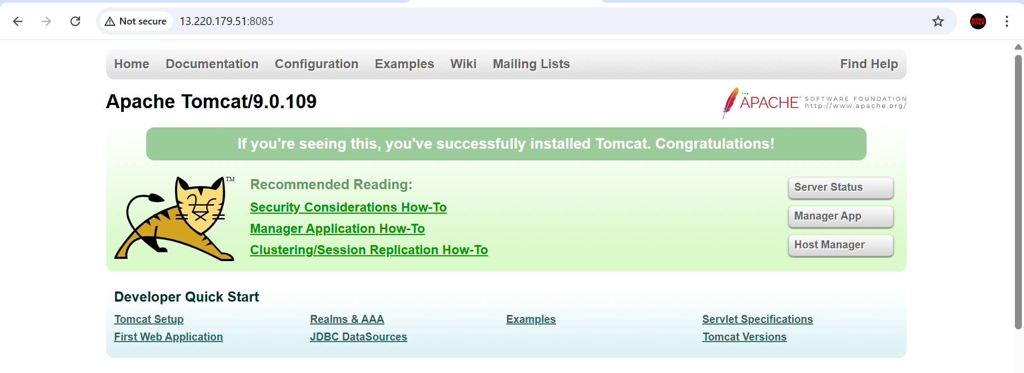
4.Create single stage and multi stage docker file using this source code: https://github.com/betawins/multi-stage-example.git

Step 1: Clone the repository
First, you need the source code on your local machine.
git clone https://github.com/betawins/multi-stage-example.git

cd multi-stage-example

Step 2: Check the project structure
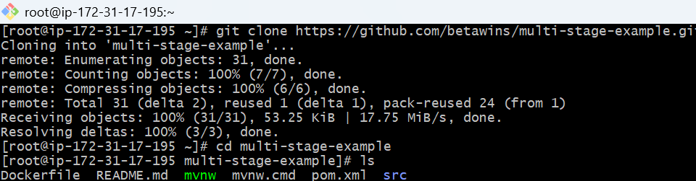

Step 3: Single-Stage Dockerfile Process
Create an index.hml file
And edit the Dockerfile and run
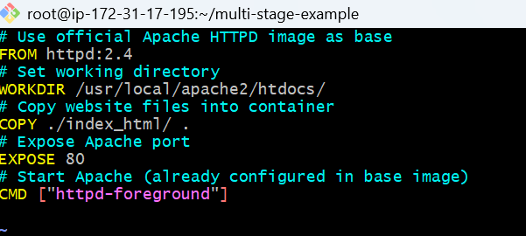

docker build -t myapp:v1 .

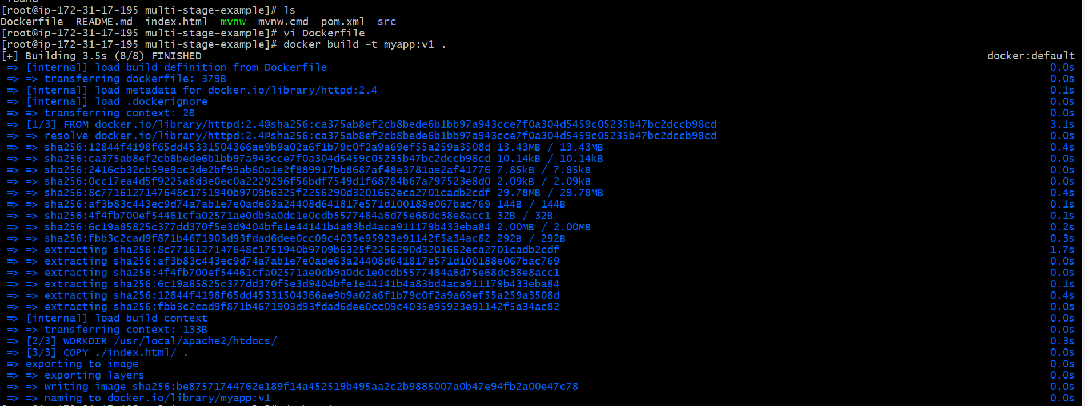
Verify the images
Docker images
Run the container
docker run -itd -p 82:80 myapp:v1

Verify


Multi-Stage Dockerfile:
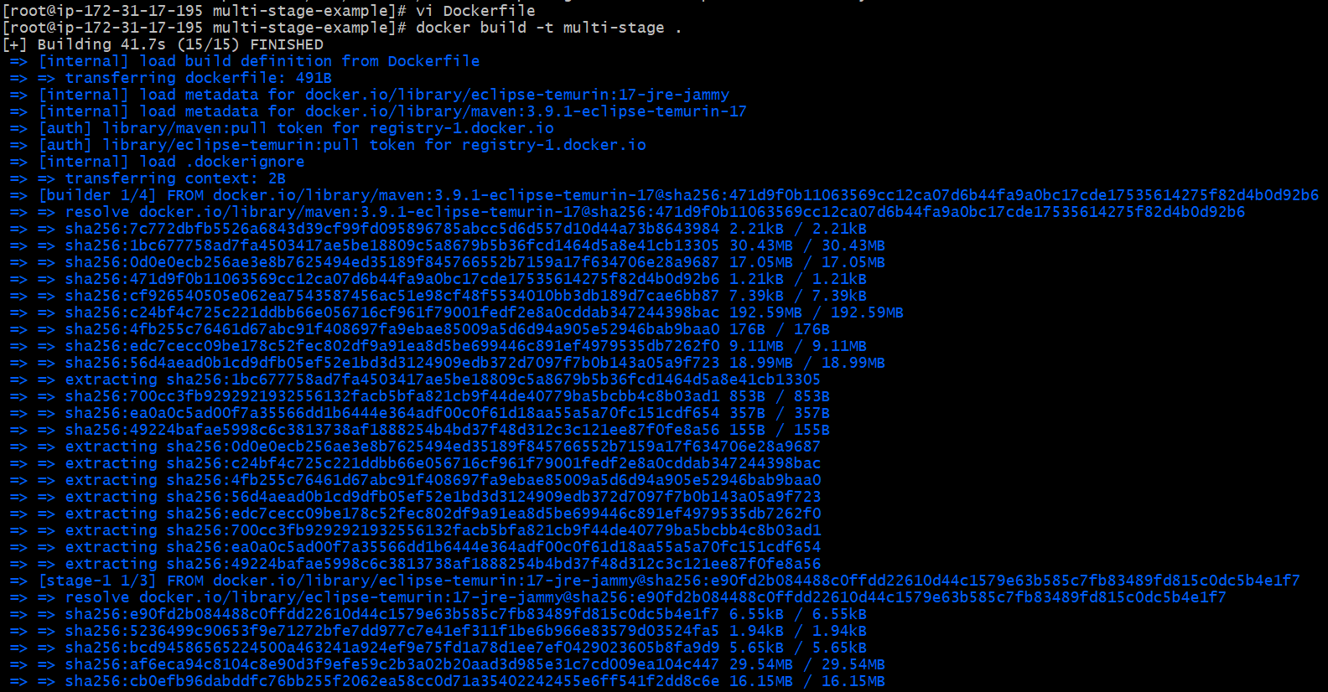

docker run -p 8080:8080 multi-stage
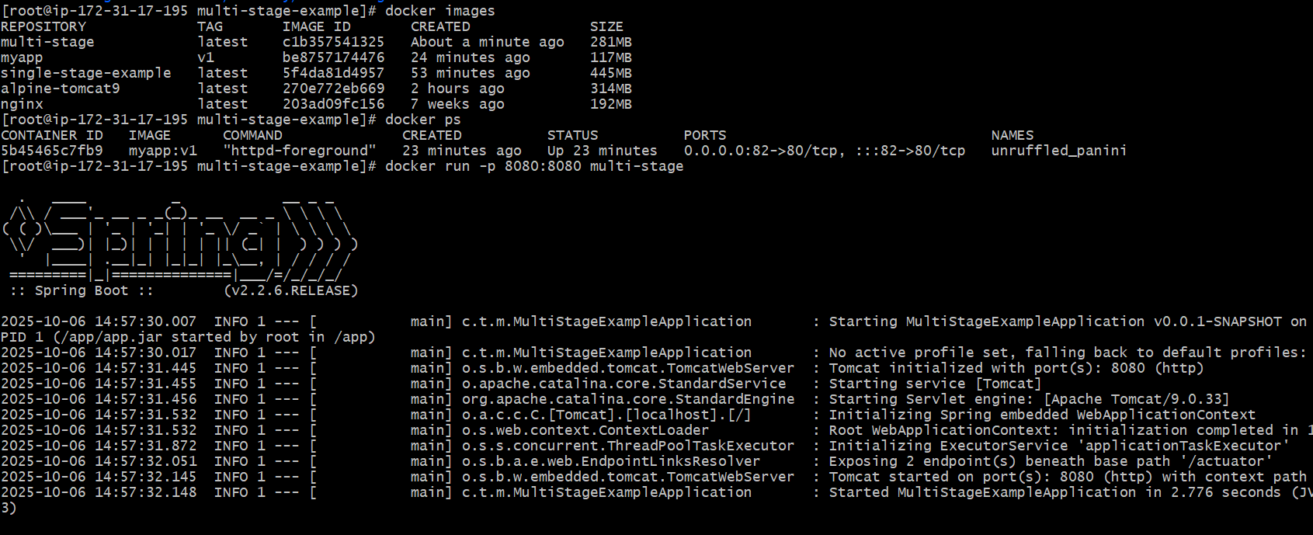

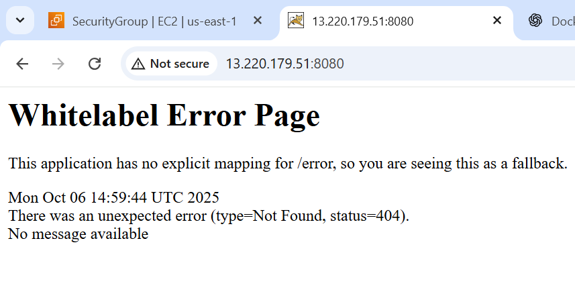
5.Install docker compose and execute sample application.

1) Install Docker over it.

2) Now to install docker-compose, run

sudo curl -L https://github.com/docker/compose/releases/download/1.21.0/docker-compose-`uname -s`-`uname -m` | sudo tee /usr/local/bin/docker-compose > /dev/null

3) For permission

sudo chmod +x /usr/local/bin/docker-compose

4) Create a symbolic link

ln -s /usr/local/bin/docker-compose /usr/bin/docker-compose

5) Check docker-compose version:
docker-compose --version

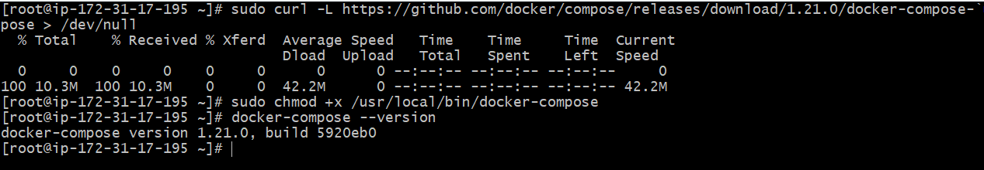

- Create a docker-compose.yml file:
version: '3'
services:
web:
image: nginx:latest
ports:
- "8080:80"

- Start the application:
docker-compose up -d
- Verify it’s running:
docker-compose ps
You should see the web service running.
- Test it in your browser or via curl:
curl http://localhost:8080

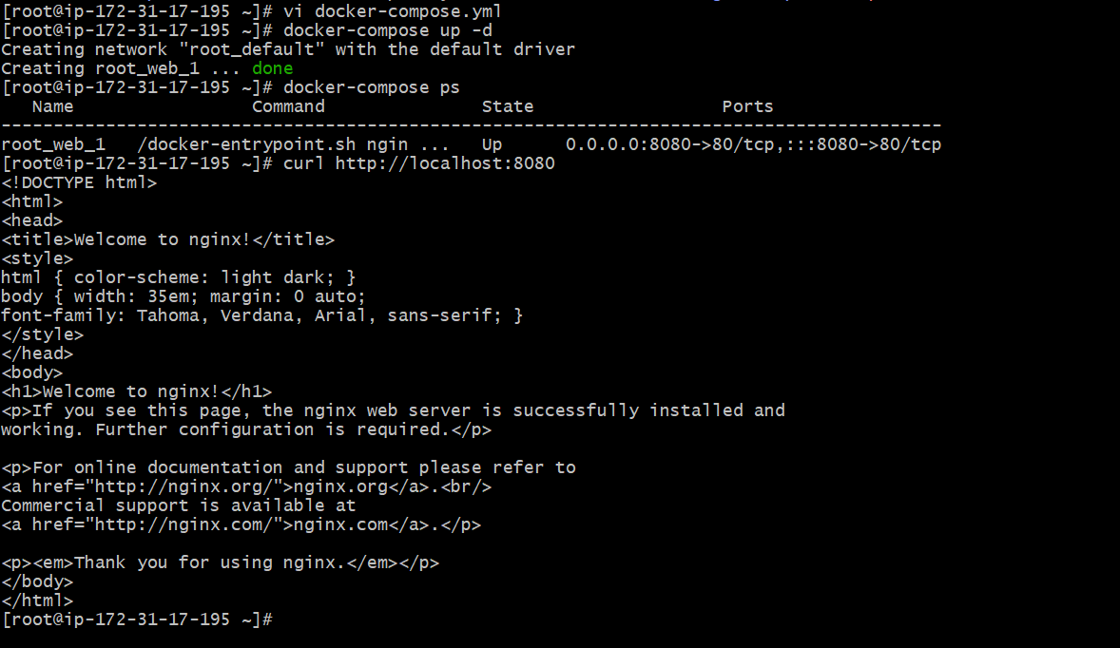

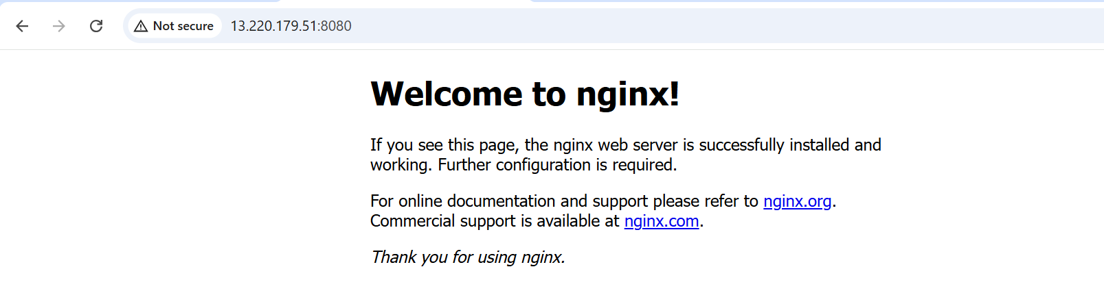
6.Implement solution to scan images when pushed to docker registry.

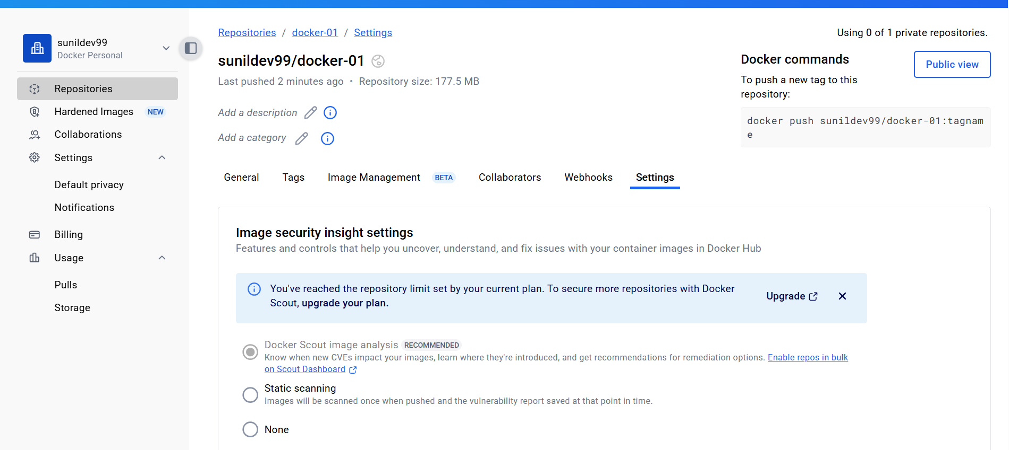
Docker login
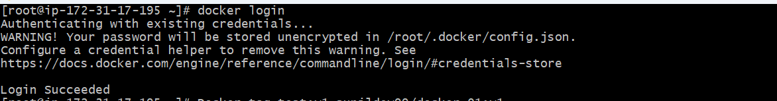
docker tag myapp:v1 sunildev99/docker-01:v1
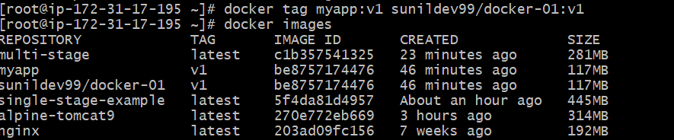
docker push sunildev99/docker-01:v1

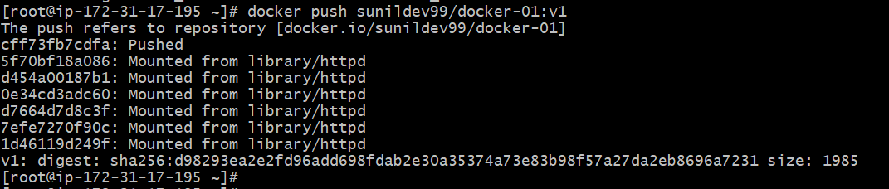
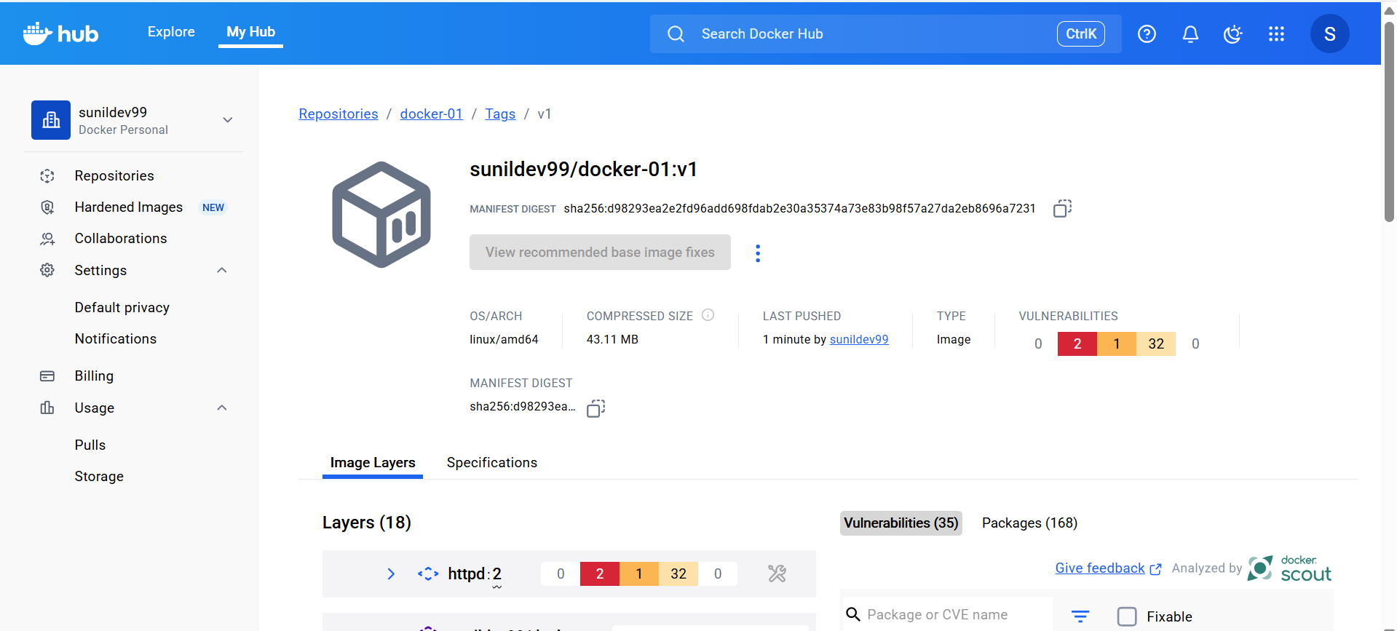

7.Implement solution to scan images when pushed to AWS ECR.

- Enable Image Scanning on ECR Repository
aws ecr create-repository \
--repository-name my-app \
--image-scanning-configuration scanOnPush=true
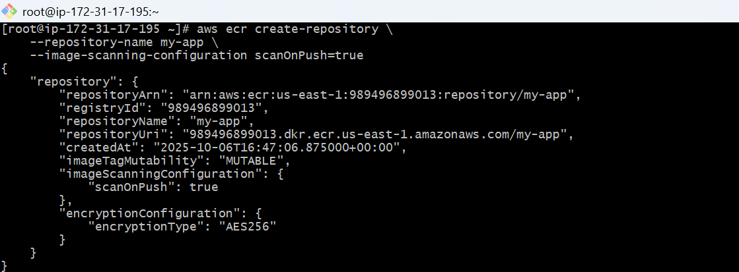
This creates a new repo and
This ensures every image pushed triggers a scan automatically.

2. Push Your Docker Image to ECR

# Authenticate Docker to ECR
aws ecr get-login-password --region us-east-1 | docker login --username AWS --password-stdin 989496899013.dkr.ecr.us-east-1.amazonaws.com

# Tag your image
docker tag my-app:latest 989496899013.dkr.ecr.us-east-1.amazonaws.com/my-app:latest
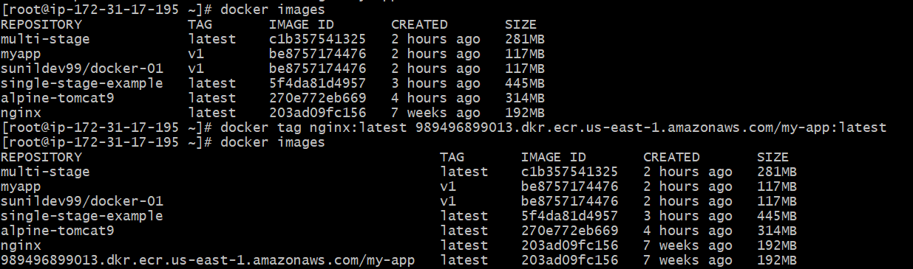

# Push image
docker push 989496899013.dkr.ecr.us-east-1.amazonaws.com/my-app:latest
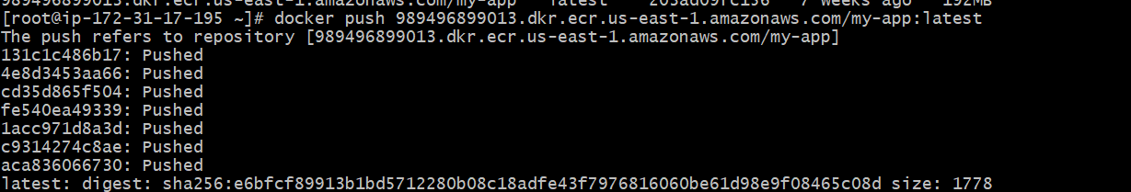
Check Image Scan Findings
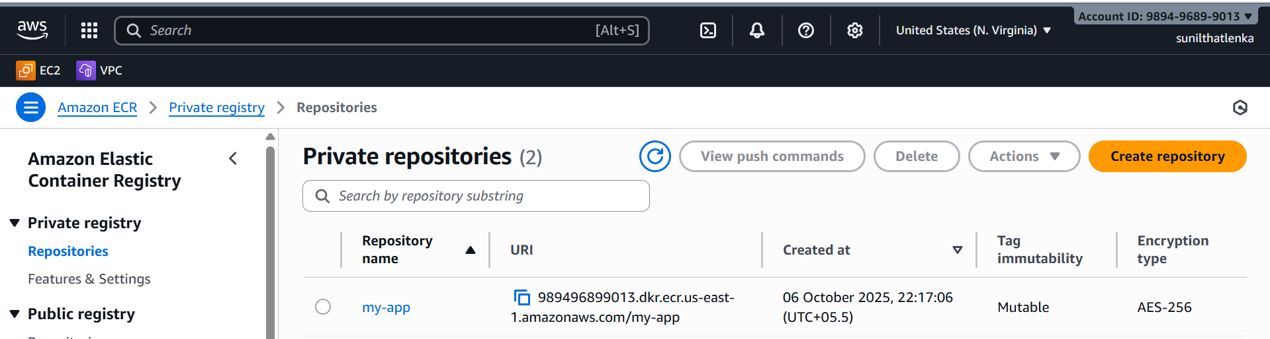
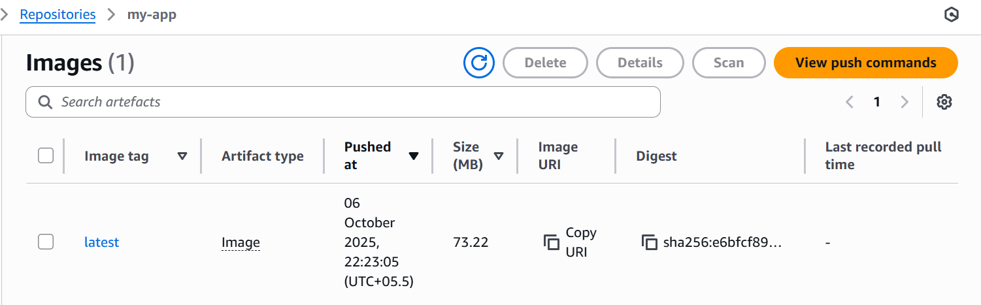
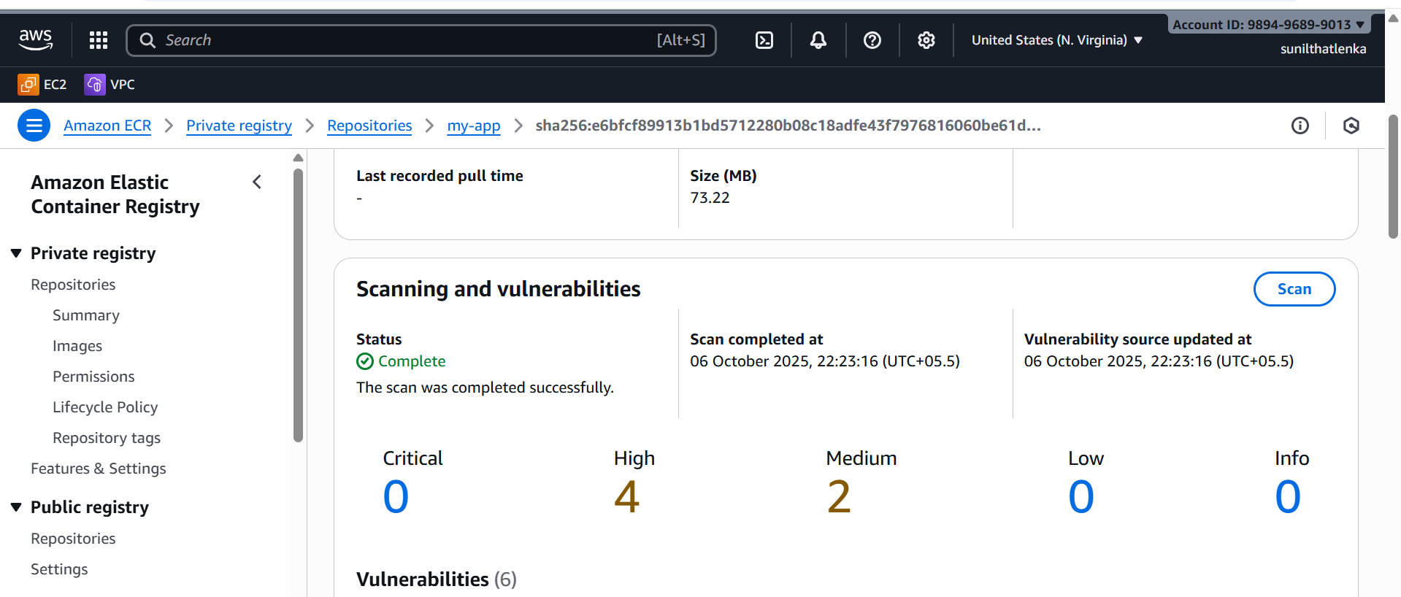

8.Create a Jenkins pipeline to create a docker image and push the image to Docker hub.

Step 1: Prerequisites
Before creating the pipeline, ensure you have:
- Jenkins Installed
  - Jenkins server up and running (can be on your local machine, EC2,).
  - Jenkins user has access to Docker.

Step 2— Run Jenkins with Docker Access
Run Jenkins container with the Docker socket mounted so it can run Docker commands on the host:
docker run -d \
--name jenkins \
-p 8080:8080 \
-p 50000:50000 \
-v jenkins_home:/var/jenkins_home \
-v /var/run/docker.sock:/var/run/docker.sock \
jenkins/jenkins:lts
🔸 This gives Jenkins full access to your Docker daemon (needed for building images).
🔸 Access Jenkins UI at:
👉 http://<your-server-public-ip>:8080
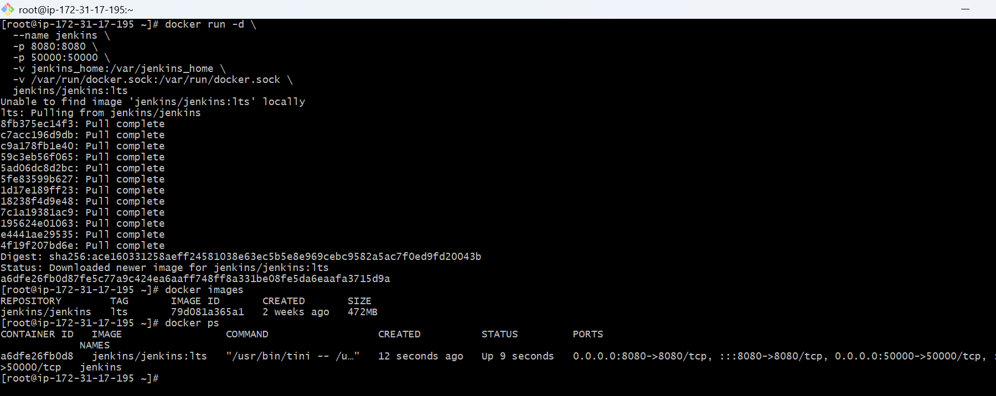

Step 3 — Get Jenkins Unlock Password
docker exec -it jenkins cat /var/jenkins_home/secrets/initialAdminPassword

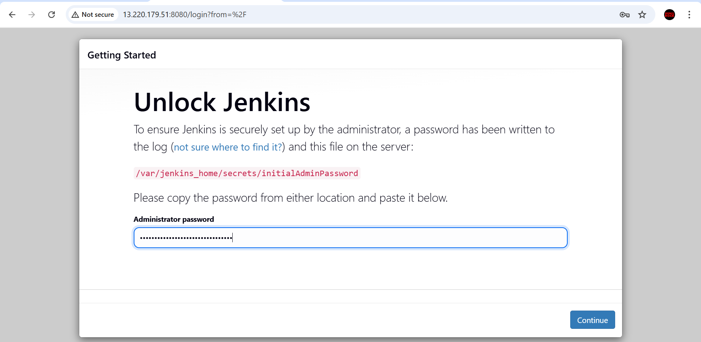

install these plugins
Docker
Docker Commons
Docker Pipeline
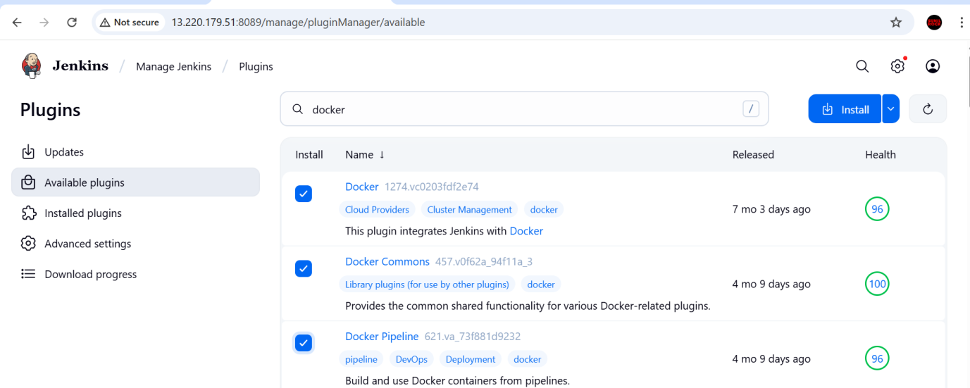

Step4 — Add Docker Hub Credentials
- Go to Manage Jenkins → Credentials → Global → Add Credentials
- Select: Username with password
  - Username → Your Docker Hub username
  - Password → Your Docker Hub password or access token
  - ID → docker-hub-cred
  - Click Save

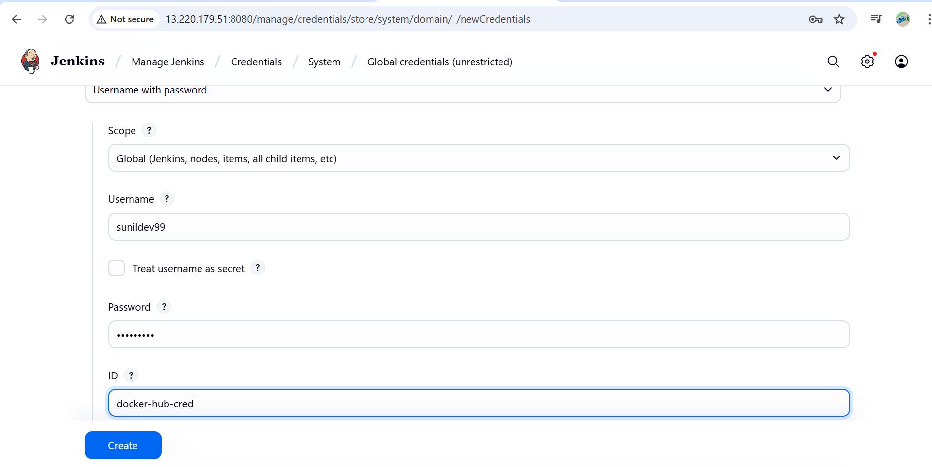

Step 5 — Create Jenkins Pipeline Job
- Go to Jenkins Dashboard → New Item → Pipeline
- Name it docker-pipeline
- Choose Pipeline script
- Paste this scripted pipeline code:
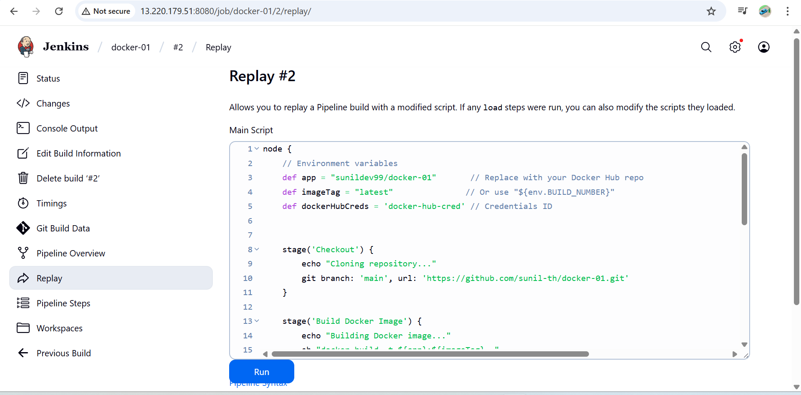

Step 6 — Test the Setup
Click Build Now.
It should:
- Clone your repo
- Build the Docker image
- Log in to Docker Hub
- Push the image
- Clean up
Check your Docker Hub repository — you’ll see your image appear!

Step 7 — Verify Docker Access Inside Jenkins
If you ever face “docker: not found”, verify:
docker exec -it jenkins bash
which docker
docker ps

