ECS.
1) Setup a highly available ecs cluster with load balancer and dynamic port mapping.
NOTE:
Your cluster should maintain atleast 6 tasks at any point of time and should be highly availble across multiple AZ's.
Use the below image from deployment:
sabair0509/hiring-app:works

Pre-reqs
Vpcs and security groups

OVERVIEW
We’ll deploy sabair0509/hiring-app:works with:
- ECS cluster name → hiring-app-cluster
- Task Definition name → hiring-app-task
- Service name → hiring-app-service
- Desired tasks → 6
- Dynamic port mapping (hostPort=0)
- ALB target type → instance
- High availability → Spread across at least 2 AZs

STEP 1 — Create an ECS Cluster (EC2 launch type)
- Go to ECS Console → Clusters → Create Cluster
- Choose “EC2 Linux + Networking”
- Name: hiring-app-cluster
- Infrastructure configuration:
  - Instance type: t3.medium (or larger)
  - Number of instances: 3 (minimum)
  - Key pair: (select one so you can SSH in)
  - Networking:
    - VPC: hiring-app-vpc
    - Subnets: select at least 2 public subnets (for high availability)
    - Security group: select ecs-instances-sg
  - IAM role: choose/create ecsInstanceRole
- Container instance IAM role:
  - If you don’t see ecsInstanceRole, click “Create new role” and select the AmazonEC2ContainerServiceforEC2Role policy.
- Click Create
Wait a few minutes for the EC2 instances to launch and appear under ECS → Clusters → your cluster → ECS Instances.

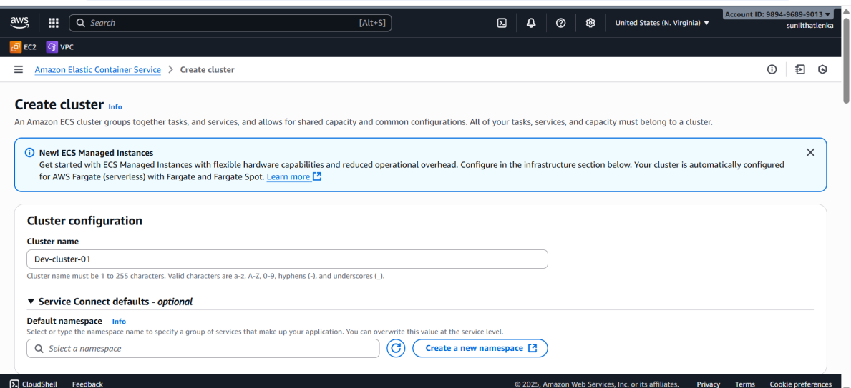
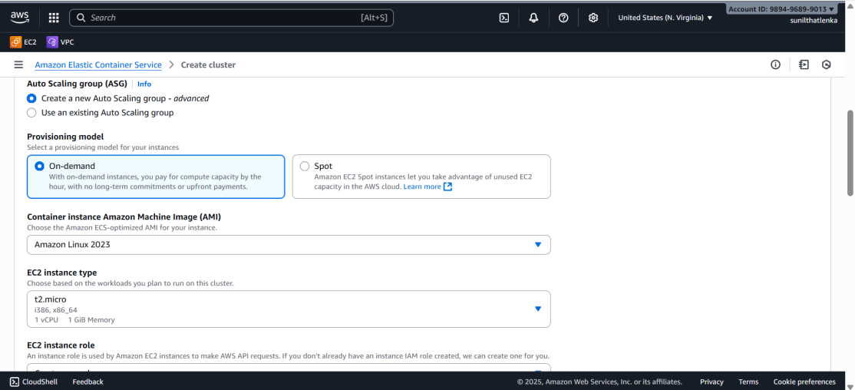=_

STEP 2 — Create Task Definition (with dynamic port mapping)
- Go to ECS Console → Task Definitions → Create new Task Definition
- Choose EC2 (not Fargate)
- Task Definition Name: hiring-app-task
- Task Role: None (optional)
- Task execution role: select ecsTaskExecutionRole
  - If you don’t have it, click “Create new role”.
→ AWS will automatically create one with the AmazonECSTaskExecutionRolePolicy.
- Network Mode: bridge
- Add container:
  - Container name: hiring-app
  - Image: sabair0509/hiring-app:works
  - Port mappings:
    - Container port: 80
    - Host port: 0 (this is key for dynamic port mapping)
- Click Add
- Click Create
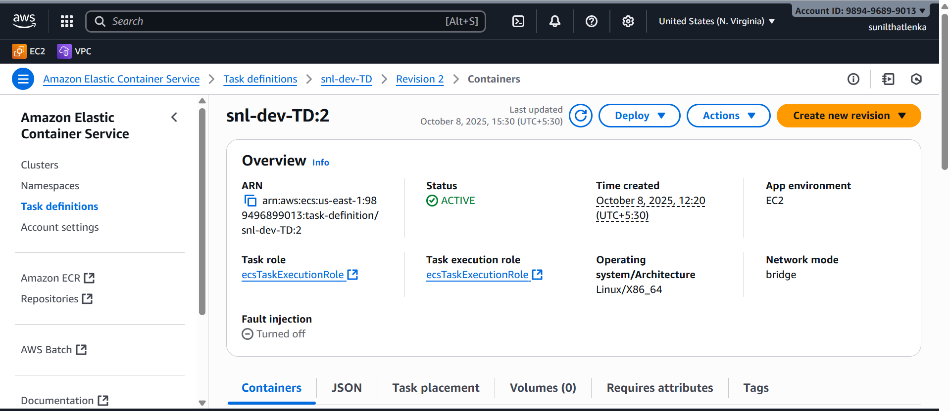

and also create tasks
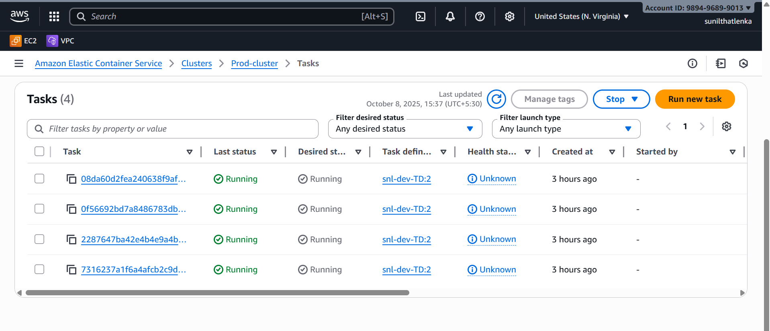

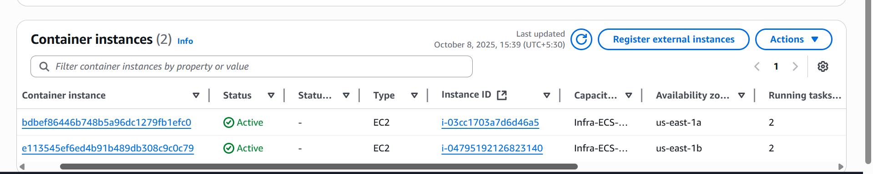

STEP 3 — Create an Application Load Balancer
- Go to EC2 Console → Load Balancers → Create Load Balancer
- Choose Application Load Balancer
- Name: hiring-app-alb
- Scheme: Internet-facing
- IP type: IPv4
- Listeners: HTTP (port 80)
- VPC: hiring-app-vpc
- Availability Zones: select at least 2 public subnets
- Security Group: alb-sg
- Click Next

Create Target Group
- Target group name: hiring-app-tg
- Target type: Instance
- Protocol: HTTP, Port: 80
- VPC: hiring-app-vpc
- Health check path: / (or your app path)
- Click Next → Create target group
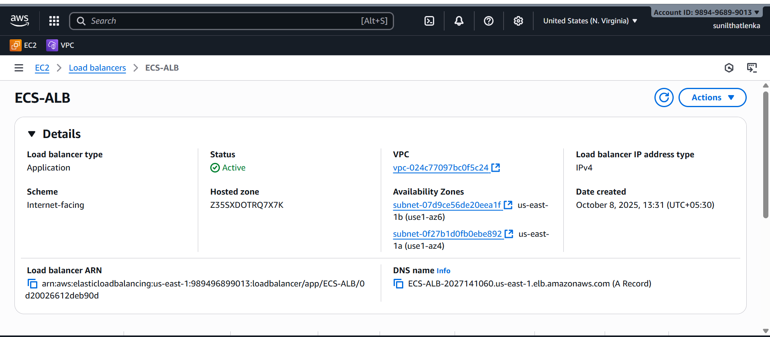
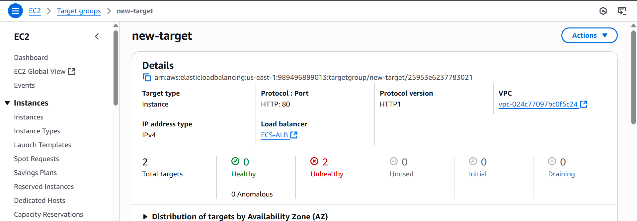

STEP 4 — Create ECS Service (Attach ALB)
- Go to ECS Console → Clusters → hiring-app-cluster → Services → Create
- Launch type: EC2
- Task Definition: choose the latest revision of hiring-app-task
- Service name: hiring-app-service
- Desired tasks: 6
- Deployment type: Rolling update
- Load balancing:
  - Choose Application Load Balancer
  - Click Add to load balancer
  - Container to load balance: hiring-app:80
  - Target group name: select hiring-app-tg
  - Health check: /
- Load balancer listener: HTTP:80 → forward to hiring-app-tg
- Service auto scaling (optional but recommended):
  - Enable service auto scaling
  - Minimum capacity: 6
  - Desired: 6
  - Maximum: 12
- Placement strategy:
  - Spread → attribute:ecs.availability-zone
- Click Create Service
