Kubernetes-01
1.Setup Minikube in your local machine.
Minikube is a lightweight tool that lets you run a single-node Kubernetes cluster locally — great for learning, development, and testing Kubernetes.

Prerequisites
1.Before installing Minikube, make sure you have:
- Virtualization support (e.g., Docker, KVM, VirtualBox)
2.Install Docker on windows.
https://docs.docker.com/desktop/install/windows-install/
3.Install Oracle box on windows
https://adamtheautomator.com/install-virtualbox-on-windows-10/
4.Install Minikube using powershell
https://minikube.sigs.k8s.io/docs/start/

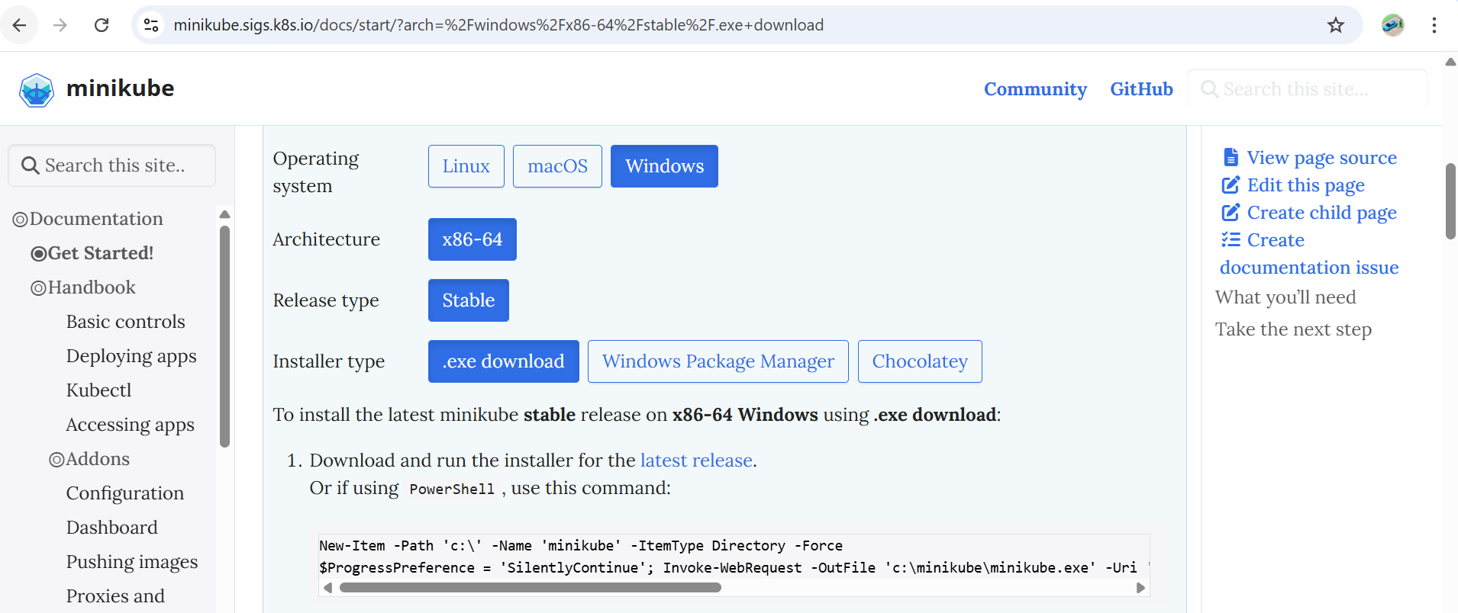
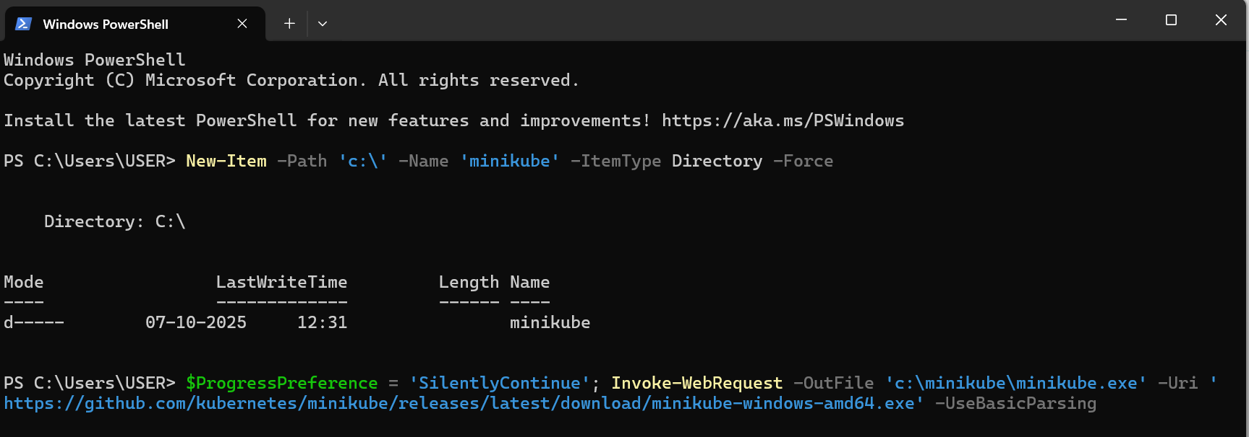

Set the minikube path to environmental varaible
export PATH=$PATH:/c/minikube
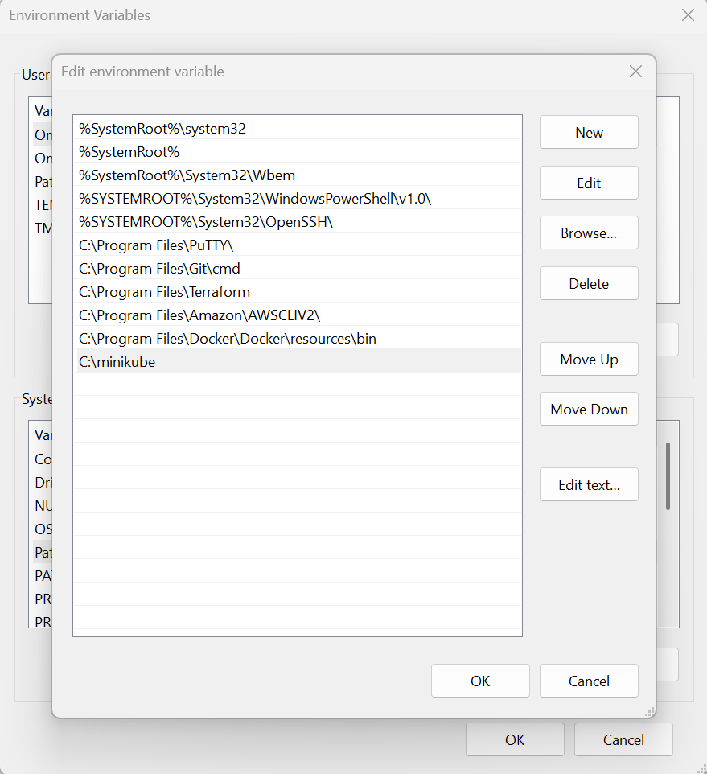

Restart powershell and start minikube
minikube start

you can start in vscode as well
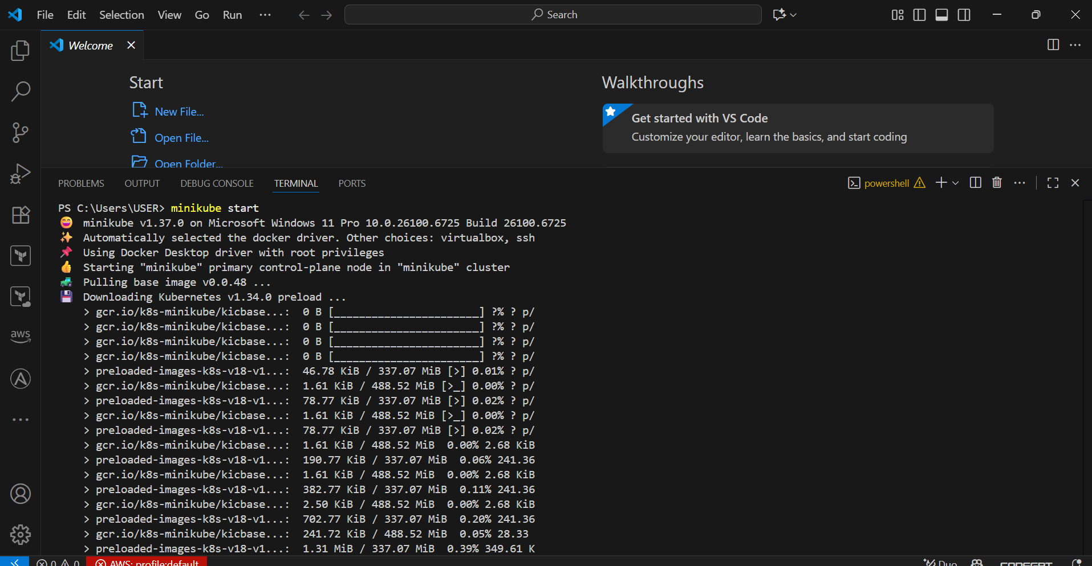
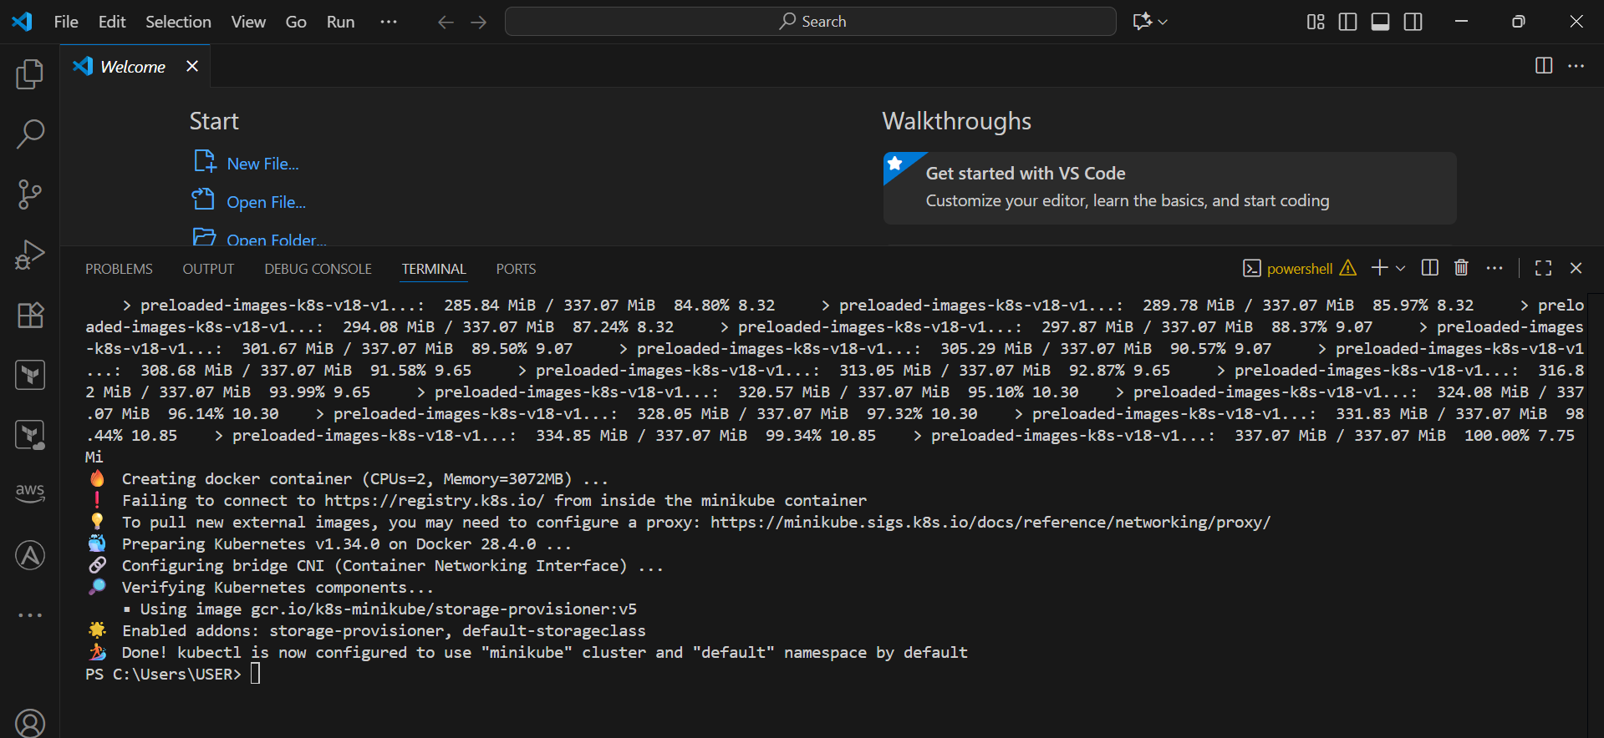

To check minikube ip use : minikube ip
To ssh to minikube: minikube ssh
To connect or check the pods : kubectl get pods

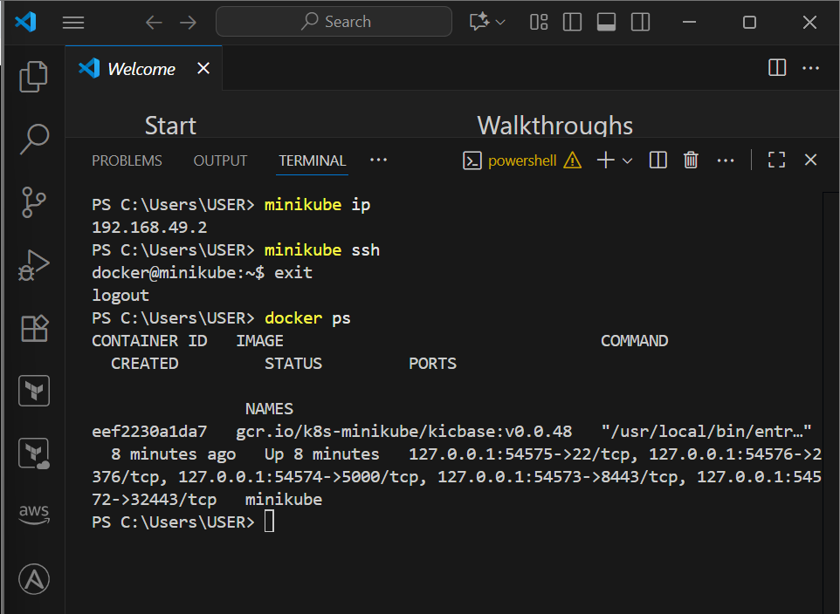

2.Setup k8s master and two worker nodes on ubuntu.

Setup 3 nodes k8s cluster,1 master and 2 node machines:
======================================================
1) launch 3 instances of type t2.medium
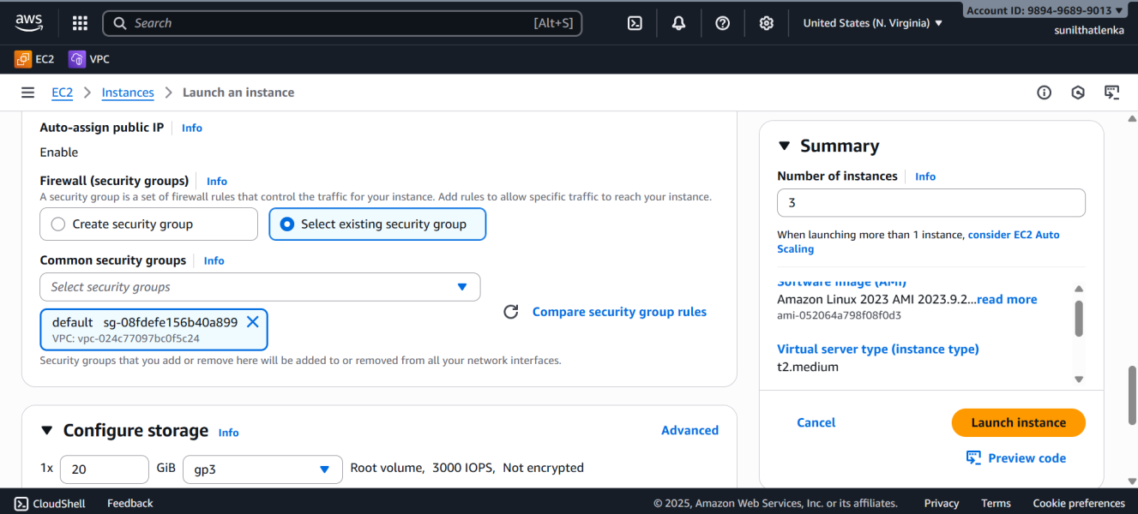
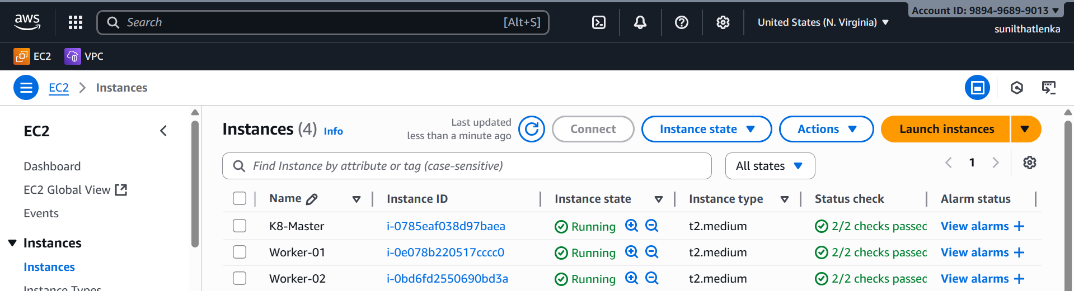
2) Change the hostname
vi /etc/hostname
hostname master
similarly do it workers hostnames
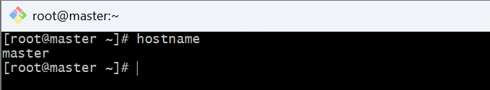
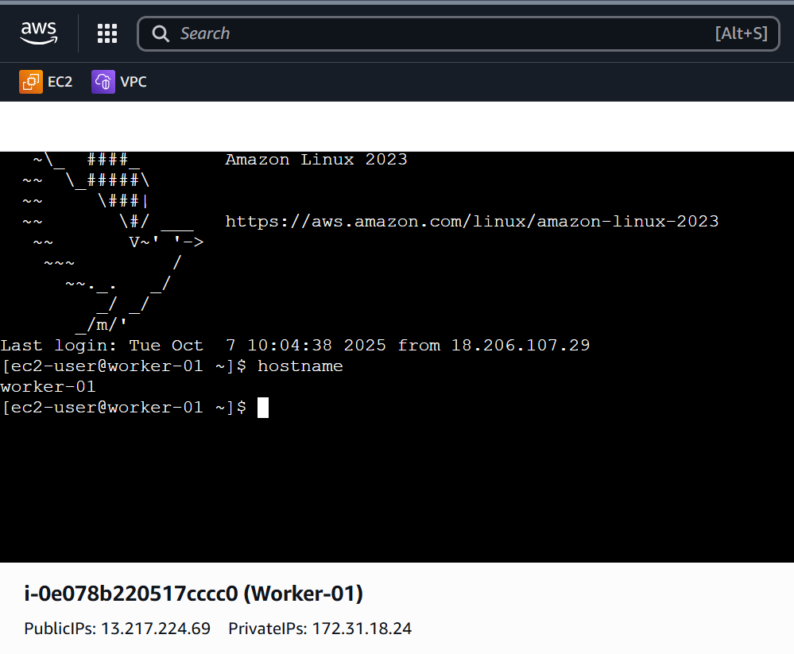
3) Install docker on all 3 instances
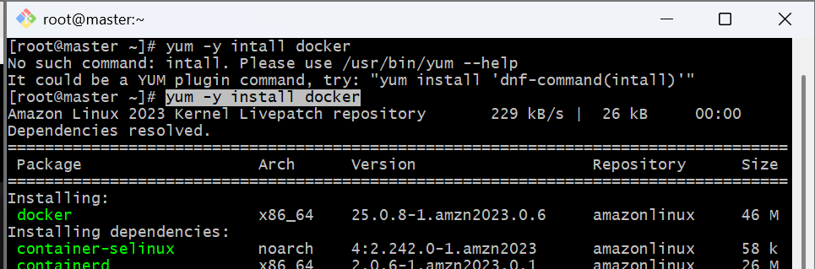
systemctl start docker
systemctl enable docker
systemctl status docker
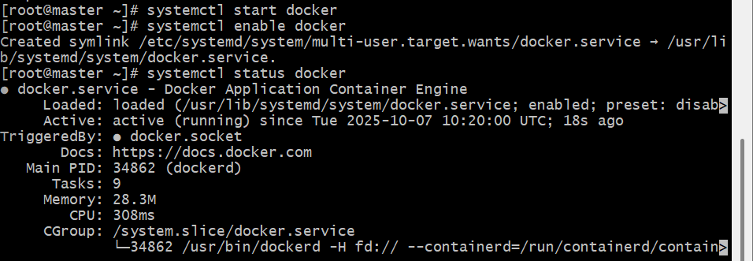
4) To setup k8s cluster we have different tools like kops and kubeadm.

https://kubernetes.io/docs/setup/production-environment/tools/kubeadm/install-kubeadm/

# This overwrites any existing configuration in /etc/yum.repos.d/kubernetes.repo
cat <<EOF | sudo tee /etc/yum.repos.d/kubernetes.repo
[kubernetes]
name=Kubernetes
baseurl=https://pkgs.k8s.io/core:/stable:/v1.34/rpm/
enabled=1
gpgcheck=1
gpgkey=https://pkgs.k8s.io/core:/stable:/v1.34/rpm/repodata/repomd.xml.key
exclude=kubelet kubeadm kubectl cri-tools kubernetes-cni
EOF

Do the same in workers nodes as well
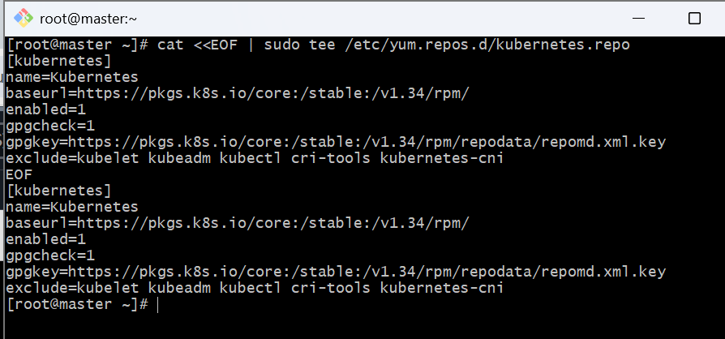

sudo yum install -y kubelet kubeadm kubectl --disableexcludes=kubernetes
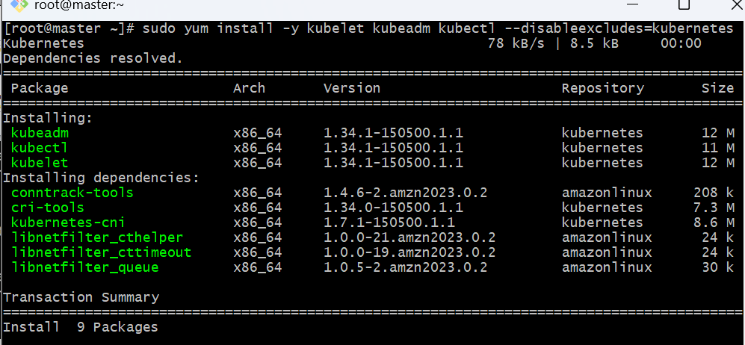
sudo systemctl enable --now kubelet
5) Now we need to setup networking and configure master and worker nodes.

https://kubernetes.io/docs/setup/production-environment/tools/kubeadm/create-cluster-kubeadm/
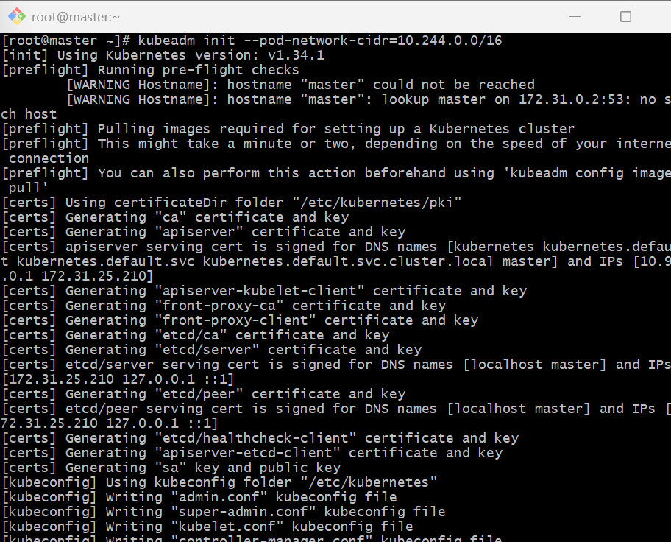
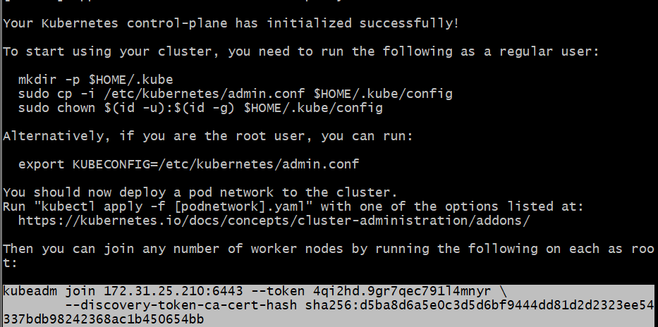

6) To start using your cluster, you need to run the following as a regular user:
mkdir -p $HOME/.kube
sudo cp -i /etc/kubernetes/admin.conf $HOME/.kube/config
sudo chown $(id -u):$(id -g) $HOME/.kube/config

7) If we execute kubectl get nodes we can see the status as notready because we haven't installed flannel
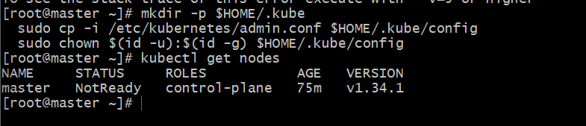
8) Now copy the token and execute on worker machines.

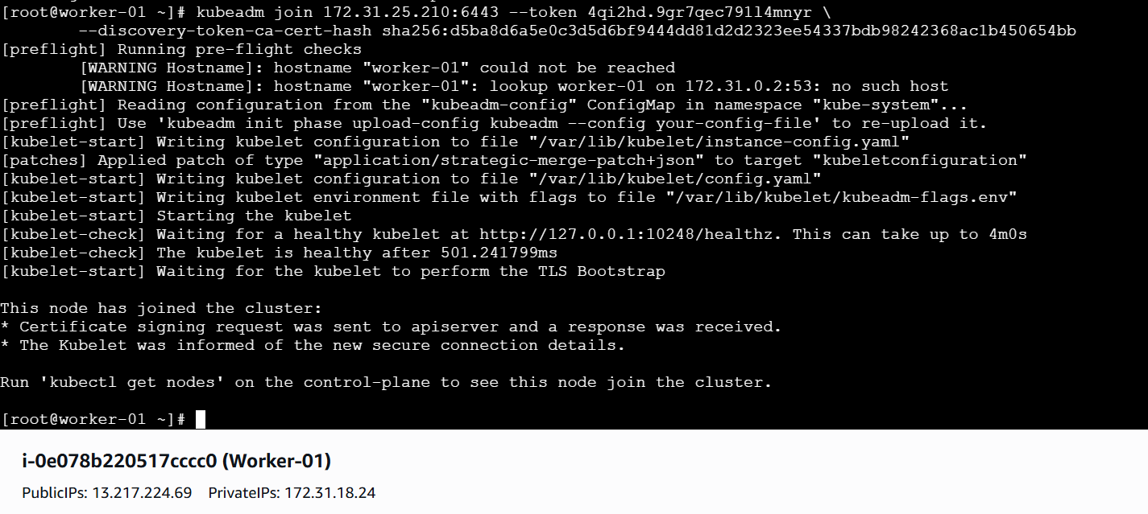
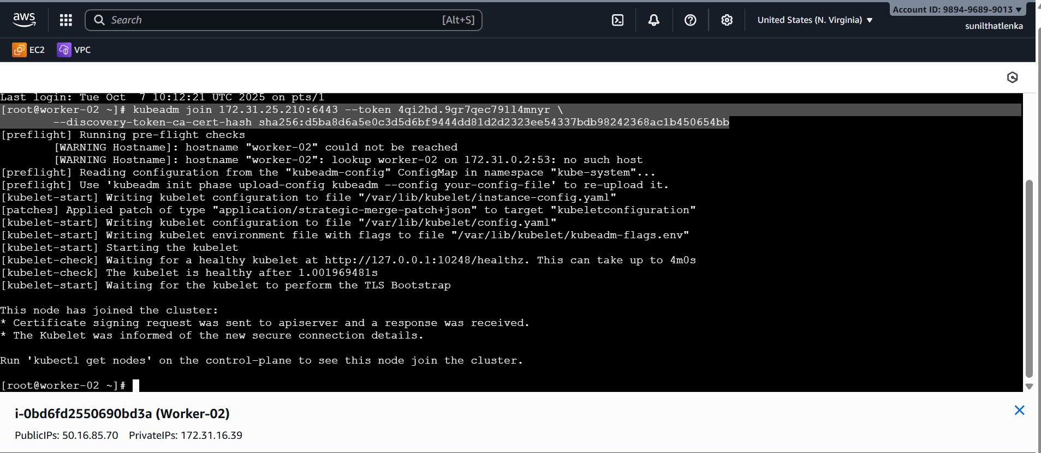
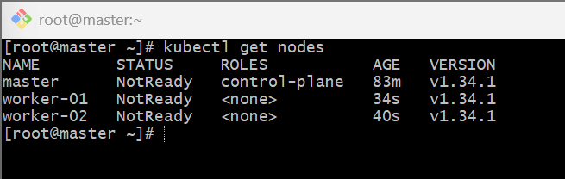
9) Install Flannel and check the status of nodes
kubectl apply -f https://github.com/flannel-io/flannel/releases/latest/download/kube-flannel.yml
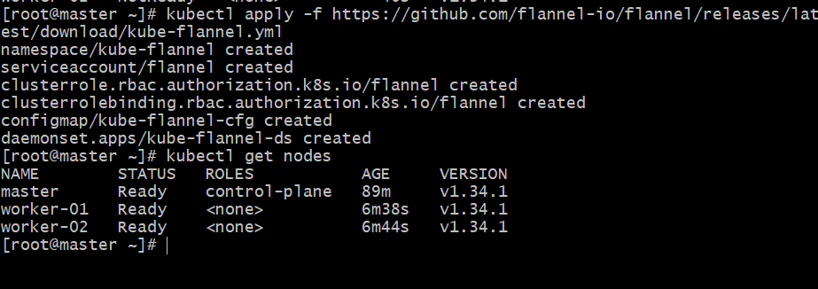

3.Run one nginx pod.
Step 1: Verify your cluster
On Master node, check if all nodes are ready:
kubectl get nodes
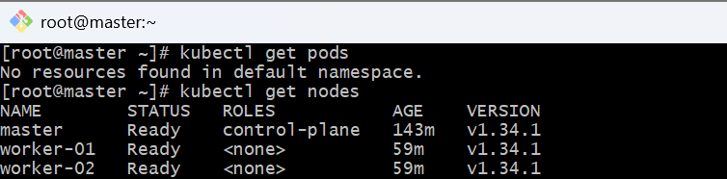Step 2: Create a Pod YAML for Nginx:
vi nginx-pod.yaml
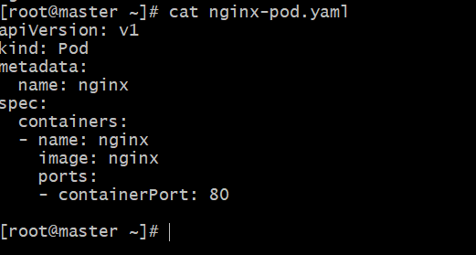
Step 3: Apply the Pod YAML:
kubectl apply -f nginx-pod.yaml
kubectl get pods

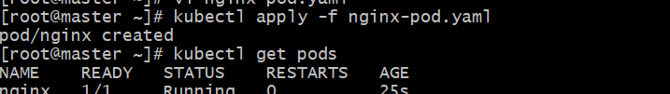

Step 4: Add a Label to Your Pod
Run:
kubectl label pod nginx app=nginx
You can confirm:
kubectl get pods --show-labels
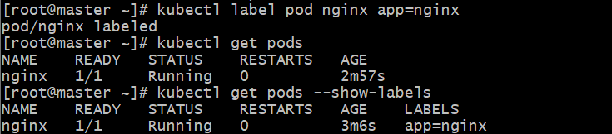

Step 5: Expose the Pod via a NodePort Service
Now that it has a label, expose it:
kubectl expose pod nginx --type=NodePort --port=80 --name=nginx-service
You can verify the service:
kubectl get svc

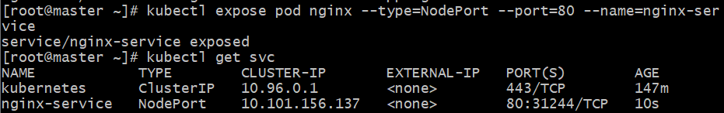

Step 6: Access the Nginx Page
- Find your NodePort (e.g., 31244 from 80:31244/TCP)
- Open your browser or use curl from any node:
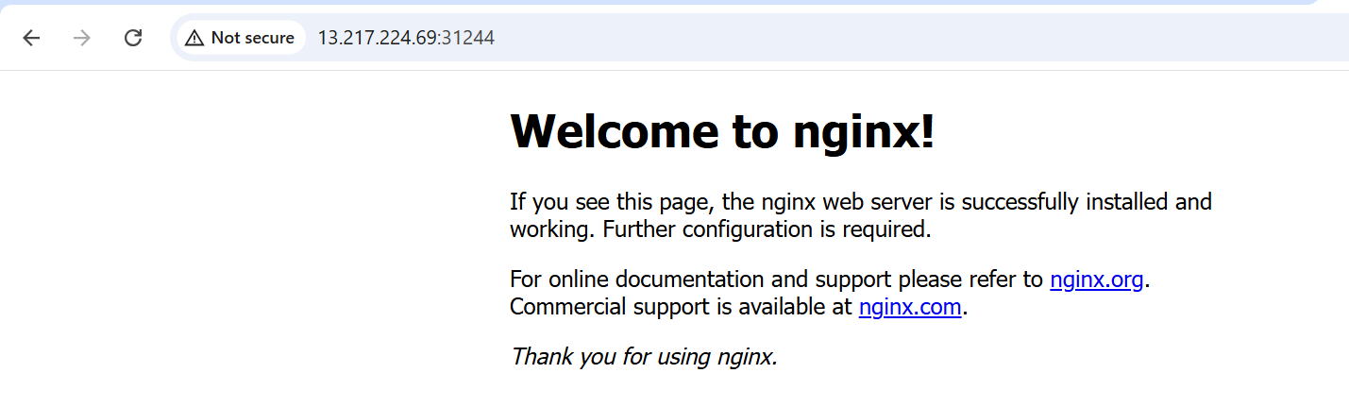

4.Mug up Master and slave components on k8s.
What is kubernetes:
==================
Kubernetes is also called as k8s.
k8s is an open source popular orchestration tool developed and used by google in prod env.
We have different orchestration technologies like dockerswarm,kubernets and
mesos.Advantages of k8s:
==================
With the help of orchestration our application is highly available, as it is deployed on multiple instances.
we can scale up the cluster if demand increase and also scale up nodes if we are out of resources.Basic k8s components:
====================
Pod: Is the smallest unit of k8s,a pod can contain one container,multiple
container,one container and one volume.
Ip will be assigned to POD.ReplicaSet: Ensures the number of pods running on node machines.
If suppose any one pod is not healthy then RS will monitor and create new POD.Deployments:Deployments are used to deploy,upgrade,undo the changes,pausing and again resuming the changes.
Deployments use rolling update means the new version will be slowing updated with the older version
and the users will be able to access our application without downtime.Hierarchy for deployment:
pods --> replicasets --> DeploymentNamespaces: These are used to group your applications.
They can be helpful when different teams or projects share a Kubernetes cluster.services: Service will help us to redirect the traffic to PODS.Kubernetes Architecture:
=======================
We have two Kind of machines in k8s.
1) Master
2) Worker nodeAgain we have different components on master and worker nodes.Master Components:
==================
1) Kube api server
2) etcd
3) Controller
4) Schedulerworker node components:
=======================
1) Docker container runtime
2) Kubelet agent
3) KubeproxyNote: kubectl is a command line tool to execute k8s commands.Api server: Acts as frontend of k8s,Authenticate user,authorization and api server is the only gateway to communciate with our k8s cluster.
Etcd: Cluster brain,which stores the information related to cluster,node in the form of key value pair.
Scheduler: Responsible to schedule pods on the node machine.
Controller manager: controller is the brain behind orchestration,if nodes,container,endpoint goes down then controller will work behind to bring them up.
Container runtime: any container service to start,stop container (Docker).
kubelet: Kubelet run on all the machines,kubelet make sure that the containers are running as expected on node machines.
KubeProxy: It maintains network rules on your nodes and enables network communication to your Pods.

